|  |
| --- |
| Principles and Applications of Digital Image Processing |

【Fall, 2020】

工科所 R08525116 吳承哲

Homework 1

**Part 1: (50%) Histogram of an Image**

Design a software program to read the special .64 image file described in our lecture. Translate the .64 text file into a 64x64 image with 32 gray levels and store the data in a 2-dimensional array. Process the image array to obtain the histogram of the image.

Test you program with the following .64 files and plot the histogram of each image.

LISA.64, LINCOLN.64, JET.64, LIBERTY.64.

You may plot the image histogram directly in your software program or plot the histogram with any plotting software such as EXCEL or MATLAB. Designing a function in your program to display the image on the screen is encouraged.

LISA.64

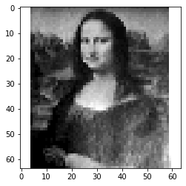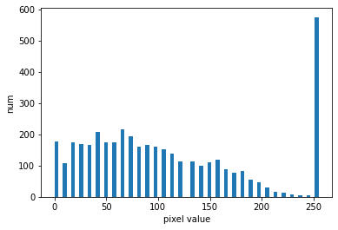

LINCOLN.64

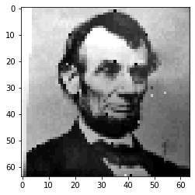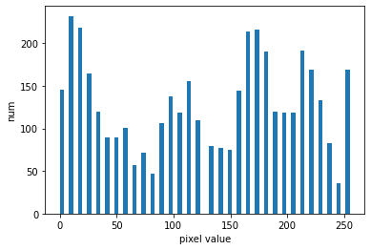

JET.64

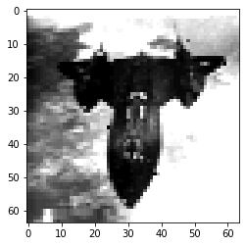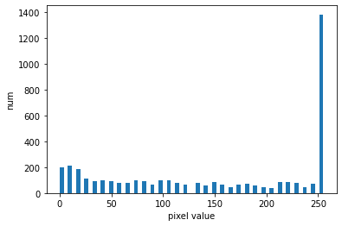

LIBERTY.64

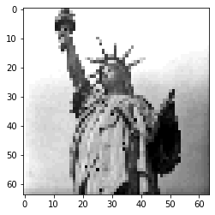 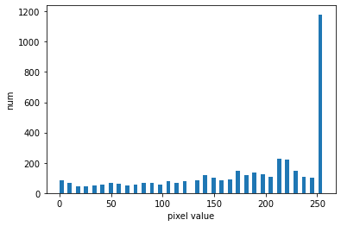

**Part 2: (50%) Arithmetic Operations of an Image Array**

Design a software program that will perform the basic tasks of arithmetic operations on an image or two images. Use the .64 image for this program. The assigned image processing operations are as follows:

1. Add or subtract a constant value to each pixel in the image.
2. Multiply a constant to each pixel in the image.
3. Create a new image which is the average image of two input images.
4. Create a new image *g*(*x*,*y*) in which the value of each pixel is determined by calculating the pixel values of the input image *f*(*x*,*y*) using the following equation:

*g*(*x*,*y*) = *f*(*x*,*y*) - *f*(*x-*1,*y*)

Calculate the histograms of the processed images from the above arithmetic operations and compare them with the histograms of the original image. Briefly discuss your results.

LISA.64

Original image



1. Add a constant 100

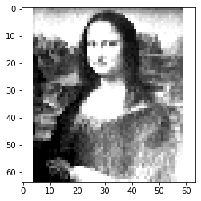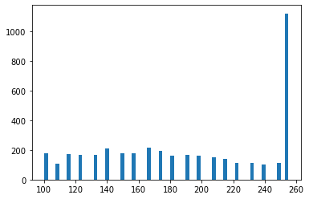

加入一個常數會使圖片變亮，減去一個常數會使圖片變暗

1. Multiply a constant 5

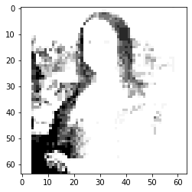 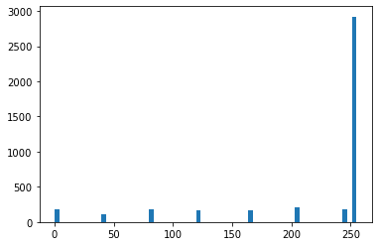

乘上大於1的常數會使pixel value較分散，對比度較高，若乘上小於1的值則反之。

1. Averge above 2 image

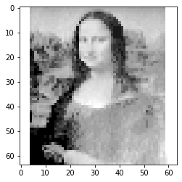 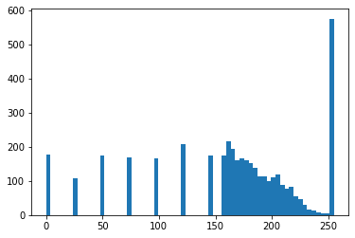

此為將原圖跟2平均，會保留2的特性，但效果較弱。

1. g(x, y)

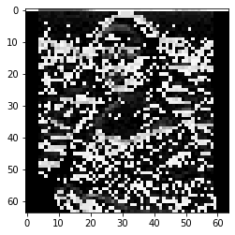 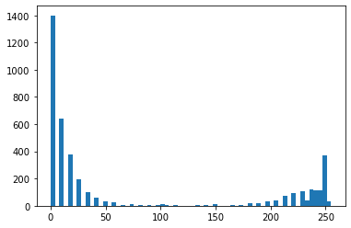

再轉後的時候，將每個pixel value減去左邊column的值，由於第一行的部分沒有左側的值，因此讓它減去最後一個colume的值，呈現一張亂碼的圖片。

**Notes:**

1. Please submit your programs and report to the CEIBA course website before **Sept. 30 (2:20PM)**.
2. Late submission will have a penalty of 10% discount per day of your homework total score toward a maximum of 50% discount. No late submission over five days will be accepted.