**I. Phoenix (Immediate Interest Payment) Option Income Structure**

The Phoenix structure, akin to the classic barrier-style雪球 (snowball) option, belongs to the category of options where the final payout depends on both knock-in and knock-out events, tied to the underlying asset and entry/trigger conditions. However, the timing and rules for payout events differ from those of the snowball.

Unlike the classic snowball where interest can only be paid upon early knock-out or at maturity without knock-in/knock-out, the Phoenix structure incorporates scheduled monthly observation days to assess eligibility for regular interest payments. If the underlying asset's price surpasses the payout threshold on the observation day, investors are entitled to the interest payment for that month.

The Phoenix structure offers investors interest payments through regular observation events, determining whether to receive interest based on the occurrence of these events. Even if the underlying asset experiences a decline, investors in the Phoenix structure can still earn interest as long as the knock-out event doesn't occur. This structure is particularly favorable for investors who might not experience a knock-out, as they still receive interest to offset potential losses in the underlying asset. Moreover, if the accumulated interest exceeds the underlying's decline, investors can realize a profit.

It's worth noting that while the Phoenix structure offers lower risk compared to the classic snowball in terms of interest income, it also offers less attractive interest rates. Under identical parameters, the Phoenix structure's interest rate will be lower, resulting in a lower quoted price compared to the classic snowball.

1.1 Product Basics (Example)

* Underlying Asset: An index or stock
* Product Term: 12 months
* Knock-in Price: e.g., Initial Price * 70%
* Knock-in Event: If the underlying asset's closing price on any observation day falls below the knock-in price
* Knock-out Price: e.g., Initial Price * 100%
* Knock-out Event: If the underlying asset's closing price on any knock-out observation day equals or exceeds the knock-out price
* Payout Price: e.g., Initial Price * 70% (usually the same as the knock-in price)
* Payout Event: If the underlying asset's closing price on any payout observation day equals the payout price
* Knock-in Observation Frequency: Daily
* Knock-out Observation Frequency: Monthly
* Payout Observation Frequency: Monthly (often the same as knock-out observation days)
* Principal Protection: 100% at maturity
* Annualized Coupon (Interest): R0 per month (R0/12)

1.2 Product Payoff Diagram

**指数涨跌幅**

R0

**一定下跌保护**

**+较高票息**

**到期收益（年化）**

1.3 Product Features

* Payout Mechanism: During the product's lifetime, if the underlying asset's closing price exceeds the payout price on any monthly observation day, the product pays interest for that month.
* Knock-out Mechanism (High Probability): During the product's lifetime, if the underlying asset's closing price exceeds the knock-out price on any knock-out observation day, the product pays back the principal and accumulated interest (based on the number of times interest was paid) and terminates early.
* Knock-in Mechanism (Moderate Protection): The daily observation ensures a safety net; only if the index falls below the knock-in price during the term and never recovers, investors bear the investment loss.

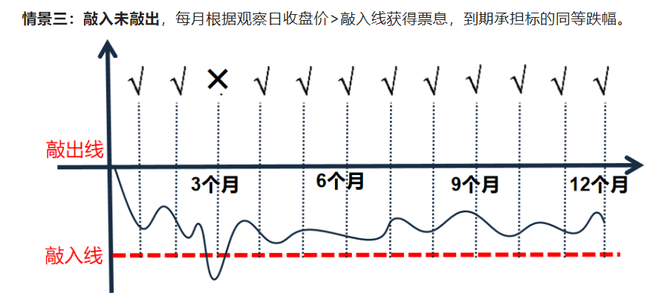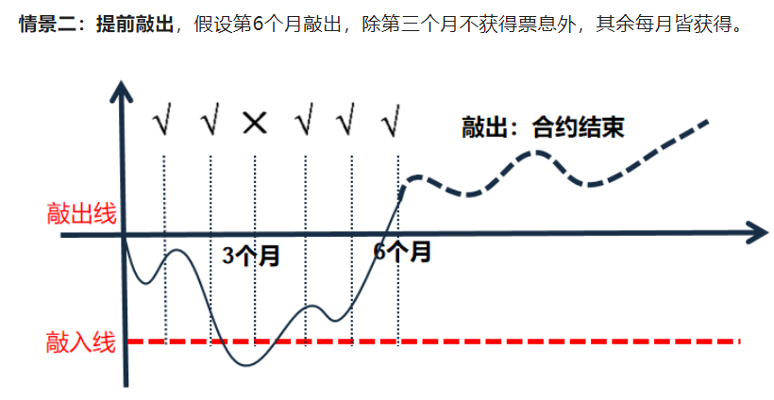1.4 Analysis of Maturity Returns Scenarios

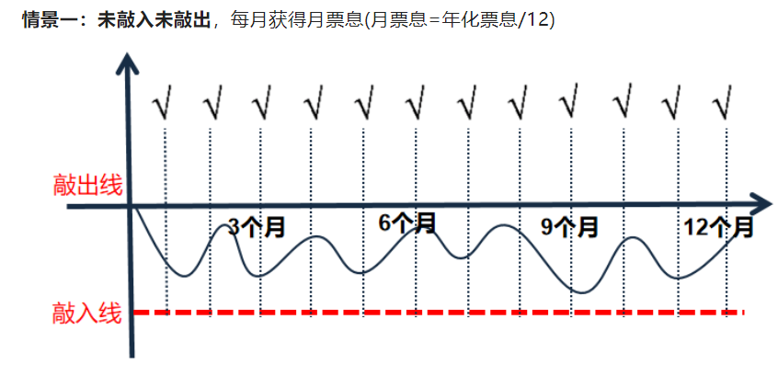

**II. Valuation Model for Phoenix (Immediate Income) Options**

2.1 Valuation Model

References:

Kunitomo, N. and Ikeda, M. (1992) Pricing Options with Curved Boundaries. Mathematical Finance, 2, 275-298

Reiner, E. and Rubinstein, M. (1991) Unscrambling the Binary Code. Risk, 4, 75-83

Reiner, E. and Rubinstein, M.(1991)"Breaking Down the Barriers,"

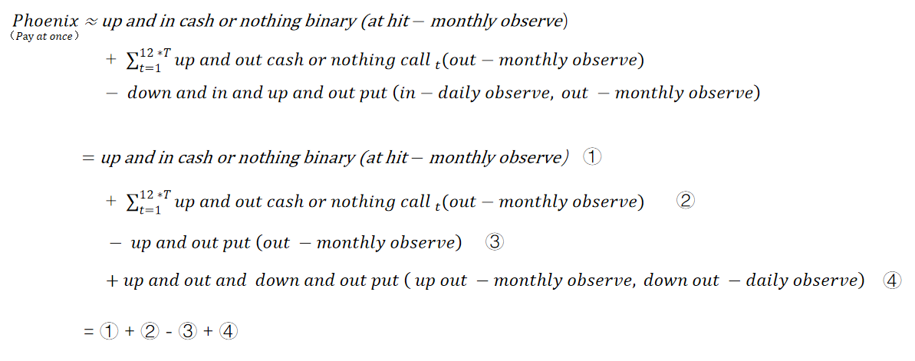

2.2 希腊字母（Greeks）计算方法

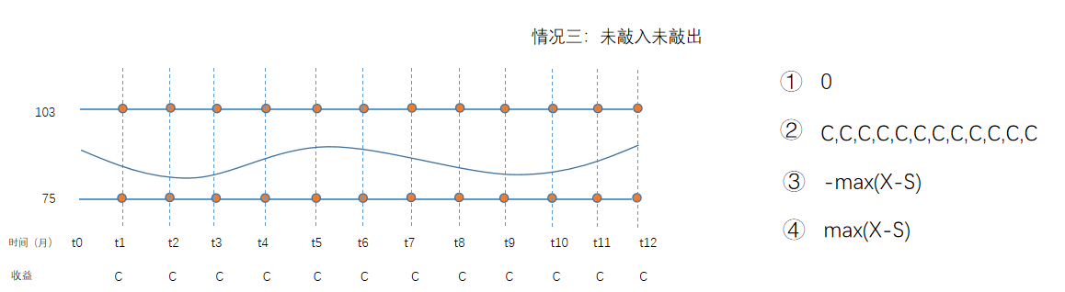

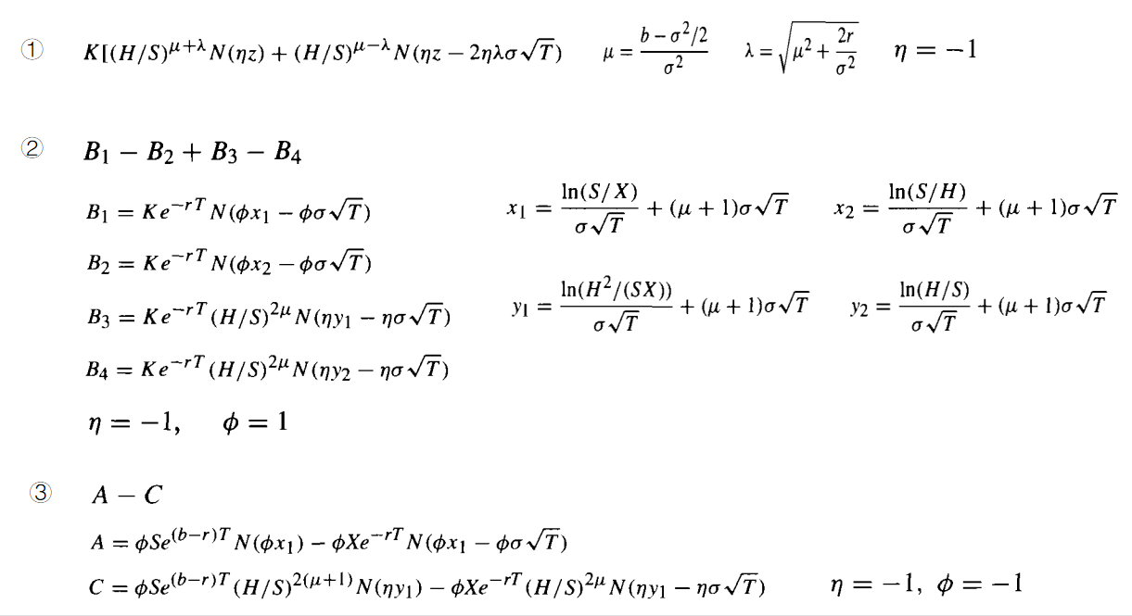

2.2 Greeks Valuation

**III. Core parameters of valuation model and their determination**

3.1 Determination of volatility

Historical volatility reflects the real volatility of the market history and can represent the level and trend of volatility over a period of time; implied volatility reflects the expectations of investors in the on-site market for future volatility trends; therefore, the model volatility is determined by comprehensively referring to historical volatility and implied volatility.

3.2 Determination of risk-free interest rate

The risk-free interest rate can use the 10-year treasury bond yield as a reference lower limit, and refer to the capital cost of the business department to comprehensively determine the risk-free interest rate.

3.3 Determination of the dividend rate of the target

The setting of the dividend margin lending rate varies according to the situation of the linked target: for individual stocks, if the contract stipulates that the dividend will not be adjusted for the equity of the option contract, the dividend rate refers to the average annualized dividend of the target in the past three years; if the contract stipulates that the dividend will adjust the initial price, the dividend rate of the individual stock contract is set to 0; for the index, the dividend rate refers to the discount rate of the stock index futures in the past week, month, and quarter.

**IV. Core parameters of valuation model and their determination** Based on the Tongyu system, pricing/bookkeeping/data management is performed for the Phoenix (immediate dividend) option structure product case.

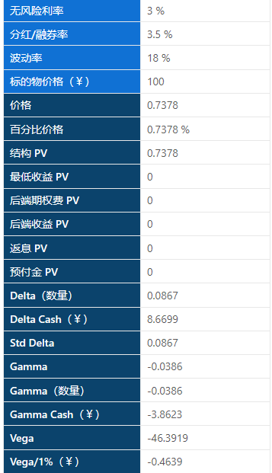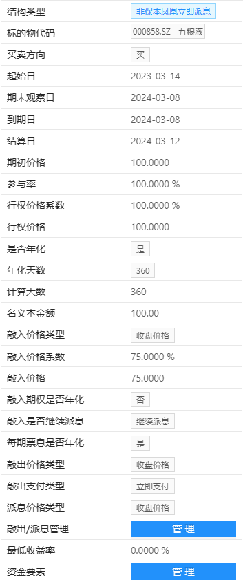

**V. Valuation scheme verification**

The valuation model of Phoenix (immediate dividend) option structure is implemented based on Python language. By constructing test cases, the valuation of Phoenix (immediate dividend) option structure model developed by third-party Tongyu Technology is verified.

Construct a series of basic test cases, first set the basic elements, and then change different element combinations based on the basic elements to test the valuation and Greek letters of Phoenix (immediate dividend) options respectively.

|  |  |  |  |  |  |
| --- | --- | --- | --- | --- | --- |
|  | **original parameters** | **Modify volatility** | **Modify barrier price** | **Modify the knock-in price** | **Modify compensation amount** |
| **start date** | 2023/3/14 | 2023/3/14 | 2023/3/14 | 2023/3/14 | 2023/3/14 |
| **expire date** | 2024/3/8 | 2024/3/8 | 2024/3/8 | 2024/3/8 | 2024/3/8 |
| **S0** | 100 | 100 | 100 | 100 | 100 |
| **Volatility** | 0.18 | **0.25** | 0.18 | 0.18 | 0.18 |
| **Knock out** | 103% | 103% | **110** | 103% | 103% |
| **Knock in** | 75% | 75% | 75% | **70%** | 75% |
| **Coupon Rate** | 7% | 7% | 7% | 7% | **9.7%** |
| **R0** | 3% | 3% | 3% | 3% | 3% |
| **Dividend rate** | 3.5% | 3.5% | 3.5% | 3.5% | 3.5% |
| **Date Rules** | Bus247 | Bus247 | Bus247 | Bus247 | Bus247 |
| **Observation frequency** | daily | daily | daily | daily | daily |

Each model calculates the estimated value:

|  |  |  |  |  |  |
| --- | --- | --- | --- | --- | --- |
| **Tongyu** | 0.7378 | -2.19 | 2.0449 | 1.913 | 1.9592 |
| **test cases** | 0.7447 | -2.0586 | 2.0324 | 1.9023 | 1.9730 |
| **Valuation Bias** | 0.0069 | -0.1314 | 0.0125 | 0.0107 | -0.0138 |

Each model calculates Greek letters:

|  |  |  |  |  |  |
| --- | --- | --- | --- | --- | --- |
| **Tongyu-delta** | 0.0867 | 0.3727 | 0.1546 | -0.0887 | -0.0296 |
| **test cases-delta** | 0.0838 | 0.4274 | 0.1904 | -0.1075 | -0.0471 |
| **Valuation Bias** | 0.0029 | -0.052 | 0.0442 | 0.0188 | 0.0175 |
| **Tongyu-gamma** | -0.0386 | -0.0325 | -0.0506 | -0.0286 | -0.0407 |
| **Test cases-gamma** | -0.0544 | -0.0275 | -0.0546 | -0.0519 | -0.0683 |
| **Valuation Bias** | 0.0158 | -0.005 | -0.1052 | 0.0233 | 0.0276 |
| **Tongyu-vega** | -46.3919 | -36.0815 | -65.0383 | -38.8486 | -49.506 |
| **test cases-vega** | -45.2982 | -32.5908 | -65.6420 | -40.1401 | -48.6266 |
| **Valuation Bias** | -1.0936 | -3.4907 | 0.3817 | 1.2915 | -0.8794 |

The calculation results show that the maximum error of the Phoenix (immediate dividend) option product valuation calculated by the verification model and the congruential system is [0.1314].

The verification results show that the valuation results of the development model are accurate and reliable.

Appendix 1: Phoenix.py is the verification model used in this article

Appendix 2: Phoenix_MC.py, reference verification model

Appendix 3: Model reference document