Tendermint block executor

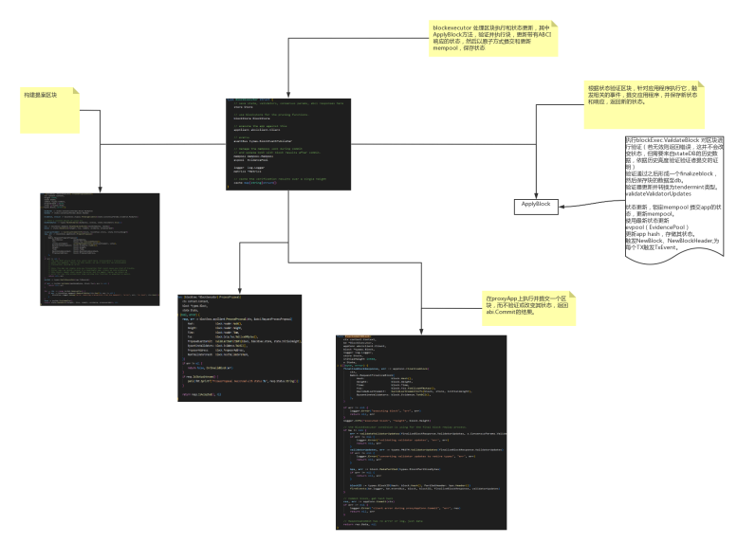

Tendermint consensus reactor(共识服务的反应器)

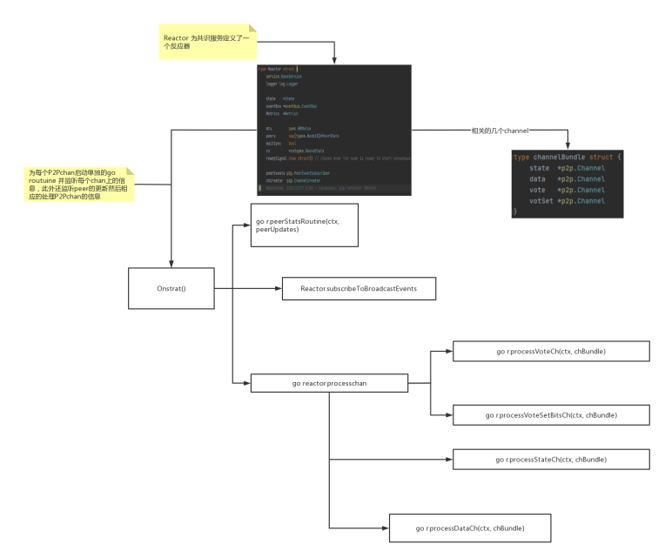

Tendermint reactor 逻辑

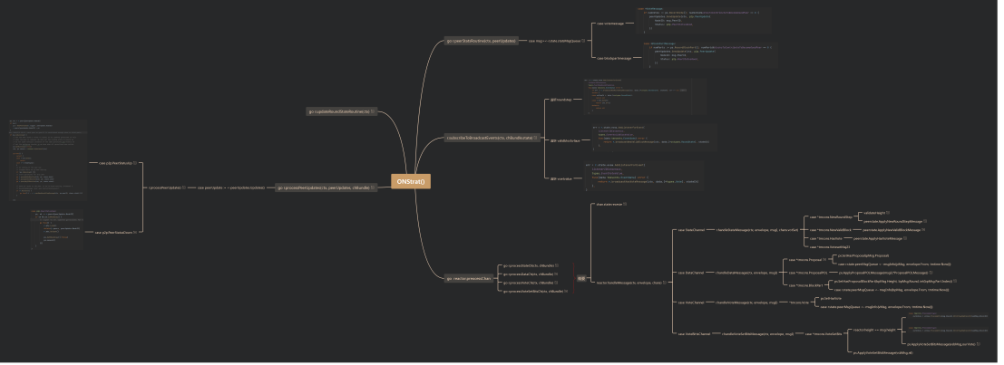

State tendermint/internal/types/state.go

