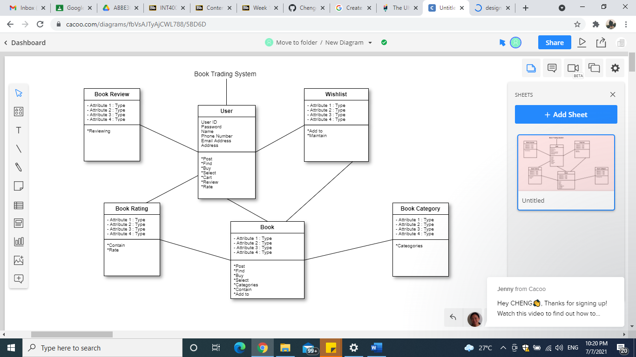

Problem: User want to return and exchange another book because they are unsatisfied with the books they purchased.

Design pattern selected: Structural Patterns is the most suitable design pattern that can be implemented on the problem.

Reason: In the original system, there is no class for user to return and exchange book. People actually start want to return and exchange books. Therefore, we need to add these functions in the system so that user can return and exchange books. Since structural patterns is the easiest way that identify and realizes the relationships among entities. Structural design patterns also specify methods of connecting objects, not just references between them. The structural class pattern uses inheritance to combine the interfaces or implementations of multiple classes. In my opinion, I think structural patterns is the most suitable design pattern that can be implemented on this problem.

