MAVUNO SACCO PAYROLL SYSTEM
Python Console Application – Project Documentation

Student Name: Davis Musungu Chenge
Student ID: SKH-2026-0101
Course: Python Programming
Trainer: Mahmoud Kenty
Date: 7th Sept 2026

Prepared as a technical project report
Implementation language: Python

Code Review
The submitted Python source was reviewed before preparing this report. The application is functionally structured around reusable functions, a persistent JSON employee list, a menu-driven while loop, for-loop processing, bitwise permissions, exception handling, and two external PIP libraries.

1. Introduction
The Mavuno Sacco Payroll System is a Python-based console application designed to demonstrate how a small payroll process can be computerized. The system stores employee information such as employee ID, name, department, basic salary, allowances, and permissions. It then uses these records to calculate gross salary, statutory deductions, and net salary.
The system addresses the problem of manually processing employee payroll information. A manual process can require repeated calculations, record searching, and checking of employee access rights. The application brings these tasks together in a menu-driven interface. Employees can be displayed, added, searched, and used to generate payslips. The application can also produce a payroll summary and demonstrate permission management.
Employee records are stored in a JSON file, which allows information entered during one execution of the program to remain available after the application is restarted. The application also includes error handling so that common invalid inputs do not terminate the program.

2. Code Implementation
The implementation is divided into several logical sections. Each section below identifies the relevant Python concept and shows a representative code snippet from the submitted source.

2.1 Data Structures – Lists and Dictionaries
Employee information is stored as dictionaries inside a list. Each dictionary contains key-value pairs such as id, name, department, basic_salary, and allowances. This structure allows the program to maintain multiple employee records and access individual fields by key.
employee = {
"id": employee_id,
"name": name,
"department": department,
"basic_salary": basic_salary,
"allowances": allowances
}
employees.append(employee)
The list is also used when searching, displaying, and summarizing employees. Python documentation describes lists as mutable collections and dictionaries as key-value data structures (Python Software Foundation, 2026).

2.2 Main While Loop and Menu
The main application uses a while True loop to keep the payroll system running until the user chooses Exit. The menu uses if/elif statements to route each choice to the appropriate function.
while True:
display_menu()
choice = input("Enter your choice: ")
if choice == "1":
# Display employees
...
elif choice == "2":
add_employee(employees)
...
elif choice == "8":
print("Exiting payroll application...")
break
The break statement terminates the loop when the user selects option 8. This demonstrates the use of a while loop for continuous menu-driven program execution.

2.3 For Loops – Searching and Processing Records
The program uses for loops to iterate through the employee list. For example, the search function checks each employee until it finds a matching ID. The payroll summary also loops through every employee to calculate totals.
for employee in employees:
if employee["id"] == search_id:
print("Employee found:")
...
return
This provides evidence of collection processing using a for loop. Python's documentation describes the for statement as iterating over the items of a sequence such as a list (Python Software Foundation, 2026).

2.4 Reusable Functions and Return Values
The application separates calculations and operations into reusable functions. Functions such as calculate_gross_salary(), calculate_paye(), calculate_nssf(), calculate_shif(), calculate_ahl(), and calculate_payroll() receive parameters and return results.
def calculate_gross_salary(basic_salary, allowances):
gross_salary = basic_salary + allowances
return gross_salary
def format_currency(amount):
return f"KSh {amount:,.2f}"
The calculate_payroll() function combines the individual calculations and returns several payroll values, which are then unpacked by the payslip, employee display, and summary features.
return (
gross_salary,
paye,
nssf,
shif,
ahl,
total_deductions,
net_salary
)

2.5 Payroll Calculation Module
The payroll module first calculates gross salary from basic salary and allowances. It then calculates NSSF, SHIF, and AHL, subtracts those deductions to obtain taxable income, calculates PAYE, and finally subtracts all deductions from gross salary to determine net salary.
gross_salary = calculate_gross_salary(
employee["basic_salary"],
employee["allowances"]
)
nssf = calculate_nssf(gross_salary)
shif = calculate_shif(gross_salary)
ahl = calculate_ahl(gross_salary)
taxable_income = gross_salary - nssf - shif - ahl
paye = calculate_paye(taxable_income)
total_deductions = paye + nssf + shif + ahl
net_salary = gross_salary - total_deductions
The PAYE function applies progressive tax bands and a personal relief value. The submitted implementation uses 10%, 25%, 30%, 32.5%, and 35% bands, with KSh 2,400 personal relief. These bands correspond to the PAYE bands published by the Kenya Revenue Authority (Kenya Revenue Authority, n.d.).

2.6 Bitwise Permission Management
Bitwise operators are used to represent employee permissions compactly. Each permission is assigned a different power-of-two value, allowing several permissions to be stored in one integer.
VIEW_PAYROLL = 1
EDIT_PAYROLL = 2
MANAGE_EMPLOYEES = 4
def has_permission(permissions, permission):
return (permissions & permission) != 0

The OR operator is used when assigning a permission so that an existing permission is retained. The AND operator checks whether a particular permission bit is present.
employee["permissions"] = (
employee.get("permissions", 0) | EDIT_PAYROLL
)
For example, VIEW_PAYROLL (1) and EDIT_PAYROLL (2) can be combined as 1 | 2 = 3. Checking 3 & 1 confirms the view permission, while 3 & 2 confirms the edit permission.

2.7 PIP Libraries – Colorama and Tabulate
The application uses two external PIP libraries. Colorama is used to display coloured terminal messages, while Tabulate is used to format employee and payroll information into readable tables. The libraries are checked at startup and installed with pip if they are not already available.
def ensure_package(package_name, import_name=None):
if import_name is None:
import_name = package_name
if importlib.util.find_spec(import_name) is not None:
print(f"{package_name} is already installed.")
return True
subprocess.check_call([
sys.executable,
"-m",
"pip",
"install",
package_name
])
Colorama is used through Fore.RED for error messages and Fore.GREEN for successful operations. Its purpose is to make terminal output easier to distinguish. Tabulate receives lists of rows and headers and renders them as a structured text table (Astanin, 2026; Hartley, 2022).

2.8 Exception Handling and Input Validation
The add_employee() function uses try/except to prevent non-numeric salary input from terminating the program. It also validates negative salary and allowance values and prevents duplicate employee IDs.
while True:
try:
basic_salary = float(input("Enter basic salary: "))
if basic_salary < 0:
print(Fore.RED + "Basic salary cannot be negative.")
continue
allowances = float(input("Enter allowances: "))
if allowances < 0:
print(Fore.RED + "Allowances cannot be negative.")
continue
break
except ValueError:
print(Fore.RED + "Invalid salary. Please enter numbers only.")

2.9 JSON Persistence
Employee records are written to employees.json using json.dump() and loaded using json.load(). This allows records to persist between executions of the application.
def save_employees(employees):
try:
with open("employees.json", "w") as file:
json.dump(employees, file, indent=4)
def load_employees():
try:
with open("employees.json", "r") as file:
employees = json.load(file)
return employees
except FileNotFoundError:
return []

3 Screenshots
The screenshots below document the operation and testing of the Mavuno Sacco Payroll System. Each figure is referenced in the implementation discussion where relevant.
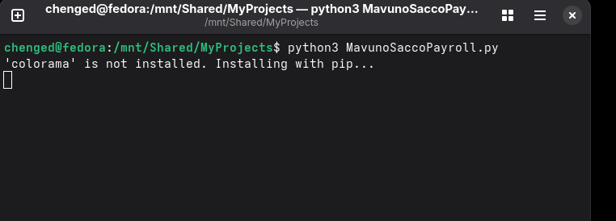
Figure 1. Installing the external Colorama library via PIP from the terminal.
Figure 1 shows the application detecting that Colorama is not installed and beginning installation with pip. This demonstrates the external-library installation mechanism implemented in ensure_package().
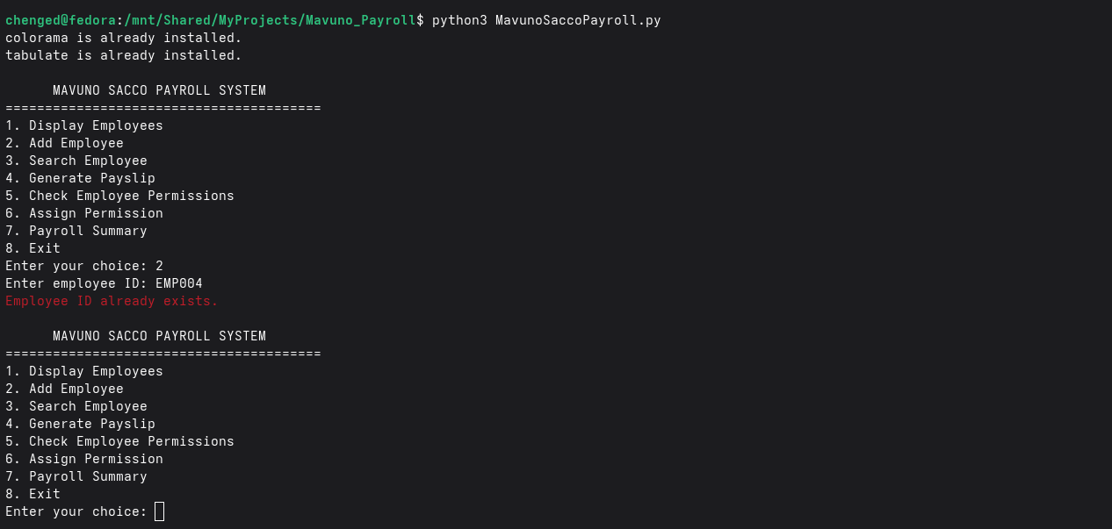
Figure 2. Main menu execution of the Mavuno Sacco Payroll System.
Figure 2 shows the menu-driven interface. The user can display employees, add or search for employees, generate payslips, manage permissions, view the payroll summary, or exit the program.
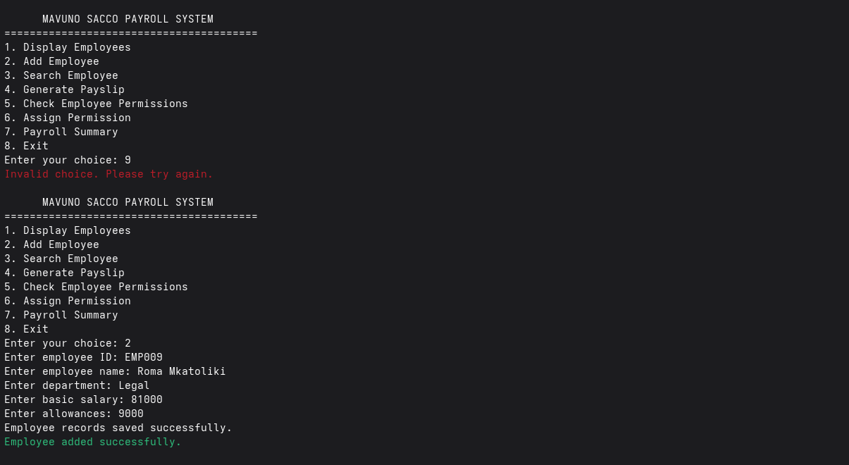
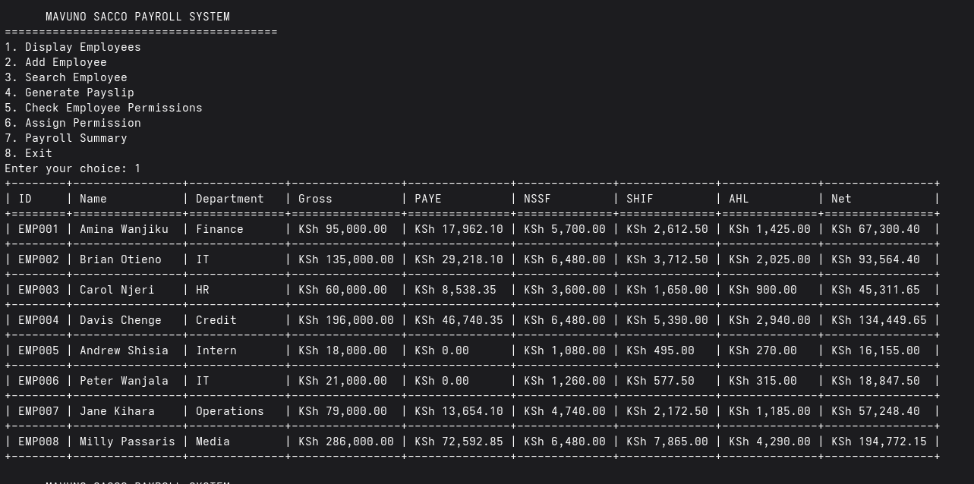
Figure 3. Successful employee data entry followed by employee data display using the list and for-loop processing.
Figure 3 provides evidence of successful data entry and subsequent processing/display of employee records. The employee records are maintained in a list of dictionaries and processed with for loops. Note the colour on the output, red for fail and green for success.
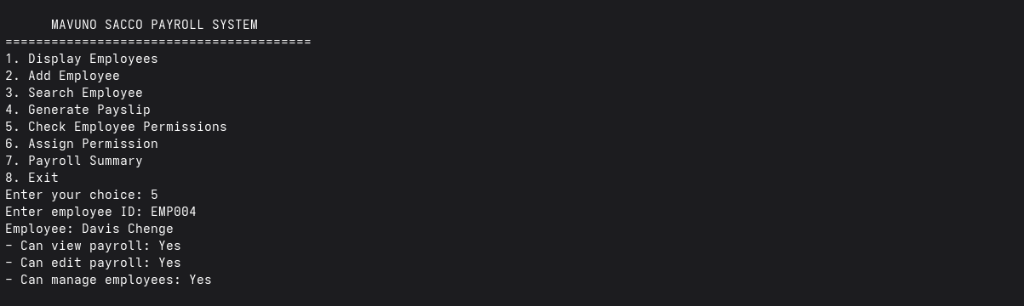
Figure 4. Bitwise permission result in the terminal.
Figure 4 demonstrates the bitwise permission feature. The displayed result confirms that the employee has view, edit, and manage permissions after permissions were combined using bitwise OR and checked using bitwise AND.
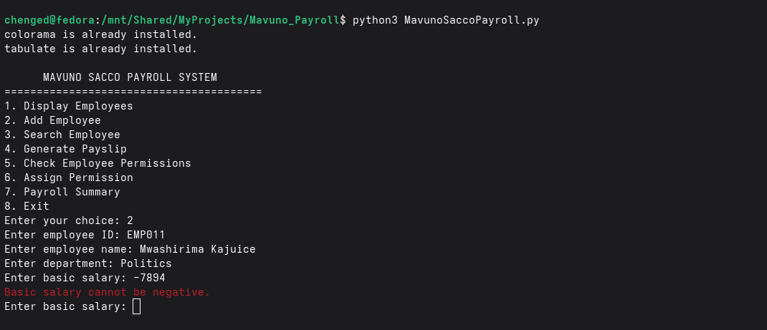
Figure 5. Exception and validation handling for invalid salary input.
Figure 5 shows the application rejecting a negative basic salary and returning to the input prompt rather than terminating. This demonstrates validation and exception-safe input processing.

4. Testing and Results
The application was tested through the major menu functions and through invalid-input scenarios. The tests confirmed that payroll calculations are displayed consistently, employee searches can identify existing and non-existing records, permissions can be assigned and checked, and invalid salary input is rejected without terminating the application.
Test | Expected Result | Observed Result
Main menu | Menu remains available until Exit is selected. | Passed
Employee display | Employee records and payroll values are displayed. | Passed
Employee search | Existing ID is found; unknown ID reports not found. | Passed
Payslip | Gross, deductions and net salary are calculated and displayed. | Passed
Bitwise permissions | Permissions can be combined and checked. | Passed
Invalid numeric input | Program rejects non-numeric salary input. | Passed
Negative salary | Program rejects negative salary values. | Passed
Duplicate ID | Existing employee ID is rejected. | Passed
JSON persistence | Employee records remain available after restart. | Passed

6. Referencing (APA 7th Edition)
Astanin, S. (2026). tabulate [Computer software]. PyPI. https://pypi.org/project/tabulate/
Hartley, J. (2022). colorama [Computer software]. PyPI. https://pypi.org/project/colorama/
Kenya Revenue Authority. (n.d.). Pay as you earn (PAYE). https://www.kra.go.ke/individual/filing-paying/types-of-taxes/paye
National Social Security Fund. (2026, February 18). Notice to employers – Year 4 (2026) NSSF contribution rates. https://www.nssf.or.ke/notice-to-employers-year-4-2026-nssf-contribution-rates
Python Software Foundation. (2026). 5. Data structures — Python 3 documentation. https://docs.python.org/3/tutorial/datastructures.html
Python Software Foundation. (2026). 4. More control flow tools — Python 3 documentation. https://docs.python.org/3/tutorial/controlflow.html

