The Cross-Braiding of the Zero spectra and the Pole Spectra

Previously, we introduced the concept of cross-braiding between two probe spectra. In fact, many types of singularities—including poles, exceptional points, and bound states in the continuum (BICs)—can participate in analogous processes, each endowing the resulting cross-braid with distinct physical significance. Here, we theoretically demonstrate a cross-braid formed between zeros and poles; this braid predicts a stable, complex version of BIC (c-BICs) within the region enclosed by the control loop.
Owing to the near symmetry between the Hamiltonians $H_{RZ}$ and $H_{res}$​, the cross-braiding of zeros and poles remains experimentally elusive. To break this approximate symmetry, we introduce a minimal theoretical model consisting of a single YIG sphere coupled to a CPW line and set the reflection coefficient of the terminating mirror to $r=0.5$. A smaller value of $r$ effectively lifts the symmetry between $H_{RZ}$ and $H_{res}$​, rendering the zeros and poles distinguishable:
$$\begin{aligned}ω_{zeros}=ω_{0}-iγ_{0}+iκ_{0}\left(1-\frac{1}{r}e^{-2iθ_{0}}\right),\#(S9.1)\end{aligned}$$
$$\begin{aligned}ω_{poles}=ω_{0}-iγ_{0}-iκ_{0}\left(1+re^{+2iθ_{0}}\right).\#(S9.2)\end{aligned}$$
For simplicity, we set $ω_{i}=γ_{i}=0$, and $κ_{0}=1$. As $θ_{0}$ swept from 0 to $π$, the trajectories of the zeros and poles intertwine to form a cross-braid, as illustrated in Fig. S5(a). Consequently, the control loop in the $\cos{2θ_{0}}$-$\sin{2θ_{0}}$ plane encloses a c-BIC, as depicted in Fig. S5(b).

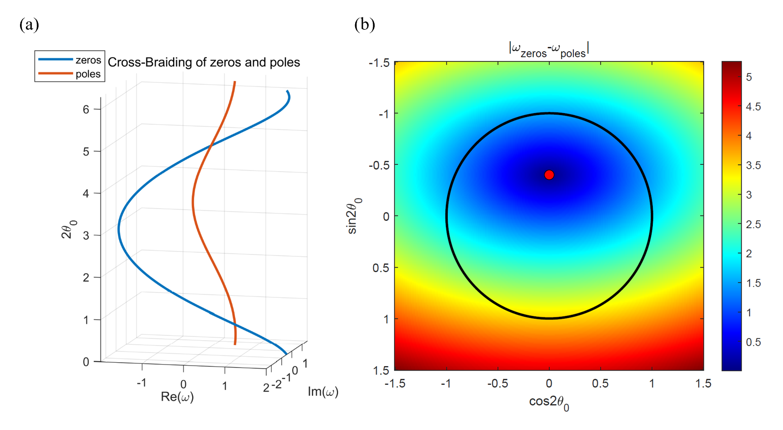
Figure. S5 (a) Cross-braiding of zeros and poles with braid word $σ_{1}^{-2}.$ (b) Mapping diagrams of the $\left|ω_{zeros}-ω_{poles}\right|$ in the $\cos{2θ_{0}}$-$\sin{2θ_{0}}$ plane. The black solid circle denotes the control loop, which encloses a red point marking a c-BIC.

[1] S. Fan, W. Suh, J.D. Joannopoulos, Temporal coupled-mode theory for the Fano resonance in optical resonators, Journal of the Optical Society of America A, 20 (2003) 569-572.
[2] T.G. Mackay, A. Lakhtakia, The transfer-matrix method in electromagnetics and optics, Springer Nature2022.
[3] W.R. Sweeney, C.W. Hsu, A.D. Stone, Theory of reflectionless scattering modes, Physical Review A, 102 (2020) 063511.
[4] Z. Rao, C. Meng, Y. Han, L. Zhu, K. Ding, Z. An, Braiding reflectionless states in non-Hermitian magnonics, Nature Physics, 20 (2024) 1904-1911.
[5] Y. Han, C. Meng, H. Pan, J. Qian, Z. Rao, L. Zhu, Y. Gui, C.-M. Hu, Z. An, Bound chiral magnonic polariton states for ideal microwave isolation, Science Advances, 9 (2023) eadg4730.
[6] A. Skopenkov, A user’s guide to basic knot and link theory, Topology, Geometry, and Dynamics, Contemporary Mathematics, 772 (2021) 281-309.

