**INFO 6205**

**Program Structures & Algorithms**

**Fall 2020**

**Assignment 4**

* **Task**

We mentioned two alternatives for implementing Union-Find:

1. For weighted quick union, store the depth rather than the size;
2. For weighted quick union with path compression, do two loops, so that all intermediate nodes point to the root, not just the alternates.

For both of these, code the alternative and benchmark it against the implementation in the repository. You have all of that available from a previous assignment.

If you can explain why alternative #1 is unnecessary to be benchmarked, you may skip benchmarking that one.

Usual submission rules apply. 40 points only for this one.

* **Evidence to support relationship** (screen shot and/or graph and/or spreadsheet)

For four different Quick unions(W-QU(Size), W-QU(Depth), W-QU-PC(twopass), W-QU-PC(onepass)). I tested the connection time of all nodes(N) and the depth of tree when all nodes were connected under different N conditions.

On different N, I test 500 times, and get the average time and depth.

The result is as follows.

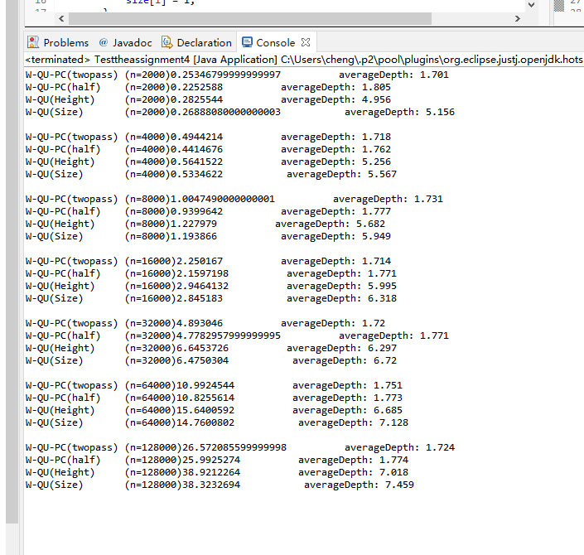

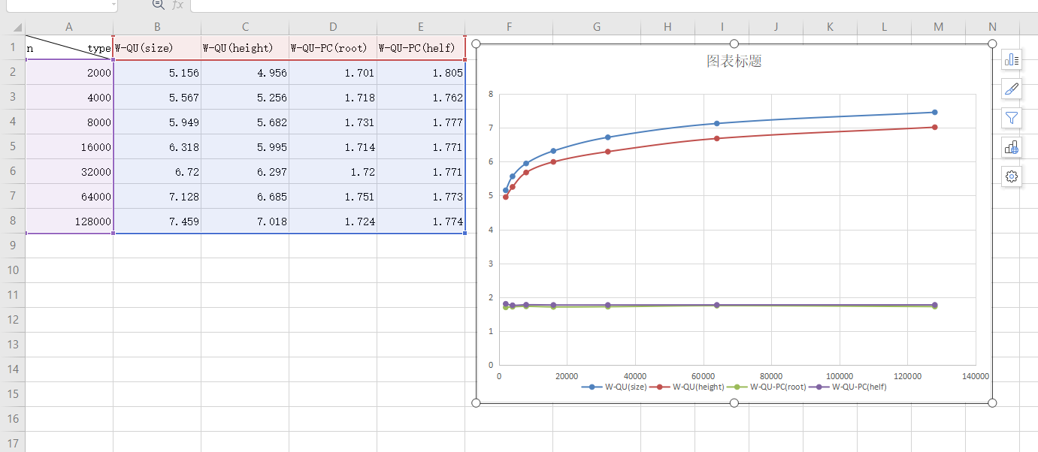For the depth of the tree. I drew the relevant chart

In this chart, we can see the

1. Path Compassion tree is much lower than Tree without Path Compassion. That is Because, though the PC, almost all nodes are directly connected to the root, which greatly reduces the height of the tree. On the contrary, the height of trees without PC is relatively high,
2. With the growth of N, the average height of trees without PC becomes higher and higher.
3. In the situation that without PC, The “Size” tree is little bit taller than “Depth”tree. This is because, in WQU(Depth), it is always possible to ensure that the lower trees are connected to the higher trees. However, in WQU(Size), a small size tree does not mean that the height of the tree is also low, so it is not guaranteed that each union tree is the lowest situation.
4. The Depth of WQUPC(twopass) and WQUPC(one pass) is similar. All is lower than 2 near 1.77

For the Time of the tree’s total union. I drew the relevant chart

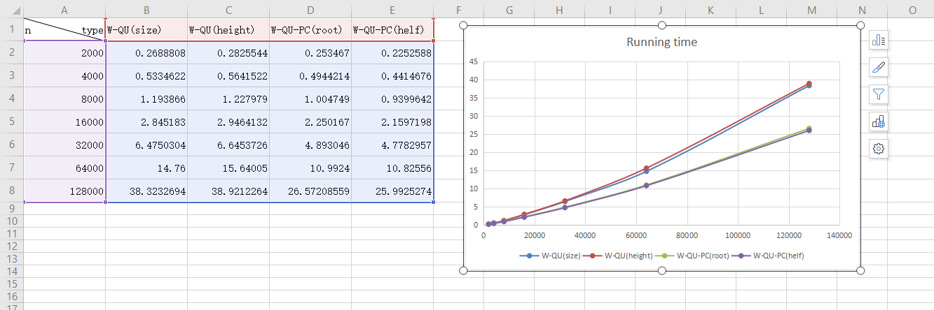

In this chart, we can see the

1. W-QU-PC has less time than just W-QU, because W-QU-PC has a lower tree height. It can greatly reduce the execution time of find();