嵌入式系统原理与技术 测控2022-01班 赵成鲁 2022110863 第十一章作业

嵌入式上机作业

题目要求

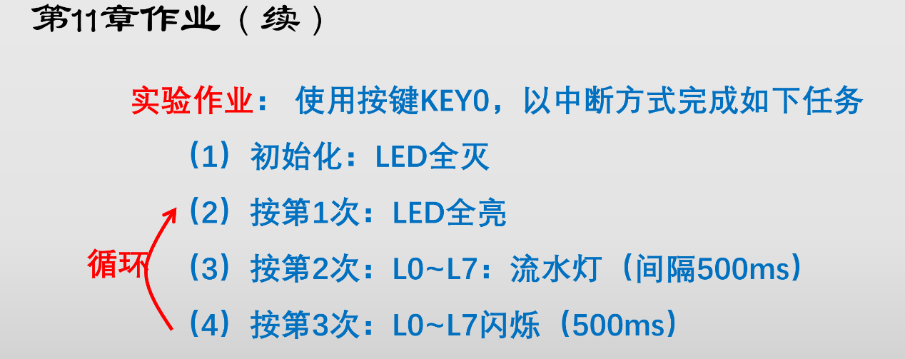二、 硬件电路与接线表
1、硬件电路
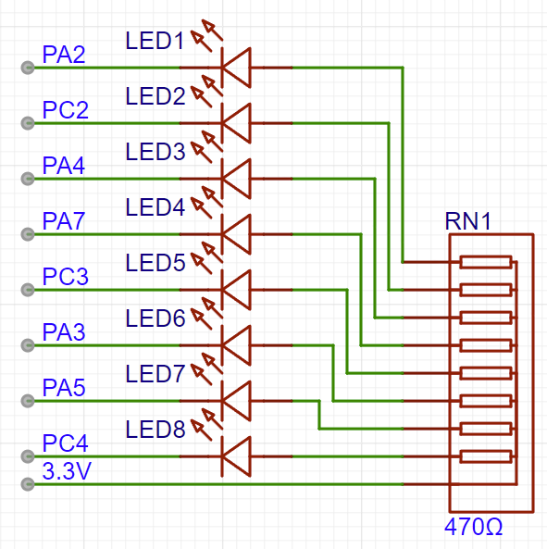
图1 流水灯模块原理图及连接原理图

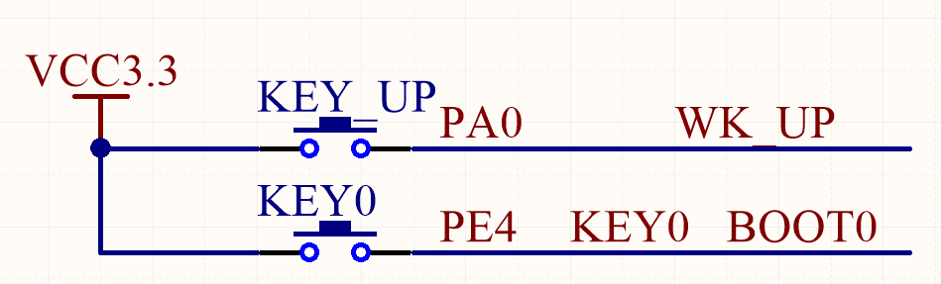
图2 按键原理图

2、硬件接线表
M-STM32F407xx | 流水灯模块
PA2 | LED1
PC2 | LED2
PA4 | LED3
PA7 | LED4
PC3 | LED5
PA3 | LED6
PA5 | LED7
PC4 | LED8
3.3V | VCC

三、软件设计方案
按键采用中断触发，在中断服务程序中设置标志位，实现不同流水灯的标志位切换。
流水灯采用非阻塞式写法，避免单片机卡在子程序中无法及时响应流水灯标志位的切换。采用定时器中断实现对计数变量自增计时，在对应时间控制LED的亮灭实现流水灯。

四、实验结果
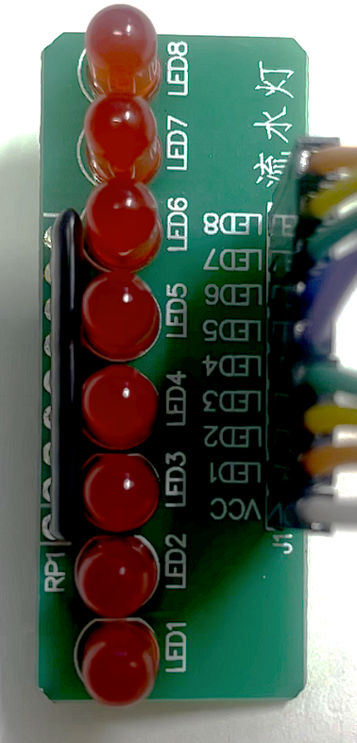
图1 (1)初始化：LED全灭

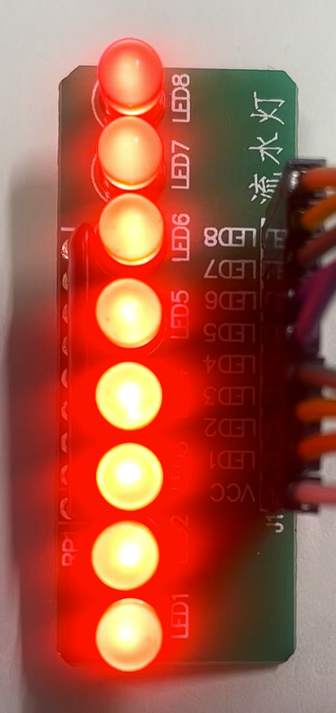

图2 (2) 按第一次：LED全亮

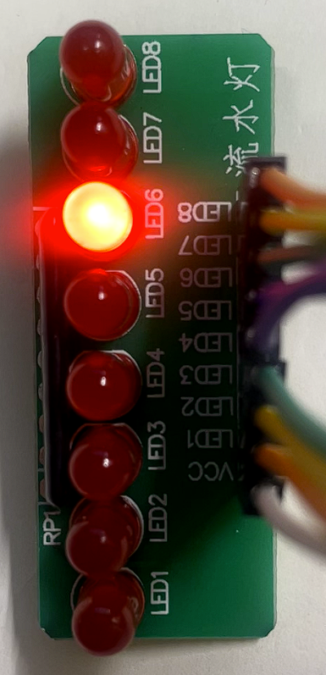
图3 (3)按第二次：L0~L7：流水灯（间隔500ms）


图4 (4) 按第三次：L0~L7闪烁（间隔500ms）

五、附录：程序（自己设计的程序，包括底层自己设计的程序，库函数不需要附录）

main.c
#include "stm32f4xx.h"
#include "LED.h"
#include "KEY.h"
#include "exti.h"
#include "timer.h"
extern u8 key_state;
int main(void)
{
TIM3_Int_Init(1000-1,8400-1);
LED_Init();
KEY_Init();
EXTIx_Init();
while(1)
{
}
}
void TIM3_IRQHandler(void)
{
if(TIM_GetITStatus(TIM3,TIM_IT_Update)==SET)
{
LED_Tick(key_state);
TIM_ClearITPendingBit(TIM3,TIM_IT_Update);
}
}
LED.c

#include "stm32f4xx.h"
#include <stdbool.h>
u32 led_count=0;
void LED_Init(void)
{
GPIO_InitTypeDef GPIOA_InitStructure;
GPIO_InitTypeDef GPIOC_InitStructure; //放在这里的原因是 不允许初始化变量在函数的中间
RCC_AHB1PeriphClockCmd(RCC_AHB1Periph_GPIOA,ENABLE);

GPIOA_InitStructure.GPIO_Mode = GPIO_Mode_OUT;
GPIOA_InitStructure.GPIO_OType = GPIO_OType_PP;
GPIOA_InitStructure.GPIO_Pin = (GPIO_Pin_2|GPIO_Pin_3|GPIO_Pin_4|GPIO_Pin_5|GPIO_Pin_7);
GPIOA_InitStructure.GPIO_PuPd = GPIO_PuPd_UP;
GPIOA_InitStructure.GPIO_Speed = GPIO_Speed_2MHz;
GPIO_Init(GPIOA,&GPIOA_InitStructure);

RCC_AHB1PeriphClockCmd(RCC_AHB1Periph_GPIOC,ENABLE);

GPIOC_InitStructure.GPIO_Mode = GPIO_Mode_OUT;
GPIOC_InitStructure.GPIO_OType = GPIO_OType_PP;
GPIOC_InitStructure.GPIO_Pin = (GPIO_Pin_2|GPIO_Pin_3|GPIO_Pin_4);
GPIOC_InitStructure.GPIO_PuPd = GPIO_PuPd_UP;
GPIOC_InitStructure.GPIO_Speed = GPIO_Speed_2MHz;

GPIO_Init(GPIOC,&GPIOC_InitStructure);
GPIO_SetBits(GPIOA,GPIO_Pin_2|GPIO_Pin_3|GPIO_Pin_4|GPIO_Pin_5|GPIO_Pin_7);
GPIO_SetBits(GPIOC,GPIO_Pin_2|GPIO_Pin_3|GPIO_Pin_4);
}
void LED_SET(int led_num,bool led_state)
{
switch(led_num)
{
case 1:
{
if(led_state==false)
GPIO_SetBits(GPIOA,GPIO_Pin_2);
else
GPIO_ResetBits(GPIOA,GPIO_Pin_2);
break;
}
case 2:
{
if(led_state==false)
GPIO_SetBits(GPIOC,GPIO_Pin_2);
else
GPIO_ResetBits(GPIOC,GPIO_Pin_2);
break;
}
case 3:
{
if(led_state==false)
GPIO_SetBits(GPIOA,GPIO_Pin_4);
else
GPIO_ResetBits(GPIOA,GPIO_Pin_4);
break;
}
case 4:
{
if(led_state==false)
GPIO_SetBits(GPIOA,GPIO_Pin_7);
else
GPIO_ResetBits(GPIOA,GPIO_Pin_7);
break;
}
case 5:
{
if(led_state==false)
GPIO_SetBits(GPIOC,GPIO_Pin_3);
else
GPIO_ResetBits(GPIOC,GPIO_Pin_3);
break;
}
case 6:
{
if(led_state==false)
GPIO_SetBits(GPIOA,GPIO_Pin_3);
else
GPIO_ResetBits(GPIOA,GPIO_Pin_3);
break;
}
case 7:
{
if(led_state==false)
GPIO_SetBits(GPIOA,GPIO_Pin_5);
else
GPIO_ResetBits(GPIOA,GPIO_Pin_5);
break;
}
case 8:
{
if(led_state==false)
GPIO_SetBits(GPIOC,GPIO_Pin_4);
else
GPIO_ResetBits(GPIOC,GPIO_Pin_4);
break;
}
}
}
void LED_Tick(u8 key_state)
{

switch(key_state)
{
case 1:
LED_SET(1,true);LED_SET(2,true);LED_SET(3,true);LED_SET(4,true);LED_SET(5,true);LED_SET(6,true);LED_SET(7,true);LED_SET(8,true);
break;
case 2:
if(led_count==45)
{
led_count=0;
}
if(led_count%5==0)
{
LED_SET(1,false);LED_SET(2,false);LED_SET(3,false);LED_SET(4,false);LED_SET(5,false);LED_SET(6,false);LED_SET(7,false);LED_SET(8,false);
LED_SET(led_count/5,true);
}break;
case 3:
if(led_count==10)
{
led_count=0;
}
switch(led_count)
{
case 0:LED_SET(1,false);LED_SET(2,false);LED_SET(3,false);LED_SET(4,false);LED_SET(5,false);LED_SET(6,false);LED_SET(7,false);LED_SET(8,false);break;
case 5:LED_SET(1,true);LED_SET(2,true);LED_SET(3,true);LED_SET(4,true);LED_SET(5,true);LED_SET(6,true);LED_SET(7,true);LED_SET(8,true);break;
}break;

}
led_count ++;
}

LED.h
#ifndef __LED_H
#define __LED_H
#include "stm32f4xx.h"
#include <stdbool.h>
void LED_Init(void);
void LED_SET(int led_num,bool led_state);
void LED_Tick(u8 key_state);
#endif

KEY.c
#include <stm32f4xx.h>
#include "delay.h"
#include "key.h"

void KEY_Init(void)
{

GPIO_InitTypeDef GPIO_InitStructure;

RCC_AHB1PeriphClockCmd(RCC_AHB1Periph_GPIOA|RCC_AHB1Periph_GPIOE, ENABLE);

GPIO_InitStructure.GPIO_Pin = GPIO_Pin_4;
GPIO_InitStructure.GPIO_Mode = GPIO_Mode_IN;
GPIO_InitStructure.GPIO_Speed = GPIO_Speed_100MHz;
GPIO_InitStructure.GPIO_PuPd = GPIO_PuPd_DOWN ;
GPIO_Init(GPIOE, &GPIO_InitStructure);

GPIO_InitStructure.GPIO_Pin = GPIO_Pin_0;
GPIO_InitStructure.GPIO_PuPd = GPIO_PuPd_DOWN ;
GPIO_Init(GPIOA, &GPIO_InitStructure);

}

KEY.h

#ifndef __KEY_H
#define __KEY_H
#include <stm32f4xx.h>

#define KEY0 GPIO_ReadInputDataBit(GPIOE,GPIO_Pin_4) //PE4
#define WK_UP GPIO_ReadInputDataBit(GPIOA,GPIO_Pin_0) //PA0
#define KEY0_PRES 1
#define WKUP_PRES 2
void KEY_Init(void);
#endif

exit.c
#include "exti.h"
#include <stm32f4xx.h>
u8 key_state;
extern u32 led_count;
void EXTIx_Init(void)
{
NVIC_InitTypeDef NVIC_InitStructure;
EXTI_InitTypeDef EXTI_InitStructure;
RCC_APB2PeriphClockCmd(RCC_APB2Periph_SYSCFG, ENABLE);

SYSCFG_EXTILineConfig(EXTI_PortSourceGPIOA, EXTI_PinSource0);
SYSCFG_EXTILineConfig(EXTI_PortSourceGPIOE, EXTI_PinSource4);
EXTI_InitStructure.EXTI_Line = EXTI_Line0 | EXTI_Line4;
EXTI_InitStructure.EXTI_LineCmd = ENABLE;
EXTI_InitStructure.EXTI_Mode = EXTI_Mode_Interrupt;
EXTI_InitStructure.EXTI_Trigger = EXTI_Trigger_Falling;
EXTI_Init(&EXTI_InitStructure);

NVIC_InitStructure.NVIC_IRQChannel = EXTI0_IRQn;
NVIC_InitStructure.NVIC_IRQChannelCmd = ENABLE;
NVIC_InitStructure.NVIC_IRQChannelPreemptionPriority = 0x01;
NVIC_InitStructure.NVIC_IRQChannelSubPriority = 0x01;

NVIC_Init(&NVIC_InitStructure);
NVIC_InitStructure.NVIC_IRQChannel = EXTI4_IRQn;
NVIC_InitStructure.NVIC_IRQChannelPreemptionPriority = 0x01;
NVIC_Init(&NVIC_InitStructure);
}

void EXTI4_IRQHandler(void)
{
EXTI_ClearITPendingBit(EXTI_Line4);
led_count=0;
key_state+=1;
if(key_state==4)
key_state=0;
if(key_state==0)
key_state=1;
}
void EXTI0_IRQHandler(void)
{
EXTI_ClearITPendingBit(EXTI_Line4);
}

exit.h
#ifndef __EXTI_H
#define __EXTI_H
#include <stm32f4xx.h>
void EXTIx_Init(void);
#endif

timer.c
#include "timer.h"
#include "led.h"

void TIM3_Int_Init(u16 arr,u16 psc)
{
TIM_TimeBaseInitTypeDef TIM_TimeBaseInitStructure;
NVIC_InitTypeDef NVIC_InitStructure;

RCC_APB1PeriphClockCmd(RCC_APB1Periph_TIM3,ENABLE);

TIM_TimeBaseInitStructure.TIM_Period = arr;
TIM_TimeBaseInitStructure.TIM_Prescaler=psc;
TIM_TimeBaseInitStructure.TIM_CounterMode=TIM_CounterMode_Up;
TIM_TimeBaseInitStructure.TIM_ClockDivision=TIM_CKD_DIV1;

TIM_TimeBaseInit(TIM3,&TIM_TimeBaseInitStructure);

TIM_ITConfig(TIM3,TIM_IT_Update,ENABLE);
TIM_Cmd(TIM3,ENABLE);

NVIC_InitStructure.NVIC_IRQChannel=TIM3_IRQn;
NVIC_InitStructure.NVIC_IRQChannelPreemptionPriority=0x00;
NVIC_InitStructure.NVIC_IRQChannelSubPriority=0x03;
NVIC_InitStructure.NVIC_IRQChannelCmd=ENABLE;
NVIC_Init(&NVIC_InitStructure);

}

timer.h
#ifndef _TIMER_H
#define _TIMER_H
#include "sys.h"

void TIM3_Int_Init(u16 arr,u16 psc);
#endif

