嵌入式系统原理与技术 测控2022-01班 赵成鲁 2022110863 第十八章作业

嵌入式上机作业

题目要求
把正弦表格存放到外部Flash中，具体要求如下：
1. 编写存表格程序，存正弦波表格到Flash中，角度分辨率：0.5°
2. 编写DAC程序，从DAC输出该波形，频率1KHz，幅度0~2.8V
3. 输出信号通过ADC回读并实用UART送给计算机

二、 硬件电路与接线表
1、硬件电路
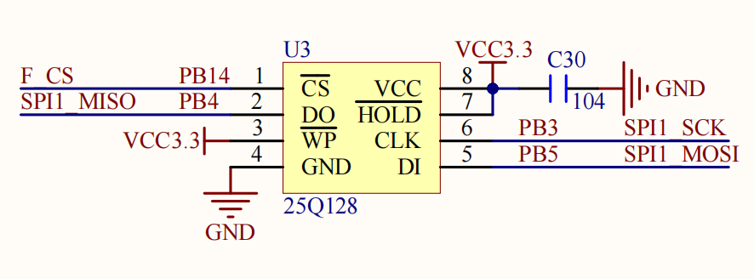
Flash硬件原理图

三、软件设计方案
保存正弦数组值：
首先使用正弦生成工具生成正弦数组，定义数组TEXT_Buffer用于存放需要写入的正弦数组, datatemp用于存放读出的正弦数组。按下KEY_0，将正弦数组存入Flash；按下KEY_1，将正弦数组从Flash中读出存入datatemp。
编写DAC程序：
设置中断频率为1KHz*正弦点数720。即设置PSC=117-1，ARR=1-1。频率即为84Mhz/(PSC+1)/(ARR+1)=720KHz。中断服务程序中使用DAC函数遍历输出数组对应电压值。
编写ADC回读：
使用ADC回读后转换电压，$V=\frac{ADC}{2^{12}−1}∗3.3$后通过UART发送到计算机显示波形。

实验结果
使用工具生成正弦表
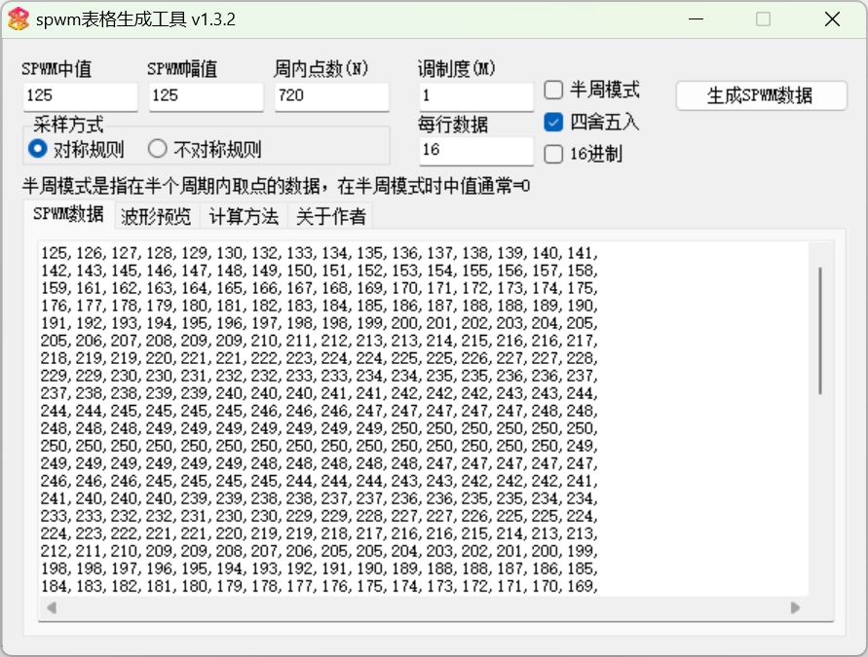
按下KEY0将TEXT_Buffer正弦表存入Flash
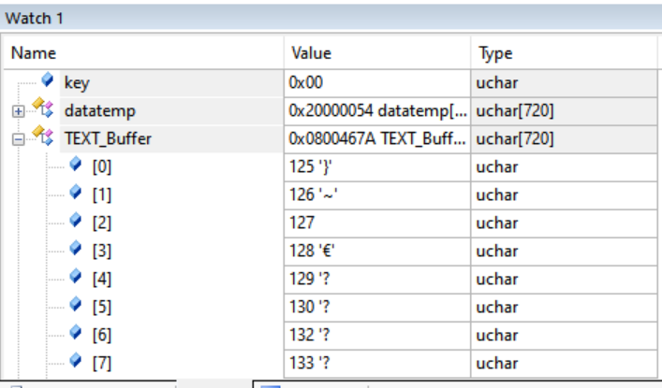
按下KEY1从Flash读取正弦表存入数组datatemp
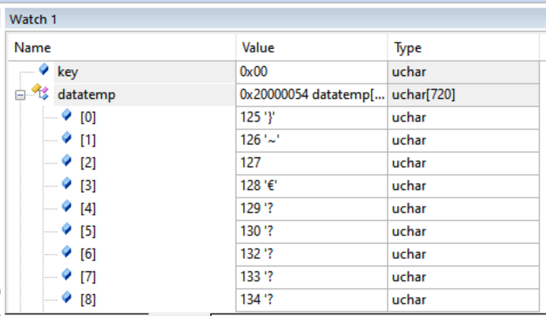
在串口软件查看输出的正弦波
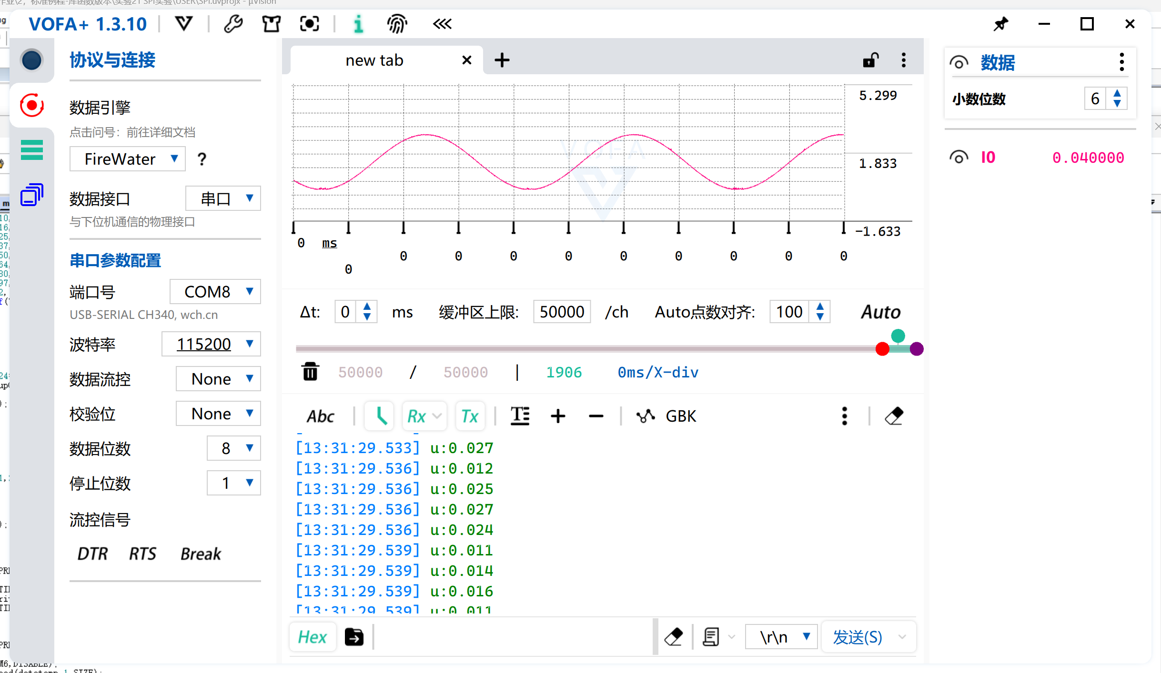

五、附录：程序（自己设计的程序，包括底层自己设计的程序，库函数不需要附录）

main.c
#include "stm32f4xx.h"
#include "usart.h"
#include "delay.h"
#include "timer.h"
#include "led.h"
#include "lcd1602.h"
#include "stdio.h"
#include "string.h"
#include "adc.h"
#include "exti.h"
#include "KEY.h"
#include "dac.h"
#include "w25qxx.h"

u16 n=0; //记录中断次数
char name[8];
//--------ADC参数----------//
u16 adcx;
float temp;
float temp1;
float temp2;

//要写入到W25Q16的字符串数组
const u8 TEXT_Buffer[]={125,126,127,128,129,130,132,133,134,135,136,137,138,139,140,141,
142,143,145,146,147,148,149,150,151,152,153,154,155,156,157,158,
159,161,162,163,164,165,166,167,168,169,170,171,172,173,174,175,
176,177,178,179,180,181,182,183,184,185,186,187,188,188,189,190,
191,192,193,194,195,196,197,198,198,199,200,201,202,203,204,205,
205,206,207,208,209,209,210,211,212,213,213,214,215,216,216,217,
218,219,219,220,221,221,222,223,224,224,225,225,226,227,227,228,
229,229,230,230,231,232,232,233,233,234,234,235,235,236,236,237,
237,238,238,239,239,240,240,240,241,241,242,242,242,243,243,244,
244,244,245,245,245,245,246,246,246,247,247,247,247,247,248,248,
248,248,248,249,249,249,249,249,249,249,250,250,250,250,250,250,
250,250,250,250,250,250,250,250,250,250,250,250,250,250,250,249,
249,249,249,249,249,249,248,248,248,248,248,247,247,247,247,247,
246,246,246,245,245,245,245,244,244,244,243,243,242,242,242,241,
241,240,240,240,239,239,238,238,237,237,236,236,235,235,234,234,
233,233,232,232,231,230,230,229,229,228,227,227,226,225,225,224,
224,223,222,221,221,220,219,219,218,217,216,216,215,214,213,213,
212,211,210,209,209,208,207,206,205,205,204,203,202,201,200,199,
198,198,197,196,195,194,193,192,191,190,189,188,188,187,186,185,
184,183,182,181,180,179,178,177,176,175,174,173,172,171,170,169,
168,167,166,165,164,163,162,161,159,158,157,156,155,154,153,152,
151,150,149,148,147,146,145,143,142,141,140,139,138,137,136,135,
134,133,132,130,129,128,127,126,125,124,123,122,121,120,118,117,
116,115,114,113,112,111,110,109,108,107,105,104,103,102,101,100,
99,98,97,96,95,94,93,92,91,89,88,87,86,85,84,83,
82,81,80,79,78,77,76,75,74,73,72,71,70,69,68,67,
66,65,64,63,62,62,61,60,59,58,57,56,55,54,53,52,
52,51,50,49,48,47,46,45,45,44,43,42,41,41,40,39,
38,37,37,36,35,34,34,33,32,31,31,30,29,29,28,27,
26,26,25,25,24,23,23,22,21,21,20,20,19,18,18,17,
17,16,16,15,15,14,14,13,13,12,12,11,11,10,10,10,
9,9,8,8,8,7,7,6,6,6,5,5,5,5,4,4,
4,3,3,3,3,3,2,2,2,2,2,1,1,1,1,1,
1,1,0,0,0,0,0,0,0,0,0,0,0,0,0,0,
0,0,0,0,0,0,0,1,1,1,1,1,1,1,2,2,
2,2,2,3,3,3,3,3,4,4,4,5,5,5,5,6,
6,6,7,7,8,8,8,9,9,10,10,10,11,11,12,12,
13,13,14,14,15,15,16,16,17,17,18,18,19,20,20,21,
21,22,23,23,24,25,25,26,26,27,28,29,29,30,31,31,
32,33,34,34,35,36,37,37,38,39,40,41,41,42,43,44,
45,45,46,47,48,49,50,51,52,52,53,54,55,56,57,58,
59,60,61,62,62,63,64,65,66,67,68,69,70,71,72,73,
74,75,76,77,78,79,80,81,82,83,84,85,86,87,88,89,
91,92,93,94,95,96,97,98,99,100,101,102,103,104,105,107,
108,109,110,111,112,113,114,115,116,117,118,120,121,122,123,124};
#define SIZE sizeof(TEXT_Buffer)
u8 datatemp[SIZE];
u8 flag=0;
int main(void)
{
volatile u8 key;
u32 FLASH_SIZE;
W25QXX_Init(); //W25QXX初始化
FLASH_SIZE=16*1024*1024; //FLASH 大小为16字节
NVIC_PriorityGroupConfig(NVIC_PriorityGroup_2);//设置系统中断优先级分组2
delay_init(168); //延时初始化
uart_init(115200); //串口初始化波特率为115200
EXTIx_Init();
LED_Init2();
KEY_Init();
Adc_Init();
Dac1_Init();

TIM6_Int_Init(1-1,117-1);
while(1)
{

key=KEY_Scan(0);
if(key)
{
switch(key)
{
case KEY0_PRES:
{
TIM_Cmd(TIM6,DISABLE);
W25QXX_Write((u8*)TEXT_Buffer,1,SIZE);
TIM_Cmd(TIM6,ENABLE);
break;

}
case WKUP_PRES:
{
TIM_Cmd(TIM6,DISABLE);
W25QXX_Read(datatemp,1,SIZE);
TIM_Cmd(TIM6,ENABLE);
break;
}

}
}

}

}

void TIM6_DAC_IRQHandler(void)
{
if (TIM_GetITStatus(TIM6, TIM_IT_Update) == SET) // 溢出中断
{
adcx=Get_Adc_Average(ADC_Channel_5,1);
n++;
//printf("adc:%u\n",adcx);
temp=(float)adcx*(3.3/4095);
adcx=temp;
temp1=adcx;
temp-=adcx;
temp*=1000;
temp2=temp;
if(temp2<100)
{
printf("u:%u.0%u\n",(int)temp1,(int)temp2);
}
else
printf("u:%u.%u\n",(int)temp1,(int)temp2);
LED0=!LED0;
if(n==720)
n=0;
Dac1_Set_Vol((int)datatemp[n]*11.2);

}
TIM_ClearITPendingBit(TIM6, TIM_IT_Update); // 清除中断标志位
}

w25qxx.c
#include "w25qxx.h"
#include "spi.h"
#include "delay.h"
#include "usart.h"

u16 W25QXX_TYPE=W25Q128; //默认是W25Q128

//4Kbytes为一个Sector
//16个扇区为1个Block
//W25Q128
//容量为16M字节,共有128个Block,4096个Sector

//初始化SPI FLASH的IO口
void W25QXX_Init(void)
{
GPIO_InitTypeDef GPIO_InitStructure;

RCC_AHB1PeriphClockCmd(RCC_AHB1Periph_GPIOB, ENABLE);//使能GPIOB时钟
RCC_AHB1PeriphClockCmd(RCC_AHB1Periph_GPIOG, ENABLE);//使能GPIOG时钟

//GPIOB14
GPIO_InitStructure.GPIO_Pin = GPIO_Pin_14;//PB14
GPIO_InitStructure.GPIO_Mode = GPIO_Mode_OUT;//输出
GPIO_InitStructure.GPIO_OType = GPIO_OType_PP;//推挽输出
GPIO_InitStructure.GPIO_Speed = GPIO_Speed_100MHz;//100MHz
GPIO_InitStructure.GPIO_PuPd = GPIO_PuPd_UP;//上拉
GPIO_Init(GPIOB, &GPIO_InitStructure);//初始化

GPIO_InitStructure.GPIO_Pin = GPIO_Pin_7;//PG7
GPIO_Init(GPIOG, &GPIO_InitStructure);//初始化

GPIO_SetBits(GPIOG,GPIO_Pin_7);//PG7输出1,防止NRF干扰SPI FLASH的通信
W25QXX_CS=1; //SPI FLASH不选中
SPI1_Init(); //初始化SPI
SPI1_SetSpeed(SPI_BaudRatePrescaler_4); //设置为21M时钟,高速模式
W25QXX_TYPE=W25QXX_ReadID(); //读取FLASH ID.
}

//读取W25QXX的状态寄存器
//BIT7 6 5 4 3 2 1 0
//SPR RV TB BP2 BP1 BP0 WEL BUSY
//SPR:默认0,状态寄存器保护位,配合WP使用
//TB,BP2,BP1,BP0:FLASH区域写保护设置
//WEL:写使能锁定
//BUSY:忙标记位(1,忙;0,空闲)
//默认:0x00
u8 W25QXX_ReadSR(void)
{
u8 byte=0;
W25QXX_CS=0; //使能器件
SPI1_ReadWriteByte(W25X_ReadStatusReg); //发送读取状态寄存器命令
byte=SPI1_ReadWriteByte(0Xff); //读取一个字节
W25QXX_CS=1; //取消片选
return byte;
}
//写W25QXX状态寄存器
//只有SPR,TB,BP2,BP1,BP0(bit 7,5,4,3,2)可以写!!!
void W25QXX_Write_SR(u8 sr)
{
W25QXX_CS=0; //使能器件
SPI1_ReadWriteByte(W25X_WriteStatusReg); //发送写取状态寄存器命令
SPI1_ReadWriteByte(sr); //写入一个字节
W25QXX_CS=1; //取消片选
}
//W25QXX写使能
//将WEL置位
void W25QXX_Write_Enable(void)
{
W25QXX_CS=0; //使能器件
SPI1_ReadWriteByte(W25X_WriteEnable); //发送写使能
W25QXX_CS=1; //取消片选
}
//W25QXX写禁止
//将WEL清零
void W25QXX_Write_Disable(void)
{
W25QXX_CS=0; //使能器件
SPI1_ReadWriteByte(W25X_WriteDisable); //发送写禁止指令
W25QXX_CS=1; //取消片选
}
//读取芯片ID
//返回值如下:
//0XEF13,表示芯片型号为W25Q80
//0XEF14,表示芯片型号为W25Q16
//0XEF15,表示芯片型号为W25Q32
//0XEF16,表示芯片型号为W25Q64
//0XEF17,表示芯片型号为W25Q128
u16 W25QXX_ReadID(void)
{
u16 Temp = 0;
W25QXX_CS=0;
SPI1_ReadWriteByte(0x90);//发送读取ID命令
SPI1_ReadWriteByte(0x00);
SPI1_ReadWriteByte(0x00);
SPI1_ReadWriteByte(0x00);
Temp|=SPI1_ReadWriteByte(0xFF)<<8;
Temp|=SPI1_ReadWriteByte(0xFF);
W25QXX_CS=1;
return Temp;
}
//读取SPI FLASH
//在指定地址开始读取指定长度的数据
//pBuffer:数据存储区
//ReadAddr:开始读取的地址(24bit)
//NumByteToRead:要读取的字节数(最大65535)
void W25QXX_Read(u8* pBuffer,u32 ReadAddr,u16 NumByteToRead)
{
u16 i;
W25QXX_CS=0; //使能器件
SPI1_ReadWriteByte(W25X_ReadData); //发送读取命令
SPI1_ReadWriteByte((u8)((ReadAddr)>>16)); //发送24bit地址
SPI1_ReadWriteByte((u8)((ReadAddr)>>8));
SPI1_ReadWriteByte((u8)ReadAddr);
for(i=0;i<NumByteToRead;i++)
{
pBuffer[i]=SPI1_ReadWriteByte(0XFF); //循环读数
}
W25QXX_CS=1;
}
//SPI在一页(0~65535)内写入少于256个字节的数据
//在指定地址开始写入最大256字节的数据
//pBuffer:数据存储区
//WriteAddr:开始写入的地址(24bit)
//NumByteToWrite:要写入的字节数(最大256),该数不应该超过该页的剩余字节数!!!
void W25QXX_Write_Page(u8* pBuffer,u32 WriteAddr,u16 NumByteToWrite)
{
u16 i;
W25QXX_Write_Enable(); //SET WEL
W25QXX_CS=0; //使能器件
SPI1_ReadWriteByte(W25X_PageProgram); //发送写页命令
SPI1_ReadWriteByte((u8)((WriteAddr)>>16)); //发送24bit地址
SPI1_ReadWriteByte((u8)((WriteAddr)>>8));
SPI1_ReadWriteByte((u8)WriteAddr);
for(i=0;i<NumByteToWrite;i++)SPI1_ReadWriteByte(pBuffer[i]);//循环写数
W25QXX_CS=1; //取消片选
W25QXX_Wait_Busy(); //等待写入结束
}
//无检验写SPI FLASH
//必须确保所写的地址范围内的数据全部为0XFF,否则在非0XFF处写入的数据将失败!
//具有自动换页功能
//在指定地址开始写入指定长度的数据,但是要确保地址不越界!
//pBuffer:数据存储区
//WriteAddr:开始写入的地址(24bit)
//NumByteToWrite:要写入的字节数(最大65535)
//CHECK OK
void W25QXX_Write_NoCheck(u8* pBuffer,u32 WriteAddr,u16 NumByteToWrite)
{
u16 pageremain;
pageremain=256-WriteAddr%256; //单页剩余的字节数
if(NumByteToWrite<=pageremain)pageremain=NumByteToWrite;//不大于256个字节
while(1)
{
W25QXX_Write_Page(pBuffer,WriteAddr,pageremain);
if(NumByteToWrite==pageremain)break;//写入结束了
else //NumByteToWrite>pageremain
{
pBuffer+=pageremain;
WriteAddr+=pageremain;

NumByteToWrite-=pageremain; //减去已经写入了的字节数
if(NumByteToWrite>256)pageremain=256; //一次可以写入256个字节
else pageremain=NumByteToWrite; //不够256个字节了
}
};
}
//写SPI FLASH
//在指定地址开始写入指定长度的数据
//该函数带擦除操作!
//pBuffer:数据存储区
//WriteAddr:开始写入的地址(24bit)
//NumByteToWrite:要写入的字节数(最大65535)
u8 W25QXX_BUFFER[4096];
void W25QXX_Write(u8* pBuffer,u32 WriteAddr,u16 NumByteToWrite)
{
u32 secpos;
u16 secoff;
u16 secremain;
u16 i;
u8 * W25QXX_BUF;
W25QXX_BUF=W25QXX_BUFFER;
secpos=WriteAddr/4096;//扇区地址
secoff=WriteAddr%4096;//在扇区内的偏移
secremain=4096-secoff;//扇区剩余空间大小
//printf("ad:%X,nb:%X\r\n",WriteAddr,NumByteToWrite);//测试用
if(NumByteToWrite<=secremain)secremain=NumByteToWrite;//不大于4096个字节
while(1)
{
W25QXX_Read(W25QXX_BUF,secpos*4096,4096);//读出整个扇区的内容
for(i=0;i<secremain;i++)//校验数据
{
if(W25QXX_BUF[secoff+i]!=0XFF)break;//需要擦除
}
if(i<secremain)//需要擦除
{
W25QXX_Erase_Sector(secpos);//擦除这个扇区
for(i=0;i<secremain;i++) //复制
{
W25QXX_BUF[i+secoff]=pBuffer[i];
}
W25QXX_Write_NoCheck(W25QXX_BUF,secpos*4096,4096);//写入整个扇区

}else W25QXX_Write_NoCheck(pBuffer,WriteAddr,secremain);//写已经擦除了的,直接写入扇区剩余区间.
if(NumByteToWrite==secremain)break;//写入结束了
else//写入未结束
{
secpos++;//扇区地址增1
secoff=0;//偏移位置为0

pBuffer+=secremain; //指针偏移
WriteAddr+=secremain;//写地址偏移
NumByteToWrite-=secremain; //字节数递减
if(NumByteToWrite>4096)secremain=4096; //下一个扇区还是写不完
else secremain=NumByteToWrite; //下一个扇区可以写完了
}
};
}
//擦除整个芯片
//等待时间超长...
void W25QXX_Erase_Chip(void)
{
W25QXX_Write_Enable(); //SET WEL
W25QXX_Wait_Busy();
W25QXX_CS=0; //使能器件
SPI1_ReadWriteByte(W25X_ChipErase); //发送片擦除命令
W25QXX_CS=1; //取消片选
W25QXX_Wait_Busy(); //等待芯片擦除结束
}
//擦除一个扇区
//Dst_Addr:扇区地址 根据实际容量设置
//擦除一个山区的最少时间:150ms
void W25QXX_Erase_Sector(u32 Dst_Addr)
{
//监视falsh擦除情况,测试用
printf("fe:%x\r\n",Dst_Addr);
Dst_Addr*=4096;
W25QXX_Write_Enable(); //SET WEL
W25QXX_Wait_Busy();
W25QXX_CS=0; //使能器件
SPI1_ReadWriteByte(W25X_SectorErase); //发送扇区擦除指令
SPI1_ReadWriteByte((u8)((Dst_Addr)>>16)); //发送24bit地址
SPI1_ReadWriteByte((u8)((Dst_Addr)>>8));
SPI1_ReadWriteByte((u8)Dst_Addr);
W25QXX_CS=1; //取消片选
W25QXX_Wait_Busy(); //等待擦除完成
}
//等待空闲
void W25QXX_Wait_Busy(void)
{
while((W25QXX_ReadSR()&0x01)==0x01); // 等待BUSY位清空
}
//进入掉电模式
void W25QXX_PowerDown(void)
{
W25QXX_CS=0; //使能器件
SPI1_ReadWriteByte(W25X_PowerDown); //发送掉电命令
W25QXX_CS=1; //取消片选
delay_us(3); //等待TPD
}
//唤醒
void W25QXX_WAKEUP(void)
{
W25QXX_CS=0; //使能器件
SPI1_ReadWriteByte(W25X_ReleasePowerDown); // send W25X_PowerDown command 0xAB
W25QXX_CS=1; //取消片选
delay_us(3); //等待TRES1
}
W25qxx.h
#ifndef __W25QXX_H
#define __W25QXX_H
#include "sys.h"

//W25X系列/Q系列芯片列表
//W25Q80 ID 0XEF13
//W25Q16 ID 0XEF14
//W25Q32 ID 0XEF15
//W25Q64 ID 0XEF16
//W25Q128 ID 0XEF17
#define W25Q80 0XEF13
#define W25Q16 0XEF14
#define W25Q32 0XEF15
#define W25Q64 0XEF16
#define W25Q128 0XEF17

#define NM25Q80 0X5213
#define NM25Q16 0X5214
#define NM25Q32 0X5215
#define NM25Q64 0X5216
#define NM25Q128 0X5217
#define NM25Q256 0X5218

extern u16 W25QXX_TYPE; //定义W25QXX芯片型号

#define W25QXX_CS PBout(14) //W25QXX的片选信号

//////////////////////////////////////////////////////////////////////////////////
//指令表
#define W25X_WriteEnable 0x06
#define W25X_WriteDisable 0x04
#define W25X_ReadStatusReg 0x05
#define W25X_WriteStatusReg 0x01
#define W25X_ReadData 0x03
#define W25X_FastReadData 0x0B
#define W25X_FastReadDual 0x3B
#define W25X_PageProgram 0x02
#define W25X_BlockErase 0xD8
#define W25X_SectorErase 0x20
#define W25X_ChipErase 0xC7
#define W25X_PowerDown 0xB9
#define W25X_ReleasePowerDown 0xAB
#define W25X_DeviceID 0xAB
#define W25X_ManufactDeviceID 0x90
#define W25X_JedecDeviceID 0x9F

void W25QXX_Init(void);
u16 W25QXX_ReadID(void); //读取FLASH ID
u8 W25QXX_ReadSR(void); //读取状态寄存器
void W25QXX_Write_SR(u8 sr); //写状态寄存器
void W25QXX_Write_Enable(void); //写使能
void W25QXX_Write_Disable(void); //写保护
void W25QXX_Write_NoCheck(u8* pBuffer,u32 WriteAddr,u16 NumByteToWrite);
void W25QXX_Read(u8* pBuffer,u32 ReadAddr,u16 NumByteToRead); //读取flash
void W25QXX_Write(u8* pBuffer,u32 WriteAddr,u16 NumByteToWrite);//写入flash
void W25QXX_Erase_Chip(void); //整片擦除
void W25QXX_Erase_Sector(u32 Dst_Addr); //扇区擦除
void W25QXX_Wait_Busy(void); //等待空闲
void W25QXX_PowerDown(void); //进入掉电模式
void W25QXX_WAKEUP(void); //唤醒
#endif

spi.c
#include "spi.h"

//以下是SPI模块的初始化代码，配置成主机模式
//SPI口初始化
//这里针是对SPI1的初始化
void SPI1_Init(void)
{
GPIO_InitTypeDef GPIO_InitStructure;
SPI_InitTypeDef SPI_InitStructure;

RCC_AHB1PeriphClockCmd(RCC_AHB1Periph_GPIOB, ENABLE);//使能GPIOB时钟
RCC_APB2PeriphClockCmd(RCC_APB2Periph_SPI1, ENABLE);//使能SPI1时钟

//GPIOFB3,4,5初始化设置
GPIO_InitStructure.GPIO_Pin = GPIO_Pin_3|GPIO_Pin_4|GPIO_Pin_5;//PB3~5复用功能输出
GPIO_InitStructure.GPIO_Mode = GPIO_Mode_AF;//复用功能
GPIO_InitStructure.GPIO_OType = GPIO_OType_PP;//推挽输出
GPIO_InitStructure.GPIO_Speed = GPIO_Speed_100MHz;//100MHz
GPIO_InitStructure.GPIO_PuPd = GPIO_PuPd_UP;//上拉
GPIO_Init(GPIOB, &GPIO_InitStructure);//初始化

GPIO_PinAFConfig(GPIOB,GPIO_PinSource3,GPIO_AF_SPI1); //PB3复用为 SPI1
GPIO_PinAFConfig(GPIOB,GPIO_PinSource4,GPIO_AF_SPI1); //PB4复用为 SPI1
GPIO_PinAFConfig(GPIOB,GPIO_PinSource5,GPIO_AF_SPI1); //PB5复用为 SPI1

//这里只针对SPI口初始化
RCC_APB2PeriphResetCmd(RCC_APB2Periph_SPI1,ENABLE);//复位SPI1
RCC_APB2PeriphResetCmd(RCC_APB2Periph_SPI1,DISABLE);//停止复位SPI1

SPI_InitStructure.SPI_Direction = SPI_Direction_2Lines_FullDuplex; //设置SPI单向或者双向的数据模式:SPI设置为双线双向全双工
SPI_InitStructure.SPI_Mode = SPI_Mode_Master; //设置SPI工作模式:设置为主SPI
SPI_InitStructure.SPI_DataSize = SPI_DataSize_8b; //设置SPI的数据大小:SPI发送接收8位帧结构
SPI_InitStructure.SPI_CPOL = SPI_CPOL_High; //串行同步时钟的空闲状态为高电平
SPI_InitStructure.SPI_CPHA = SPI_CPHA_2Edge; //串行同步时钟的第二个跳变沿（上升或下降）数据被采样
SPI_InitStructure.SPI_NSS = SPI_NSS_Soft; //NSS信号由硬件（NSS管脚）还是软件（使用SSI位）管理:内部NSS信号有SSI位控制
SPI_InitStructure.SPI_BaudRatePrescaler = SPI_BaudRatePrescaler_256; //定义波特率预分频的值:波特率预分频值为256
SPI_InitStructure.SPI_FirstBit = SPI_FirstBit_MSB; //指定数据传输从MSB位还是LSB位开始:数据传输从MSB位开始
SPI_InitStructure.SPI_CRCPolynomial = 7; //CRC值计算的多项式
SPI_Init(SPI1, &SPI_InitStructure); //根据SPI_InitStruct中指定的参数初始化外设SPIx寄存器

SPI_Cmd(SPI1, ENABLE); //使能SPI外设

SPI1_ReadWriteByte(0xff);//启动传输
}
//SPI1速度设置函数
//SPI速度=fAPB2/分频系数
//@ref SPI_BaudRate_Prescaler:SPI_BaudRatePrescaler_2~SPI_BaudRatePrescaler_256
//fAPB2时钟一般为84Mhz：
void SPI1_SetSpeed(u8 SPI_BaudRatePrescaler)
{
assert_param(IS_SPI_BAUDRATE_PRESCALER(SPI_BaudRatePrescaler));//判断有效性
SPI1->CR1&=0XFFC7;//位3-5清零，用来设置波特率
SPI1->CR1|=SPI_BaudRatePrescaler; //设置SPI1速度
SPI_Cmd(SPI1,ENABLE); //使能SPI1
}
//SPI1 读写一个字节
//TxData:要写入的字节
//返回值:读取到的字节
u8 SPI1_ReadWriteByte(u8 TxData)
{

while (SPI_I2S_GetFlagStatus(SPI1, SPI_I2S_FLAG_TXE) == RESET){}//等待发送区空

SPI_I2S_SendData(SPI1, TxData); //通过外设SPIx发送一个byte 数据

while (SPI_I2S_GetFlagStatus(SPI1, SPI_I2S_FLAG_RXNE) == RESET){} //等待接收完一个byte

return SPI_I2S_ReceiveData(SPI1); //返回通过SPIx最近接收的数据

}

#ifndef __SPI_H
#define __SPI_H
#include "sys.h"

void SPI1_Init(void); //初始化SPI1口
void SPI1_SetSpeed(u8 SpeedSet); //设置SPI1速度
u8 SPI1_ReadWriteByte(u8 TxData);//SPI1总线读写一个字节

#endif

key.c
#include "key.h"
#include "delay.h"

void KEY_Init(void)
{

GPIO_InitTypeDef GPIO_InitStructure;

RCC_AHB1PeriphClockCmd(RCC_AHB1Periph_GPIOA|RCC_AHB1Periph_GPIOE, ENABLE);//使能GPIOA,GPIOE时钟

GPIO_InitStructure.GPIO_Pin = GPIO_Pin_4; //KEY0 对应引脚
GPIO_InitStructure.GPIO_Mode = GPIO_Mode_IN;//普通输入模式
GPIO_InitStructure.GPIO_Speed = GPIO_Speed_100MHz;//100M
GPIO_InitStructure.GPIO_PuPd = GPIO_PuPd_DOWN ;//下拉
GPIO_Init(GPIOE, &GPIO_InitStructure);//初始化GPIOE4

GPIO_InitStructure.GPIO_Pin = GPIO_Pin_0;//WK_UP对应引脚PA0
GPIO_InitStructure.GPIO_PuPd = GPIO_PuPd_DOWN ;//下拉
GPIO_Init(GPIOA, &GPIO_InitStructure);//初始化GPIOA0

}

u8 KEY_Scan(u8 mode)
{
static u8 key_up=1;//按键按松开标志
if(mode)key_up=1; //支持连按
if(key_up&&(KEY0==1||WK_UP==1))
{
delay_ms(10);//去抖动
key_up=0;
if(KEY0==1)return KEY0_PRES;
else if(WK_UP==1)return WKUP_PRES;
}else if(KEY0==0&&WK_UP==0)key_up=1;
return 0;// 无按键按下
}
key.h
#ifndef __KEY_H
#define __KEY_H
#include "sys.h"

#define KEY0 GPIO_ReadInputDataBit(GPIOE,GPIO_Pin_4) //PE4
#define WK_UP GPIO_ReadInputDataBit(GPIOA,GPIO_Pin_0) //PA0
#define KEY1 GPIO_ReadInputDataBit(GPIOE,GPIO_Pin_3) //PE3
#define KEY2 GPIO_ReadInputDataBit(GPIOE,GPIO_Pin_2) //PE2

#define KEY0_PRES 1 //KEY0按下
#define KEY1_PRES 2 //KEY1按下
#define KEY

adc.c
#include "adc.h"
#include "delay.h"

void Adc_Init(void)
{
GPIO_InitTypeDef GPIO_InitStructure;
ADC_CommonInitTypeDef ADC_CommonInitStructure;
ADC_InitTypeDef ADC_InitStructure;

RCC_AHB1PeriphClockCmd(RCC_AHB1Periph_GPIOA, ENABLE);//使能GPIOA时钟
RCC_APB2PeriphClockCmd(RCC_APB2Periph_ADC1, ENABLE); //使能ADC1时钟

//先初始化ADC1通道5 IO口
GPIO_InitStructure.GPIO_Pin = GPIO_Pin_5;//PA5 通道5
GPIO_InitStructure.GPIO_Mode = GPIO_Mode_AN;//模拟输入
GPIO_InitStructure.GPIO_PuPd = GPIO_PuPd_NOPULL ;//不带上下拉
GPIO_Init(GPIOA, &GPIO_InitStructure);//初始化

RCC_APB2PeriphResetCmd(RCC_APB2Periph_ADC1,ENABLE); //ADC1复位
RCC_APB2PeriphResetCmd(RCC_APB2Periph_ADC1,DISABLE); //复位结束

ADC_CommonInitStructure.ADC_Mode = ADC_Mode_Independent;//独立模式
ADC_CommonInitStructure.ADC_TwoSamplingDelay = ADC_TwoSamplingDelay_5Cycles;//两个采样阶段之间的延迟5个时钟
ADC_CommonInitStructure.ADC_DMAAccessMode = ADC_DMAAccessMode_Disabled; //DMA失能
ADC_CommonInitStructure.ADC_Prescaler = ADC_Prescaler_Div4;//预分频4分频。ADCCLK=PCLK2/4=84/4=21Mhz,ADC时钟最好不要超过36Mhz
ADC_CommonInit(&ADC_CommonInitStructure);//初始化

ADC_InitStructure.ADC_Resolution = ADC_Resolution_12b;//12位模式
ADC_InitStructure.ADC_ScanConvMode = DISABLE;//非扫描模式
ADC_InitStructure.ADC_ContinuousConvMode = DISABLE;//关闭连续转换
ADC_InitStructure.ADC_ExternalTrigConvEdge = ADC_ExternalTrigConvEdge_None;//禁止触发检测，使用软件触发
ADC_InitStructure.ADC_DataAlign = ADC_DataAlign_Right;//右对齐
ADC_InitStructure.ADC_NbrOfConversion = 1;//1个转换在规则序列中 也就是只转换规则序列1
ADC_Init(ADC1, &ADC_InitStructure);//ADC初始化

ADC_Cmd(ADC1, ENABLE);//开启AD转换器

}
//获得ADC值
//ch: @ref ADC_channels
//通道值 0~16取值范围为：ADC_Channel_0~ADC_Channel_16
//返回值:转换结果
u16 Get_Adc(u8 ch)
{
//设置指定ADC的规则组通道，一个序列，采样时间
ADC_RegularChannelConfig(ADC1, ch, 1, ADC_SampleTime_480Cycles ); //ADC1,ADC通道,480个周期,提高采样时间可以提高精确度

ADC_SoftwareStartConv(ADC1); //使能指定的ADC1的软件转换启动功能

while(!ADC_GetFlagStatus(ADC1, ADC_FLAG_EOC ));//等待转换结束

return ADC_GetConversionValue(ADC1); //返回最近一次ADC1规则组的转换结果
}

u16 Get_Adc1(u8 ch)
{
//设置指定ADC的规则组通道，一个序列，采样时间
ADC_RegularChannelConfig(ADC1, ch, 1, ADC_SampleTime_480Cycles ); //ADC1,ADC通道,480个周期,提高采样时间可以提高精确度

ADC_SoftwareStartConv(ADC1); //使能指定的ADC1的软件转换启动功能

//while(!ADC_GetFlagStatus(ADC1, ADC_FLAG_EOC ));//等待转换结束

return ADC_GetConversionValue(ADC1); //返回最近一次ADC1规则组的转换结果
}
//获取通道ch的转换值，取times次,然后平均
//ch:通道编号
//times:获取次数
//返回值:通道ch的times次转换结果平均值
u16 Get_Adc_Average(u8 ch,u8 times)
{
u32 temp_val=0;
u8 t;
for(t=0;t<times;t++)
{
temp_val+=Get_Adc(ch);
delay_ms(5);
}
return temp_val/times;
}
adc.h
#ifndef __ADC_H
#define __ADC_H
#include "sys.h"

void Adc_Init(void); //ADC通道初始化
u16 Get_Adc(u8 ch); //获得某个通道值
u16 Get_Adc1(u8 ch);
u16 Get_Adc_Average(u8 ch,u8 times);//得到某个通道给定次数采样的平均值
#endif

dac.c
#include "dac.h"

//DAC通道1输出初始化
void Dac1_Init(void)
{
GPIO_InitTypeDef GPIO_InitStructure;
DAC_InitTypeDef DAC_InitType;

RCC_AHB1PeriphClockCmd(RCC_AHB1Periph_GPIOA, ENABLE);//使能GPIOA时钟
RCC_APB1PeriphClockCmd(RCC_APB1Periph_DAC, ENABLE);//使能DAC时钟

GPIO_InitStructure.GPIO_Pin = GPIO_Pin_4;
GPIO_InitStructure.GPIO_Mode = GPIO_Mode_AN;//模拟输入
GPIO_InitStructure.GPIO_PuPd = GPIO_PuPd_DOWN;//下拉
GPIO_Init(GPIOA, &GPIO_InitStructure);//初始化

DAC_InitType.DAC_Trigger=DAC_Trigger_None; //不使用触发功能 TEN1=0
DAC_InitType.DAC_WaveGeneration=DAC_WaveGeneration_None;//不使用波形发生
DAC_InitType.DAC_LFSRUnmask_TriangleAmplitude=DAC_LFSRUnmask_Bit0;//屏蔽、幅值设置
DAC_InitType.DAC_OutputBuffer=DAC_OutputBuffer_Disable ; //DAC1输出缓存关闭 BOFF1=1
DAC_Init(DAC_Channel_1,&DAC_InitType); //初始化DAC通道1

DAC_Cmd(DAC_Channel_1, ENABLE); //使能DAC通道1

DAC_SetChannel1Data(DAC_Align_12b_R, 0); //12位右对齐数据格式设置DAC值
}
//设置通道1输出电压
//vol:0~3300,代表0~3.3V
void Dac1_Set_Vol(u16 vol)
{
double temp=vol;
temp/=1000;
temp=temp*4096/3.3;
DAC_SetChannel1Data(DAC_Align_12b_R,temp);//12位右对齐数据格式设置DAC值
}
dac.h
#ifndef __DAC_H
#define __DAC_H
#include "sys.h"

void Dac1_Init(void); //DAC通道1初始化
void Dac1_Set_Vol(u16 vol); //设置通道1输出电压
#endif
timer.c
#include "timer.h"
#include "led.h"

void TIM2_Int_Init(u16 arr,u16 psc)
{
TIM_TimeBaseInitTypeDef TIM_TimeBaseInitStructure;
TIM_OCInitTypeDef TIM_OCInitStructure;

RCC_APB1PeriphClockCmd(RCC_APB1Periph_TIM2,ENABLE); ///使能TIM3时钟

TIM_TimeBaseInitStructure.TIM_Period = arr; //自动重装载值
TIM_TimeBaseInitStructure.TIM_Prescaler=psc; //定时器分频
TIM_TimeBaseInitStructure.TIM_CounterMode=TIM_CounterMode_Up; //向上计数模式
TIM_TimeBaseInitStructure.TIM_ClockDivision=TIM_CKD_DIV1;

TIM_TimeBaseInit(TIM2,&TIM_TimeBaseInitStructure);//初始化TIM2

TIM_OCInitStructure.TIM_OCMode = TIM_OCMode_PWM1;
TIM_OCInitStructure.TIM_OutputState = TIM_OutputState_Enable;
TIM_OCInitStructure.TIM_OCPolarity = TIM_OCPolarity_Low;
TIM_OC3Init(TIM2,&TIM_OCInitStructure);

TIM_OC3PreloadConfig(TIM2,TIM_OCPreload_Enable);
TIM_ARRPreloadConfig(TIM2,ENABLE);

TIM_Cmd(TIM2,ENABLE); //使能定时器2
}

void TIM3_Int_Init(u16 arr,u16 psc)
{
TIM_TimeBaseInitTypeDef TIM_TimeBaseInitStructure;
NVIC_InitTypeDef NVIC_InitStructure;

RCC_APB1PeriphClockCmd(RCC_APB1Periph_TIM3,ENABLE); ///使能TIM3时钟

TIM_TimeBaseInitStructure.TIM_Period = arr; //自动重装载值
TIM_TimeBaseInitStructure.TIM_Prescaler=psc; //定时器分频
TIM_TimeBaseInitStructure.TIM_CounterMode=TIM_CounterMode_Up; //向上计数模式
TIM_TimeBaseInitStructure.TIM_ClockDivision=TIM_CKD_DIV1;

TIM_TimeBaseInit(TIM3,&TIM_TimeBaseInitStructure);//初始化TIM3

TIM_ITConfig(TIM3,TIM_IT_Update,ENABLE); //允许定时器3更新中断
TIM_Cmd(TIM3,ENABLE); //使能定时器3

NVIC_InitStructure.NVIC_IRQChannel=TIM3_IRQn; //定时器3中断
NVIC_InitStructure.NVIC_IRQChannelPreemptionPriority=0x04; //抢占优先级1
NVIC_InitStructure.NVIC_IRQChannelSubPriority=0x03; //子优先级3
NVIC_InitStructure.NVIC_IRQChannelCmd=ENABLE;
NVIC_Init(&NVIC_InitStructure);

}

void TIM6_Int_Init(u16 arr,u16 psc)
{
TIM_TimeBaseInitTypeDef TIM_TimeBaseInitStructure;
NVIC_InitTypeDef NVIC_InitStructure;

RCC_APB1PeriphClockCmd(RCC_APB1Periph_TIM6,ENABLE); ///使能TIM6时钟

TIM_TimeBaseInitStructure.TIM_Period = arr; //自动重装载值
TIM_TimeBaseInitStructure.TIM_Prescaler=psc; //定时器分频
TIM_TimeBaseInitStructure.TIM_CounterMode=TIM_CounterMode_Up; //向上计数模式
TIM_TimeBaseInitStructure.TIM_ClockDivision=TIM_CKD_DIV1;

TIM_TimeBaseInit(TIM6,&TIM_TimeBaseInitStructure);//初始化TIM6

TIM_ITConfig(TIM6,TIM_IT_Update,ENABLE); //允许定时器6更新中断
TIM_Cmd(TIM6,ENABLE); //使能定时器6

NVIC_InitStructure.NVIC_IRQChannel=TIM6_DAC_IRQn; //定时器6中断
NVIC_InitStructure.NVIC_IRQChannelPreemptionPriority=0x01; //抢占优先级1
NVIC_InitStructure.NVIC_IRQChannelSubPriority=0x03; //子优先级6
NVIC_InitStructure.NVIC_IRQChannelCmd=ENABLE;
NVIC_Init(&NVIC_InitStructure);

}
timer.h
#ifndef _TIMER_H
#define _TIMER_H
#include "sys.h"

void TIM2_Int_Init(u16 arr,u16 psc);
void TIM3_Int_Init(u16 arr,u16 psc);
void TIM6_Int_Init(u16 arr,u16 psc);

#endif

