An Introduction to Statistical Taylor Expansion

Author and Affiliation
Chengpu Wang, Chengpu@gmail.com
No academic affiliation

Abstract
Statistical Taylor expansion is a rigorous extension of conventional Taylor expansion that replaces each precise input variable with a random variable characterized by a known distribution and sample count. It then computes the mean, deviation, and a reliability bound for each result. By tracking the propagation of input uncertainties through every intermediate step, the method produces a path-independent final result while precisely quantifying the quality of the uncertainty tracking. This path independence fundamentally distinguishes it from conventional numerical approaches, which are path dependent. This study presents an implementation called variance arithmetic and evaluates its performance across a range of mathematical applications.

Introduction
Let a signal value contain a value x and an uncertainty deviation $δx$. As input, $x$ and $δx$ are usually the mean and standard deviation of a measurement, respectively [1, 2]. If $δx = 0$, then $x$ is a precise value; otherwise, the pair specifies an imprecise value $x±δx$. Let $P(x)=δx/|x|$ be the statistical precision (hereafter referred to as precision) of $x±δx$. A smaller $P(x)$ indicates a higher measurement quality of $x±δx$.
Statistical Taylor expansion [3] determines the result $f±δf$ and its corresponding statistical reliability in the range $[0,1]$ of a general analytic expression $f(x,⋯)$ on the basis of inputs $x±δx, ⋯$ and their corresponding distribution and sample counts. Variance arithmetic is the numerical implementation of statistical Taylor expansion in this paper, which counts for the rounding errors of conventional floating-point calculation [4, 5]. As an extension to statistical Taylor expansion, statistical algebra [3] can treat each coefficient or initial conditions in a conventional analytic expression as a random value, to obtain the result mean and standard deviation.
Unlike conventional floating-point calculation and interval arithmetic [6, 7, 8], statistical Taylor expansion has no dependency problem [9, 10]. Unlike interval arithmetic, statistical Taylor expansion needs no subdivision of input uncertainty range [9] because it has convergence range for each input, and it has a closed form for any analytic expression. statistical Taylor expansion does not overestimate the result uncertainty [11]. Similar to interval arithmetic, the convergence conditions and the sample statistics of statistical Taylor expansion require that the input $x±δx$ to be bounded, for example, $[x - 6δx,x+6δx]$ when $x±δx$ is Gaussian distributed, even though statistics of statistical Taylor expansion does not justify interval arithmetic. Statistical Taylor expansion provides a direct characterization, whereas stochastic arithmetic [12, 13] is computationally expensive as a statistical sampling process,
Because of these advantages, statistical Taylor expansion is expected to have wide application and adaptations.

Theoretical Foundation

Distributional Zero and Distributional Pole
Let $ρ(\tilde{x},μ,σ)$ denote the probability density function of a random variable $\tilde{x}$ around $x$ with distribution mean $μ$ and distribution deviation $σ$. Let $f(x,⋯)$ be a function of x and $f_{x}^{(n)}$ be the $n$-th derivative of $f(x,⋯)$ with respect to $x$:
- A distributional pole occurs when $f_{x}^{(1)}=0$.
- A distributional zero occurs when $f_{x}^{(1)}=∞$.

One-Dimensional Statistical Taylor Expansion
$ς(n,κ)≡\frac{\int_{ϱ}^{κ}{{\tilde{z}}^{n}ρ( \tilde{z}) d \tilde{z}}}{\int_{ϱ}^{κ}{ρ( \tilde{z}) d \tilde{z}}}$; (2-1)
$ς(1,κ) = 0$; (2-2)
Define $\tilde{z}=\tilde{(x} - μ)/σ$ and let $ρ(\tilde{z})$ be the normalized form of $ρ(\tilde{x},μ,σ)$ such that $\tilde{z}$ has distribution mean 0 and deviation 1. Let $\tilde{z}∈[ϱ,κ]$ where $ϱ$ and $κ$ specify the bounding range. Formula (2-1) defines the corresponding bound moment $ς(n,κ)$, which further satisfies the mean-reverting condition of Formula (2-2) such that $κ$ determines $ϱ$. For any symmetric probability distribution: $ρ(-\tilde{z})=ρ(\tilde{z})$, $ϱ=-κ$, and $ς(2n+1,κ)=0$.
In reality, instead of distribution mean $µ$ and deviation $σ$, only sample mean $x$ and deviation $δx$ are known for $f\left(x\right)$. Section “Statistical Bounding” will discuss the statistical foundation of replacing µ and $σ$ with $x$ and $δx$, respectively.
$f(x+\tilde{x})=f(x+\tilde{z}δx)=f(x)+\sum_{n=1}^{∞}{{{(δx)}^{n}\frac{f_{x}^{(n)}}{n!}\tilde{z}}^{n}};$ (2-3)
$\overline{f\left(x\right)}=f(x)+\sum_{n=1}^{∞}{{(δx)}^{n}\frac{f_{x}^{(n)}}{n!}ς(n,κ);}$ (2-4)
$δ^{2}f\left(x\right)=\sum_{n=2}^{∞}{{(δx)}^{n}\sum_{j=1}^{n-1}{\frac{f_{x}^{(j)}}{j!}\frac{f_{x}^{(n, j)}}{(n-j)!}ς(j,κ)}ς(n-j,κ);}$ (2-5)
An analytic function f(x) can be accurately evaluated near $x$ using the Taylor series as shown in Formula (2-3). Formulas (2-4) and (2-5) yield the mean $\overline{f\left(x\right)}$ and variance $δ^{2}f\left(x\right)$ of $f\left(x\right)$, respectively. This paper focuses on $δ^{2}f\left(x\right),$ with further simplification of $μ=x$ and $σ=δx$. In Formula (2-5), $δ^{2}$ is a variance operator in contrast to an input variance ${(δx)}^{2}$. For example, $δ^{2}x=ς(2,κ){(δx)}^{2}$ is a special case of Formula (2-5), which has important statistical meaning.
$\frac{δ^{2}e^{x}}{{(e^{x})}^{2}}=\sum_{n=2}^{∞}{{(δx)}^{n}\sum_{j=1}^{n-1}{\frac{ς(n,κ)-ς(j,κ)ς(n-j,κ)}{j!(n-j)!}};}$ (2-6)
$δ^{2}log\left(x\right)=\sum_{n=2}^{∞}{{P(x)}^{n}{(-1)}^{n}\sum_{j=1}^{n-1}{\frac{ς(n,κ)-ς(j,κ)ς(n-j,κ)}{j(n-j)}};}$ (2-7)
$δ^{2}sin(x)=\sum_{n=2}^{∞}{{(δx)}^{n}\sum_{j=1}^{n-1}{{sin(x)}^{(j)}{sin(x)}^{(n-j)}\frac{ς(n,κ)-ς(j,κ)ς(n-j,κ)}{j!(n-j)!}};}$ (2-8)
$\frac{δ^{2}x^{c}}{{(x^{c})}^{2}}=\sum_{n=2}^{∞}{{P(x)}^{n}\sum_{j=1}^{n-1}{\left(\begin{matrix}c \\ j\end{matrix}\right)\left(\begin{matrix}c \\ n-j\end{matrix}\right)\left(ς(n,κ)-ς(j,κ)ς(n-j,κ)\right)};}$ (2-9)
The input and output in statistical Taylor expansion reflect the inherent characteristics of the calculation, such as $δx→P(e^{x})$, $P(x)→δ^{2}log\left(x\right)$, $δx→δsin(x)$, and $P(x)→P(x^{c})$ in Formulas (2-6), (2-7), (2-8), and (2-9).

Convergence of Variance
$ρ(-\hat{z})=ρ(\hat{z}): \lim_{n→∞}{ς(2n,κ)}=\frac{κρ(κ)}{\int_{ϱ}^{κ}{ρ(\tilde{z})d\tilde{z}}}\frac{κ^{n}}{2n};$ (2-10)
$\lim_{n→∞}{ς(n,κ)-ς(j,κ)ς(n-j,κ)}≈\frac{κ^{n}}{n};$ (2-11)
Formula (2-10) states the corresponding asymptote for any $ρ(\tilde{z})$ for symmetric distribution. Formula (2-11) estimates the convergence of Formulas (2-6), (2-7), (2-8), and (2-9):
- $δ^{2}e^{x}$ converge unconditionally but with an upper bound [3].
- As shown in Figure 1, $δx$ has a periodic upper bound at each $x$ for $δ^{2}sin(x)$ to be non-zero for terminating the expansion at any $n$ [3]. The result $δ^{2}sin(x)$ is capped at $0.6,$ which is comparable to the value range of $sin(x)$.
- $P(x)$ for $δ^{2}log\left(x\right)$ has an upper bound of 1/$κ$ [3].
- As shown in Figure 2, when $c$ is not a natural number, $P(x)$ for $δ^{2}x^{c}$ has an upper bound $δx$ close to 1/$κ$ but increases with $c$ [3]. Except for the upper bound $δx,$ $δ^{2}x^{c}$ is continuous across any natural number $c$.
Statistical Taylor expansion rejects the distributional zero of $log(x±δx$) in the range of $P(x)>1/κ$ statistically because of the divergence of Formulas (2-7) mathematically, with $ς(n,κ)$ providing the connection between these two perspectives.

Statistical Bounding
Ideally, the bounding range $κ$ should be as small as possible. When $κ→∞$, the convergence range of Formulas (2-7) and (2-9) approaches zero, such that the choice of $κ$ is a compromise. The corresponding bound range $\hat{κ}$ and variance $\hat{δ^{2}}f(x)$ are the ideal bound ing range and ideal variance, respectively. For a Uniform distribution, by definition $\hat{κ}=\sqrt{3}$.
$ω(κ)=\frac{4 ρ(κ)κ}{2 ξ(\frac{κ}{\sqrt{2}})}$; (2-12)
$ω(\hat{κ},N)=\frac{4 ρ(\hat{κ})\hat{κ}}{ξ(\frac{\hat{κ}δx - \overline{x}}{\sqrt{2}})+ξ(\frac{\hat{κ}δx+\overline{x}}{\sqrt{2}})}$; (2-13)
The first-order approximation of Formula (2-5) contains the term ${(δx)}^{2}ς(2,κ)$, with the special precise case for input $δ^{2}x={(δx)}^{2}ς(2,κ)$. $∆κ>0:ς(2,κ)<ς(2,κ+∆κ)$ and $\lim_{κ→∞}{ς(2,κ)=1.}$ Define linear leakage $ω(κ)≡1-ς(2,κ)$. When sampling from a distribution, the sample mean $\overline{x}$ and sample deviation $δx$ approach the distribution mean $μ$ and deviation $σ$ respectively as the sample count $N$ increases [14]. This yields the sample linear leakage $ω(κ,N)$for the interval $[x-ϱδx,x+κδx]$, in contrast to the distributional linear leakage $ω(κ)$ for the interval $[μ - ϱσ,μ+κσ]$, where $ξ(\tilde{z})$ is the normal error function. Let $ω(κ)=ω(\hat{κ},N)$, to solve for the effective bound range $κ(\hat{κ},N)$ used in calculating $ς(n,κ)$. $κ(\hat{κ},N)<κ(\hat{κ},N+1)$ and $\lim_{N→∞}{κ(\hat{κ},N)}=\hat{κ}$. For example, for Gaussian distribution, Formulas (2-12) and (2-13) show $ω(κ)$ and $ω(\hat{κ},N)$, respectively.
Define ideal leakage as $ε≡1-δ^{2}f(x)/\hat{δ^{2}}f(x)$, which quantifies the reliability of $δ^{2}f(x)$. When the input uncertainty is Gaussian distributed with $\hat{κ}=6$, Figure 3 shows that $ε(6, N)$ decreases with the sample count $N$ following $ω(6,N).$ Figure 3 also displays $ω(5,N)$ as a comparison, which reaches a stable value when $N>{10}^{4}$. Figure 3 illustrates that the choice of $\hat{κ}=5$ ceases to benefit from larger sample size when $N>{10}^{3}$, which contradicts the conventional wisdom [14] and the conventional $5-σ$ rule for determining the statistical significance of an experimental result [1, 2]. Because the leakage is already comparable to the improvement of $[x-5δx,x+5δx]$ due to larger $N$, $ε(N,5)$reaches the plateau in Figure 3 when $N>{10}^{3}$. The improvement of larger $N$ when $N>{10}^{3}$needs to be detected using a finer leakage $ε(6, N)$, as what Figure 3 demonstrates.

Two-Dimensional Statistical Taylor Expansion
Between two random variables $x+\tilde{x}$ and $y+\tilde{x}$, the uncorrelated uncertainty condition [11] of statistical Taylor expansion assumes that at the uncertainty levels of $\tilde{x}$ and $\tilde{y}$, $x+\tilde{x}$ and $y+\tilde{x}$ are uncorrelated to each other, even when the two signals $x$ and $y$ can be highly correlated.
$f(x+\tilde{x},y+\tilde{y})=f(x)+\sum_{m+n≥1}^{∞,∞}{{{\frac{f_{x,y}^{(m,n)}}{m!n!}\tilde{x}}^{m}\tilde{y}}^{n}};$ (2-14)
$\overline{f\left(x,y\right)}=f(x,y)+\sum_{m+n≥2}^{∞,∞}{{(δx)}^{m}{(δy)}^{m}\frac{f_{x,y}^{(m,n)}}{m!n!}ς_{x}(m,κ_{x}) ς_{y}(n,κ_{y})};$ (2-15)
$δ^{2}f(x,y)=\sum_{m+n≥2}^{∞,∞}{\begin{aligned}{(δx)}^{m}{(δy)}^{m}\sum_{i=1}^{m-1}{\sum_{j=1}^{n-1}{\frac{f_{x,y}^{(i,j)}}{i!j!}}}\frac{f_{x,y}^{(m-i, n-j)}}{(m-i)!(n-j)!} \\ \left(ς_{x}(m,κ_{x}) ς_{y}(n,κ_{y})-ς_{x}(i,κ_{x}) ς_{y}(j,κ_{y})ς_{x}(m-i,κ_{x}) ς_{y}(n-j,κ_{y})\right)\end{aligned};}$ (2-16)
With the uncorrelated uncertainty condition between $x$ and $y$, Formulas (2-15) and (2-16) compute the mean and variance of the Taylor expansion of $f(x,y)$ given in Formula (2-14), where $ς_{x}(m,κ_{x})$ and $ς_{y}(n,κ_{y})$denote the bound moments for $x$ and $y$, respectively. Although Formulas (2-14), (2-15) and (2-16) cover only the 2-dimensional case, they extend readily to any number of dimensions.
$\overline{x±y}=\overline{x}±\overline{y}$; (2-17)
$δ^{2}(x±y)=ς_{x}(2,κ_{x}){(δx)}^{2}+ς_{y}(2,κ_{y}){(δy)}^{2}$; (2-18)
$ε(x±y)=\frac{{ω_{x}(δx)}^{2}+ω_{y}{(δy)}^{2}}{{(δx)}^{2}+{(δy)}^{2}}$; (2-19)
$\overline{x y}=\overline{x} \overline{y}$; (2-20)
${P(x y)}^{2}=ς_{x}(2,κ_{x}){P(x)}^{2}+ς_{y}(2,κ_{y}){P(y)}^{2}+{ς_{x}(2,κ_{x})ς_{y}(2,κ_{y}) P(x)}^{2}{P(y)}^{2}$; (2-21)
$ε(x y)=\frac{ω_{x}{P(x)}^{2}+ω_{y}{P(y)}^{2}+(ω_{x}+ω_{y}+ω_{x}ω_{y}){P(x)}^{2}{P(y)}^{2}}{{P(x)}^{2}+{P(y)}^{2}+{P(x)}^{2}{P(y)}^{2}}$; (2-22)
Formulas (2-17), (2-21), and (2-18) show the mean, variance, and ideal leakage of $x±y$, while Formulas (2-19), (2-20), and (2-22) display them for $x y$, respectively. Formulas (2-17) and (2-18) become the convolution results for $x±y$ [14] when $N→∞,$ while otherwise with a leakage depending on $N$.

Dependency Tracing
When all inputs satisfy the uncorrelated uncertainty condition, statistical Taylor expansion traces dependencies through the intermediate steps. Some typical examples of dependency tracing:
- The dependency tracing of $δ^{2}(f±g)$ is illustrated by $δ^{2}(f - f)=0$, and $δ^{2}(f(x)±g(y))=δ^{2}f(x)+δ^{2}g(y)$, with the latter corresponding to Formula (2-18).
- The dependency tracing of $δ^{2}(f g)$ is illustrated by $δ^{2}(f f)=δ^{2}(f^{2})$, and ${P(f(x) g(y))}^{2}={ P(f(x))}^{2} +{P(g(y))}^{2}+{ P(f(x))}^{2} {P(g(y))}^{2}$, with the latter corresponding to Formula (2-20).
- The dependency tracing of $δ^{2}(f(g(x)))$ is illustrated by $δ^{2}(f^{-1}(f(x))) = {(δx)}^{2}$.
The dependency tracing is more than mathematical expression cancellation in Taylor expansion. For a reversible transformation such as matrix inversion or FFT (Fast Fourier Transform), after a round-trip transformation which is a forward transformation followed by a reverse transformation, the original inputs should be restored, even when the forward and the reverse transformations are carried out numerically as two separated steps.
Statistical Taylor expansion employs dependency tracing to ensure that the calculated mean and variance satisfy statistics rigorously. Dependency tracing also implies that the results of statistical Taylor expansion must remain path independent. However, dependency tracing comes at a cost: variance calculations are more complex than value calculations and exhibit a narrower convergence range for input variables.

Traditional Execution and Dependency Problem
Dependency tracing requires applying statistical Taylor expansion to the complete analytic form of a function, not to its decomposed parts. This requirement often conflicts with conventional numerical methods for analytic functions [4]:
- In conventional practice, an analytic expression is often decomposed into simpler, ostensibly independent arithmetic operations such as negation, addition, multiplication, division, square root, and library calls. However, this decomposition solution introduces the dependency problem. For example, if $x^{2} - x$ is evaluated in the three equivalent forms $x^{2}-x$, $x(x-1)$, and ${(x-1/2)}^{2}-1/4$, only ${(x-1/2)}^{2}-1/4$gives the correct result, while the other two give incorrect results due to false independence assumptions between $x^{2}$ and $x$, or between $x-1$ and $x$, respectively.
- Large calculations are often divided into sequential steps, such as computing $f(g(x))$ in two steps: first $y=g(x)$, then $f(y)$. This approach also introduces the dependency problem by ignoring dependency tracing within $g(x)$ affecting $f(g(x))$, such as $\overline{{(\sqrt{x±δx})}^{2}}>$ $\overline{\sqrt{{(x±δx)}^{2}}}>\overline{x}$ and ${δ^{2}(\sqrt{x±δx})}^{2}>$ $δ^{2}\sqrt{{(x±δx)}^{2}}>δ^{2}x$ when $δx>0$.
- Conditional executions are often employed to optimize performance and minimize rounding errors, for example, using Gaussian elimination to minimize floating-point rounding errors in matrix inversion [4]. For dependency tracing, such conditional executions should instead be replaced by direct matrix inversion.
- Traditionally, intermediate variables are widely used in computations; however, this practice disrupts dependency tracing by obscuring the relationships among the original input variables.
Dependency tracing therefore removes nearly all flexibility from traditional numerical executions, effectively eliminating the associated dependency problems. Consequently, conventional numerical algorithms must be reexamined, and many will need to be redesigned, to align with the principles of statistical Taylor expansion.

Validation
Analytic functions or algorithms with precisely known results are used to evaluate the outputs of variance arithmetic based on the following statistical properties:
- Value error: the difference between the numerical result and the corresponding known precise analytic result.
- Normalized error: the ratio of a value error to the corresponding result deviation from statistical Taylor expansion.
- Error deviation: the standard deviation of a set of normalized errors.
- Error distribution: the histogram of a set of normalized errors.
Once input errors from all sources are accounted for precisely, ideal coverage is achieved in either context:
- Distribution Test: When comparing the calculated mean and deviation with the result data set, the error deviation is exactly $1$ and the error distribution is Normal, regardless of input uncertainty distribution. Such convergence to Gaussian distributions occurs rapidly [11] because of the central limit theorem [14].
- Value Test: When comparing values one-by-one between a calculated data set and the corresponding result data set, the error deviation is much less than $1$ and the error distribution is Delta (Dirac-delta-like, concentrated at zero error). For example, a round-trip test is a value test.
However, if the input uncertainty is known only to an order of magnitude, proper coverage is achieved when the error deviations fall within the range $\left[0.1,10\right]$. When an input contains unspecified errors, such as numerical errors in library functions or floating-point rounding errors, Gaussian noise with progressively increasing deviations can be added to inputs, until ideal coverage is attained. The minimal noise deviation required for the ideal coverage provides a good estimate of the magnitude of the unspecified input uncertainty deviations. Achieving ideal coverage serves as a necessary verification step to ensure that statistical Taylor expansion has been applied correctly within the given context. The input noise range that yields ideal coverage defines the ideal application range for the analytic function. For the value test, the error slope, which is defined as the slope of the linear regression of normalized error deviation on input noise, should be exactly $-1$.

Result of Using Statistical Taylor Expansion

Tracking Rounding Errors
Rounding error is generated numerically such that it cannot be tracked by statistical Taylor expansion directly. Instead, variance arithmetic incorporates floating-point rounding errors as $δx$ when converting a floating-point value $x$ into $x±δx$. Unless the least $20$ bits of the significand of $x$ are all zero, $δx$ is assumed to be $1/\sqrt{3}$ times the ULP (Unit in the Last Place [5]) of $x$, because rounding errors are shown to be uniformly distributed over this range [11].
$\sum_{j=0}^{N}{c_{j }{(x+\tilde{x})}^{j}}=\sum_{j=0}^{N}{p_{j }{\tilde{x}}^{j}}$, $p_{j }=\sum_{k=0}^{N-1}{c_{j+k }\left(\begin{matrix}j+k \\ j\end{matrix}\right) x^{k}}$; (4-1)
The rounding error is evaluated as the difference of $\sum_{j=0}^{N}{x^{j}}-1/(1-x)$, in which $N$ is sufficiently large so that the remaining contribution to both $\sum_{j=0}^{N}{x^{j}}$ using Formula (4-1) and $1/(1-x)$ are zero. Figure 4 shows the residual error of $\sum_{j=0}^{224}{x^{j}}-1/(1-x)$. The figure also displays the required expansion orders for $1/(1-x),$ which are all less than $224$. Therefore, the residual error reflects the rounding error of $\sum_{j=0}^{224}{x^{j}}$. The calculated uncertainty bounds the residual error effectively for all $x$, with a $2.60$ error deviation when the expansion order is less than $224$. Variance arithmetic can provide proper coverage for rounding errors.

Tracking Catastrophic Cancellation
$sin(0)=cos(\frac{π}{2})=0, sin(\frac{π}{2})=cos(0)=1$; (4-2)
$sin\left(\frac{α+β}{2}\right)=\sqrt{\frac{1-cos\left(α+β\right)}{2}}=\sqrt{\frac{1-cos\left(α\right)cos\left(β\right)+sin\left(α\right)sin\left(β\right)}{2}}$; (4-3)
$cos\left(\frac{α+β}{2}\right)=\sqrt{\frac{1+cos\left(α+β\right)}{2}}=\sqrt{\frac{1+cos\left(α\right)cos\left(β\right)-sin\left(α\right)sin\left(β\right)}{2}}$; (4-4)
Formulas (4-3) and (4-4) compute $sin\left(\frac{k}{2^{L}}\frac{π}{2}\right),cos\left(\frac{k}{2^{L}}\frac{π}{2}\right),k=0,1...2^{L}$ recursively for recursion order $L=0,1,...,17$ starting from Formula (4-2). Formula (4-3) is not suitable for computing $sin\left(x\right)$ as $x→0$ because it suffers from catastrophic cancellation [15]. Unlike the hidden catastrophic cancellation in floating-point arithmetic, $δsin\left(\frac{k}{2^{L}}\frac{π}{2}\right)$ using recursion increases monotonically with decreasing $k$, until $P\left(sin\left(\frac{1}{2^{L}}\frac{π}{2}\right)\right)≈{10}^{-7}$. In contrast, without using recursion, $δsin\left(\frac{k}{2^{L}}\frac{π}{2}\right)$ decreases monotonically with $j$, such that $P\left(sin\left(\frac{k}{2^{L}}\frac{π}{2}\right)\right)≈{10}^{-16}$ for all $k$. Catastrophic cancellation is the worst form of floating-point rounding errors [15, 16], still the error deviation is around $1.23$ across $j=0,1⋯2^{17}$ in this case. Variance arithmetic uses coarser precision to demonstrate where and by how much the recursive algorithm becomes unfit to compute $sin\left(x\right)$.

Matrix Calculations
$\left|\tilde{M}\right|=\sum_{{[j_{1}⋯j_{n}]}_{n}}{{(-1)}^{{[j_{1}⋯j_{n}]}_{n}} \prod_{i=1}^{n}{\left(x_{i,j_{i}}+{\tilde{x}}_{i,j_{i}}\right);}}$ (4-5)
$\overline{\left|M\right|}=\left|M\right|;$ (4-6)
$δ^{2}\left|M\right|=\sum_{m=1}^{n}{\sum_{{<i_{1}⋯i_{m}>}_{n}}{\sum_{{[j_{1}⋯j_{m}]}_{n}}{{\left|M_{{<i_{1}⋯i_{m}>}_{n},{[j_{1}⋯j_{m}]}_{n}}\right|}^{2}}}}\prod_{k=1}^{m}{ς_{i_{k},j_{k}}(2,κ_{i_{k},j_{k}}){({δx}_{i_{k},j_{k}})}^{2}};$(4-7)
$\left|M_{{<i_{1}⋯i_{m}>}_{n},{[j_{1}⋯j_{m}]}_{n}}\right| = {(-1)}^{{[j_{1}⋯j_{m}]}_{n}}\left|M_{{<i_{1}⋯i_{m}>}_{n},{<j_{1}⋯j_{m}>}_{n}}\right|;$ (4-8)
Let ${<j_{1}⋯j_{m}>}_{n}$ denote a selection of m numbers from the sequence of natural numbers $1,2...n$ in sequence, which is a combination. Let ${[j_{1}⋯j_{m}]}_{n}$ and ${\left(-1\right)}^{{[j_{1}⋯j_{m}]}_{n}}$denote a permutation of ${<j_{1}⋯j_{m}>}_{n}$and the corresponding sign [17]. Let $M$ be a square matrix of size $n$ with element $x_{i, j}±δx_{i, j},$ $i, j=1⋯n$ at row index $i$ and column index $j$. Formula (4-5) presents the Taylor expansion of the determinant $\left|M\right|$ for a matrix $M$ when the uncertainties of matrix elements are all independent of each other, whereas Formulas (4-6) and (4-7) give the statistical Taylor expansion of the determinant. Formula (4-6) can be extended as $\overline{f(x,⋯)}=f(x,⋯)$ to define mean-reverting operations, which contains linear operations. In Formula (4-4), $M_{{<i_{1}⋯i_{m}>}_{n},{[j_{1}⋯j_{m}]}_{n}}$is a sub-matrix for $M$, in which ${<i_{1}⋯i_{m}>}_{n}$ contains the row indexes, and ${[j_{1}⋯j_{m}]}_{n}$ contains the column indexes [17]. Formula (4-8) simplifies the calculation of Formula (4-7).
The square matrix whose element is ${\left(-1\right)}^{j+i}\left|M_{j,i}\right|$ is defined as the adjugate matrix${ M}^{A}$ [17] to the original square matrix M. Each element $x_{i, j}$of $M$ is assigned a random integer from $\left[-2^{8},+2^{8}\right]$such that ${ M}^{A}$ can be computed exactly in floating point arithmetic when $n≤7$. By adding Gaussian noise ${\tilde{x}}_{i, j}$ of deviation $δx$ to each element $x_{i, j}$ of $M$, $\tilde{M}$ is created as shown in Formula (4-5). The value error of ${ M}^{A}$ is the difference between ${ \tilde{M}}^{A}$ and ${ M}^{A}$, whereas the result deviation is calculated using Formula (4-6), such that ${ \tilde{M}}^{A}-M^{A}$ is a distribution test. Figure 5 shows that the error deviations of ${ \tilde{M}}^{A}-M^{A}$ are very close to 1 when $δx>{10}^{-17}$, as $1.000±0.019$. The matrix size serves as the algorithm-specific dimension in Figure 5.
${ M}^{A}×M={ M×M}^{A}=\left|M\right| I$; (4-9)
${ M}^{-1}={ M}^{A}/\left|M\right|$; (4-10)
Let $I$ be the identity matrix for $M$ [17]. Formula (4-9) shows the relationship between ${ M}^{A}$ and $M$ which leads to the definition of inverse matrix ${ M}^{-1}$ in Formula (4-10) [17]. ${ M×M}^{A}-\left|M\right| I$ is a value test applied to each matrix element. Figure 6 shows the error deviation of a typical value test: the error deviation decreases linearly with increasing input uncertainty deviation $δx$, with error slopes very close to $-1$, as $-0.998±0.008$. The matrix size serves as the algorithm-specific dimension in Figure 6.
Matrix calculation verifies both distribution test and value test of statistical Taylor expansion.
$${{\left|M\right|}^{4} δ}^{2}{\left(\begin{matrix}x_{1,1}±δx_{1,1} & x_{1,2}±δx_{1,2} \\ x_{2,1}±δx_{2,1} & x_{2,2}±δx_{2,2}\end{matrix}\right)}^{-1}≈ \\ \left(\begin{matrix}{x_{2,2}}^{2}{x_{2,2}}^{2} & {x_{1,2}}^{2}{x_{2,2}}^{2} \\ {x_{2,1}}^{2}{x_{2,2}}^{2} & {x_{1,2}}^{2}{x_{2,1}}^{2}\end{matrix}\right)ς_{1,1}(2,κ_{1,1}){(δx_{1,1})}^{2}+\left(\begin{matrix}{x_{2,1}}^{2}{x_{2,2}}^{2} & {x_{1,2}}^{2}{x_{2,2}}^{2} \\ {x_{2,1}}^{2}{x_{2,1}}^{2} & {x_{1,1}}^{2}{x_{2,1}}^{2}\end{matrix}\right)ς_{1,2}(2,κ_{1,2}){(δx_{1,2})}^{2}+ \\ \left(\begin{matrix}{x_{1,2}}^{2}{x_{2,2}}^{2} & {x_{1,2}}^{2}{x_{1,2}}^{2} \\ {x_{1,1}}^{2}{x_{2,2}}^{2} & {x_{1,1}}^{2}{x_{1,2}}^{2}\end{matrix}\right)ς_{2,1}(2,κ_{2,1}){(δx_{2,1})}^{2}+\left(\begin{matrix}{x_{1,2}}^{2}{x_{2,1}}^{2} & {x_{1,1}}^{2}{x_{1,2}}^{2} \\ {x_{1,1}}^{2}{x_{2,1}}^{2} & {x_{1,1}}^{2}{x_{1,1}}^{2}\end{matrix}\right)ς_{2,2}(2,κ_{2,2}){(δx_{2,2})}^{2};$$
(4-11)
Unlike the result by Gaussian elimination [4, 17] , the formula for ${δ^{2}M}^{-1}$ is symmetric to each element. ${δ^{2}M}^{-1}$ increases exponentially with its matrix size $n$ when the uncertainties of matrix elements are all independent of each other. Formula (4-11) shows the first-order approximation of a $2×2$ matrix.

Mathematical Library Functions
Table 1 shows that by sampling random inputs $x+\tilde{x}$ from Gaussian noise $x±δx$, Formulas (2-6), (2-7), (2-8), and (2-9) provide nearly perfect characterization $f\left(x\right)±δf$ for the result distributions of $f\left(x+\tilde{x}\right)$, where $f\left(x+\tilde{x}\right)$, denotes the corresponding mathematical library functions. The result error deviation is similar to that shown in Figure 5, but with the specific dimension as $x$ in $e^{x±δx},$ $log\left(x±δx\right)$, and $sin\left(x±δx\right)$ or $c$ in ${\left(1±δx\right)}^{c}$. The coverage is proper when $δx<{10}^{-15}$.
Figure 7 shows that the error deviation for $sin\left(x±δx\right)$ is $1.000±0.010$, except approaching $0$ when $x=±π/2$and $δx<{10}^{-8}$. Near a distributional pole, the input uncertainty is suppressed, resulting in zero error deviation.
In contrast to rejecting distributional zeros, statistical Taylor expansion accepts distributional poles, as in Figure 7. The presence of such poles does not disrupt the continuity of the resulting mean, variance, or error distribution. Another example of distributional pole is ${\left(0±δx\right)}^{c},c>1$.

Moving-Window Linear Regression
$β_{j}= β\frac{ H(H+1)(2H +1)}{3}=β_{j-1}-α_{j-1}+H\left(Y_{j-2H-1}+Y_{j}\right);$ (4-12)
$α_{j}=α 2H=α_{j-1} -Y_{j-2H-1} +Y_{j};$ (4-13)
In many applications, data set $Y_{j}, j= 0,1⋯$denotes an input data stream where $j$ represents the time index or sequence index. $Y_{j}$ is thus referred to as a time-series input. A moving window algorithm [4] is applied within a small window centered on each $j$. For each calculation window, Formulas (4-12) and (4-13) present the least-squares line-fit of $Y=α+β j$for a window width $2H+1$of $Y_{j}$ [11].
$δ^{2}α_{j}=δ^{2}α_{j-1} -δ^{2}Y_{j-2H-1} +δ^{2}Y_{j};$ (4-14)
$δ^{2}β_{j}=\sum_{x=-H}^{H}{X^{2} δ^{2}Y_{j-H=X}};$ (4-15)
However, if Formulas (4-12) and (4-13) were used to calculate $δα_{j}$ ${and δβ}_{j},$ the result would increase quadratically with time $j$, due to the accumulation of dependence problem when each $Y_{j}$ is used multiple times in the expressions. Thus, $δα_{j}$ ${and δβ}_{j}$ have to be calculated separately, as Formula (4-14) and (4-15), in which Formula (4-15) is no longer windowed because the windowed formula is more computationally expensive. After this adjustment, $δα$ and $δβ$ both become nearly constant when $δY$ is a constant.

Fast Fourier Transform (FFT)
With FFT order $L,$ the trigonometric library functions $sin(j\frac{2π}{2^{L}}), tan(j\frac{2π}{2^{L}}), j=0,1⋯$ are shown to have numerical errors proportional to $j$ with a beat of $π$, with the numerical errors for the latter about ${10}^{2}$-fold larger than those for the former. Such numerical errors resonant with a signal with a periodicity of an integer fold of $π$, and such resonance increases both with $j$ and the frequency of the signal.
Because these numerical errors are not accounted for, statistical Taylor expansion may not be able to track either the forward or the reverse FFT transformation with either ideal coverage or proper coverage. For example, statistical Taylor expansion will break down to FFT reverse transform a signal $f\left(j\right)=j$ when $L>24$. Even when both forward and reverse transformation fail, roundtrip FFT can still recover the original input uncertainties.
Adding input noise is an effective way to combat the numerical errors in the trigonometric library functions. For example, to achieve ideal coverage for FFT reverse transforming the signal $f\left(j\right)=j$, ${10}^{-3}$ Gaussian noise is necessary when $L=18$, or ${10}^{-6}$ Gaussian noise is necessary when $L=12$.
However, the result of FFT depends on the input signal $f\left(j\right)$ strongly. When $f\left(j\right)=sin(j\frac{2π}{2^{L}}f),$in which $f$ is the signal frequency, adding Gaussian noise as little as ${10}^{-15}$ achieves ideal coverage, with the error deviations for forward and reverse transformation resemble Figure 5, and those for roundtrip transformation resemble Figure 6.
Such dependency on the input signal makes finding ideal applicable range for an algorithm difficult.
When ideal coverage is achieved, the result error distribution becomes Gaussian. When the precise result is not known, perhaps the result error distribution can be used to judge if ideal coverage is reached.

Solving Equations Using Statistical Taylor Expansion
When an analytic equation $0=g\left(f\left(x,...\right),...\right)$has an analytic solution $f\left(x,...\right)$, $0={g\left(f\left(x,...\right),...\right)}_{x}^{\left(j\right)},j=0,1...$, which means $∀\tilde{x}:0=g\left(f\left(x+\tilde{x},...\right),...\right)$. Thus, $x$ in $f\left(x,...\right)$ can be a random variable $x±δx$. A proposed statistical algebra:
- Treats any of the variable, the coefficients, initial conditions, and boundary conditions in $f\left(x,...\right)$ as either random or precise as far as the term is treated abstract without a precise range during the derivation of $f\left(x,...\right)$.
- Uses statistical Taylor expansion to provide the interpretation of $f\left(x,...\right)$, such as $\overline{f\left(x,...\right)}$ and $δ^{2}f\left(x,...\right)$.
However, some crucial fundamental questions remain for this new algebra.

The Simplest Ordinary Differential Equation
$\frac{d}{dx}f\left(x\right)=c_{0};$ (5-1)
$f\left(x\right)=\left(x-x_{0}\right)c_{0}+f\left(x_{0}\right);$ (5-2)
Equation (5-1) shows the simplest ordinary differential equation, with its precise solution in Formula (5-2) [4].
$f\left(x\right)=\left(x-x_{0}\right)\left(c_{0}±δc_{0}\right)+\left(f\left(x_{0}\right)±δf\left(x_{0}\right)\right);$ (5-3)
$\overline{f\left(x\right)}=\left(x-x_{0}\right)\overline{c_{0}}+\overline{f\left(x_{0}\right)};$ (5-4)
$δ^{2}f\left(x\right)={\left(x-x_{0}\right)}^{2} {\left(δc_{0}\right)}^{2}+{\left(δf\left(x_{0}\right)\right)}^{2};$ (5-5)
Formula (5-3) replaces $c_{0}$ and $f\left(x_{0}\right)$ with $\left(c_{0}±δc_{0}\right)$ and $f\left(x_{0}\right)±δf\left(x_{0}\right),$ respectively. Formulas (5-4) and (5-5) give the mean and variance for Formula (5-2), respectively.
$f\left(x\right)=\left(x-\left(x_{0}±δx_{0}\right)\right)\left(c_{0}±δc_{0}\right)+\left(f\left(x_{0}\right)±δf\left(x_{0}\right)\right);$ (5-6)
$\overline{f\left(x\right)}=\left(x-\overline{x_{0}}\right)\overline{c_{0}}+\overline{f\left(x_{0}\right)};$ (5-7)
$δ^{2}f\left(x\right)={\left(x-\overline{x_{0}}\right)}^{2} {\left(δc_{0}\right)}^{2}+{\left(δf\left(\overline{x_{0}}\right)\right)}^{2}+ \left({\overline{c_{0}}}^{2}+{(δc_{0})}^{2}\right) {(δx_{0})}^{2};$ (5-8)
When the initial condition is at $x_{0}±δx_{0}$ but with the same $δf\left(x_{0}\right)$, Formula (5-6) shows the solution after replacing $x_{0}$ with $x_{0}±δx_{0}$in Formula (5-3). Formulas (5-7) and (5-8) give the mean and variance for Formula (5-6), respectively.
$f\left(x±δx\right)=\left(\left(x±δx\right)-\left(x_{0}±δx_{0}\right)\right)\left(c_{0}±δc_{0}\right)+\left(f\left(x_{0}\right)±δf\left(x_{0}\right)\right);$ (5-9)
$\overline{f\left(x\right)}=\left(\overline{x}-\overline{x_{0}}\right)\overline{c_{0}}+\overline{f\left(x_{0}\right)};$ (5-10)
$δ^{2}f\left(x±δx\right)={\left(\overline{x}-\overline{x_{0}}\right)}^{2} {\left(δc_{0}\right)}^{2}+{\left(δf\left(\overline{x_{0}}\right)\right)}^{2}+ \left({\overline{c_{0}}}^{2}+{(δc_{0})}^{2}\right) \left({(δx)}^{2}+{(δx_{0})}^{2}\right);$ (5-11)
Formula (5-9) evaluates the solution at an imprecise point $x±δx$, Formulas (5-10) and (5-11) give the mean and variance for Formula (5-9), respectively.
$f(x)=\frac{x_{1}-x}{x_{1}-x_{0}}f(x_{0})+\frac{x-x_{0}}{x_{1}-x_{0}}f(x_{1});$ (5-12)
Formula (5-12) shows the precision solution with two initial conditions $f(x_{0})$ and $f(x_{1})$. Likewise, it can easily turn into a random solution by replacing any precise term into random term.
The above solutions for the simplest differential equation show that equations with random variables provide much richer structure than their precise counterparts. Although Formula (5-3) as a random solution of Equation (5-1) can be obtained by another method [18], the presentation of the equation, the method, the solution, the interpretation of the solution, and the extension to more complicated cases using the proposed statistical algebra are all much simpler.

Second Order Constant-Coefficient Homogeneous Ordinary Differential Equation
$0 =(c_{0}±δc_{0})x+(c_{1}±δc_{1})\frac{dx}{dt}+(c_{2}±δc_{2})\frac{d^{2}x}{dt^{2}};$ (5-13)
$γ≡\frac{1}{2}\frac{c_{1}±δc_{1}}{c_{2}±δc_{2}};$ (5-14)
$∆ ≡{\left(c_{1}±δc_{1}\right)}^{2}-4\left(c_{2}±δc_{2}\right)\left(c_{0}±δc_{0}\right);$ (5-15)
$\hat{κ}δ∆<\overline{∆}: x=e^{-γt}\left(A cosh(μ t)+B sinh(μ t)\right), μ≡\frac{1}{2}\frac{\sqrt{∆}}{c_{2}±δc_{2}};$ (5-16)
$\hat{κ}δ∆<-\overline{∆}: x=e^{-γt}\left(A cos(ω t)+B sin(ω t)\right), ω≡\frac{1}{2}\frac{\sqrt{-∆}}{c_{2}±δc_{2}};$ (5-17)
Equation (5-13) is a random second-order constant-coefficient homogeneous ordinary differential equation, whose most familiar application is the natural damping of a displacement x over time t [4]. Formula (5-14) describes the damping rate $γ$. The $∆$ in Formula (5-15) determines whether the solution is over-damping as in Formula (5-16) or under-damping as in Formula (5-17. When $\hat{κ}δ∆>\left|∆\right|$, neither solution is statistically stable, so it forms a separation band of the two solutions.
When $c1±δc1≠0$, over-damping and under-damping for a damped oscillator are only two shapes of decay toward the same rest position, the separation band has little observable consequence.
$0 = \left(\left(E-V\right)±δ\left(E-V\right)\right)φ+\frac{ℏ^{2}}{2 m}\frac{d^{2}φ}{dx^{2}};$ (5-18)
When $c1±δc1=0$, $γ=0$, such as the stationary Schrödinger equation [19], the separation band becomes observable, as in the case of tunneling of a particle of mass $m$ at energy $E±δE$ through a region of constant potential $V±δV$, as in Equation (5-18). Formula (5-16) is thus the evanescent solution of the classically forbidden region, with $µ=2m\left(V-E\right)/ℏ$ as the tunneling decay rate, while Formula (5-17) is the propagating solution of the classically allowed region, with $ω=2m\left(E-V\right)/ℏ$ as the de Broglie wave number. According to statistical algebra, the separation band near $E=V$ no longer has zero width due to $δV$: inside the separation band, it is a mixture of both cases of different probabilities, to transform smoothly from one case to another.

Second Order Constant-Coefficient Homogeneous Ordinary Differential Equation with $sin(ω t)$ Forcing
$A sin(ω t) =(c_{0}±δc_{0})x+(c_{1}±δc_{1})\frac{dx}{dt}+(c_{2}±δc_{2})\frac{d^{2}x}{dt^{2}};$ (5-19)
$x_{∞} = A_{∞} sin(ω t - φ);$ (5-20)
$A_{∞} = \frac{A}{\sqrt{{\left(\left(c_{0}±δc_{0}\right)-\left(c_{2}±δc_{2}\right) ω^{2}\right)}^{2}+{\left((c_{1}±δc_{1}) ω\right)}^{2}} };$ (5-21)
$tan(φ)=\frac{(c_{1}±δc_{1}) ω}{\left(c_{0}±δc_{0}\right)-\left(c_{2}±δc_{2}\right) ω^{2}};$ (5-22)
Equation (5-19) describes a forced oscillation of the displacement over time x(t) [20], with its steady solution provided in Formula (5-20), (5-21), and (5-22).
$A sin(\left(ω±δω\right) t)≡\int{sin(\tilde{ω} t) ρ(\tilde{ω}, ω,δω) d\tilde{ω}};$ (5-23)
In Equation (5-19), if $Asin\left(ωt\right)$ is replaced by a wave packet $Asin\left(\left(ω±δω\right)t\right)$ as defined in Formula (1-.23), in which $ρ(\tilde{ω}, ω,δω)$ is a probability density function, then $ω$ in Formula (5-20) can be replaced by $ω±δω$ because Equation (5-19) is linear. Such replacement also seems to apply to Formulas (5-21) and (5-22) after applying the same integration over $ρ(\tilde{ω}, ω,δω)$as in Formula (5-23). While its notation is more concise and powerful, the proposed statistical algebra needs a solid mathematical ground for wider applicability. For example, such application of $ω→ω±δω$ is faulty when Equation (5-19) is a Duffing equation [20].

A Comment on Numerical Solution
When available, an analytic solution is preferable to a numerical one because the latter must sample over the distributional range of coefficients, initial conditions, and boundary conditions. For example, a numerical solution for Equation (5-1) has to sample from the two distributions in Formula (5-2).

Discussion

Summary
Statistical Taylor expansion incorporates the sample counts and uncertainty distributions of each input to calculate the mean, deviation, and reliability of an analytic expression. It tracks the variable dependencies in intermediate steps and rejects invalid calculations. Although statistical Taylor expansion eliminates the de pendency problem, it also reduces execution flexibility.
When all input uncertainties are specified, statistical Taylor expansion achieves ideal coverage:
- For a distribution test, the normalized error is Normal distributed with deviation 1,
- For a value test, the normalized error is Delta-distributed with an error slope -1.
In statistical algebra, if any term in an analytic expression is derived abstractly without precise range, the term can be either precise or random.

Improvements Needed
This study presents statistical Taylor expansion and variance arithmetic, which are still in early stages of development. Accordingly, several important questions remain.
Mathematical library functions should be recalculated to ensure that each output value is accompanied by its corresponding uncertainty. Without this refinement, the value errors in the library functions can produce unpredictable and potentially significant result errors.
The bound moment $ζ\left(n,κ\right)$ and the choice of ideal bounding range $\hat{κ}$ should be extended to all probability distributions. The procedure for determining the bound range $κ$ from sample count $N$ should be developed for discrete distributions.
The performance of variance arithmetic must be improved for broader practical adoption. The fundamental formulas of statistical Taylor expansion, Formulas (2-4), (2-5), (2-15), and (2-16), contain many independent summations, making them excellent candidates for parallel processing. Moreover, the inherently procedural nature of these formulas allows statistical Taylor expansion to be implemented efficiently at the hardware level.
A key open question is more accurately quantification of rounding errors, because many theoretical calculations lack explicit input uncertainties. The current approach of variance arithmetic is only a rough estimation to achieve proper coverage only. A better quantification of rounding errors needs to be real-time and digital.
In variance arithmetic, deviations are comparable to values; however, variances are used in calculation. This approach effectively limits the range of deviations to the square root of that of the values. If the sign bit of the floating-point type can be repurposed as an exponent bit in a new unsigned floating-point representation, the range of the deviations will be identical to that of the values.
When an analytic expression undergoes statistical Taylor expansion, the resulting expression can become highly complex, as in the case of matrix inversion. Modern symbolic computation tools such as SymPy and Mathematica can significantly facilitate such calculations. This observation suggests that it may be time to shift from purely numerical programming toward analytic programming, particularly for problems that possess inherently analytic formulations.
As an enhancement to dependency tracing, source tracing identifies each input’s contribution to the overall result uncertainty. This capability enables engineers to pinpoint the primary sources of measurement inaccuracy and to make targeted improvements in data acquisition and processing strategies. For example, Formulas (2.19) and (2.22) can provide guidance on improving the ideal leakage of x±y and xy, respectively.
In variance arithmetic, $δ^{2}f$ in $f±δf$ is also calculated as an imprecise value. The implication of such uncertainty-of-uncertainty requires further clarification.
Because conventional numerical approaches are based on floating-point arithmetic and are path-dependent in general, they must be reexamined or even reinvented within the framework of variance arithmetic. Conventional numerical algorithms aim to identify optimal computational paths, whereas statistical Taylor expansion conceptually rejects all path-dependent calculations. Reconciling these two paradigms may present a significant and ongoing challenge.
Establishing a theoretical foundation for applying statistical Taylor expansion in the absence of a closed-form analytic solution, or when only limited low-order numerical derivatives are available, as in solving differential equations, remains an important direction for future research.
The convergence of $δ^{2}f$ depends on $κ$, while $κ$ can be changed in a measurement by an introduced limit on the space-time of the wave function. Such change of convergence may explain the collapse of waveform during the measurement. The coexistence of two solutions with predefined probabilities within a separation band suggests similarity to Born interpretation [19]. As a mathematics to describe uncertainties in analytic expressions, the correlation between statistical algebra and quantum physics is quite natural and waits to be investigated.

Reference

[1] | S. Ehrenfeld and S. B. Littauer, Introduction to Statistical Methods, McGraw-Hill, 1965.
[2] | J. R. Taylor, Introduction to Error Analysis: The Study of Output Precisions in Physical Measurements, University Science Books, 1997.
[3] | C. Wang, "Statistical Taylor Expansion: A New and Path-Independent Method for Uncertainty Analysis," https://arxiv.org/abs/2410.01223, 2024.
[4] | W. H. Press, S. A. Teukolsky, W. T. Vetterling and B. P. Flannery, Numerical Recipes in C, Cambridge University Press, 1992.
[5] | Institute of Electrical and Electronics, "ANSI/IEEE 754-2008 Standard for Binary Floating-Point Arithmetic," Institute of Electrical and Electronics Engineers, 2008.
[6] | R. E. Moore, Interval Analysis, Prentice Hall, 1966.
[7] | W. Kramer, "A prior worst case error bounds for floating-point computations," IEEE Transactions on Computers, no. 47, p. 750–756, 1998.
[8] | B. Kearfott, M. T. Nakao, A. Neumaier, S. M. Rump, S. P. Shary and P. Van Hentenryck, "Standardized notation in interval analysis," Computational Technologies, no. 15, p. 7–13, 2010.
[9] | G. Alefeld and G. Mayer, " Interval analysis: Theory and applications," Journal of Computational and Applied Mathematics, no. 121, p. 421–464, 2000.
[10] | N. J. Higham, Accuracy and Stability of Numerical Algorithms, SIAM, 2002.
[11] | C. Wang, "A New Uncertainty-Bearing Floating-Point," Reliable Computing, vol. 15, pp. 308-361, 2012.
[12] | J. Vignes, "A stochastic arithmetic for reliable scientific computation," Mathematics, vol. 35, no. :233–261, p. 1993.
[13] | N. S. Scott, F. Jezequel, C. Denis and J. M. Chesneaux, "Numerical ‘health’ check for scientific codes: the CADNA approach," Computer Physics Communications, vol. 176, no. 8, p. 501–527, 2007.
[14] | M. J. Evans and J. S. Rosenthal, Probability and Statistics: The Science of Uncertainty, W. H. Freeman, 2003.
[15] | J. H. Wilkinson, Rounding Errors in Algebraic Processes, SIAM, 1961.
[16] | O. Aberth, Precise Numerical Methods Using C++, Academic Press, 1998.
[17] | J. Hefferon, Linear Algebra, https://hefferon.net/linearalgebra/, 2011.
[18] | T. T. Soong, Random Differential Equations in Science and Engineer, Academic Press, 1973.
[19] | D. J. Griffiths and D. F. Schroeter, Introduction to Quantum Mechanics, Cambridge University Press, 2018.
[20] | R. Fitzpatrick, Oscillations and waves: An introduction, University of Texas at Austin, 2013.

Statements and Declarations

Acknowledgments
As an independent researcher without institutional affiliation, the author expresses sincere gratitude to Dr. Zhong Zhong (Brookhaven National Laboratory) and Prof. Weigang Qiu (Hunter College) for their encouragement and valuable discussions. The author also gratefully acknowledges Prof. Dongfeng Wu (University of Louisville) for her guidance on statistical topics. Unrelated to this work, the author is very grateful to Prof. Lizhi Fang (University of Arizona) and Prof. Paul Hough (Brookhaven National Laboratory) for their life-long leadership in scientific adventures, especially their encouragement to work on fundamental and novel research. Special thanks are extended to the organizers of AMCS 2005, particularly Prof. Hamid R. Arabnia (University of Georgia), and to the organizers of the NKS Mathematica Forum 2007. Finally, heartfelt appreciation is extended to the editors and reviewers of Reliable Computing for their substantial assistance in shaping and accepting an earlier version of this work, with special recognition to Managing Editor Prof. Ralph Baker Kearfott.

Materials and Methods
All data for this study are generated using unit test mechanism by the open-source code in git hub, at https://github.com/Chengpu0707/VarianceArithmetic. The open-source project also contains data analysis code to generate all figures and statements in this study.

Data Availability Statement
The code should be self-explanatory. Assistance with running and understanding the code is available from the author upon request.

Competing Interests
The author has no competing interests to declare that are relevant to the content of this article.

Funding
No funding was received from any organization or agency in support of this research.

Figures and Tables
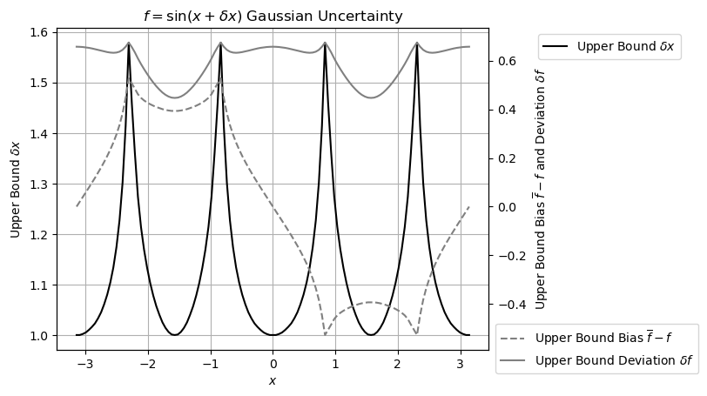
Figure 1: Measured upper bound $δx$ (left y-axis) for $sin(x±δx)$ across different values of x (x-axis) for Gaussian uncertainty. The corresponding resulting uncertainty bias and deviation are also shown (right y-axis).
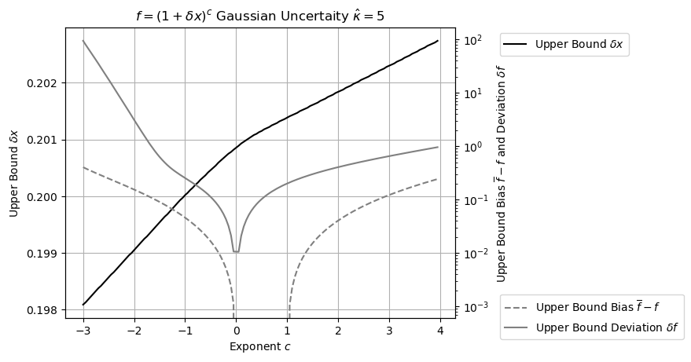
Figure 2: Measured upper bound $δx$ (left y-axis) for ${(x±δx)}^{c}$ across different values of $c$ (x-axis) for Gaussian uncertainty. The corresponding resulting uncertainty bias and deviation are also shown (right y-axis).
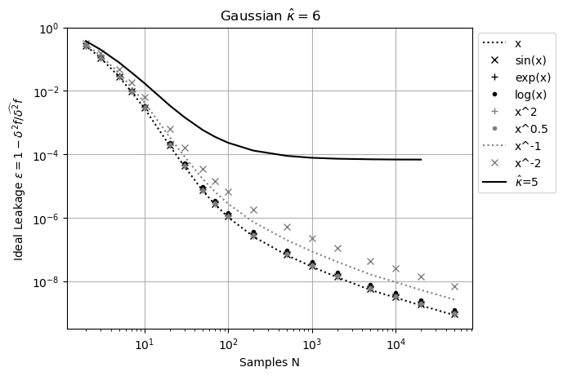
Figure 3: Measured ideal leakage ε$(\hat{κ}=6,N)$ (y-axis) for varying sample count N (x-axis) for the selected function $f(x=1±0.1)$ (legend) for Gaussian input uncertainties. Also included is $ω(\hat{κ}=5,N)$ for comparison.
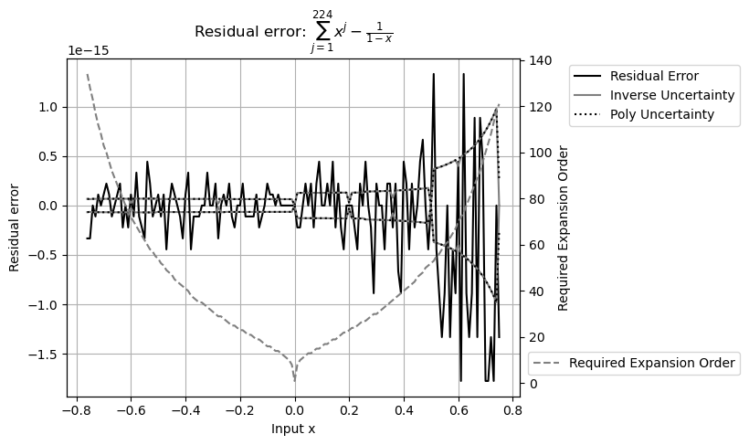
Figure 4: Residual error of $\sum_{j=0}^{224}{x^{j}}-1/(1-x)$ vs x (x-axis). The left y-axis shows both the value and the uncertainty of the residual errors. The right y-axis indicates the expansion order needed to reach convergence for each $x$.
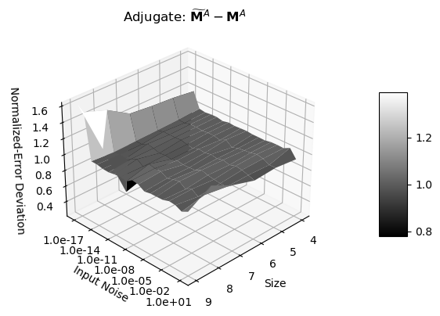
Figure 5: Error deviations (z-axis) of an adjugate matrix ${ \tilde{M}}^{A}-M^{A}$as a function of input noise precision (x-axis) and matrix size (y-axis).
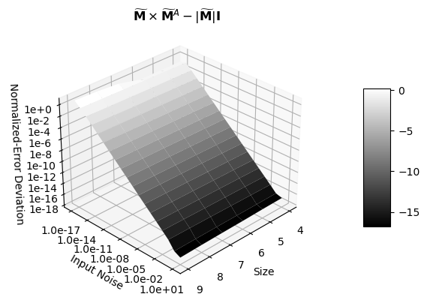
Figure 6: Error deviations (z-axis) of ${ \tilde{M}}^{A}×\tilde{M}-\left|\tilde{M}\right| I$, as a function of input noise precision (x-axis) and matrix size (y-axis).
Basic Function | $$e^{x±δx}$$ | $$log(x±δx)$$ | $${(1+δx)}^{c}$$ | $$sin(x±δx)$$
Value | $$x∈[-100,100]$$ | $$x∈[1/32,32]$$ | $$c∈[-3,3]$$ | $$x∈[-π,π]$$
Uncertainty | $$δx∈[{10}^{-15},1]$$ | $$P(x)∈[{10}^{-15},0.2]$$ | $$P(x)∈[{10}^{-15},0.2]$$ | $$δx∈[{10}^{-15},0.1]$$
Error Deviation | $$1.000±0.010$$ | $$0.999±0.011$$ | $$1.000±0.007$$ | $$1.000±0.010$$
Table 1: The result error deviations of selected basic functions with Gaussian input noise $x±δx$. The error deviation for ${(1+δx)}^{c}$ has excluded the diverging regions. The error deviation for $sin(x±δx)$ has excluded the distributional pole regions.
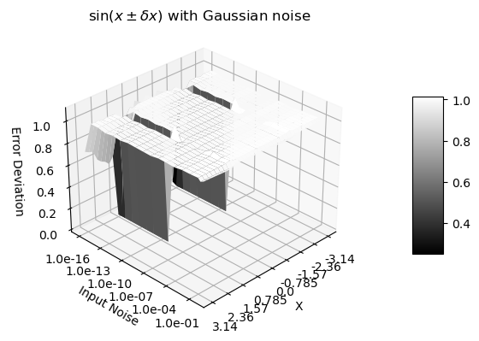
Figure 7: Error deviation for $sin\left(x±δx\right)$as a function of $x$ and $δx$. The x-axis represents $x$ values between $-π$ and $+π$. The y-axis represents $δx$ values between ${10}^{-16}$and $1$. The z-axis shows the corresponding error deviations.

