Statistical Taylor Expansion: A New and
Path-Independent Method for Uncertainty
Analysis *
Chengpu Wang
40 Grossman Street, Melville, NY 11747, USA
Chengpu@gmail.com
January 22, 2026

Abstract
Statistical Taylor expansion, a rigorous extension of conventional Taylor expansion, replaces precise input variables with random variables of known distributions to compute the means and standard deviations of results. This approach tracks the propagation of input uncertainties through intermediate steps, rendering variables in intermediate analytic expressions interdependent, while the final analytic result remains path independent. This feature fundamentally distinguishes it from conventional applied mathematics approaches, which optimize the computational path for each calculation. Statistical Taylor expansion thus provides a standardized framework for numerical computation of analytic expressions. Its statistical nature allows reliable verification of results with sufficiently large sample sizes and incorporates sample count in result qualification. This study further presents an implementation of statistical Taylor expansion, termed variance arithmetic, and demonstrates its performance across diverse mathematical applications.
The study also highlights that numerical errors in library functions can substantially impact outcomes; for example, periodic errors in trigonometric functions can resonate with periodic signals, producing amplified numerical errors in the results.
Keywords: computer arithmetic, error analysis, interval arithmetic, uncertainty, numerical algorithms.
AMS subject classifications: G.1.0 Copyright '2024

*
1

Introduction
Let x and δx denote a value and its uncertainty deviation, respectively. As input, x and δx are the mean and standard deviation of a measurement, respectively [1][2]. If δx = 0, x is a precise value; otherwise, the pair specifies an imprecise value x ± δx.
Let P(x) ≡ δx/|x| be the statistical precision (hereafter referred to as precision) of x ± δx. A smaller P(x) indicates higher measurement quality of x ± δx, and when P(x) ≪ 1, it may be unclear whether δx is excessively large or whether the measurement corresponds to x = 0.
Statistical Taylor expansion determines the result x ± δx of a general analytic expression.
- Previous studies have examined the effect of input uncertainties on output values for specific cases [3]. Statistical Taylor expansion generalizes these effects as uncertainty bias, as shown in Formulas (2.5) and (2.8) of this study.
- The traditional variance–covariance framework accounts only for linear interactions between random variables through an analytic function [3][4][5], whereas statistical Taylor expansion extends this framework to include higher-order interactions, as expressed in Formula (2.9) of this study.
Conventional floating-point arithmetic [6][7][8] computes only the result x, while the bounding range produced by interval arithmetic [9][10][11][12][13] is inconsistent with the statistical nature of an x ± δx pair [14]. Moreover, both approaches depend strongly on the specific algebraic form of an analytic function, a phenomenon known as the dependency problem [9][11][15][16], which can render numerical evaluation of analytic problems more an art than a science. In contrast, statistical Taylor expansion is path independent.
To ensure mathematical and statistical rigor, statistical Taylor expansion abandons the significance-arithmetic nature of its processor [14].
As a statistical sampling process, stochastic arithmetic [17][18] is computationally expensive, whereas statistical Taylor expansion provides a direct characterization of the result’s mean and deviation without sampling. In this study:
- Section 1 briefly compares statistical Taylor expansion with other numerical arithmetic methods.
- Section 2 develops the theoretical foundation of statistical Taylor expansion.
- Section 3 describes variance arithmetic as an implementation of statistical Taylor expansion.
- Section 4 presents standards for validating variance arithmetic.
- Section 5 illustrates variance arithmetic in polynomial computations, demonstrating its capability to trace floating-point rounding errors and distributional poles.
- Section 6 evaluates variance arithmetic on common mathematical library functions and shows that the error deviation should be close to 1 except near a distributional pole.
- Section 7 applies variance arithmetic to adjugate matrices and matrix inversion, showing that uncertainty propagation in linear calculations is no longer linear and that, for a reversible transformation, the original input uncertainties should be recovered after forward and backward transformations.
- Section 8 examines the impact of numerical library errors and shows that these errors can be significant.
- Section 9 concludes with a summary and discussion.

Statistical Taylor Expansion

The Uncorrelated Uncertainty Condition
When there is no systematic error [1][2] among the inputs, their uncertainties are uncorrelated, even though there can be significant correlations among the inputs. This condition can be characterized quantitatively in statistics as the uncorrelated uncertainty condition [14].

Distributional Zero and Distributional Pole
Let ρ($\tilde{x}$,µ,σ) denote the probability density function of a random variable $\tilde{x}$ with the distribution mean µ and distribution deviation σ. Let $\tilde{y}$=f($\tilde{x}$) be a strictly monotonic function, so that its inverse function $\tilde{x}$ = f⁻¹($\tilde{y}$) exists. Formula (2.1) shows the probability density function of $\tilde{y}$ [1][4]. In Formula (2.1), the same distribution can be expressed in terms of either $\tilde{x}$ or $\tilde{y}$, which are simply different representations of the same underlying random variable.
$ρ\left(\tilde{x},μ,σ\right)d\tilde{x}=ρ\left(f^{-1}\left(\tilde{y}\right),μ,σ\right)\frac{d\tilde{x}}{d\tilde{y}}d\tilde{y}=ρ\left(\tilde{y},μ_{y},σ_{y}\right)d\tilde{y}$. (2.1)
Viewed in the f⁻¹($\tilde{y}$) coordinate system, ρ($\tilde{y}$,µ_{y},σ_{y}) is given by ρ($\tilde{x}$,µ,σ) modulated by $\frac{d\tilde{x}}{d\tilde{y}}=1/f_{x}^{\left(1\right)}$, in which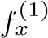 is the first derivative of f(x) with respect to x. A distributional zero of the uncertainty distribution occurs when $f_{x}^{\left(1\right)}=∞→ρ\left(\tilde{y},μ_{y},σ_{y}\right)=0$, whereas a distributional pole occurs when $f_{x}^{\left(1\right)}=0→ρ\left(\tilde{y},μ_{y},σ_{y}\right)= 0$. Zeros and poles provide the strongest local modulation to ρ($\tilde{x}$,µ,σ):
- Figure 1 shows the probability density function for (x ± 1)². The distribution (0±1)² corresponds to the χ² distribution [1]. At the distributional pole x = 0, the probability density function resembles a delta distribution.
- Figure 2 illustrates the probability density function for $\sqrt{x+1}$. At the distributional zero x = 0, the probability density function is zero.
In both Figures 1 and 2, ρ($\tilde{y}$,µ_{y},σ_{y}) closely representation resembles ρ($\tilde{x}$,µ,σ) when the mode of ρ($\tilde{x}$,µ,σ) lies sufficiently far away from either a distributional pole or a distributional zero, thereby allowing for a generic characterization of the output f(x) using the mean $\overline{f\left(x\right)}$ and the deviation $δf(x)$ only.

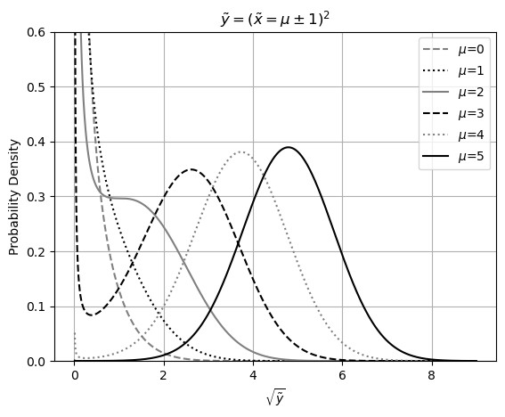
Figure 1: Probability density function of $\tilde{y}$ = $\tilde{x}$², for various values of µ as indicated in the legend. The variable $\tilde{x}$ follows a Gaussian distribution with mean µ and deviation 1. The horizontal axis is scaled as $\sqrt{\tilde{y}}$.

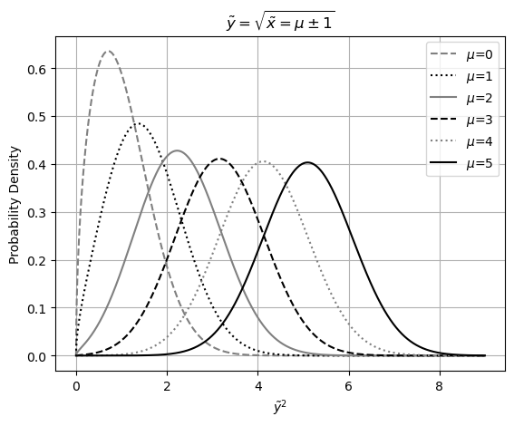
Figure 2: Probability density function for $\tilde{y}$ = $\sqrt{\tilde{x}}$, various values of µ as indicated in the legend. The variable $\tilde{x}$ follows a Gaussian distribution with the distributional mean µ and deviation 1. The horizontal axis is scaled as $\tilde{y}$².

Statistical Taylor Expansion
Define $\tilde{z}$ ≡ ($\tilde{x}$−µ)/σ and let ρ($\tilde{z}$) be the normalized form of ρ($\tilde{x}$,µ,σ) such that $\tilde{z}$ has distribution mean 0 and distribution deviation 1.
$ζ\left(n\right)≡\int_{-ϱ}^{+κ}{\tilde{z^{n}}}ρ\left(\tilde{z}\right)d\tilde{z}$; (2.2)
ζ(1) = 0; (2.3)
Let $\tilde{z}$ ∈ [−ϱ,+κ] where 0 < ϱ,κ specify the bounding ranges. Formula (2.2) defines the corresponding bound moment ζ(n), which further satisfies the mean-reverting condition of Formula (2.3) so that κ determines ϱ. For any symmetric ρ($\tilde{z}$), ζ(2n + 1) = 0. The probability of $\tilde{z}/∈\left[-ϱ,+κ\right]$ is defined as the bounding leakage ϵ(κ).
$f\left(x+\tilde{x}\right)=f\left(x+\tilde{z}σ\right)=f\left(x\right)+\sum_{n=1}^{∞}{\frac{f_{x}^{\left(n\right)}}{n!}}{\tilde{z}}^{n}σ^{n}$; (2.4)
$\overline{f\left(x\right)}=\int_{-ϱ}^{+κ}{f\left(x+\tilde{x}\right)ρ\left(\tilde{x},μ,σ\right)d}\tilde{x}=f\left(x\right)+\sum_{n=1}^{∞}{σ^{n}\frac{f_{x}^{\left(n\right)}}{n!}}ζ\left(n\right)$; (2.5)
$δ^{2}f\left(x\right)δ^{2}f\left(x\right)=\sum_{n=1}^{∞}{σ^{n}\sum_{j=1}^{n-1}{\frac{f_{x}^{\left(j\right)}}{j!}}\frac{f_{x}^{\left(n-j\right)}}{\left(n-j\right)!}}\left(ζ\left(n\right)-ζ\left(j\right)ζ\left(n-j\right)\right)$; (2.6)
An analytic function f(x) can be accurately evaluated over in a range using the Taylor series as shown in Formula (2.4). Formula (2.5) and Formula (2.6) yield the mean $\overline{f\left(x\right)}$ and the deviation $δf(x)$, respectively. The difference $\overline{f\left(x\right)}$ − f(x) is defined as the uncertainty bias, representing the effect of input uncertainty on the resulting value.
$f\left(x+\tilde{x},y+\tilde{y}\right)=\sum_{m=0}^{∞}{\sum_{n=0}^{∞}{\frac{f_{\left(x,y\right)}^{\left(m,n\right)}}{m!n!}{{\tilde{x}}^{m}\tilde{y}}^{n}}}$; (2.7)
$\overline{f\left(x,y\right)}=\sum_{m=0}^{∞}{\sum_{n=0}^{∞}{{\left(σ_{x}\right)}^{m}{\left(σ_{y}\right)}^{n}\frac{f_{\left(x,y\right)}^{\left(m,n\right)}}{m! n!}}ζ_{x}\left(m\right)ζ_{y}\left(n\right)}$; (2.8)
$δ^{2}f\left(x,y\right)=\sum_{m=1}^{∞}{\sum_{n=1}^{∞}{{\left(σ_{x}\right)}^{m}{\left(σ_{y}\right)}^{n}\sum_{i=0}^{m}{\sum_{j=0}^{n}{\frac{f_{\left(x,y\right)}^{\left(i,j\right)}}{i! j!}\frac{f_{\left(x,y\right)}^{\left(m-i,n-j\right)}}{\left(m-i\right)! \left(n-j\right)!}}}}}$
$\left(ζ_{x}\left(m\right)ζ_{y}\left(n\right)-ζ_{x}\left(i\right)ζ_{x}\left(m-i\right) ζ_{y}\left(j\right)ζ_{y}\left(n-j\right)\right);$ (2.9)
Under the uncorrelated uncertainty assumption, Formula (2.8) and (2.9) compute the mean and variance of the Taylor expansion given in Formula (2.7), where ζ_{x}(m) and ζ_{y}(n) denote the variance moments for x and y, respectively. Although Formula (2.9) is only for 2-dimensional, it can be extended easily to any dimension.
With the mean reverting condition of Formula (2.3):
$\overline{x±y}$= ζ(0,κ_{x})x ± ζ(0,κ_{x})y; (2.10)
δ²(xy) = ζ(2,κ_{x})(σ_{x})²y² + x²ζ(2,κ_{y})(σ_{y})² + ζ(2,κ_{x})(σ_{x})² ζ(2,κ_{y})(σ_{y})² (2.11)
δ²(x ± y) = ζ(2,κ_{x})(σ_{x})² + ζ(2,κ_{y})(σ_{y})²; | (2.12)

$\overline{xy}=ζ\left(0,κ_{x}\right)x ζ\left(0,κ_{y}\right)y$; (2.13)
$$δ^{2}\left(xy\right)=ζ\left(2,κ_{x}\right){\left(σ_{x}\right)}^{2}y^{2}+x^{2}ζ\left(2,κ_{y}\right){\left(σ_{y}\right)}^{2}+ζ\left(2,κ_{x}\right){\left(σ_{x}\right)}^{2} ζ\left(2,κ_{y}\right){\left(σ_{y}\right)}^{2}$$
; (2.14)
When N → ∞, ζ(0,κ) → 1 and ζ(2,κ) → 1, making Formula (2.10) and (2.11) the convolution results for x ± y [4], and Formula (2.12) and (2.13) the corresponding results of the product distribution for xy [4].

One-Dimensional Examples
Formula (2.14) and (2.15) give the mean and variance for e^{x}, respectively:
$\frac{\overline{e^{x}}}{e^{x}}=1+\sum_{n=1}^{∞}{σ^{n}ζ\left(n\right)\frac{1}{n!}}$; (2.14)
$\frac{δ^{2}e^{x}}{{\left(e^{x}\right)}^{2}}=\sum_{n=2}^{∞}{σ^{n}\sum_{j=1}^{n-1}{\frac{ζ\left(n\right)-ζ\left(j\right)ζ\left(n-j\right)}{j! \left(n-j\right)!}}}$; (2.15)
Formula (2.16) and (2.17) give the mean and variance for log(x), respectively:
$\overline{\log\left(x\right)}=\log\left(x\right)+\sum_{n=1}^{+∞}{P{\left(x\right)}^{n}\frac{{\left(-1\right)}^{n+1}ζ\left(n\right)}{n}}$; (2.16)
$δ^{2}\log\left(x\right)=\sum_{n=2}^{+∞}{P{\left(x\right)}^{n}\sum_{j=1}^{n-1}{\frac{ζ\left(n\right)-ζ\left(j\right)ζ\left(n-j\right)}{j\left(n-j\right)}}}$; (2.17)
Formula (2.19) and (2.20) give the mean and variance for sin(x), respectively:
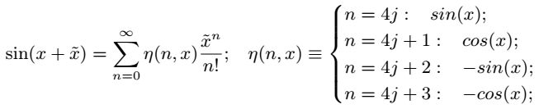 (2.18)
$\overline{\sin\left(x\right)}=\sum_{n=0}^{∞}{σ^{n}η\left(n,x\right)\frac{ζ\left(n\right)}{n!}}$; (2.19)
$δ^{2}\sin\left(x\right)=\sum_{n=2}^{∞}{σ^{n}\sum_{j=1}^{n-1}{\frac{η\left(j,x\right)η\left(n-j,x\right)}{j!\left(n-j\right)!}}\left(ζ\left(n\right)-ζ\left(j\right)ζ\left(n-j\right)\right)}$; (2.20)
Formula (2.21) and (2.22) give the mean and variance for x^{c}, respectively:
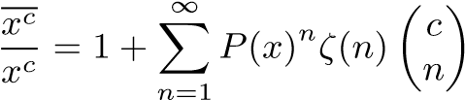 ; (2.21)
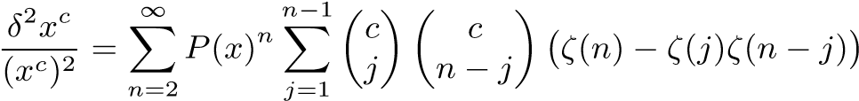; (2.22)
The result variance in statistical Taylor expansion reflects the inherent characteristics of the calculation, such as σ → P(e^{x}), P(x) → δ log(x), σ → δ sin(x), and P(x) → P(x^{c}).

Convergence of Variance
Formula (2.23) shows that the asymptotic behavior of ζ(n,κ) when n → ∞ determines if Formula (2.6) will converge.
- Formula (2.15) for e^{x±δx} and Formula (2.20) for sin(x ± δx) both converge unconditionally. However, as shown later in this pap, δ² sin(x±δx) can become negative for large δx, which imposes an upper-bound constraint on the input δx.
- Formula (2.17) for log(x ± δx) can be approximated by Formula (2.24), which converges when P(x) < 1/κ.
- Formula (2.22) for (x ± δx)^{c} can be approximated by Formula (2.25). which converges when P(x) ≲ 1/κ although the precise upper bound for P(x) varies with c.
$∀j:\lim_{n→+∞}{ζ}\left(n\right)-ζ\left(j\right)ζ\left(n-j\right)=\frac{κ^{n}}{n}$; (2.23)
$δ^{2}\log\left(x±δx\right)∼\sum_{n=1}^{+∞}{\frac{{\left(P\left(x\right)κ\right)}^{2n}}{{\left(2n\right)}^{2}}}$; (2.24)
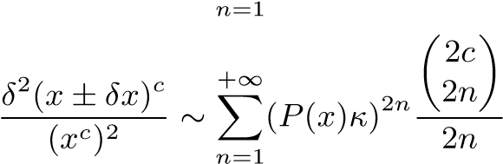; (2.25)

Statistical Bounding
When sampling from a distribution, the sample mean x and sample deviation δx approach the distribution mean µ and distribution deviation σ respectively as the sample count N increases [4]. This yields the sample bounding leakage ϵ(κ,N) for the interval [x − ϱδx,x + κδx], in contrast to the distributional bounding leakage ϵ(κ) for the interval [µ − ϱσ,µ + κσ]. Because ϵ(κ) ̸= ϵ(κ,N) for finite N, let ϵ(κ) = ϵ(κ_{s},N), where κ_{s} is the measuring bonding range, and κ(κ_{s},N) is the measured bounding range.
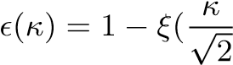); (2.26)
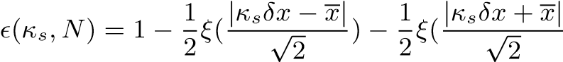); (2.27)
When the underlying distribution is Normal, Formulas (2.26) and (2.27) give the distributional bounding leakage ϵ(κ) and the sample bounding leakage ϵ(κ_{s},N), respectively, where ξ() is the Normal error function [4]. Figure 3 shows that ϵ(κ_{s}) < ϵ(κ_{s},N) and lim_{N→∞} ϵ(κ_{s},N) = ϵ(κ_{s}) along the y-axis direction and that κ(κ_{s},N) < κ_{s} and lim_{N→∞} κ(κ_{s},N) = κ_{s} along the x-axis direction. Figure 4 further demonstrates that, for smaller κ_{s}, κ(κ_{s},N) approaches κ_{s} more rapidly as N increases but converges to a larger stable bounding leakage.
When the underlying distribution is uniform, the portion of sampled range $\left[\overline{x}-\sqrt{3}δx,\overline{x}+\sqrt{3}δx\right]$ outside the actual range $[μ-\sqrt{3}σ,μ+\sqrt{3}σ]$ contributes to the bounding leakage ϵ(N). Figure 4 shows that 0 < ϵ(N) ∼ N^{−0.564} empirically. The measured bounding range κ(N) = $\sqrt{3}$(1 − ϵ(N)).

Ideal Statistics
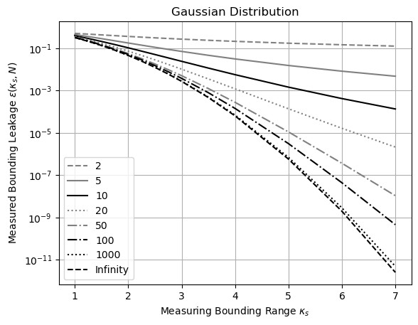
Figure 3: Measured bounding leakage ϵ(κ_{s},N) (y-axis) for varying measuring bounding range κ_{s} (x-axis) and sample count N (legend).

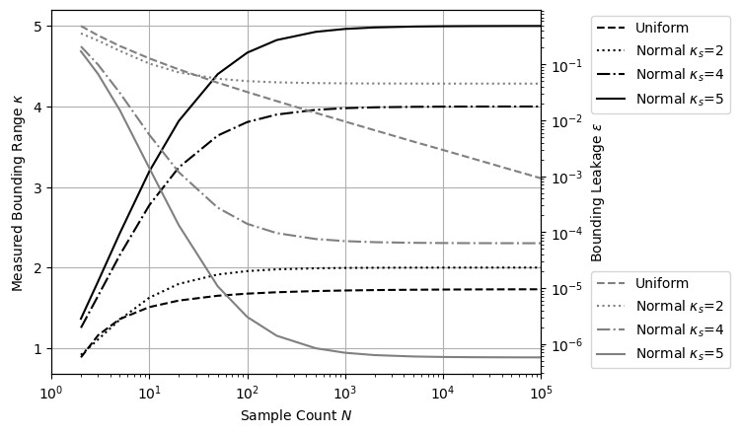
Figure 4: Measured bounding range κ (left y-axis) and corresponding measured bounding leakage ϵ(κ) (right y-axis) for varying sample count N (x-axis) when the underlying distribution is uniform or normal (legend), with different measuring bounding range κ_{s} for the normal distribution.
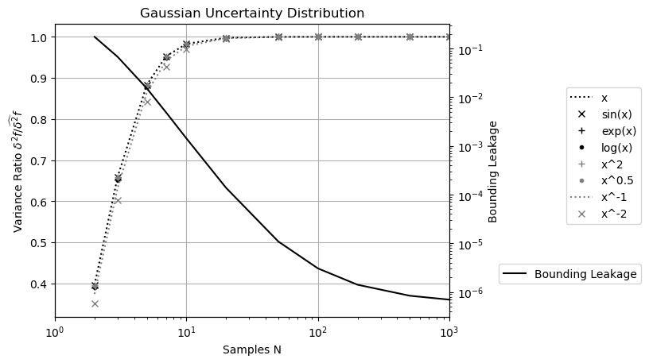
Figure 5: Ratio of resulting variance δ²f to the ideal variance δ_{b}²f (left y-axis) and the bounding leakage (right y-axis) for varying sample count N (x-axis) for the selected function f(x = 1 ± 0.1) (legend) when the uncertainty distribution is Gaussian.

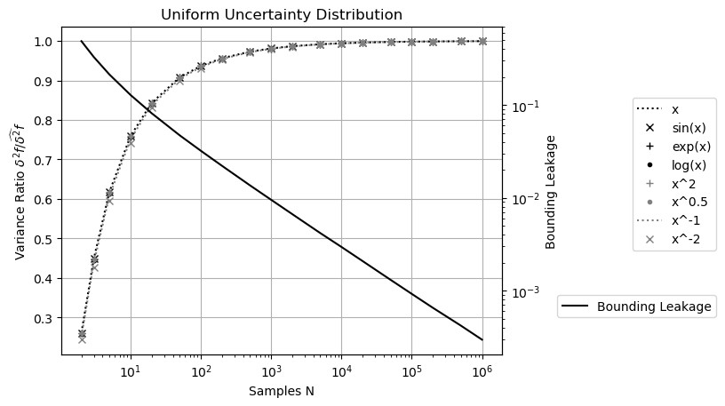
Figure 6: Ratio of resulting variance δ²f to the ideal variance δ_{b}²f (left y-axis) and the bounding leakage (right y-axis) for varying sample count N (x-axis) for the selected function f(x = 1 ± 0.1) (legend) when the uncertainty distribution is Uniform.

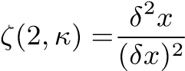; (2.28)
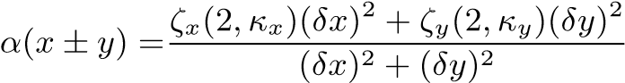; (2.29)

when the sample count N → ∞, ζ(0) → 1, ζ(2) → 1 and δ²x → (δx)² in Formula
(2.28). Such a relationship between δ²f and sample count N is general:
- Figure 5 shows that, when the underlying uncertainty distribution is Gaussian and κ_{s} = 5, the resulting variance δ²f for a selected function rises with N until reaching the corresponding stable value $\hat{δ^{2}}f$ when N ≥ 50.
- When the underlying uncertainty distribution is Uniform, κ_{s} = $\sqrt{3}$. Figure 6 shows the same trend; however, the stable variances $\hat{δ^{2}}f$ are reached only when N ≥ 10⁴.
The trends in the uncertainty biases $\overline{f} - f$ versus sample count N are exactly the same as those in Figure 5 and 6, except that $x - x = 0.$ This similarity is expected because the first-order approximation in both Formulas (2.5) and (2.6) contain σ²ζ(2,κ).
In both Figures 5 and 6, the bonding leakage ϵ(N) decreases as the sample count N increases. The stable resulting variance $\hat{δ^{2}}f$ is reached only when ϵ(s,N) < 10⁻³. All functions approach their corresponding ideal variances, following the same trends in each figure. These observations suggest that bounding leakage is the reason for δ²f < $\hat{δ^{2}}f$ and it is justified to infer the confidential interval range κ from bounding leakage ϵ(N,κ).
We define the stable variance when the sample count N is sufficient large as the ideal variance $\hat{δ^{2}}f$. The choice of κ_{s} to calculate $\hat{δ^{2}}f$ is defined as the ideal bounding range√ κˆ. For a Uniform distribution, ˆκ = 3 by definition. When the input distribution is unbounded, the choice of ˆκ is a trade-off: a larger ˆκ means a smaller bounding leakage for the result but a narrower convergence range for the input. For a Gaussian distribution, ˆκ = 5 according to the 5-σ rule for determining the statistical significance of experimental result [1][2][4].
When the sample count N is insufficient, $\hat{δ^{2}}f$ is calculated using ˆκ , for which N will be sufficient. δ²f is calculated using the actual value of N. We define the ideal ratio as α ≡ δ²f/$\hat{δ^{2}}f$, which is 0 when N = 1 and 1 when N is sufficiently large. The ideal ratio α quantifies the reliability of δ_{b}²f from the underlying distributions and the corresponding sample counts of all inputs. Formula (2.29) provides an example of the case for α(x ± y).

Dependency Tracing
$δ^{2}\left(f+g\right)=δ^{2}f+δ^{2}g+2\left(\overline{fg}-\overline{f\overline{g}}\right)$; (2.30)
$δ^{2}\left(fg\right)=\overline{f^{2}g^{2}}-{\overline{fg}}^{2}$; (2.31)
$δ^{2}f\left(g\right)=\overline{f{\left(g\right)}^{2}}-{\overline{f\left(g\right)}}^{2}$; (2.32)
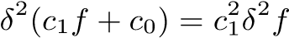; (2.33)
When all inputs satisfy the uncorrelated uncertainty assumption, statistical Taylor expansion traces dependencies through the intermediate steps. For example:
- Formula (2.30) expresses δ²(f + g), whose dependency tracing is illustrated by δ²(f − f) = 0, and δ²(f(x) + g(y)) = δ²f + δ²g, with the latter corresponding to Formula (2.11).
- Formula (2.31) expresses δ²(fg), illustrated by δ²(f/f) = 0, δ²(ff) = δ²f², and δ²(f(x)g(y)) = f²(δ²g)+(δ²f)g² +(δ²f)(δ²g), with the latter corresponding to Formula (2.13).
- Formula (2.32) shows δ²f(g(x)), whose dependency tracing is demonstrated by δ²(f⁻¹(f(x))) = (δx)².
- Formula (2.33) gives the variance of the linear transformation of a function, which can be applied to Formula (2.30) and (2.31) for more general dependency tracing.
Statistical Taylor expansion employs dependency tracing to ensure that the calculated mean and variance satisfy statistics rigorously. Dependency tracing also implies that the results of statistical Taylor expansion must remain path independent. However, dependency tracing comes at a cost: variance calculations are generally more complex than value calculations and exhibits a narrower convergence range for input variables.

Traditional Execution and Dependency Problem
Dependency tracing requires an analytic form of the function to apply statistical Taylor expansion for the result mean and variance, as in Formula (2.5), (2.6), (2.8), and (2.9). This requirement often conflicts with conventional numerical methods for analytic functions:
- Traditionally, intermediate variables are widely used in computations; however, this practice disrupts dependency tracing by obscuring the relationships among the original input variables.
- Similarly, conditional executions are often employed to optimize performance and minimize rounding errors, for example, using Gaussian elimination to minimize floating-point rounding errors in matrix inversion [19]. For dependency tracing, such conditional executions should instead be replaced by direct matrix inversion as described in Section 7.
- Furthermore, traditional approaches frequently apply approximations to result values during execution. Under the statistical Taylor expansion, Formula (2.6) shows that the variance converges more slowly than value in statistical Taylor expansion. Consequently, approximation strategies should prioritize variances than values. Section 7 illustrates this principle through a first-order approximation used in computing a matrix determinant.
- Traditionally, results from mathematical library functions are accepted without scrutiny, with accuracy assumed down to the last digit. As demonstrated in Section 8, statistical Taylor expansion enables the detection of numerical errors within these functions and requires that they be recalculated with uncertainty explicitly incorporated into the output.
- In conventional practice, an analytic expression is often decomposed into simpler, ostensibly and independent arithmetic operations such as negation, addition, multiplication, division, square root, and library calls. However, this decomposition introduces dependency problems. For example, if x² − x is calculated as x² − x, x(x − 1), and 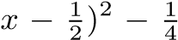(, only (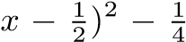 gives the correct result, while the other two give wrong results for wrong independence assumptions between x² and x, or between x − 1 and x, respectively.
- Similarly, large calculations are often divided into sequential steps, such as computing f(g(x)) as f(y)|_{y=g(x)}. This approach also introduces the dependency problem by ignoring dependency tracing within g(x) affecting f(g(x)), such as (√x)² > √x² and δ2(√x)2 > δ2√x2.
Dependency tracing therefore removes nearly all flexibility from traditional numerical executions, effectively eliminating the associated dependency problems. Consequently, all conventional numerical algorithms must be reevaluated or redesigned to align with the principles of statistical Taylor expansion.

Variance Arithmetic
Variance arithmetic implements statistical Taylor expansion. Because of the finite precision and limited range of conventional floating-point representation, ζ(n) can only be computed to limited terms. Consequently, the following numerical rules are introduced:
- finite: The resulting value and variance must remain finite.
- monotonic: As a necessary condition for convergence, the last 20 terms of the expansion must decrease monotonically in absolute value, ensuring that the probability of the expansion exhibiting an absolute increase is no more than $2^{-20}≈9.53 {10}^{-7}$.
- positive: At every order, the expansion variance must be positive.
- stable: To avoid truncation error [5], the value of the last expansion term must be less than ϵ times of both the result uncertainty and the result absolute value, in which ϵ ≃ 5.73 10⁻⁷ is the bounding leakage for Gaussian distribution with ideal bounding range ˆκ = 5. This rule ensures sufficiently fast convergence in the context of monotonic convergence.
- reliable: At every order, the uncertainty of the variance must be less than 1/5 times the value of the variance.
For simplicity of discussion, the Taylor coefficients in Formula (2.4) and (2.7) are assumed to be precise.

Numerical Representation
Variance arithmetic represents an imprecise value x±δx using a pair of 64-bit standard floating-point numbers and uses floating-point arithmetic for computation.
The δx of a floating-point value is assumed to be 1/ $\sqrt{3}$ times of the ULP of the value x, where ULP refers to the Unit in the Last Place in conventional floating-point representation [8], unless the least 20 bits of the significand are all zeros, because rounding errors are shown to be uniformly distributed within the ULP [14].

Monotonic
Beyond an upper bound δx, the expansion is no longer monotonic for e^{x±δx}, log(x±δx), and (x±δx)^{c}. Variance arithmetic rejects the distributional zero of log(x) or (x±δx)^{c} in the range of P(x) ⪆ 1/κˆ statistically due to the divergence of Formula (2.24) and (2.25) mathematically, with ζ(2n,κˆ) providing the connection between these two perspectives.
For Gaussian input uncertainty with $\hat{κ}$ = 5:
- For e^{x±δx}, δx ≲ 19.864 and P(e^{x±δx}) ≲ 1681.767 regardless of x. These limits follow directly from the relationship δx → P(e^{x}), as indicated in Formula (2.15).
- For log(x ± δx), P(x) ≲ 0.20086 and δ log(x ± δx) ≲ 0.213 regardless of x. These limits follow directly from the relationship P(x) → δ log(x), as indicated in Formula (2.17).
- For (x±δx)^{c}, except when c is a natural number, the upper bound P(x) is close to 1/5 but increasing with c. This trend is confirmed in Figure 7.
Similar trends holds when the input uncertainty is uniform but with different values. For example, after the respective upper bound P(x) for (x ± δx)^{c} are normalized by the corresponding $\hat{κ}$, they show almost the same trends of increasing with c.

Positive
In some cases, the variance expansion may yield negative results, as in Formula (2.20) for sin(x ± δx). Figure 8 shows that the upper bound of δx for sin(x ± δx) varies periodically between 0.318π and 0.416π for Gaussian input uncertainty. Beyond this upper bound, the expansion is no longer positive. Similar trend holds when the input uncertainty is uniform but with larger upper bound δx.

Verification of Variance Arithmetic
Analytic functions or algorithms with precisely known results are used to evaluate the outputs of variance arithmetic based on the following statistical properties:
- Value error: the difference between the numerical result and the corresponding known precise analytic result.
- Normalized error: the ratio of a value error to the corresponding uncertainty.
- Error deviation: the standard deviation of normalized errors.
- Error distribution: the histogram of the normalized errors.
One objective of uncertainty-based computation is to account precisely for all input errors from every source, thereby achieving ideal coverage:
- The error deviation is exactly 1.
- The error distribution should follow a Normal distribution when an imprecise value is expected or a Delta distribution when a precise value is expected.
As indicated later in this paper, if the precise result is unknown, the result error distribution can be used to assess whether ideal coverage is achieved.
However, if the input uncertainty is known only to an order of magnitude, proper coverage is achieved when the error deviations fall within the range [0.1,10].
When an input contains unspecified errors, such as numerical errors in library functions or floating-point rounding errors, Gaussian noise with progressively increasing deviations can be added until ideal coverage is attained. The minimal noise deviation required provides a good estimate of the magnitude of the unspecified input uncertainty deviations, for example, empirically, 10⁻¹⁵ such noise is enough if floating-point rounding errors is the only unspecified uncertainty. Achieving ideal coverage serves as a necessary verification step to ensure that statistical Taylor expansion has been applied correctly within the given context. The input noise range that yields ideal coverage defines the ideal application range for input uncertainties.
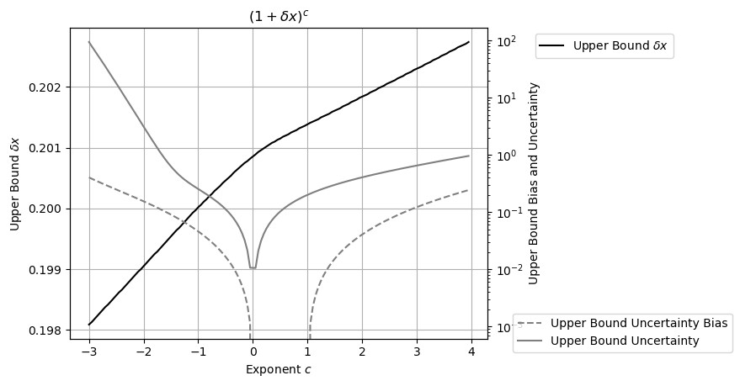
Figure 7: Measured upper bound δx (left y-axis) for (1 ± δx)^{c} across different values of c (x-axis) for Gaussian uncertainty. The corresponding uncertainty bias and uncertainty are also shown (right y-axis). The x-axis is expressed in units of π. When c is a natural number, δx has no upper bound; however, such cases are omitted in the figure.
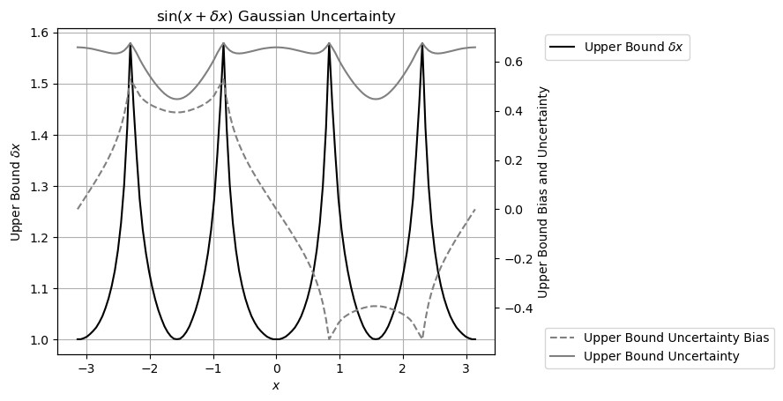
Figure 8: Measured upper bound δx (left y-axis) for sin(x±δx) across different values of x (x-axis) for Gaussian uncertainty. The corresponding uncertainty bias and uncertainty are also shown (right y-axis). The x-axis is expressed in units of π.

Polynomial
Formula (5.1) presents polynomial Taylor expansion:
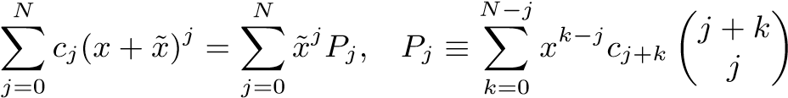; (5.1)
Because the maximal term in Formula (5.1) is ˜x^{2N}, Formula (5.1) has only half of the maximal expansion order of Formula (2.6).

Tracking Rounding Error
Variance arithmetic can track rounding errors effectively. Figure 9 shows the residual error of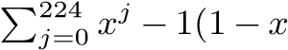), in which 224 is half of the max index for Gaussian bound moment. Whenever the required expansion order for 1/(1−x) is no more than 224, the residual error reflects solely the rounding error between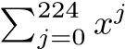and 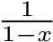. A detailed analysis indicates that the maximal residual error is four times the ULP of 1/(1−x). In all cases, the calculated uncertainty bounds the residual error effectively for all x.

Continuity
In variance arithmetic, the result mean, variance and histogram are generally continuous across parameter space. For example, δx has an upper bound for (x ± δx)^{c} to converge except when c is a natural number n. The result mean, variance and histogram of (x ± δx)^{c} remain continuous around c = n.

Distributional Hole
A statistical bounding range in variance arithmetic can include a distributional pole if the analytic function is defined in its vicinity, such as around (0 ± δx)^{c}, c > 1. The presence of such poles does not disrupt the continuity of the result mean, variance, or histogram. Figure 10 illustrates the histograms of (x ± 0.2)^{n} when x = 0, −0.2, +0.2 and n = 2,3.
- When the second derivative is zero, the resulting distribution is symmetric two-sided and Delta-like, such as when n = 3, x = 0.
- When the second derivative is positive, the resulting distribution is right-sided Delta-like, such as the distribution when n = 2,x = 0, or when n = 2,x = ±0.2, or when n = 3,x = 0.2.
- When the second derivative is negative, the resulted distribution is left-sided and Delta-like, such as when n = 3, x = −0.2, which is the mirror image of the distribution when n = 3, x = 0.2.
In each case, the transition from x = 0 to x = 0.2 is continuous.

Mathematical Library Functions

Basic Function | $$e^{x±δx}$$ | log(x ± δx) | (1 ± δx)^{c} | sin(x ± δx)
Range | x ∈ [−100,+100] | x ∈ [1/32,32] | c ∈ [−3,+3] | x ∈ [−π,+π]
Error Deviation | 1.000 ± 0.010 | 0.999 ± 0.011 | 0.989 ± 0.104 | 0.978 ± 0.150
Table 1: The result error deviation of selected basic functions with Gaussian input noise ( δx > 10⁻¹⁵), obtained using variance arithmetic.

Table 1 shows that, by sampling Gaussian input noise with distributional deviation δx, Formulas (2.15), (2.17), (2.20), and (2.22) provide almost perfect deviations for result values calculated using corresponding math library functions. Table 1 shows results obtained using Python, which differ slightly from those obtained from either C++ or Java.

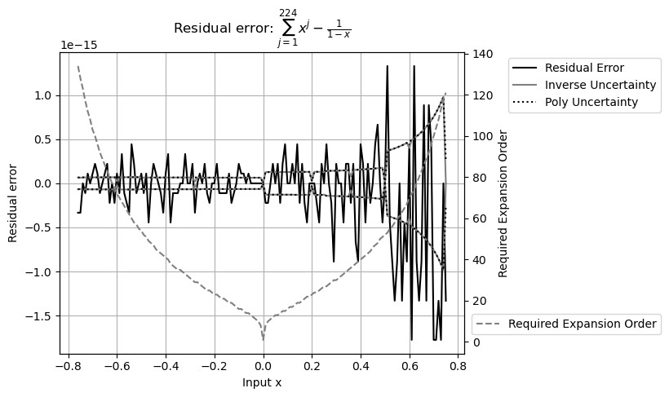
Figure 9: Residual error of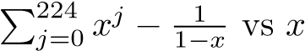 (x-axis). The y-axis to the left shows both the value and the uncertainty of the residual errors. The y-axis to the right indicates the expansion order needed to reach stable value for each x.
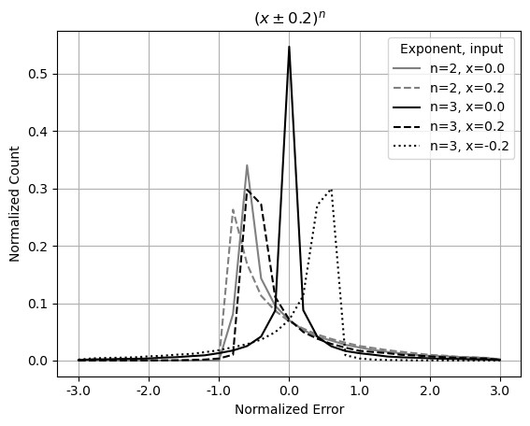
Figure 10: Histograms of normalized errors for (x±0.2)^{n}, with x = 0, −0.2, +0.2, and n = 2,3, as indicated in the legend.

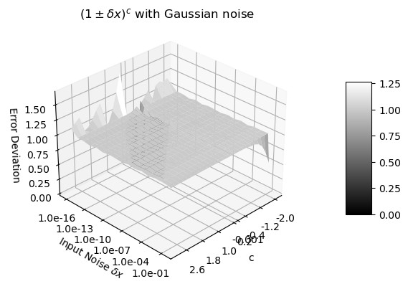
Figure 11: Error deviation for (1 ± δx)^{c} as a function of c and δx. The x-axis represents c value between −2 and +3. The y-axis represents δx value between −10⁻¹⁶ and 1. The z-axis shows the corresponding error deviation.
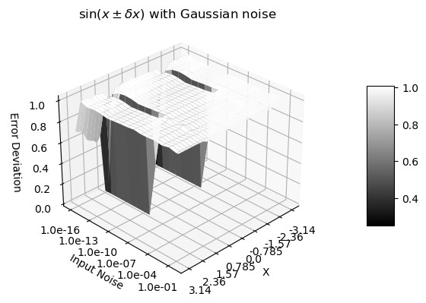
Figure 12: Error deviation for sin(x±δx) as a function of x and δx. The x-axis represents x values between −π and +π. The y-axis represents δx values between −10⁻¹⁶ and 1. The z-axis shows the corresponding error deviations.
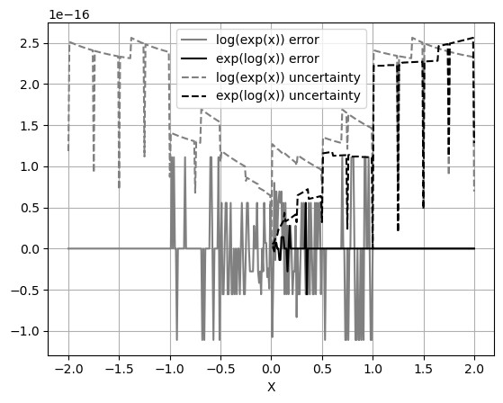
Figure 13: Values and uncertainties of log(e^{x}) − x and e^{log(x)} − x as functions of x, evaluated in increments of 0.1. When x is 2’s fractional such as 1/2 or 1, the resulting uncertainties are significantly smaller.
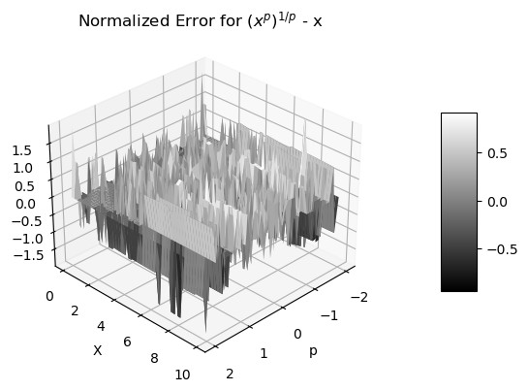
Figure 14: Normalized errors of (x^{p})^{p1} − x as functions of x and p.
Figure 11 shows that the error deviations of (1+δx)^{c} are very close to 1 for all input exponents c and input uncertainties δx > 10¹⁵. It shows a typical desired relation between error deviation and input noise deviation δx and another specific dimension, with the ideal coverage over all areas except for δx → 0. The specific dimension in Figure 11 is c in (1 + δx)^{c}, which can also be x in e^{x±δx} and log(x ± δx). In Figure 11, when c = −3, δx = 0.2; the error deviation has an abnormality of less than 1 because (1 + δx)^{c} no longer converges at this point.
By contrast, Figure 12 shows that the error deviation for sin(x+δx) is 1.000±0.010, except approaching 0 when x = ±π/2 and δx < 10⁻⁸. At the distributional poles, input uncertainty is suppressed. As expected, δ² sin(x) exhibits the same periodicity as sin(x). The numerical errors of the library functions sin(x) and cos(x) over a larger range of x will be examined in greater detail in Section 8.
To test that f⁻¹(f(x)) − x = 0 when δx = 0 for the library functions:
- Figure 13 shows that the value errors in e^{log(x)} − x are much more than those in log(e^{x}) − x. For log(e^{x}) − x, the error deviation is 0.41 when |x| ≤ 1 or 0 otherwise.
- Figure 14 shows that the error deviation for (x^{p})^{1/p} −x is 0.56, independent of neither x nor p.
The reasons why (x^{p})^{1/p} − x has larger value errors than log(e^{x}) − x and e^{log(x)} − x has nearly no value error are not clear.

Matrix Calculations
Let [j₁,j₂ ...j_{m}]_{n} denote a permutation of length m from the vector (1,2...n), and let < j₁,j₂ ...j_{m} >_{n} for the ordered permutation of length m [19]. Formula (7.1) and (7.2) gives the statistical Taylor expansion of the determinant of a square matrix M of size n, when the uncertainties of matrix elements are all independent of each other. In
Formula (7.2), M_{<i1}...i_{m}>_{n},_{[j1}...j_{m}]_{n} is the sub-matrix for M, in which < i₁ ...i_{m} >_{n} contains the row indices, and [j₁ ...j_{m}]_{n} contains the column indices.
|M| = |M|; (7.1)
$δ^{2}\left|M\right|=\sum_{m=1}^{n}{\sum_{<i_{1}…i_{m}>_{n}}{\sum_{{\left[j_{1}…j_{m}\right]}_{n}}{{\left|M_{<i_{1}…i_{m}>_{n},{\left[j_{1}…j_{m}\right]}_{n}}\right|}^{2}\prod_{k=1…n}^{i_{k}∈\{i_{1}…i_{m}\}}{{\left(δx_{i_{k},j_{k}}\right)}^{2}}}}}$; (7.2)
The square matrix whose element is a_{i,j} = (−1)^{i+j}|M_{j,i}| is defined as the adjugate matrix [19] M^{A} to the original square matrix M. By adding Gaussian noise of deviation δx to M at each element, M_{f} is created. The value error of M^{A} is the difference between M_{g}^{A} and M^{A}; the result deviation is calculated using Formula (7.2). The result error deviation is similar to that Figure 11 but with matrix size as the specific dimension.
Let I be the identity matrix for M [19]. Formula (7.3) shows the relationship between M^{A}
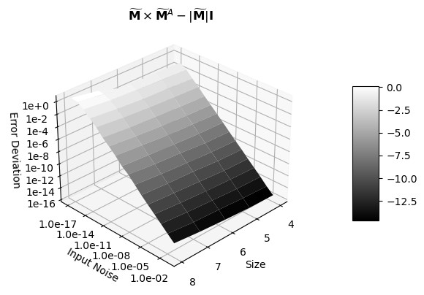
Figure 15: Error deviations (z-axis) as a function of matrix size (x-axis) and input noise precision (y-axis) for the difference of the two sides of Formula (7.3).
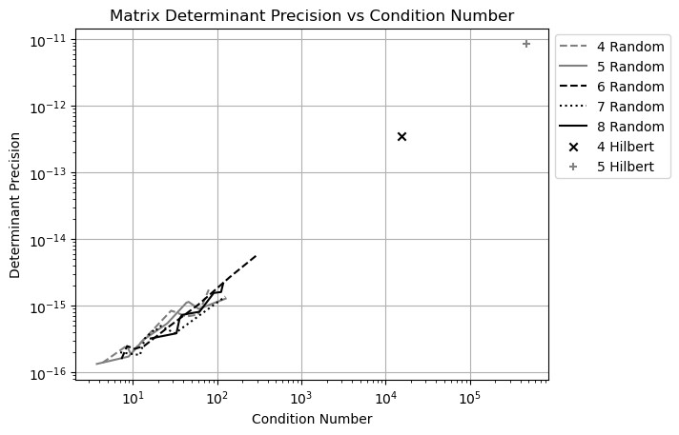
Figure 16: Linear correlation between the precision of a matrix determinant (y-axis) to its condition number (x-axis). The legend shows the size of the matrix, as well as the type of the matrix as Random for randomly generated matrix, and Hilbert as the Hilbert matrix.
and M, which leads to the definition of inverse matrix M⁻¹ in Formula (7.4) [19]:
M × M^{A} | = M^{A} × M = |M|I; | (7.3)
M−1 | ≡ M^{A}/|M|; | (7.4)
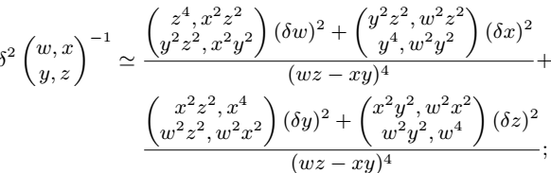 (7.5)
Whereas $\tilde{M}$^{A}−M^{A} qualifies the distribution predicted by statistical Taylor expansion so that the result normalized errors should be Normal distributed in a manner similar to that shown in Figure 11, $\tilde{M}$ × $\tilde{M}$ ^{A} − |$\tilde{M}$ |I tests each value so that the result normalized errors should be Delta distributed. Figure 16 shows the error deviation of a typical value test; the error deviation decreases with increasing input uncertainty deviation δx because a round-trip transformation will recover the original inputs exception at δx → 0 when floating-point rounding errors dominate. The matrix size is the specific dimension in Figure 16.
Because an element of the original matrix M appears multiple times in Formula (7.4), its variance, as obtained using Formula (2.9), is very complicated. For example, Formula (7.5) shows the simplest case for Formula (7.4): the first-order approximation of a 2x2 matrix. To use such an approximation, the original matrix M should be scaled so that all input deviations are less than 1. Contrary to conventional approaches, statistical Taylor expansion uses Formula (7.4) for matrix inversion instead of Gaussian elimination [5] because ,logically, the result should be symmetric for all matrix elements, as demonstrated by Formula (7.5).
In Formula (7.4), M⁻¹ is dominated by 1/|M|, suggesting that the precision of M⁻¹ is largely determined by the precision of |M|. Figure 16 shows that there is a strong linear correlation between conditional numbers and the corresponding determinant precision of the matrices. As a reference, Figure 16 presents the Hilbert matrix [19] for each matrix size and shows that the Hilbert matrices also follow the linear relation between determinant precision and condition number. Thus, determinant precision can replace matrix condition number.

FFT (Fast Fourier Transformation)

DFT (Discrete Fourier Transformation)
$H\left[n\right]=\sum_{k=0}^{N-1}{h\left[k\right]{ e}^{\frac{i2π}{N}kn}}$; (8.1)
$h\left[k\right]=\frac{1}{N}\sum_{n=0}^{N-1}{H\left[n\right] e^{-\frac{i2π}{N}nk}}$; (8.2)
For each signal sequence h[k], where k = 0,1...N −1, and N is a natural number, the discrete Fourier transform (DFT) H[n], for n = 0,1...N − 1, along with its inverse transformation, is defined by Formula (8.1) as the forward transformation, and (8.2) as the reverse transformation, respectively [5]. In these expressions, k denotes the time index while n represents the frequency index. The frequency index and time index are not necessarily associated with physical time unit or frequency unit, respectively; rather, the naming convention provides a convenient way to distinguish between the two opposite domains in DFT: the waveform domain h[k] and the frequency domain H[n].
Although mathematically self-consistent, DFT implies a periodic boundary condition in the time domain [14]. Consequently, it is only an approximation for the mathematically defined continuous Fourier transform (FT) [14]. To avoid the modeling errors inherent in DFT, only Formulas (8.1) and (8.2) are used in this paper.

FFT (Fast Fourier Transformation)
When N = 2^{L}, where L is a natural number, the generalized Danielson-Lanczos lemma can be applied to DFT to produce FFT [5].
- For each output, each input is used only once, therefore no dependency problem arises when decomposing FFT into arithmetic operations such as Formulas (2.10), (2.11), (2.12), and (2.13).
- When L is large, the substantial volume of input and output data enables high-quality statistical analysis.
- The computational complexity is proportional to L, since increasing L by 1 adds an additional step involving a sum of multiplications.
- Each step in the forward transformation doubles the variance, so the uncertainty deviation increases with the FFT order L as ${\sqrt{2}}^{L}$ . Because the reverse transformation divides the result by 2^{L}, its uncertainty deviation decreases with L as 1/${\sqrt{2}}^{L}$. Consequently, the uncertainty deviation for the roundtrip transformation is therefore ${\sqrt{2}}^{L}/{\sqrt{2}}^{L}=$1.
- The forward and reverse transformations are identical except for a sign difference, meaning that they are essentially the same algorithm, and any observed difference arises solely from the input data.
- In normal usage, forward and reverse FFT transforms differ in their data prospective of time domain versus frequency domain:
- The forward transformation converts a time-domain sine or cosine signal into a frequency-domain spectrum in which most values are zeros, causing its uncertainties to grow more rapidly.
- In contrast, the reverse transformation spreads the precise frequency-domain spectrum (where most values are zeros) back into a time-domain sine or cosine signal, causing its uncertainties to grow more slowly.
The question is: does the value error match the above trend of uncertainty? If so, the result error deviation should be close to 1.

Testing Signals
The following signals are used for testing:
- Sin: h[k] = sin(2πkf/N),f = 1,2,...N/2 − 1.
- Cos: h[k] = cos(2πkf/N),f = 1,2,...N/2 − 1.
- Linear: h[k] = k, whose DFT is given by Formula (8.3).
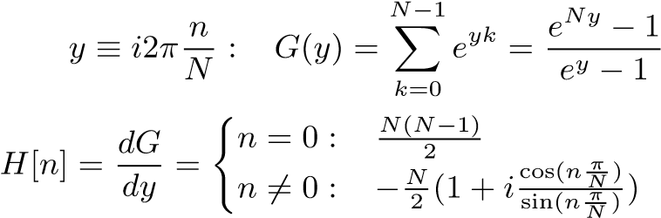
; (8.3)

Trigonometric Library Errors
Formulas (8.1) and (8.2) restrict the use of sin(x) and cos(x) to x = 2πj/2^{L}, where L is the FFT order. To minimize numerical errors in computing sin(x), the following indexed sine can be used in place of standard library sine functions:
- Instead of a floating-point value x as input for sin(x), an integer index j defines the input as sin(πj/2^{L}), thereby eliminating the floating-point rounding error of x.
- The values of sin(πj/2^{L}),j ∈ [0,2^{L−2}] are library sine directly, while sin(πj/2^{L}),j ∈ [2^{L−2},2^{L−1}] are computed from library cos(π(2^{L−1} − j)/2^{L}).
- The values of sin(πj/2^{L}) are extended from j ∈ [0,2^{L−1}] to j ∈ [0,2^{L+1}] by exploiting the symmetry of sin(πj/2^{L}).
- The values of sin(πj/2^{L}) are extended to all the integer value of j by leveraging the periodicity of sin(2πj/2^{L}).
The constructed indexed sin(x) is referred to as the Quart indexed sine function. In contrast, the direct use of the standard library sin(x) is referred to as the Library sine function.
Because the Quart sine function strictly preserves the symmetry and periodicity of the sine function, it provides better numerical accuracy than the Library function.
- Figure 17 shows that the value differential between the Quart and Library sin(x) and the Quart sin(x) increases approximately linearly with |x|.
- Figure 18 shows the value differential between the Quart and Library cos(x)/sin(x) also increases roughly linearly with |x| but is 10² times larger than that observed for sin(x). Therefore, the linear spectrum in Formula (8.3) can contain significant numerical errors when computed using library sine functions.

Using Quart Sine for Sin/Cos Signals
The error deviations obtained using the Quart sine resemble those shown in Figure 11 but with the FFT order as the specific dimension, independent of whether a Sin or Cos signal is used or the signal frequency. Therefore, the results for Sin and Cos signals across all frequencies are pooled together for statistical analysis, under the unified category Sin/Cos signals. When the FFT order L is less than 8, the error deviations deviate from 1 owing to an insufficient sample count of 2^{L}.
Figure 19 shows that the error distributions of the Sin/Cos signal resemble Gaussian distributions, with an additional Delta-like distribution at zero. Detailed analysis reveals that the Delta-like distribution is caused by floating-point rounding errors. Figure 19 further demonstrates that the reverse transformation is more sensitive to imperfections in Quart sine function, because its error distribution is structured.
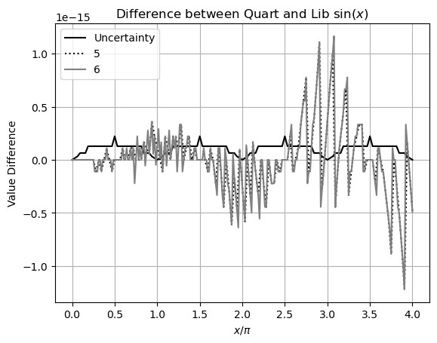
Figure 17: Difference between Library and Quart sin(x) (y-axis) for x = 2πj/2^{L},j = 0,1...2^{L+2} (x-axis), and L = 5,6 (legend). The uncertainty of Quart sin(x) is sin(x) ULP, which shows a periodicity of π.
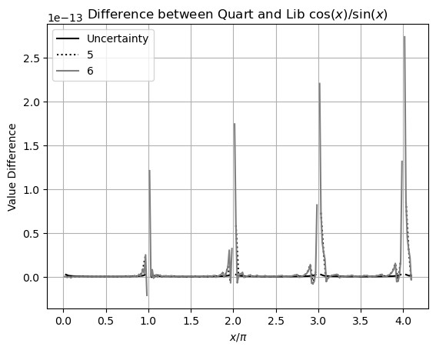
Figure 18: Difference between the Library and the Quart cos(x)/sin(x) (y-axis) for x = 2πj/2^{L},j = 0,1...2^{L+2} (x-axis), and L = 5,6 (legend).

Using Library Sine for Sin/Cos Signals
The error deviations obtained using the Library sine resemble those shown in Figure 11 but with the FFT order as the specific dimension. In addition, the error deviations are larger than 1 when δx < 10¹⁴ instead of when δx < 10¹⁵. When δx = 0, the error deviations for the reverse transformation increase with the FFT order.
When δx = 0, as shown in Figure 17, the Library sine function contains more numerical errors; as a result, the error distribution for the reverse transformation obtained using the Library sine function in Figure 20 is more structured and broader than that in Figure 19 obtained using the Quart sine function; by contrast, the error distributions for the forward transformations are more consistent. This difference is consistent with a larger error deviation 6.2 > 1 for the reverse transformation, compared with the comparable error deviation 1.1 > 1 for the forward transformation, when δx = 0.
Using the Library sine function, for a sine wave with a frequency of 3, Figures 21, 22, and 23 present the value errors for forward, reverse, and round-trip transformations, respectively. In the reverse transformation, the value errors exhibit a clear trend of increasing with the time index. These large value errors appear systematic rather than random and visually resemble a resonant pattern. Similar increases are observed at other frequencies and FFT orders as well as in computational results obtained using mathematical libraries such as SciPy. By contrast, such resonance is absent for the roundtrip transformation shown in Figure 23. Furthermore, such resonant patterns are completely absent in the results obtained using the Quart sine function. Figure 24 demonstrates that the error deviations increase with sine or cosine frequency. Figure 17 indicates that the numerical errors obtained using the Library sine function increase with a periodicity of π, which can resonate with a signal whose periodicity is an integer multiply of π, producing the resonant pattern in Figure 22. At higher frequencies, the resonant beats between the signal and the numerical errors in the Library sine function become stronger. To suppress this numerical error resonance, an input noise level of approximately 10⁻¹⁴ input noise must be added to the sine or cosine signals. Such resonance of numerical errors seems to have not been discussed previously in the literature.

Using Quart Sine for Linear Signal
Figures 25 and 26 show the error deviations for the forward and reverse transformations, respectively. The forward transformation exhibits a broader ideal coverage area than the reverse transformations when δx → 0, which is consistent with the enhanced sensitivity of the reverse transformation to calculation errors. In other areas, both transformations achieve proper coverage with error values of around 1.
When δx = 0, the error distribution of reverse transformation in Figure 27 is narrower than that in Figure 20. The corresponding error deviations are 1.5 < 6.2, respectively.
The error deviations for the round-trip transformation resemble those in Figure 15 but with the FFT order as the specific dimension.

Using Library Sine for Linear Signal
Figure 28 shows the reverse error distribution when δx = 0 is no longer bound. The difference between Figures 28 and 27 is consistent with the large numerical errors, as demonstrated in Figure 18. Variance arithmetic fails because of the large amount of unspecified input uncertainties without added noise.
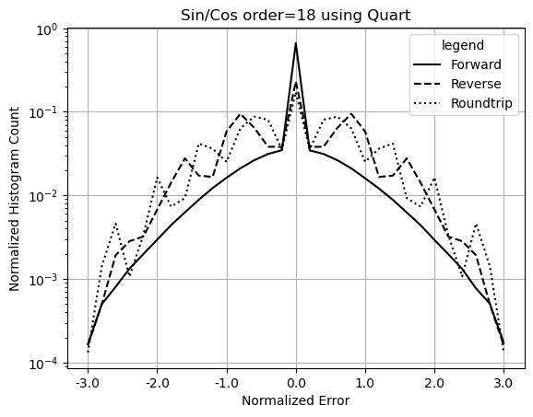
Figure 19: Histograms of normalized errors of Sin/Cos signals for forward, reverse, and roundtrip transformations (legend) using the Quart sine function. The FFT order is 18.
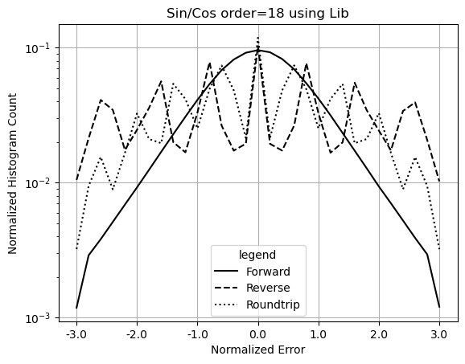
Figure 20: Histograms of normalized errors of Sin/Cos signal for forward, reverse and roundtrip transformations (legend) computed using the Library sine function. The FFT order is 18.
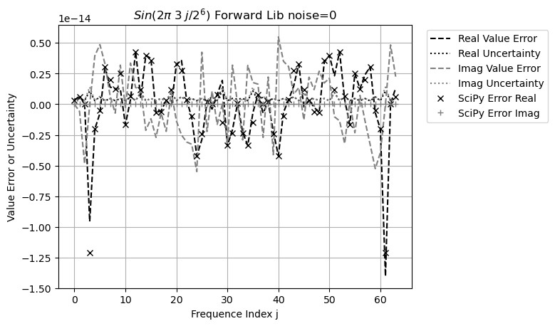
Figure 21: FFT value error spectrum of sin(3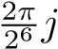) computed using either the Library sine function or SciPy after the forward transformation. The legend distinguishes between uncertainty and value error. The x-axis represents the frequency index, while the y-axis represents both uncertainty and value error.
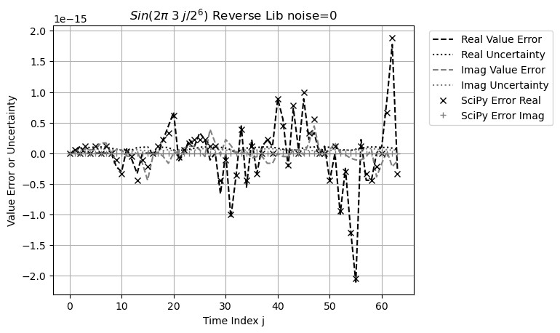
Figure 22: FFT value error waveform of sin(3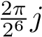) computed using either the Library sine function or SciPy after the reverse transformation. The legend distinguishes between uncertainty and value error. The x-axis represents the time index, while the y-axis represents both uncertainty and value error.
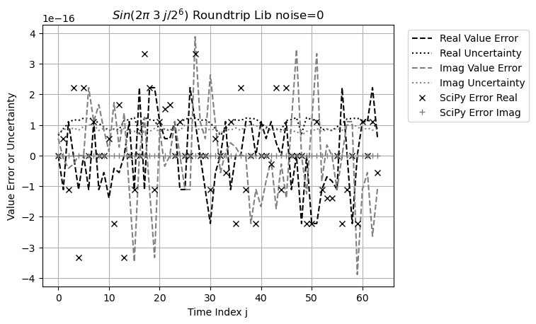
Figure 23: FFT value error waveform of sin(3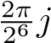) computed using either the Library sine function or SciPy after the roundtrip transformation. The legend distinguishes between uncertainty and value error. The x-axis represents the frequency index, while the y-axis represents both uncertainty and value error.
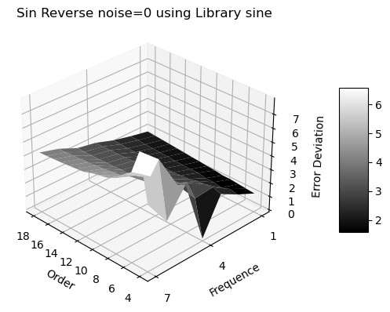
Figure 24: Error deviation (z-axis) of FFT reverse transformation of 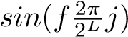 versus frequency f (x-axis) and FFT Order L (y-axis).
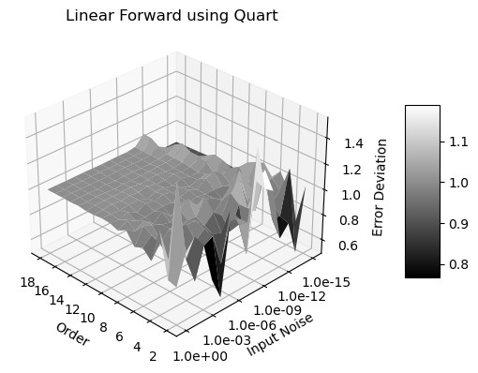
Figure 25: Error deviation (z-axis) versus input uncertainty (x-axis) and FFT order (y-axis) for the forward transformations of Linear signals computed using the Quart sine function.
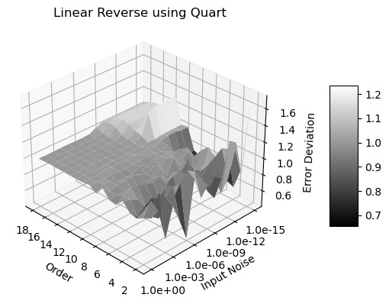
Figure 26: Error deviation (z-axis) versus input uncertainty (x-axis) and FFT order (y-axis) for the reverse transformations of Linear signals computed using the Quart sine function.
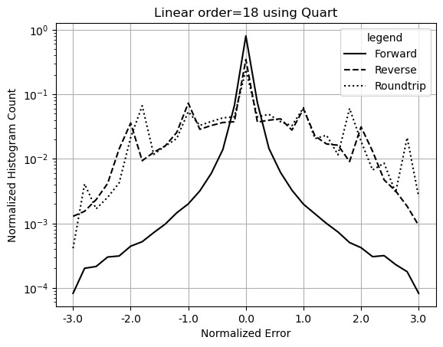
Figure 27: Histograms of normalized errors of Linear signals for forward, reverse and roundtrip transformations (legend) computed using the Quart sine function. The FFT order is 18.
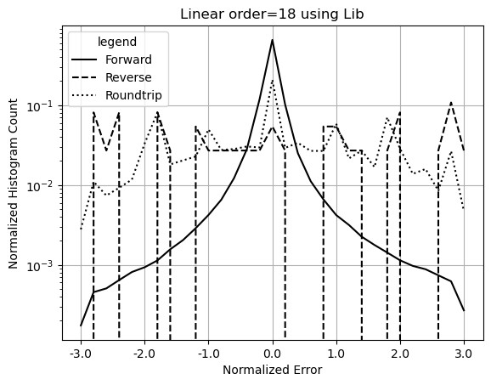
Figure 28: Histograms of normalized errors of Linear signals for forward, reverse and roundtrip transformations (legend) computed using the Library sine function. The FFT order is 18.
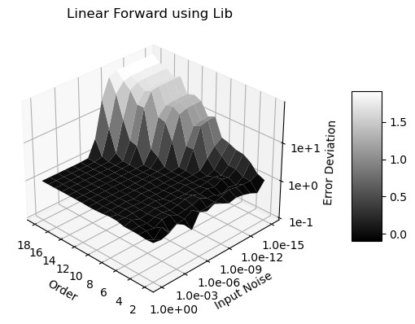
Figure 29: Error deviation (z-axis) versus input uncertainty (x-axis) and FFT order (y-axis) for the forward transformations of Linear signals computed using the Library sine function.
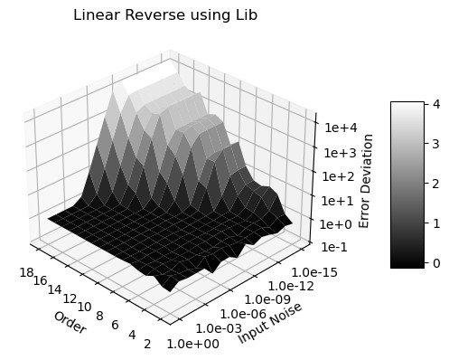
Figure 30: Error deviation (z-axis) versus input uncertainty (x-axis) and FFT order (y-axis) for the reverse transformations of Linear signals computed using the Library sine function.
Figures 29 and 30 show a much smaller ideal coverage areas than those in Figures 25 and 26. Because uncertainties grow more slowly in the reverse transformation than in the forward transformation, the former exhibits a smaller ideal coverage region. Outside of the ideal coverage region, proper coverage cannot be achieved for the reverse transformation. Furthermore, as numerical errors increase with computational load, the range of input noise that produces ideal coverage decreases with increasing FFT order. At sufficiently high FFT orders—visually beyond FFT order 25 for the reverse transformation—ideal coverage may no longer be achievable. Although FFT is widely regarded as one of the most robust numerical algorithms and is generally insensitive to input errors, it can still fail owing to numerical errors in the Library sine function. Such deterioration in calculation accuracy is not easily detectable when using conventional floating-point arithmetic.
Figure 31 shows that, even when variance arithmetic can no longer effectively track the value errors for either the forward or reverse transformation, it can still effectively track the value errors for the round-trip transformation, as shown by the plateau region in the figure. Such error cancellation arises from dependence tracing in statistical Taylor expansion.

Ideal Coverage
Adding noise to the input can suppress unspecified input errors. After adding a Gaussian input noise of δx = 10⁻³ to a Linear signal when using the Library sine function, the error distributions for both forward and reverse transformations become Gaussian whereas the error distribution for the round-trip transformation becomes Delta. Figure 32 illustrates the corresponding error deviations and uncertainty deviations versus FFT order:
- As expected, the resulting uncertainty deviations for forward transformations increase with FFT order L as ${\sqrt{2}}^{L}$.
- As expected, the resulting uncertainty deviations for reverse transformations decrease with FFT order L as 1/${\sqrt{2}}^{L}$.
- As expected, the resulting uncertainty deviations for round-trip transformations remains equal to the corresponding input uncertainties of 10⁻³.
- As expected, the resulting error deviations for forward and reverse transformations remain constant at 1.
- As expected, the resulting error deviations for round-trip transformations are far less than 1 but increase with FFT order L exponentially due to increasing calculation.

Conclusion and Discussion

Summary
When the uncorrelated uncertainty condition [14] was satisfied, statistical Taylor expansion produced exact error deviations, with normalized errors following either a normal or a delta distribution, depending on the context. Statistical Taylor expansion tracked variable dependencies through intermediate steps, rejected invalid computations, and explicitly incorporated sample counts and underlying input uncertainty distributions into the statistical analysis. Although statistical Taylor expansion eliminated the dependency problem, it also reduced execution flexibility.

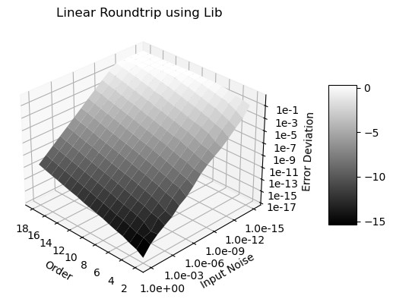
Figure 31: Error deviation (z-axis) versus input uncertainty (x-axis) and FFT order (y-axis) for the roundtrip transformations of Linear signals computed using the Library sine function.
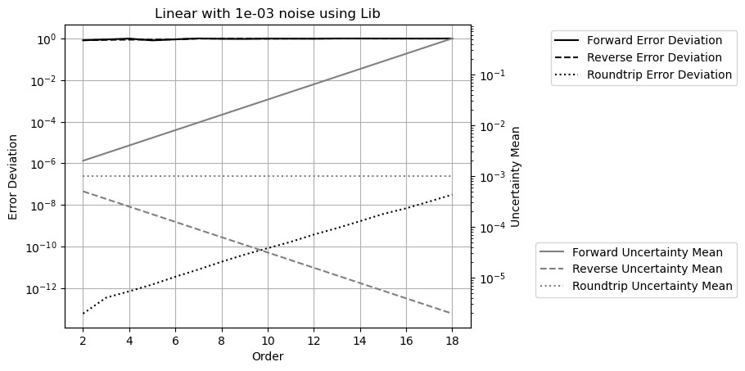
Figure 32: Result error deviation (left y-axis) and uncertainty deviation (right y-axis) of Linear signals versus FFT order (x-axis) and transformation types (legend) computed using the Library sine function.

The presence of ideal coverage is a necessary condition for a numerical algorithm based on statistical Taylor expansion to be considered correct. Ideal coverage defines the optimal range of applicability for an algorithm.
Variance arithmetic simplifies statistical Taylor expansion by introducing numerical rules that eliminate invalid results, such as divergent, unstable, negative, infinite, or otherwise unreliable outcomes. It also provides appropriate coverage for floating-point rounding errors. The applicability of variance arithmetic was demonstrated across a wide range of computational scenarios.
The code and analysis framework for variance arithmetic are available as an open-source project at https://github.com/Chengpu0707/VarianceArithmetic. A more detailed description of this study is available at https://arxiv.org/abs/2410.01223.

Improvements Needed
This paper presents statistical Taylor expansion and variance arithmetic, which are still in early stages of development. Accordingly, several important questions remain.
Library mathematical functions should be recalculated using variance arithmetic to ensure that each output value is accompanied by its corresponding uncertainty. Without this refinement, the value errors in the library functions can produce unpredictable and potentially significant effects on numerical results.
Bound momentum ζ(2n) needs to be extended to all probability distributions. The statistical bounding used to find the bounding range κ for a sample count needs to be extended to discrete distributions. The choice of the ideal bounding range ˆκ needs to be extended to other distributions. The ideal ratio appears to be the likelihood that the result is within the bounding range defined by the ideal bounding range ˆκ, but such connection needs to be deduced statistically.
The performance of variance arithmetic must be improved for broader practical adoption. The fundamental formulas of statistical Taylor expansion, Formulas (2.5), (2.6), (2.8), and (2.9), contain many independent summations, making them excellent candidates for parallel processing. Moreover, the inherently procedural nature of these formulas allows statistical Taylor expansion to be implemented efficiently at the hardware level.
In variance arithmetic, deviations are comparable to values but variances are used in calculation. This effectively limits the range of deviations to the square root of that of the values. If the sign bit of the floating type can be re-purposed as an exponent bit as an unsigned floating-point type for deviation, the range of the deviation will be identical to that of the values.
When an analytic expression undergoes statistical Taylor expansion, the resulting expression can become highly complex, as in the case of matrix inversion. Modern symbolic computation tools such as SymPy and Mathematica can significantly facilitate such calculations. This observation suggests that it may be time to shift from purely numerical programming toward analytic programming, particularly for problems that possess inherently analytic formulations.
As an enhancement to dependency tracing, source tracing identifies each input’s contribution to the overall result uncertainty. This capability enables engineers to pinpoint the primary sources of measurement inaccuracy, allowing them to guide targeted improvements in data acquisition and processing strategies. For example, Formula (2.29) can provide guidance on improving the ideal ratio of x ± y.
A key open question is whether variance arithmetic can be adapted to achieve ideal coverage for floating-point rounding errors. Developing variance arithmetic with ideal coverage for floating-point rounding errors would be quite valuable because many theoretical calculations lack explicit input uncertainties.
Because conventional numerical approaches are based on floating-point arithmetic, they must be reexamined or even reinvented within the framework of variance arithmetic. For instance, most conventional numerical algorithms aim to identify optimal computational paths, whereas variance arithmetic conceptually rejects all path-dependent calculations. Reconciling these two paradigms may present a significant and ongoing challenge.
Establishing theoretical foundation for applying statistical Taylor expansion in the absence of a closed-form analytic solution or when only limited low-order numerical derivatives are available, as occurs when solving differential equations, remains an important direction for future research.

Possible Connections to Quantum Physics
For input distribution without bounding, Formula (2.6) may not converge, for example, when the input uncertainty is Laplace [4] so that ζ(2n) = (2n)!. It is necessary that the input uncertainty is bounded because of sampling, which resembles the need for renormalization in quantum field theory. Furthermore, the dependence of convergence on the choice of ideal bounding range ˆκ suggests the principle quantum physics: what it is depends on how it is measured. Both resemblances are worth further investigation.

Statements and Declarations

Acknowledgments
As an independent researcher without institutional affiliation, the author expresses sincere gratitude to Dr. Zhong Zhong (Brookhaven National Laboratory) and Prof. Weigang Qiu (Hunter College) for their encouragement and valuable discussions. Special thanks are extended to the organizers of AMCS 2005, particularly Prof. Hamid R. Arabnia (University of Georgia), and to the organizers of the NKS Mathematica Forum 2007. The author also gratefully acknowledges Prof. Dongfeng Wu (University of Louisville) for her insightful guidance on statistical topics. Finally, heartfelt appreciation is extended to the editors and reviewers of Reliable Computing for their substantial assistance in shaping and accepting an earlier version of this work, with special recognition given to Managing Editor Prof. Rolph Baker Kearfott.

Data Availability Statement
The data set used in this study are all generated in the open-source project at https
://github.com/Chengpu0707/VarianceArithmetic. The execution assistance and explanation of the above code are available from the author upon request.

Competing Interests
The author has no competing interests to declare that are relevant to the content of this article.
10.4 Founding
No funding was received from any organization or agency in support of this research.

References
- Sylvain Ehrenfeld and Sebastian B. Littauer. Introduction to Statistical Methods. McGraw-Hill, 1965.
- John R. Taylor. Introduction to Error Analysis: The Study of Output Precisions in Physical Measurements. University Science Books, 1997.
- Fredrik Gustafsson and Gustaf Hendeby. Some relations between extended and unscented kalman filters. IEEE Transactions on Signal Processing, 60-2:545–555, 2012.
- Michael J. Evans and Jeffrey S. Rosenthal. Probability and Statistics: The Science of Uncertainty. W. H. Freeman, 2003.
- William H. Press, Saul A Teukolsky, William T. Vetterling, and Brian P. Flannery. Numerical Recipes in C. Cambridge University Press, 1992.
- John P Hayes. Computer Architecture. McGraw-Hill, 1988.
- David Goldberg. What every computer scientist should know about floating-point arithmetic. ACM Computing Surveys, March 1991.
- Institute of Electrical and Electronics Engineers. ANSI/IEEE 754-2008 Standard for Binary Floating-Point Arithmetic, 2008.
- R.E. Moore. Interval Analysis. Prentice Hall, 1966.
- W. Kramer. A prior worst case error bounds for floating-point computations. IEEE Trans. Computers, 47:750–756, 1998.
- G. Alefeld and G. Mayer. Interval analysis: Theory and applications. Journal of Computational and Applied Mathematics, 121:421–464, 2000.
- W. Kramer. Generalized intervals and the dependency problem. Proceedings in Applied Mathematics and Mechanics, 6:685–686, 2006.
- A. Neumaier S.M. Rump S.P. Shary B. Kearfott, M. T. Nakao and P. Van Hentenryck. Standardized notation in interval analysis. Computational Technologies, 15:7–13, 2010.
- C. P. Wang. A new uncertainty-bearing floating-point arithmetic. Reliable Computing, 16:308–361, 2012.
- Oliver Aberth. Precise Numerical Methods Using C++. Academic Press, 1998.
- Nicholas J. Higham. Accuracy and Stability of Numerical Algorithms. SIAM, 2002.
- J. Vignes. A stochastic arithmetic for reliable scientific computation. Mathematics and Computers in Simulation, 35:233–261, 1993.
- C. Denis N. S. Scott, F. Jezequel and J. M. Chesneaux. Numerical ’health’ check for scientific codes: the cadna approach. Computer Physics Communications, 176(8):501–527, 2007.
- J. Hefferon. Linear algebra. http://joshua.smcvt.edu/linearalgebra/, 2011.

