Homework 2

Name：刘承奇 Student ID：2018533249

1. Fault Tree Analysis on the faulty design

Construct a fault tree：

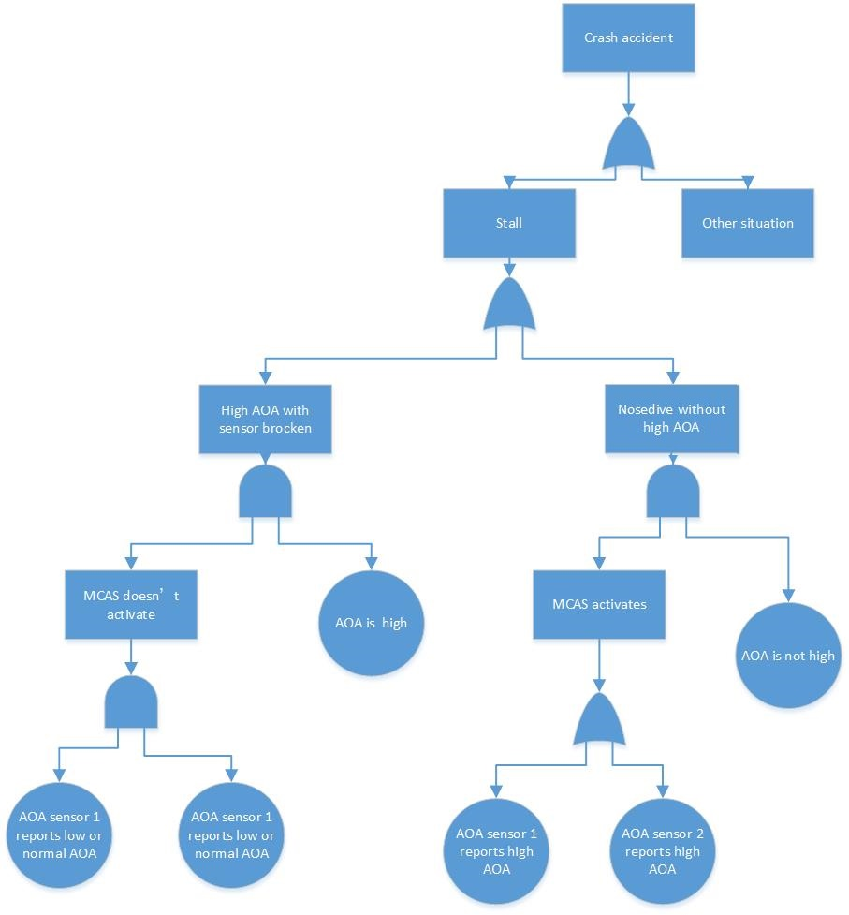

Calculate:

Let the event  be “AOA is high”,  be “AOA is not high”,  be “Sensor 1 reports high AOA”,  be “Sensor 1 reports low or normal AOA”,  be “Sensor 2 reports high AOA”,  be “Sensor 2 reports low or normal AOA”.

So, .

Let this event “MCAS mis-activation when the actual AOA is normal” be .



1. A More Aggressive Design

Construct a fault tree：

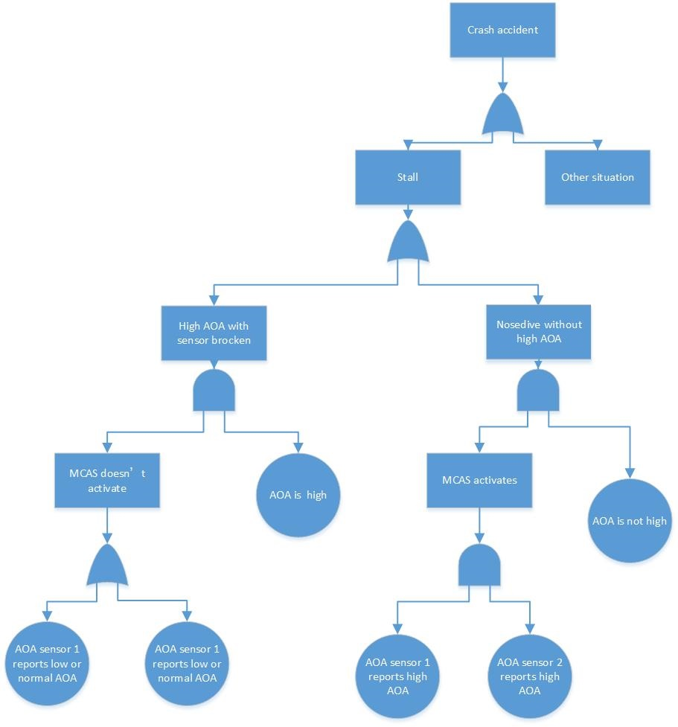

Calculate:

Let the event in new design be .



So, ,the probability for MCAS mis-activation has been reduced.

1. Balancing False-Positives and False-Negatives

Let the event “the MCAS fails to activate when needed” be , it in new design be .

1. The faulty design



1. The new aggressive design



, so in the new aggressive design, the risk of “the MCAS fails to activate when needed” has increased significantly.

1. Adding Another AOA Sensor

Construct a fault tree：

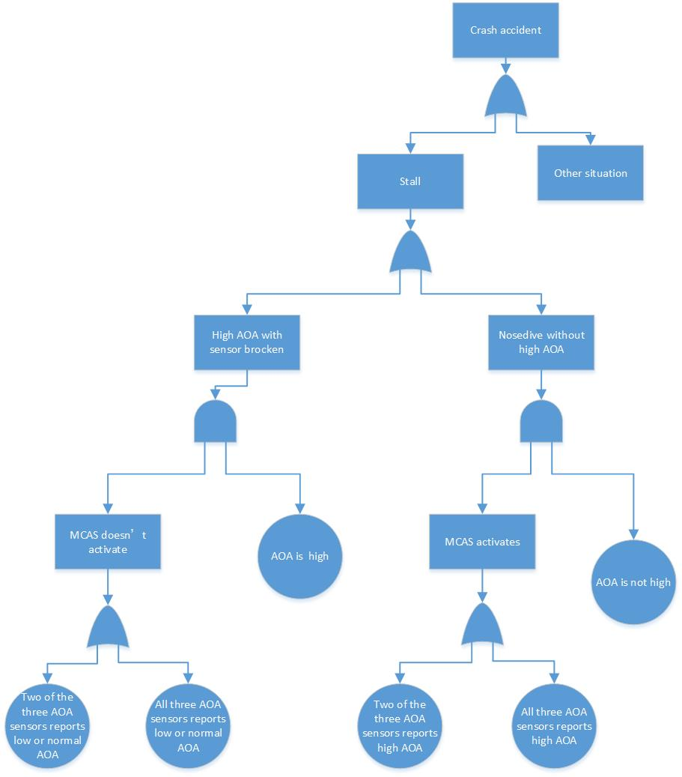

Let the event  be “Sensor 3 reports high AOA”,  be “Sensor 3 reports low or normal AOA”. So, .

Calculate:

“MCAS mis-activation when the actual AOA is normal”:

Let this event be .



“MCAS fails to activate when needed”

Let this event be .



Discuss whether this is an overall better design:

We need to calculate the probability that the plane crash because of stall. Let this be the event , ,  in the three designs (the fault design, new aggressive design and another AOA sensor design).



Because , we can derive that



, plot them:

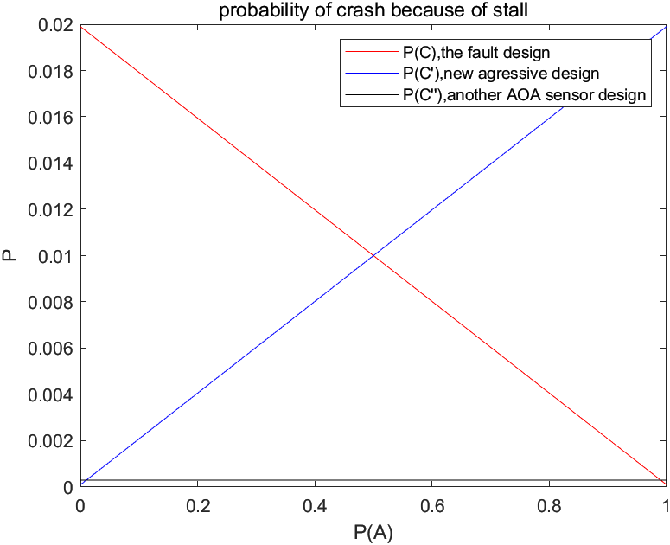

So, in most cases it is an overall better design . In detail, we should choose

 where  is the probability of “AOA is high”.

In actual situation, it should also be balanced with the cost. (Adding a sensor increases the cost.)

Fill the table:

