Homework 4

Name：刘承奇 Student ID：2018533249

1, a

Number all the statements:

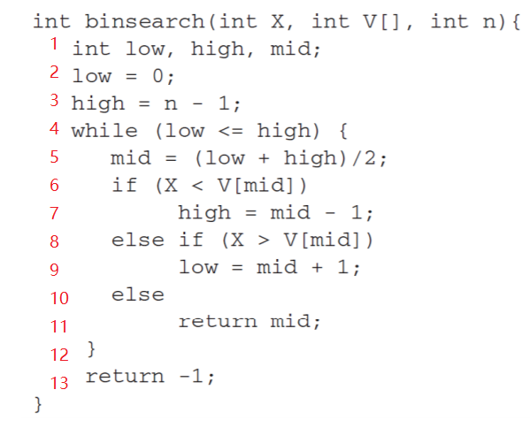

Draw the Control Flow diagram:

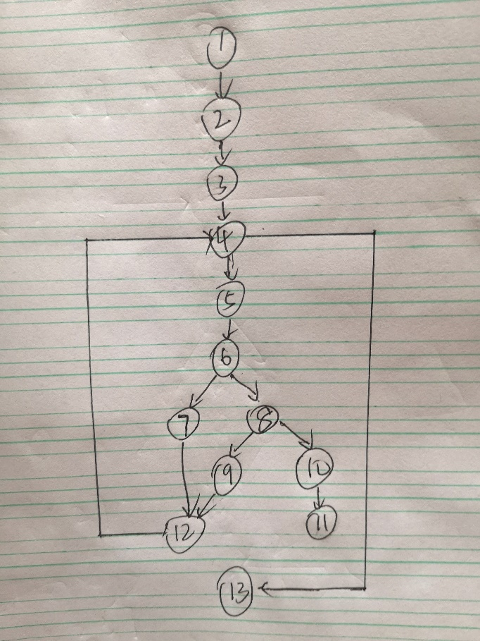

1, b

The set of linearly independent paths:

1: 1-2-3-4-13

2: 1-2-3-4-5-6-7-12-4-13

3: 1-2-3-4-5-6-8-9-12-4-13

4: 1-2-3-4-5-6-8-10-11

1, c

1: 1-2-3-4-13

Input:

X=2, V= [1 2 3], n=0

Output:

-1

2: 1-2-3-4-5-6-7-12-4-13

Input:

X=0, V= [1 2], n=2

Output:

-1

3: 1-2-3-4-5-6-8-9-12-4-13

Input:

X=2, V= [1], n=1

Output:

-1

4: 1-2-3-4-5-6-8-10-11

Input:

X=2, V= [1 2 3], n=3

Output:

1

2, a

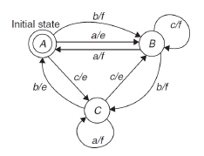

State Table:

|  |  |  |  |
| --- | --- | --- | --- |
|  | a | b | c |
| A | B/e | B/f | C/e |
| B | A/f | C/f | B/f |
| C | C/f | A/e | B/e |

2 b,

0-switch test cases:

|  |  |  |  |  |  |  |  |  |  |
| --- | --- | --- | --- | --- | --- | --- | --- | --- | --- |
| Test case | 1 | 2 | 3 | 4 | 5 | 6 | 7 | 8 | 9 |
| Start State | A | A | A | B | B | B | C | C | C |
| Input | a | b | c | a | b | c | a | b | c |
| Expected Output | e | f | e | f | f | f | f | e | e |
| Finish State | B | B | C | A | C | B | C | A | B |
| Test Coverage Item | 1 | 2 | 3 | 4 | 5 | 6 | 7 | 8 | 9 |