

UNDERGRADUATE PROJECT REPORT

|  |  |
| --- | --- |
| **Project Title:** | **Interactive Storytelling App for Language Learning** |
| **Surname:** | **Xiao** |
| **First Name:** | **Yanliang** |
| **Student Number:** | **202118020109** |
| **Supervisor Name:** | **Dr. Yasir Mustafa** |
| **Module Code:** | **CHC 6096** |
| **Module Name:** | **Project** |
| **Date Submitted:** | **May 6, 2024** |

# **Declaration**

Here, students would sign a statement indicating that they adhered to appropriate academic conduct in carrying out their final project.

# **Acknowledgment**

This article not only reflects my years of study and research achievements, but also

embodies the support and help of my teachers, classmates, friends, and family. Here, I

express my sincere gratitude to them.

My supervisor Dr. Yasir Mustafa provided comprehensive and meticulous guidance

for the completion of my thesis, from topic selection, outline drafting, research work

development to the completion of the thesis. He devoted a lot of effort to my work, despite

being busy with other tasks. He often took time to guide and support me through phone

calls, emails, and other means. He helped me solve problems and overcome difficulties

in my research, which saved me a lot of time and effort in my daily work and study.

# **Table of Contents**

**Declaration** i

**Acknowledgment** ii

**Table of Contents** iii

**Abstract** iv

**Abbreviations** v

**Glossary** vi

**Chapter 1 Introduction** 1

**1.1****Background** 1

**1.2****Aim** 1

**1.3****Objectives** 1

**1.4****Project Overview** 1

**1.4.1****Scope** 1

**1.4.2****Audience** 1

**Chapter 2 Background Review** 2

**Chapter 3 Methodology** 3

**3.1****Approach** 3

**3.2****Technology** 3

**3.3****Project Version Management** 3

**Chapter 4 Results** 4

**Chapter 5 Professional Issues** 5

**5.1****Project Management** 5

**5.1.1****Activities** 5

**5.1.2****Schedule** 5

**5.1.3****Project Data Management** 5

**5.1.4****Project Deliverables** 5

**5.2****Risk Analysis** 5

**5.3****Professional Issues** 5

**Chapter 6 Conclusion** 6

**References** 7

**6.1****Formatting Requirements** 7

**6.2****Written Presentation** 7

**Appendices** 8

# **Abstract**

As network technology continues to advance, ordinary people from different countries can freely cross borders or communicate online about culture. However, in this process, they often encounter various issues due to language barriers. This project aims to develop a software that helps people more easily tackle these problems. The software is designed to assist those with weaker abilities in foreign language expression, making it easier for them to learn a new language. In addition to the application used by users, the project also provides a management platform. For the application, users can first choose to practice some simple everyday phrases through interactive exercises. Next, users can practice their pronunciation by reading simple sentences aloud, with the system providing corresponding feedback to help improve their skills. Furthermore, the software offers a word search function that includes not only the definition of words but also phonetic symbols and classic examples, which can be used to understand and familiarize users with unfamiliar words. For the background management system, it is mainly to manage the information of users, words and the content of examples.The project employs a combination of software development methodologies and technologies to ensure a smooth and effective learning experience for users. The development process involves iterative testing and feedback loops to refine the user interface and functionality.The technology stack includes a mix of programming languages and frameworks to ensure compatibility across different devices and platforms.The results of the project demonstrate the potential of the software to significantly improve language learning outcomes for individuals with limited language proficiency.

***Keywords: Language learning, Foreign language, Interactive learning, Software development, Web Development***

**Abbreviations：**

This is an explanation of the relevant abbreviations in this article.

Table 1 Abbreviations Explanation

|  |  |
| --- | --- |
| **Abbreviations** | **Definition** |
| **CPU** | Central Processing Unit |
| **IoT** | Internet of Things |
| **AI** | Artificial Intelligence |
| **HTML** | HyperText Markup Language |
| **CSS** | Cascading Style Sheets |
| **SQL** | Structured Query Language |
| **API** | Application Programming Interface |
| **CSV** | Comma-Separated Values |
| **HTTP** | HyperText Transfer Protocol |
| **URL** | Uniform Resource Locator |
| **JSON** | JavaScript Object Notation |
| **HTTPs** | HyperText Transfer Protocol Secure |
| **XML** | eXtensible Markup Language |

# **Glossary**

This section should have the definition of all the keywords you stated in the “Abstract” section. You can also define other relevant keywords. Particularly, if your final project report includes rare, unfamiliar, specialized, or made-up words or terms, the glossary serves as a dictionary for the reader to reference throughout their reading of the project report. (Note: this section should only contain definitions for specific terms in the project report. It does NOT function as an ordinary dictionary. Hence, common words related to the Computer Science and Software Engineering disciplines should NOT be included in this list.)

# **Introduction**

This section mainly introduces the project background, overall objectives, specific objectives and project overview.

## **Background**

In today's world where globalization is accelerating, the ability to communicate across languages has become a key skill for people from different backgrounds. With the rapid development of technology and the widespread use of the internet, people from different countries and cultural backgrounds can interact more easily than ever before. However, this increasing connectivity also brings significant challenges, particularly in terms of language barriers. In traditional English as a foreign language oral courses, students do not have enough time or opportunities to practice. Moreover, they lack the cultural and communicative context to improve their speaking skills. Additionally, many students, especially those from Asian countries, have low self-efficacy regarding their spoken English abilities and try to avoid any activities that require public speaking[1]. In addition, in terms of efficiency, the fast pace of modern society largely diverts learners' time, creating many obstacles for lifelong learning; regarding content, the era of "one-time and done" learning has ended, and learners can no longer acquire lifelong knowledge through concentrated study over a period of time; concerning form, the single offline teaching method also makes learners feel bored, reducing learning efficiency[2].The popularity of mobile devices makes people more inclined to use mobile phones or tablets for learning, so there is a huge market potential for English learning applications based on mobile devices. Compared with traditional education, mobile education has the characteristics of "mobile", "distributed", "intermittent" and "distributed"[3] .

## **Aim**

This project aims to develop an interactive English learning application to help beginners learn and master some everyday conversational phrases and pronunciation. According to the corresponding functions, users can practice sentence interaction. They can also choose to follow along for pronunciation practice, with the system providing corresponding scores to help improve their skills. Additionally, users can search for unfamiliar words, view definitions and examples to reinforce their understanding.

## **Objectives**

The project will be completed in four stages. The contents of each stage are as follows:

* Complete the background investigation of the existing Language learning software.
* Complete the detailed design and codes of modules.
* Choose the appropriate programming language (such as Java or Kotlin) for Android development
* Get the story content suitable for different English levels and collect it into the software
* Test software feasibility and maintenance

## **Project Overview**

### **Scope**

The Android-based English learning software automatically generates suitable story content according to the user's English level and learning objectives. When the user reads the story, the software will use a microphone to record the user's pronunciation. With advanced speech recognition technology, the software can analyze the user's pronunciation accuracy in real time and provide instant feedback. After the user finishes reading the entire story, the software will analyze their overall pronunciation. This will include an analysis of the pronunciation of individual phonemes, words, and sentences. The software also generates a detailed report summarizing the user's pronunciation problems and providing suggestions for improvement. Users can also download stories and read and practice without an Internet connection

### **Audience**

The software is suitable for beginners, especially children, through simple stories and interactive exercises to build English foundation step by step. It is also suitable for travelers who plan to travel abroad or are already abroad, and they need to quickly improve their daily oral English skills. Provide practical dialogue exercises and a simulation of common scenarios.

# **Background Review**

* **2.1** **Comparison and summary of existing products**

Many popular language learning programs are used for powerful features and a large user base, each using its own functionality to attract users without developing all possible features. They function more efficiently and more mature over time. They have their own strengths and weaknesses, and personally developed systems cannot be compared, but different development concepts can be summarized from other systems in functional and front-end design. The comparison table of the five systems is as follows:

Table 2 Comparison and Analysis

|  |  |  |  |  |  |
| --- | --- | --- | --- | --- | --- |
|  | K. Villalba et al. [4] | Farkhan et al. [5] | Y. Getman *et al.*[6] | C. Tejedor-García et al.[7] | B. B. N. Prasad[8] |
| Easy to operate | √ | √ | √ | √ | √ |
| pronunciation practice | N/A | N/A | √ | √ | N/A |
| The convenience of the page design | √ | √ | √ | √ | √ |
| Practice of everyday language | √ | N/A | √ | √ | √ |
| The fun of the process | √ | √ | √ | √ | √ |

These five papers introduce different language learning software, each with its unique target users and functional features:. Farkhan et al. [5] primarily aimed at college students for academic writing, providing rich vocabulary and grammar guidance; although user-friendly and resource-rich, it does not involve daily language practice. Y. Getman et al.[6] and C. Tejedor-Garcia et al.[7] both focus on pronunciation exercises for children or L2 learners, where AI-assisted applications use advanced speech recognition technology to provide instant feedback, while COP games enhance user engagement through gamified design and competitive mechanisms, but both require online connectivity and have higher device requirements. B. B. N. Prasad[8] is suitable for daily learning and communication, supporting multiple devices through real-time translation, though the translation quality may be limited, it is highly practical. K. Villalba et al. [4] is specifically designed for visually impaired students, offering an accessible English learning experience, with task-based learning and collaboration features that help improve learning outcomes, but the functions are relatively simple. In summary, these software programs each have their strengths, and users can choose appropriate tools based on their needs and scenarios to enhance their language skills.

* **2.2**

# **Methodology**

## **Approach**

**3.1.1 Software Development Process**

The project chose to use the waterfall model to complete the system design and

development. The waterfall model divides the software development stage into 6 stages.

At the end of each stage, there will be fixed documents or source programs flowing into

the next stage, providing checkpoints divided by stages for the project, improving the

quality and efficiency of the project development. A diagram of the development model

structure is shown in Figure 1.

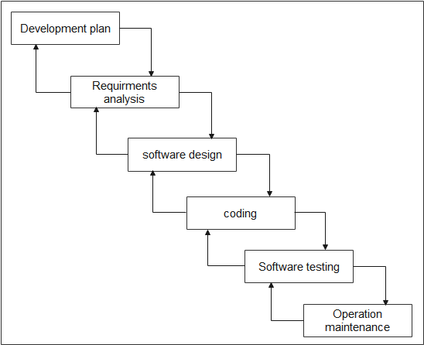

Figure 1. Software Development - Waterfall Model

**3.1.2 Requirement Gathering Methods**

为了确保开发的互动式语言学习应用能够满足目标用户的需求，我们采用了多种需求收集方法，主要包括以下几种：

* User research

We designed and distributed an online questionnaire targeting beginners, children, travelers, and English learning enthusiasts. The content covered users' expectations for language learning apps, usage habits, challenges encountered, and evaluations of existing applications. By collecting and analyzing this feedback, we gained a better understanding of specific user needs, such as what types of interactive exercises, story content, and pronunciation feedback features they hope to see in the app.

* User interviews

In addition to the questionnaire survey, we conducted a series of user interviews. These interviews primarily targeted specific user groups, such as children and their parents, English teachers, and adults with overseas travel or study experiences. During the interviews, we gained deep insights into the specific issues users encounter in language learning and their views on interactive learning tools. For example, we found that many parents hope for an app that can help their children learn English independently at home, while travelers are more concerned about whether the app can provide practical daily conversation practice.

* Market analysis

We conducted a comprehensive analysis of the existing language learning app market, examining the features of competitors' products, user reviews, and market performance. By analyzing this data, we identified the strengths and weaknesses of current products, providing valuable insights for our application design. For example, we found that while there are many excellent language learning apps on the market, most still have room for improvement in terms of interactivity and entertainment value, especially among children.

* Expert Advisory Group on Education

To ensure the educational value of the app, we consulted several language education experts and child education specialists. These experts provided valuable advice, helping us design learning paths and content that align with language learning theories and suit users of different age groups. For example, they suggested incorporating more task-based learning activities into the app to enhance users' practical language skills.

* User feedback analysis

We also collect and analyze user feedback on existing language learning apps. By studying reviews from app stores, social media, and online forums, we can identify the most pressing concerns and needs of users. This feedback helps us pinpoint core features of the app, such as pronunciation correction, interactive exercises, and personalized learning paths.

**3.1.3 Function analysis**

Table 3 User Function

|  |  |  |  |
| --- | --- | --- | --- |
|  | **functional description** | **user demand** | **Implementation** |
| User registration and login | Users can register and log in using their phone number, email or social media account. | Convenient and fast registration and login methods, support a variety of login options. | Provide a variety of login interfaces, such as Google, Facebook login, and local account registration. |
| Personalized learning paths | Personalized learning paths are automatically generated according to users' English proficiency and learning objectives. | Customize learning content according to individual level and needs to improve learning efficiency. | The user level is determined through user testing and questionnaire survey, and the learning path is generated by combining the algorithm. |
| Interactive story practice | Provides interactive story exercises where users can practice their language skills by reading and reading stories. | Improve language skills through interesting stories and interactive exercises. | Design stories of different difficulty levels and provide instant feedback with speech recognition technology. |
| Vocal practice and feedback | Users can read sentences or words, and the system provides pronunciation accuracy scores and suggestions for improvement. | Get instant pronunciation feedback to help improve your speaking skills. | Integrates speech recognition and analysis technology to evaluate the user&#039;s pronunciation in real time. |
| Word learning and search | Users can search for words, view definitions, phonetic symbols and examples to help understand and remember new words. | It is convenient to find and learn new words and enhance vocabulary. | Provides a powerful vocabulary database with search and memory capabilities. |

## **Technology**

State the implementation tools & resources, such as hardware and software.

Table4 Technology Show

|  |  |  |
| --- | --- | --- |
| **Type** | **Work** | **Name** |
| Hardware | CPU | 11th Gen Intel(R) Core(TM) i7-11800H @ 2.30GHZ |
| GPU | Intel(R) UHD Graphics  NVIDIA GeForce RTX 3060 Laptop GPU |
| RAM | 16.0 GB |
| ROM | 512 GB |
| Software | Operating System | Windows 11 |
| Front-end | XML |
| Back-end | Koltlin |
| Database | SharedPreferences |
| Code Tool | Android Studio |
| Visualization | Draw.io |
| Management Tool | Gitee |

## **Project Version Management**

Use Gitee for project source code management. Create multiple sub-files under the

project source code file to manage the code.

During the project preparation phase, create a code file naming convention, naming

according to functions + version number (naming should reflect the functions of the

code), with words separated by underscores to achieve a clear version control effect. In

the project development phase, to ensure the security and validity of the source code,

after each development cycle, the code files are uploaded and updated to Gitee for

project version control and cloud backup to improve development efficiency. In the

project maintenance phase, after modifying the code, update the file to the

corresponding location in Gitee according to the version number promptly and write the

modified content completely in the extended information section.

URL of full project source：

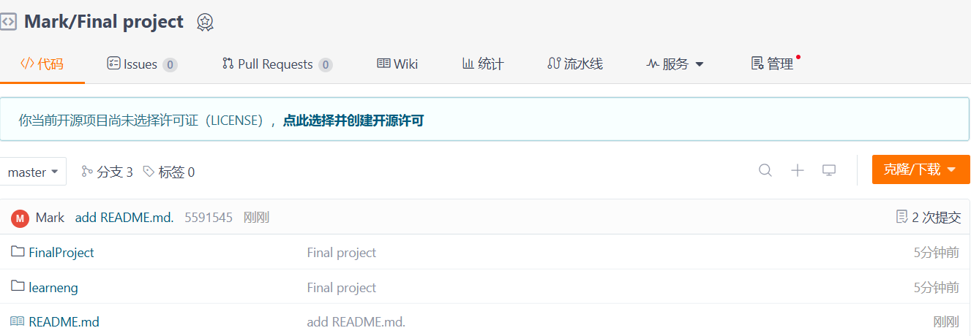

# **Implementation and Results**

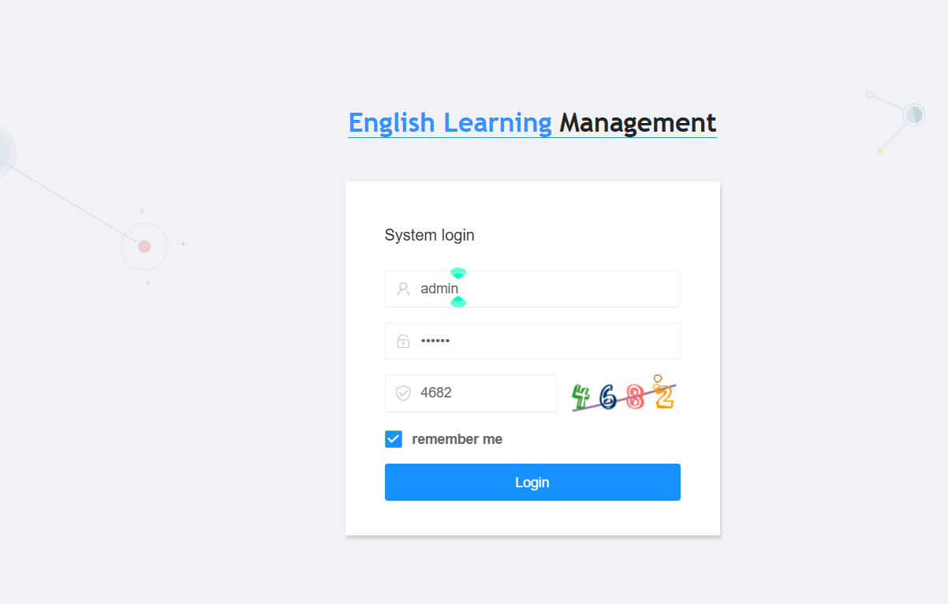

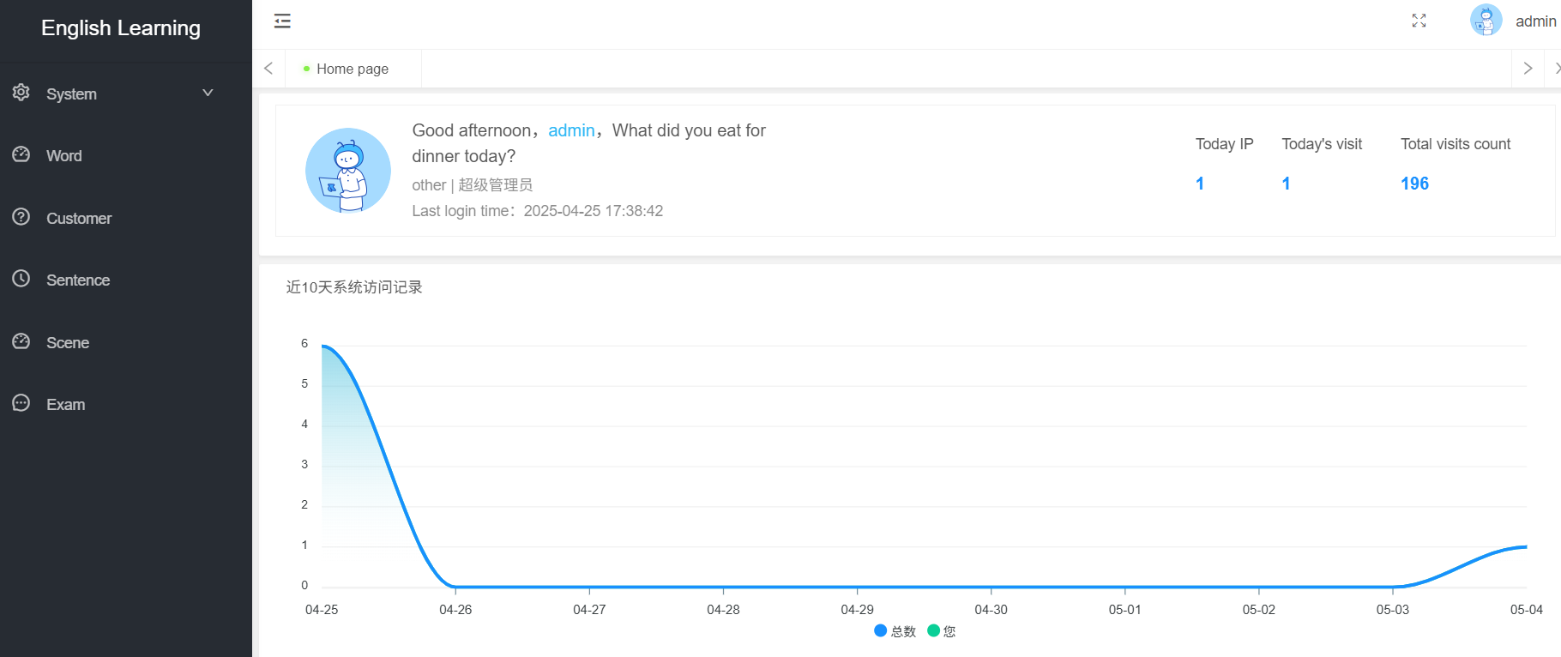

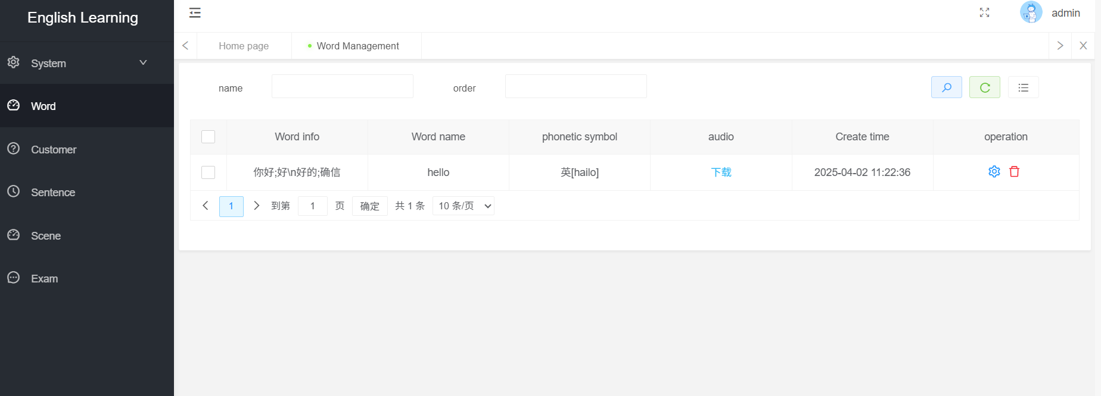

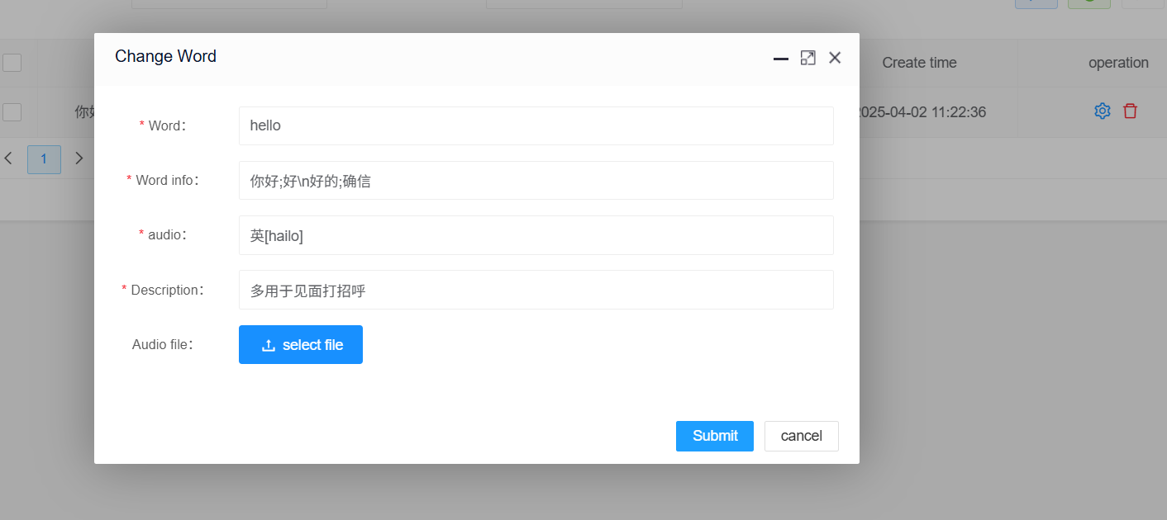

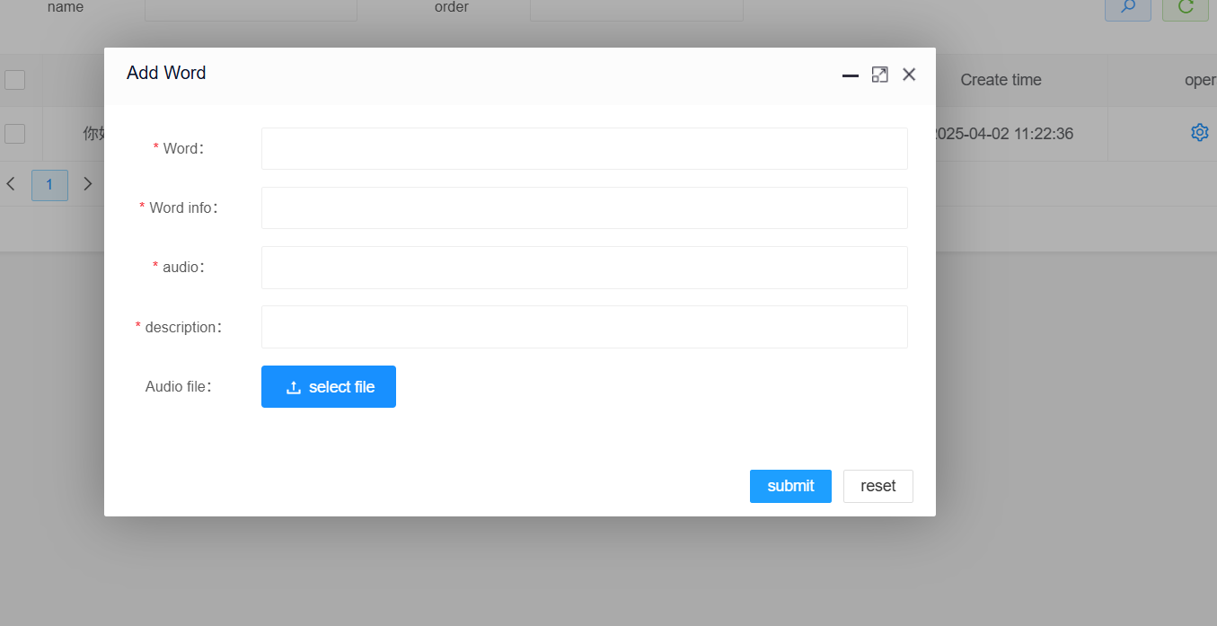

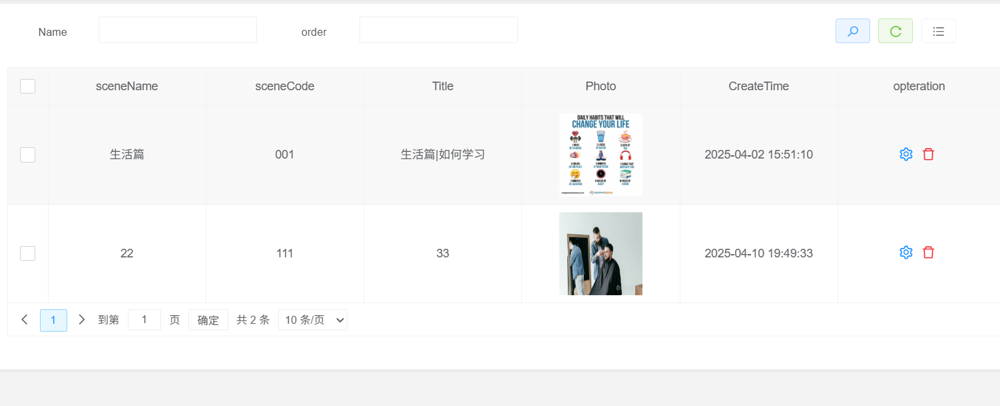

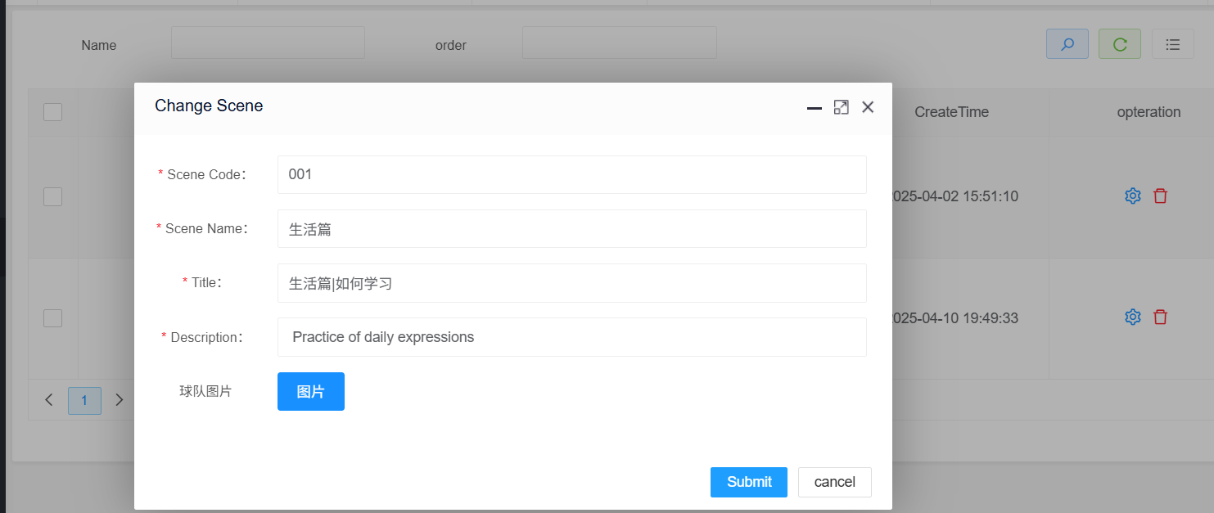

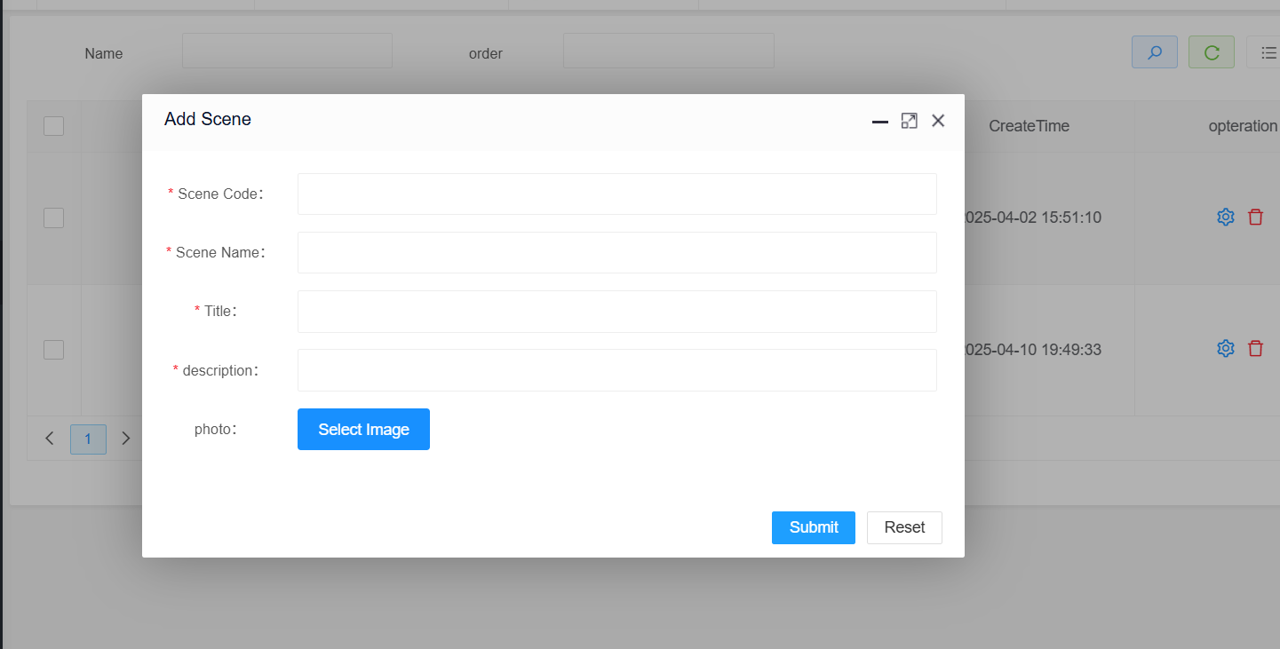

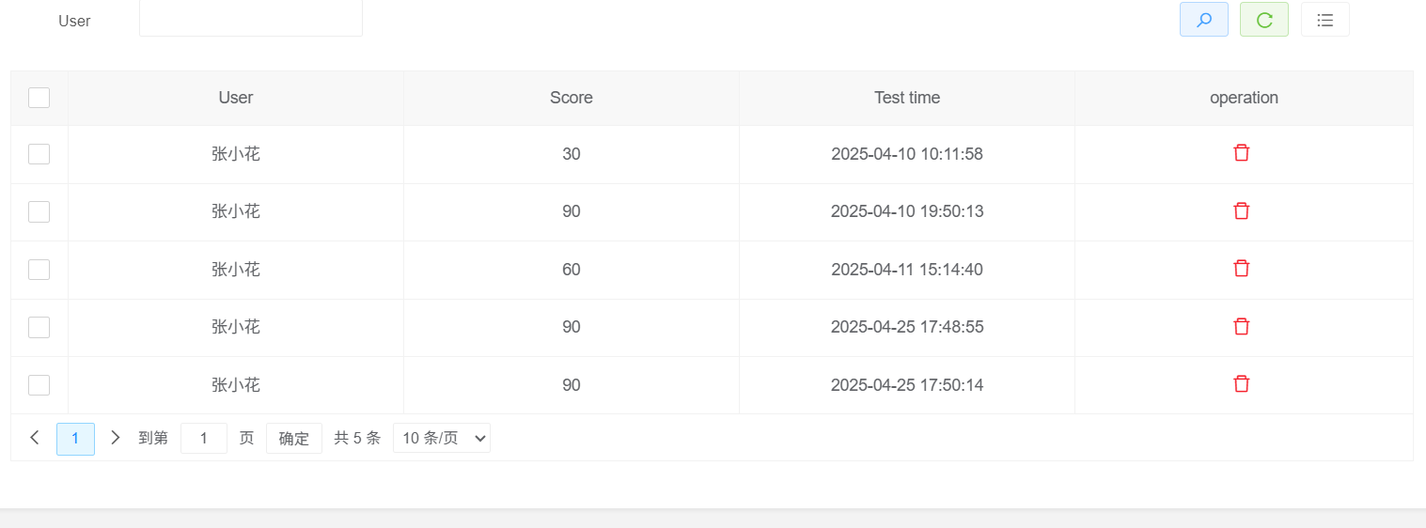

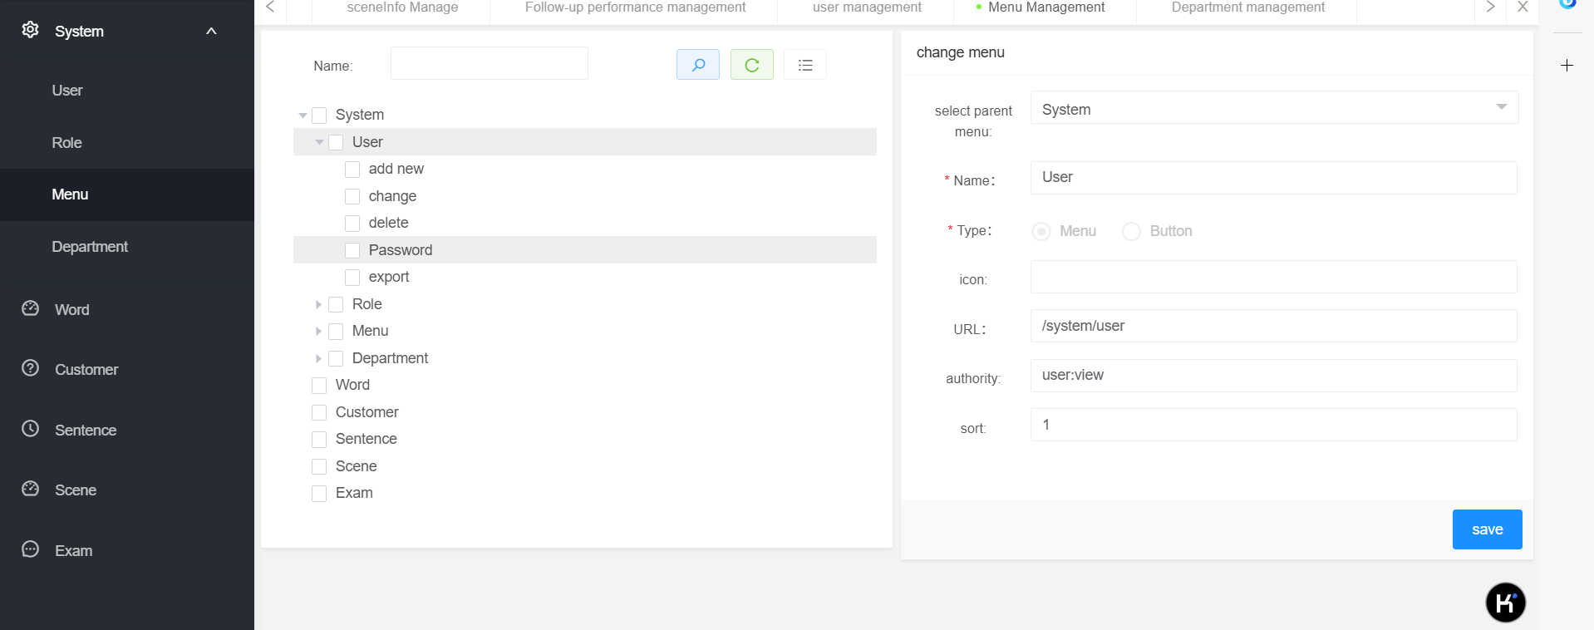

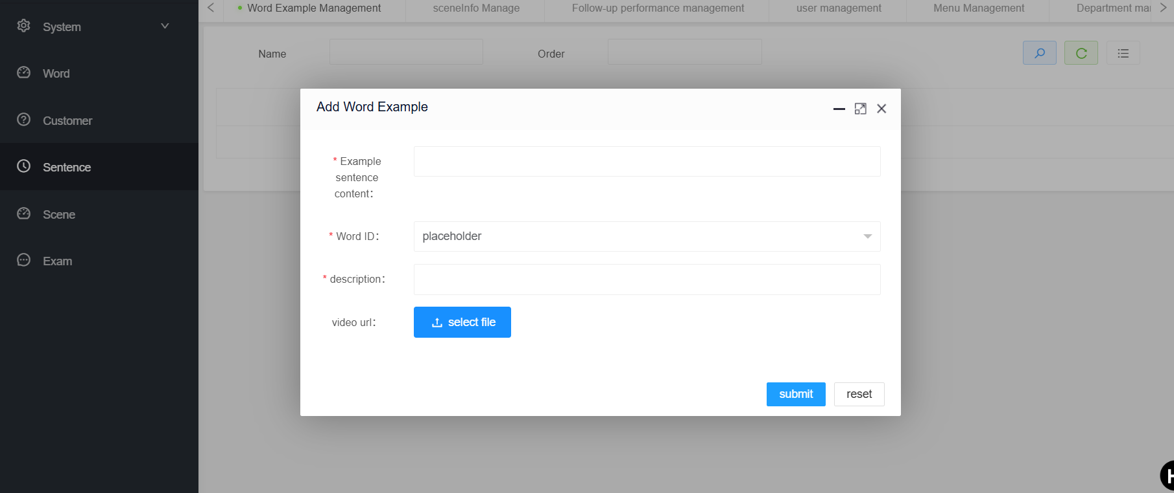

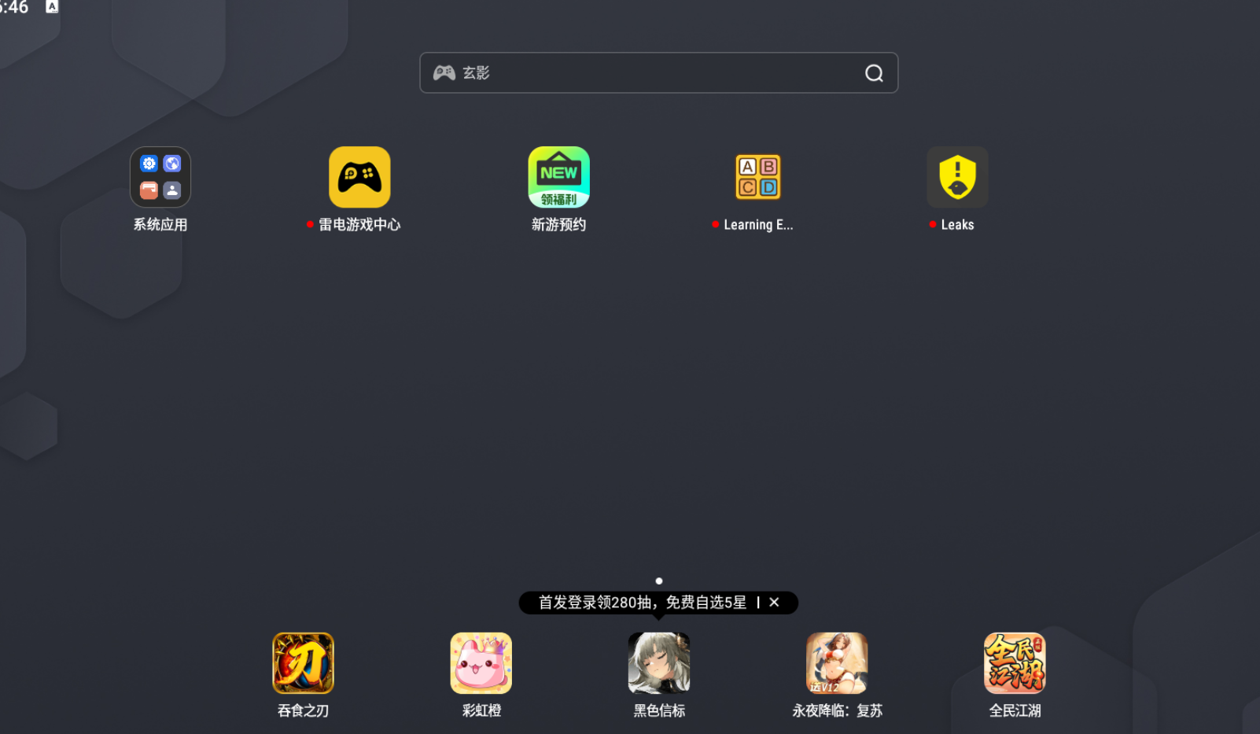

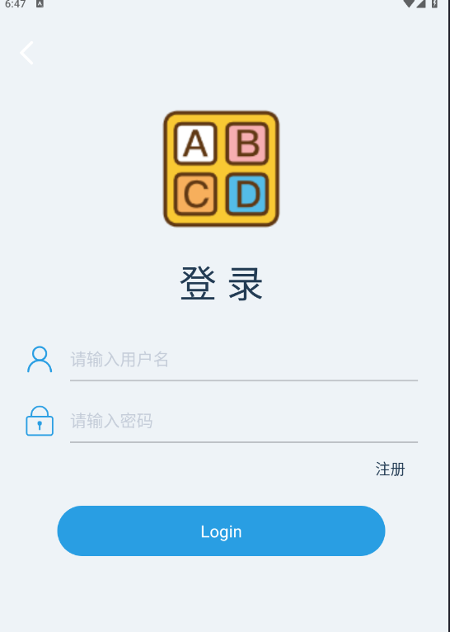

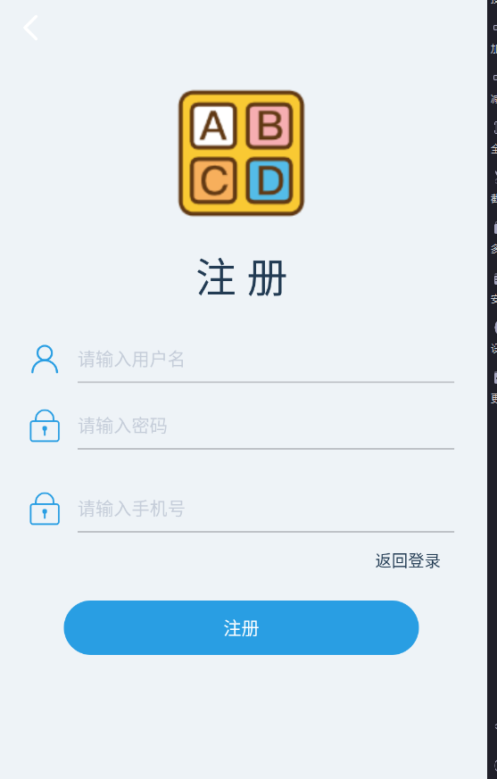

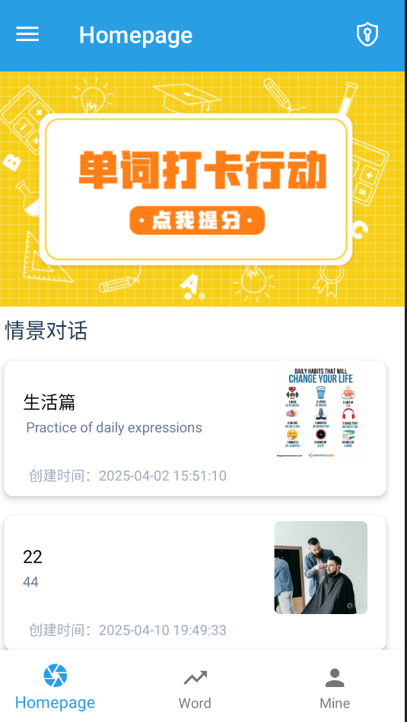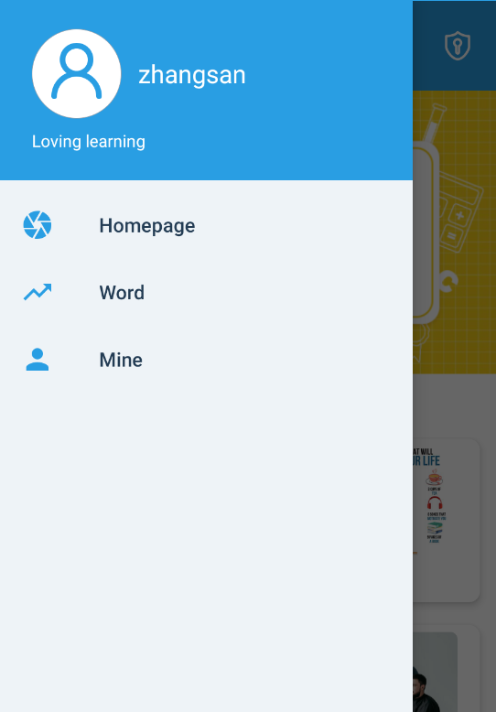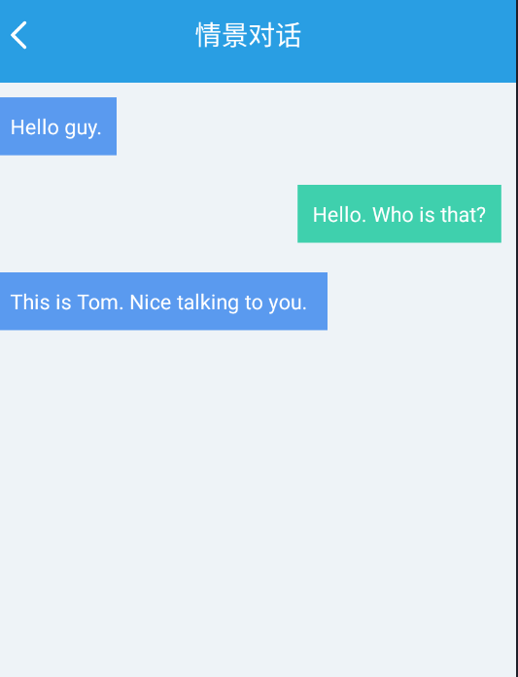

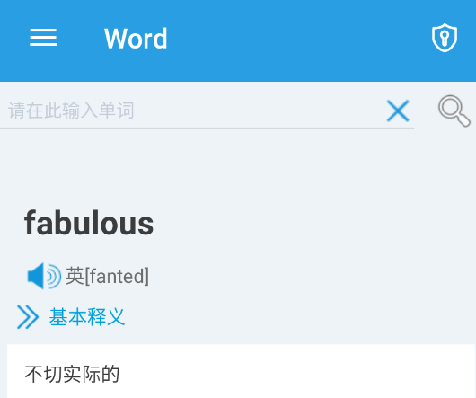

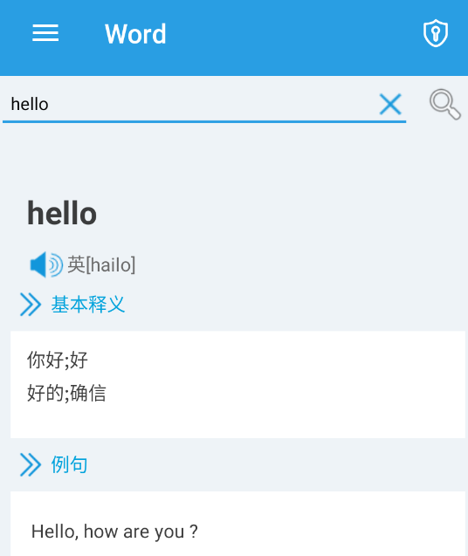

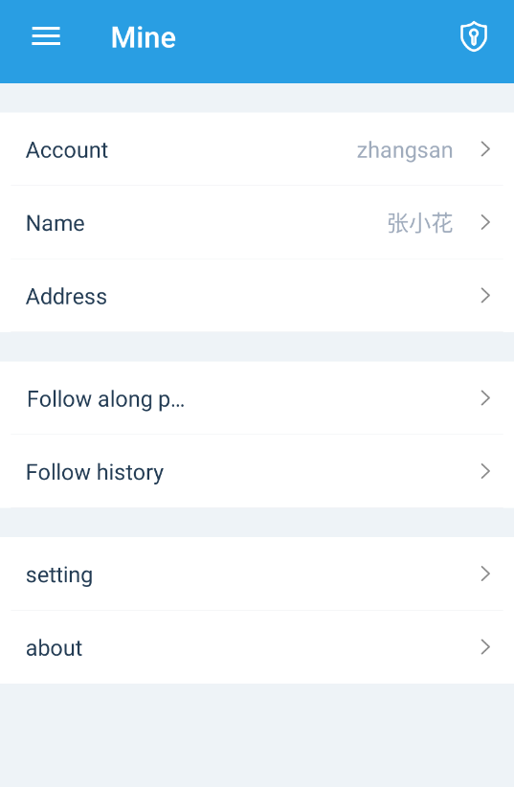

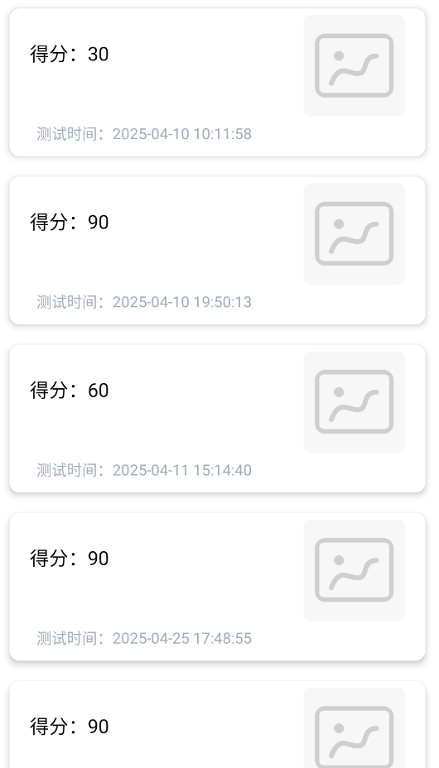

Here students are to provide detailed descriptions and documentation of results and testing. Critical evaluation and discussion of results, issues encountered constraints, limitations, and originality.

The subsection layouts of this section mostly depends on the type of project that the student is carrying out. Students can introduce subsections that will help the readability of their work.

For instance, students doing software development-based projects should provide the detailed use of their software in this chapter. Screenshots (images) of their graphical user interfaces can be depicted in this chapter. Other relevant details about the testing and evaluation of their software can be stated here as well.

# **Professional Issues**

## **Project Management**

Project management includes specific activities for each objective, Gantt charts, project data management methods and deliverables.

### **Activities**

### **Schedule**

Figure 34 employs a Gantt chart to visually depict the scheduled activities and

corresponding deadlines. The activities were completed within the planned time.

### **Project Data Management**

In this section, students must describe how they have used resources such as Baidu drive, Gitee, etc., to manage project logs, reports, literature, etc.

### **Project Deliverables**

In this section, briefly list all the documents and project resources that have been submitted for assessment. Example: Project proposal, progress report, final report, project code/ software, poster presentation file, etc.

## **Risk Analysis**

Risk analysis as informed by the current project progress; Resolved risks and the success of the mitigation strategy; Changes to the project plan as a result of risks; Future risks.

## **Professional Issues**

Identification and discussion of relevant legal, social, ethical, and environmental issues in the context of the project. Refer to professional codes of conduct, e.g. BCS, ACM.

# **Conclusion**

Summary of what was achieved and potential future work.

# **References**

[1] R. Shadiev, J. Liu, and P.-Y. Cheng, “The Impact of Mobile-Assisted Social Language Learning Activities on Speaking Skills and Self-Efficacy Development,” *IEEE Transactions on Learning Technologies*, vol. 16, no. 5, pp. 664–679, Oct. 2023, doi: [10.1109/TLT.2023.3243721](https://doi.org/10.1109/TLT.2023.3243721).

[2] Y. Xu, “The construction of an open language learning platform based on the Internet context,” in *2023 International Conference on Computer Engineering and Distance Learning (CEDL)*, Jun. 2023, pp. 132–135. doi: [10.1109/CEDL60560.2023.00033](https://doi.org/10.1109/CEDL60560.2023.00033).

[3] W. Zhou and X. Sun, “The Design of English Mobile Learning Software Based on Android Application,” in *2022 Second International Conference on Advanced Technologies in Intelligent Control, Environment, Computing & Communication Engineering (ICATIECE)*, Dec. 2022, pp. 1–5. doi: [10.1109/ICATIECE56365.2022.10046888](https://doi.org/10.1109/ICATIECE56365.2022.10046888).

[4] K. Villalba *et al.*, “Eyeland: A Visually-Impaired Accessible English Learning Application Using a Design-Based Research Framework,” *IEEE Access*, vol. 12, pp. 142275–142290, 2024, doi: [10.1109/ACCESS.2024.3444741](https://doi.org/10.1109/ACCESS.2024.3444741).

[5] M. Farkhan, M. Nisa, I. Chusna, Moh. Supardi, Saefudin, and E. Oktafiyani, “Developing Mobile English Dictionary for Academic Writing: An Initial Model for College Students,” in *2021 9th International Conference on Cyber and IT Service Management (CITSM)*, Sep. 2021, pp. 1–6. doi: [10.1109/CITSM52892.2021.9588954](https://doi.org/10.1109/CITSM52892.2021.9588954).

[6] Y. Getman *et al.*, “Developing an AI-Assisted Low-Resource Spoken Language Learning App for Children,” *IEEE Access*, vol. 11, pp. 86025–86037, 2023, doi: [10.1109/ACCESS.2023.3304274](https://doi.org/10.1109/ACCESS.2023.3304274).

[7] C. Tejedor-García, D. Escudero-Mancebo, V. Cardeñoso-Payo, and C. González-Ferreras, “Using Challenges to Enhance a Learning Game for Pronunciation Training of English as a Second Language,” *IEEE Access*, vol. 8, pp. 74250–74266, 2020, doi: [10.1109/ACCESS.2020.2988406](https://doi.org/10.1109/ACCESS.2020.2988406).

[8] B. B. N. Prasad, I. Patra, D. Indumathi, A. Saranya, G. Kaur, and R. S. Rawat, “IoT-Based Teaching of English and It’S Translation Using Artificial Intelligence,” in *2024 IEEE International Conference on Computing, Power and Communication Technologies (IC2PCT)*, Feb. 2024, pp. 843–847. doi: [10.1109/IC2PCT60090.2024.10486522](https://doi.org/10.1109/IC2PCT60090.2024.10486522).

* The layout above is a suggestion of how to present your Final Project Report. Whenever appropriate, introduce sections that will help the readability of your work.
* The Length of the final report should be **8000 – 10000 words**.
* All sections and subsections should be numbered for cross-referencing purposes.
* Regarding citations and references, students must adhere to the University guidelines or IEEE referencing style. **Students doing software development-based projects can cite related websites, web applications, developer documentation, etc. They can cite related articles to their projects, but it is not required. Students doing research-oriented projects should focus on citing research articles. They can also cite appropriate websites whenever necessary. Students are advised to use appropriate reference management software such as Mendeley Reference Manager or Zotero to ensure the correctness of all references.**

## **Formatting Requirements**

Your written report must be presented in the following format:

* All main sections/chapters should begin on a new page. The Declaration page, Tables of Contents pages, Acknowledgment, Abstract, Abbreviation, Glossary, Project Chapters (Chapters 1 to 6), and Appendices should all start on a new page.
* It must be word-processed in 11-point Arial font.
* It must be black text on a white or ivory background
* All pages must be numbered. Follow the appropriate page numbering format specified in the template.
* Margins must be as follows: Top: 1 inch, Bottom: 1 inch (2.5 cm), Left: 1.25 inches, Right:
* 1.25 inches (3.2 cm)
* Use a line spacing of 1.5
* Numbers and captions to figures and tables should be at the bottom of the figure or table. If the figure or table is mounted sideways into the report, then its bottom is on the right-hand side of the report. **All tables and figures must be labeled**.
* Normally, the report should not contain more than 80 tables/figures.

## **Written Presentation**

* The final project report must have a concise written presentation and referencing style.
* It should also have a clear & logical presentation.

**NOTE:**

**所有红色文本均为基本指南，使用本指南后必须删除。**

**最后，适当更新“目录”，以显示正确的章节标题和相应的页码。**

# **Appendices**

本节可以包含报告中必须包括但会破坏主要论点的流程的基本信息/数据。本节不标记。示例包括链接到数据和软件存储库、问卷、原始调查结果和线框图。