

UNDERGRADUATE PROJECT PROGESS REPORT

|  |  |
| --- | --- |
| **Project Title:** | **Interactive Storytelling App for Language Learning** |
| **Surname:** | **Xiao** |
| **First Name:** | **Yanliang** |
| **Student Number:** | **202118020109** |
| **Supervisor Name:** | **Yasir Mustafa** |
| **Module Code:** | **CHC 6096** |
| **Module Name:** | **Project** |
| **Date Submitted:** | **2024/12/31** |

目录

UNDERGRADUATE PROJECT PROGESS REPORT 1

1 Introduction 3

1.1 Background 3

1.2 Aim 3

1.3 Objectives 3

1.4 Project Overview 4

1.4.1 Scope 4

1.4.2 Audience 4

2 Background Review 4

3 Technical Progress 5

3.1 Approach 5

3.2 Technology 5

3.3 Testing and Evaluation Plan 6

3.4 Design and Implementation 7

3.4.1 Database design 7

3.4.2 Web design 8

4 Project Management 9

4.1 Activities 9

4.2 Schedule 9

4.3 Project Version Management 10

4.4 Project Data Management 10

4.5 Project Deliverables 11

5 Professional Issues and Risk: 12

5.1 Risk Analysis 12

5.2 Professional Issues 14

5.2.1 Legal Compliance 14

5.2.2 Social Responsibility 14

5.2.3 Ethical Considerations 14

5.2.4 Environmental Impact 14

5.2.5 Mitigation Strategies and Future Considerations 14

6 References 16

# Introduction

## Background

With the development of globalization, the importance of English as an international common language is increasing. More and more people want to improve their English skills to gain more opportunities in academic, professional and personal life. Modern users are increasingly inclined to fragmented learning, that is, to use fragmentary time for short and efficient learning [1]. The popularity of mobile devices makes people more inclined to use their mobile phones or tablets for learning, so mobile-based English learning applications have huge market potential. In addition, the development of artificial intelligence (AI) and machine learning technology has provided the possibility for personalized learning [2]. By analyzing users' learning behaviors and progress, the software can provide customized learning content and suggestions. Advances in speech recognition technology have made real-time pronunciation correction a reality, which is particularly helpful in improving users' speaking skills [3]. Timely feedback is one of the keys to effective learning[4]. Through the real-time feedback mechanism, users can immediately understand their mistakes and correct them, thus speeding up the learning process.

## Aim

The purpose of this project is to develop a robot-based language learning application for interactive storytelling, which generates a story where people then read and judge the software based on the user's voice. If correct, it moves on to the next stage, reminds them when the answer is incorrect, and finally analyzes and reports the user's pronunciation. Mainly for foreign language beginners and users who will travel abroad but do not know the local language. On this basis, by collecting data from the network and investigating the well-known language learning software, the main function of the software is to train the user's listening and communication ability, and the UI design of the software and the relevant information of the database are preliminarily completed

## Objectives

The project will be completed in four stages. The contents of each stage are as follows:

1. Complete the background investigation of the existing Language learning software.

b) Complete the detailed design and codes of modules.

c) Choose the appropriate programming language (such as Java or Kotlin) for Android development

d) Get the story content suitable for different English levels and collect it into the software

e) Test software feasibility and maintenance

## Project Overview

### Scope

The Android-based English learning software automatically generates suitable story content according to the user's English level and learning objectives. When the user reads the story, the software will use a microphone to record the user's pronunciation. With advanced speech recognition technology, the software can analyze the user's pronunciation accuracy in real time and provide instant feedback. After the user finishes reading the entire story, the software will analyze their overall pronunciation. This will include an analysis of the pronunciation of individual phonemes, words, and sentences. The software also generates a detailed report summarizing the user's pronunciation problems and providing suggestions for improvement. Users can also download stories and read and practice without an Internet connection

.

### Audience

The software is suitable for beginners, especially children, through simple stories and interactive exercises to build English foundation step by step. It is also suitable for travelers who plan to travel abroad or are already abroad, and they need to quickly improve their daily oral English skills. Provide practical dialogue exercises and a simulation of common scenarios.

# Background Review

Many popular language learning programs are used for powerful features and a large user base, each using its own functionality to attract users without developing all possible features[5]. They function more efficiently and more mature over time. They have their own strengths and weaknesses, and personally developed systems cannot be compared, but different development concepts can be summarized from other systems in functional and front-end design[6]. The comparison table of the five systems is as follows:

Table 1 Comparison of System Features

|  |  |  |  |  |  |
| --- | --- | --- | --- | --- | --- |
|  | [Cristian Tejedor-García](https://ieeexplore.ieee.org/author/37088390396) et. al  [2] | [Benjamín Maraza-Quispe](https://ieeexplore.ieee.org/author/582712720811590) et. Al  [7] | [Rustam Shadiev](https://ieeexplore.ieee.org/author/37947720700) et. Al  [8] | [Karen Villalba](https://ieeexplore.ieee.org/author/828211112462014)  et. al [10] | [Catherine Akoth Ongoro](https://ieeexplore.ieee.org/author/37085443618)  et. al [11] |
| aural learning | N/A | N/A | √ | √ | √ |
| pronunciation practice | √ | √ | √ | √ | √ |
| The convenience of the page design | √ | √ | N/A | N/A | √ |
| Pronunciation analysis | √ | √ | √ | N/A | N/A |
| The fun of the process | √ | √ | √ | N/A | √ |

# Technical Progress

## Approach

For individual items, you would also prefer to choose agile methods. Because this model not only does it save me time when I want to add new features beyond my schedule, but it is also a way to develop the system. The requirements of the system should be through data generation, collect usability testing and data analysis.

For the overall project, the waterfall model is used to complete the system design and the structure diagram of the development model is shown in Figure 1：

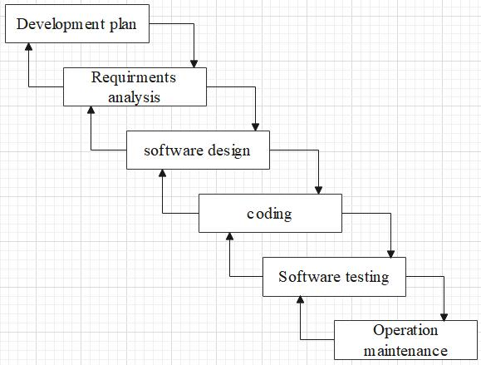

Figure 1. Software Development - Waterfall Mode

## Technology

This system is based on Android and the chosen programming language is Java or Kotlin. Therefore, the development software is Android Studio, Google Chrome, MySQL Workbench, and Sublime Text. Android Studio is a great integrated development environment for Android app development, Google Chrome will be used to display the app's web content in a browser, MySQL Workbench is a free platform to design and implement databases, and Sublime Text is a paid but indefinitely usable editor with a simple interface and powerful features that can make work efficient. Android app development with frameworks like Android SDK and libraries is popular because of its ease of use, ease of documentation support, less redundancy, and support for API integration. This is why Java or Kotlin is chosen as the programming language to complete the project.

## Testing and Evaluation Plan

The system will be designed using test-driven development test, a core technique derived

from agile development, to define the test plan before the functional code is formally released.

Test-Driven development for this project will include an acceptance test to verify that the whole

system works as intended, functional tests to ensure that the system meets functional

requirements, and unit tests to verify that different units can perform their tasks individually as

expected

A sample test plan section is shown below：

Table 2 Unit test

|  |  |
| --- | --- |
| Test Case | Status |
| Enter correct user username, corresponding password | Pass |
| Enter the normal staff username and the password that does not correspond | Reject |
| Enter regular employee username, and password with unmatched characters | Reject |
| Enter regular employee username that exceeds the length, and the corresponding password | Reject |
| Enter a regular employee username with non-compliant characters and the corresponding password | Reject |
| Enter a username that is not registered, and the password that exists | Reject |

1. System test plan

Table 3 System test

|  |  |
| --- | --- |
| Test Case | Status |
| All users are able to register accounts | Pass |
| All users are able to log into the system | Pass |
| All users use the navigation bar to jump between all the pages they are allowed to view | Pass |
| All users jump to each detail page by presenting relevant information on the home page | Pass |
| Ordinary users can view the internal user information management page | Reject |

1. Function Test plan

Table 4 Function test

|  |  |
| --- | --- |
| Test case | Statue |
| Each link has a corresponding page | Pass |
| Each link can jump to the corresponding  page | Pass |
| Other functions are normal after modifying a  project | Pass |
| Other functions are normal after saving the  new project | Pass |
| Enter the wrong content at the location with  the input content limited | Reject |

## Design and Implementation

### Database design

The database design of all functionalities that have been implemented or is still

in coding is show below:

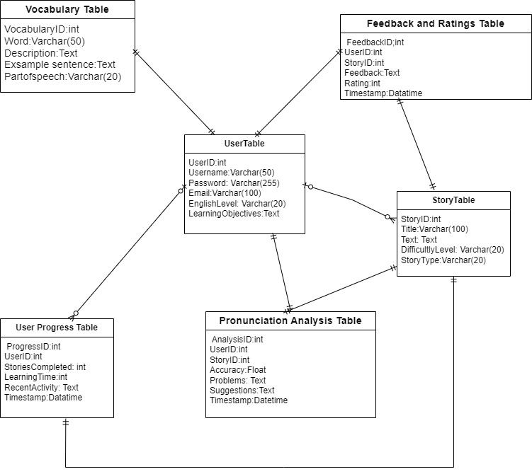

Figure 2 Database

### Web design

The front-end page design is initially completed, including user registration and login, home page, etc. By using bright colors to help the user with a clearer overall structure and accessible navigation bars.

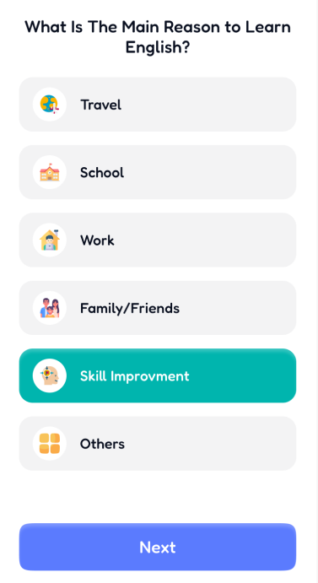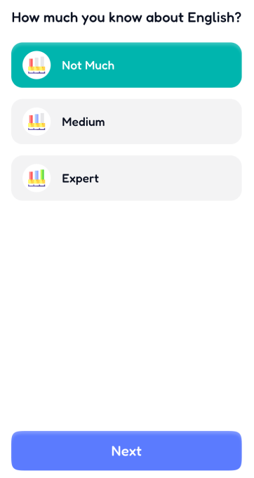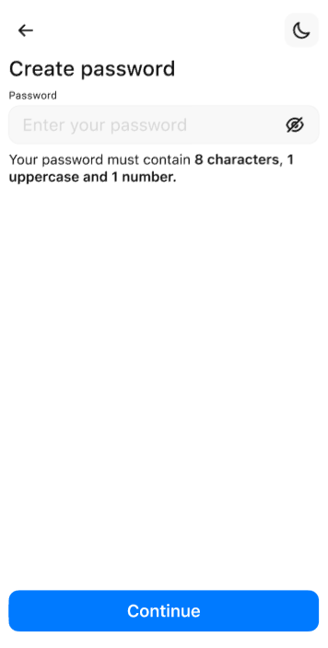

Figure 3 Web design

# Project Management

## Activities

In the following table outlines the complete tasks of each objective of the project, detailed on these activities and their current status:

Table 5 Project Management

|  |  |  |  |
| --- | --- | --- | --- |
| Task ID | Objective | Description | State |
| 1 | Background research | Search for existing language learning tools, compare the evolution of past and current language learning methods, and the current advantages | Completed |
| 2 | Conduct the user demand analysis | Collect the needs of users through the network, and list the priority of all functions | Completed |
| 3 | UI design | Provide language learning users with a UI interface with clear structure and perfect functions | Completed |
| 4 | Database design | Design a suitable database to store the user information | Completed |
| 5 | Backed-end design | According to the front-end page and database, to complete the back-end function implementation | progressing |
| 6 | Test | Test the completed apps to ensure the proper operation of the respective functions | No Started |
| 7 | Documentation | Prepare project documentation and user manuals | No Started |

## Schedule

The project uses Gantt charts for project schedule management, as shown in Figure 3.

## 

Figure 4 Gantt charts

## Project Version Management

I leverage various resources to manage project logs, reports, and literature:

Baidu Drive: For storing and sharing project documents, user manuals, and research materials. It allows for real-time collaboration and version control.

Gitee: for version control for the project code. It ensures that all code changes are tracked and can work efficiently on the code base.

## Project Data Management

Upload Weekly progress on Gitee with subfolders (As shown in Figure 5)

URL of project： <https://gitee.com/ten-years-of-solo-fishing/final-project.git>

Upload the system code to the Code folder

Upload presentation-related ppt, videos and posters to the Presentation folder

Upload reports to the Reports folder

Upload the system UI prototyping files to the UI_design folder

Upload the weekly meeting logs to the Weekly meeting logs folder

Upload other project-related materials to the Other folder

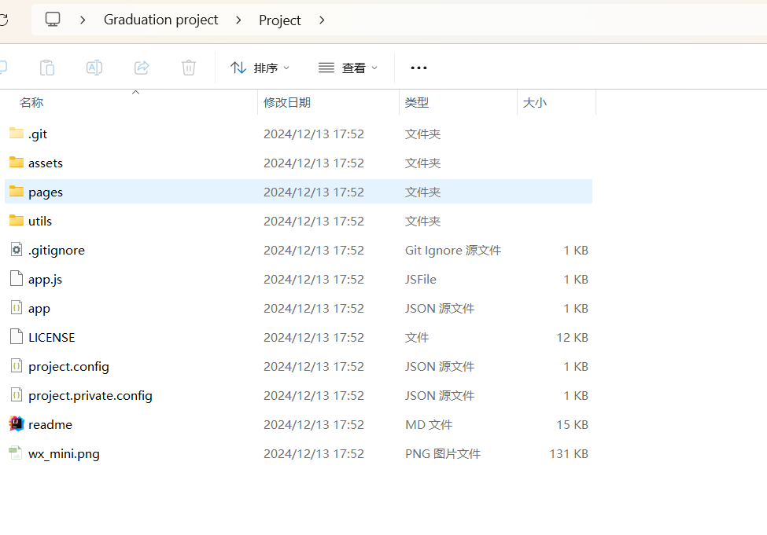

## Project Deliverables

(1) Project proposal

(2) Progress Report

(3) Final Project Report

(4) Softerware Code

(5) Presentation: slide, poster and video

# Professional Issues and Risk:

## Risk Analysis

Table 6 Risk Analysis

|  |  |  |  |  |  |  |
| --- | --- | --- | --- | --- | --- | --- |
| Risk ID | Description | Potential Causes | Severity | Likelihood | Risk | Mitigation Strategy |
| R1 | Technical Complexity | Integration of AI and speech recognition technologies may present challenges | 4 | 3 | 12 | Allocate additional R&D resources, conduct thorough testing and system testing |
| R2 | Resource Availability | Key personnel or technical resources might not be available as planned | 3 | 3 | 9 | Develop a contingency plan with alternative resource allocation and scheduling |
| R3 | Data Privacy Concerns | Handling of user data could lead to privacy issues if not managed properly | 5 | 2 | 10 | Implement robust data protection measures, conduct regular security audits |
| R4 | Market Acceptance | The target audience may not find the app's approach to language learning appealing | 3 | 4 | 12 | Conduct market research and user testing to refine features and user interface |
| R5 | Dependency on Third-Party Services | Reliance on third-party services for certain functionalities could be disrupted | 3 | 4 | 12 | Establish contracts with multiple service providers for redundancy and reliability |
| R6 | The user interface design may not meet the needs and expectations of the target users | Insufficient user research or poor design decision making | 2 | 4 | 8 | User testing and feedback loops were performed to guide the iterations of the interface design |
| R7 | The technology used by the project may become obsolete before the project is completed | Fast-changing technology environment and market trends | 1 | 2 | 2 | Continuously monitor technology trends and update the technology stack if necessary |

The overall risk score based on different Likelihood and Severity can divide each case into

different severity levels. This is shown in the table below where:

Table 7 Risk color description

|  |  |  |
| --- | --- | --- |
| Colour | Meaning | Description |
| Green | Low Risk | These risks have little impact on the project and are relatively easy to avoid. |
| Yellow | Moderate Risk | These risks have a moderate  impact on the project, and  take time to recover after  occurrence. |
| Red | High Risk | These risks will have a serious  impact on the project and are  difficult to recover after  occurrence. |

## Professional Issues

# Identification and Discussion of Relevant Issues:

# In the development of the "Interactive Storytelling App for Language Learning," several professional issues have been identified and considered throughout the project lifecycle. These issues are crucial for ensuring the app's compliance with ethical standards, legal requirements, and social responsibilities.

# 5.2.1 Legal Compliance

# The app's development adheres to copyright laws, particularly in the use of story content. All stories integrated into the app are either original works or have been licensed appropriately. Additionally, the app complies with data protection regulations, such as the General Data Protection Regulation (GDPR), by implementing robust data encryption and anonymization techniques to protect user information.

# 5.2.2 Social Responsibility

# The app is designed to be inclusive, providing language learning opportunities to a diverse user base, including children and adults from different cultural backgrounds. The content is carefully curated to avoid cultural insensitivity and to promote a positive learning environment. The app also includes features that support learners with disabilities, aligning with the principles of universal design.

# 5.2.3 Ethical Considerations

# Ethical considerations are paramount in the use of AI and machine learning within the app. The system is programmed to avoid bias in language learning content and pronunciation feedback. Regular audits and updates are conducted to ensure the AI algorithms do not perpetuate discriminatory practices. User consent is obtained for data collection, and the app provides clear information on how user data is used and protected.

# 5.2.4 Environmental Impact

# While the app itself is digital and does not have a direct environmental impact, the development process considers the environmental footprint of digital technology. Efforts are made to optimize the app's performance to reduce energy consumption on devices, and the development team is educated on sustainable practices in software development.

# 5.2.5 Mitigation Strategies and Future Considerations

# To address these professional issues, the project team has implemented several mitigation strategies:

# Legal Compliance: Regular legal reviews and consultations with experts to ensure ongoing adherence to copyright and data protection laws.

# Social Responsibility: Continuous user feedback and community engagement to refine the app's inclusivity and cultural relevance.

# Ethical Considerations: Establishing an ethical AI committee within the development team to oversee AI algorithms and update ethical guidelines.

# Environmental Impact: Investing in energy-efficient software practices and promoting digital sustainability within the organization.

# Future developments of the app will continue to prioritize these professional issues, with a commitment to regular updates and improvements based on user feedback and emerging best practices in the field of educational technology.

# References

[1] “Using Challenges to Enhance a Learning Game for Pronunciation Training of English as a Second Language | IEEE Journals & Magazine | IEEE Xplore.” Accessed: Oct. 31, 2024. [Online]. Available: <https://ieeexplore.ieee.org/document/9069189>

[2] “Toward the Achievement of English Language Learning Competencies Through the Use of an Application: A Case Study | IEEE Journals & Magazine | IEEE Xplore.” Accessed: Oct. 31, 2024. [Online]. Available: <https://ieeexplore.ieee.org/document/10207842>

[3] R. Shadiev, J. Liu, and P.-Y. Cheng, “The Impact of Mobile-Assisted Social Language Learning Activities on Speaking Skills and Self-Efficacy Development,” *IEEE Transactions on Learning Technologies*, vol. 16, no. 5, pp. 664–679, Oct. 2023, doi: [10.1109/TLT.2023.3243721](https://doi.org/10.1109/TLT.2023.3243721).

[4] Y. Xu, “The construction of an open language learning platform based on the Internet context,” in *2023 International Conference on Computer Engineering and Distance Learning (CEDL)*, Jun. 2023, pp. 132–135. doi: [10.1109/CEDL60560.2023.00033](https://doi.org/10.1109/CEDL60560.2023.00033).

[5] F. Lin, “Mobile Foreign Language Learning in the Era of Educational Information,” in *2020 2nd International Conference on Information Technology and Computer Application (ITCA)*, Dec. 2020, pp. 560–563. doi: [10.1109/ITCA52113.2020.00123](https://doi.org/10.1109/ITCA52113.2020.00123).

[6] D. Carlander-Reuterfelt, Á. Carrera, C. A. Iglesias, Ó. Araque, J. F. Sánchez Rada, and S. Muñoz, “JAICOB: A Data Science Chatbot,” *IEEE Access*, vol. 8, pp. 180672–180680, 2020, doi: [10.1109/ACCESS.2020.3024795](https://doi.org/10.1109/ACCESS.2020.3024795).

[7] “Eyeland: A Visually-Impaired Accessible English Learning Application Using a Design-Based Research Framework | IEEE Journals & Magazine | IEEE Xplore.” Accessed: Oct. 31, 2024. [Online]. Available: <https://ieeexplore.ieee.org/document/10637399>

[8] “ Enhancing English Language Education Through Big Data Analytics and Generative AI | River Publishers Journals & Magazine | IEEE Xplore.” Accessed: Oct. 31, 2024. [Online]. Available: <https://ieeexplore.ieee.org/document/10504108>

[9] C. A. Ongoro and Y.-Y. Fanjiang, “Digital Game-Based Technology for English Language Learning in Preschools and Primary Schools: A Systematic Analysis,” *IEEE Transactions on Learning Technologies*, vol. 17, pp. 202–228, 2024, doi: [10.1109/TLT.2023.3268282](https://doi.org/10.1109/TLT.2023.3268282).

[10] “Development Of An Interactive Language Learning Application For Children | IEEE Conference Publication | IEEE Xplore.” Accessed: Oct. 31, 2024. [Online]. Available: <https://ieeexplore.ieee.org/document/10379361>

[11] “Developing an AI-Assisted Low-Resource Spoken Language Learning App for Children | IEEE Journals & Magazine | IEEE Xplore.” Accessed: Oct. 31, 2024. [Online]. Available: <https://ieeexplore.ieee.org/document/10214276>

[12] H. Kassim, A. Kassim, N. Y. Khamis, N. Jatin, A. A. Hussin, and A. Uthayakumaran, “Creative Digital Language Learning Environment: A Model to Foster Creative Experiences for Language Learners,” in *2023 7th IEEE Congress on Information Science and Technology (CiSt)*, Dec. 2023, pp. 479–482. doi: [10.1109/CiSt56084.2023.10409930](https://doi.org/10.1109/CiSt56084.2023.10409930).

[13] M. Deng, “Application of Artificial Intelligence Technology in College Students’ Foreign Language Learning,” in *2022 IEEE 5th Eurasian Conference on Educational Innovation (ECEI)*, Feb. 2022, pp. 302–304. doi: [10.1109/ECEI53102.2022.9829486](https://doi.org/10.1109/ECEI53102.2022.9829486).