整体排版示例：

排版效果：
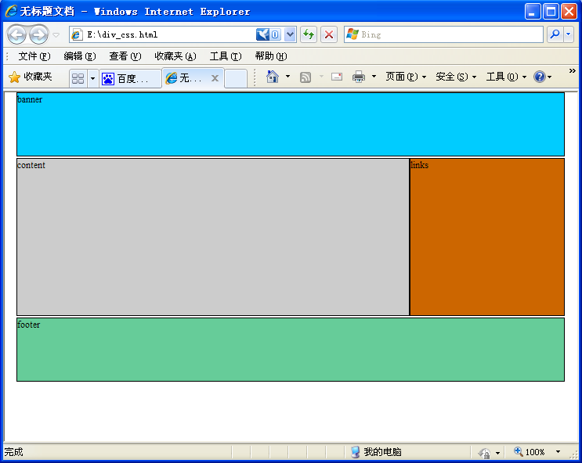

网页代码：
<!DOCTYPE html PUBLIC "-//W3C//DTD XHTML 1.0 Strict//EN" "http://www.w3.org/TR/xhtml1/DTD/xhtml1-strict.dtd">
<html xmlns="http://www.w3.org/1999/xhtml">
<head>
<meta http-equiv="Content-Type" content="text/html; charset=utf-8" />
<title>无标题文档</title>
<style type="text/css">
<!--
body {
font-size: 12px;
margin: 0px;
padding:0px;
text-align:center; /*使内容居中对齐*/
}
#container {
margin:0 auto;/*把container容器上下margin设置为0，把左右marge设置为自动，就可以页面居中了*/
position: relative;
width: 700px;/*设置固定宽度*/
text-align:left;/*网页内容恢复靠左对齐*/
}
#banner {
background-color: #00CCFF;
height: 80px;
margin-bottom: 2px;
border: 1px solid #000000;
}
#content {
float: left;/*设置浮动，靠左*/
background-color: #CCCCCC;
border: 1px solid #000000;
height:200px;
width:500px;
}
#links {
float: left;/*设置浮动，靠左*/
background-color:#CC6600;
border: 1px solid #000000;
margin-bottom: 2px;
height:200px;
width:196px;
}
#footer {
clear:both;/*清除浮动，还是正常一个图层一行*/
height: 80px;
background-color: #66CC99;
border: 1px solid #000000;
}
-->
</style>
</head>

<body>
<div id="container">
<div id="banner">banner</div>
<div id="content">content</div>
<div id="links">links</div>
<div id="footer">footer</div>
</div>
</body>
</html>

