LUNA Test Automation Compile By Robot Framework

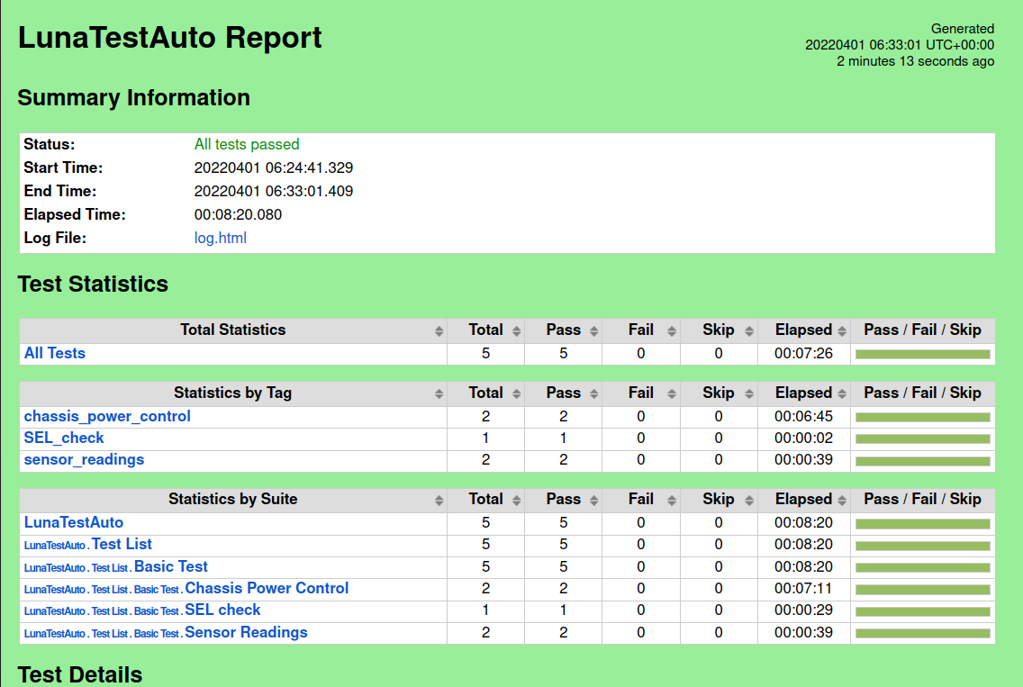

Environment
OS:Linux(ubuntu20.04)
Python(3.8)
Browser:friefox(98.0.2(64bit))
geckodriver(release version:3.0 on github)
ipmitool
Python need app:
robotframework
requests
robotframework-requests>=0.3.9,<0.8.0
paramiko>=2.5.0
robotframework-sshlibrary
robotframework-scplibrary
redfish
click
PyYAML>=5.1
Redfishtool
robotframework-seleniumlibrary
robotframework-selenium2library
webdrivermanager
robotframework-angularjs
robotframework-xvfb

build:
Geckodriver:
Go to the geckodriver releases page. Find the latest version of the driver for your platform and download it. For example:
wget https://github.com/mozilla/geckodriver/releases/download/v0.24.0/geckodriver-v0.24.0-linux64.tar.gz
- Extract the file with:
tar -xvzf geckodriver*
- Make it executable:
chmod +x geckodriver
- Add the driver to your PATH so other tools can find it:
sudo mv geckodriver /usr/local/bin/
ipmi tool:
install command:
sudo apt-get install ipmitool
python app can use requirements.txt:
pip3 install -i requirements.txt

Settings:
- 所有設定值皆存於 Data/ resource_variables.robot 之中可在此設置 BMC IP 、BMC中使用的帳號密碼、SERVER中的 OS IP、OS遠端可使用ipmitool的帳號密碼、連線設置等

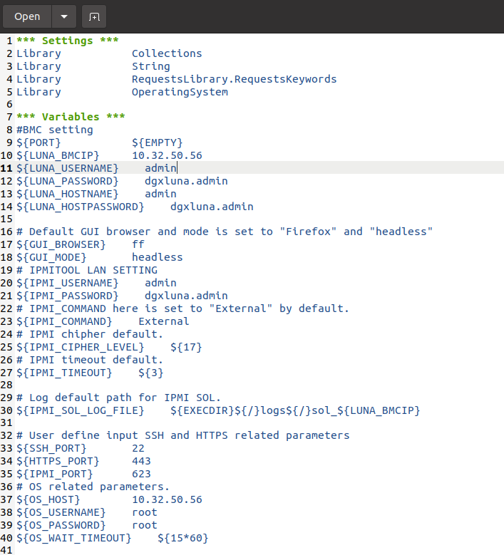

- sensors 列表目前使用 Data/sensors.robot 儲存
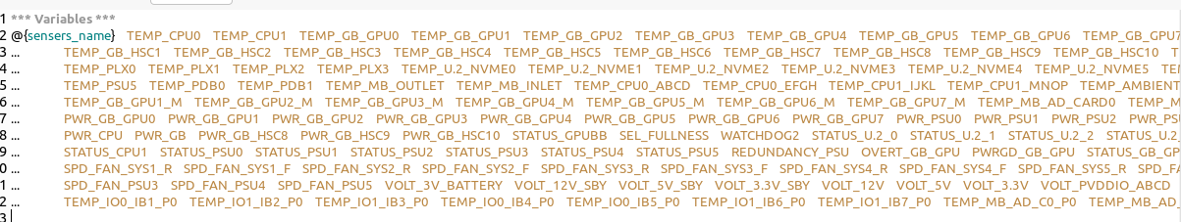

Execute:
- 所有測項皆存於Test_List 之中
- 執行時在command line 以 robot 指令執行
- 目前完成的 test case 項目如下表:

Suite Name(Function) | test case
chassis_power_control | chassis_power_off
chassis_power_control | chassis_power_on
chassis_power_control | chassis_power_cycle
chassis_power_control | chassis_power_hard_reset
chassis_power_control | chassis_power_softshutdown
chassis_power_control | chassis_ipmi_power_off
chassis_power_control | chassis_ipmi_power_on
chassis_power_control | chassis_ipmi_power_cycle
chassis_power_control | chassis_ipmi_power_hard_reset
chassis_power_control | chassis_ipmi_power_softshutdown
sensor_readings | webpage_case
sensor_readings | Ipmitool_case
user_account | Ipmitool_create_account
user_account | error_password
SEL_check | clear_event_log
 | SEL_event

執行test case 時可在資料夾command:
- robot ${path} :執行所有資料夾內的測項
- robot ${ Suite Name }.robot :執行 suite 中所有 test case
- robot -t ${test case} ${ Suite Name }.robot :執行 suite 中指定test case
- 下為一執行指定test case 範例:
  - 於 Basic_Test 資料夾中存在所有上表的測項檔案
  - Command 為 : robot -v LUNA_BMCIP:${BMC_IP} -t ${test case} ${ Suite Name}.robot
    - -v LUNA_BMCIP:${BMC_IP}:${欲複寫的變數}:${複寫值}
    - -t ${test case}:欲執行的測項
    - ${ Suite Name}.robot:欲執行的測項存在於哪個 Suite

