**四川大学期末考试试题（闭卷）**

**（2019~2020学年第1学期）**A卷

课程号：**304064030** 课程名称：**现代软件工程** 任课教师：

适用专业年级：学号： 姓名：

|  |  |  |  |  |  |  |  |  |  |
| --- | --- | --- | --- | --- | --- | --- | --- | --- | --- |
| **考生承诺**  我已认真阅读并知晓《四川大学考场规则》和《四川大学本科学生考试违纪作弊处分规定（修订）》，郑重承诺：   1. 已按要求将考试禁止携带的文具用品或与考试有关的物品放置在指定地点； 2. 不带手机进入考场； 3. 考试期间遵守以上两项规定，若有违规行为，同意按照有关条款接受处理。   **考生签名：** | | | | | | | | | |
| **题号** | **一(20%)** | **二(10%)** | **三(15%)** | **四(20%)** | **五(35%)** | | **六(0%)** | **七(0%)** | **八(0%)** |
| **得分** |  |  |  |  |  | |  |  |  |
| **卷面总分** |  | | **教师签名** |  | **阅卷时间** |  | | | |

##### 注意事项：1. 请务必将本人所在学院、姓名、学号、任课教师姓名等信息准确填写在试题纸和添卷纸上；

##### 2. 请将答案全部填写在本试题纸上；

##### 3. 考试结束，请将试题纸、添卷纸和草稿纸一并交给监考老师。

◈◈◈◈◈◈◈◈◈◈◈◈◈◈◈◈◈◈◈◈◈◈◈◈◈◈◈◈◈◈◈◈◈◈◈◈◈◈◈◈◈◈◈◈◈◈◈◈◈◈◈◈◈◈◈◈◈◈◈

##### 一、单项选择题（本大题共20小题，每小题1分，共20分）

##### 提示：在每小题列出的四个备选项中只有一个是符合题目要求的，请将其代码填写在下表中。错选、多选或未选均无分。

|  |  |  |  |  |  |  |  |  |  |
| --- | --- | --- | --- | --- | --- | --- | --- | --- | --- |
| **1** | **2** | **3** | **4** | **5** | **6** | **7** | **8** | **9** | **10** |
|  |  |  |  |  |  |  |  |  |  |
| **11** | **12** | **13** | **14** | **15** | **16** | **17** | **18** | **19** | **20** |
|  |  |  |  |  |  |  |  |  |  |

1. Software is . (c)  
   a) set of programs  
   b) documentation and configuration of data  
   c) set of programs, documentation & configuration of data  
   d) None of above
2. Which one of the following is a functional requirement? (d)  
   a) Maintainability  
   b) Portability  
   c) Robustness  
   d) None of above
3. Which of the following is the best type of module coupling? （c）  
   a) Control Coupling  
   b) Stamp Coupling  
   c) Data Coupling  
   d) Content Coupling
4. Which is the first step in the software development life cycle ?（c）  
   a) Analysis  
   b) Design  
   c) Problem Identification  
   d) Development and Documentation
5. In Design phase, which is the primary area of concern ?(d)  
   a) Architecture  
   b) Data  
   c) Interface  
   d) All of above
6. Which model in system modeling depicts the dynamic behavior of the system ? (b)  
   a) Context Model  
   b) Behavioral Model  
   c) Data Model  
   d) Object Model
7. What is the first step of requirement elicitation? (a)  
   a) Identifying Stakeholder  
   b) Listing out Requirements  
   c) Requirements Gathering  
   d) All of above
8. What are the types of requirement in Quality Function Deployment(QFD) ? (d)  
   a) Known, Unknown, Functional  
   b) User, Customer ,Developer  
   c) Functional, Non-Functional  
   d) Normal, Expected, Exciting
9. Which of the following is not included in software requirement specifications?(c)  
   a) Performance  
   b) Functionality  
   c) Design solutions  
   d) External Interfaces
10. Which of the following does not apply to agility to a software process? (c)  
    a) Uses incremental product delivery strategy  
    b) Only essential work products are produced  
    c) Eliminate the use of project planning and testing  
    d) All of above
11. Which of the following activities of a Generic Process Framework provides a feedback report? (d)  
    a) Communication  
    b) Planning  
    c) Modeling & Construction  
    d) Deployment
12. Which of the following is a mechanism that allows several objects in a class hierarchy to have different methods with the same name? (b)  
    a) Aggregation  
    b) Polymorphism  
    c) Inheritance  
    d) All of above
13. Which of the following describes “is a kind of” relationship? (b)   
    a) Aggregation  
    b) Inheritance  
    c) Dependency  
    d) All of above
14. Which of the following interface design principles does not allow the user to remain in control of the interaction with a computer (d)   
    a) allow interaction to interruptible   
    b) allow interaction to be undoable   
    c) hide technical internals from casual users   
    d) only provide one defined method for accomplishing a task
15. White Box testing is also classified as （b）  
    a) Design based testing  
    b) Structural testing  
    c) Error guessing technique  
    d) None of above
16. Exhaustive testing is (c)  
    a) always possible  
    b) practically possible  
    c) impractical but possible  
    d) impractical and impossible
17. Boundary value analysis belongs to? (b)  
    a) White Box Testing  
    b) Black Box Testing  
    c) White Box & Black Box Testing  
    d) None of above
18. Which of the following is one of the steps in the integration testing of OO software? (a)  
    a) cluster testing  
    b) thread-based testing  
    c) use-based testing  
    d) none of above
19. An abstract class is ? （c）  
    a) A class that has direct instances, but whose descendants may have direct instances  
    b) A class that has direct instances, but whose descendants may not have direct instances  
    c) A class that has no direct instances, but whose descendants may have direct instances  
    d) All of above
20. Which diagram in UML emphasizes the time-ordering of messages? （b）  
    a) Activity  
    b) Sequence  
    c) Collaboration  
    d) Class

**二、判断题（本大题共10小题，每小题1分，共10分）**

##### 提示：正确打🗸，错误打🗶。

|  |  |  |  |  |  |  |  |  |  |
| --- | --- | --- | --- | --- | --- | --- | --- | --- | --- |
| **1** | **2** | **3** | **4** | **5** | **6** | **7** | **8** | **9** | **10** |
|  |  |  |  |  |  |  |  |  |  |

1. Object diagram captures the behavior of a single use case. (F)
2. A software engineer designs the user interface by applying an iterative process.（T）
3. Software Debugging is a set of activities that can be planned and conducted systematically. （F）
4. Spiral Model has user involvement in all its phases. （F）
5. In XP, the work on a task will be integrated into the whole system as soon as it is completed. （T）
6. A Use-case actor is always a person having a role that different people may play.（F）
7. Functional requirements capture the intended behavior of the system.（T）
8. Requirements elicitation is an iterative process.（T）
9. Activity diagrams are used to model the processing of data.(T)
10. The reason for reducing the user's memory load is make his or her interaction with the computer quicker to complete.(F)

##### 三、名词解释（本大题共5小题，每小题3分，共15分）

##### 提示：解释每小题所给名词的含义，若解释正确则给分，若解释错误则无分，若解释不准确或不全面，则酌情扣分。

|  |  |  |  |  |
| --- | --- | --- | --- | --- |
| **1** | **2** | **3** | **4** | **5** |
|  |  |  |  |  |

1. Regression Testing

Regression Testing is the process of testing the modified parts of the code and the parts that might get affected due to the modifications to ensure that no new errors have been introduced in the software after the modifications have been made. Regression means return of something and in the software field, it refers to the return of a bug.

2. Prototyping Model

The Prototyping Model is one of the Software Development Life Cycle Models. This model is used when the customers do not know the exact project requirements beforehand. In this model, a prototype of the end product is first developed, tested and refined as per customer feedback repeatedly till a final acceptable prototype is achieved which forms the basis for developing the final product.

3. QFD (Quality Function Deployment)

Quality function deployment (QFD) is a quality management technique that translates the needs of the customer into technical requirements for software. QFD concentrates on maximizing customer satisfaction from the software engineering process.

4. Refactoring

Refactoring is the process of changing a software system in such a way that it does not alter the external behavior of the code yet improves its internal structure.

5. Use Case

A use case is a software engineering term that describes how a actor uses a system to accomplish a particular goal. A use case acts as a software modeling technique that defines the features to be implemented and the resolution of any errors that may be encountered.

##### 四、问答题（本大题共2小题，每小题10分，共20分）。

##### 1. What does OCP (Open-Closed Principle) stand for? Please modify the following design model to avoid violation of OCP.

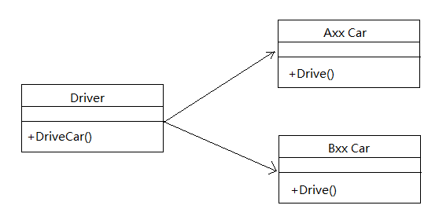

答：

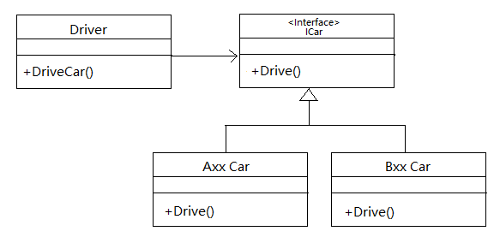

##### 2. What are the contents of user interface analysis ? (4分) Please describe them in detail. (6分)

##### 答：

##### User analysis, task analysis, content analysis , environment analysis.

##### User analysis means understanding the people (end-users) who will interact with the system through the interface ,

##### Task analysis means understanding the tasks that end-users must perform to do their work;

##### Content analysis means understanding the content that is presented as part of the interface;

##### Environment analysis means understanding the environment in which these tasks will be conducted.

**五．分析设计题（本大题共5小题，共35分）。**(无标准答案，根据回答情况酌情给分)

Suppose you are a member of a team and are asked to develop a hotel reservation system according to the following requirements:

**Customers can check available rooms ( rooms that are not booked). Customers can book one or more rooms with their names, phone numbers, check-in time and check-out time. Customers can check the room they reserved by their names. They may withdraw their reservation. System administrators can set up the type and number of rooms for customers to book. Reserved rooms cannot be booked by other customers for same time period.**

Please answer the following questions:

1. Identify your stakeholders.（5分）

使用软件的顾客，使用软件的旅馆经验者，软件的信息录入者，软件的系统维护者，软件工程师，软件的营销人员，软件的测试工程师

1. What elicitation techniques will you use to elicit the requirements of the system?（5分）

通过协商开会

通过使用QFD进行问卷调查

通过敏捷方式，向利益相关者询问生成用户故事

1. Draw a Use Case Diagram for the system.（5分）

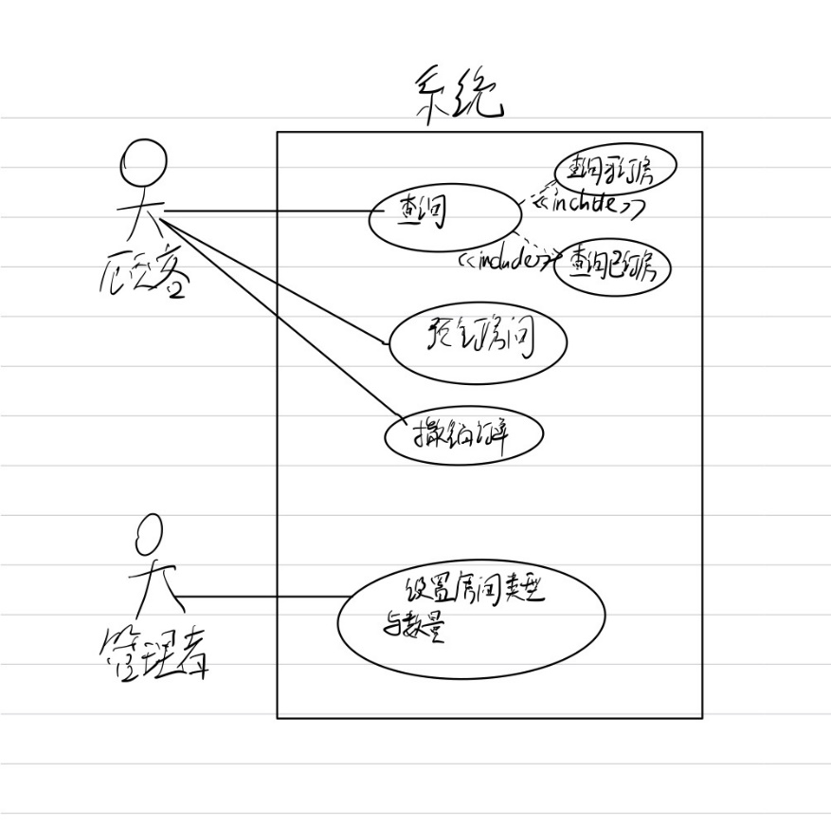

1. Write a Use Case Specification for each use case.（10分）

用例：查询

参与者：顾客

目标：顾客通过查询功能查询该旅馆的空闲房间及自己已经预定的房间相关信息。

前置条件：系统支持用户对空闲房间和客户已订房间的查询，系统已获得用户的登陆信息

触发器：用户登陆后在主界面选择点击查询按钮

基本事件流：

* + - 1. 顾客点击查询按钮
      2. 顾客进入查询界面，选择查询已订房或查询空闲房
      3. 查询成功，界面返回房间具体信息
      4. 顾客点击退出查询界面到主界面

备用事件流：

* + - 1. 顾客进入查询界面后没有选择，直接退出到主界面
      2. 顾客进入成功查询后，选择继续查询已订房或空闲房

异常情况：

顾客没有预定过房间，点击查询已订房失败

该旅馆没有空闲房，点击查询空闲房失败

用例：预定房间

参与者：顾客

目标：顾客通过预定房间按钮浏览房间信息，成功预定所选房间。

前置条件：系统具备查询功能，具备预定功能。

触发器：用户在主界面点击预定房间

基本事件流：

顾客点击进入预定房间界面

顾客选择空闲房间进入该房间具体界面并查看该房信息

顾客选择点击预定按钮

系统将该房间从空闲房间列表中撤除。

顾客选择退出界面

备用事件流：

1. 顾客进入预定房间界面，选择返回到主界面

2. 顾客进入房间具体界面，选择返回到上一界面或返回到主界面

异常：

在顾客进入某房间的同时，另一名顾客预定了该房间，这位顾客点击预定按钮提示已被预定

当所有房间都被预定后，顾客进入预定房间界面没有显示具体房间界面入口

用例：撤销订单

参与者:顾客

目标：顾客通过撤销订单那按钮，对他的订单撤销

前置条件：系统实现了撤销订单功能，系统实现了查询功能

触发器：顾客进入主界面点击撤销订单按钮

基本事件流：

* + - 1. 顾客进入撤销订单那界面，选择自己的已定房间
      2. 顾客进入选择的房间，点击撤销订单那按钮
      3. 撤销订单那成功后，顾客选择退出到主界面

备用事件流：

* + - 1. 顾客进入撤销订单界面，选择退出到主界面
      2. 顾客进入到已订房间界面，选择返回到上一个界面或返回到主界面

异常：

* + - 1. 顾客没有预定过房间，撤销订单界面没有显示已定房间

用例：管理房间

参与者：旅店管理者

目标：管理者通过管理房间功能，管理房间的类型信息，及房间的数量信息。

前置条件：系统配备了管理房间的功能，查询功能

触发器：管理者在系统主界面点击管理房间按钮。

基本事件流：

* + - 1. 管理者点击管理房间按钮
      2. 管理者选择旅店的房间
      3. 管理者对该房间的信息进行修改
      4. 管理者设置房间可见信息，如可见，则可以让顾客预定，如不可见，则顾客无法看到并预定。
      5. 管理者选择退出界面到主界面

备用事件流：

* + - 1. 管理者进入管理房间界面，直接选择退出界面
      2. 管理者进入房间具体界面，选择返回上一级界面或直接到主界面

异常:

* + - 1. 管理房间界面没有准备就绪

1. Draw a Sequence Diagram to show object interactions when customers withdraw their reservation.（10分）

