## **Start Controller**

root@server03:~/ryu/ryu/app# ryu-manager simple_switch_stp_13.py

## **Start Mininet**

root@server03:~/mininet/custom# sudo mn --custom ./dc_topo.py --topo=mytopo --controller=remote

1. **Pingall Test**

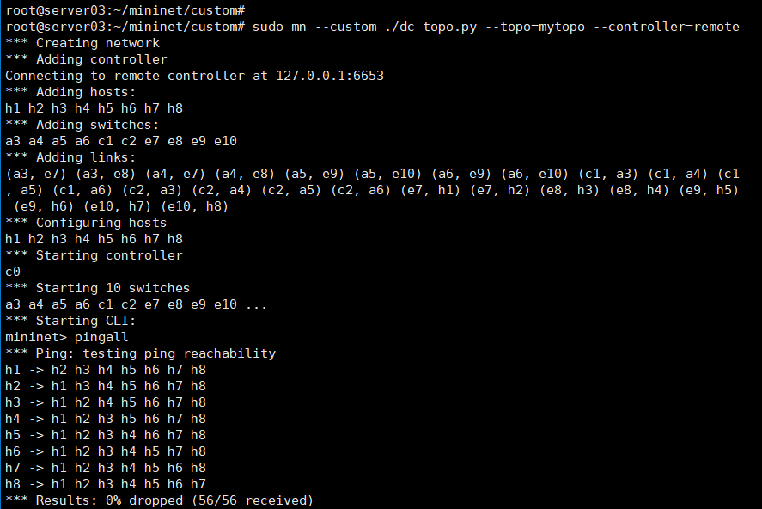

1. **Topo Check**

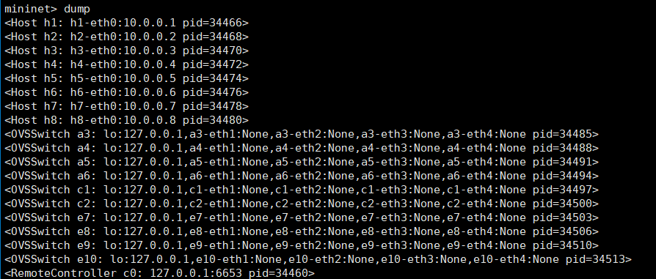

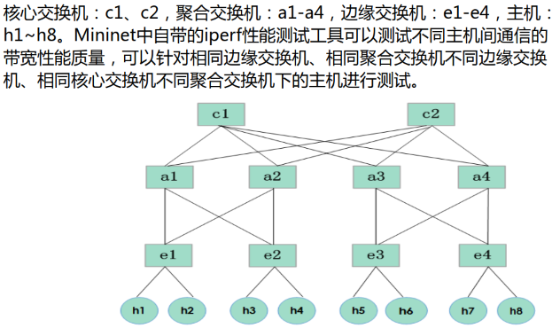

1. **End to end bandwidth test**

