## **COVER PAGE**

## **CST 8283 Business Programming (COBOL)**

**NAME：**Chengzhi Yu (040975517), lab session: 302, email: [yu000209@algonquinlive.com](mailto:yu000209@algonquinlive.com)

Xiaomei Lin (040979167), lab session: 302. email: [lin00164@algonquinlive.com](mailto:lin00164@algonquinlive.com)

Yongxiong Huang(040768231), lab session: 302, email: [huan0143@algonquinlive.com](mailto:huan0143@algonquinlive.com)

**PROJECT , Assignment or Lab assignment number** __Project 2____

Your signature is required below (Student Signature) certifying that the work submitted with this cover page is your own work, even if you have had help from me or other students. If you are going to use my solution set (logic or code) from a previous project, you must state that in the **Student’s Comments** below.

If you do not sign this cover page, I may not mark your submission.

**Student Comments**

Chengzhi Yu

Xiaomei Lin

Yongxiong Huang

______________________________________

(Student Signature)

===============================================================

**Marking Scheme (as applicable)**

The project will be marked out of 100% using the following breakdown.

### Refer to Notes Regarding Grading below for specific points that will be checked and influence the marks allocated.

**NOTE** – if this cover page is not used, you will immediately lose 10%

Output format and content ___ / 20

Program listing ___ / 50

Documentation ___ / 30

**TOTAL ____ / 100**

Hierarchy Charts

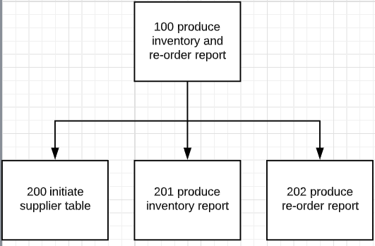

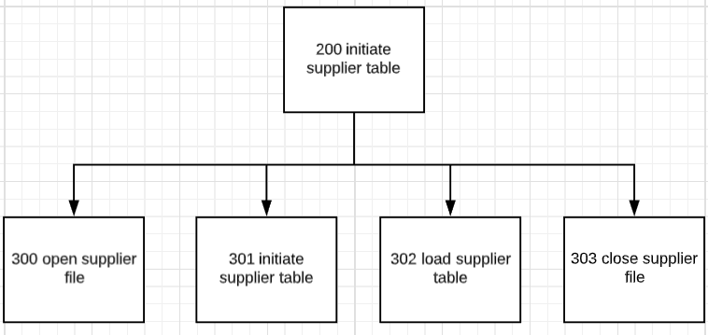

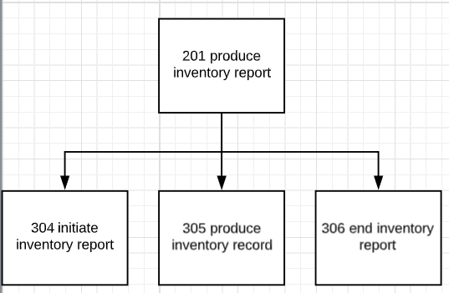

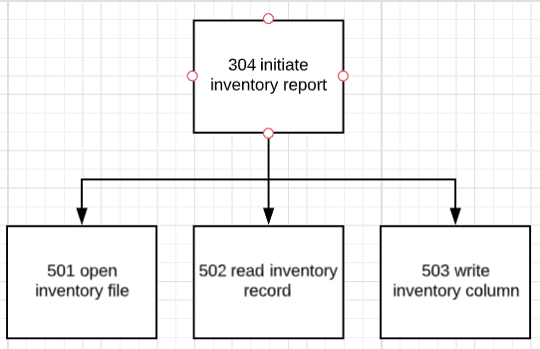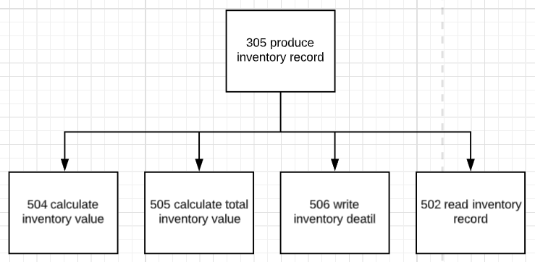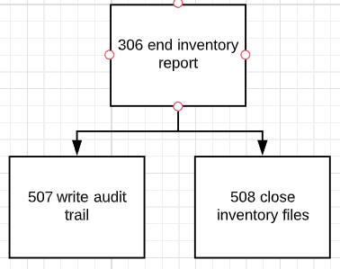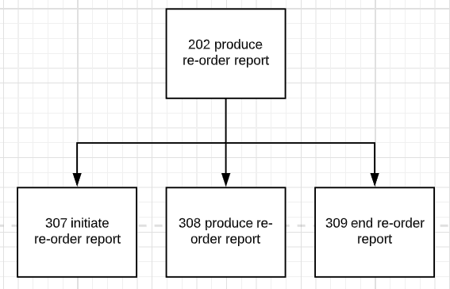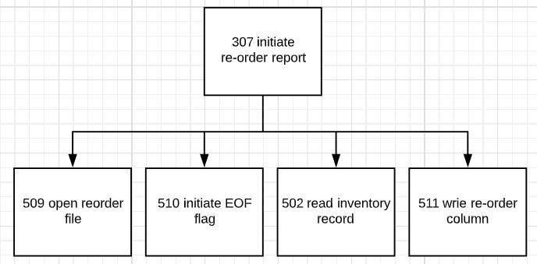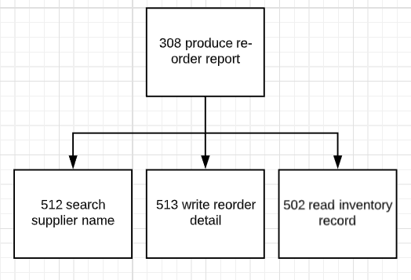

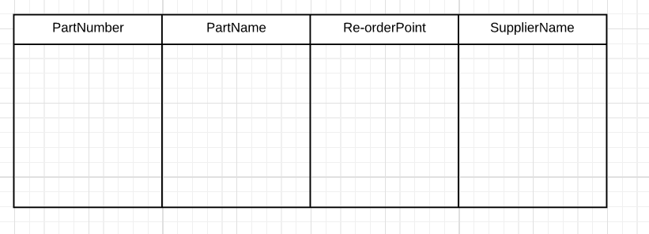

Output Layout Diagram