1. **Delicious cold shredded white radish**

**Materials**

White radish

Dried chili powder

Sesame

Soy sauce

Oyster sauce

Salt

Vinegar

Onion

Coriander

Sichuan pepper

**Cooking steps**

1. Wash and peel the white radish and cut into strips (hand-cutting is more delicious)
2. Chop green onion and coriander
3. Mix the dried chili powder and sesame evenly. Heat the pan with oil and add it until the oil starts to smoke. Pour it in and stir.
4. Heat the pan again and add oil until it reaches a certain temperature to add the peppercorns. Heat for about a minute and pour the peppercorns and oil on the prepared shredded white radish.
5. Then, add salt, vinegar, oyster sauce, soy sauce, blanched chili powder and sesame seeds, green onions, coriander, mix well and serve.
6. **Japanese curry chicken rice**

|  |  |
| --- | --- |
| [chicken](https://www.xiachufang.com/category/1136/) | Chicken breast or chicken thigh meat is fine, the amount depends on the individual |
| Curry cubes | For 2 people, use about 50 grams; for 4 people, use 100 grams |
| [milk](https://www.xiachufang.com/category/2316/) | 1\3 bags about 80ml🥛 |
| [Potato](https://www.xiachufang.com/category/206/) | 1 large or 2 medium sized ones |
| Carrots, broccoli, onions | Add or subtract based on personal preference, green is also an embellishment |
| non-stick pan |  |

1) Cut the chicken into small pieces and marinate them: 1 spoon of cooking wine, 2 spoons of soy sauce, a little onion, ginger and salt, and then mix them with starch (put less salt because the curry will be very tasty later, otherwise it will be too salty) Note: Chicken marinated with starch will be very tender and taste good. Chicken without starch will taste dry. If you don't like fat, just buy a large chicken breast! Marinate for about 20 minutes.

2) Cut the carrots into small pieces. 🥕It depends on your personal taste. Note: Carrots should be cut a little smaller than potatoes.

3) Cut the potatoes into cubes. 🥔If it is very delicious, you can add more. Potatoes will melt when stewed, so don't cut them too small, otherwise they will become smaller or even melted after stewing. (Note: The cut potatoes need to be placed in water, one is to make them powdery, and the other is to prevent them from turning black)

4) Add a little oil to the pan, stir-fry the diced potatoes and carrots, and the carrots will be more nutritious. When the surface of the potatoes is golden, it is basically done, and set aside. Add a little oil to the bottom of the pan and put onions in shreds because the onions will basically melt when stewing later, but they can be used to enhance the taste of the soup. Fry on low heat to bring out the sweet taste, then add the marinated chicken and stir-fry until the chicken changes color. Then add all the potatoes and carrots that have just been fried. I didn't buy onions at home today, so I didn't put them in. Be careful when frying onions because they tend to get mushy.

5) Then pour cold water into the pot and simmer all the ingredients. Don't put too little water, just enough to simmer all the ingredients. The final soup is the soul! Cover the pot until the water in the pot boils! While waiting for the water to boil, you can put the prepared curry cubes in a small bowl and break them into small pieces. At this time, the water is almost boiling. If you see that the water in the pot is boiling, turn to low heat, pour the curry cubes you just broke into the pot and start stewing the curry. (Cold water is raw water, not boiled water, thick soup, or broth.)

6) Cook over low heat, the flavor will gradually absorb. You can cover the lid and stir from time to time, because it is easy to get mushy. It is recommended to use a non-stick pan. . . After cooking for a while, poke a potato and try it. It is done when it is smooth. This process takes about 10 minutes.

7) It's almost done, the soup is boiling, and bubbles are coming out. Now it's time to collect the soup! Here's a unique trick for collecting the soup: turn the heat up first and add a little milk, which is equivalent to the effect of Japanese coconut milk, making the curry richer and more delicious. (It is the emulsification effect that makes the curry soup taste richer and richer). Pay attention to the amount of milk: don't put too much!

8) The final color and thickness should be similar to this, leave more soup!!! You can add a small spoonful of peanut butter to enhance the flavor (you don’t have to!! Note that the amount is a small spoonful! A little bit like a [coffee](https://www.xiachufang.com/category/20168/) spoon, ❌ It’s not for you to taste the peanut butter, but like milk, it is a flavor enhancer! Make the taste more intense and rich, this is an improvement step! Beginners don’t have to add it.

9) At this time, the whole house is filled with the aroma of curry~ (Put a bowl of rice on it, sprinkle some sesame seeds!! Add two broccoli florets for garnish, and it’s ready! The one I made myself is rich in soup!

1. 番茄土豆炖牛腩

Sirloin 750 g

tomato 2

Potato 1

carrot 1 root

ginger piece

onion Half

Green onions 1 root

Garlic Half

Cinnamon, star anise, bay leaves 1 piece, 2 pieces, 3 pieces

Salt 5g

crystal sugar 10

Light Soy Sauce 80 ml

Cooking wine 200 ml

Teriyaki sauce 15 ml

Steps：

1.1 All the ingredients are ready. Buy the kind of beef brisket that is fat and lean. Don't just buy the lean ones, which are tougher to cook. Just like when you cook braised pork, pork belly is the best, right? The same goes for beef brisket.

1.2 Cut into 3×4 cm pieces. It doesn't matter if it's bigger, beef is meant to be eaten in big bites. Soak in cold water for half an hour, changing the water once during this period. This step is to remove the blood from the beef.

1.3 Take a large casserole and fill it with half a pot of cold water, pour half of the cooking wine in the recipe, cut half of the ginger and put it in, then put the cut beef brisket in

1.4 Boil over high heat until blood foam comes out. Use a spoon to skim off the blood foam little by little. When it is almost clean, use a colander to pick up the beef brisket. Turn off the heat about two minutes after boiling. Do not pour out the blanching water, save it:) Because we have soaked the beef brisket before, the blanching water is not fishy but fragrant. It would be a pity to pour it out. But if you really mind, you can also leave it.

1.5 Other condiments can be washed and cut while waiting for blanching.

1.6 Pour oil into a cold pan and add rock sugar, simmer over medium-low heat

1.7 Cook it into this caramel color

1. 1.8 The photo of putting the blanched beef brisket into the pan and stir-frying    
   fully reflects my confusion at the time 😂. It is really troublesome to take pictures of the steps when cooking. My hands are full of oil and water. The stove is on and I have to use one hand to operate and take pictures with the other hand. It’s no wonder that so many recipes don’t have process pictures. It’s really troublesome. I also have to worry about whether the food in the pot is burnt 😹

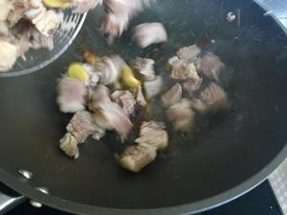

1. Fry until everything turns into this color and the surface is slightly burnt, then add the onion, ginger, garlic, star anise, cinnamon and bay leaves.

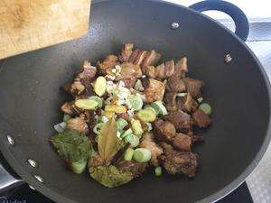

1. Stir-fry for about a minute, then pour in the remaining half of the cooking wine and stir-fry until the water is dry (the intoxicating aroma begins to emit at this time)

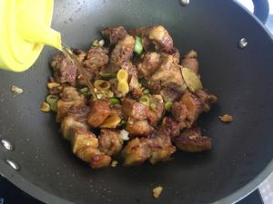

1. Pour it into the casserole that was blanched just now and boil it over high heat

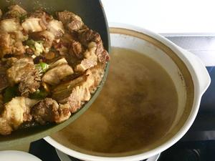

1. Then pour the braised soy sauce

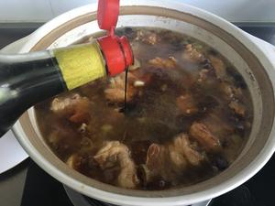

1. Then add soy sauce and simmer for 40 minutes. The whole house should be filled with fragrance. Yes, you smelled it right, it is the spicy smell of Master Kang's braised beef noodles! Isn't it inspiring? !

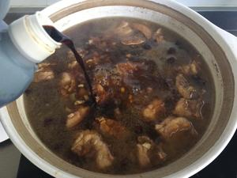

1. Then we continue to prepare other ingredients. You don't need to peel the tomatoes and cut them directly. The skin is full of lycopene. Just pick it out when you eat it. Onions can be cut in any way. Carrots and potatoes are cut with a rolling knife. Do you know what a rolling knife is? Do you know how to sharpen a pencil? Just cut it like that. Cut the potatoes into large pieces. If the pieces are too small, they will melt into the soup when cooking. (You can also peel the potatoes before putting them in the pot to prevent oxidation and blackening)

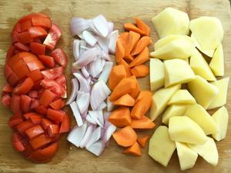

1. Put oil in the pan, throw the carrots in and fry them for a while. The carotene in carrots is fat-soluble and will taste better when fried. Then put onions and tomatoes in one by one.

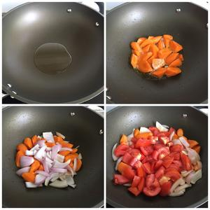

1. Add salt

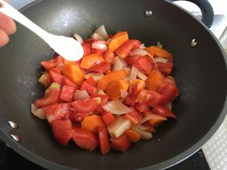

1. Fry until the tomatoes are a little mushy, pour some soup from the casserole where the beef brisket was cooked into the casserole and cook for 2 minutes

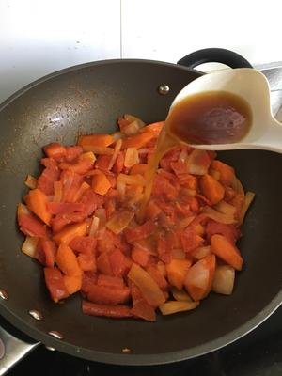

1. Use a spoon to scoop out the soup, leaving only a tiny bit. You will know why in a moment (if the pot is big enough, you can skip this step)

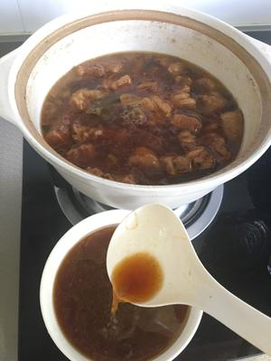

1. Pour the fried tomatoes, onions and carrots into the pot and cook together

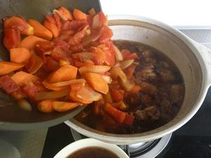

1. After stewing for 1 hour, pour the potatoes in. Look, if you don’t scoop out some soup in advance, it won’t be able to hold it, right? (Tsk, that’s because your pot is small.) Then we boil the potatoes over high heat and then simmer over low heat for about 20 minutes. During this time, don’t forget to add all the broth that you have scooped out. Be careful not to let it stick to the pot. If you put the potatoes in first, try not to turn the pot over during cooking, because if the potatoes are cooked, they will become mushy if you turn them over frequently. Then, when stewing, you can taste the meat to see if it is flavored enough. If it is cooked, it will not be easy to absorb the flavor. If it is not enough, you can add salt or light soy sauce. If it is too salty, you can add potatoes to absorb the flavor.

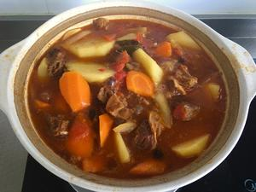

1. Ding ding ding ding~ It’s out of the pot! Isn’t it so tempting~ Go and get some rice and eat two bowls :) This soup is invaluable for mixing with rice!

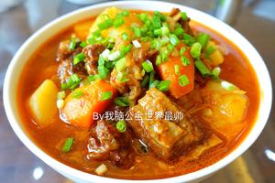

**Tips**

If it is not cooked well after following the instructions, it must be the meat's problem! I once bought some beef brisket, and it was not cooked well after being stewed in a casserole for 5 hours. I also put it in a pressure cooker for 3 hours, but it was still not cooked well. In the end, I had to chop it up and make ants climbing a tree (ㅍ_ㅍ) Don't forget to hand in your homework