1.在OK61XX 开发板上测试BT 功能时
请提前启动蓝牙服务；命令： /etc/init.d/bluetooth start

2.bluez 中直接使用了D-BUS 的底层API.
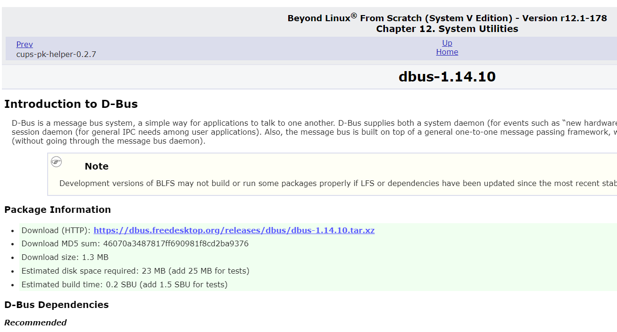

3.bluetoothctl 创建本地服务
Ref@https://stackoverflow.com/questions/25427768/bluez-how-to-set-up-a-gatt-server-from-the-command-line

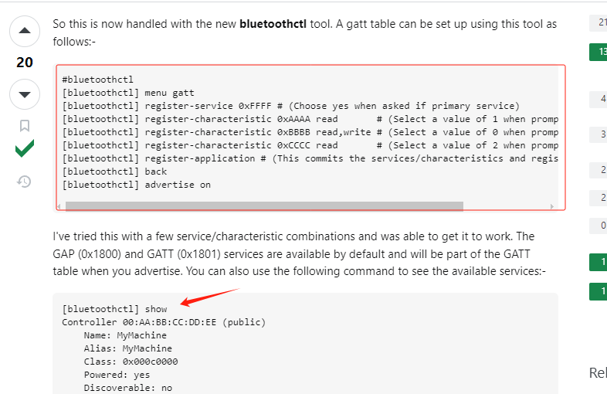

4.glib
ref@https://fuchsia.googlesource.com/third_party/glib/+/refs/tags/2.80.0

5.pthread

a. thread programming ref
D:\AALIBRARY\LIB_C\Linux应用开发\ben-books-master

b.pthread programming guide
pthread_ref\lecture_pthreads.pdf
pthread_ref\pthread.pdf
pthread_ref\pthread-Tutorial.pdf
D:\AALIBRARY\LIB_C\Linux应用开发\ben-books-master\POSIX_Thread\MultiThreaded-Programming-With-POSIX.pdf

c.pthread source code
http://git.savannah.gnu.org/cgit/hurd/libpthread.git/refs/

//_______________________________________________________________________

