By Diane Liu, Colin Mo, Dara Rubin and Chenhui Zhou

**What emojify Does For You**

emojify provides a clean-cut and simplistic interface for any user to input a proposed English headline and receive a translated string of the initial sentence as emojis in mere moments, acting as a translator from English to emojis.

As digital media evolves and the landscape moves towards drawing a veritable amount of attention from millennials, utilizing a pure or mixed headline of emojis and traditional text may serve as a way for headliners to make users pause.

By identifying that potential users have a desire for such a process and others may simply be interested in having fun with what we can create, we’ve provided an interface for the process in the most non-distracting way possible, emphasizing on the user’s ability to clearly get an output for an input, as well as share whatever funny results they end up with.

For the trendy editor who wishes to attract a different kind of article viewership to the bored office worker seeking a few minutes of entertainment, emojify can provide a service that meets both of their needs.

**How It Works**

Our app works by taking user input in plain English and using our Flask server. Here, the phrase goes through many parts - it finds the root of the word, trims punctuation, performs synonym lookups (via WordNet), handles negation, changes any capitalization to lowercase, and also looks at the words in groups of two (bigram lookup) since many of the emoji definitions (e.g. New York) have two words before doing a unigram lookup. All of this is based on a .json file we have with emojis, their definitions, and some synonyms. This file is lemmatized before it returns to the user. After all these tasks run, the emoji translation goes back through Flask and returns a string of emojis to the user on our website.

**Key Technologies**

* **Flask**
* **Lemmatization**
* **Word-Net**
* **JSON Dictionary**

**Next Steps**

Considering the lack of emojis for many words and phrases, we would love to have an expanded emoji library to utilize more translations. The lack of many emojis for our translator is akin to translating into English without being able to use prepositional words or phrases; far too many semantics are lost in the translation process.

We would also need to consider the impact of Apple OS and non-Apple computers getting different icons corresponding to the same emoji; in particular, some emojis are only displayed in black and white on non-Apple products, while the Apple products display it in color. Depending on the context, sometimes this may have a factor for the receiver if a user on one device shared it and the context became different due to the difference in emojis on a different system.

**Screenshot**

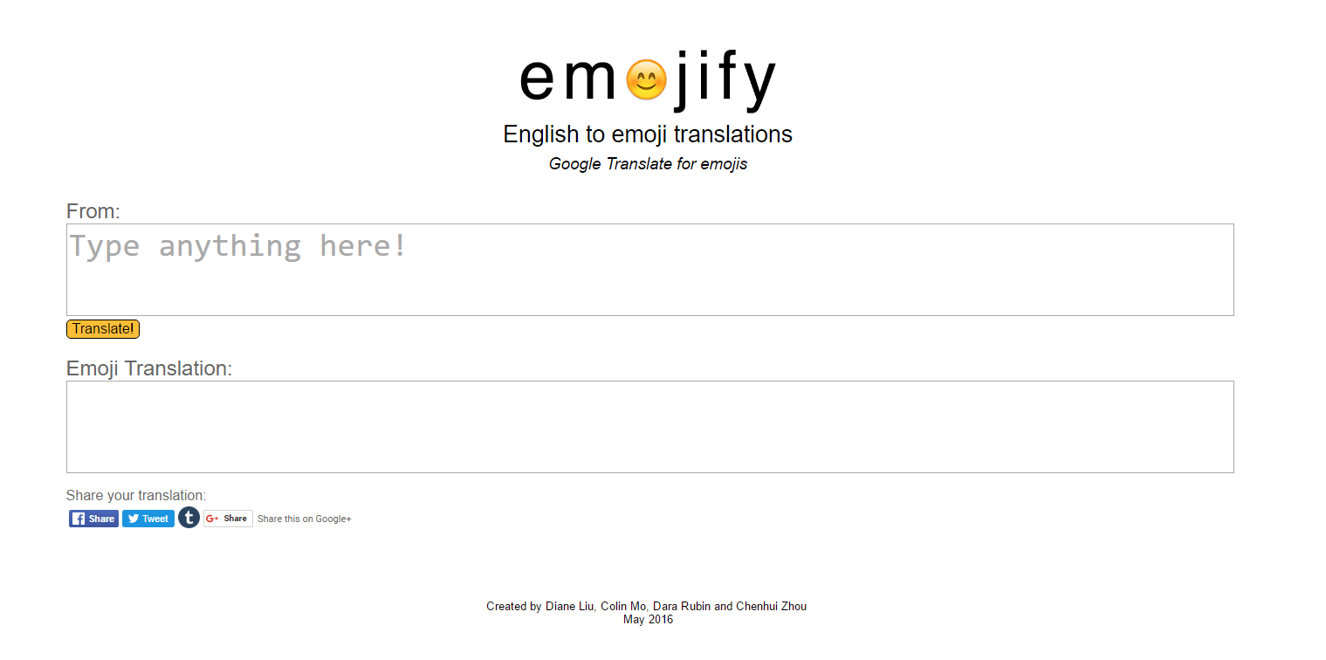

**Display of emojify’s home page**