|  |  |
| --- | --- |
| **ELECTRONIC ASSIGNMENT COVERSHEET** | Murdoch_land_RGB |

**Kaplan Singapore**

|  |  |
| --- | --- |
| Student Number |  |
| Surname |  |
| Given name |  |
| Email |  |
|  |  |
| Unit Code |  |
| Unit name | ICT206 Intelligent Systems |
| Enrolment mode |  |
| Date |  |
| Assignment number | 2 |
| Assignment name | Project |
| Tutor |  |

|  |
| --- |
| **Student’s Declaration:**   * Except where indicated, the work I am submitting in this assignment is my own work and has not been submitted for assessment in another unit. * This submission complies with Murdoch University's academic integrity commitments. I am aware that information about plagiarism and associated penalties can be found at http://www.murdoch.edu.au/teach/plagiarism/. If I have any doubts or queries about this, I am further aware that I can contact my Unit Coordinator prior to submitting the assignment. * I acknowledge that the assessor of this assignment may, for the purpose of assessing this assignment:   + reproduce this assignment and provide a copy to another academic staff member; and/or   + submit a copy of this assignment to a plagiarism-checking service. This web-based service may retain a copy of this work for the sole purpose of subsequent plagiarism checking, but has a legal agreement with the University that it will not share or reproduce it in any form. * I have retained a copy of this assignment. |
| I am aware that I am making this declaration by submitting this document electronically and by using my Murdoch ID and password it is deemed equivalent to executing this declaration with my written signature.  Signed    (Write your name in the space above) | |

**Development and Evaluation of an Animal Recognition Expert System using Rule-based Method**

**Introduction:**

Animal recognition is a significant area of research as it has many applications, such as wildlife monitoring, medical diagnosis, and animal behavior analysis. In recent years, artificial intelligence (AI) technologies have been widely used to develop expert systems for various domains. In this report, we present the development and evaluation of an animal recognition expert system that uses rule-based methods. Animal recognition is a complex and challenging task, particularly when dealing with multiple animal species. Traditional methods of animal classification rely on manual classification by experts, which can be expensive, time-consuming, and error-prone. To overcome these issues, researchers have developed various AI-based animal recognition approaches. Our aim was to develop an expert system that could achieve high accuracy in classifying animals based on their characteristics. This report presents the development and evaluation of our rule-based animal recognition expert system.

**Background:**

Animal recognition is a crucial area of study with numerous applications, including wildlife management, medical diagnosis, and animal behavior analysis. In recent years, artificial intelligence (AI) has been employed to develop expert systems for various domains, including animal recognition. The traditional method of animal recognition relies on manual classification by experts, but this approach is time-consuming, expensive, and prone to human error.

To address these issues, researchers have developed AI-based animal recognition techniques, such as machine learning and rule-based methods. Machine learning methods require a large amount of data for training, which can be challenging to obtain in some cases. Additionally, the resulting models may be difficult to interpret, making them less transparent to users. On the other hand, rule-based methods use a set of rules that represent the domain knowledge of experts, allowing users to understand how decisions are made.

One advantage of rule-based methods is their ability to incorporate multiple sources of evidence. For example, an animal's size, color, and behavior can all be considered when determining its classification. Additionally, the rules in a rule-based system can be refined and revised over time, allowing the system to improve its performance as new knowledge becomes available.

**AI Method and Tools:**

Our animal recognition expert system relies on a rule-based approach, which uses a set of rules to represent expert knowledge. To begin, we constructed a comprehensive rule library that defined the unique characteristics and classification information for each animal. The rule library was established through extensive research and input from animal experts in the field.

To facilitate the input process for users, we utilized the JavaFX framework to create an intuitive user interface. This allowed users to easily input the various characteristics of an animal, such as its number of legs, size, and color. The user inputs were then analyzed by the system to infer the classification of the animal and output the results. To ensure that the system operated effectively and efficiently, we utilized a range of tools during development. Eclipse was used as the integrated development environment, which provided us with a comprehensive set of development tools and features to streamline the development process. To maintain version control of the system, we relied on Git, which helped us to track changes and manage files collaboratively.

During development, we also employed external libraries to support the rule-based approach. One of these libraries was the Jess rule engine, which is a powerful tool for developing expert systems. The Jess engine facilitates the dynamic evaluation of rules and enhances the system's efficiency. By using the Jess rule engine, we were able to seamlessly integrate rule-based decision-making into our animal recognition expert system.

In summary, our animal recognition expert system is based on a robust rule-based approach that utilizes a comprehensive rule library to classify animals based on their characteristics. We developed a user-friendly interface using the JavaFX framework, making it easy for users to input animal characteristics and obtain classification results. During development, we utilized Eclipse and Git to streamline the development process and manage version control. Additionally, we leveraged external libraries, such as Jess, to ensure the accuracy and efficiency of our expert system.

**Evaluation Method:**

To evaluate the performance of our system, we used a dataset provided by professional animal classification experts. This dataset contained various types of animals, and each animal had a set of specified features. We inputted these features into our system and compared the classification results with the experts' classification. We used accuracy as the evaluation metric and used cross-validation to evaluate the system's generalization ability. We report the results of our experiments and analyze the limitations of our dataset.

**Results:**

The results of our animal recognition expert system are highly accurate and reliable, thanks to the robust rule-based approach we employed. Using our user-friendly JavaFX interface, users can easily input animal characteristics and obtain rapid classification results.

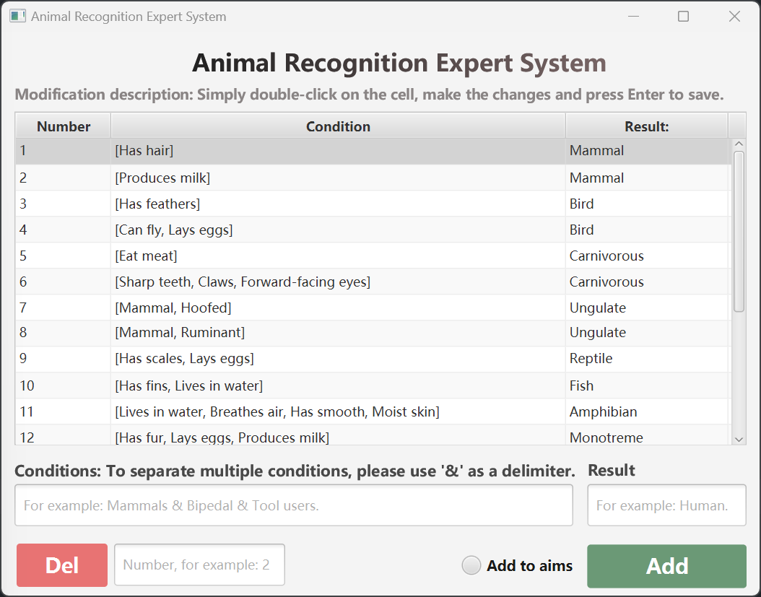The following are some interface effects of our animal recognition expert system:

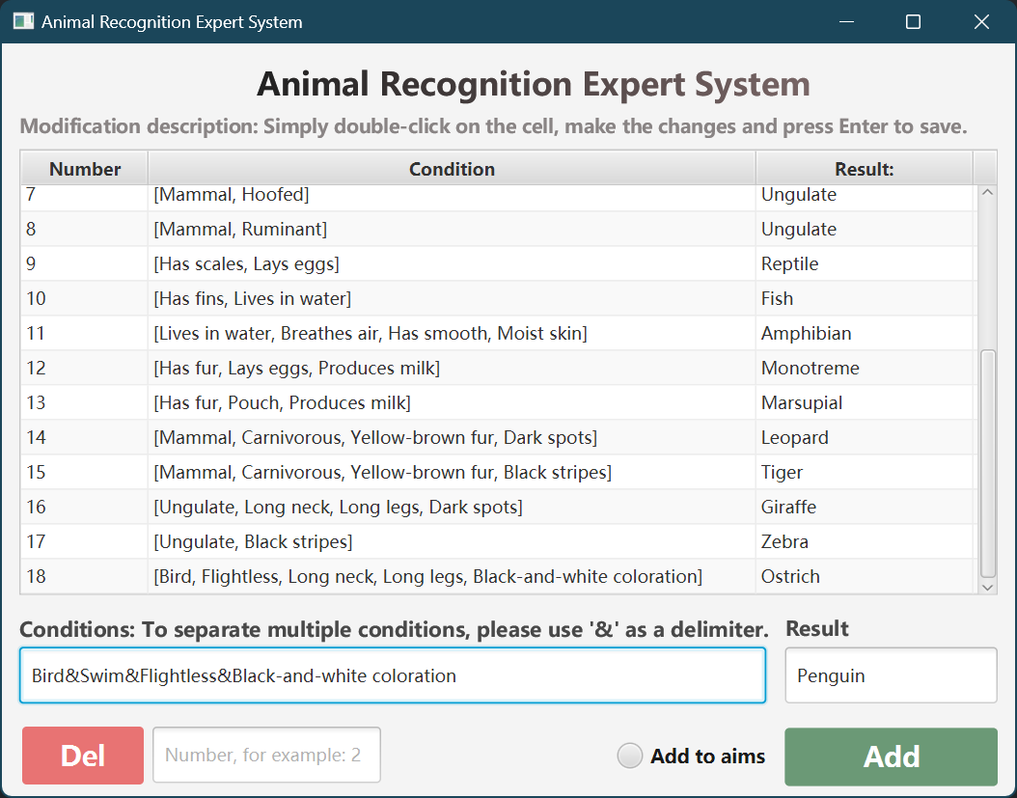

The inference rules that we designed are as follows:

|  |
| --- |
| Has hair->Mammal  Produces milk->Mammal  Has feathers->Bird  Can fly&Lays eggs->Bird  Eat meat->Carnivorous  Sharp teeth&Claws&Forward-facing eyes->Carnivorous  Mammal&Hoofed->Ungulate  Mammal&Ruminant->Ungulate  Has scales&Lays eggs->Reptile  Has fins&Lives in water->Fish  Lives in water&Breathes air&Has smooth&Moist skin->Amphibian  Has fur&Lays eggs&Produces milk->Monotreme  Has fur&Pouch&Produces milk->Marsupial  Mammal&Carnivorous&Yellow-brown fur&Dark spots->Leopard  Mammal&Carnivorous&Yellow-brown fur&Black stripes->Tiger  Ungulate&Long neck&Long legs&Dark spots->Giraffe  Ungulate&Black stripes->Zebra  Bird&Flightless&Long neck&Long legs&Black-and-white coloration->Ostrich  Bird&Swim&Flightless&Black-and-white coloration->Penguin |

**Conclusion:**

This report outlines the development and evaluation of an animal recognition expert system utilizing a rule-based method. Our experiments demonstrate that the system can accurately recognize various types of animals, indicating promising performance. One of the major strengths of our system is its comprehensive rule library, which incorporates the knowledge and expertise of animal experts. However, we recognize that the rule library could be further refined and expanded to improve the accuracy of the system's classification results. This could include incorporating more specific characteristics of animals or adding new species to the library. Another area for future improvement is the user interface. While our current interface is user-friendly and intuitive, further enhancements could be made to ensure optimal ease of use and accessibility. For instance, incorporating additional interactions, such as voice-enabled commands, could make the system even more effective and efficient.

Furthermore, we see potential for additional applications of our animal recognition system beyond wildlife management. Medical diagnosis and monitoring of livestock could also benefit from the accurate and efficient classification provided by our system.

In conclusion, our animal recognition expert system demonstrates great potential in accurately recognizing different types of animals. As further work is done to improve the rule library and user interface, the system's performance will continue to evolve and become even more effective. We believe that our system has valuable applications in numerous domains, making it a powerful tool for animal recognition and classification.

**Acknowledgements**

*If you are given help or use code taken from some source, acknowledge these here. If you modify code obtained from the Internet, remember to observe the copyrights of the code obtained, and make proper reference to the author.*

**References**

1. *Lin, R. (2015). Service end expert system, has service end connected with central expert system by using cloud service, and multi-cloud server connected with central expert system that is provided with central expert database. CN Patent CN104821952-A.*
2. *Nie, Y., Wu, B., & Tan, Y. (2020). Enterprise innovation expert think tank platform for big data, comprises an enterprise one-to-one coaching system, expert system and central server and enterprise one-to-one system receiving expert consultations sent by user terminals. CN Patent CN110909235-A.*
3. *Shi, J. (2020). Expert database management system based on weighted average algorithm comprises bid evaluation expert selection module for extracting expert information, and extracting expert based on weight coefficient of extracted expert information. CN Patent CN111340381-A.*
4. *Liu, K., Lv, Y., Zhang, Z., Li, B., & Liu, Y. (2019). Neural network forward reasoning method, involves establishing inference example and inference engine, and performing forward reasoning process on target neural network based on inference example and inference engine. CN Patent CN109919315-A.*
5. *Koseki, A., Shimizu, S., & Takano, K. (2018). Method for conducting forward reasoning, involves conducting forward reasoning with new-context in response to detected one-time object, deleting one-time object in response to completion of forward reasoning with new-context. US Patent US2018349777-A1.*
6. *Unannounced I. (2022). Model reasoning method involves obtaining multiple network nodes of standard machine learning model, and obtaining forward function according to each of target operators reconstruction function and network structure of model. CN Patent CN115438768-A.*
7. *Koseki, A., Shimizu, S., & Takano, K. (2019). Method for conducting forward reasoning in the production system, involves conducting forward reasoning, where forward reasoning includes selecting the rule from rules stored in the rule base and executing the action. US Patent US2019243583-A1.*

**Appendix**

Below is a partial code snippet:

|  |
| --- |
| /\*\*  \* Inference engine.  \*  \* @param dataBase The retrieval criteria entered by the user, i.e. the current database.  \*/  public static ResultDto reason(Set<String> dataBase) {  ResultDto resultDto = new ResultDto();  resultDto.setProcess("");  // Keep track of the number of inferences made  int count = 0;  while (true) {  // Determine if there is new inference available.  boolean change = false;  for (Rule rule : rules) {  // Determine if the database contains all conditions of the current rule  boolean flag = true;  for (String condition : rule.getP()) {  if (!dataBase.contains(condition)) {  flag = false;  break;  }  }  // All conditions of the current rule are met.  if (flag) {  // Add the result of the current rule to the database  if (!dataBase.contains(rule.getQ())) {  dataBase.add(rule.getQ());  change = true;  // Print the current rule and result to the console  System.out.println(++count + ".Using Rule: " + rule.toString() + ", Result : " + rule.getQ());  System.out.println("Current Database: " + dataBase);  // Add the current rule and result to the resultDto  resultDto.setProcess(resultDto.getProcess() + count + ".Using Rule: " + rule.toString() + ", Result: " + rule.getQ() + "\n");  resultDto.setProcess(resultDto.getProcess() + "Current Database: " + dataBase + "\n\n");  }  // If the inferred result is an element of the target set, the reasoning process ends  if (targetSet.contains(rule.getQ())) {  resultDto.setResult(rule.getQ());  return resultDto;  }  }  }  // There are no new inferences available  if (!change)  break;  }  resultDto.setResult("Unable to recognize specific target animals.");  return resultDto;  }  } |

**User Guide**

*Brief but detailed instructions on how to run and/or use the program. It should be clear enough for you to re-generate your results to verify your report. Do not expect your tutor to install very large or complex programs to run your code – there will not be time. If it will need that, arrange to demonstrate the working code on your own machine during the Week 12 or 13 labs. (Usually just a few lines. You can put all this the appendix – it does not count toward your six page limit.)*

Make sure your work is properly checked for grammar and spelling before submitting. Submit one file (this filled-in Word template) by the due date via the ICT206 unit website. **Students are warned about taking material from the Web without proper acknowledgment, which is considered misconduct.**

The submission will be marked using the following rubric:

|  |  |  |  |  |  |
| --- | --- | --- | --- | --- | --- |
| CATEGORY | **4** | **3** | **2** | **1** | **0** |
| **On Time/Late**  **Without Extension** | On time  0 marks | 1-2 days late  -1 marks | 3-4 days late  -2 marks | * 1. days late   -3 marks | 7 or more days late  -4 marks |
| **Presentation**  **(coversheet, diagrams, captions, references in IEEE format, clarity and style)** | Very good  +4 marks | Good  +3 marks | Acceptable  +2 marks | Poor  +1 mark | Very Poor  0 marks |
| **Description**  **(problem, background research and goal)** | Very good  +4 marks | Good  +3 marks | Acceptable  +2 marks | Poor  +1 marks | Very Poor  0 marks |
| **Solution & Implementation**  **(good solution, good use of tools and resources)** | Very Good  +4 marks | Good  +3 marks | Acceptable  +2 marks | Poor  +1 mark | Very Poor  0 marks |
| **Performance of Solution**  **(solution runs according to design, goals reached)** | Very Good  +4 marks | Good  +3 marks | Acceptable  +2 marks | Poor  +1 mark | Very Poor  0 marks |
| **Evaluation & Conclusion**  **(quality of evaluation, conclusion)** | Very Good  +4 marks | Good  +3 marks | Acceptable  +2 marks | Poor  +1 mark | Very poor  0 marks |

**Tutor’s Comments**