院 系 数据科学与计算机学院 学 号 16337233 姓 名 王凯祺

【实验题目】**Android控件布局实验**

【实验目的】学习Android的基本控件、列表和布局。

【实验准备】

下载并安装Android Studio 3.3.2。

【注意事项】

（1）按照要求的步骤和列举的例程做，不要进行简化。

（2）全部完成后参照“参考运行截屏”进行截屏，可以增加截屏。

（3）参考“1、控件布局源代码.rar”中的源代码。

【实验内容】

1、注册界面(Register)，要求用相对布局(Relative Layout) 进行布局，下拉框(Spinner)要求先用静态数组(arrays.xml)方式直接显示（参考SpinnerStatic），然后采用自定义方式改变字体大小和颜色（参考ListViewArray-**自定义列表模式**）。

部分控件参考：RadioGroup，CheckBox

全部完成后的运行截屏：

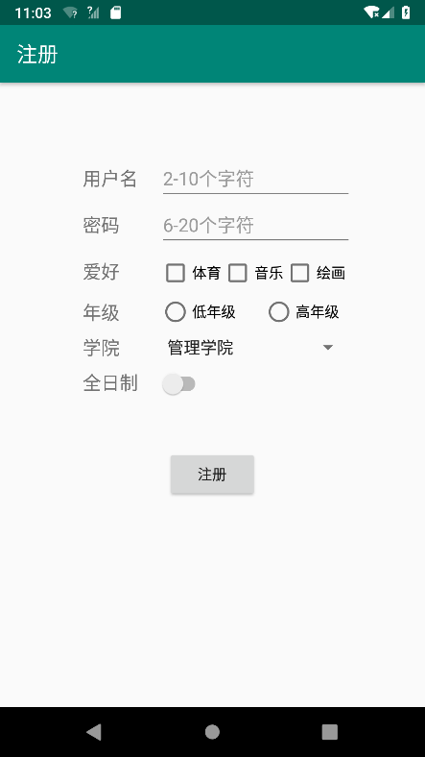 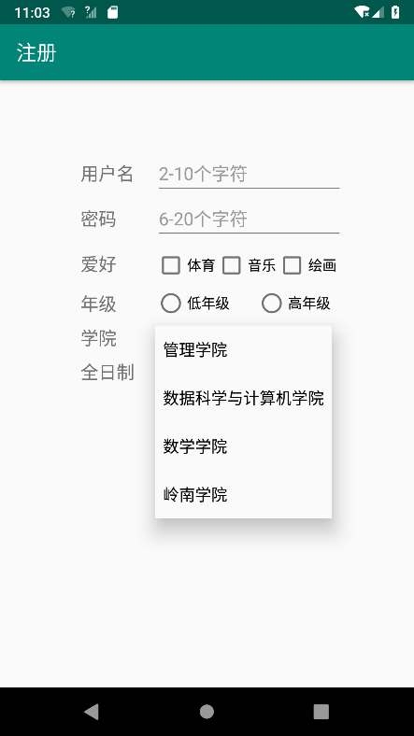

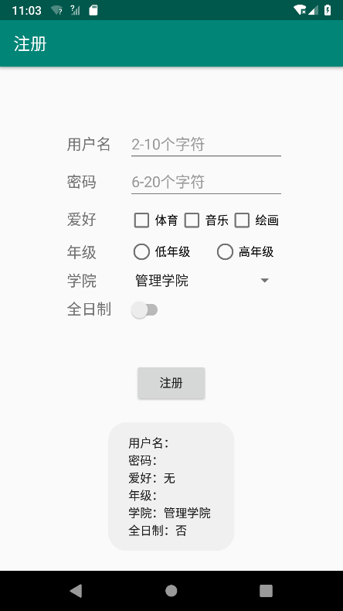 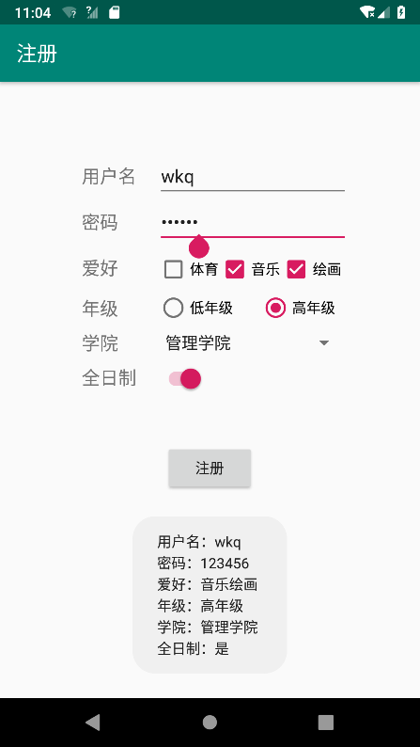

(输入为空时点击**注册按钮**) (输入不为空时点击**注册按钮**)

全部完成后源码(.java和.xml)：

**app\src\main\java\com\example\lab1\MainActivity.java：**

package com.example.lab1;

import android.support.v7.app.AppCompatActivity;

import android.os.Bundle;

import android.widget.Button;

import android.widget.CheckBox;

import android.widget.EditText;

import android.widget.RadioButton;

import android.widget.Spinner;

import android.widget.TextView;

import android.widget.Switch;

import android.view.View;

import android.view.View.OnClickListener;

import android.widget.Toast;

public class MainActivity extends AppCompatActivity {

Button btn;

@Override

protected void onCreate(Bundle savedInstanceState) {

super.onCreate(savedInstanceState);

setContentView(R.layout.activity_main);

initView();

}

private void initView() {

btn = (Button)findViewById(R.id.register);

btn.setOnClickListener(new OnClickListener() {

@Override

public void onClick(View v) {

String str = "";

TextView t1 = (TextView)findViewById(R.id.textView);

EditText e1 = (EditText)findViewById(R.id.username);

str += t1.getText() + "：" + e1.getText() + "\n";

TextView t2 = (TextView)findViewById(R.id.textView3);

EditText e2 = (EditText)findViewById(R.id.password);

str += t2.getText() + "：" + e2.getText() + "\n";

TextView t3 = (TextView)findViewById(R.id.textView2);

String hobby = "";

CheckBox c1 = (CheckBox)findViewById(R.id.tiyu);

if (c1.isChecked()) hobby += c1.getText();

CheckBox c2 = (CheckBox)findViewById(R.id.yinyue);

if (c2.isChecked()) hobby += c2.getText();

CheckBox c3 = (CheckBox)findViewById(R.id.huihua);

if (c3.isChecked()) hobby += c3.getText();

if (hobby == "") hobby = "无";

str += t3.getText() + "：" + hobby + "\n";

TextView t4 = (TextView)findViewById(R.id.textView4);

RadioButton r1 = (RadioButton)findViewById(R.id.dinianji);

RadioButton r2 = (RadioButton)findViewById(R.id.gaonianji);

str += t4.getText() + "：";

if (r1.isChecked()) str += r1.getText();

if (r2.isChecked()) str += r2.getText();

str += "\n";

TextView t5 = (TextView)findViewById(R.id.textView5);

Spinner s1 = (Spinner)findViewById(R.id.xueyuan);

str += t5.getText() + "：" + s1.getSelectedItem().toString() + "\n";

TextView t6 = (TextView)findViewById(R.id.textView6);

Switch s2 = (Switch)findViewById(R.id.quanrizhi);

str += t6.getText() + "：";

if (s2.isChecked()) str += "是"; else str += "否";

Toast.makeText(getApplicationContext() ,str, Toast.LENGTH_SHORT).show();

}

});

}

}

**app\src\main\res\layout\activity_main.xml：**

<?xml version="1.0" encoding="utf-8"?>

<android.support.constraint.ConstraintLayout xmlns:android="http://schemas.android.com/apk/res/android"

xmlns:app="http://schemas.android.com/apk/res-auto"

xmlns:tools="http://schemas.android.com/tools"

android:layout_width="match_parent"

android:layout_height="match_parent"

android:layout_margin="0dp"

tools:context=".MainActivity">

<RelativeLayout

android:layout_width="match_parent"

android:layout_height="match_parent"

android:layout_margin="70dp"

tools:layout_editor_absoluteX="100dp"

tools:layout_editor_absoluteY="100dp">

<TextView

android:id="@+id/textView"

android:layout_width="wrap_content"

android:layout_height="wrap_content"

android:layout_alignParentLeft="true"

android:layout_marginLeft="10dp"

android:layout_marginTop="10dp"

android:text="@string/username"

tools:layout_editor_absoluteX="100dp"

tools:layout_editor_absoluteY="130dp"

android:layout_alignParentStart="true"

android:layout_marginStart="10dp" />

<EditText

android:id="@+id/username"

android:layout_width="wrap_content"

android:layout_height="wrap_content"

android:layout_alignParentEnd="true"

android:layout_alignParentRight="true"

android:maxLength="10"

android:inputType="textPersonName" />

</RelativeLayout>

</android.support.constraint.ConstraintLayout>

2、（GridViewSimple）做一个GridView画面（参考ListBoxSimple），要做长短点击事件，采用相对布局。

全部完成后的运行截屏：

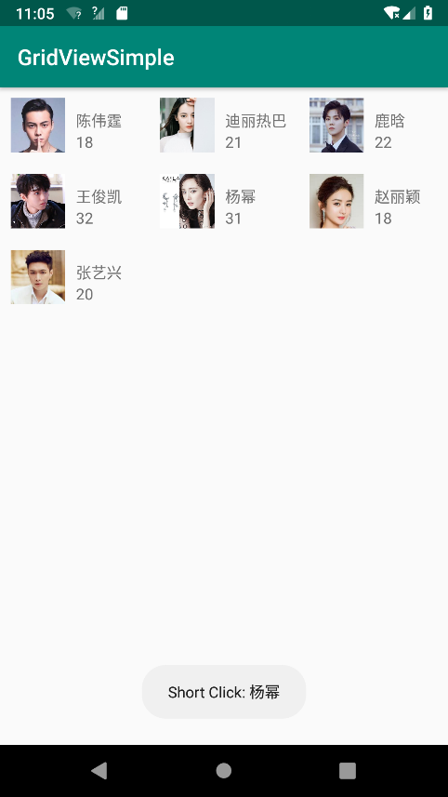 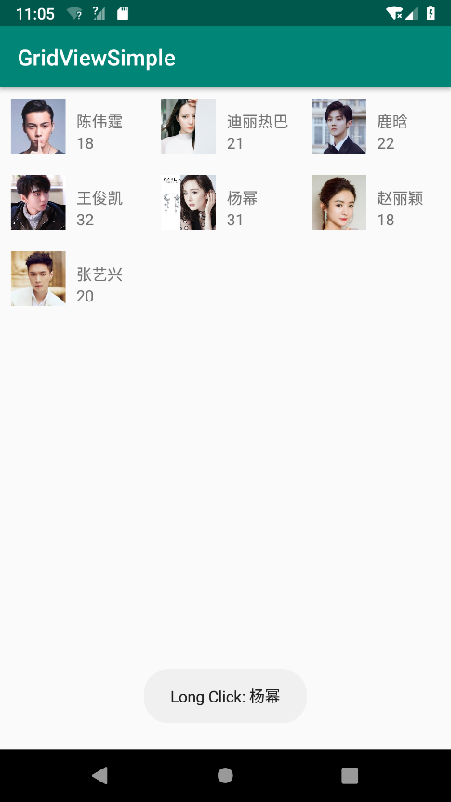

全部完成后源码(.java和.xml)：

**app\src\main\java\com\example\lab2\MainActivity.java：**

package com.example.lab2;

import android.content.Context;

import android.support.v7.app.AppCompatActivity;

import android.os.Bundle;

import android.view.View;

import android.view.ViewGroup;

import android.widget.AdapterView;

import android.widget.BaseAdapter;

import android.widget.GridView;

import android.widget.ImageView;

import android.widget.RelativeLayout;

import android.widget.TextView;

import android.widget.Toast;

import org.w3c.dom.Text;

public class MainActivity extends AppCompatActivity {

@Override

protected void onCreate(Bundle savedInstanceState) {

super.onCreate(savedInstanceState);

setContentView(R.layout.activity_main);

GridView gridview = (GridView)findViewById(R.id.grid_view);

gridview.setAdapter(new ImageAdapter(this));

bindListener();

gridview.setOnItemClickListener(ocl_gridview);

gridview.setOnItemLongClickListener(olcl_gridview);

}

public void bindListener() {

ocl_gridview = new AdapterView.OnItemClickListener() {

@Override

public void onItemClick(AdapterView<?> parent, View v, int position, long id) {

Toast.makeText(MainActivity.this, "Short Click: " + Names[position], Toast.LENGTH_SHORT).show();

}

};

olcl_gridview = new AdapterView.OnItemLongClickListener() {

@Override

public boolean onItemLongClick(AdapterView<?> parent, View view, int position, long id) {

Toast.makeText(MainActivity.this, "Long Click: " + Names[position], Toast.LENGTH_SHORT).show();

return true;

}

};

}

public class ImageAdapter extends BaseAdapter {

private Context mContext;

public ImageAdapter(Context c) {

mContext = c;

}

public int getCount() {

return mThumbIds.length;

}

public Object getItem(int position) {

return null;

}

public long getItemId(int position) {

return 0;

}

public View getView(int position, View convertView, ViewGroup parent) {

View view = View.inflate(mContext, R.layout.gridview, null);

RelativeLayout rl = (RelativeLayout)view.findViewById(R.id.grid_view);

ImageView image = (ImageView)rl.findViewById(R.id.chooseImage);

TextView name = (TextView)rl.findViewById(R.id.chooseName);

TextView age = (TextView)rl.findViewById(R.id.chooseAge);

image.setImageResource(mThumbIds[position]);

name.setText(Names[position]);

age.setText(String.valueOf(Ages[position]));

return rl;

}

}

private Integer[] mThumbIds = {

R.drawable.a1,

R.drawable.a2,

R.drawable.a3,

R.drawable.a4,

R.drawable.a5,

R.drawable.a6,

R.drawable.a7

};

private String[] Names = {"陈伟霆", "迪丽热巴", "鹿晗",

"王俊凯", "杨幂", "赵丽颖", "张艺兴"};

private int[] Ages = {18, 21, 22, 32, 31, 18, 20, 25};

private AdapterView.OnItemClickListener ocl_gridview;

private AdapterView.OnItemLongClickListener olcl_gridview;

}

**app\src\main\res\layout\activity_main.xml：**

<?xml version="1.0" encoding="utf-8"?>

<android.support.constraint.ConstraintLayout xmlns:android="http://schemas.android.com/apk/res/android"

xmlns:app="http://schemas.android.com/apk/res-auto"

xmlns:tools="http://schemas.android.com/tools"

android:layout_width="match_parent"

android:layout_height="match_parent"

tools:context=".MainActivity">

<GridView

android:id="@+id/grid_view"

android:layout_width="match_parent"

android:layout_height="match_parent"

android:numColumns="3"

tools:layout_editor_absoluteX="10dp"

tools:layout_editor_absoluteY="10dp" />

</android.support.constraint.ConstraintLayout>

**app\src\main\res\layout\gridview.xml：**

<?xml version="1.0" encoding="utf-8"?>

<android.support.constraint.ConstraintLayout

xmlns:android="http://schemas.android.com/apk/res/android"

xmlns:app="http://schemas.android.com/apk/res-auto"

android:layout_width="match_parent"

android:layout_height="match_parent">

<RelativeLayout

android:id="@+id/grid_view"

android:layout_width="match_parent"

android:layout_height="match_parent">

<ImageView

android:id="@+id/chooseImage"

android:layout_width="50dp"

android:layout_height="50dp"

android:layout_marginStart="10dp"

android:layout_marginTop="10dp"

android:layout_marginEnd="10dp"

android:layout_marginBottom="10dp"

app:srcCompat="@drawable/a1" />

<TextView

android:id="@+id/chooseName"

android:layout_width="wrap_content"

android:layout_height="wrap_content"

android:layout_above="@+id/chooseAge"

android:layout_toRightOf="@+id/chooseImage"

android:text="Name" />

<TextView

android:id="@+id/chooseAge"

android:layout_width="wrap_content"

android:layout_height="wrap_content"

android:layout_alignBottom="@+id/chooseImage"

android:layout_toRightOf="@+id/chooseImage"

android:text="Age" />

</RelativeLayout>

</android.support.constraint.ConstraintLayout>

3、（Chronometer）利用安卓的控件Chronometer（使用方法自己上网查）做一个秒表，要求采用相对布局：

（1）启动后开始计时

（2）按暂停键暂停计时

（3）按重置键重新计时

参考函数：String.format("%02d:02d",i,j)

全部完成后的运行截屏：

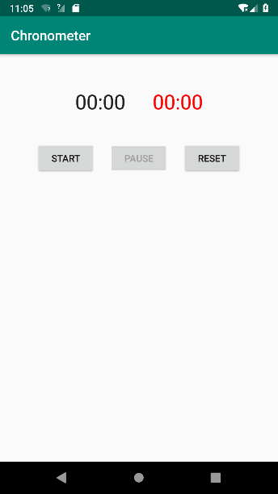 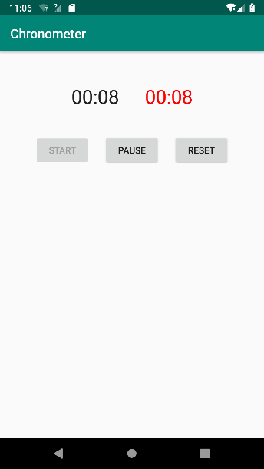 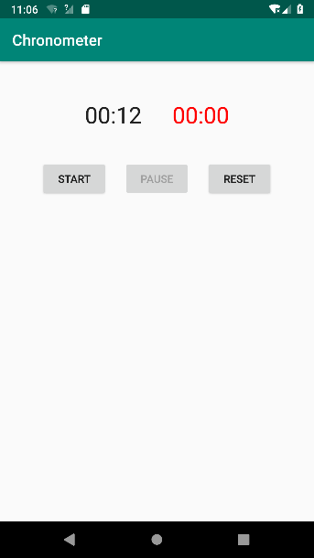

（开始和重置后） （按启动键） （按暂停键—停止走表）

红色字是Chronometer显示出来的

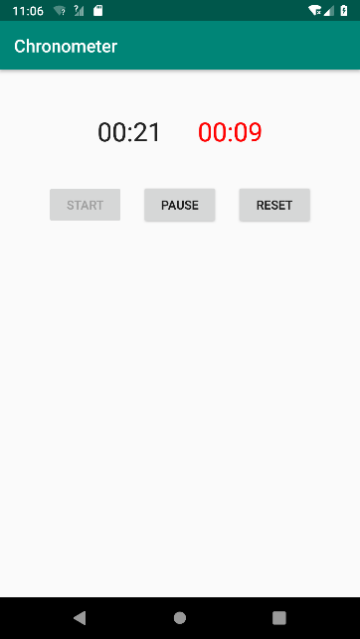 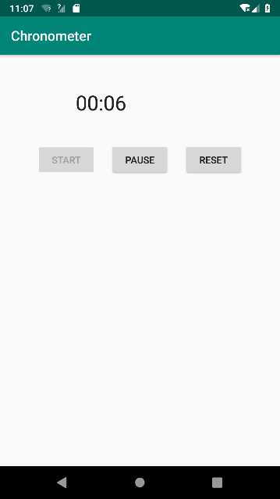

（再按启动键） （隐藏Chronometer:  
visibility:gone|invisible）

全部完成后源码(.java和.xml)：

**app\src\main\java\com\example\lab3\MainActivity.java：**

package com.example.lab3;

import android.os.SystemClock;

import android.support.v7.app.AppCompatActivity;

import android.os.Bundle;

import android.view.View;

import android.widget.Button;

import android.widget.Chronometer;

import android.widget.Toast;

public class MainActivity extends AppCompatActivity {

@Override

protected void onCreate(Bundle savedInstanceState) {

super.onCreate(savedInstanceState);

setContentView(R.layout.activity_main);

bindListener();

}

public void bindListener() {

status = 0;

mRecordTime = 0;

mainChronometer = (Chronometer)findViewById(R.id.main);

secondChronometer = (Chronometer)findViewById(R.id.second);

startButton = (Button)findViewById(R.id.start);

pauseButton = (Button)findViewById(R.id.pause);

resetButton = (Button)findViewById(R.id.reset);

pauseButton.setEnabled(false);

startListener = new View.OnClickListener() {

@Override

public void onClick(View v) {

pauseButton.setEnabled(false);

startButton.setEnabled(false);

if (status == 0) {

mainChronometer.setBase(SystemClock.elapsedRealtime());

secondChronometer.setBase(SystemClock.elapsedRealtime());

} else if (status == 1) {

mainChronometer.setBase(SystemClock.elapsedRealtime());

secondChronometer.setBase(secondChronometer.getBase() + (SystemClock.elapsedRealtime() - mRecordTime));

}

mainChronometer.start();

secondChronometer.start();

status = 2;

pauseButton.setEnabled(true);

}

};

startButton.setOnClickListener(startListener);

pauseListener = new View.OnClickListener() {

@Override

public void onClick(View v) {

pauseButton.setEnabled(false);

startButton.setEnabled(false);

mainChronometer.stop();

secondChronometer.stop();

mainChronometer.setBase(SystemClock.elapsedRealtime());

mRecordTime = SystemClock.elapsedRealtime();

status = 1;

startButton.setEnabled(true);

}

};

pauseButton.setOnClickListener(pauseListener);

resetListener = new View.OnClickListener() {

@Override

public void onClick(View v) {

pauseButton.setEnabled(false);

startButton.setEnabled(false);

mainChronometer.stop();

secondChronometer.stop();

mainChronometer.setBase(SystemClock.elapsedRealtime());

secondChronometer.setBase(SystemClock.elapsedRealtime());

status = 0;

startButton.setEnabled(true);

}

};

resetButton.setOnClickListener(resetListener);

}

private View.OnClickListener startListener;

private Button startButton;

private View.OnClickListener pauseListener;

private Button pauseButton;

private View.OnClickListener resetListener;

private Button resetButton;

private Chronometer mainChronometer;

private Chronometer secondChronometer;

private int status;

private long mRecordTime;

}

**app\src\main\res\layout\activity_main.xml：**

<?xml version="1.0" encoding="utf-8"?>

<android.support.constraint.ConstraintLayout xmlns:android="http://schemas.android.com/apk/res/android"

xmlns:app="http://schemas.android.com/apk/res-auto"

xmlns:tools="http://schemas.android.com/tools"

android:layout_width="match_parent"

android:layout_height="match_parent"

tools:context=".MainActivity">

<RelativeLayout

android:layout_width="match_parent"

android:layout_height="match_parent">

<TextView

android:id="@+id/guideLine"

android:layout_width="wrap_content"

android:layout_height="wrap_content"

android:layout_centerHorizontal="true" />

<Chronometer

android:id="@+id/second"

android:layout_width="wrap_content"

android:layout_height="wrap_content"

android:layout_alignRight="@+id/guideLine"

android:layout_marginStart="20dp"

android:layout_marginTop="50dp"

android:layout_marginEnd="20dp"

android:layout_marginBottom="40dp"

android:format="%s"

android:textSize="30sp" />

<Chronometer

android:id="@+id/main"

android:layout_width="wrap_content"

android:layout_height="wrap_content"

android:layout_alignLeft="@+id/guideLine"

android:layout_marginStart="20dp"

android:layout_marginTop="50dp"

android:layout_marginEnd="20dp"

android:layout_marginBottom="40dp"

android:format="%s"

android:textColor="#F00"

android:textSize="30sp" />

<Button

android:id="@+id/pause"

android:layout_width="wrap_content"

android:layout_height="wrap_content"

android:layout_below="@+id/main"

android:layout_centerHorizontal="true"

android:layout_marginLeft="20dp"

android:layout_marginRight="20dp"

android:text="Pause" />

<Button

android:id="@+id/start"

android:layout_width="wrap_content"

android:layout_height="wrap_content"

android:layout_below="@+id/main"

android:layout_toLeftOf="@+id/pause"

android:text="Start" />

<Button

android:id="@+id/reset"

android:layout_width="wrap_content"

android:layout_height="wrap_content"

android:layout_below="@+id/main"

android:layout_toRightOf="@+id/pause"

android:text="Reset" />

</RelativeLayout>

</android.support.constraint.ConstraintLayout>

4、（Calculator）做一个简单计算器，可以参考Windows计算器，要求用线性布局(LinearLayout)，控件使用TextView和Button。符号：＋－×÷←.±。

全部完成后按步骤操作的运行截屏：

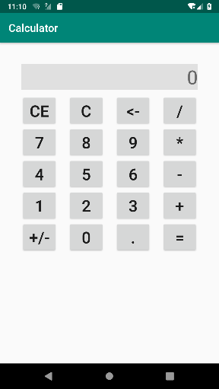 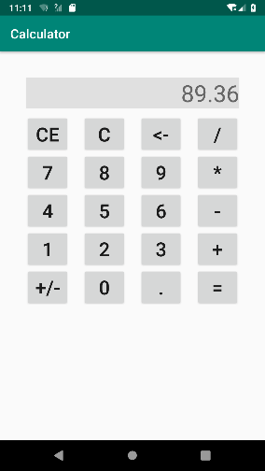 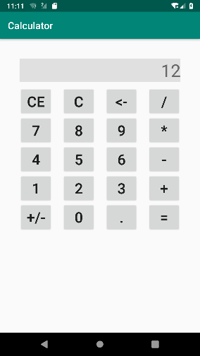

初始 输入一个数 输入X和12

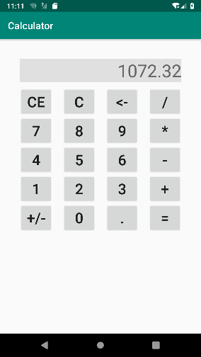 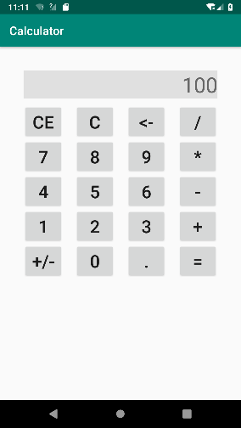 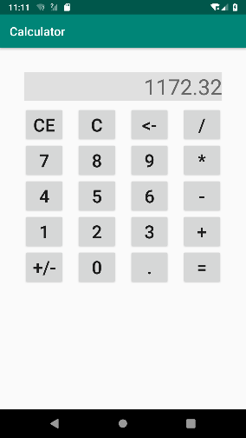

按+号后 输入100 按=号后

（1）对所有控件进行布局。要求全部采用线性布局。

（2）完成数字和小数点输入。注意处理按了多次小数点的情况。

（3）（选做）完成+-*/=操作。运算结果不能被修改。

（4）（选做）其他功能：CE、C、←（删除）、±

全部完成后源码(.java和.xml)：

**app\src\main\java\com\example\lab4\MainActivity.java：**

package com.example.lab4;

import android.support.v7.app.AppCompatActivity;

import android.os.Bundle;

import android.view.View;

import android.widget.Button;

import android.widget.TextView;

import android.widget.Toast;

import org.w3c.dom.Text;

import java.math.BigDecimal;

public class MainActivity extends AppCompatActivity {

@Override

protected void onCreate(Bundle savedInstanceState) {

super.onCreate(savedInstanceState);

setContentView(R.layout.activity_main);

operation = 0;

screen_s = "0";

last_s = "0";

sign = "";

setButtonClick();

}

private void setButtonClick() {

text = (TextView)findViewById(R.id.textView);

button1 = (Button)findViewById(R.id.button1);

button2 = (Button)findViewById(R.id.button2);

button3 = (Button)findViewById(R.id.button3);

button4 = (Button)findViewById(R.id.button4);

button5 = (Button)findViewById(R.id.button5);

button6 = (Button)findViewById(R.id.button6);

button7 = (Button)findViewById(R.id.button7);

button8 = (Button)findViewById(R.id.button8);

button9 = (Button)findViewById(R.id.button9);

button10 = (Button)findViewById(R.id.button10);

button11 = (Button)findViewById(R.id.button11);

button12 = (Button)findViewById(R.id.button12);

button13 = (Button)findViewById(R.id.button13);

button14 = (Button)findViewById(R.id.button14);

button15 = (Button)findViewById(R.id.button15);

button16 = (Button)findViewById(R.id.button16);

button17 = (Button)findViewById(R.id.button17);

button18 = (Button)findViewById(R.id.button18);

button19 = (Button)findViewById(R.id.button19);

button20 = (Button)findViewById(R.id.button20);

button1.setOnClickListener(new View.OnClickListener() {

@Override

public void onClick(View v) {

if (text.getText().equals("Error")) return;

sign = "";

screen_s = "0";

text.setText(getString(R.string.display_result, sign, screen_s));

}

});

button2.setOnClickListener(new View.OnClickListener() {

@Override

public void onClick(View v) {

operation = 0;

screen_s = "0";

last_s = "0";

sign = "";

text.setText(getString(R.string.display_result, sign, screen_s));

}

});

button3.setOnClickListener(new View.OnClickListener() {

@Override

public void onClick(View v) {

if (text.getText().equals("Error")) return;

if (screen_s.length() > 0) {

if (screen_s.equals("0")) {

sign = "";

}

screen_s = screen_s.substring(0, screen_s.length() - 1);

}

if (screen_s.length() == 0) {

screen_s = "0";

}

text.setText(getString(R.string.display_result, sign, screen_s));

}

});

button4.setOnClickListener(new View.OnClickListener() {

@Override

public void onClick(View v) {

if (text.getText().equals("Error")) return;

button20.callOnClick();

last_s = sign + screen_s;

text.setText(getString(R.string.display_result, sign, screen_s));

screen_s = "0";

sign = "";

operation = 4;

}

});

button5.setOnClickListener(new View.OnClickListener() {

@Override

public void onClick(View v) {

if (text.getText().equals("Error")) return;

if (screen_s.length() >= max_value_length) return;

if (screen_s.equals("0")) screen_s = "";

screen_s += '7';

text.setText(getString(R.string.display_result, sign, screen_s));

}

});

button6.setOnClickListener(new View.OnClickListener() {

@Override

public void onClick(View v) {

if (text.getText().equals("Error")) return;

if (screen_s.length() >= max_value_length) return;

if (screen_s.equals("0")) screen_s = "";

screen_s += '8';

text.setText(getString(R.string.display_result, sign, screen_s));

}

});

button7.setOnClickListener(new View.OnClickListener() {

@Override

public void onClick(View v) {

if (text.getText().equals("Error")) return;

if (screen_s.length() >= max_value_length) return;

if (screen_s.equals("0")) screen_s = "";

screen_s += '9';

text.setText(getString(R.string.display_result, sign, screen_s));

}

});

button8.setOnClickListener(new View.OnClickListener() {

@Override

public void onClick(View v) {

if (text.getText().equals("Error")) return;

button20.callOnClick();

last_s = sign + screen_s;

text.setText(getString(R.string.display_result, sign, screen_s));

screen_s = "0";

sign = "";

operation = 3;

}

});

button9.setOnClickListener(new View.OnClickListener() {

@Override

public void onClick(View v) {

if (text.getText().equals("Error")) return;

if (screen_s.length() >= max_value_length) return;

if (screen_s.equals("0")) screen_s = "";

screen_s += '4';

text.setText(getString(R.string.display_result, sign, screen_s));

}

});

button10.setOnClickListener(new View.OnClickListener() {

@Override

public void onClick(View v) {

if (text.getText().equals("Error")) return;

if (screen_s.length() >= max_value_length) return;

if (screen_s.equals("0")) screen_s = "";

screen_s += '5';

text.setText(getString(R.string.display_result, sign, screen_s));

}

});

button11.setOnClickListener(new View.OnClickListener() {

@Override

public void onClick(View v) {

if (text.getText().equals("Error")) return;

if (screen_s.length() >= max_value_length) return;

if (screen_s.equals("0")) screen_s = "";

screen_s += '6';

text.setText(getString(R.string.display_result, sign, screen_s));

}

});

button12.setOnClickListener(new View.OnClickListener() {

@Override

public void onClick(View v) {

if (text.getText().equals("Error")) return;

button20.callOnClick();

last_s = sign + screen_s;

text.setText(getString(R.string.display_result, sign, screen_s));

screen_s = "0";

sign = "";

operation = 2;

}

});

button13.setOnClickListener(new View.OnClickListener() {

@Override

public void onClick(View v) {

if (text.getText().equals("Error")) return;

if (screen_s.length() >= max_value_length) return;

if (screen_s.equals("0")) screen_s = "";

screen_s += '1';

text.setText(getString(R.string.display_result, sign, screen_s));

}

});

button14.setOnClickListener(new View.OnClickListener() {

@Override

public void onClick(View v) {

if (text.getText().equals("Error")) return;

if (screen_s.length() >= max_value_length) return;

if (screen_s.equals("0")) screen_s = "";

screen_s += '2';

text.setText(getString(R.string.display_result, sign, screen_s));

}

});

button15.setOnClickListener(new View.OnClickListener() {

@Override

public void onClick(View v) {

if (text.getText().equals("Error")) return;

if (screen_s.length() >= max_value_length) return;

if (screen_s.equals("0")) screen_s = "";

screen_s += '3';

text.setText(getString(R.string.display_result, sign, screen_s));

}

});

button16.setOnClickListener(new View.OnClickListener() {

@Override

public void onClick(View v) {

if (text.getText().equals("Error")) return;

button20.callOnClick();

last_s = sign + screen_s;

text.setText(getString(R.string.display_result, sign, screen_s));

screen_s = "0";

sign = "";

operation = 1;

}

});

button17.setOnClickListener(new View.OnClickListener() {

@Override

public void onClick(View v) {

if (text.getText().equals("Error")) return;

if (sign.equals("")) sign = "-";

else sign = "";

text.setText(getString(R.string.display_result, sign, screen_s));

}

});

button18.setOnClickListener(new View.OnClickListener() {

@Override

public void onClick(View v) {

if (text.getText().equals("Error")) return;

if (screen_s.length() >= max_value_length) return;

if (screen_s.equals("0")) screen_s = "";

screen_s += '0';

text.setText(getString(R.string.display_result, sign, screen_s));

}

});

button19.setOnClickListener(new View.OnClickListener() {

@Override

public void onClick(View v) {

if (text.getText().equals("Error")) return;

if (screen_s.length() >= max_value_length) return;

if (screen_s.charAt(screen_s.length() - 1) == '.') return;

screen_s += '.';

text.setText(getString(R.string.display_result, sign, screen_s));

}

});

button20.setOnClickListener(new View.OnClickListener() {

@Override

public void onClick(View v) {

if (text.getText().equals("Error")) return;

if (operation == 0) return;

BigDecimal a = new BigDecimal(last_s);

BigDecimal b = new BigDecimal(sign + screen_s);

if (operation == 1) {

a = a.add(b);

} else if (operation == 2) {

a = a.subtract(b);

} else if (operation == 3) {

a = a.multiply(b);

} else if (operation == 4) {

if (b.compareTo(BigDecimal.ZERO) == 0) {

text.setText("Error");

operation = 0;

return;

}

a = a.divide(b, 10, BigDecimal.ROUND_HALF_UP);

}

screen_s = a.stripTrailingZeros().toPlainString();

sign = "";

if (screen_s.charAt(0) == '-') {

sign = "-";

screen_s = screen_s.substring(1);

}

operation = 0;

text.setText(getString(R.string.display_result, sign, screen_s));

}

});

}

private int operation;

private String sign, screen_s, last_s;

private TextView text;

private Button button1, button2, button3, button4, button5, button6, button7, button8, button9, button10, button11, button12, button13, button14, button15, button16, button17, button18, button19, button20;

private final int max_value_length = 100;

}

**app\src\main\res\layout\activity_main.xml：**

<?xml version="1.0" encoding="utf-8"?>

<android.support.constraint.ConstraintLayout xmlns:android="http://schemas.android.com/apk/res/android"

xmlns:app="http://schemas.android.com/apk/res-auto"

xmlns:tools="http://schemas.android.com/tools"

android:layout_width="match_parent"

android:layout_height="match_parent"

tools:context=".MainActivity">

<RelativeLayout

android:layout_width="match_parent"

android:layout_height="match_parent"

android:layout_margin="30dp"

tools:layout_editor_absoluteX="10dp"

tools:layout_editor_absoluteY="10dp">

<LinearLayout

android:id="@+id/L1"

android:layout_width="match_parent"

android:layout_height="wrap_content"

android:orientation="vertical">

<TextView

android:id="@+id/textView"

android:layout_width="match_parent"

android:layout_height="wrap_content"

android:layout_marginStart="10dp"

android:layout_marginTop="10dp"

android:layout_marginEnd="10dp"

android:layout_marginBottom="10dp"

android:layout_weight="10"

android:background="#e0e0e0"

android:gravity="right"

android:text="0"

android:textSize="36sp"

tools:layout_editor_absoluteX="20dp"

tools:layout_editor_absoluteY="20dp" />

</LinearLayout>

<LinearLayout

android:id="@+id/L2"

android:layout_width="match_parent"

android:layout_height="wrap_content"

android:layout_below="@+id/L1"

android:orientation="horizontal">

<Button

android:id="@+id/button1"

android:layout_width="wrap_content"

android:layout_height="wrap_content"

android:layout_marginLeft="10dp"

android:layout_marginRight="10dp"

android:layout_weight="1"

android:textSize="30sp"

android:text="CE" />

<Button

android:id="@+id/button2"

android:layout_width="wrap_content"

android:layout_height="wrap_content"

android:layout_marginLeft="10dp"

android:layout_marginRight="10dp"

android:layout_weight="1"

android:textSize="30sp"

android:text="C" />

<Button

android:id="@+id/button3"

android:layout_width="wrap_content"

android:layout_height="wrap_content"

android:layout_marginLeft="10dp"

android:layout_marginRight="10dp"

android:layout_weight="1"

android:textSize="30sp"

android:text="&lt;-" />

<Button

android:id="@+id/button4"

android:layout_width="wrap_content"

android:layout_height="wrap_content"

android:layout_marginLeft="10dp"

android:layout_marginRight="10dp"

android:layout_weight="1"

android:text="/"

android:textSize="30sp" />

</LinearLayout>

<LinearLayout

android:id="@+id/L3"

android:layout_width="match_parent"

android:layout_height="wrap_content"

android:layout_below="@+id/L2"

android:orientation="horizontal">

<Button

android:id="@+id/button5"

android:layout_width="wrap_content"

android:layout_height="wrap_content"

android:layout_marginLeft="10dp"

android:layout_marginRight="10dp"

android:layout_weight="1"

android:textSize="30sp"

android:text="7" />

<Button

android:id="@+id/button6"

android:layout_width="wrap_content"

android:layout_height="wrap_content"

android:layout_marginLeft="10dp"

android:layout_marginRight="10dp"

android:layout_weight="1"

android:textSize="30sp"

android:text="8" />

<Button

android:id="@+id/button7"

android:layout_width="wrap_content"

android:layout_height="wrap_content"

android:layout_marginLeft="10dp"

android:layout_marginRight="10dp"

android:layout_weight="1"

android:textSize="30sp"

android:text="9" />

<Button

android:id="@+id/button8"

android:layout_width="wrap_content"

android:layout_height="wrap_content"

android:layout_marginLeft="10dp"

android:layout_marginRight="10dp"

android:layout_weight="1"

android:textSize="30sp"

android:text="*" />

</LinearLayout>

<LinearLayout

android:id="@+id/L4"

android:layout_width="match_parent"

android:layout_height="wrap_content"

android:layout_below="@+id/L3"

android:orientation="horizontal">

<Button

android:id="@+id/button9"

android:layout_width="wrap_content"

android:layout_height="wrap_content"

android:layout_marginLeft="10dp"

android:layout_marginRight="10dp"

android:layout_weight="1"

android:textSize="30sp"

android:text="4" />

<Button

android:id="@+id/button10"

android:layout_width="wrap_content"

android:layout_height="wrap_content"

android:layout_marginLeft="10dp"

android:layout_marginRight="10dp"

android:layout_weight="1"

android:textSize="30sp"

android:text="5" />

<Button

android:id="@+id/button11"

android:layout_width="wrap_content"

android:layout_height="wrap_content"

android:layout_marginLeft="10dp"

android:layout_marginRight="10dp"

android:layout_weight="1"

android:textSize="30sp"

android:text="6" />

<Button

android:id="@+id/button12"

android:layout_width="wrap_content"

android:layout_height="wrap_content"

android:layout_marginLeft="10dp"

android:layout_marginRight="10dp"

android:layout_weight="1"

android:textSize="30sp"

android:text="-" />

</LinearLayout>

<LinearLayout

android:id="@+id/L5"

android:layout_width="match_parent"

android:layout_height="wrap_content"

android:layout_below="@+id/L4"

android:orientation="horizontal">

<Button

android:id="@+id/button13"

android:layout_width="wrap_content"

android:layout_height="wrap_content"

android:layout_marginLeft="10dp"

android:layout_marginRight="10dp"

android:layout_weight="1"

android:textSize="30sp"

android:text="1" />

<Button

android:id="@+id/button14"

android:layout_width="wrap_content"

android:layout_height="wrap_content"

android:layout_marginLeft="10dp"

android:layout_marginRight="10dp"

android:layout_weight="1"

android:textSize="30sp"

android:text="2" />

<Button

android:id="@+id/button15"

android:layout_width="wrap_content"

android:layout_height="wrap_content"

android:layout_marginLeft="10dp"

android:layout_marginRight="10dp"

android:layout_weight="1"

android:textSize="30sp"

android:text="3" />

<Button

android:id="@+id/button16"

android:layout_width="wrap_content"

android:layout_height="wrap_content"

android:layout_marginLeft="10dp"

android:layout_marginRight="10dp"

android:layout_weight="1"

android:textSize="30sp"

android:text="+" />

</LinearLayout>

<LinearLayout

android:id="@+id/L6"

android:layout_width="match_parent"

android:layout_height="wrap_content"

android:layout_below="@+id/L5"

android:orientation="horizontal">

<Button

android:id="@+id/button17"

android:layout_width="wrap_content"

android:layout_height="wrap_content"

android:layout_marginLeft="10dp"

android:layout_marginRight="10dp"

android:layout_weight="1"

android:textSize="30sp"

android:text="+/-" />

<Button

android:id="@+id/button18"

android:layout_width="wrap_content"

android:layout_height="wrap_content"

android:layout_marginLeft="10dp"

android:layout_marginRight="10dp"

android:layout_weight="1"

android:textSize="30sp"

android:text="0" />

<Button

android:id="@+id/button19"

android:layout_width="wrap_content"

android:layout_height="wrap_content"

android:layout_marginLeft="10dp"

android:layout_marginRight="10dp"

android:layout_weight="1"

android:textSize="30sp"

android:text="." />

<Button

android:id="@+id/button20"

android:layout_width="wrap_content"

android:layout_height="wrap_content"

android:layout_marginLeft="10dp"

android:layout_marginRight="10dp"

android:layout_weight="1"

android:textSize="30sp"

android:text="=" />

</LinearLayout>

</RelativeLayout>

</android.support.constraint.ConstraintLayout>

【完成情况】

是否完成了这些实验题目？√完成 ×未做，x%--未完成(已完成比例)

1 [√] 2 [√ ] 3[√ ]

4(1)[ √ ] 4(2)[ √ ] 4(3)[ √] 4(4)[ √]

5[×] 6[×]

【实验体会】

写出实验过程中遇到的问题，解决方法和自己的思考；并简述实验体会（如果有的话）。

万事开头难，做第一个APP是比较困难的，因为我对Java以及安卓的原理都不是很了解。不过幸好老师在上课的时候有讲过如何用xml来做Layout，结合网上查的RelativeLayout的用法，大致能画出像样例一样的注册界面。接下来就考虑按钮如何实现，安卓提供了OnClickListener，一捕捉到点击事件就会触发OnClick函数。第二个实验也不简单，GridView的每个格子都要有相同的布局，该怎么办？我们要为格子内部再设计一个layout（见gridview.xml），然后在ImageAdapter.getView把position的东西填进去之后返回这样一个View就好了。第三个实验相对比较简单。第四个实验算是对前面实验的一个总结，不仅需要做Layout，还需要实现按钮的逻辑，想清楚就能实现好。

【交实验报告】

(a) 每位同学独立完成本实验内容并填写实验报告。

(b) 截止时间：2019年4月13日(周六) 23:00

上交作业网站：<http://172.18.187.9/netdisk/default.aspx?vm=16and>

文件夹: /实验上交/01、控件布局实验

上传文件：学号_姓名_控件布局实验.doc (实验报告)   
学号_姓名_控件布局实验.rar (按项目压缩，注意删除build和app/build目录)