1.修改数据库，添加模块:
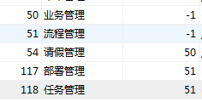
给中间表添加对应关系

2.创建请假单表:
CREATE TABLE `leavebill` (
`id` int(11) NOT NULL AUTO_INCREMENT,
`days` int(11) DEFAULT NULL,
`content` varchar(255) DEFAULT NULL,
`date` date DEFAULT NULL,
`remark` varchar(255) DEFAULT NULL,
`userid` int(11) DEFAULT NULL,
`state` int(11) DEFAULT NULL,
PRIMARY KEY (`id`)
) ENGINE=InnoDB AUTO_INCREMENT=5 DEFAULT CHARSET=utf8;
State 请假状态0初始录入 1 开始审批 2 审批完成
修改用户表:
在表中添加对应用户的管理人id列:managerid

3.添加activiti依赖包:
<!--- Activiti依赖导入 -->
<dependency>
<groupId>org.activiti</groupId>
<artifactId>activiti-spring</artifactId>
<version>5.18.0</version>
</dependency>
<dependency>
<groupId>org.activiti</groupId>
<artifactId>activiti-engine</artifactId>
<version>5.18.0</version>
<exclusions>
<exclusion>
<artifactId>slf4j-api</artifactId>
<groupId>org.slf4j</groupId>
</exclusion>
<exclusion>
<artifactId>spring-beans</artifactId>
<groupId>org.springframework</groupId>
</exclusion>
<exclusion>
<artifactId>jackson-core-asl</artifactId>
<groupId>org.codehaus.jackson</groupId>
</exclusion>
<exclusion>
<artifactId>commons-lang3</artifactId>
<groupId>org.apache.commons</groupId>
</exclusion>
</exclusions>
</dependency>
注意分页插件的版本更改为:
<!-- PageHelper4.1.6 -->
然后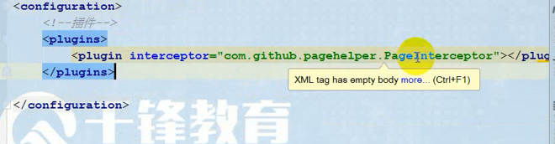
更改为：
<plugin interceptor="com.github.pagehelper.PageHelper">
</plugin>
Mybatis的jar包版本:3.2.8

4.修改spring配置文件
<!-- spring负责创建流程引擎的配置文件 -->
<bean
id="processEngineConfiguration" class="org.activiti.spring.SpringProcessEngineConfiguration">
<!-- 数据源 -->
<property name="dataSource" ref="dataSource" />
<!-- 配置事务管理器，统一事务 -->
<property name="transactionManager" ref="tx" />
<!-- 设置建表策略，如果没有表，自动创建表 -->
<property name="databaseSchemaUpdate" value="true" />
</bean>
<!-- 创建流程引擎对象 -->
<bean id="processEngine" class="org.activiti.spring.ProcessEngineFactoryBean">
<property name="processEngineConfiguration" ref="processEngineConfiguration" />
</bean>
<!-- 由流程引擎对象，提供的方法，创建项目中使用的Activiti工作流的Service
Id随便，工厂对象创建这些getRepositoryService方法
-->
<bean id="repositoryService"
factory-bean="processEngine" factory-method="getRepositoryService" />
<bean id="runtimeService" factory-bean="processEngine"
factory-method="getRuntimeService" />
<bean id="taskService" factory-bean="processEngine" factory-method="getTaskService" />
<bean id="historyService" factory-bean="processEngine" factory-method="getHistoryService" />
<bean id="formService" factory-bean="processEngine" factory-method="getFormService" />

如果没有流程的21张表，使用配置文件初始化数据库
配置ProcessEngineConfiguration对象，主要定义数据库的连接配置和建表策略
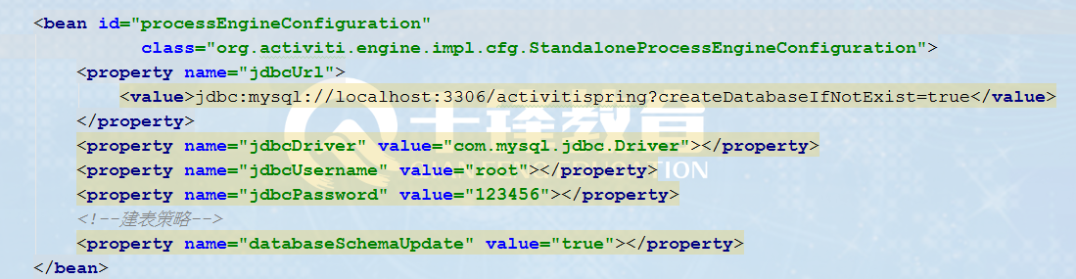
注意:对象名必须叫processEngineConfiguration
测试:
ProcessEngine pe=
ProcessEngineConfiguration.
createProcessEngineConfigurationFromResource
("spring_activiti.xml").buildProcessEngine();
System.out.println(pe);

作用
1) 可以产生RepositoryService
2)可以产生RuntimeService
3)可以产生TaskService
各个Service的作用：
RepositoryService | 管理流程定义
RuntimeService | 执行管理，包括启动、推进、删除流程实例等操作
TaskService | 任务管理
HistoryService | 历史管理(执行完的数据的管理)
IdentityService | 组织机构管理
FormService | 一个可选服务，任务表单管理
ManagementService | 对 Activiti 流程引擎的管理和维护功能，这些功能不在工作流驱动的应用程序中使用，主要用于 Activiti 系统的日常维护

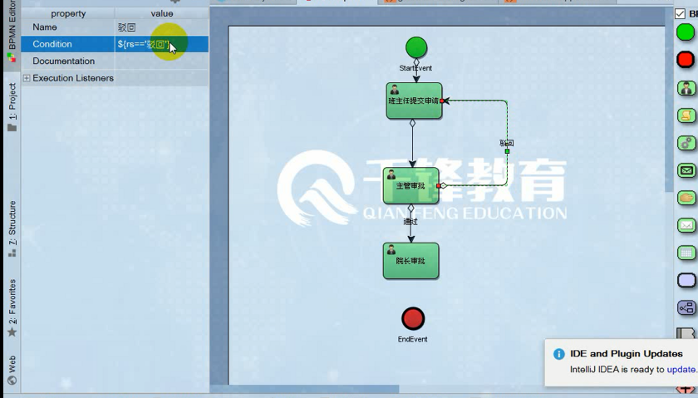

后台给流程图的条件，$获取

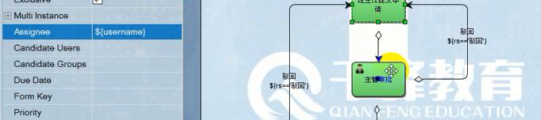
然后是提交这个请求的申请人（或者说是代理人，assignee），因为提交申请总有人，所以后台把教师用户传过来就行了

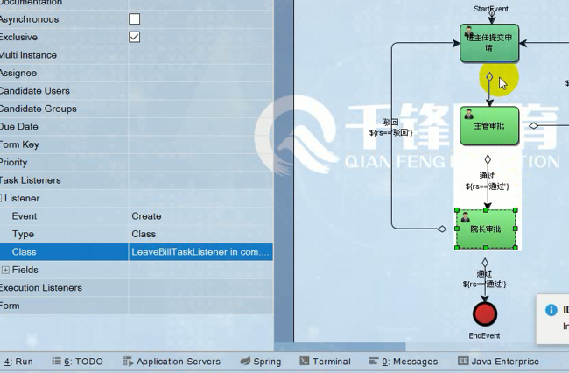
用类监听实现。

如果普通使用图片上传，multipartresolver配置，然后前端enctype=multipart/form-data

功能1 :部署管理
画流程图，使用表达式或者类的方式指定办理人,然后将流程部署到数据库中
注意指定formkey,即办理该业务时的请求地址（后面再说），如主管审批：加上formkey，
相当于这时候发送了一个请求，去请求查看审批信息。
注意:流程定义的key是用来表示流程的唯一性，所以一般我们都是用实体类中的类名
来作为key的值，如请假单的类名是leavebill ,则流程定义的key:leavebill

流程部署：

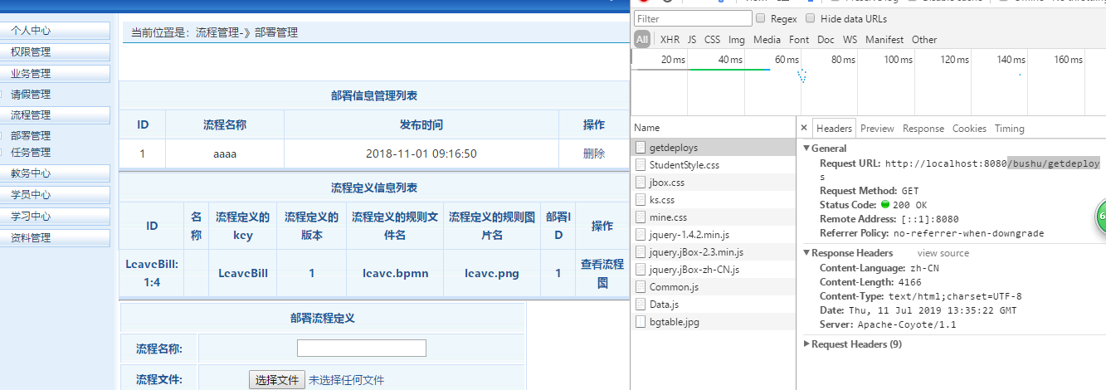

后台代码：//1.查询流程定义和部署信息
@RequestMapping("/bushu/getdeploys")
public String chaxun(ModelMap map){
//查询部署信息
List<Deployment> dlist=activitiService.getdeplist();
//查询流程定义信息
List<ProcessDefinition> prolist=activitiService.getprolist();
map.put("dlist",dlist);
map.put("prolist",prolist);
return "/bushu/list";
}
serviceImpl代码：

查询部署表信息：
@Override
public List<Deployment> getdeplist() {
List list= repositoryService.createDeploymentQuery().list();
return list;
}

查询流程定义表信息
@Override
public List<ProcessDefinition> getprolist() {
List list=repositoryService.createProcessDefinitionQuery().list();
return list;
}

上传流程图：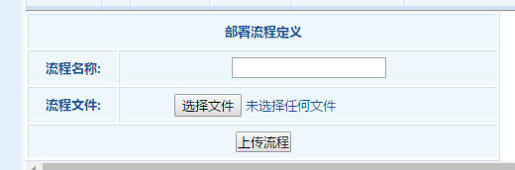

看后台代码。

功能2:请假管理（与业务关联）-查看，修改，删除
申请请假-启动流程实例
实现思路:(1)根据请假单id,修改请假单状态
- 获得流程定义的key,等于实体类名
使用流程变量设置字符串(leaveBill.id)，让启动的流程实例关联业务
使用字段BUSSINESS_KEY来关联业务
- 启动流程实例，并将business_key，和办理人传入
startProcessInstanceByKey(“key”,buessid,map)
工作流的开发重点:让流程关联业务
关联方式1:使用leavebill类存放流程变量,与流程实例绑定，通过序列化保存
方式2:使用字符串，即business_key的值来关联业务数据
Business_key的值格式: 流程定义的key.业务数据的id

功能3:任务办理-查询个人任务

这

整合的情况：如果是条件，${rs == ‘驳回’},如果是变量，${username}
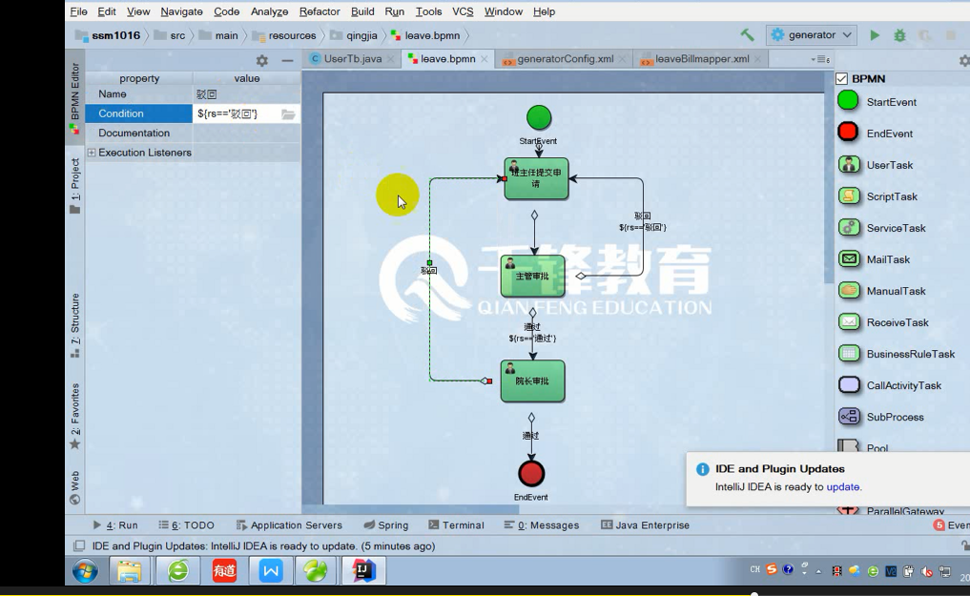

Formkey，流程图往下执行的时候所发送的请求。

监听的类：

package com.util;
import com.bean.UserTb;
import org.activiti.engine.delegate.DelegateTask;
import org.activiti.engine.delegate.TaskListener;
import org.springframework.web.context.request.RequestContextHolder;
import org.springframework.web.context.request.ServletRequestAttributes;
import javax.servlet.http.HttpSession;
public class LeaveBillTaskListener implements TaskListener {
@Override
public void notify(DelegateTask delegateTask) {
//任务的执行人
//当前登录用户
HttpSession session=((ServletRequestAttributes)
(RequestContextHolder.getRequestAttributes())).getRequest().getSession();
System.out.println(session);
UserTb users= (UserTb) session.getAttribute("u1");
delegateTask.setAssignee(users.getManger().getUserName());
}
}

Controller:
package com.web;
import com.bean.LeaveBill;
import com.bean.UserTb;
import com.service.ActivitiService;
import org.activiti.engine.repository.Deployment;
import org.activiti.engine.repository.ProcessDefinition;
import org.activiti.engine.task.Comment;
import org.activiti.engine.task.Task;
import org.springframework.beans.factory.annotation.Autowired;
import org.springframework.stereotype.Controller;
import org.springframework.ui.ModelMap;
import org.springframework.web.bind.annotation.RequestMapping;
import org.springframework.web.multipart.MultipartFile;
import javax.servlet.http.HttpServletResponse;
import javax.servlet.http.HttpSession;
import java.io.IOException;
import java.io.InputStream;
import java.io.OutputStream;
import java.util.List;
@Controller
public class ActivitiController {
@Autowired
private ActivitiService activitiService;
//1.查询流程定义和部署信息
@RequestMapping("/bushu/getdeploys")
public String chaxun(ModelMap map){
//查询部署信息
List<Deployment> dlist=activitiService.getdeplist();
//查询流程定义信息
List<ProcessDefinition> prolist=activitiService.getprolist();
map.put("dlist",dlist);
map.put("prolist",prolist);
return "/bushu/list";
}
//2.上传流程文件
@RequestMapping("/bushu/adddeploy")
public String up(MultipartFile depfile,String name){
try {
activitiService.add(depfile.getInputStream(),name);
} catch (IOException e) {
e.printStackTrace();
}
return "redirect:/bushu/getdeploys";
}
//3.查看流程图
@RequestMapping("/bushu/image")
public String image(String depid,String imagename,ModelMap map){
map.put("depid",depid);
map.put("imagename",imagename);
return "/bushu/image";
}
@RequestMapping("/bushu/lookimage")
public void liuchengtu(String depid, String imagename, HttpServletResponse response){
try {
//根据部署id和图片名称，查看文件流
InputStream inputStream=activitiService.findimage(depid,imagename);
//将文件保存到本地
/* FileUtils.copyInputStreamToFile(inputStream,new File("e://"+imagename));
response.setContentType("text/html;charset=utf-8");
response.getWriter().print("<script>alert('文件保存在e盘,文件名:"+imagename+"');location.href='/bushu/getdeploys'</script>");
*/
OutputStream outputStream=response.getOutputStream();
int k=-1;
while((k=inputStream.read())!=-1){
outputStream.write(k);
}
outputStream.close();
inputStream.close();
} catch (IOException e) {
e.printStackTrace();
}
}
//4.删除流程部署
@RequestMapping("/bushu/deletedeploy")
public void delete(String depid,HttpServletResponse response){
response.setContentType("text/html;charset=utf-8");
try {
activitiService.deletedeploy(depid);
response.getWriter().print("<script>location.href='/bushu/getdeploys'</script>");
} catch (Exception e) {
try {
response.getWriter().print("<script>alert('流程正在使用，不能删除');location.href='/bushu/getdeploys'</script>");
} catch (IOException e1) {
e1.printStackTrace();
}
}
}
//5.提交请假申请
@RequestMapping("/qingjia/tijiao")
public String qingjia(int leaveid, HttpSession session){//请假条的id值
UserTb userTb=(UserTb) session.getAttribute("u1");
activitiService.qingjia(leaveid,userTb.getUserName());
return "redirect:/qingjia/getleavebills";
}
//6.个人任务查询
@RequestMapping("/renwu/gettastlist")
public String renwu(HttpSession session,ModelMap map){
UserTb userTb=(UserTb) session.getAttribute("u1");
List<Task> list=activitiService.gettasks(userTb.getUserName());
map.put("tlist",list);
return "/renwu/list";
}
//7.查询具体任务
@RequestMapping("/renwu/banli")
public String chakan(String taskid){
//使用form_key执行流程的请求
String url=activitiService.getformkey(taskid);
return "redirect:/"+url+"?tid="+taskid;
}
@RequestMapping("/shenpi")
public String shenpi(String tid,ModelMap map){
//1.通过任务id查询请假条
LeaveBill leaveBill=activitiService.findleavebillbytaskid(tid);
map.put("leavebill",leaveBill);
//2.通过任务id，查询正在活动的节点对象，并获得任务的连线信息
List<String> strs=activitiService.getnames(tid);
map.put("names",strs);
//3.保存任务id
map.put("taskid",tid);
//4.得到任务的批注信息
List<Comment> comments=activitiService.getcomments(tid);
map.put("allcomments",comments);
return "/renwu/banli";
}
//审批任务
@RequestMapping("/renwu/shenpi")
public String chulirenwu(String taskid,String pizhu,
String result,int leaveid,
HttpSession session){
UserTb userTb=(UserTb)session.getAttribute("u1");
//审批任务:
activitiService.chuli(taskid,pizhu,result,leaveid,userTb.getUserName());
return "redirect:/renwu/gettastlist";
}
}

serviceImpl:
package com.service.impl;
import com.bean.LeaveBill;
import com.service.ActivitiService;
import com.service.LeaveBillService;
import org.activiti.engine.*;
import org.activiti.engine.form.TaskFormData;
import org.activiti.engine.impl.identity.Authentication;
import org.activiti.engine.impl.persistence.entity.ProcessDefinitionEntity;
import org.activiti.engine.impl.pvm.PvmTransition;
import org.activiti.engine.impl.pvm.process.ActivityImpl;
import org.activiti.engine.repository.Deployment;
import org.activiti.engine.repository.ProcessDefinition;
import org.activiti.engine.runtime.ProcessInstance;
import org.activiti.engine.task.Comment;
import org.activiti.engine.task.Task;
import org.springframework.beans.factory.annotation.Autowired;
import org.springframework.stereotype.Service;
import javax.transaction.Transactional;
import java.io.InputStream;
import java.util.ArrayList;
import java.util.HashMap;
import java.util.List;
import java.util.Map;
import java.util.zip.ZipInputStream;
@Service
public class ActivitiServiceImpl implements ActivitiService {
@Autowired
private RepositoryService repositoryService;
@Autowired
private LeaveBillService leaveBillService;
@Autowired
private RuntimeService runtimeService;
@Autowired
private TaskService taskService;
@Autowired
private FormService formService;
@Autowired
private HistoryService historyService;
@Override
public int deletedeploy(String depid) {
repositoryService.deleteDeployment(depid);
return 1;
}
@Override
@Transactional //如何将业务过程和流程定义进行关联
public int qingjia(int leaveid,String username) {
//1.修改请假单的状态
leaveBillService.updateState(leaveid,1);
//2.启动流程实例时候，需要建立流程和业务之间的关系
//使用business_key来保存业务的信息
//business_key的组成方式: 流程定义的key+业务的id
String business="LeaveBill."+leaveid;
Map map=new HashMap();
map.put("busid",business);
map.put("username",username);
ProcessInstance instance=
runtimeService.startProcessInstanceByKey("LeaveBill",business,map);
//查询流程实例的id查询任务对象
Task task=
taskService.createTaskQuery()
.processInstanceId(instance.getId()).singleResult();
//完成个人任务
taskService.complete(task.getId());
return 1;
}
@Override
public List<Task> gettasks(String username) {
List list=
taskService.createTaskQuery().taskAssignee(username).list();
return list;
}
@Override
public String getformkey(String tid) {
TaskFormData data=formService.getTaskFormData(tid);
return data.getFormKey();
}
@Override
public void chuli(String taskid, String pizhu, String result, int leaveid,String username) {
//1.添加批注信息表
Task task=taskService.createTaskQuery().taskId(taskid).singleResult();
Authentication.setAuthenticatedUserId(username);
taskService.addComment(taskid,task.getProcessInstanceId(),pizhu);
//2.设置流程变量的值
Map map=new HashMap();
map.put("rs",result);
//完成个人任务
taskService.complete(taskid,map);
//指定下一个任务的办理人---已经完成
if(result.equals("驳回")){
//修改请假条状态
leaveBillService.updateState(leaveid,3);
}
//3.判断任务是否执行完毕
//查询流程实例对象
ProcessInstance pro=
runtimeService.createProcessInstanceQuery()
.processInstanceId(task.getProcessInstanceId())
.singleResult();
if(pro==null){//任务完成
//修改请假条状态
leaveBillService.updateState(leaveid,2);
}
}
@Override
public List<String> getnames(String tid) {
List names=new ArrayList();
//1.通过任务id查询任务对象
Task task=taskService.createTaskQuery().taskId(tid).singleResult();
//2.得到流程定义id
String processdefinitionid= task.getProcessDefinitionId();
//3.通过流程定义id得到流程图对象
// repositoryService.createProcessDefinitionQuery().processDefinitionId("").singleResult();
ProcessDefinitionEntity entity=(ProcessDefinitionEntity)
repositoryService.getProcessDefinition(processdefinitionid);
//4.得到当前任务正在活动的activiti_id
String instanceid=task.getProcessInstanceId();//得到流程实例的id
ProcessInstance instance= //通过流程定义id查询流程实例
runtimeService.createProcessInstanceQuery().processInstanceId(instanceid).singleResult();
String act_id= instance.getActivityId();//得到正在获得的id
//5.查找正在获得的act对象
ActivityImpl activity= entity.findActivity(act_id);
/* List<ActivityImpl> activity1=entity.getActivities();
for (ActivityImpl activity2 : activity1) {
System.out.println(activity2.getProperty("id"));
}*/
System.out.println(act_id+"//////"+entity+",,,,"+processdefinitionid+"..."+activity);
List<PvmTransition> list= activity.getOutgoingTransitions();
if(list.size()>0){
for (PvmTransition pvmTransition : list) {
String name=(String) pvmTransition.getProperty("name");
names.add(name);
}
}
return names;
}
@Override
public List<Comment> getcomments(String tid) {
List alllist=new ArrayList();
//得到任务的流程实例id
Task task=taskService.createTaskQuery().taskId(tid).singleResult();
String instanceid= task.getProcessInstanceId();
//查询历史信息,通过流程实例id查询该该id对应的历史任务
//方法1
/*List<HistoricTaskInstance> list=
historyService.createHistoricTaskInstanceQuery()
.processInstanceId(instanceid).list();
//判断是否有历史信息
if(list.size()>0){
for (HistoricTaskInstance taskInstance : list) {
String taskid= taskInstance.getId();//得到历史任务id
List list2=taskService.getTaskComments(taskid);//得到任务的批注信息
alllist.addAll(list2);
}
}*/
//方法2
alllist=taskService.getProcessInstanceComments(instanceid);
return alllist;
}
@Override
public LeaveBill findleavebillbytaskid(String tid) {
//1.通过任务id查询任务对象
Task task= taskService.createTaskQuery().taskId(tid).singleResult();
//2.通过task得到流程实例的id
String instanceid=task.getProcessInstanceId();
//3.通过流程实例id查询流程实例对象
ProcessInstance processInstance=
runtimeService.createProcessInstanceQuery().processInstanceId(instanceid).singleResult();
//4.通过流程实例的对象得到business_key
String str= processInstance.getBusinessKey();
//5.截取id
String id=str.substring(str.indexOf(".")+1);
//6.通过id查询请假单对象
LeaveBill lb=leaveBillService.findbyleaveid(Integer.parseInt(id));
return lb;
}
@Override
public int add(InputStream in, String name) {
ZipInputStream zip=new ZipInputStream(in);
repositoryService.createDeployment()
.addZipInputStream(zip)
.name(name)
.deploy();
return 1;
}
/**
* 查询部署信息。
* @return
*/
@Override
public List<Deployment> getdeplist() {
List list= repositoryService.createDeploymentQuery().list();
return list;
}
/**
* 查询流程定义信息。
* @return
*/
@Override
public List<ProcessDefinition> getprolist() {
List list=repositoryService.createProcessDefinitionQuery().list();
return list;
}
@Override
public InputStream findimage(String depid, String imagename) {
return repositoryService.getResourceAsStream(depid,imagename);
}
}

