[2.0 mtr 迁移常见问题解决 - 腾讯iWiki (woa.com)](https://iwiki.woa.com/p/4010728898#3.2-2.0-和-2.5-语法自动转换规则)

[TDSQL2.5分布式表方案设计 - 腾讯iWiki (woa.com)](https://iwiki.woa.com/p/4008870749)

## 2.0与2.5的语法转换问题

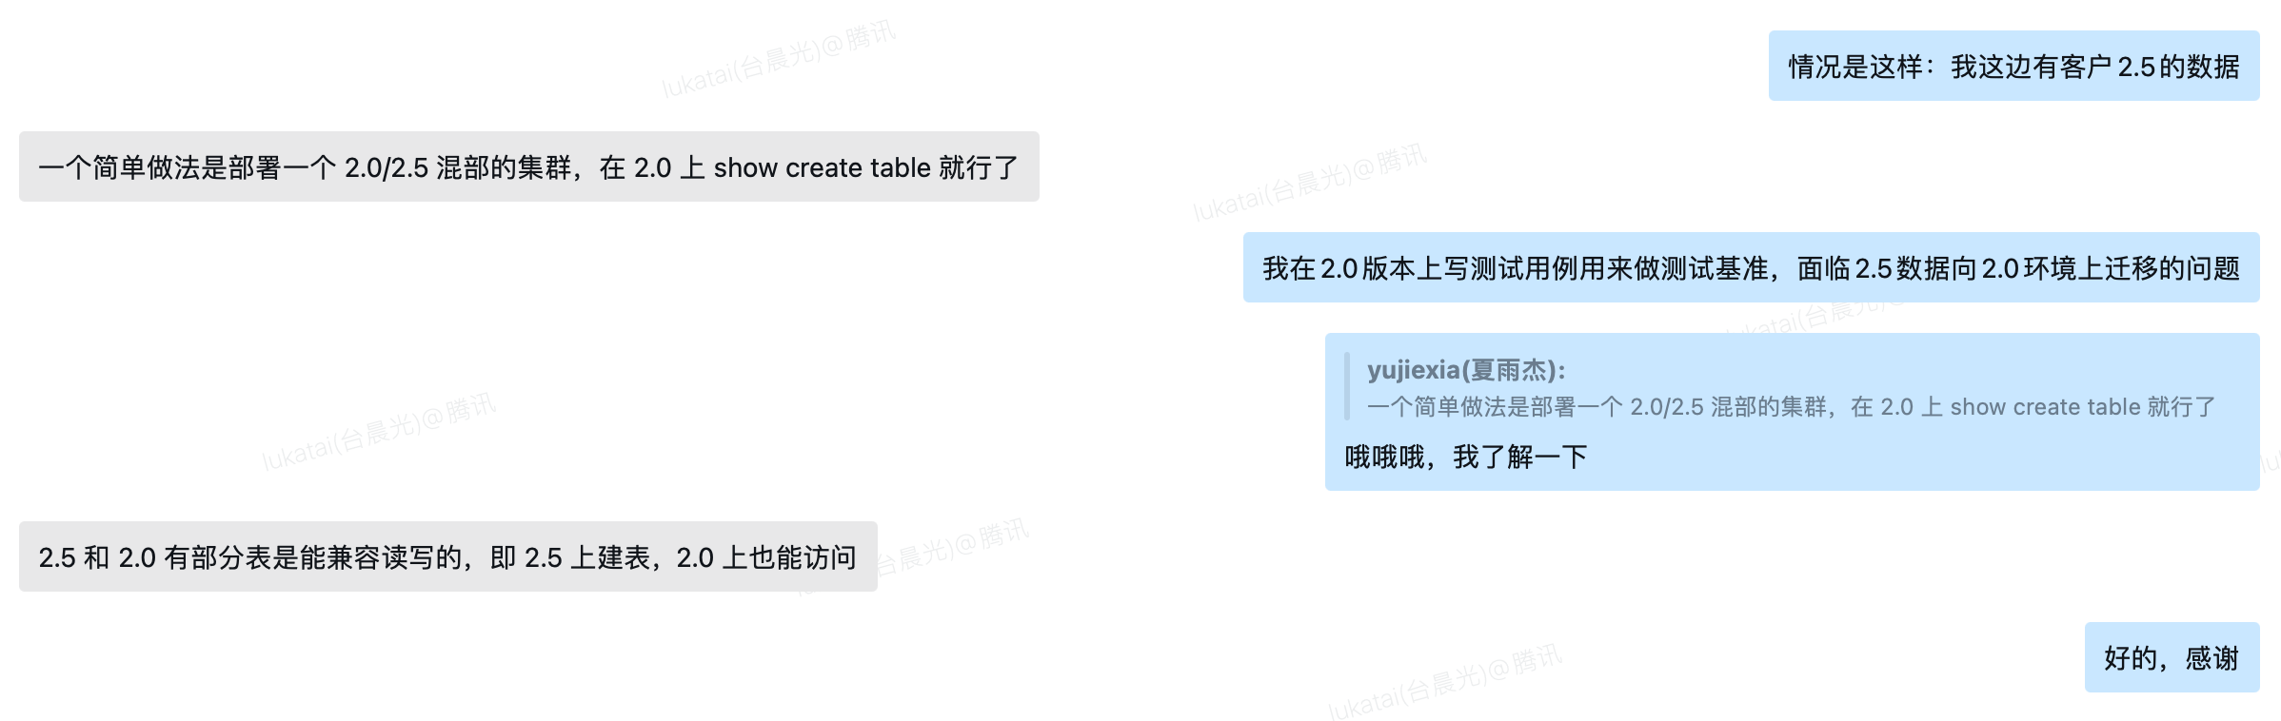

**混部proxy，然后2.5上创建，2.0上查询**

### 2.0上创建，2.5上可以查到

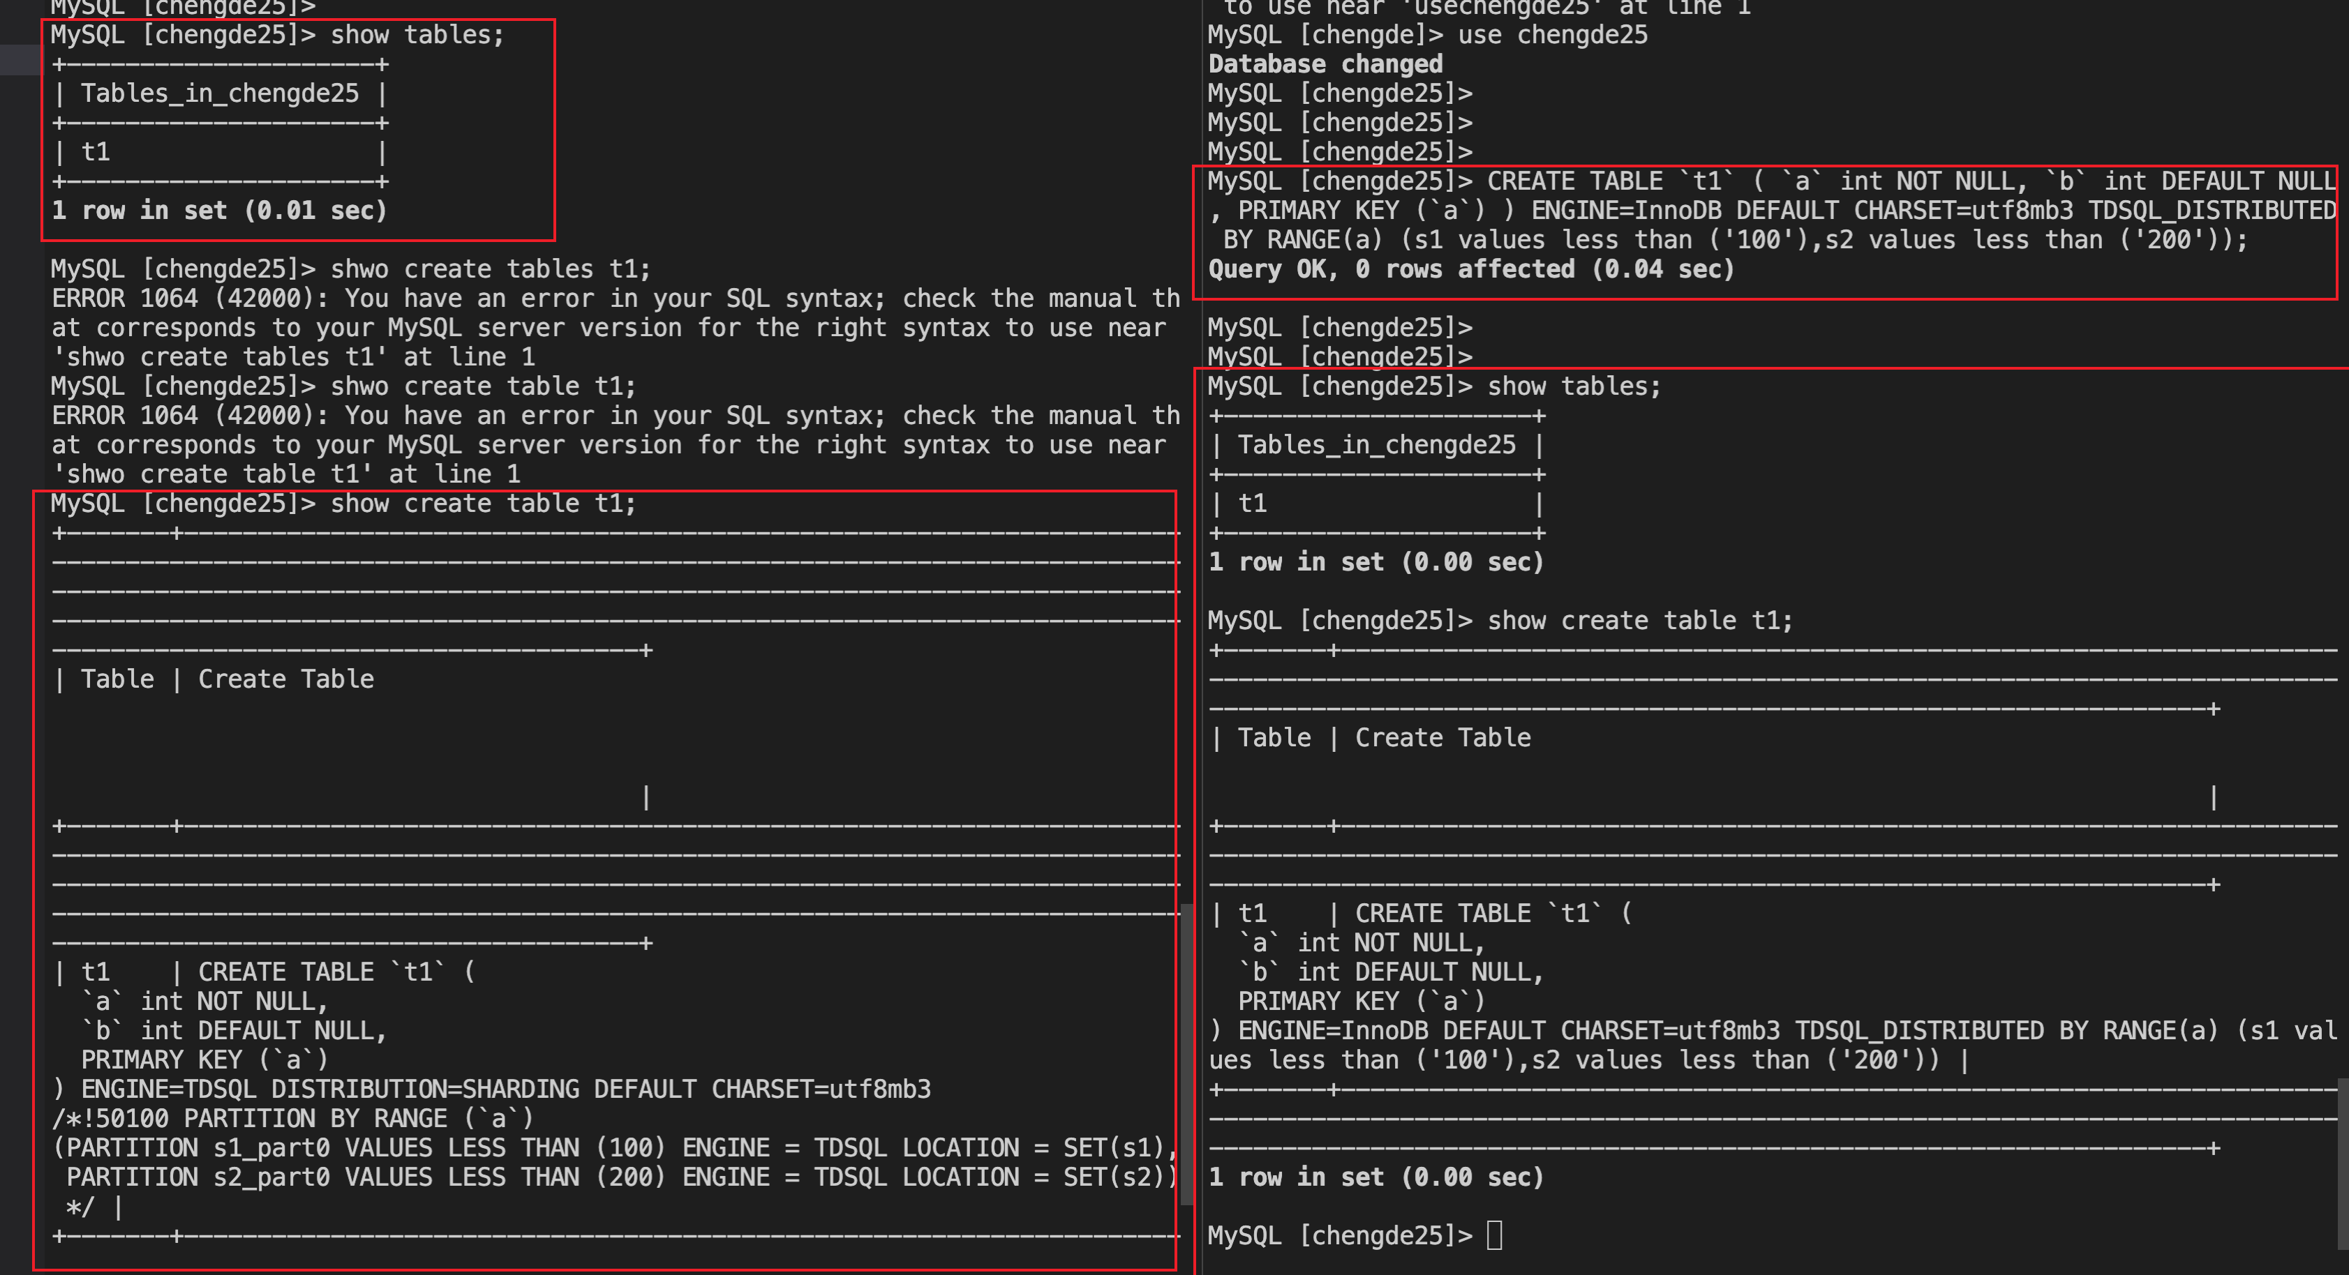

CREATE TABLE `t1` ( `a` int NOT NULL, `b` int DEFAULT NULL, PRIMARY KEY (`a`) ) ENGINE=InnoDB DEFAULT CHARSET=utf8mb3 TDSQL_DISTRIBUTED BY RANGE(a) (s1 values less than ('100'),s2 values less than ('200'));

### 2.5上创建，2.0上查

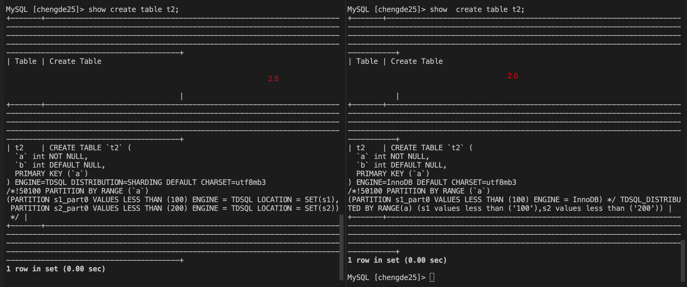

CREATE TABLE `t2` (  
 `a` int NOT NULL,  
 `b` int DEFAULT NULL,  
 PRIMARY KEY (`a`)  
) ENGINE=TDSQL DISTRIBUTION=SHARDING DEFAULT CHARSET=utf8mb3  
/*!50100 PARTITION BY RANGE (`a`)  
(PARTITION s1_part0 VALUES LESS THAN (100) ENGINE = TDSQL LOCATION = SET(s1),  
 PARTITION s2_part0 VALUES LESS THAN (200) ENGINE = TDSQL LOCATION = SET(s2)) */

## 创建环境

1. 构建3proxy的实例，proxy版本为2.0
2. 将其中一个proxy的版本更换为2.5

* 更换方法：<https://iwiki.woa.com/p/4010697647>
* 2.5 proxy路径：<https://devops.woa.com/console/pipeline/zhiyan-tdsqlv2/p-855b1b68bb42406ba9dec202ab077349/detail/b-6590c1e3737c444cbad580eda1198515/outputs>

/data/tdsql_run/portNumber 下面进行替换

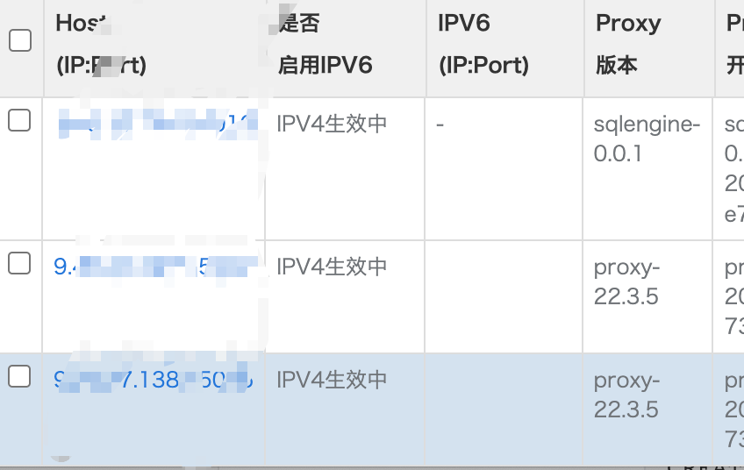

1. 使用指定porxy登录数据库

## 大批量实践环节

待操作