

The Experiment Report of Machine Learning

SCHOOL: SHIEN-MING WU SCHOOL OF INTELLIGENT ENGINEERING

SUBJECT: The super robot Everest class

|  |  |
| --- | --- |
| *Author:*  Xilang Zeng | *Supervisor:*  Mingkui Tan |
|  |  |
| *Student ID:*  202130461984 | *Grade:*  Undergraduate |

2024-3-28

# Experiment 2: Logistic Regression and Support Vector Machine

***Abstract—This experiment involves using logistic regression models and support vector machine models to handle binary classification problems with the a9a dataset in LIBSVM Data. In this experiment, we tried the method of stochastic gradient descent to update the model parameters and used the validation set to test the loss value after training.***

## INTRODUCTION

This section introduces the problem to solved and leads the reader on to the main part. Detailed motivation is necessary. What’s more, you can show your expected results and contributions.

This experiment utilizes two methods, logistic regression models and support vector machine models, to conduct binary classification experiments on the a9a dataset within LIBSVM Data. In logistic regression, we used the sigmoid activation function as the logistic function. Afterwards, we calculate the cross-entropy loss for positive and negative samples and update the model parameters using stochastic gradient descent.

To accommodate some samples that do not meet linear constraints, we use the hinge loss function in the support vector machine experiment and calculate its gradient. By updating the parameters of the support vector machine through stochastic gradient descent, we achieve the purpose of classification. Finally, we are able to effectively implement binary classification problems through these two methods.

## METHODS AND THEORY

In this section, you are asked to give a complete introduction to the experiment. For instance, the chosen methods, the related theories, the related equations (loss function), the derivation process (taking the gradient) and so on.

### Reading the experimental data

### Choosing the loss function

### Update Model Parameters

### Validating with the validation set

### Printing the loss curve

## EXPERIMENT

### Dataset

This section represents the related information of datasets, such as the content, the number of data, the training set, the validation set and so on.

### Implementation

All detailed implementation in your experiment: initialization, process, results, all kinds of parameters. In a word, describe clearly What you do and how you do. Figures and tables should be labeled and numbered, such as in Table I and Fig. 1.

TABLE I

SIMULATION PARAMETERS

|  |  |
| --- | --- |
| Information message length | *k* = 16000 bit |
| Radio segment size | *b* = 160 bit |
| Rate of component codes | R = 1/3 |

## CONCLUSION

This section summarizes the paper. In our experiments, you can also write your gains and inspirations in here.

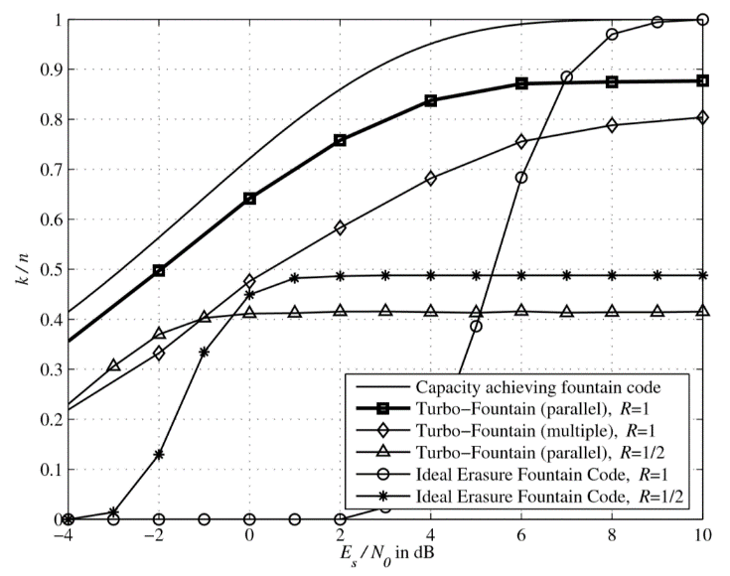Figure. 1. Simulation results on the AWGN channel.