Data Screening

目录

Import la-palma.csv - a clean subset of [catalogoComunSV_1663233588717.csv](https://github.com/Notebooks-Now/submission-quarto-full/blob/main/data/catalogoComunSV_1663233588717.csv):

|  | Longitude | Latitude | Depth(km) | Magnitude | DateTime |
| --- | --- | --- | --- | --- | --- |
| 11346 | -17.8349 | 28.5346 | 26.0 | 1.6 | 2017-03-09 23:44:06+00:00 |
| 11343 | -17.8459 | 28.5491 | 27.0 | 2.0 | 2017-03-10 00:16:10+00:00 |
| 11344 | -17.8863 | 28.5008 | 20.0 | 2.1 | 2017-03-10 00:16:11+00:00 |
| 11345 | -17.8657 | 28.5204 | 30.0 | 1.6 | 2017-03-10 03:20:26+00:00 |
| 11342 | -17.7156 | 28.5985 | 0.0 | 1.6 | 2017-08-21 02:06:55+00:00 |

|  | Longitude | Latitude | Depth(km) | Magnitude |
| --- | --- | --- | --- | --- |
| count | 11347.000000 | 11347.000000 | 11347.000000 | 11347.000000 |
| mean | -17.844062 | 28.568893 | 14.089345 | 2.432423 |
| std | 0.027345 | 0.021899 | 8.624787 | 0.705282 |
| min | -17.995800 | 28.310200 | 0.000000 | 0.200000 |
| 25% | -17.854100 | 28.558000 | 10.100000 | 1.900000 |
| 50% | -17.838700 | 28.564000 | 11.300000 | 2.600000 |
| 75% | -17.829700 | 28.574300 | 13.900000 | 2.900000 |
| max | -17.705700 | 28.697800 | 46.900000 | 5.100000 |

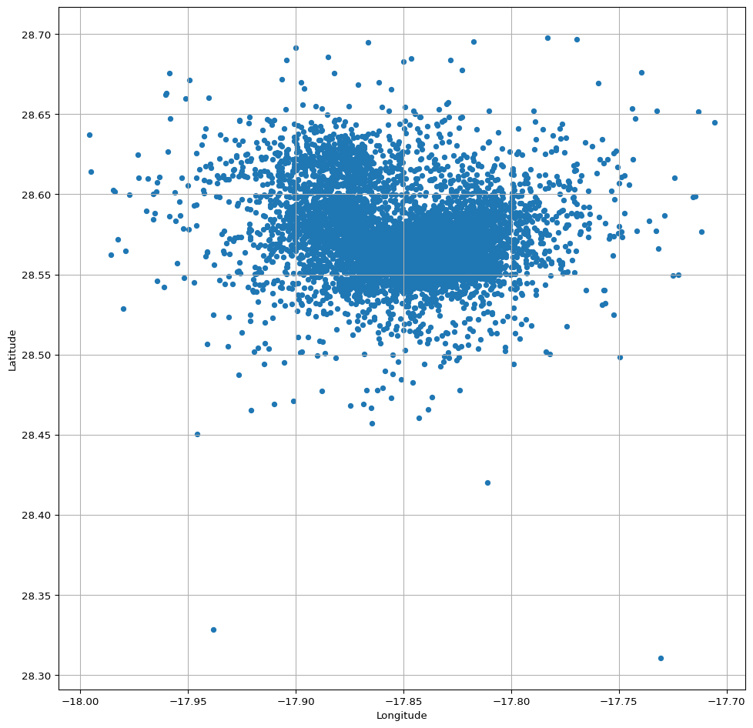

### 0.1 Filter

Also some rows seem to be missing depth measurements, (see differences in the **count** for columns above) - take only rows with valid depths

|  | Longitude | Latitude | Depth(km) | Magnitude |
| --- | --- | --- | --- | --- |
| count | 11347.000000 | 11347.000000 | 11347.000000 | 11347.000000 |
| mean | -17.844062 | 28.568893 | 14.089345 | 2.432423 |
| std | 0.027345 | 0.021899 | 8.624787 | 0.705282 |
| min | -17.995800 | 28.310200 | 0.000000 | 0.200000 |
| 25% | -17.854100 | 28.558000 | 10.100000 | 1.900000 |
| 50% | -17.838700 | 28.564000 | 11.300000 | 2.600000 |
| 75% | -17.829700 | 28.574300 | 13.900000 | 2.900000 |
| max | -17.705700 | 28.697800 | 46.900000 | 5.100000 |

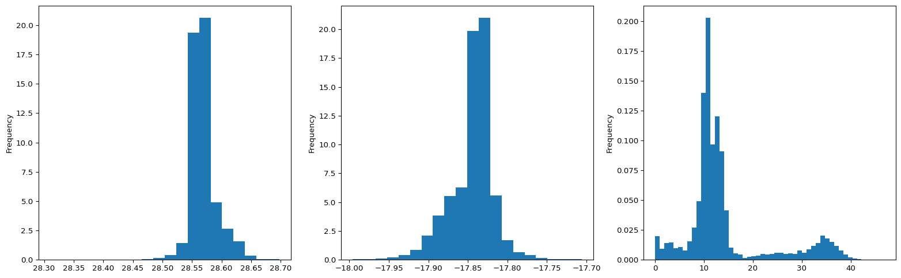

## 1 Spatial Plot

Scatter plot the spatial locations of events

|  |
| --- |
| Figure 1: Locations of earthquakes on La Palma since 2017. |

### 1.1 Timeline Plot

Scatter plot the event time series and look for any quantization issues. Have times & dates been loaded correctly?

ax = df.plot.scatter(x=‘DateTime’, y=‘Depth(km)’, figsize=(20,8)) ax.set_ylim(50,0);