1.Papertrail

Search Query :Microsoft-Windows-Security-Auditing

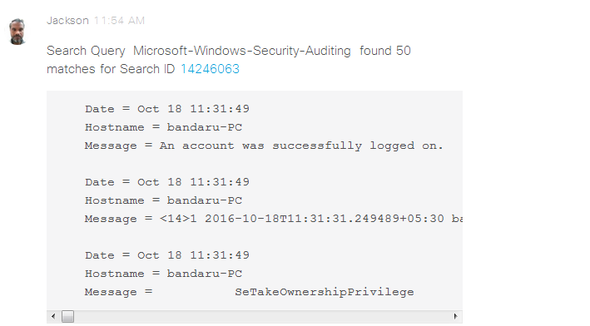

Search Query: Service_Control_Manager

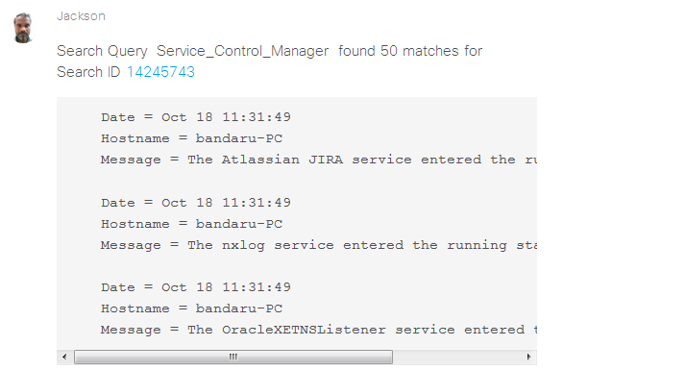

2.Docusign

Send Document:

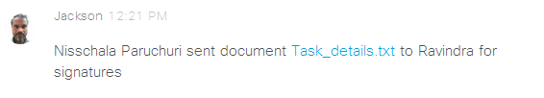

Document Delivered:

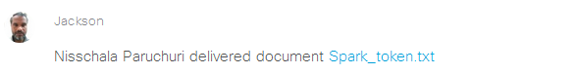Document Signed:

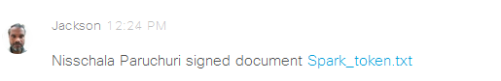  
Document voided:



3.Asana

Task Created:



Task Completed:

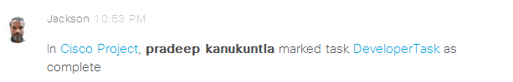

Task Assigned:



Sub Task Added:



Comment Added:



Task Incomplete:

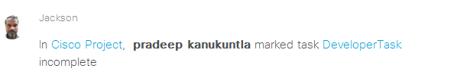

Attachment Added:



Due Date Update:



Copy Task:

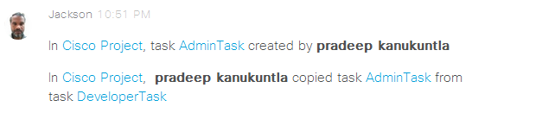

Marked as Favorite:

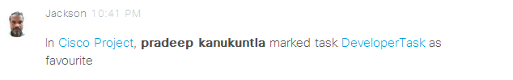

Marked as Duplicate:

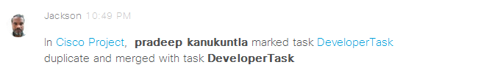

4.User Voice

Ticket Created:

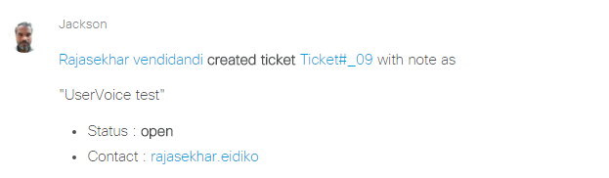

Ticket Commented:

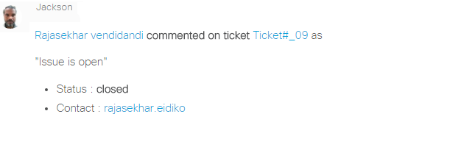Ticket Status Updated:

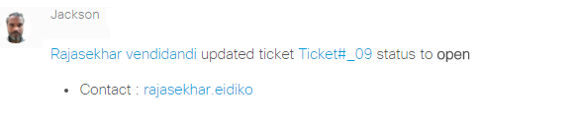

Ticket Status Updated:

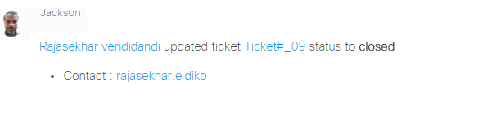

suggestion Created:

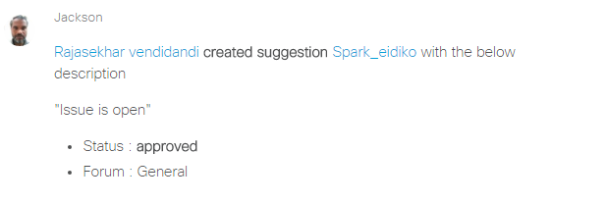

Suggestion Votes Updated:

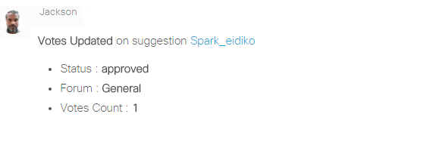

New Kudo:

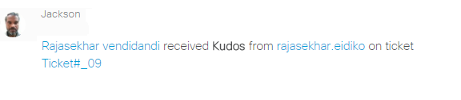

Ticket Admin Reply:

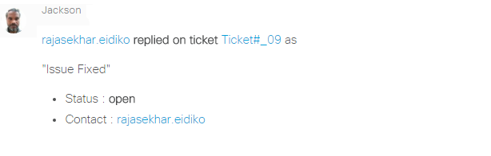

Commented on suggestion:

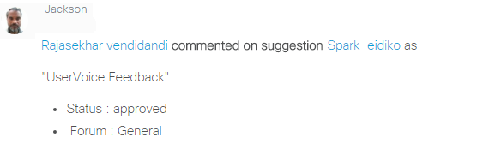

Article Created:

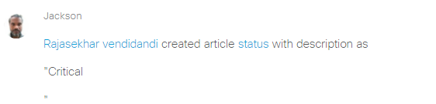

User Feedback:

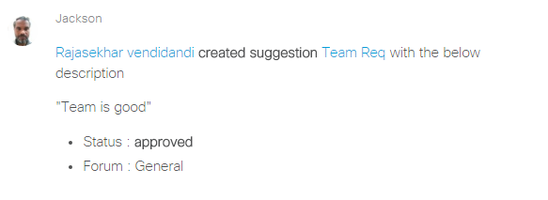

5.Wunderlist

Reopened Subtask:

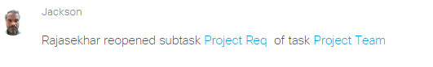

Assigned Task:

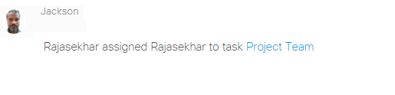

Marked Task:

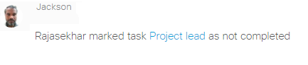

Set Due date:

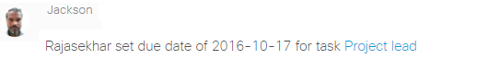

Added Subtask:

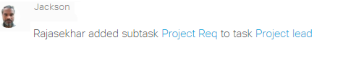

Added Note:

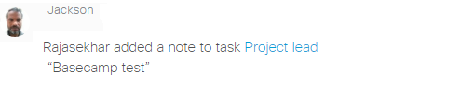

Attached file :

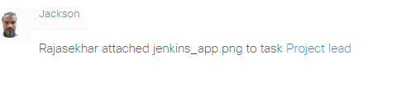

Commented on Task:

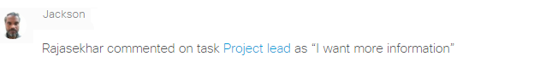

Starred Task:

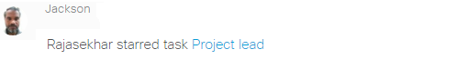

Unstarred Task:



6.Stripe

Customer Created:

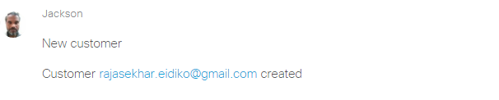

Customer Updated:

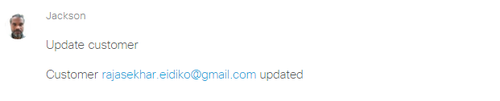

Customer Deleted:

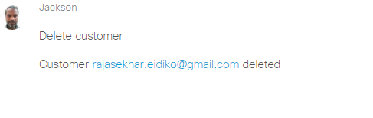

Payment Succeeded:

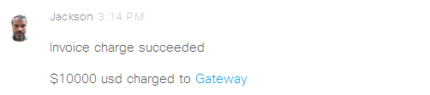

Payment Refunded:

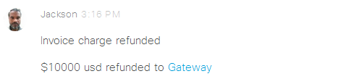

Plan Created:



Product Ordered:



Product Cancelled:

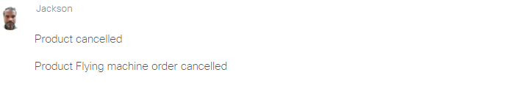

7.Onedrive

Folder Created:



File Created:



Folder Updated:



File Copied:



File Commented:



Folder Deleted:

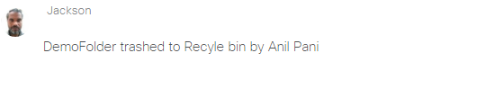

Basecamp

Todo:

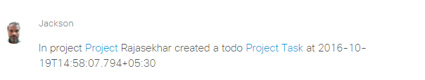

Todo-list:

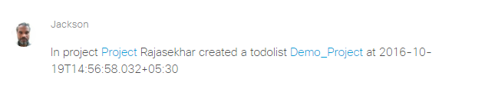

Comment:

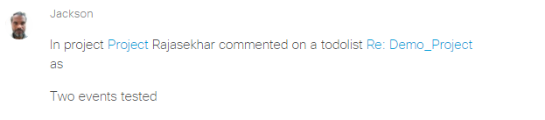

Start a Doc:

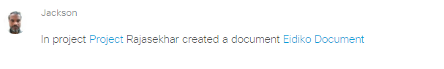

Upload File:

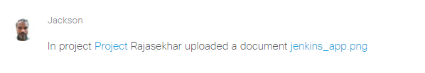

Link a Google Doc:

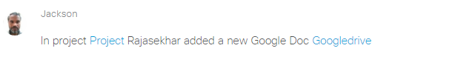

Automatic check-ins:

Question:



Question Answer:

