Marriott Procurement Spend Analysis
Project Report
Prepared using Python • Excel • Power BI
Year: 2019 Procurement Analysis

Prepare by: Chennakeshav Kanepogu

Table of Contents
- 1. Executive Summary
- 2. Business Objective
- 3. Dataset Overview
- 4. Data Preparation
- 5. Exploratory Data Analysis
- 6. ABC Classification
- 7. Pareto Analysis
- 8. Pepsi Procurement Analysis
- 9. Kimberly-Clark Procurement Analysis
- 10. Key Findings
- 11. Recommendations
- 12. Tools & Technologies
- 13. Conclusion

1. Executive Summary
This project analyzes procurement transactions across multiple hotel properties to identify spending behavior, supplier concentration, category-wise expenditure, monthly purchasing trends, and brand-specific procurement for Pepsi and Kimberly-Clark. The objective is to support better purchasing decisions and reduce procurement costs through data-driven insights.

2. Business Objective
• Understand procurement spend across hotels.
• Identify high-value suppliers and categories.
• Classify inventory using ABC analysis.
• Identify supplier dependency using Pareto analysis.
• Analyze Pepsi and Kimberly-Clark procurement.
• Provide business recommendations.

3. Dataset Overview
The consolidated procurement dataset contains hotel name, supplier, category, product, unit price, quantity received, transaction date, and total spend. Data from multiple hotel properties was cleaned and merged into a single analytical dataset.

4. Data Preparation
Cleaning steps included removing duplicates, handling missing values, converting date formats, validating product names, standardizing supplier names, correcting numeric fields, and creating calculated measures for spend and monthly trends.

5. Exploratory Data Analysis
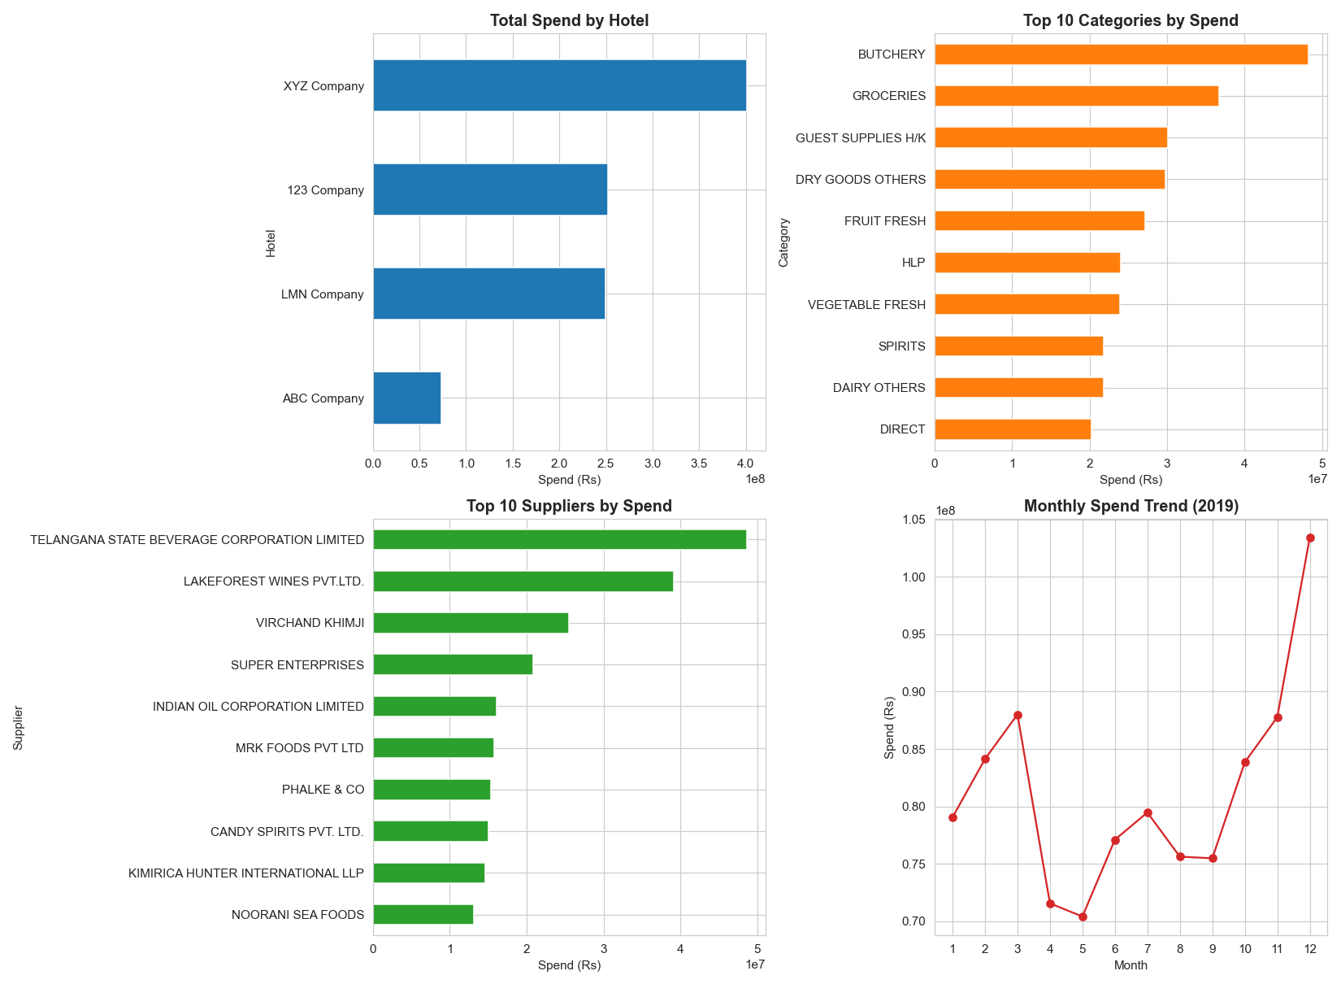
EDA highlights hotel-wise spend, top suppliers, leading categories, and monthly procurement trends.

6. ABC Classification
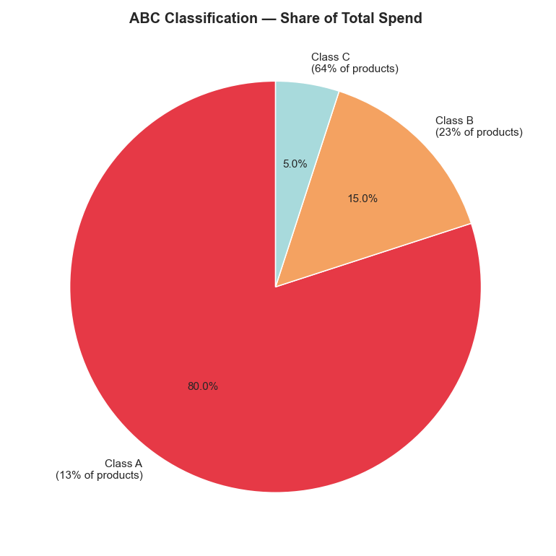
Only 13% of products contribute nearly 80% of procurement spend (Class A), while 64% of products contribute only 5% (Class C). This supports focused inventory management.

7. Pareto Analysis
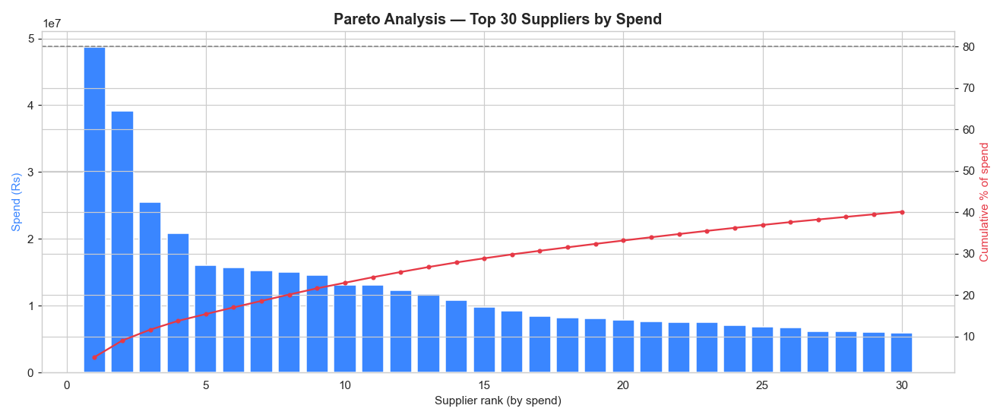
Supplier spend is concentrated among a limited number of vendors, indicating opportunities for strategic supplier management.

8. Pepsi Procurement Analysis
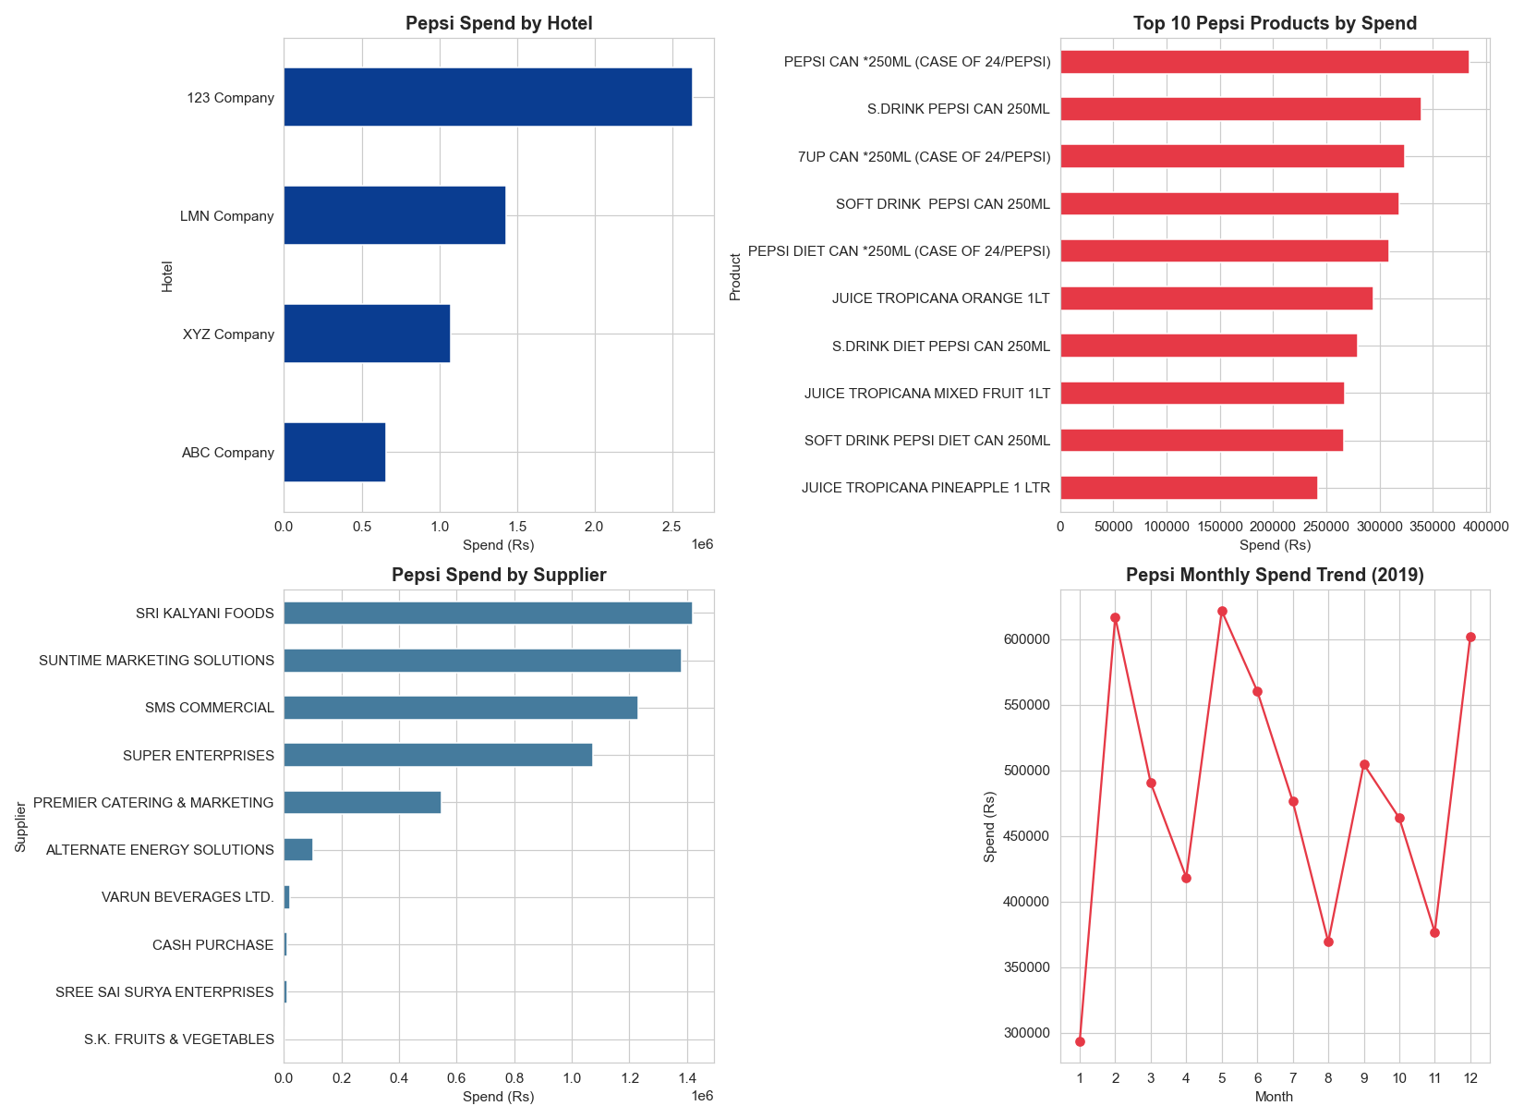
Pepsi procurement is concentrated around canned beverages and Tropicana products, with spending varying across hotels and months.

9. Kimberly-Clark Procurement Analysis
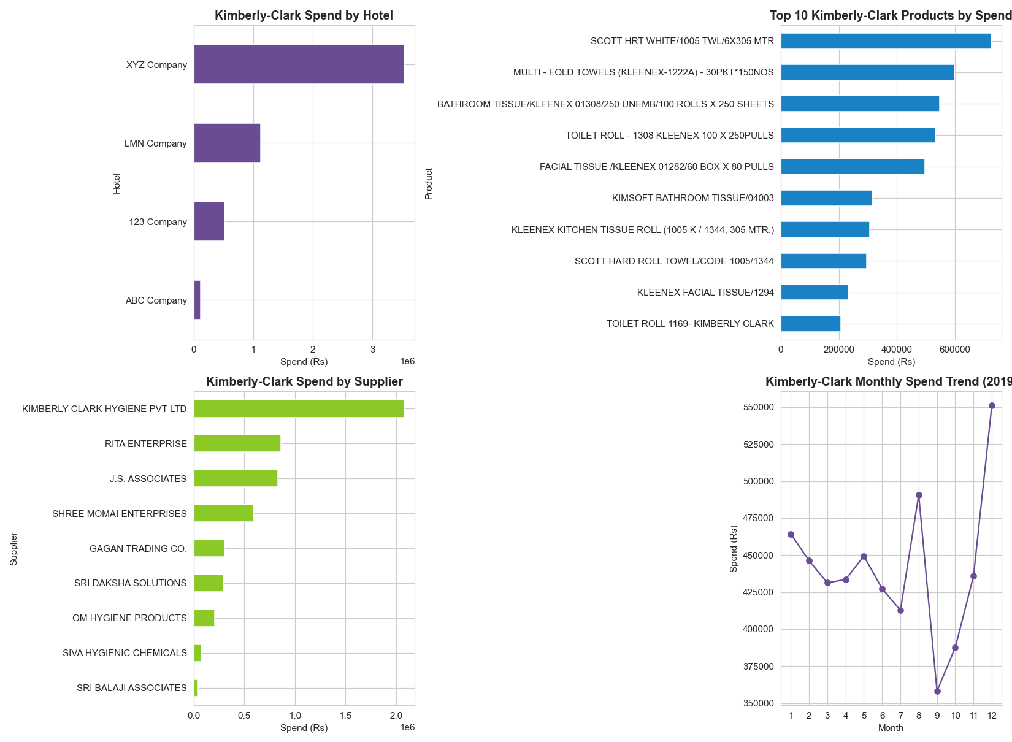
Kimberly-Clark procurement is driven mainly by tissue and hygiene products, with a few suppliers contributing most purchases.

10. Key Findings
- Class A products represent only 13% of items but account for approximately 80% of total procurement spend.
- Supplier spending is concentrated among a small group of vendors.
- Butchery, Groceries, and Guest Supplies are the highest spending categories.
- Procurement spending increases toward the end of the year.
- Brand-specific analysis identifies major products and suppliers for Pepsi and Kimberly-Clark.

11. Recommendations
- Negotiate long-term contracts with high-spend suppliers.
- Closely monitor Class A inventory.
- Review procurement plans before year-end demand peaks.
- Diversify suppliers where dependency is high.
- Use dashboards for continuous procurement monitoring.

12. Tools & Technologies
Python (Pandas, NumPy, Matplotlib), Jupyter Notebook, Microsoft Excel, Power BI.

13. Conclusion
The procurement analysis successfully identified spending patterns, supplier concentration, inventory priorities, and seasonal purchasing trends. The insights generated can support cost optimization, supplier negotiations, inventory planning, and data-driven procurement decisions.

