



**PSU Hershey, College Of Medicine 2**

**Orthopaedic Surgery Gaming App**

**Final Report**

*April 28, 2019*

Nicholas Duffner

Amber Graham

Chenning Zhang

*Student Team*

*Capstone, Penn State*

Submitted To:

Dr. April Armstrong

MD, Penn State College of Medicine

Steven Shaffer

College of Engineering, Penn State

Intellectual Property Rights Agreement Does Not Apply

Non-Disclosure Agreement Does Not Apply

***Executive Summary***

For our Senior Capstone Design Project, we have been teamed with a sponsor from Penn State Hershey School of Medicine, Dr. April Armstrong, to design a gaming app to inform high school students of the field of Orthopaedic Surgery. This app will be published to both Android’s Play Store and Apple’s App Store at no cost to the user in order to reach a wide range of students to encourage or spark interest in a profession in this field. In order to reach and engage a diverse population of high school students, we will develop the game in such a way that it is visually similar to other popular games for this age group. Such games utilize a style of play that is repetitive and goal-oriented, displayed with appealing colors and graphics. We will incorporate educational components into the surgical scenarios and also provide a review of human anatomy so that students with less exposure to the topic can gain background knowledge that their peers may possess. In addition to researching the topic and method for delivering the game to the target audience, we have carefully planned the development of the game so that we can deliver the product on time and monitor our progress throughout the semester. We will also closely monitor our budget and spending on any needed supplies so that we do not exceed the funding we have been provided with. We will maintain regular contact with our sponsor and her team of colleagues to provide updates and results, as well as to seek consultation to ensure that our game uses accurate medical terminology. Upon completion of the project, we will provide source code for the game, thorough documentation for future development, and a business plan and any foreseeable legal requirements for publishing the game.

**Contents**

Statement of Problem…………………………………………………………………………………….4

Patent and Literature Search…………………………………………………………………………....4

Social Impact……………………………………………………………………………………………...9

Project Objectives………………………………………….………………………………..…….…….10

Technical Approach……………………………………………………………………………………..10

1. Identifying Needs of Customers………………………………………………………………10
2. Identifying Target Specifications………………………………………………………………10
3. Generating Design Concepts………………………………………………………………….11
4. Selecting Design Concept……………………………………………………………………..11

Project Management…………………………………………………………………………………....12

1. Deliverables……………………………………………………………………………………..13
2. Budget……………………………………………………………………………………………14
3. Bill of Materials………………………………………………………………………………….14
4. Communication and Coordination with Sponsor……………………………………………14

Detailed Design………………………………………………………………………………………….15

1. Component and Component Selection Process…………………………………………….15
2. Object Oriented Design………………………………………………………………………..15
3. GUI Design………………………………………………………………………………………17
4. Database Design……………………………………………………………………………….18
5. Use Case Definitions…………………………………………………………………………...18
6. Interface Design………………………………………………………………………………...19
7. Testing Procedure………………………………………………………………………………19

Final Discussion………………………………………………………………………………………....21

1. Implementation Process……………………………………………………………………….21
2. Test Results and Discussion…………………………………………………………………..22

Team Qualifications…………………………………………………………………………………..…23

Conclusion……………………………………………………………………………………………….23

References….……………………………………………………………………………………………25

**Statement of Problem**

Dr. Armstrong and the other orthopaedic surgeons came to us looking for a way to get high school students interested in orthopaedic surgery. She pointed out how most students are not exposed to this field until they are already in college pursuing a degree in medicine. Our other sponsors noted how it is mostly younger boys that are introduced to orthopaedic surgery because of sports. This in turn creates a lack of diversity to the point where only about 1 in 10 orthopaedic surgeons are women. The field is also composed of a large majority of caucasians, so diversity by race is a concern as well. Our sponsors want to create a gaming app that is fun and engaging to these younger students but is also informative enough to familiarize these students with what orthopaedic surgeons actually do. Their goal is for this game to be easily accessible to a wide range of high school students.

**Patent & Literature Search**

1. **Patents for Development Tools**

We conducted a preliminary patent search to ensure that we do not violate any proprietary technology. Currently, we are using free open source development software Unity-individual version to develop our Gaming App. In the future, we might use commercial software Adobe Photoshop or other free open source software for graphic design.

1. **Existing Solutions to the Problem**

* **The Perry Initiative** - Building the Pipeline for Women in Engineering and Medicine

<https://perryinitiative.org/>

1. **What is the product or solution you looked at?**The Perry Initiative is a program that inspires young women to become Engineers and Orthopaedic Surgeons through hands-on outreach programs across the country. It is directed toward students who identify as female in high school. The program, founded in 2009, includes an integrative educational curriculum for middle school and high school students, and runs over 40 one-day outreach programs nationwide. To date, they have reached over 7500 students in high school, college, and medical school through 260 outreach events.
2. **How is it like what your product does?**This program is like our application in that it is attempting to inspire more young women to pursue a career in orthopedic surgery on a national level.
3. **How is it different from your project?**This program is different from our application in many ways. First, it is a selective program requiring an application and essays, and only students who have not participated before may be admitted. Our app will be available to anyone, regardless of age or gender identity. A second key difference is that it is only a one-day program. Our application, being mobile rather than in person, will be available to students any time.
4. **What are the legal and cost issues?**A legal issue with this program is that it requires a liability waiver to attend. However, like our app, this program is free.
5. **Why (or why not) are you using this (or not)?**This program is not something we can use, because it is very different in structure being an in-person event rather than a gaming app. However, it may be very valuable to advertise events like this in our app to make users more aware should they become interested in learning more about orthopedic surgery. This is an idea we can pass on to our sponsors and could be implemented in the future.

* **Bonedoc -** , <https://www.imedicalapps.com/2014/04/bonedoc-game-orthopedic-surgeons/>

1. **What is the product or solution you looked at?**Bondoc is a serious game which allows users to perform virtual orthopedic surgery. For high school students, they can have fun, taking virtual X-ray as you fix the patient’s broken hips. For orthopedic trainees, they could get real-time feedback on facets of their surgical performance.
2. **How is it like what your project does?**One of the main purposes of Bonedoc is to attract high school student to have orthopedic surgery simulation and have fun with it. It shares same professional level as we do. Medical term and surgery process are precisely.
3. **How is it different from your project?**Our purposes are making App free for everyone and lower the entry-level cost for people who interested in. To download Bonedoc for any reason, it needs cost $1.99 on Appstore which is unlikely that high school students would play it. Bonedoc has professional graphics and real-world images, to introduce to high school students, our app will design cartoonish.
4. **What are the legal and cost issues?**You needs to accept Terms and Conditions before the user can pay and play. There is no other cost in App.
5. **Why (or why not) are you using this (or not)?**We will use technical format or constructs of this app to make the model of ours, but our App will more focusing on education rather than professional. And we want to make our app more acceptable for a beginner. And our app will not charge for any reason.

* **Stanford Extension of Perry Initiative**

<https://scopeblog.stanford.edu/2013/08/20/teen-girls-become-orthopaedic-surgeons-for-a-day/>

1. **What is the product or solution you looked at?**This is a medical mentorship program for high school students in the area surrounding the Carolina Coast Surgery Center. Students submit applications to their health science teachers and then the surgery center’s community liaison narrows down the applicants and picks out the group.
2. **How is it like what your project does?**This program in particular chose 50 female students out of the 55 that attended. The article noted how 95% of orthopaedic surgeons were male in the U.S. in 2015. However, there are also a record number of women enrolled in medical school now, so this program is trying to continue that trend to balance out the field. This is similar to our project because we are trying to even the playing field for both males and females with our app.
3. **How is it different from your project?**Our app does not allow students to speak with surgeons directly or get in-person, hands-on surgical experience, but it does let students learn about orthopaedic surgery in a much more accessible way. The app is also intended to be much less gory than real life surgery which turned several students off to surgery in this story.
4. **What are the legal and cost issues?**Similar to the Perry Initiative, the only legal issue would be having students fill out a waiver for safety reasons. This program is also free to attend.
5. **Why (or why not) are you using this (or not)?**This solution is not as inclusive as our app would be. We are using the concepts of real surgery, but we want the app to appear cartoonish so that students are not too grossed out. This app also does not require an application which makes it more accessible to any student.

* **Amateur Surgeon 4** (Apple/Android)

1. **What is the product or solution you looked at?**This is a surgery gaming app. It includes surgical puzzles that help you navigate through levels of ridiculous surgery scenarios including pizza cutters, giant squids, chainsaws and more.
2. **How is it like what your project does?**This app is similar to our project in the way that it is intended to attract younger smartphone users. It also is very cartoonish in the way that is displays the human body and surgical tools.
3. **How is it different from your project?**Our project will need to be more educational than this gaming app. Amateur Surgeon is very engaging to younger students, but it does not teach them any real surgical procedures or any useful anatomy information.
4. **What are the legal and cost issues?**The game makes you accept Terms and Conditions before the user can play. The app is also free, but there are many in-app purchases the user can choose to spend money on.
5. **Why (or why not) are you using this (or not)?**We will want to use their animations to effectively make our game engaging to younger students, but we will want to do it in a way that is still educational. If the game is too cartoonish, students will not seriously consider a career in orthopaedic surgery.

* **Operate Now: Hospital** (Apple/Android)

1. **What is the product or solution you looked at?**This is another surgery gaming app. It involves realistic trauma scenarios that also takes the user through surgery simulations. The user is able to build and customize their hospital as well.
2. **How is it like what your project does?**Our project also plans on employing some brief storylines to make the game interesting and engaging for younger students. This will also put these injuries in perspective for each user. The surgery simulations are realistic but are still illustrated like our visuals will be. It also provides a score based on the user’s performance which we are trying to include as well.
3. **How is it different from your project?**This game is better than most simulators, but it still does not specify a lot of surgical terms that we want to include to make our game educational. Many of the games themes are also somewhat dark and morbid, which is what we want to avoid so that young students do not feel pressured when playing the game. This game puts a lot of emphasis on the side project of building the hospital which is too complex for our purposes.
4. **What are the legal and cost issues?**This app also asks to collect the analytical data the user creates while playing. The app is free, but is another game with in-app costs to increase the amount of money you can spend in the game.
5. **Why (or why not) are you using this (or not)?**We will not be using the intricate storylines and hospital building aspects of this game because it takes away from the learning portion of the game. We want to take note of their interesting scenarios and simulator graphics in order to make our game as appealing as possible.

* **Touch Surgery** (Android/Apple)

1. **What is the product or solution you looked at?**Touch Surgery is a multi-award winning surgical training platform for doctors and surgeons, and it has been researched by world-leading institutions and published in peer-reviewed journals.
2. **How is it like what your project does?**The basic concept of this app is to provide an educational platform. It has introduction for tools, organs and procedures. Like our game, it divides the human body into several parts, and in each part, it has instruction or article to read. And this app has a test part to test user as surgeon to do what next step is right.
3. **How is it different from your project?**This app is more focusing on researches and articles which is obscure for high school students, and it does not have any interactive system. App has a professional orthopedic surgery simulation which including crucial images, our app needs to avoid crucial images and find the balance between professional and entertainment.
4. **What are the legal and cost issues?**This app is free to download and free to use. But the user must create an account to access these articles and relative surgeon operation. This app needs to collect user data and linking email.
5. **Why (or why not) are you using this (or not)?**We are not using this solution because this app is too professional for a high school student, Although the user does not need to pay to download, the user still need to create an account to login which will not work if there is no internet. And this app has more weight on articles and researches, entry-level learner (high school student) will lose interests at begin.

* **Surgeon Doctor 2018**

1. **What is the product or solution you looked at?**Surgeon Doctor 2018 is a game that is available on the Android app store.
2. **How is it like what your project does?**It is similar to our product in that it presents surgical scenarios with cartoonish visuals, and it guides the user through the procedures.
3. **How is it different from your project?**It is different from our project because it is not specifically for orthopedic surgery. There are different varieties of procedures including burn treatment, wood and glass removal, and scoliosis surgery. Some levels must be played to unlock new levels, and the user may only perform one option to complete a task, rather than having to make a choice. A key difference between this game and the one we will develop is that it contains no educational component. No bones are identified.
4. **What are the legal and cost issues?**The game has no cost to download, but the user must navigate through advertisements several times throughout the game. The company that makes the game, Tapinator, also collects data on its users, including browsing history and approximate location. The game also has the option to link with various social media platforms.
5. **Why (or why not) are you using this (or not)?**We are not using this solution because it does not provide an educational component and it does not provide choices to the user to perform the surgery. The game is only a “point and click” type of game, and it is not specifically for orthopedic surgery.

* **Surgeon Simulator** (Apple/Apple)

1. **What is the product or solution you looked at?**Surgeon Simulator is a mobile game available on both Android and IOS app store. In the game, you will be a surgeon to ‘save’ those patients. It sells more than 2.5 Million.
2. **How is it like what your project does?**In the app, tool use is the most important part. In our project, users need to pick a right to tool to make surgery right. It has a physical reaction when player picks a tool and make a reaction with an organ. Survive of a patient is depends on the correctness of surgical procedure.
3. **How is it different from your project?**Different from our game, surgeon simulator is not an educational app, it is a spoof app. The purpose of playing is to kill the patients and to the worse, as they can.
4. **What are the legal and cost issues?**The app is a commercial game, it need cost $4.99 to download, and there has no in-app purchases or unlock system.
5. **Why (or why not) are you using this (or not)?**We will not use this solution, because the basic idea is contradicted with ours. We want to make orthopedic surgery as a serious job and more professional. But this game is design for entertainment and charges money.

* **Hospital Surgery: Operate Like a Master Surgeon 3D** (Android)

1. **What is the product or solution you looked at?**This is a cartoonish surgery game that is available in the Android app store.
2. **How is it like what your project does?**It is like our game in that it provides the user with a scenario of how the patient obtained an injury. It also provides the user with some choices for actions to take, but those choices do not always lead to a relevant action.
3. **How is it different from your project?**It is unlike our game because it does not contain an educational component. It is also not specifically for orthopedic surgery.
4. **What are the legal and cost issues?**The app is free to download, but requires some in-app purchases and contains multiple pop-up ads.
5. **Why (or why not) are you using this (or not)?**We are not using this solution because, while it does contain some of the details we are intending to use, it is not a solution to the problems we have. Additionally, this game is not very accurate in the actions performed reflecting the actions selected by the user.

**Social Impact**

1. **Issue to be addressed:** The issue we are attempting to address with our gaming app is a lack of diversity in the field of Orthopedic Surgery. Women account for roughly 10% of the field, and that disparity is due to a variety of factors, including a lack of exposure to the field, leading to a lack of awareness. Becoming a doctor, and specifically an orthopedic surgeon, requires years of school and training, so reaching students to increase their awareness of the field before they begin college is how we see our game having a positive social impact, increasing the number of women in orthopedic surgery.
2. **Anticipated outcome:** According to a recent poll by USA Today, nearly 89% of teens have smartphones, which makes creating a mobile gaming app a solution with the potential to be very effective. By creating a gaming app, we can reach nearly every teen in the country regardless of geological and socioeconomic constraints, access to education, and any other barrier preventing individuals from entering this field. While there are many successful in-person programs across the country for teaching teens, specifically young women, about orthopedic surgery, they have limits to how many students they can reach due to budget restrictions and location.
3. **Measured outcome of a similar program:** One such program that has been very successful is the Perry Initiative, a program with the specific purpose of encouraging young women to enter the fields of orthopedic surgery and engineering. This program recently conducted a five-year program evaluation, and found that 93% of students who went through their program are enrolled in STEM fields in college with 56% intending to go to medical school and 23% likely to become orthopedic surgeons. For an outreach program that is both selective and geographically confined, they have had over 7500 students participate in their program, yielding a potential increase of 1725 new female orthopedic surgeons. Considering that there are roughly 29,613 orthopedic surgeons in the US, according the a 2016 report from AAOS, The Perry Initiative has the potential to be responsible for a 5.8% increase in female orthopedic surgeons.
4. **How we will have an impact:** This is accomplished by providing awareness and access to orthopedic surgery. Because our game will reach an even wider range of students, we anticipate a positive social impact in this field as well.

**Project Objectives**

1. Introduce orthopedic surgery to high school students
2. Stimulate high school students interests in orthopedic surgery
3. Increase the diversity of Orthopedic Surgeons

**Technical Approach**

1. **Identifying Needs of Customers**

The orthopaedic surgeons at Hershey Medical want us to create a gaming app with multiple trauma scenarios for the player to work through as well as an introduction to basic skeletal anatomy. They want the game to be “cartoonish” so that it is more entertaining to younger people.

1. **Identifying Target Specifications**

Our target is to have a working game that does not have bugs, is functional on both iOS and Android, and includes both the multiple trauma scenarios and anatomy review. This will allow us to hand the game over to our sponsors at the end of the semester for them to build upon.

1. **Generating Design Concepts**

In order to generate concepts for our design, our team held several meetings to discuss and share our ideas and research. We analyzed current popular gaming apps among our target age group, teenagers, to study different aspects from the way the games are played and scored to the color schemes and style of graphics used. From this research, we concluded that the most popular games are ones that are repetitive. A simple concept or sequence of events is repeated until a user reaches a desired or passing score. Additionally, graphics are typically cartoonish rather than realistic. Many popular games are interactive, yet simple, so that the game can easily be played on a phone or tablet without requiring the user to learn many rules or controls, which can quickly clutter the screen. Color schemes often include a dark or simple background, with more colorful high-contrast elements and fonts used for game play and providing the user with information.

From these observations, we were able to narrow a wide range of design concepts to a few concise ideas. Relating our general idea of the design to the needs of the customer, we came up with a few concepts for how the game would be played. Initial ideas included incorporating the review of anatomy into the actual surgical part of the game, and incorporating an animation of a patient obtaining an injury prior to entering the hospital for surgery. Additional considerations for the review of anatomy were whether to include both the skeletal and muscular systems, and exactly how many bones a high school student is expected to know or would be able to identify before losing interest. For the surgical aspect of the game, we needed to decide how the patient would be displayed to the user as well as how the tools and materials would be displayed. Without any medical knowledge on our parts, much less the specifics of orthopaedic surgery, we would need to rely heavily on information from our sponsors and find reference resources that are both credible and easy to comprehend. Another important consideration we took into account is the level of detail high schoolers would be expected to know and find interesting.

1. **Selecting Design Concept**

From our discussions with the customer, we knew that the game needed to include surgical scenarios in varying levels of difficulty, as well as a review of the skeletal system to ensure that the game was both educational and fun. For the actual visual design of the game, cartoonish graphics will be used with a color scheme that is striking and simple while also gender-neutral. This design choice enables us to draw in a younger audience and make the field of orthopaedic surgery more accessible to females while avoiding alienation of any gender identification. We want the game to be available to everyone. To keep the game fun and interesting, we decided to make the anatomy review and surgical scenarios separate. That way, gameplay is not too lengthy or monotonous.

With the anatomy review, a full human skeleton will be present on the screen, so the amount of information that can be displayed is limited considering the size of a phone. We elected to display the name of one bone at a time, having the user locate that bone on the body. If the user selects the correct location, or a correct location in a case where there are 2 or more locations of that bone, the user will be informed that it is correct. If an incorrect bone is located, the user will be informed of the name of that bone, and shown the correct location of the bone. Areas that contain several small bones, like the hands, feet, ribs, and spine, will be grouped together to prevent the need to zoom in on the screen and because that is typically the way those areas are taught at the high-school level. The user will cycle through all of the bones, and we will use a randomized ordering to ensure that the review is interesting. Users may play through this portion as many times as they like, and their performance will not affect their overall score. We believe that this detail will encourage learning.

For the surgical portion of the game, we will present the user with a briefing of the situation the patient has gotten into, whether it is a car accident, skateboard accident, sports injury, etc. We will use situations that high school students can relate to or understand easily. This will help spark their interest and create a way for them to engage with the game, as performing surgery is likely very separate from their lives. We will then ask them to identify the injured part of the body, and take an x-ray. Upon inspecting the x-ray, the user will be able to determine that surgery is needed. The operating room screen will display the injured bone alongside a scrolling menu of plates, screws, and other relevant materials and/or tools to perform the surgery. The user will select which to use, and the visual of the bone will change to reflect their selections. As the user makes choices, a score will be maintained. At the end, the score will be displayed to the user. Due to time constraints, we have promised to implement two scenarios, one more challenging than the other.

**Project Management**

We are using a Gantt Chart to track our tasks and progress throughout the project, as seen in Figure 1. We have broken the project down into 6 phases, which are highlighted in light gray. These phases include Preparation, Development Planning, Report, Code Development for iOS, Code Adaptation for Android, and Wrap Up, which will include writing the final report and preparing all documentation and presentations. The phases have been further broken down into tasks, where we are able to manage the amount of time to complete the task as well as the team member or members responsible. Tasks that have been completed are in green and tasks that are not yet complete are in blue.

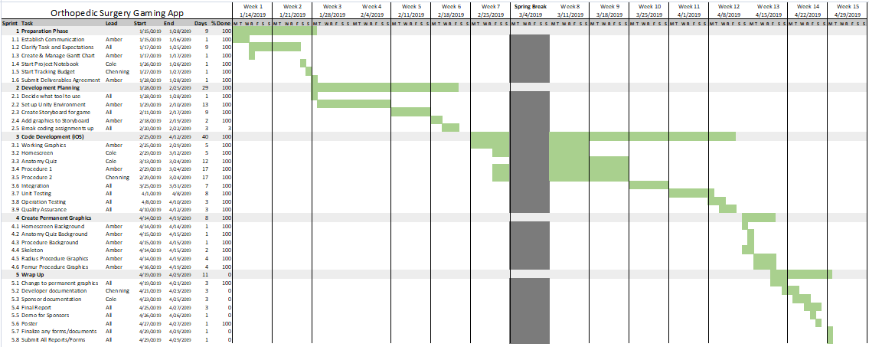  
*Figure 1: Gantt Chart*

1. **Deliverables**

To fulfill the requirements of our customer, we will deliver our gaming application in a working state so that it can be demonstrated. Realizing the scope of the project will likely require more time than we have available in the semester, we have promised that our game will be delivered with the anatomy quiz and two working surgical scenarios. If the sponsor chooses to hire a software engineer to complete the game or sponsor another Capstone team in the future, our code will be well-documented to ensure that further development is possible. All source code for the game and needed documentation, such as instructions for opening and using, will be provided as well.

In addition to delivering an unpublished application, we will provide a business plan specifying the procedure and funds necessary to publish the app to Android and iOS. We will also provide any necessary documentation pertaining to legal requirements for publishing the app, including copyright information, requirements of using Unity, the integrated development environment used to create the app, and recommendations and legal requirements for disclaimers that may be required by law regarding the medical aspects of the application.

1. **Budget**

|  |  |  |
| --- | --- | --- |
| **Item** | **Cost** | **Description** |
| Unity - Personal Version | No Cost | Software for developing game |
| Graphic Designer | No Cost | We produced our own graphics |
| Printing | $62.50 | Cost for printing poster |
| **Allotted Budget:**  **$1000** | **Total Expenditure:**  **$62.50** | **Remaining Budget:**  **$937.50** |

*Table 1: Budget*

Note: We are able to utilize the free version of Unity for development because our app will not generate revenue. By doing this, we are able to keep our cost low.

1. **Bill of Materials**

* Unity-Personal Version
* Poster Board
* Graphic Designer

1. **Communication and Coordination with Sponsor**

Our communication and coordination with our sponsor is executed primarily through emails. While we will have several video conference calls via Zoom, emails have been much more successful for our communication as we are consulting a team of three surgeons. We send out weekly emails to Dr. Armstrong and her colleagues following our team meetings on Mondays, and send any additional correspondence as needed. We have selected one member of our team, Amber Graham, to be responsible for communicating with the sponsors in order to ensure that the emails are easy to keep track of. Prior to video conferences, the team meets to ensure that the information we present during the the conference is organized and concise.

**Detailed Design**

1. **Component and Component Selection Process**

For our gaming app, we chose the landscape orientation over portrait since most of the existing games we have researched also have the landscape orientation. We are creating the game in Unity because it will allow us to make the game accessible to as many users as possible on Apple and Android devices. Since users will generally be playing this game with their thumbs on both sides of their device, we decided to put most of the buttons on either the left or right side of the screen instead of the middle so it would be more ergonomic for the user’s hands.

1. **Object Oriented Design**

Object Oriented Design is to describe every element in the project, including its name, property, and way to access. Our project includes UI, panel, canvas, scene, and button manager. UI is the user interface. Everything a user sees and can be interfaced is called UI which including text, button, and pictures. We gather those UI elements and put them on an empty screen to create a game interface and that screen called panel. We can create as many panels as we need based on our requirements. To classify these panels easily, we built an outer class called a canvas, and panels are classified lower than canvases. Those panels and canvases are built under the same environment, and that environment is called scene. We also create a C# program called button manager, and it contains code designed to load another scene. We use the build manager to link all scenes together and that is the final project.

Figure 2, below, is our Object Oriented Design Structure. Our project is divided into two parts, button manager and scenes. We also divide our project into four scenes called home screen, anatomy quiz, and two trauma scenarios. By calling functions in button manager, the home screen can load the other three scenes. Each scene is split into some questions, and each question has its own canvas. Each canvas has three panels, one made for the description of the question, and the other two are made for the correct answer and the incorrect answer. For button manager, the code can achieve loading the home screen, loading the anatomy quiz, loading the two scenarios and quitting the game, a total of five functions as below.

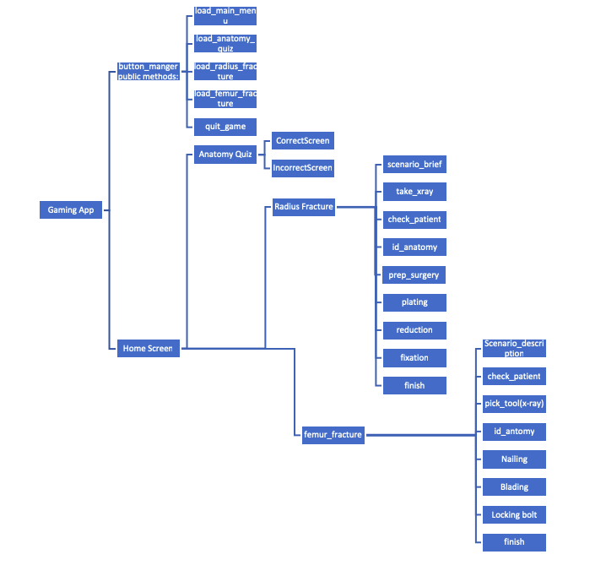

*Figure 2: Object Oriented Design Diagram*

1. **GUI Design**   
     
   Over the course of this project, our GUI has evolved significantly. We started developing our game with very simple graphics until our permanent graphics were complete. Screenshots from the early stages of development can be seen below in Figure 3:  
   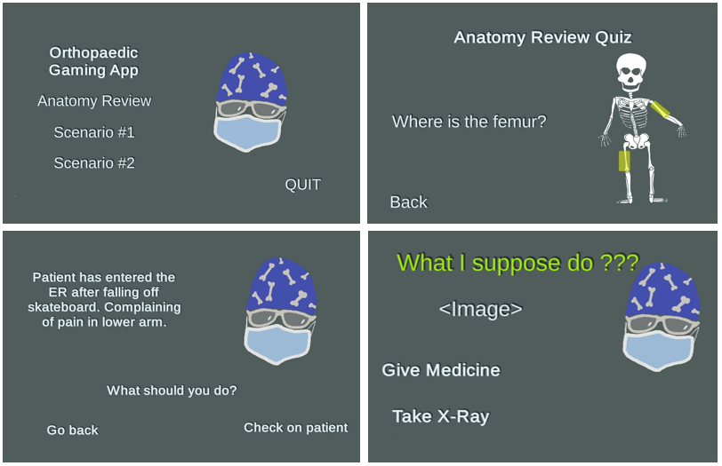

*Figure 3: Development GUI Design*

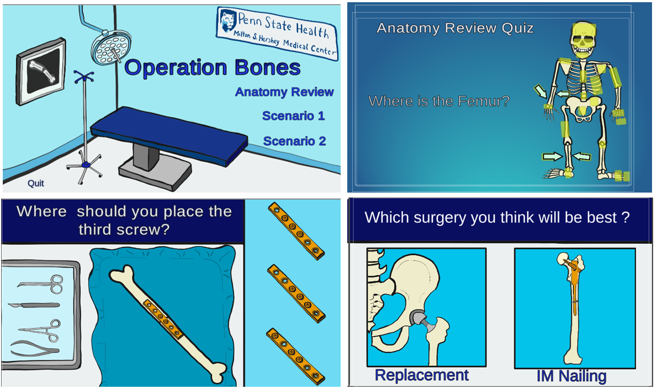

*Figure 4: Final GUI Design*

In Figure 4, above, we have displayed selections from the sections of the game with the permanent graphics installed. For the implementation of our GUI, we use both text and images as buttons to obtain user-input. Outputs displayed to the user are in the form of screen changes, which depend on whether the user has selected a correct answer or not. As can be seen in the above image, our graphics have a cartoonish appearance and simple layout of text and graphics, making the screens engaging and easy to navigate for younger users.

We initially intended to utilize a drag-and-drop interface for the surgical screens, but implemented point-and-click interfaces due mostly to time constraints. An additional consideration with our Graphic User Interface is that we used a consistent style when designing the two trauma scenarios. They share common background images and use them in a similar way, which increases familiarity of the user, making the game look more consistent and preventing the user from having to learn how to play the game in each level.

Finally, we elected to highlight buttons that have been selected by the user. This provides feedback to the user confirming that their button-press has been accepted by the game, and allows them to confirm that they have, in fact, pressed a button. These design decisions were carefully planned and considered to ensure optimal usability of the game. As the game covers topics and vocabulary that may be new to the user, we wanted to make the design a bit simpler so that there were less distractions from the information we wanted to convey.

1. **Database Design**

We will not be utilizing a database for two primary reasons. The first reason is that the aim of our customer is to create a game that is accessible to all high school students in order to increase diversity in the field of orthopedic surgery. Considering this fundamental requirement, we believe it is important that the game can be played offline, in case a student does not have access to wifi or mobile data, or has a mobile data plan with a limit that would prevent them from being able to play. By creating a game that does not connect to a database, we ensure that any student who is able to connect once to initially download the game is able to play it. The second reason we will not use a database is that the levels of the game will be created as independent objects. In the event that a new level is added, an update to the game would involve simply installing the new object and updating the home screen as needed.

1. **Use Case Definitions**

The user will be going through one use case from the beginning to the end of our app. They will start with the Anatomy Review Quiz which will have a correct choice along with several other incorrect choices. Once all the bones are chosen correctly, the user will be able to return to the main menu. At this point, they will navigate through the steps of the two different surgical procedures. These scenarios will differ depending on the type of trauma the patient experienced, and each checkpoint will have a correct answers to take the user to the next step. Incorrect answers will take them to a screen explaining what they did wrong, and ask them to try again. At the end of each scenario, the user can return to the main menu or play the game again.

1. **Interface Design**

Our interface design will be very simple. The only inputs will be from touch screen and output will be what we provide on the display. Regarding other hardware components, we will not be using sound, so we will not interface with the speakers. Additionally, the game will be available offline, therefore we will not provide an interface to the networking hardware. There will be no interfaces with external software systems for our design, as we will not be pushing updates or running advertisements.

1. **Test Procedure**

Testing our project will be composed of both technical aspects and content aspects, as it will be very important to ensure that all anatomical and medical information presented in our game is accurate. The technical aspects include testing for smooth integration of our four separate objects, testing for bugs within each of those objects, speed and optimization of code, and finding and correcting any cases that may cause our application to crash such as prolonged play and inaccurate or unexpected inputs from the user, or other faults associated with the graphical user interface.

We are using object-oriented design, so as we create each object, we are ensuring that items on the screen are displayed correctly. Since we have divided the components of the game into different objects, we are able to test for proper display piece by piece, which drastically reduces the number of errors that can occur. Additionally, as we create the screens in the game, we are testing to ensure that button action handlers are set up to transition correctly between screens. As our game is divided between three primary games, we are each able to handle roughly one third of this basic level of testing.

Following this level, we are integrating our code as we develop it to ensure that transitions between the three sections and the home screen are smooth. Since the home screen, anatomy quiz, radius surgery, and femur surgery are all separate objects with multiple frames within them, we must verify that the transitions between them are correct. Using Unity Collaborate, we are each able to maintain the most current version of the code, pushing updates to each member of our team in real-time. This allows us to ensure that transitions between game objects remain accurate, and we can easily test code written by other members of our team. Performing this level of testing as we develop allows us to catch errors early-on in the development process, so that we will prevent losing time later on when we integrate our final code.

Regarding speed and optimization, we have researched how to most optimally design our GUI so that we prevent lagging, crashing, and other possible faults. We found that if we create multiple screens within each object, rather than simply changing what shows up on the display (changing panels), we reduce the amount of code included in each display and we also reduce the number of screens we will need to disable which prevents our own error significantly. Therefore, each section of the game is divided into several subsections, and no subsection contains more than four screens. They are grouped by similarity. This is an optimal method for developing our game. Once the game is complete with graphics, we will test further to ensure that objects do not become too large. However, we do believe that our game will be well within the processing capabilities of the devices it will be played on.

The final technical aspect we are testing for is faulty user inputs, and other ways to “break” the code. Testing the surgical procedures as we develop them will enable us to reduce a great amount of these errors, but once we implement a drag-and-drop interface to our game, we will have more room for error. Using Unity for development provides three ways to test our GUI. The first is directly in the code, in Game mode. We can test a rough version of the game in the same window in which we develop the code. This is a good way to test, but does not tell us much about how the game appears on our devices, and image quality is a little lower than it will actually be in the finished game. The second way we are able to test is by using a mobile app called Unity Remote 5, which is created by Unity and available on both the Android and Apple app stores. With this app, we are able to perform the above level of testing, but instead of viewing the game on our computer, it is displayed on our mobile devices. This gives us a better idea of how well the touch inputs are working, as well as the aspect ratio of the display on various devices. We are able to use this capability to test the game on an Android phone, iPhone, and iPad to ensure that the game displays and works as we anticipate. We are able to perform a better test of the GUI to ensure that user-caused errors are eliminated. The final method of testing the GUI we are able to do is building the full version of the game. We are able to create a single executable file from all of our source code that displays on the computer. While this is different from displaying on a mobile device, we can see on the build that the image quality is greatly increased to what it will be in our final product. Running the executable on a computer with a touch screen, we are able to ensure that the input method the user will have, touch, is functioning properly, as well as ensuring that transitions between screens and objects works as expected.

Testing for medical and anatomical accuracy will be very important, and also challenging. We will verify the accuracy of our information to the best of our ability with the resources provided by our sponsor. When we demonstrate the prototype to them, we will be sure to collect their feedback on inaccuracies as they are experts in the field of orthopedic surgery. Their feedback on correct anatomy, procedures, techniques, and the logic of options we provide to the user for wrong selection will be critical in making sure that our product meets their expectations in providing a game that is medically accurate as well as fun.

Finally, in addition to testing for technical functionality as well as medical accuracy, we will ensure that our game is free of spelling and grammatical errors, to provide a professional looking product.

**Final Discussion**

1. **Implementation Process**

The process of doing our project can be divided into six parts.

1: Setting up the Scene

Because we want to make a 2D game, we have to create a 2D scene in Unity. Setting the template to 2D will satisfy our need. After we create the project, a sample scene is created in the Assets/Scenes file, and we automatically enter the scene.

2: Setting up the Canvases

After we enter the scene, the catalog is on the left side of the screen. We can see everything we make in the catalog. Clicking the catalog, we can choose what to add. Find UI first then click the canvas. Canvas is implemented successfully.

3: Setting up the Panels

We use the same method to create a panel, which is also in UI. After panels and canvases are created, we position them to satisfy our needs. When we want to input some UI elements in a panel, we close all other panels or canvases, otherwise, all the pictures will be superimposed on each other.

4: Adding in graphics and text

We want a panel to look more vivid, so we decide to add text and pictures into it. We use the same method as before to create a picture and text. We choose TextMeshPro because it can support more modifications than regular text. To make sure we do not lose the image source during the project and can reuse it easily, we create a file in Assets to save all images we used in the game. Everything we made so far is shown in the catalog. We sorted these images in the catalog to achieve the requirements we wanted to present to the user.

5: Integrating with team

We want to link all panels and canvases together to be a game, and a linked button can help us, so we use the same method as before to create a button and text. We need a text button, so we move our text under the button in the catalog and adjust its size to make it fit. After the button is made, we have to link the next panel we want to show. In button setting, we have to activate the panel we want to show and deactivate other panels. Because we separate our project into four scenes to share work, and we have to link these scenes to become a game. To achieve linking between scenes is a little bit different, we code a C# program to load the scene. We call it “button manager” and it can be accessed by all scenes. We input our button manager into the button, so the button achieves a function to access another scene and make all scenes link together to be a game.

6: Running the game

When we finish our scenes and link them successfully, we want to test if it achieves our expectation or not. First of all, we create a Unity cloud to share our work smoothly, then, we gather all four scenes into one file path and click 'build and run' in Unity. If code is correct, it will be built successfully and run like a game.

1. **Test Results and Discussion**

During the prototype test, three critical aspects were carefully examined:

1. Transitions between the three sections and the home screen are smooth and correct.
2. Every UI element, including text, images, and buttons have correct performance and function.
3. Making sure our medical terminology, spelling, and grammar are correct.

During the transition test, all transitions between scenes, canvases, and panels were correct. We also optimized our load speed between them, and the test showed perfectly smooth transition.

We not only tested those UI elements by ourselves but invited other Computer Science students to do the test as users. Their purpose was to crash the game, but our project performed with no malfunction during the test.

During the test, we made multiple checks about medical terminology, spelling, and grammar in the game. We each checked each other’s Scenes for spelling and grammar, and we do not find any such errors in the test. We also demonstrated the game to our sponsors to check the medical terminology, and they also did not find such errors.

According to the results of our tests, our game passed and reached three critical aspects. It fully achieved the sponsor's and our expectations.

**Team Qualifications**

Nicholas Duffner is a senior Computer Science major at Penn State. Nicholas’ coursework and internship experience has allowed him to work successfully in developing code within a group. In his time at Penn State, Nicholas has been exposed to a range of different software engineering disciplines including Object Oriented Programming, Data Structures and Algorithms, and Data Mining. His internship at the Penn State Applied Research Lab consisted of working in an agile development environment to create a Web UI for the Department of Defense. His experiences will be useful when it comes to adapting to new software and working with his team to achieve their shared goals.

Amber Graham is a senior studying Computer Science at The Pennsylvania State University. Amber’s experience outside of the classroom combined with her coursework at Penn State have provided her with valuable skills working in a collaborative and customer-facing environment. Her relevant work experience includes managing and tracking milestones and tasks for a team while she was serving in the U. S. Navy, which taught her the importance of setting measurable goals to ensure deadlines were met, to developing software during an internship at Lockheed Martin, where she worked on a small team of software engineers to understand and meet the needs of a customer. Her relevant coursework includes several courses in software development as well as courses in Art, Communication, and Technical Writing. These experiences have cultivated a strong foundation in several programming languages and the use of many tools for collaborating and communicating within a team.

Chenning Zhang is a junior Computer Science major and Physics minor at The Pennsylvania State University. Chenning’s extracurricular activities allowed him to have sufficient ability for gaming development. He has adequate knowledge on UI design, database and black-box testing for small game development His internship experience on Bank provided him a good cooperative relationship with team and sponsors. His experience includes leading a team to create an account management software model for HSBC. His experiences will help him to program on a new game app and collaborate with his team to reach the final goal.

**Conclusion**

Our main goal was to create a way for high school students to learn more about orthopaedic surgery through a gaming app that they will enjoy playing. We believe that the product we delivered is a very strong base for a more detailed app that another Capstone group can build upon in the future. Some possible additions that would improve this app further would be more game modes or scenarios, a High Score feature, a time limit, sounds and music, and better transition animations between each screen. We were happy to see that our sponsors enjoyed the app and we look forward to seeing what another group can do with this game in the future.

**References**

Budget

Unity-Personal Version:<https://store.unity.com/>

Poster Board:

<https://www.dickblick.com/products/elmers-acid-free-foam-board/?clickTracking=true&wmcp=pla&wmcid=items&wmckw=13214-1124&gclid=Cj0KCQiA-8PjBRCWARIsADc18TLrtPUbLY_AJGgfACu_p7m1UKjwcBY9t00Dg_3fI1x2XyrHIVDFKuIaAsr9EALw_wcB>

Patent Search

All games were found and researched through the Apple App Store and Google Play for Android.

AAOS. <https://www.aaos.org/uploadedFiles/PreProduction/Research/Research_Tools/orthocensus/2016%20Census%20Final%20-%20Public%20Quick%20Facts.pdf?_ga=2.69500240.1992612825.1551240478-931819280.1551240478>. Accessed Feb 26, 2019.

The Perry Initiative. <https://perryinitiative.org/2015/11/30/exciting-results-from-our-follow-up-study/>. Accessed Feb. 26, 2019.

USA Today. <https://www.usatoday.com/story/life/allthemoms/2018/09/10/teens-say-social-media-has-positive-effect-how-they-feel-common-sense-media/1204457002/>. Accessed Feb. 26, 2019.