Road traffic Statistics
Source
https://roadtraffic.dft.gov.uk/#6/55.254/-1.813/basemap-regions-countpoints
Data
- Raw Count Data – Major and Minor Roads – 2000 to 2023
- AADF Data – Major and Minor Roads – 2000 to 2023
- AADF Data by Direction – Major Roads – 2000 to 2023
- Regional Traffic – By Vehicle Type – 1993 to 2023
- Regional Traffic – By Road Type – 1993 to 2023
- Local Authority Traffic – 1993 to 2023
Design Schema
Table_1: region Table
Field Name | Data Type | Constraints | Description
region_id  region_name  region_ons_code | INT  VARCHAR(100)  VARCHAR(50) | PK  NOT NULL  NOT NULL | Region ID  Region Name  ONS Code

Table_2: road_category Table
Field Name | Data Type | Constraints | Description
road_category_id  road_category_name | INT  VARCHAR(20) | PK  NOT NULL | Road type ID  Name of road type

Table_3: local_authority Table
Field Name | Data Type | Constraints | Description
local_authority_id  local_authority_name  local_authority_code | INT  VARCHAR(100)  VARCHAR(50) | PK  NOT NULL  NOT NULL | Local authority ID  Name of local authority  Code of local authority

Relationships
- region_id connects region tables to traffic datasets.
- road_category_id classifies road types.
- local_authority_id links local authorities to their traffic records.
Dataset 1: Region Traffic by Vehicle Type
This dataset provides yearly traffic volume data for different vehicle types aggregated at the region level.
Table_4: region_traffic_by_vehicle_type Table
Field Name | Data Type | Constraints | Description
traffic_vehicle_id  year  region_id  link_length_km  link_length_miles  pedal_cycles  two_wheeled_motor_vehicles  cars_and_taxis  buses_and_coaches  LGVs  all_HGVs  all_motor_vehicles | AUTO INC  INT  INT  FLOAT  FLOAT  BIGINT  BIGINT  BIGINT  BIGINT  BIGINT  BIGINT  BIGINT | PK  NOT NULL  FK  NOT NULL  NOT NULL  NOT NULL  NOT NULL  NOT NULL  NOT NULL  NOT NULL  NOT NULL  NOT NULL | Unique ID  Year  Region ID  Road length (km)  Road length (miles)  Count of pedal cycles  Count of 2-wheeled motor vehicles  Count of cars & taxis  Count of buses & coaches  Light Goods Vehicles  Heavy Goods Vehicles  Total motor vehicles

Dataset 2: Region Traffic by Road Type
This dataset captures motor vehicle volumes aggregated by road type for each region.
Table_5: region_traffic_by_road_type Table
Field Name | Data Type | Constraints | Description
traffic_road_id  year  region_id  road_category_id  link_length_km  link_length_miles  all_motor_vehicles | AUTO INC  INT  INT  INT  FLOAT  FLOAT  BIGINT | PK  NOT NULL  FK  FK  NOT NULL  NOT NULL  NOT NULL | Unique ID  Year of record  Region ID  Road Type ID  Road length (km)  Road length (miles)  Total motor vehicles on that road type

Dataset 3: Local Authority Traffic
This dataset shows traffic volume aggregated at the local authority level for each year.
Table_6: local_authority_traffic Table
Field Name | Data Type | Constraints | Description
traffic_local_id  year  local_authority_id  link_length_km  link_length_miles  cars_and_taxis  all_motor_vehicles | AUTO INC  INT  INT  FLOAT  FLOAT  BIGINT  BIGINT | PK  NOT NULL  FK  NOT NULL  NOT NULL  NOT NULL  NOT NULL | Unique ID  Year of record  Local authority ID  Road length (km)  Road length (miles)  Cars and taxis count  Total motor vehicles

Dataset 4: aadf_by_direction_traffic_count
This dataset contains Annual Average Daily Flow (AADF) counts by road segment. It is aggregated annually for each count point.
Table_7: dft_traffic_counts_aadf
Field Name | Data Type | Constraints | Description
count_point_id  year  region_id  local_authority_id  road_name  road_category  road_type  start_junction_road_name  end_junction_road_name  easting  northing  latitude  longitude  link_length_km  link_length_miles  estimated_method  estimated_method_detailed  direction_of_travel  pedal_cycle  two_wheeled_motor_vehicles  cars_and_taxis  buses_and_coaches  LGVs  HGVs_2_rigid_axle  HGVs_3_rigid_axle  HGVs_4_or_more_rigid_axle  HGVs_3_or_4_articulated_axle  HGVs_5_articulated_axle  HGVs_6_articulated_axle  all HGVs  all_motor_vehicles | INT  INT  INT  INT  VARCHAR(20)  VARCHAR(20)  VARCHAR(20)  VARCHAR(20)  VARCHAR(20)  INT  INT  FLOAT  FLOAT  FLOAT  FLOAT  VARCHAR(30)  VARCHAR(30)  CHAR(1)  INT  INT  INT  INT  INT  INT  INT  INT  INT  INT  INT  INT  INT | PK  FK  FK | Unique identifier  Year  Region ID  Local Auth ID  Road name  Road Category  Major/Minor  Start of road junction  End of road junction  Grid coordinates  Grid coordinates  Geographic coordinates  Geographic coordinates  Road segment length(km)  Road segment length(miles)  Estimated  More estimated details  Direction indicators  Light Goods Vehicles  Heavy Goods Vehicle  Total of all HGVs  Total of all motor vehicles

Dataset 5: dft_traffic_count_points.csv
Contains metadata for each traffic count point including location and road characteristics.
Table_8: dft_traffic_counts_aadf_by_direction
Field Name | Data Type | Constraints | Description
count_point_id  year  region_id  local_authority_id  road_name  road_category  road_type  start_junction_road_name  end_junction_road_name  easting  northing  latitude  longitude  link_length_km  link_length_miles  estimated_method  estimated_method_detailed  pedal_cycle  two_wheeled_motor_vehicles  cars_and_taxis  buses_and_coaches  LGVs  HGVs_2_rigid_axle  HGVs_3_rigid_axle  HGVs_4_or_more_rigid_axle  HGVs_3_or_4_articulated_axle  HGVs_5_articulated_axle  HGVs_6_articulated_axle  all HGVs  all_motor_vehicles | INT  INT  INT  INT  VARCHAR(20)  VARCHAR(20)  VARCHAR(20)  VARCHAR(20)  VARCHAR(20)  INT  INT  FLOAT  FLOAT  FLOAT  FLOAT  VARCHAR(30)  VARCHAR(30)  INT  INT  INT  INT  INT  INT  INT  INT  INT  INT  INT  INT  INT | PK  FK  FK | Unique identifier  Year  Region ID  Local Auth ID  Road name  Road Category  Major/Minor  Start of road junction  End of road junction  Grid coordinates  Grid coordinates  Geographic coordinates  Geographic coordinates  Road segment length(km)  Road segment length(miles)  Estimated  More estimated details  Total of all HGVs  Total of all motor vehicles

Dataset 6: raw_traffic_count
Contains manually collected traffic counts conducted on specific dates at specific hours. More detailed than AADF but less frequent.
Table_9: dft_traffic_counts_raw_counts
Field Name | Data Type | Constraints | Description
count_point_id  direction_of_travel  year  count_date  hour  region_id  local_authority_id  road_name  road_category  road_type  start_junction_road_name  end_junction_road_name  easting  northing  latitude  longitude  link_length_km  link_length_miles  pedal_cycle  two_wheeled_motor_vehicles  cars_and_taxis  buses_and_coaches  LGVs  HGVs_2_rigid_axle  HGVs_3_rigid_axle  HGVs_4_or_more_rigid_axle  HGVs_3_or_4_articulated_axle  HGVs_5_articulated_axle  HGVs_6_articulated_axle  all HGVs  all_motor_vehicles | INT  CHAR(1)  INT  DATE  INTEGER  INT  INT  VARCHAR(20)  VARCHAR(20)  VARCHAR(20)  VARCHAR(20)  VARCHAR(20)  INT  INT  FLOAT  FLOAT  FLOAT  FLOAT  INT  INT  INT  INT  INT  INT  INT  INT  INT  INT  INT  INT  INT | PK  FK  FK | Unique identifier  Direction indicators  Year  Exact date of measurement  Hour  Region ID  Local Auth ID  Road name  Road Category  Major/Minor  Start of road junction  End of road junction  Grid coordinates  Grid coordinates  Geographic coordinates  Geographic coordinates  Road segment length(km)  Road segment length(miles)  Light Goods Vehicles  Heavy Goods Vehicle  Total of all HGVs  Total of all motor vehicles

ER Diagram
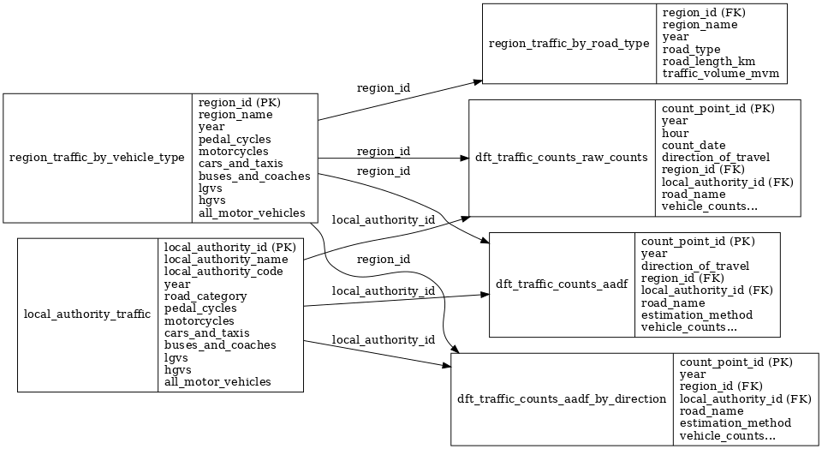

Future Enhancements
- Add external data like weather.

