1. SELSCT COUNT(*) AS total_transactions

FROM ACC_TRANSACTION;

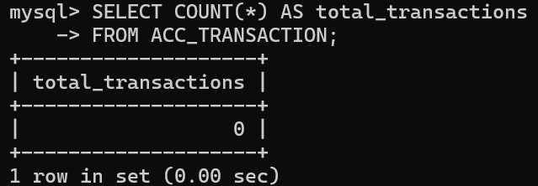

1. SELECT COUNT(*) AS chk_accounts

FROM ACCOUNT

WHERE PRODUCT_CD = 'CHK';

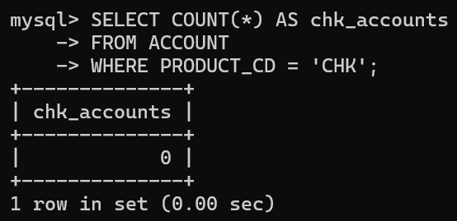

1. 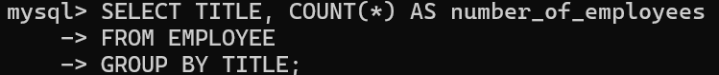

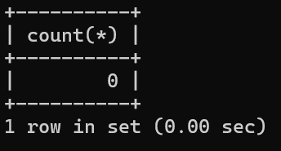

4.

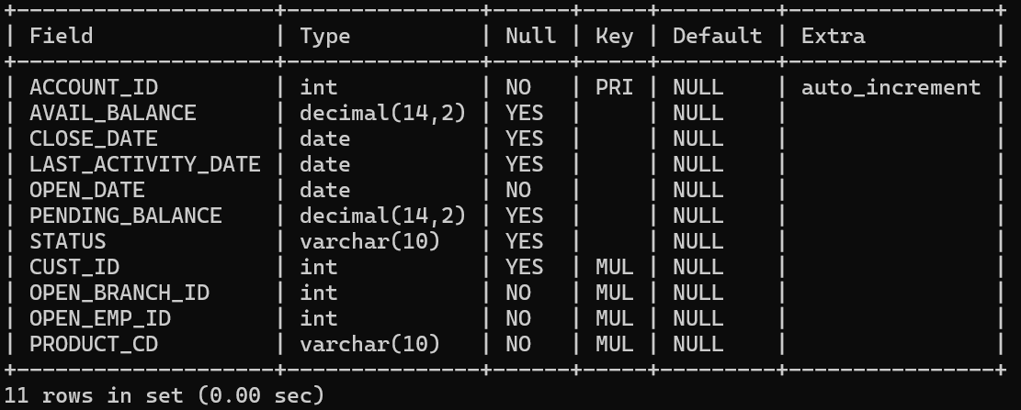

5.

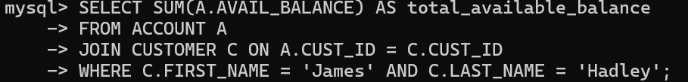

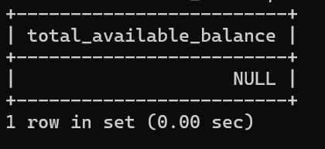

6.

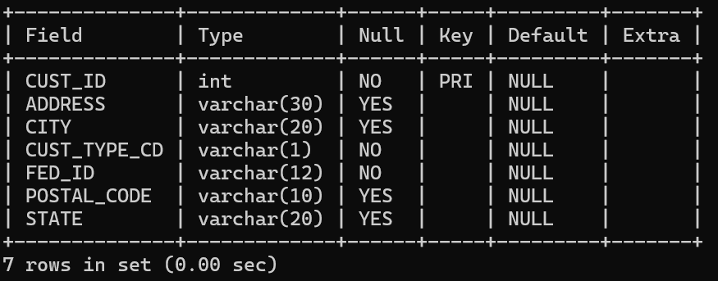

7.

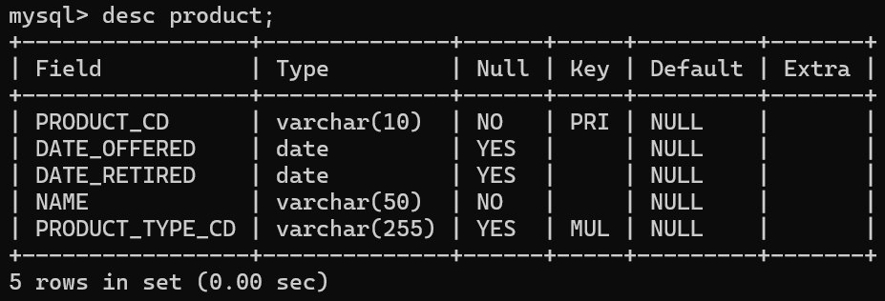

1. Find the total available balance in customers’ accounts where the opening branch was the Woburn Branch.

SELECT SUM(AVAIL_BALANCE) AS TOTAL_AVAILABLE_BALANCE

FROM ACCOUNT

WHERE OPEN_BRANCH_ID = 2;

1，1057.75

2，500

3，3000

4，2258.02

5，200

14，5000

1057.75+500+3000+2258.02+200+5000=12015.77

1. Produce a list of account product types and the highest available balance for each.

SELECT PRODUCT_CD, MAX(AVAIL_BALANCE) AS Max_Available_Balance

FROM ACCOUNT

GROUP BY PRODUCT_CD;

CHK:23575.12

SAV:767.77

CD:50000

MM:9845.55

BUS:0

1. What is the minimum available balance?

SELECT MIN(AVAIL_BALANCE) AS Min_Available_Balance

FROM ACCOUNT;

0

1. Produce a list of the total available balance per customer. The balance displayed should be rounded down.

CELECT CUST_ID,

FLOOR（SUM（AVAIL_BALANCE））AS Total_Rounded_Down_Balance FROM ACCOUNT GROUP BY CUST_ID;

- Customer 1: 1057.75 + 500 + 3000 = 4557.75 -> 4557

- Customer 2: 2258.02 + 200 = 2458.02 -> 2458

- Customer 3: 1057.75 + 2212.5 = 3270.25 -> 3270

- Customer 4: 2258.02 + 200 + 767.77 + 5487.09 = 8712.88 -> 8712

- Customer 5: 2237.97 -> 2237

- Customer 6: 122.37 + 10000 = 10122.37 -> 10122

- Customer 7: 5000 -> 5000

- Customer 8: 3487.19 + 387.99 = 3875.18 -> 3875

- Customer 9: 125.67 + 9345.55 + 1500 = 10971.22 -> 10971

- Customer 10: 23575.12 + 0 = 23575.12 -> 23575

- Customer 12: 38552.05 -> 38552

- Customer 13: 50000 -> 50000

12. The Output lists of EMPLOYEE details in the following formats (only one column should be output):

a. Employees Name; [LAST_NAME], [FIRST_NAME] e.g. Smith, Michael

SELECT LAST_NAME || ', ' || FIRST_NAME AS Employee_Name

FROM EMPLOYEE;

1. Employee Position; [FIRST_NAME] [LAST_NAME] Position: [TITLE] e.g. Michael Smith Position:

SELECT FIRST_NAME || ' ' || LAST_NAME || ' Position: ' || TITLE AS Employee_Position

FROM EMPLOYEE;

name:Smith,Michael

position:Michael Smith Position:President

1. Update ‘Fear leads to anger; anger leads to hatred; hatred leads to conflict; conflict leads to suffering’ set ‘Fear leads to panic buying; Panic buying leads to hatred; hatred leads to conflict; conflict leads to suffering.’;
2. UPDATE CUSTOMER

SET FED_ID = CASE

WHEN FED_ID LIKE '%-%' AND LENGTH(FED_ID) = 10 THEN SUBSTRING(FED_ID, 1, 3) || SUBSTRING(FED_ID, 4, 7)

WHEN FED_ID LIKE '%-%' AND LENGTH(FED_ID) = 9 THEN SUBSTRING(FED_ID, 1, 2) || SUBSTRING(FED_ID, 3, 7)

ELSE FED_ID

END

WHERE FED_ID LIKE '%-%';

1. SELECT YEAR(TXN_DATE) AS Year, COUNT(*) AS Count

FROM ACC_TRASACTION

GROUP BY YEAR(TXN_DATE)

ORDER BY Year;

1. UPDATE EMPLOYEE

SET Job_Title = UPPER(Job_Title);

SELECT

COUNT(*) AS Count,

CASE

WHEN Job_Title LIKE '%TELLER%' THEN 'Cashier'

ELSE 'Other'

END AS JobTitle

FROM EMPLOYEE

GROUP BY JobTitle

ORDER BY JobTitle;

1. SELECT

c.CUST_ID,

c.ADDRESS,

c.CITY,

SUM(a.AVAL_BALANCE) AS TOTAL_AVAILABLE_BALANCE

FROM

CUSTOMER c

JOIN

ACCOUNTS a ON c.CUST_ID = a.CUST_D

GROUP BY

c.CUST_ID,

c.ADDRESS,

c.CITY

HAVING

SUM(a.AVAL_BALANCE) < 5000;

1. SELECT

b.BRANCH_ID,

b.NAME,

COUNT(e.EMP_ID) AS TOTAL_EMPLOYEES

FROM

BRANCH b

LEFT JOIN

EMPLOYEE e ON b.BRANCH_ID = e.ASSIGNED_BRANCH_ID

GROUP BY

b.BRANCH_ID,

b.NAME

ORDER BY

b.BRANCH_ID;

1. SELECT

COUNT(*) AS Count,

CASE

WHEN PRODUCT_CD = 'CHK' THEN 'Checking Account'

WHEN PRODUCT_CD = 'SAV' THEN 'Savings Account'

END AS Product_Type

FROM

ACCOUNTS

WHERE

PRODUCT_CD IN ('CHK', 'SAV')

GROUP BY

PRODUCT_CD;