**2. The database schema of that system are shown below (Faculty and Staff). Use the data types introduced**

**in the lecture and create the tables for the Staff and Faculty relations. Add constraints to ensure that the**

**facultyName is not NULL. Using appropriate data types create the tables for both of these relation. Make**

**sure that you create the PRIMARY and FOREIGN keys:**

a. STAFF (staffId, staffName, staffDOB, staffFaculty)

b. FACULTY (facultyId, facultyName, NoOfStaff)

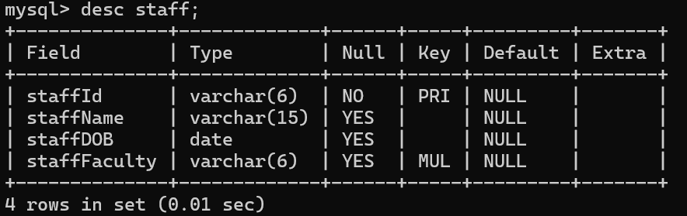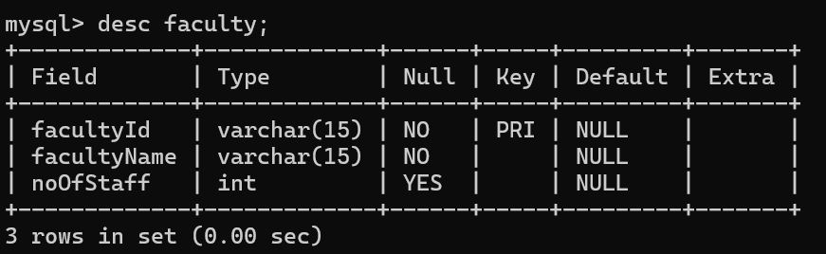

**3. Insert the following data into the tables you have just created. Use Data Manipulation Language (DML)**

**component of SQL command to populate the tables created. Think about which data has to be populated**

**first and why.**

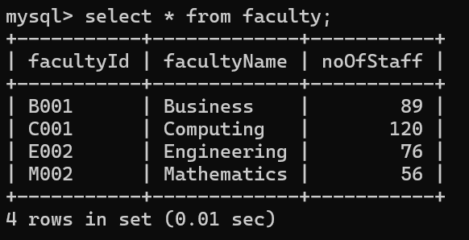

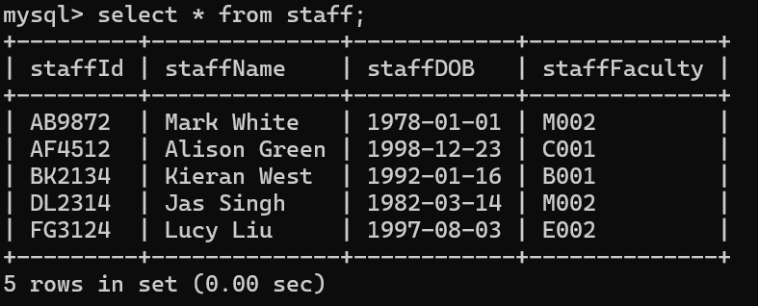

4.

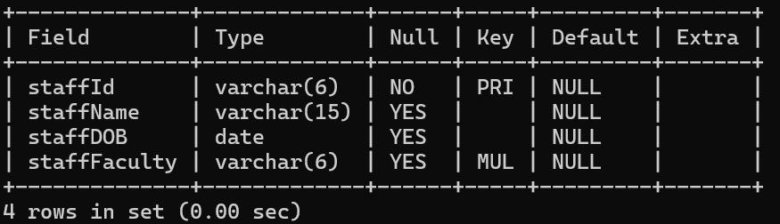

5.

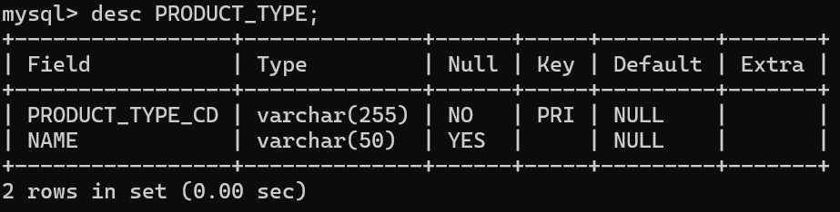

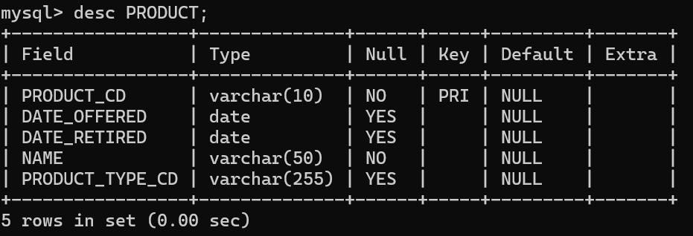

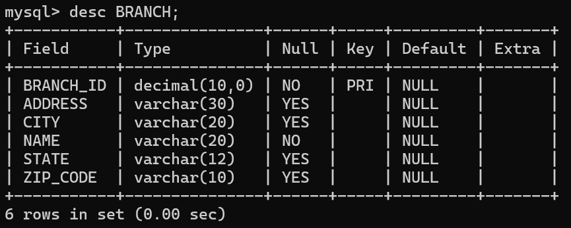

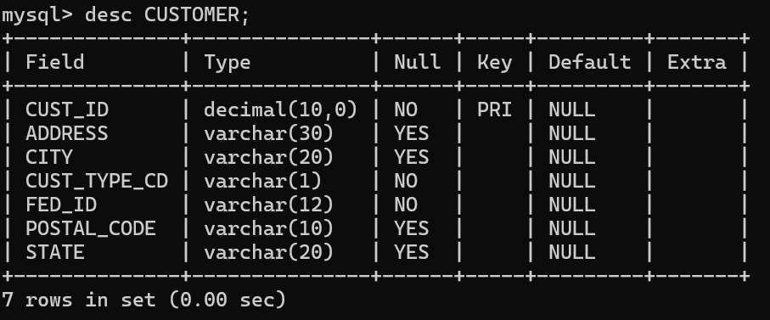

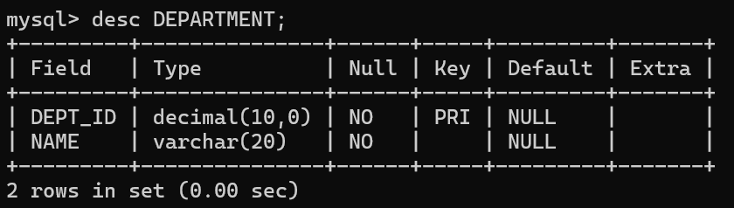

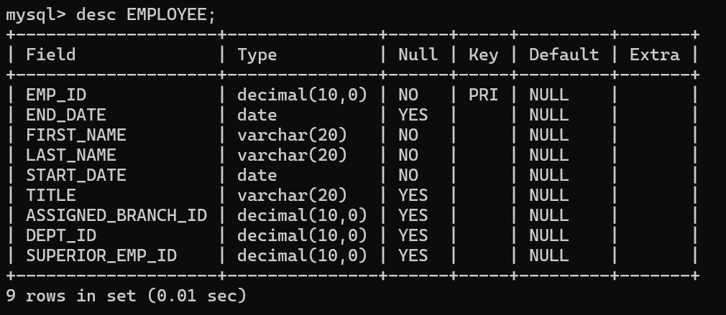

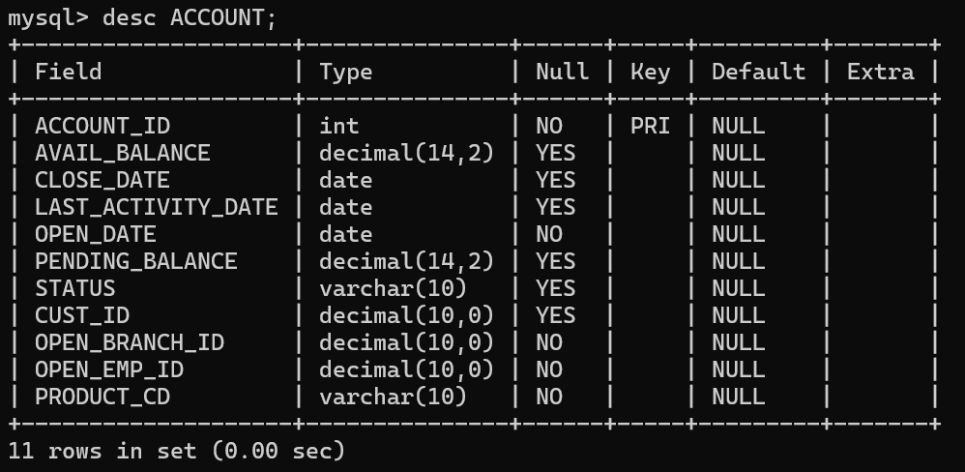

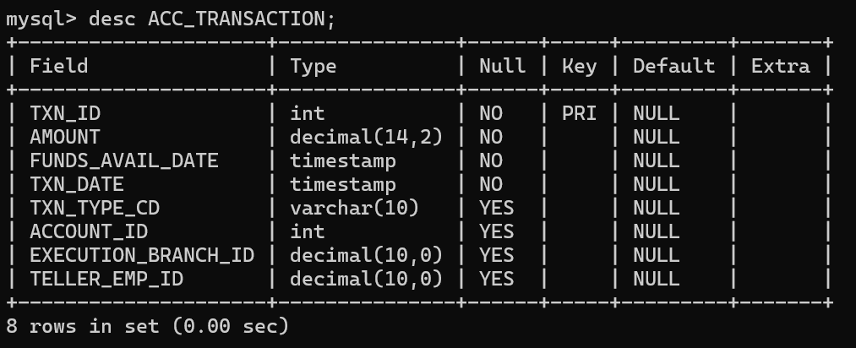

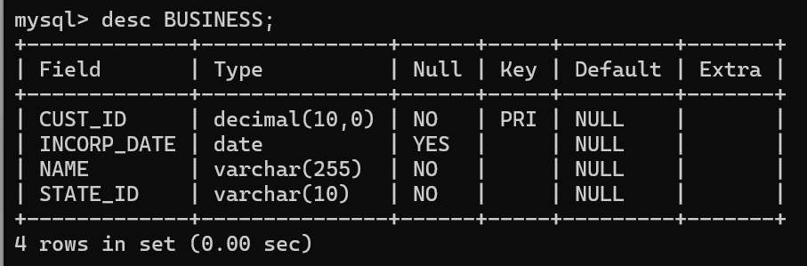

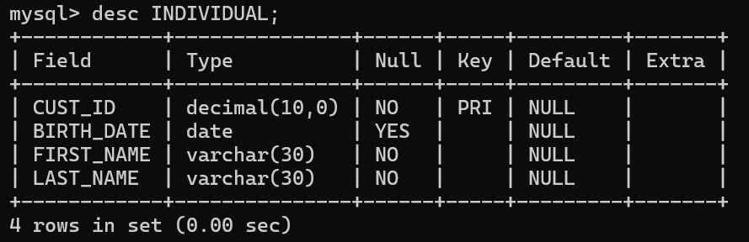

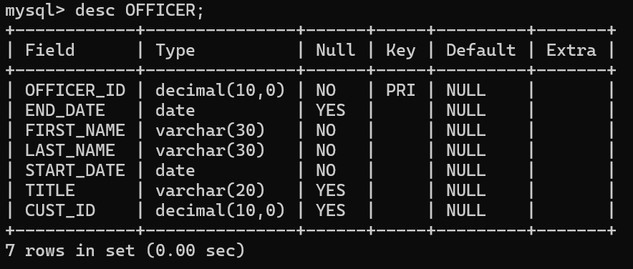

**6.**

a.

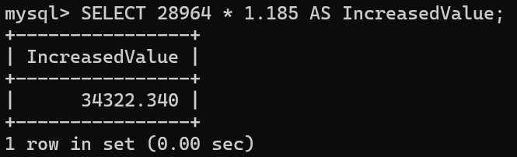

b.

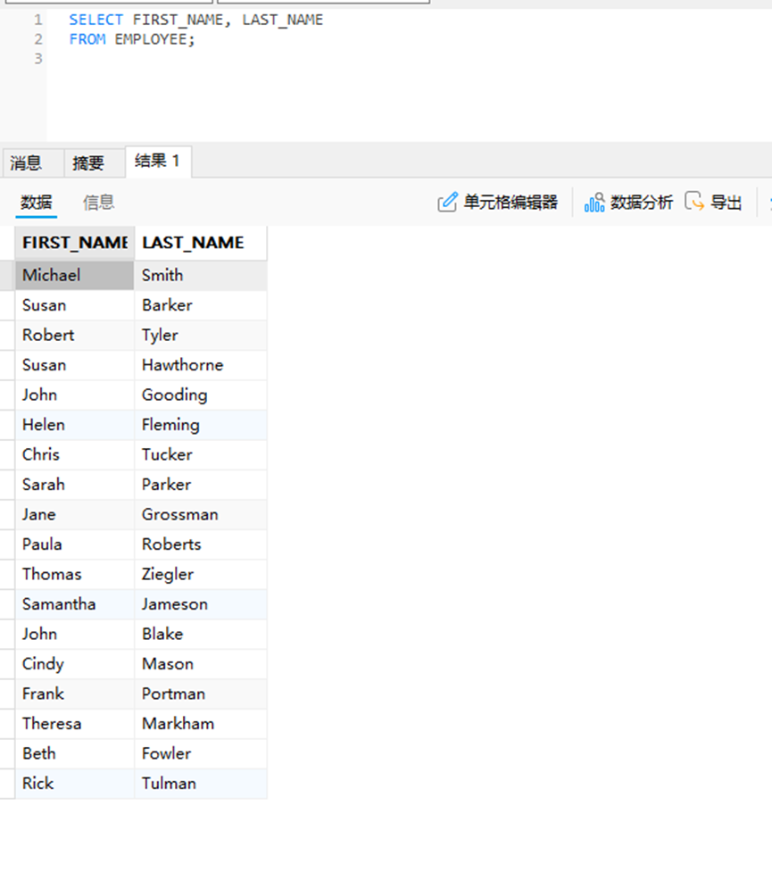

c.

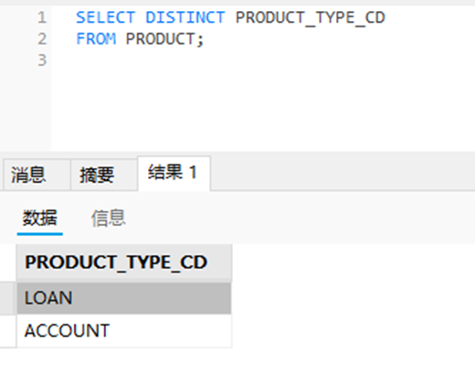

d.

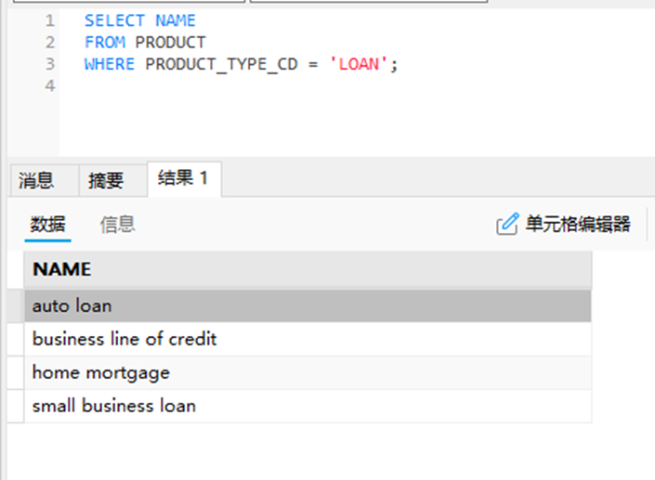

e.

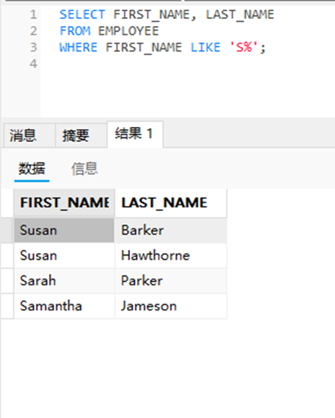

**f.**

SELECT FIRST_NAME, LAST_NAME

FROM EMPLOYEE

WHERE (FIRST_NAME LIKE 'S%' OR FIRST_NAME LIKE 'T%')

AND DEPT_ID = (SELECT DEPT_ID FROM DEPARTMENT WHERE NAME = 'Operations');

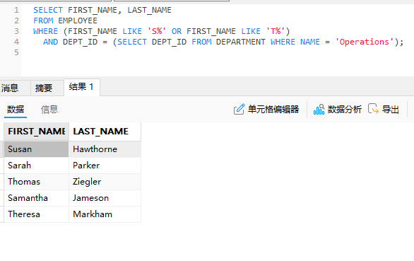

**g.**

SELECT EMP_ID, FIRST_NAME, LAST_NAME

FROM EMPLOYEE

WHERE FIRST_NAME IN ('Susan', 'Helen', 'Paula');

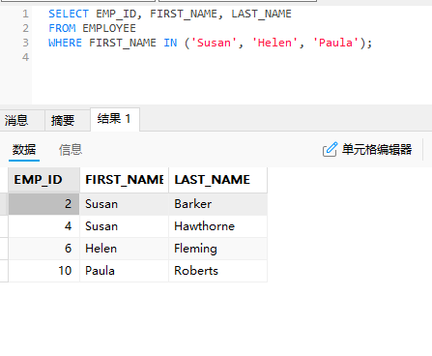

**h.**

SELECT EMP_ID, FIRST_NAME, LAST_NAME, START_DATE

FROM EMPLOYEE

WHERE START_DATE BETWEEN '2001-01-01' AND '2002-12-31';

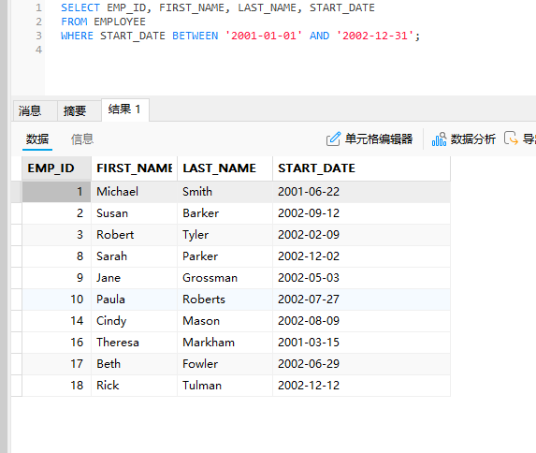

**i.**

SELECT CUST_ID, FED_ID

FROM CUSTOMER

WHERE FED_ID LIKE '___-__-____';

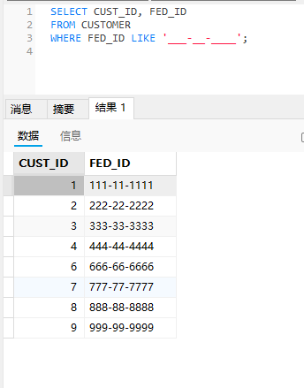

**j.**

SELECT PRODUCT_TYPE_CD, NAME

FROM PRODUCT

ORDER BY PRODUCT_TYPE_CD ASC, NAME DESC;

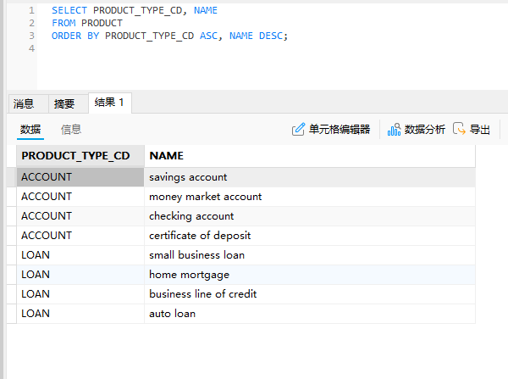

**k.**

SELECT FIRST_NAME, LAST_NAME, START_DATE

FROM EMPLOYEE

WHERE TITLE = 'Teller'

ORDER BY START_DATE ASC;

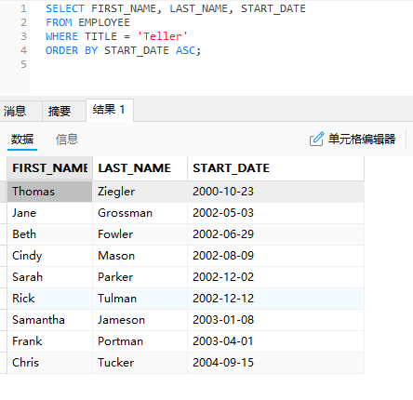

**l.**

SELECT ACCOUNT_ID, PRODUCT_CD, AVAILABLE_BALANCE, PENDING_BALANCE

FROM ACCOUNTS

WHERE CUST_ID = 1;

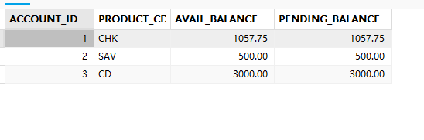

UPDATE ACCOUNTS

SET AVAILABLE_BALANCE = AVAILABLE_BALANCE * 1.02,

PENDING_BALANCE = PENDING_BALANCE * 1.02

WHERE CUST_ID = 1;

SELECT ACCOUNT_ID, PRODUCT_CD, AVAILABLE_BALANCE, PENDING_BALANCE

FROM ACCOUNTS

WHERE CUST_ID = 1;

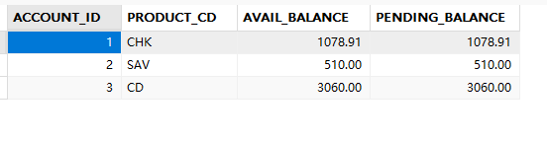

**m.**

DELETE FROM acc_transaction

WHERE TXN_DATE = '2003-07-30';

SELECT ROW_COUNT() AS Deleted_Records;

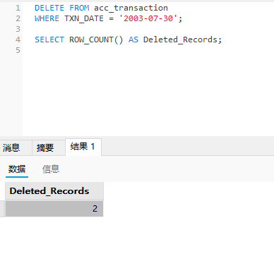

**n.**

SELECT ACCOUNT_ID, CUST_ID, AVAILABLE_BALANCE

FROM ACCOUNTS

WHERE AVAILABLE_BALANCE > 10000

ORDER BY AVAILABLE_BALANCE DESC;

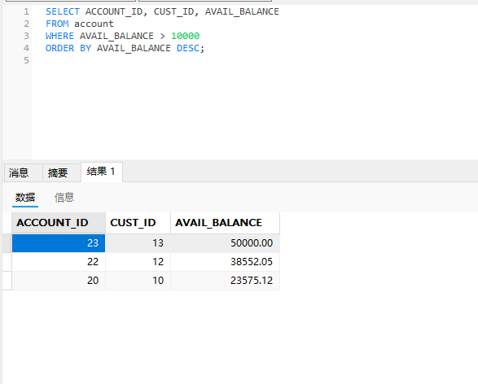

**o.**

SELECT DISTINCT CITY

FROM CUSTOMER

WHERE STATE = 'NH'

ORDER BY CITY ASC;

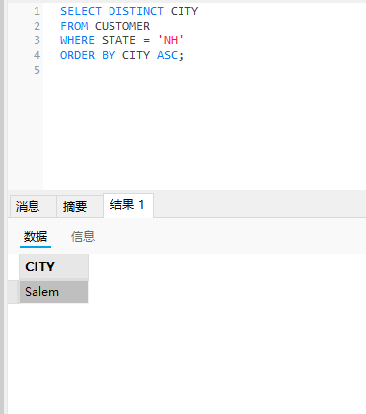

**p.**

UPDATE INDIVIDUAL

SET LAST_NAME = 'Brown'

WHERE FIRST_NAME = 'Susan' AND LAST_NAME = 'Tingley';

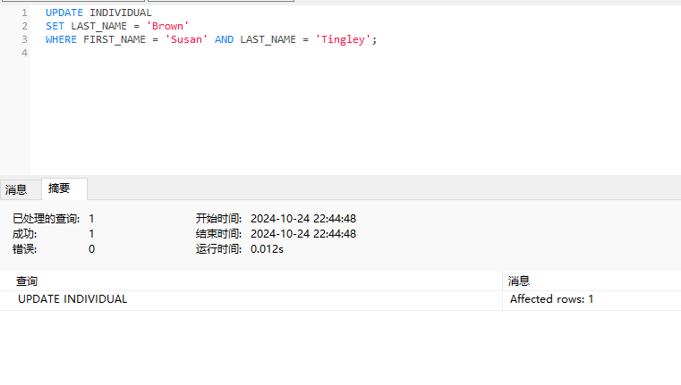

**q.**

SELECT CUST_ID, FIRST_NAME, LAST_NAME, BIRTH_DATE

FROM INDIVIDUAL

WHERE BIRTH_DATE < '1965-01-01';

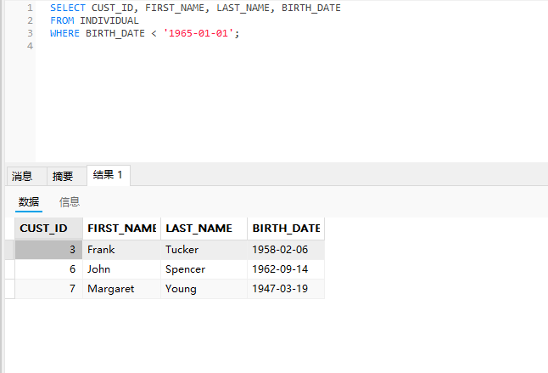

**r.**

UPDATE EMPLOYEE

SET END_DATE = '2019-11-01'

WHERE FIRST_NAME = 'Thomas' AND LAST_NAME = 'Ziegler';

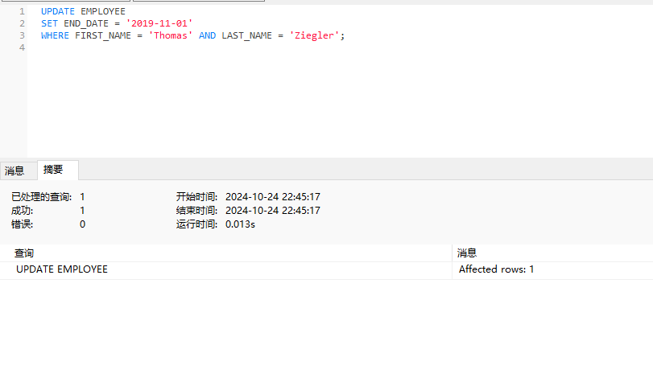

**s.**

SELECT CUST_ID, AVAILABLE_BALANCE

FROM ACCOUNTS

WHERE PRODUCT_CD = 'SAV'

ORDER BY AVAILABLE_BALANCE DESC;

