**STAT6289 Network HW1**

**Part A**

The Moreno is the classic network dataset that contains friendship ties among a 4th grade class. It has 33 vertices and 46 edges.

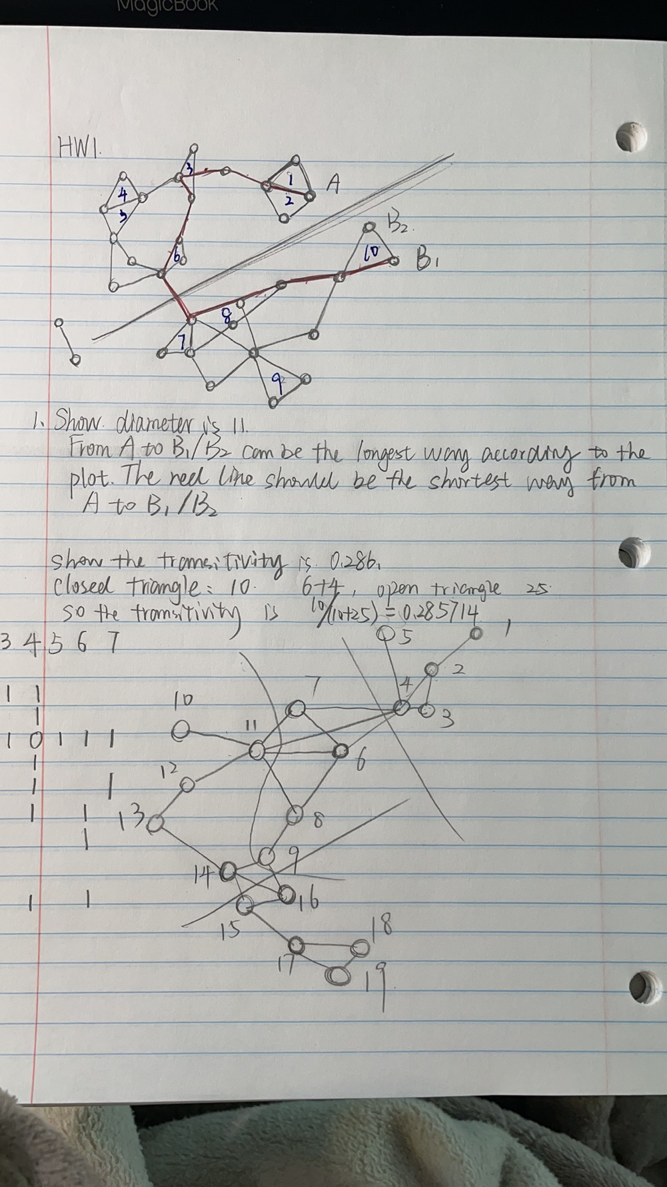

Diameter is 11.

In terms of diameter, it is the longest of the shortest paths across all pairs of nodes. It is not hard for us to get from the plot that the longest path should be point A and point B1 or B2. And the red line showed in the picture above should be the answer.

Transitivity:

There are 10 closed triangles in the plot (marked in plot). And the number of open ones is 25. According to the definition of transitivity, it is defined as proportion of closed triangles to the total number of open and close triangles. So it should be 10/(10+25)=0.285714.

**Part B**

The plot is directed network with 11 vertices.

Some definitions:

-**size** is simply the number of members, usually called nodes, vertices or actors

-**density** is the proportion of observed ties in a network to the max number of possible ties

-**component** is a subgroup in which all actors are connected, directly or indirectly

-**diameter** is the longest of the shortest paths across all pairs of nodes

-**transitivity** is defined as the proportion of closed triangles to the total number of open and closed triangles

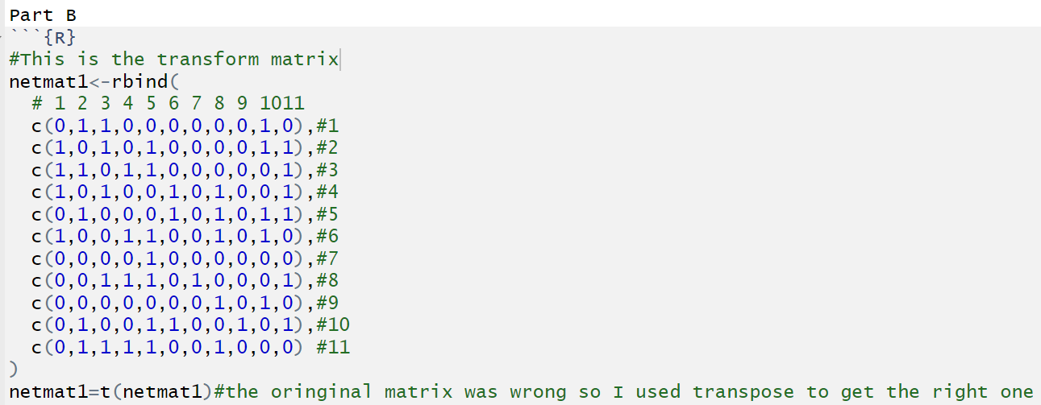

At first, I convert the plot information into the adjacency matrix and found the matrix was wrong (the columns and rows should exchange). So, I used a transform function later to make it right. In this case, the edges are directed, so the transform matrix can be different from the matrix. What is more, we need to pay attention that there is no edge between 3 and 6, it should be the edge between 3 and 8, it happened to pass through 6.

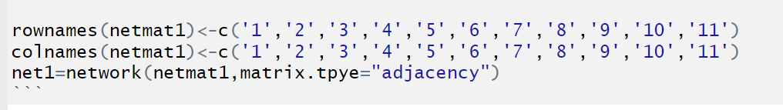

Gave rows and columns names.

Then we gave the nodes attributes to divide nodes into four colors.

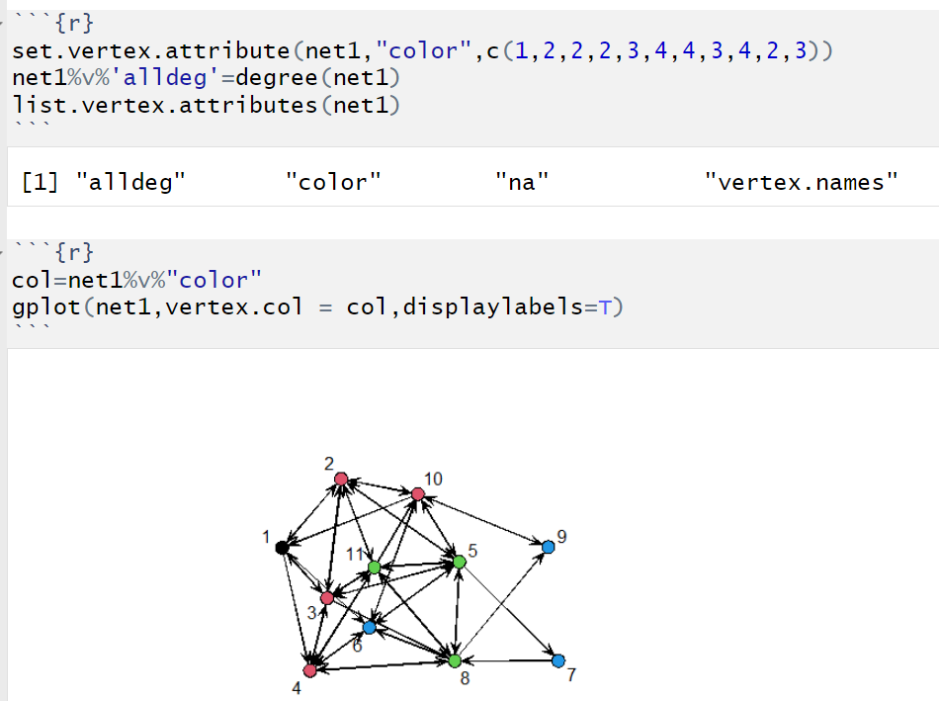

Based on the node attributes, we can use function gplot to draw plot with displaylabes = T.

Here are some statistics:

-size is 11

-density is 0.4181818

-components is 1

-diameter is 4

-transitivity is 0.4636872

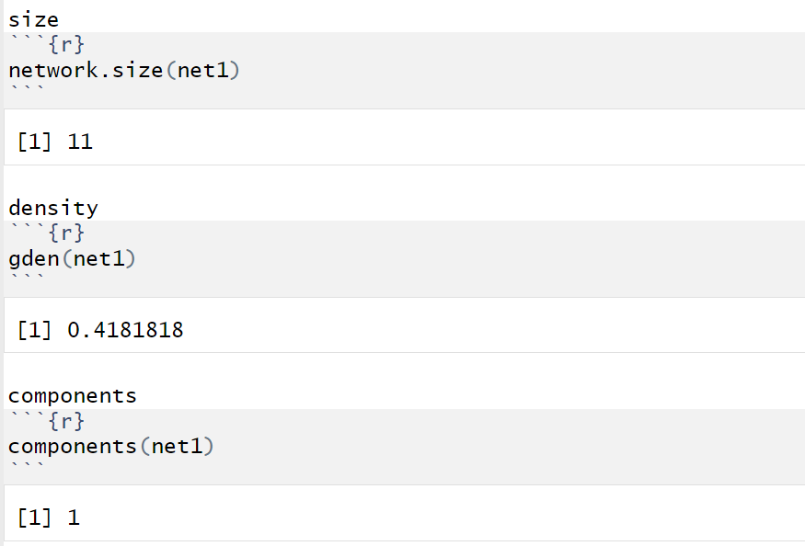

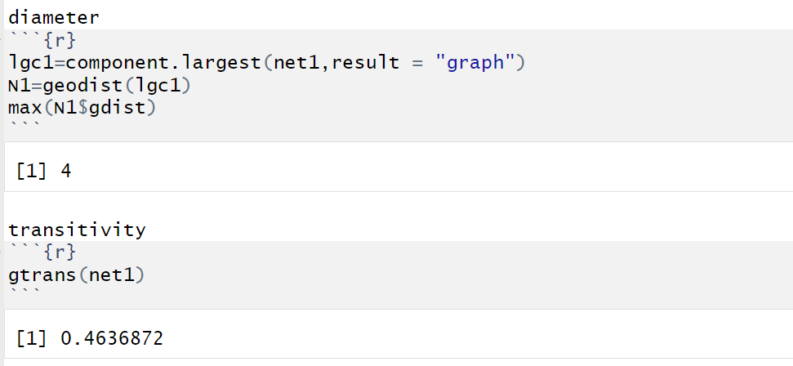

**Part C**

Some definitions:

-**size** is simply the number of members, usually called nodes, vertices or actors

-**density** is the proportion of observed ties in a network to the max number of possible ties

-**component** is a subgroup in which all actors are connected, directly or indirectly

-**diameter** is the longest of the shortest paths across all pairs of nodes

-**transitivity** is defined as the proportion of closed triangles to the total number of open and closed triangles

The network is undirected network with 19 vertices.

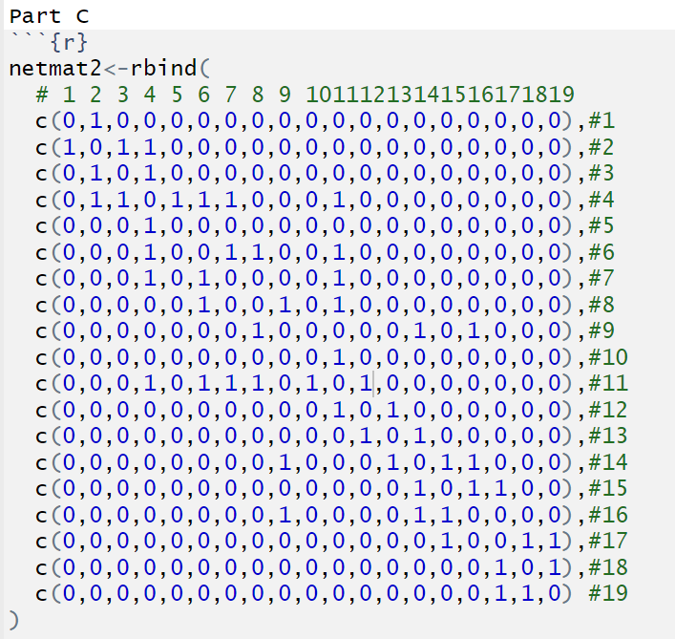

The colored plot is shown below.

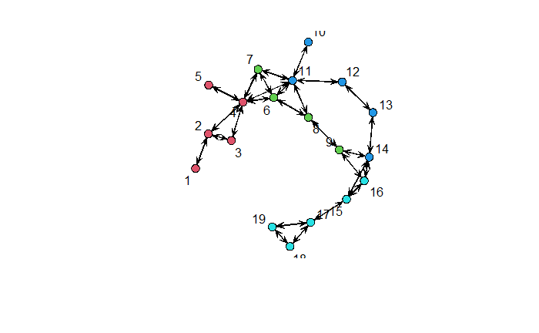

And there are the statistics:

-size is 19

-density is 0.1578947

-components is 1

-diameter is 9

-transitivity is 0.3970588

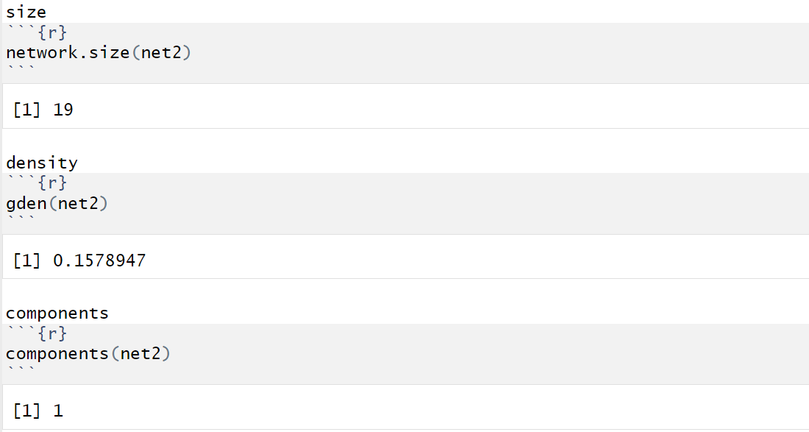

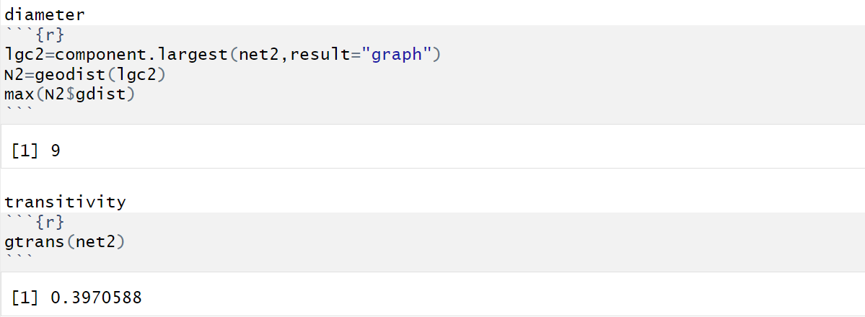

**Appendix**

---

title: "Network_HW1"

author: "Chenrui Xu"

date: "2021/2/1"

output: html_document

---

```{r}

library(statnet)

library(UserNetR)

```

Part A

diameter

```{r}

components(Moreno)

lgc<-component.largest(Moreno,result = "graph")

gd=geodist(lgc)

max(gd$gdist)

```

There are two components in the Moreno network the diameter for the whole network doesn't exist. But we can calculate the diameter for each component and the answer is 11.

transitivity

```{r}

gtrans(Moreno,mode="graph")

```

Part B

```{R}

#This is the transform matrix

netmat1<-rbind(

# 1 2 3 4 5 6 7 8 9 1011

c(0,1,1,0,0,0,0,0,0,1,0),#1

c(1,0,1,0,1,0,0,0,0,1,1),#2

c(1,1,0,1,1,0,0,0,0,0,1),#3

c(1,0,1,0,0,1,0,1,0,0,1),#4

c(0,1,0,0,0,1,0,1,0,1,1),#5

c(1,0,0,1,1,0,0,1,0,1,0),#6

c(0,0,0,0,1,0,0,0,0,0,0),#7

c(0,0,1,1,1,0,1,0,0,0,1),#8

c(0,0,0,0,0,0,0,1,0,1,0),#9

c(0,1,0,0,1,1,0,0,1,0,1),#10

c(0,1,1,1,1,0,0,1,0,0,0) #11

)

netmat1=t(netmat1)#the oringinal matrix was wrong so I used transpose to get the right one

rownames(netmat1)<-c('1','2','3','4','5','6','7','8','9','10','11')

colnames(netmat1)<-c('1','2','3','4','5','6','7','8','9','10','11')

net1=network(netmat1,matrix.tpye="adjacency")

```

```{r}

summary(net1)

```

```{r}

set.vertex.attribute(net1,"color",c(1,2,2,2,3,4,4,3,4,2,3))

net1%v%'alldeg'=degree(net1)

list.vertex.attributes(net1)

```

```{r}

col=net1%v%"color"

gplot(net1,vertex.col = col,displaylabels=T)

```

size

```{r}

network.size(net1)

```

density

```{r}

gden(net1)

```

components

```{r}

components(net1)

```

diameter

```{r}

lgc1=component.largest(net1,result = "graph")

N1=geodist(lgc1)

max(N1$gdist)

```

transitivity

```{r}

gtrans(net1)

```

Part C

```{r}

netmat2<-rbind(

# 1 2 3 4 5 6 7 8 9 10111213141516171819

c(0,1,0,0,0,0,0,0,0,0,0,0,0,0,0,0,0,0,0),#1

c(1,0,1,1,0,0,0,0,0,0,0,0,0,0,0,0,0,0,0),#2

c(0,1,0,1,0,0,0,0,0,0,0,0,0,0,0,0,0,0,0),#3

c(0,1,1,0,1,1,1,0,0,0,1,0,0,0,0,0,0,0,0),#4

c(0,0,0,1,0,0,0,0,0,0,0,0,0,0,0,0,0,0,0),#5

c(0,0,0,1,0,0,1,1,0,0,1,0,0,0,0,0,0,0,0),#6

c(0,0,0,1,0,1,0,0,0,0,1,0,0,0,0,0,0,0,0),#7

c(0,0,0,0,0,1,0,0,1,0,1,0,0,0,0,0,0,0,0),#8

c(0,0,0,0,0,0,0,1,0,0,0,0,0,1,0,1,0,0,0),#9

c(0,0,0,0,0,0,0,0,0,0,1,0,0,0,0,0,0,0,0),#10

c(0,0,0,1,0,1,0,1,0,1,0,1,0,0,0,0,0,0,0),#11

c(0,0,0,0,0,0,0,0,0,0,1,0,1,0,0,0,0,0,0),#12

c(0,0,0,0,0,0,0,0,0,0,0,1,0,1,0,0,0,0,0),#13

c(0,0,0,0,0,0,0,0,1,0,0,0,1,0,1,1,0,0,0),#14

c(0,0,0,0,0,0,0,0,0,0,0,0,0,1,0,1,1,0,0),#15

c(0,0,0,0,0,0,0,0,1,0,0,0,0,1,1,0,0,0,0),#16

c(0,0,0,0,0,0,0,0,0,0,0,0,0,0,1,0,0,1,1),#17

c(0,0,0,0,0,0,0,0,0,0,0,0,0,0,0,0,1,0,1),#18

c(0,0,0,0,0,0,0,0,0,0,0,0,0,0,0,0,1,1,0) #19

)

rownames(netmat2)<-c('1','2','3','4','5','6','7','8','9','10','11','12','13','14','15','16','17','18','19')

colnames(netmat2)<-c('1','2','3','4','5','6','7','8','9','10','11','12','13','14','15','16','17','18','19')

net2=network(netmat2,matrix.tpye="adjacency")

```

```{r}

summary(net2)

```

```{r}

set.vertex.attribute(net2,"color",c(1,1,1,1,1,2,2,2,2,3,3,3,3,3,4,4,4,4,4))

net2%v%'alldeg'=degree(net2)

list.vertex.attributes(net2)

```

```{r}

col=net2%v%"color"

gplot(net2,vertex.col = col+1,displaylabels=T)

```

size

```{r}

network.size(net2)

```

density

```{r}

gden(net2)

```

components

```{r}

components(net2)

```

diameter

```{r}

lgc2=component.largest(net2,result="graph")

N2=geodist(lgc2)

max(N2$gdist)

```

transitivity

```{r}

gtrans(net2)

```