**Network Homework 6**

**Chenrui Xu**

**Part I Background**

In this project, we are going to use dynamic network model to simulate data and analysis. The network that can change over time (or we can say the network have multi-status) can be seen as dynamic network. It is based on the ERGMs and it can grow or shrink (in terms of nodes).

Also, the package we are going to use in this project is RSiena. The package can be used to deal with longtitude network data. There is a basic network variable and also there is a behavior variable that is a dependent variable. It is a node characteristic that changes over time, the evolution of which may considered in a co-evolutionary model.

By using the simulated model and data, we can get two models and analysis those results and statistics. And if the t-ratio is smaller than 0.1 (absolute value), it should be converge and 0.15 is reasonable. Four significant, we divide the estimation by standard error and the result should be larger than four, so it should be significant.

**Part II Question I**

At first, we extracted four period network data from whole data.

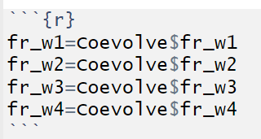

Then we operated them into another network data by using sienaDependent.

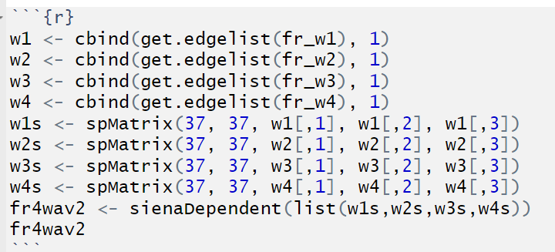

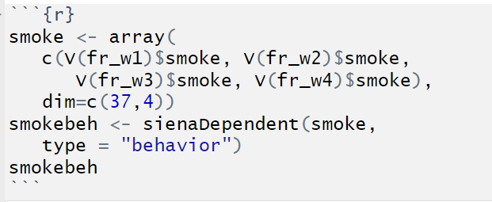

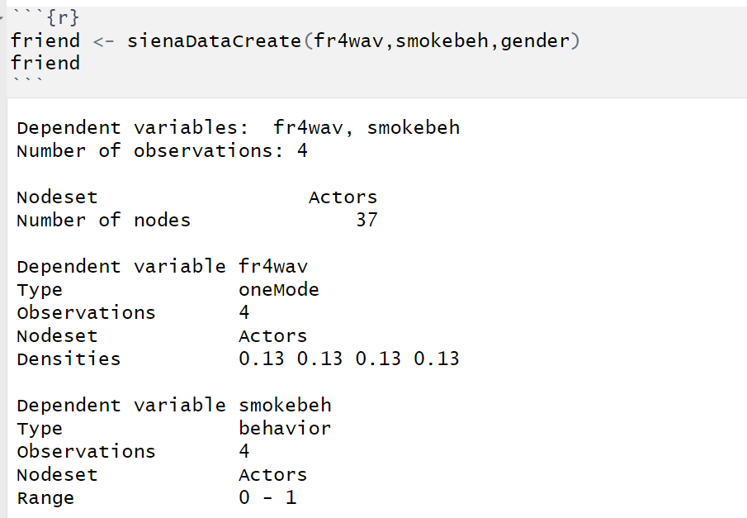

So we get the data friend

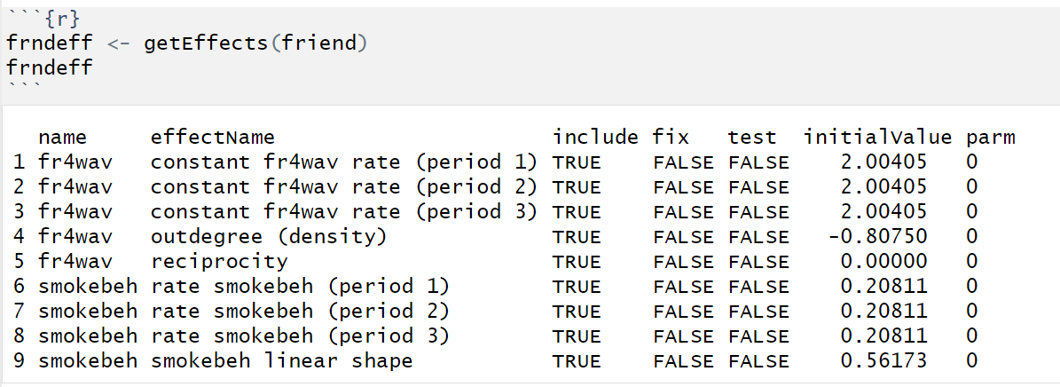

Here is the original effect table based on friend data. And then we can add kinds of effects to it.

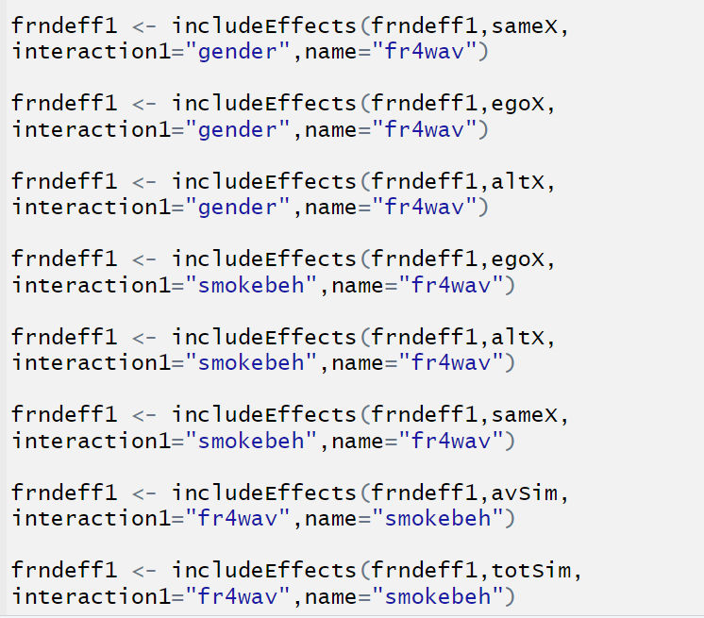

And I got the following result.

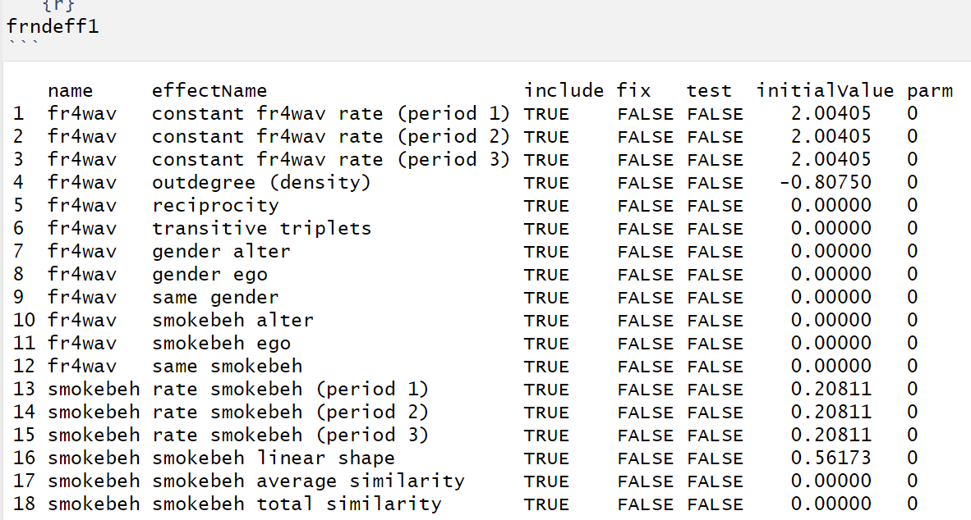

**Part III Question II**

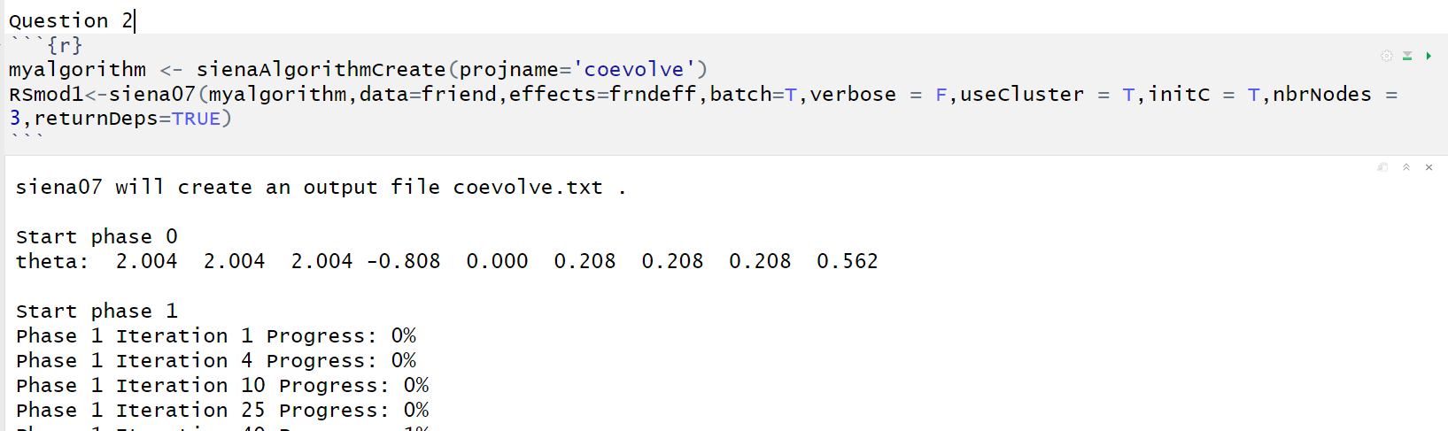

Here is the model we built.

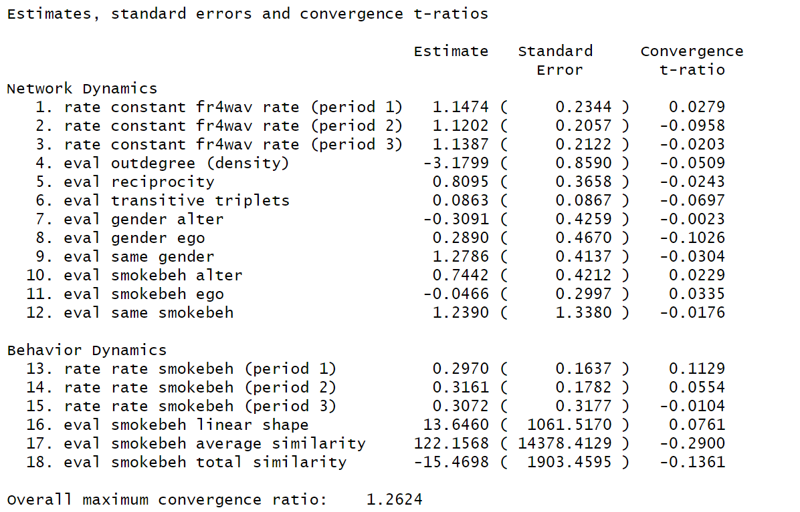

And here is the summary of the model from where we can get a lot of statistics.

**Part IV Question III**

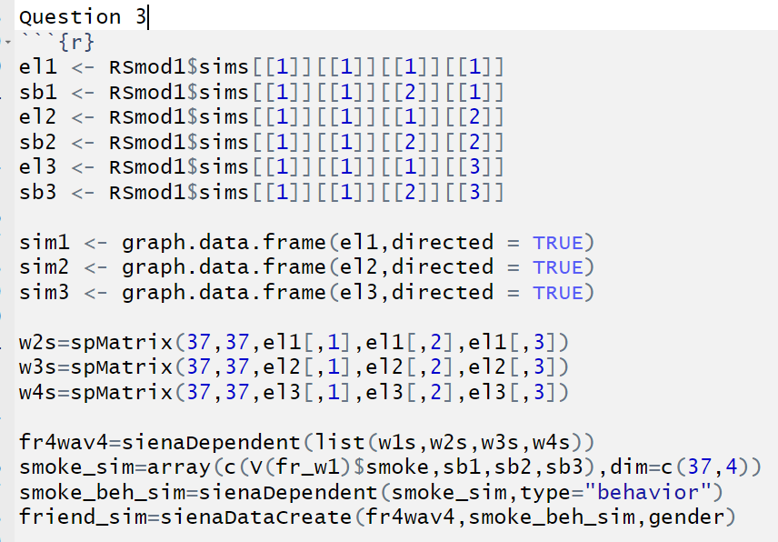

By following the method shown in the PowerPoint Lecture 9, we can re-simulate data based on the RSmod1. And after adding effects to it, we can use these two to get two corresponding models.

Here are the statistics about model 1.

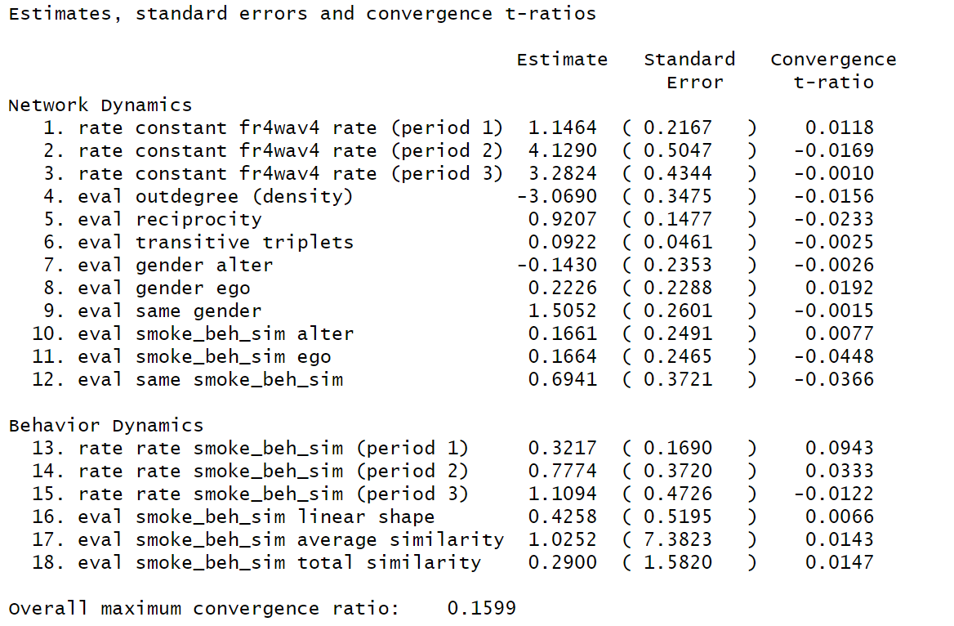

From the result, we can get that for all convergence t-ratio are good and they can be excellent convergence (abs value smaller than 0.1). And overall convergence ratio is reasonable. And based on both estimation and standard error, we can calculate approximately that item 6, 7, 8, 10, 11, 12, 13, 14, 15, 16, 17, 18 are not significant (not larger than 4).

And here is the result of model 2.

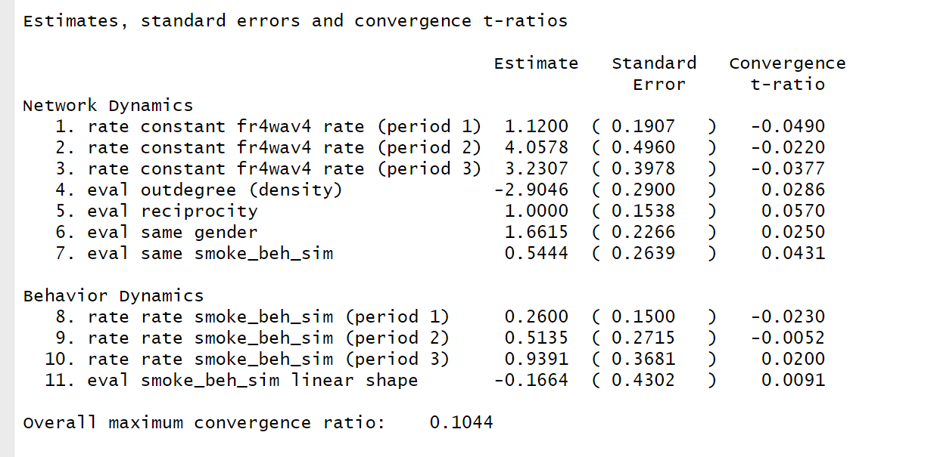

All t-ratio are good and they can be convergence (abs value smaller than 0.1) and max convergence ratio is good. In terms of significance, item 7, 8, 9, 10, 11 are not significant (not larger than 4).

So, based on the results above, we can say that the model two is better as the ratio is smaller so it can be more possible to converge and less non-significant variables.

**Part V Appendix**

**---**

**title: "Network_HW6"**

**author: "Chenrui Xu"**

**date: "2021/3/28"**

**output: html_document**

**---**

**```{r}**

**library(igraph)**

**library(UserNetR)**

**library(RSiena)**

**library(Matrix)**

**data(Coevolve)**

**set.seed(999)**

**```**

**```{r}**

**fr_w1=Coevolve$fr_w1**

**fr_w2=Coevolve$fr_w2**

**fr_w3=Coevolve$fr_w3**

**fr_w4=Coevolve$fr_w4**

**```**

**```{r}**

**matw1 <- as.matrix(get.adjacency(fr_w1))**

**matw2 <- as.matrix(get.adjacency(fr_w2))**

**matw3 <- as.matrix(get.adjacency(fr_w3))**

**matw4 <- as.matrix(get.adjacency(fr_w4))**

**```**

**```{r}**

**fr4wav<-sienaDependent(**

**array(c(matw1,matw2,matw3,matw4),**

**dim=c(37,37,4)), sparse=FALSE)**

**class(fr4wav)**

**fr4wav**

**```**

**```{r}**

**w1 <- cbind(get.edgelist(fr_w1), 1)**

**w2 <- cbind(get.edgelist(fr_w2), 1)**

**w3 <- cbind(get.edgelist(fr_w3), 1)**

**w4 <- cbind(get.edgelist(fr_w4), 1)**

**w1s <- spMatrix(37, 37, w1[,1], w1[,2], w1[,3])**

**w2s <- spMatrix(37, 37, w2[,1], w2[,2], w2[,3])**

**w3s <- spMatrix(37, 37, w3[,1], w3[,2], w3[,3])**

**w4s <- spMatrix(37, 37, w4[,1], w4[,2], w4[,3])**

**fr4wav2 <- sienaDependent(list(w1s,w2s,w3s,w4s))**

**fr4wav2**

**```**

**```{r}**

**gender_vect <- V(fr_w1)$gender**

**table(gender_vect)**

**gender <- coCovar(gender_vect)**

**gender**

**```**

**```{r}**

**smoke <- array(**

**c(V(fr_w1)$smoke, V(fr_w2)$smoke,**

**V(fr_w3)$smoke, V(fr_w4)$smoke),**

**dim=c(37,4))**

**smokebeh <- sienaDependent(smoke,**

**type = "behavior")**

**smokebeh**

**```**

**```{r}**

**friend <- sienaDataCreate(fr4wav,smokebeh,gender)**

**friend**

**```**

**```{r}**

**frndeff <- getEffects(friend)**

**frndeff**

**```**

**```{r}**

**effectsDocumentation(frndeff)**

**```**

**```{r}**

**frndeff <- getEffects(friend)**

**frndeff1 <- getEffects(friend)**

**#frndeff2 <- getEffects(friend)**

**# frndeff2 <- includeEffects(frndeff2,sameX,**

**# interaction1="gender",name="fr4wav")**

**#**

**# frndeff2 <- includeEffects(frndeff2,sameX,**

**# interaction1="smokebeh",name="fr4wav")**

**frndeff1 <- includeEffects(frndeff1,sameX,**

**interaction1="gender",name="fr4wav")**

**frndeff1 <- includeEffects(frndeff1,egoX,**

**interaction1="gender",name="fr4wav")**

**frndeff1 <- includeEffects(frndeff1,altX,**

**interaction1="gender",name="fr4wav")**

**frndeff1 <- includeEffects(frndeff1,egoX,**

**interaction1="smokebeh",name="fr4wav")**

**frndeff1 <- includeEffects(frndeff1,altX,**

**interaction1="smokebeh",name="fr4wav")**

**frndeff1 <- includeEffects(frndeff1,sameX,**

**interaction1="smokebeh",name="fr4wav")**

**frndeff1 <- includeEffects(frndeff1,avSim,**

**interaction1="fr4wav",name="smokebeh")**

**frndeff1 <- includeEffects(frndeff1,totSim,**

**interaction1="fr4wav",name="smokebeh")**

**frndeff1 <- includeEffects(frndeff1,recip,transTrip,**

**name="fr4wav")**

**```**

**```{r}**

**frndeff**

**```**

**```{r}**

**frndeff1**

**```**

**Question 2**

**```{r}**

**myalgorithm <- sienaAlgorithmCreate(projname='coevolve')**

**RSmod1<-siena07(myalgorithm,data=friend,effects=frndeff1,batch=T,verbose = F,useCluster = T,initC = T,nbrNodes = 3,returnDeps=TRUE)**

**```**

**```{r}**

**RSmod1**

**```**

**```{r}**

**RSmod1$sims[[1]]**

**```**

**```{r}**

**summary(RSmod1)**

**```**

**```{r}**

**# myalgorithm <- sienaAlgorithmCreate(projname='coevolve')**

**# RSmod2<-siena07(myalgorithm,data=friend,effects=**

**# S**

**# frndeff2,batch=T,verbose = F,useCluster = T,initC = T,nbrNodes = 3,returnDeps=TRUE)**

**# RSmod2**

**```**

**Question 3**

**```{r}**

**el1 <- RSmod1$sims[[1]][[1]][[1]][[1]]**

**sb1 <- RSmod1$sims[[1]][[1]][[2]][[1]]**

**el2 <- RSmod1$sims[[1]][[1]][[1]][[2]]**

**sb2 <- RSmod1$sims[[1]][[1]][[2]][[2]]**

**el3 <- RSmod1$sims[[1]][[1]][[1]][[3]]**

**sb3 <- RSmod1$sims[[1]][[1]][[2]][[3]]**

**sim1 <- graph.data.frame(el1,directed = TRUE)**

**sim2 <- graph.data.frame(el2,directed = TRUE)**

**sim3 <- graph.data.frame(el3,directed = TRUE)**

**w1 <- cbind(get.edgelist(fr_w1), 1)**

**w1s <- spMatrix(37, 37, w1[,1], w1[,2], w1[,3])**

**w2s_sim=spMatrix(37,37,el1[,1],el1[,2],el1[,3])**

**w3s_sim=spMatrix(37,37,el2[,1],el2[,2],el2[,3])**

**w4s_sim=spMatrix(37,37,el3[,1],el3[,2],el3[,3])**

**fr4wav4=sienaDependent(list(w1s,w2s_sim,w3s_sim,w4s_sim))**

**smoke_sim=array(c(V(fr_w1)$smoke,sb1,sb2,sb3),dim=c(37,4))**

**smoke_beh_sim=sienaDependent(smoke_sim,type="behavior")**

**friend_sim=sienaDataCreate(fr4wav4,smoke_beh_sim,gender)**

**# V(sim1)$smoke <- sb1**

**# V(sim1)$gender <- V(fr_w4)$gender**

**# sim1**

**#**

**# matsim1=as.matrix(get.adjacency(sim1))**

**# simwav1=sienaDependent(matsim1,sparse=F)**

**# simgender_vect1=V(sim1)$gender**

**# gender1 <- coCovar(simgender_vect1)**

**#**

**# smoke1 <- array(V(sim1)$smoke,dim=c(37,1))**

**# smokebeh1 <- sienaDependent(c(smoke1),type = "behavior")**

**# smokebeh1**

**#**

**#**

**# w1 <- cbind(get.edgelist(fr_w1), 1)**

**# w1s <- spMatrix(37, 37, w1[,1], w1[,2], w1[,3])**

**```**

**```{r}**

**friend_sim**

**```**

**```{r}**

**frndeff1_sim <- getEffects(friend_sim)**

**frndeff2_sim <- getEffects(friend_sim)**

**frndeff2_sim <- includeEffects(frndeff2_sim,sameX,**

**interaction1="gender",name="fr4wav4")**

**frndeff2_sim <- includeEffects(frndeff2_sim,sameX,**

**interaction1="smoke_beh_sim",name="fr4wav4")**

**frndeff1_sim <- includeEffects(frndeff1_sim,sameX,**

**interaction1="gender",name="fr4wav4")**

**frndeff1_sim <- includeEffects(frndeff1_sim,egoX,**

**interaction1="gender",name="fr4wav4")**

**frndeff1_sim <- includeEffects(frndeff1_sim,altX,**

**interaction1="gender",name="fr4wav4")**

**frndeff1_sim <- includeEffects(frndeff1_sim,egoX,**

**interaction1="smoke_beh_sim",name="fr4wav4")**

**frndeff1_sim <- includeEffects(frndeff1_sim,altX,**

**interaction1="smoke_beh_sim",name="fr4wav4")**

**frndeff1_sim <- includeEffects(frndeff1_sim,sameX,**

**interaction1="smoke_beh_sim",name="fr4wav4")**

**frndeff1_sim <- includeEffects(frndeff1_sim,avSim,**

**interaction1="fr4wav4",name="smoke_beh_sim")**

**frndeff1_sim <- includeEffects(frndeff1_sim,totSim,**

**interaction1="fr4wav4",name="smoke_beh_sim")**

**frndeff1_sim <- includeEffects(frndeff1_sim,recip,transTrip,**

**name="fr4wav4")**

**```**

**```{r}**

**RSmod1_sim<-siena07(myalgorithm,data=friend_sim,effects=frndeff1_simZ,batch=T,verbose = F,useCluster = T,initC = T,nbrNodes = 3,returnDeps=TRUE)**

**```**

**```{r}**

**RSmod2_sim<-siena07(myalgorithm,data=friend_sim,effects=frndeff2_sim,batch=T,verbose = F,useCluster = T,initC = T,nbrNodes = 3,returnDeps=TRUE)**

**```**

**```{r}**

**summary(RSmod1_sim)**

**```**

**```{r}**

**summary(RSmod2_sim)**

**```**