Experiment – 10
Schedules
Creating Scheduled Workflows in Zoho Creator
Department of Computer Science and Engineering
Student Name: Chenthan Amuthan D
Roll No: 240701090
Application Name: SpendGuard (Expense Claim / Reimbursement Application)

Objective
To create a Schedule workflow in Zoho Creator that runs an action automatically at a specified date and time and repeats at a chosen interval (daily, weekly, or monthly), and to use it to prepare a weekly digest of pending reimbursements in the SpendGuard application.

Introduction
A Schedule is a type of workflow that is not triggered by a user submitting or editing a record. Instead, it runs on its own at a set time, so that routine work such as reminders, reports, and follow-ups does not depend on someone remembering to do it. A schedule can run once, or repeat daily, weekly, monthly, or yearly from a chosen start date and time. It can also be tied to a date field stored in the records, so that actions run on the date saved in each record. When the schedule fires, it executes the actions added to it, such as sending an email or SMS, adding or updating records in another form, or running a Deluge script.

Schedule Requirements
The schedule workflow in this experiment was required to support three repetition intervals: daily, weekly, and monthly. The interval is chosen in the Run field while the schedule is being created. Table 10.1 lists the three intervals together with an example of how each one is used in the SpendGuard application.
Table 10.1: Schedule frequencies required in this experiment.
Frequency | Meaning | Example use in this application
Daily | Runs every day at the chosen time | Daily reminder of expense claims awaiting review
Weekly | Runs once every week on the day of the start date | Weekly digest of pending reimbursements for Finance Admins
Monthly | Runs once every month on the date of the start date | Monthly report of approved claims and budget expenditure
Table 10.2: Settings used to create the schedule.
Setting | Value | Purpose
Schedule type | Specify Date and Time | Runs at a fixed date and time, rather than from a date field in a record
Start date and time | 26-Oct-2026, 09:00:00 | When the schedule runs for the first time
Run | Weekly | How often the schedule repeats after the start date
Workflow name | Weekly Pending Reimbursements Digest | Name under which the schedule is saved
Action type | Deluge script (Execute without condition) | Action carried out each time the schedule runs

Screenshot-based lab record
The following section contains the actual Zoho Creator screenshots of the schedule configured in the SpendGuard application.

Screenshots 1 – Schedules Tab
The Schedules tab of the Workflow section lists the scheduled workflows of the application. The schedule created in this experiment appears under Custom Schedules. For each schedule the list shows the Workflow Name, the number of actions in Details, the date and time in the When column, the Status, and the Created On date. The Weekly Pending Reimbursements Digest schedule has 1 action, is set for 26-Oct-2026 at 09:00:00, is Enabled, and was created on 21-Oct-2026.
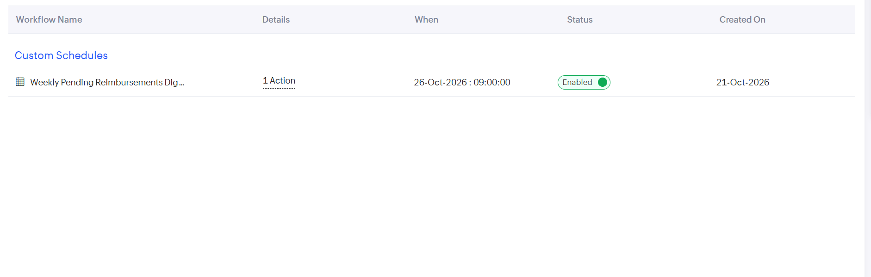
Figure 1: Schedules tab listing the enabled Weekly Pending Reimbursements Digest schedule under Custom Schedules.
The values shown in the list are summarised in Table 10.3. Because the status is Enabled, the schedule will run on its own at the time shown, and it can be disabled at any time from the same list without being deleted.
Table 10.3: Details of the schedule as shown in the Schedules tab.
Column | Value | Meaning
Workflow Name | Weekly Pending Reimbursements Digest | Name under which the schedule is saved
Details | 1 Action | Number of actions attached to the schedule
When | 26-Oct-2026 : 09:00:00 | Date and time at which the schedule runs
Status | Enabled | The schedule is active and will run at the set time
Created On | 21-Oct-2026 | Date on which the schedule was created

Screenshots 2 – Scheduled Workflow and Action
Opening the schedule shows its header: On 26-Oct-2026, At 09:00:00, followed by the workflow name Weekly Pending Reimbursements Digest, with a note that actions are executed based on date and time. The actions are arranged in blocks below the header. The block shown is labelled Execute without condition, which means its action runs every time the schedule fires, with no condition checked first. Inside the block is a Deluge script action, marked with the fx icon and with edit and delete icons, and the Add New Action option below it allows further actions to be added.
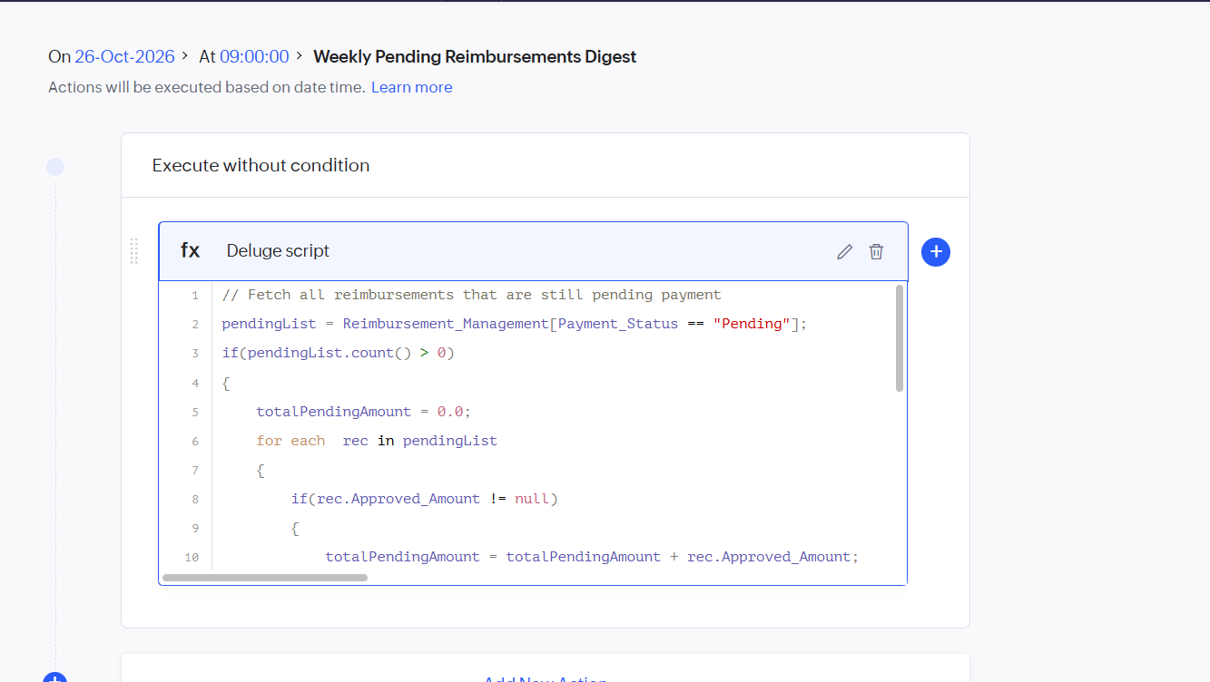
Figure 2: Scheduled workflow with a Deluge script action that totals the pending reimbursements.
The Deluge script is the action that this schedule carries out. As visible in the editor, it first fetches every record of the Reimbursement_Management form whose Payment_Status is Pending. If at least one such record exists, it sets a running total to zero and loops through the pending records, adding the Approved_Amount of each record to the total. Table 10.4 explains the lines that are visible in the screenshot.
Table 10.4: Walk-through of the Deluge script shown in the editor.
Line | Statement | Purpose
1 | // Fetch all reimbursements that are still pending payment | A comment that states what the script does
2 | pendingList = Reimbursement_Management[Payment_Status == "Pending"]; | Fetches all reimbursements whose payment is still pending
3 | if(pendingList.count() > 0) | Runs the remaining steps only if at least one pending record exists
5 | totalPendingAmount = 0.0; | Starts the running total at zero
6 – 10 | for each rec in pendingList { if(rec.Approved_Amount != null) { totalPendingAmount = totalPendingAmount + rec.Approved_Amount; | Loops through each pending record, skips records with no approved amount, and adds the approved amount to the total

Observation
The schedule was set up without building any workflow screens. Once the start date, time, and interval were given, Zoho Creator ran the attached action at the set time with no user action needed. The action used here is a Deluge script that looks up the reimbursements whose payment is still pending and adds up their approved amounts, so the total owed can be calculated each week without opening and filtering the records by hand. The same schedule can be changed from Weekly to Daily or Monthly just by choosing a different value in the Run field, so the three required intervals are handled by one feature.
The Choose a Date Field option provides a second way to schedule, by running actions on a date stored in each record, such as an expense claim due date. The script can also be extended with further statements, for example to send the calculated total to the Finance Admins by email, and more actions can be added to the same schedule with Add New Action.
A schedule differs from the form workflows and blueprint of the earlier experiments. A form workflow reacts to a form event such as submitting or editing a record, and a blueprint controls the steps a record must follow. A schedule is driven by time alone, which makes it suitable for automated financial summaries, reminders, and periodic audit reports.

Result
A scheduled workflow named Weekly Pending Reimbursements Digest was successfully created and enabled in the Zoho Creator SpendGuard application. It starts on 26-Oct-2026 at 09:00:00, repeats weekly, and has one Deluge script action that totals the approved amounts of reimbursements whose payment is pending. The Run option also provides the Daily and Monthly intervals required by the experiment.

