Experiment – 11
Portal User
Creating a Portal and Adding Portal Users in Zoho Creator
Department of Computer Science and Engineering
Student Name: Chenthan Amuthan D
Roll No: 240701090
Application Name: SpendGuard

Objective
To create a portal for the SpendGuard application in Zoho Creator, to add portal users to it, and to control what each portal user can do by assigning a portal user permission, so that people outside the organization such as contractors and customers can use the application securely through a separate web address.

Introduction
A portal in Zoho Creator is an online, self-service gateway through which customers, vendors, contractors, and business partners interact with an application without being regular users of the organization. Each portal has its own web address and sign-in page, so external people never need access to the Creator account itself.
People are added to the portal as portal users, and every portal user is given a portal user permission. A permission is a profile that decides which forms, reports, and pages that user can see and what the user can do with the data, such as adding, viewing, editing, or deleting records. In this way one application can serve different groups of external users, each seeing only what is meant for them.
A portal can be Public, which lets people sign up or be invited, or restricted to users added by the administrator. The sign-in method, the notification emails, and the look of the portal pages can all be configured from the portal settings without writing any code.

Portal Components
Table 11.1: Components of a Zoho Creator portal.
Component | Description | In this Experiment
Portal | Online gateway to the application for external users, with its own URL | Portal of the SpendGuard application, shown as Public
Portal URL | Web address through which portal users reach the application | chenthanamuthand2024cs963.zohocreatorportal.in
Portal user | An external person who is allowed to sign in to the portal | dca (portal_dca) and amuthan6909@gmail.com
Portal user permission | Profile that decides what a portal user can access | Contractor Permission and Customer
Portal tabs | Settings areas of the portal | Portal User, Authentication, Email Notification, SMS Notification, Page Customization

Procedure
Table 11.2: Steps followed to create the portal and add a portal user.
Step | Action
1 | Open the SpendGuard application in Zoho Creator and select Portal under the Deploy section of the left menu.
2 | Click Create New and choose the application on which the portal is to be based. The portal is created with its own URL.
3 | Confirm that the portal appears in the Portal list with the type Public, authentication Default, and the number of portal users.
4 | Open the portal and select the Portal User tab to see the users who already have access.
5 | Click Add Portal Users, enter the Email Address and Name of the new user.
6 | Choose the Permission for the user from the drop-down. Customer was selected here.
7 | Decide whether to tick Send Notification Mail, then click Add User to save.
8 | Check the Portal User tab again to confirm the new user is listed with the correct permission.

Portal Users and Permissions
The portal of SpendGuard has one approved portal user, and a second user was being added during the experiment. The permission assigned to each user decides what that person can do inside the portal.
Table 11.3: Portal users of the SpendGuard portal.
Name | Email Address | Username | Permission
dca | dcamuthan123@gmail.com | portal_dca | Contractor Permission
(to be added) | amuthan6909@gmail.com | — | Customer

Screenshot-based lab record
The following pages contain the actual Zoho Creator screenshots of the portal configuration.

Screenshots 1 – Portal Section
The Portal section of Zoho Creator, under Deploy, describes a portal as a way to create exclusive portals with a personalised login experience for external users. The list shows the application SpendGuard with its portal URL, the Portal Type as Public, the Authentication as Default, and the number of Portal Users as 1. A Create New button at the top right is used to create further portals.
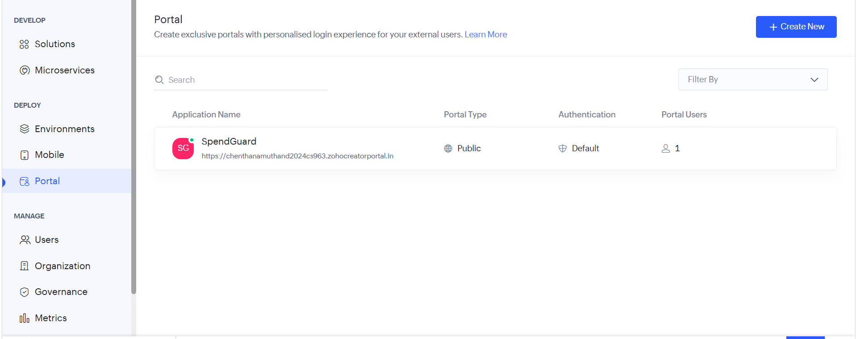
Figure 1: Portal section showing the SpendGuard portal.

Screenshots 2 – Portal User Tab
Opening the portal shows the application name SpendGuard, the label Public, and its web address. The tabs are Portal User, Authentication, Email Notification, SMS Notification, and Page Customization. The Portal User tab lists the approved users with their name, email address, username, and permission. One user is present: dca with the email dcamuthan123@gmail.com, the username portal_dca, and the Contractor Permission. The Add Portal Users button, the Export button, and the Approved filter are also available.
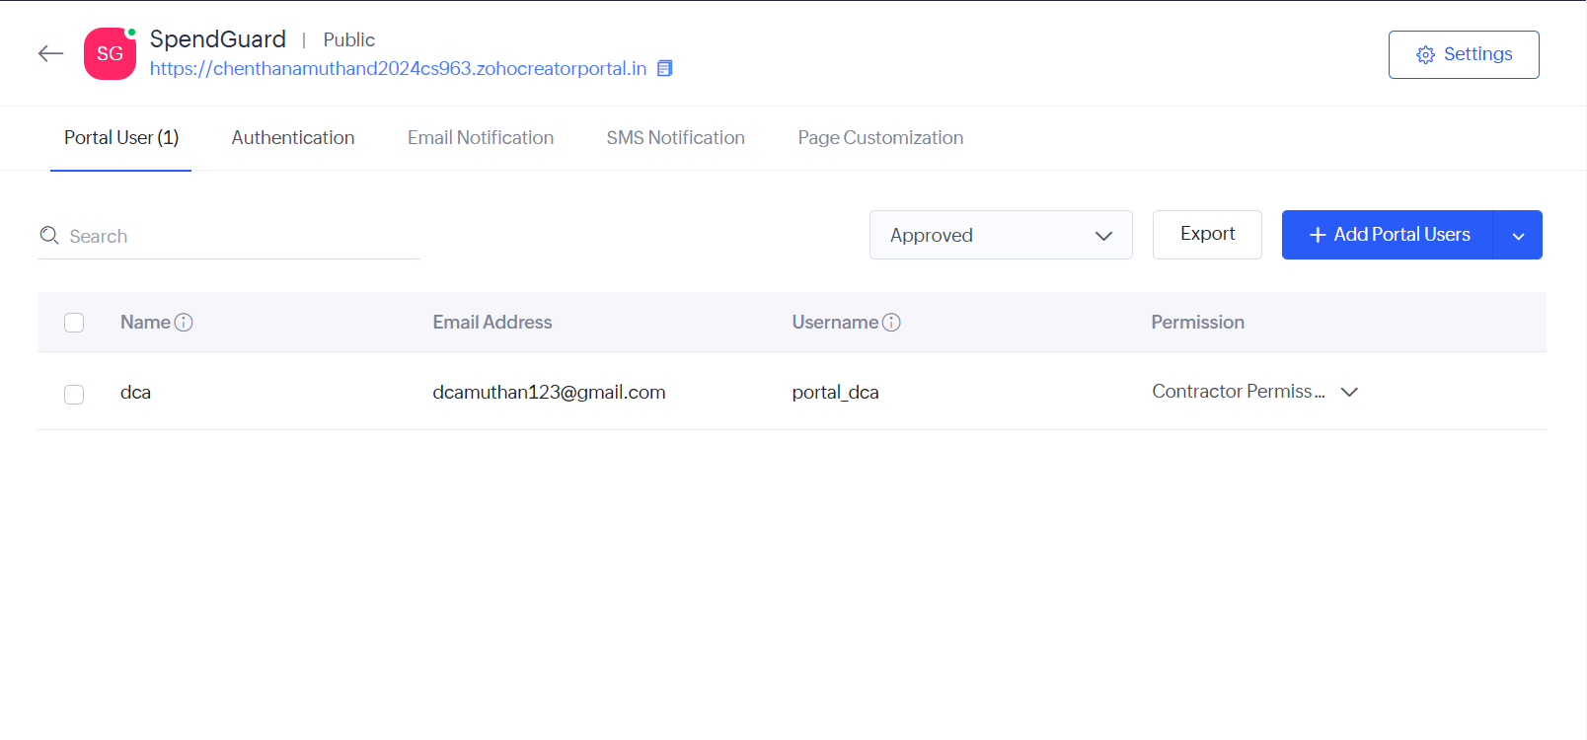
Figure 2: Portal User tab listing the existing portal user and permission.

Screenshots 3 – Adding a Portal User
Add Portal Users opens a side panel where the email address and name of the new user are entered. Here the email address amuthan6909@gmail.com was typed. More users can be added at once with the Add User link, and the Send Notification Mail option can be ticked so that the user is informed by email. The Permission drop-down, set to Customer here, decides what the new user can access, and the Add User button saves the user to the portal.
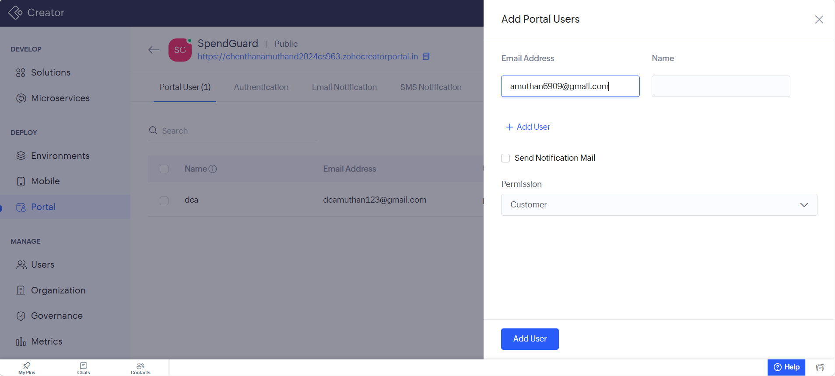
Figure 3: Add Portal Users panel with email address, notification option, and permission.

Observation
The portal was created and its users were managed without writing any code. Each portal user signs in with an email address and sees only what the assigned permission allows. The existing user dca works under the Contractor Permission, while the new user was given the Customer permission, so each group is limited to the part of the application that concerns it. A single portal therefore serves several kinds of external users, and the access of a user can be changed later by selecting a different permission in the Portal User tab.
A portal user differs from the regular users added under Users in Zoho Creator. Regular users belong to the organization and are given user permissions, whereas portal users are outside people who reach the application only through the portal and are given portal user permissions. The portal also keeps its own authentication, email notification, SMS notification, and page customization settings.

Result
A portal was successfully created for the SpendGuard application as a Public portal with Default authentication. The portal user dca was listed with the Contractor Permission, and a new portal user with the email address amuthan6909@gmail.com was added through the Add Portal Users panel with the Customer permission.

