Experiment – 12
Approval Process
Creating an Approval Process in Zoho Creator
Department of Computer Science and Engineering
Student Name: Chenthan Amuthan D
Roll No: 240701090
Application Name: SpendGuard (Expense Claim / Reimbursement Application)

Objective
To create an approval process in Zoho Creator that sends every new Expense Claim record to an approver for review, and to define the actions that run when the approver approves or rejects the record.

Introduction
An approval process in Zoho Creator is a workflow in which a record must be reviewed by one or more approvers before it is accepted. When a record is added to the chosen form, it is sent to the approver, who can approve or reject it. Actions can be attached to the start of the process and to each outcome, such as sending an email, updating fields of the record, adding records to another form, or running a Deluge script. The approval process therefore moves a record forward according to the decision of the approver, with no manual follow-up.
An approval process can have more than one level. Each level has its own approver and its own Approve and Reject outcomes, and a record reaches the next level only after it has been approved at the one before. The process is listed in the Approvals tab of the Workflow section, from where it can be enabled, disabled, or edited at any time.

Approval Process Components
Table 12.1: Components of a Zoho Creator approval process.
Component | Description | In this Experiment
Form | The form whose new records need approval | Expense Claim
Approver | The person or role who reviews the record at a level | Level 1 Approver: dcamuthan123@gmail.com (Reviewer)
Approval and Denial labels | Names of the two decision buttons shown to the approver | Approve and Reject
Actions on start | Actions that run when the process begins | None added
Actions on approval or rejection | Actions that run after the decision of the approver | Send email to the submitter, and update the record on approval

Table 12.2: Settings used to create the approval process.
Setting | Value
Workflow name | Expense Claim Approval Process
Form | Expense Claim
Run this process | Always
Approver type | User
Approver | dcamuthan123@gmail.com
Approval label | Approve
Denial label | Reject

Table 12.3: Fields updated when the Reviewer approves a record.
Form | Criteria | Field | New Value
Expense Claim | Current record | Claim Status | Pending Finance Payout
Expense Claim | Current record | Review_Decision | Approve

Procedure
Table 12.4: Steps followed to create the approval process.
Step | Action
1 | Open the SpendGuard application in Zoho Creator and go to the Workflow section, then select the Approvals tab.
2 | Click New Workflow and choose the Expense Claim form, name the workflow, and set it to run Always on record addition.
3 | Add the Level 1 approver by selecting the type User and choosing the reviewer, with the labels Approve and Reject.
4 | Under Approve, add an action that sends an email to the submitter without any condition.
5 | Add a Data access action under Approve to update Claim Status and Review_Decision of the current record.
6 | Under Reject, add an action that sends an email to the submitter without any condition.
7 | Open the Send email action and type the message that is sent to the submitter, then click Update.
8 | Save the process and check in the Approvals tab that it is Enabled.

Screenshot-based lab record
The following pages contain the actual Zoho Creator screenshots of the approval process configuration for SpendGuard.

Screenshots 1 – Approvals Tab
The Approvals tab of the Workflow section lists the approval processes of the application, next to the tabs Form workflows, Schedules, Payments, Blueprints, Batch workflows, and Functions. Under the Expense Claim form it shows the process Expense Claim Approval Process with 2 Actions, the trigger On review, the status Enabled, and the creation date 21-Oct-2026. A new process is started with the New Workflow button.
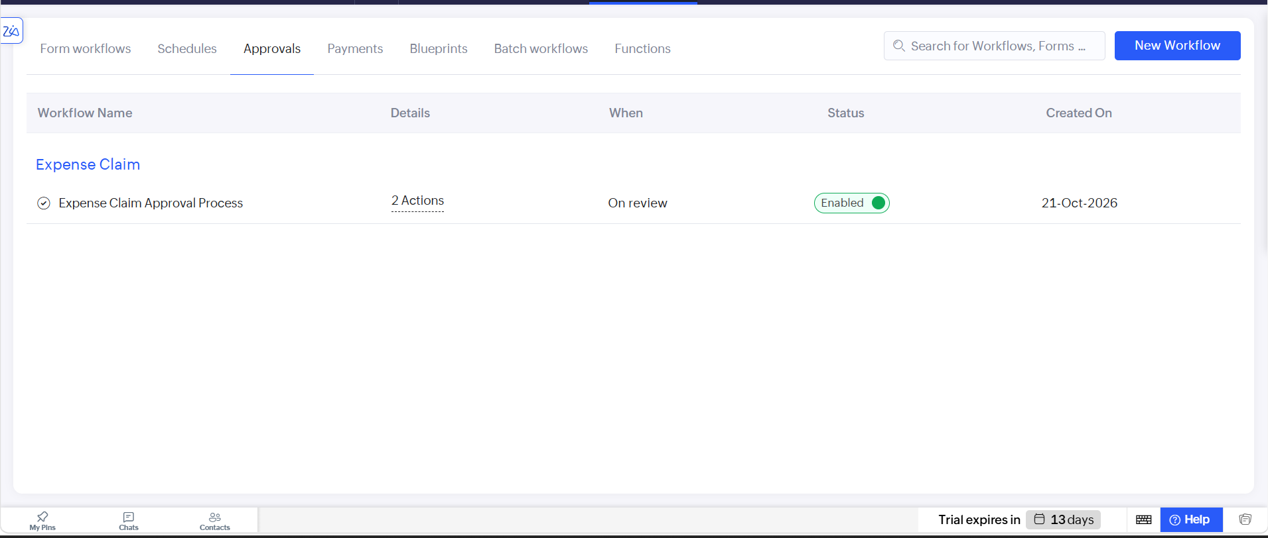
Figure 1: Approvals tab of the Workflow section showing the Expense Claim approval process.

Screenshots 2 – Approval Events and Actions
The process page shows the approval events. The Approval Events list on the right shows On Start and the Level 1 Approver with its two outcomes, Approve and Reject. Under Reject, an action that sends a mail to the submitter of the record runs without any condition, and further actions can be added with Add New Action. A further level of approval can be added with Add New Approver.
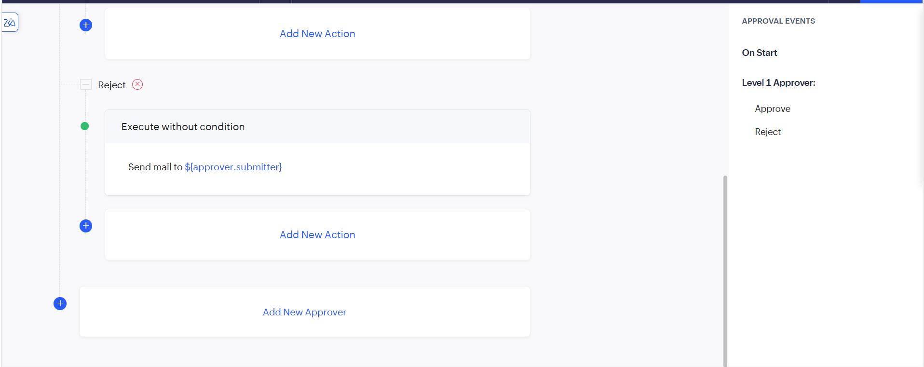
Figure 2: Approval events with the Level 1 Approver and the action under Reject.

Screenshots 3 – Send Email Action
Opening the send mail action shows the Send email panel of the Expense Claim Approval Process in the SpendGuard application. The Message box has a formatting toolbar and an Insert fields drop-down, and the message written for the submitter is that the request has been approved. The Update button saves the message and Cancel closes the panel. The same action is shown under Approve and Reject in the background.
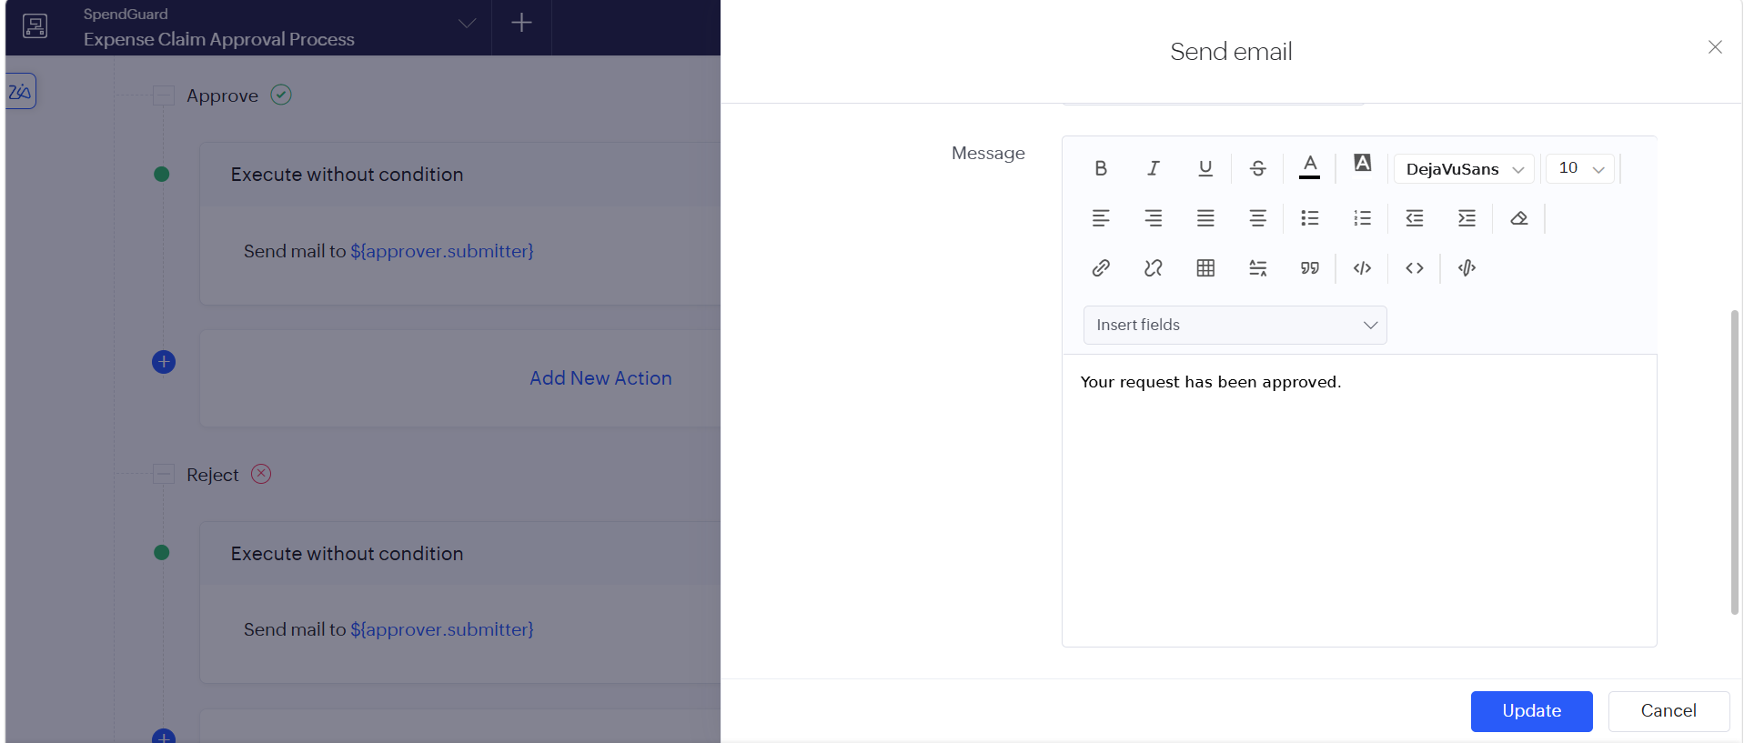
Figure 3: Send email panel with the message sent to the submitter.

Observation
The approval process was created without writing any code. Every new Expense Claim is sent to the reviewer, who sees the Approve and Reject buttons, and each decision can start its own actions. On approval, the submitter is informed by email and the record is updated automatically so that its status shows that it is now waiting for Finance payout. The same process can be extended by adding more levels of approvers, so that a claim passes through several reviewers one after another.
An approval process differs from a blueprint, which controls the stages a record must follow by means of transitions chosen by the user, and from a form workflow, which only reacts to an event. In an approval process the record waits for the decision of a named approver, and the outcome of that decision decides what happens next.

Result
An approval process named Expense Claim Approval Process was successfully created for the Expense Claim form in the SpendGuard application. The configured user is the Level 1 approver with the Approve and Reject outcomes. On approval, an email is sent to the submitter and the record is updated with the status Pending Finance Payout and the reviewer decision Approve.

