Experiment – 7
Users, Roles and Permissions
Access Control in Zoho Creator
Department of Computer Science and Engineering
Student Name: Chenthan Amuthan D
Roll No: 240701090
Application Name: SpendGuard (Expense Claim / Reimbursement Application)

Objective
To implement role-based access control in a Zoho Creator application by adding users, defining a role hierarchy, and creating permission sets, so that each user sees and performs only the actions appropriate to their position.

Introduction
Zoho Creator controls access to an application through three connected concepts. A User is an individual who has been granted access to the solution. A Role places the user in a reporting hierarchy and decides whose records the user can see. A Permission Set (profile) decides what the user can do — access, view, edit, and delete — on each form and report. Every user added to an application is assigned one role and one permission set, so access is managed centrally rather than record by record.
In the SpendGuard application, employees submit expense claims, reviewers validate them, and the finance team processes the reimbursements. Because claims contain financial information, every person should see only the records and actions that belong to their position. This experiment sets up that separation using users, roles, and permission sets, entirely through configuration and without writing any code.

Concepts Used
Concept | Description | Configured in this Experiment
User | A person invited to the application by e-mail and assigned an application, role, and permission | Super Admin (Chenthan Amuthan D), dca140107, and amuthan6909
Role | A position in the reporting hierarchy; higher roles can see the records of roles beneath them | CEO → Employee / Reviewer / Finance Admin
Permission Set | A profile defining Access, View, Edit, Delete, and More rights for each module (form) | Employee Permission, Finance Admin Permission, Read, Reviewer Permission, Write
Data Sharing | Rules controlling how records are shared between roles beyond the hierarchy | Available under the Data Sharing tab
Table 7.1: Access-control concepts in Zoho Creator.

Procedure
- Open the SpendGuard application in Zoho Creator and go to Settings → User Permissions.
- Open the Roles tab and create the role hierarchy: CEO at the top, with Employee, Reviewer, and Finance Admin reporting to the CEO.
- Open the Permissions tab and use Add Permission to create the Employee, Reviewer, and Finance Admin permission sets, alongside the default Read and Write profiles.
- For each permission set, tick the Access, View, Edit, Delete, and More rights required on every form and report.
- From the Users page, use Add User to invite dca140107 and amuthan6909 by e-mail, selecting the application, role, and permission for each.
- Verify that every user appears as Active on the Users page and that the role tree and permission list match the design.

Configuration Summary
The Role Hierarchy created for the SpendGuard application is shown below. Each role reports to the one above it, so the CEO sits at the top and can view the records of every role beneath.
Role | Reports To | Purpose
CEO | Top of hierarchy | Overall visibility of all expense claims and organizational metrics
Employee | CEO | Raises and tracks personal expense claim submissions
Reviewer | CEO | Reviews, validates, and approves/rejects submitted expense claims
Finance Admin | CEO | Full administrative access to financial processing, audit logs, and system settings
Table 7.2: Role hierarchy.
The Permission Sets created for the application are listed below.
Permission Set | Description
Employee Permission | Restricted access for regular employees to submit and track claims
Finance Admin Permission | Full administrative access to all financial processing, audit logs, and system settings
Read | This profile will have read permission for all components
Reviewer Permission | Access to review claims and approve/reject submissions
Write | This profile will have write permission for all components
Table 7.3: Permission sets.
The users added to the account are listed below.
User | Account Type | Status
Chenthan Amuthan D | Super Admin | Active
dca140107 | Application user | Active (Invited)
amuthan6909 | Application user | Active (Invited)
Table 7.4: Users in the account.

Screenshot-based lab record
The following section details the actual Zoho Creator screenshots of the user, role, and permission configuration updated for SpendGuard.

Screenshots 1 – Users
The Users page of Zoho Creator lists every user with their e-mail address, status, and last activity. The primary user is Chenthan Amuthan D (Super Admin) who owns the account, alongside invited application users (dca140107 and amuthan6909).
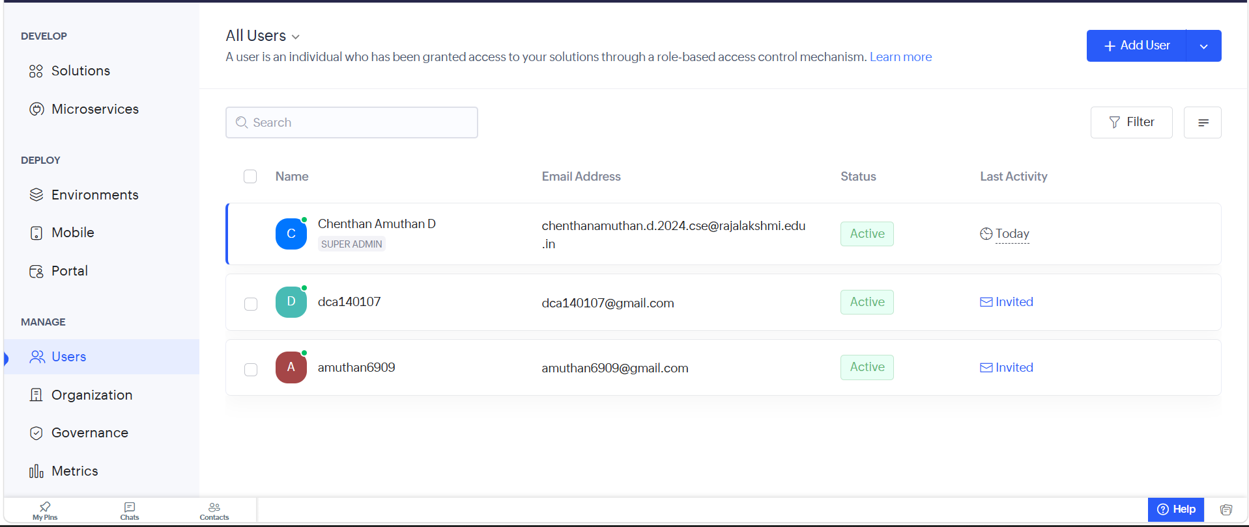
Figure 1.1: All Users page showing Super Admin (Chenthan Amuthan D) and active invited users.
A new user is added using the Add User option at the top right of the page. The e-mail address and name are entered, and the application, role, and permission are then selected for that user. Invited users show an Invited link under Last Activity until they accept the invitation and sign in.

Screenshots 2 – Roles
Roles are managed from Settings → User Permissions → Roles. The hierarchy is displayed as a tree consisting of CEO at the top, followed by Employee, Reviewer, and Finance Admin. The tree can be expanded, collapsed, or rearranged using Manage Role Hierarchy.
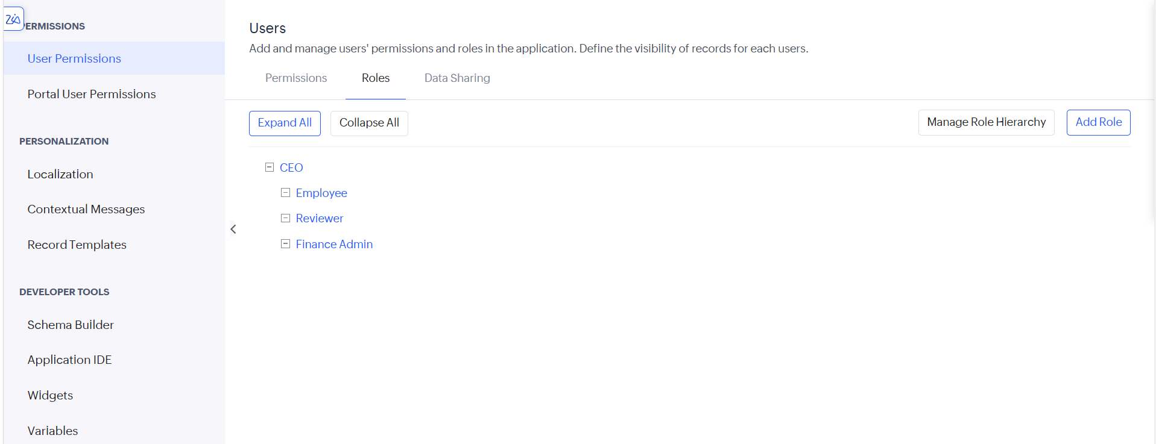
Figure 2.1: Roles tab showing the configured hierarchy CEO → Employee / Reviewer / Finance Admin.
A new role is created with Add Role by giving it a name, choosing the role it reports to, and optionally adding a description. Since Employee, Reviewer, and Finance Admin all report to the CEO, the CEO can see the records of all three, while the three roles are kept separate from one another.

Screenshots 3 – Permissions
Permission sets are managed from the Permissions tab. The active permission sets configured include Employee Permission, Finance Admin Permission, Read, Reviewer Permission, and Write. Each set has a name and description and can be assigned to any number of users.
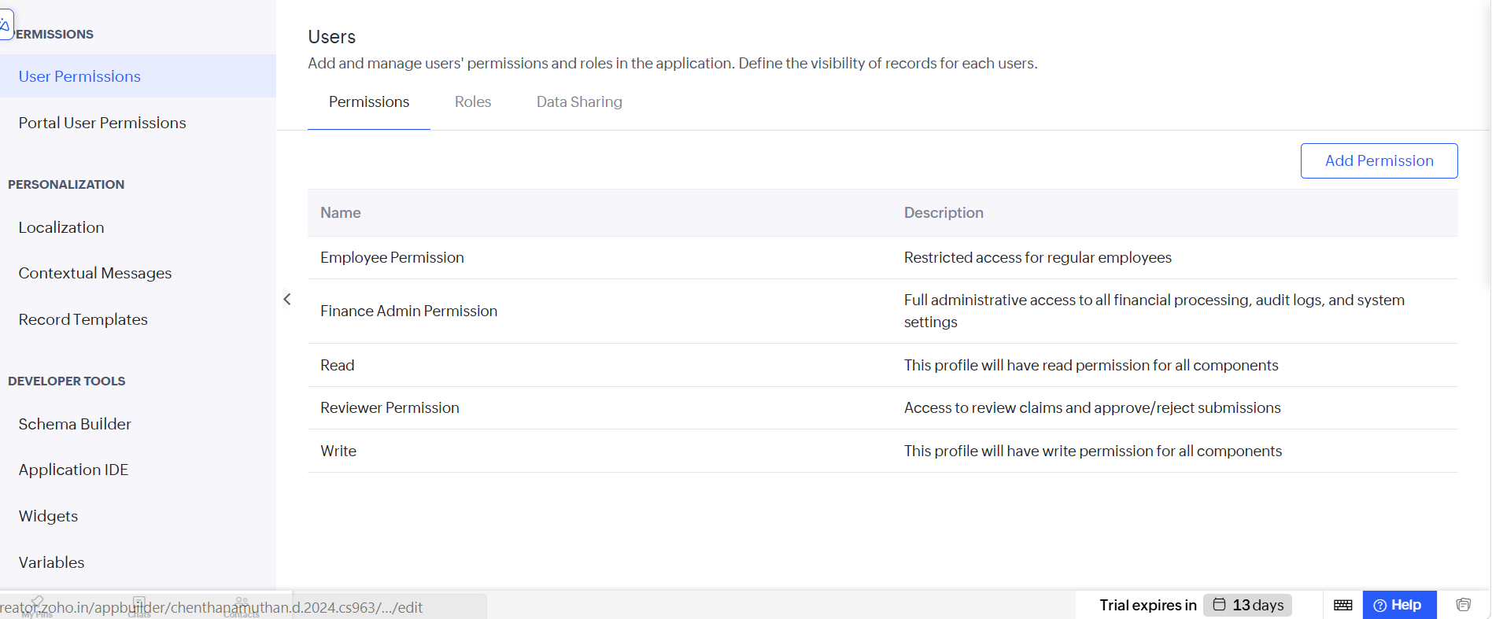
Figure 3.1: Permissions tab listing Employee Permission, Finance Admin Permission, Read, Reviewer Permission, and Write.
A new permission set is created with Add Permission. The name and description are entered first, and the Set Permissions table then defines, for each module (form) of the application, whether the user gets Access, View, Edit, Delete, and More rights, by ticking the corresponding check boxes.

Observation
Access to the application was controlled entirely through configuration, without writing any code. The role hierarchy determines whose records a user can see, while the permission set determines what the user can do with those records, so the two settings work together. An Employee, for example, can be given a permission set that allows raising and tracking expense claims, while the Reviewer, Finance Admin, and CEO roles above it see those requests for validation and financial payout processing. Permission sets can be reused for any number of users, which keeps administration simple as the organization grows.

Result
Users, roles, and permission sets were successfully created in Zoho Creator for the SpendGuard application, and a role hierarchy of CEO, Employee, Reviewer, and Finance Admin was configured. Role-based access control was thereby successfully implemented for the application.

