Experiment – 9
Blueprint
Designing a Process Blueprint in Zoho Creator
Department of Computer Science and Engineering
Student Name: Chenthan Amuthan D
Roll No: 240701090
Application Name: SpendGuard (Expense Claim / Reimbursement Application)

Objective
To model a multi-step business process in Zoho Creator using a Blueprint, by defining the stages a record passes through and the transitions that move it from one stage to the next, and to apply it to the approval process of expense claims and reimbursement processing.

Introduction
A Blueprint in Zoho Creator is a visual tool for designing and enforcing a process. Instead of allowing a record to be edited freely, a blueprint fixes the sequence in which the record must travel: the record is always in exactly one stage, and it can leave that stage only through a defined transition. Each transition appears to the user as a button, and conditions, field updates, notifications, and approvals can be attached to it. A blueprint therefore guarantees that every record follows the same approved path, and the history of the path taken is recorded.

Blueprint Components
Component | Description | In this Experiment
Blueprint | The complete process definition attached to a form | Expense Claim Lifecycle blueprint, on the Expense Claim form
Stage | A state in which a record can be at any given time | Draft, Submitted, Approved, Rejected
Transition | The action that moves a record from one stage to another, shown as a button | Submit Claim, Approve Claim, Reject Claim
Start | The entry point of the process | Start → Draft
Table 9.1: Components of a Zoho Creator Blueprint.

Blueprint Design – Approval Workflow
The blueprint was designed for the approval process of an expense claim in the SpendGuard application. A claim starts at the Draft stage, where the employee prepares it. When the employee presses the Submit Claim button, the claim moves to the Submitted stage, where it waits for the reviewer’s decision. From Submitted the reviewer has two possible actions: Approve Claim, which moves the claim to Approved, or Reject Claim, which moves it to Rejected. Approved and Rejected are the end stages of the process.
Stage | Transition | Next Stage | Type
Start | — | Draft | Entry
Draft | Submit Claim | Submitted | Forward
Submitted | Approve Claim | Approved | End
Submitted | Reject Claim | Rejected | End
Table 9.2: Stages and transitions of the Expense Claim Lifecycle blueprint (as listed in the Transitions tab).
Each stage describes the exact position of a claim in the process. Because a record is always in exactly one stage, the reviewer can tell at a glance whether a claim is still being prepared, is waiting for a decision, or has been finalised. Table 9.3 explains each stage and lists the transitions available from it.
Stage | Meaning of the Stage | Transitions Out of the Stage
Draft | The claim is being prepared by the employee and has not yet been sent for review | Submit Claim → Submitted
Submitted | The claim has been submitted and is waiting for the reviewer’s decision | Approve Claim → Approved; Reject Claim → Rejected
Approved | The claim has been accepted for reimbursement; end of the process | None (end stage)
Rejected | The claim has been declined by the reviewer; end of the process | None (end stage)
Table 9.3: Meaning of each stage and the transitions that leave it.

Screenshot-based lab record
The following section contains the actual Zoho Creator screenshots of the Expense Claim Lifecycle blueprint configured in the SpendGuard application.

Screenshots 1 – Blueprint List
The Blueprints tab of the Workflow section lists the blueprints of the application, grouped by form. The Expense Claim form appears under Forms with Blueprints and holds one blueprint, Expense Claim Lifecycle, which is Enabled and was created on 21-Oct-2026. The remaining forms — Audit Log, Claim Review, Department Management, Employee Management, Expense Policy, and Reimbursement — appear under Forms without Blueprints.
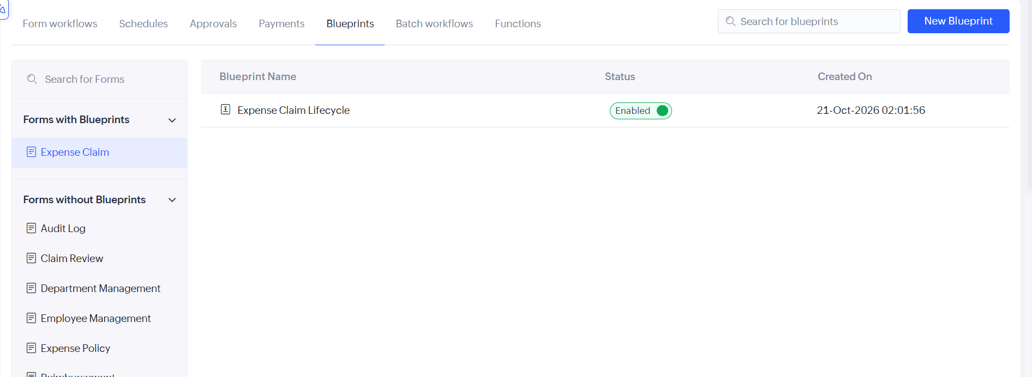
Figure 1: Blueprints tab showing the enabled Expense Claim Lifecycle blueprint on the Expense Claim form.

Screenshots 2 – Blueprint Designer and Stages
The blueprint is drawn on a canvas that begins at a Start node. Every stage is a box on the canvas, and every transition is a dark button placed on the connection between two stages. The canvas shows the claim flowing from Start to Draft, then through the Submit Claim transition to Submitted, where the flow splits into Approve Claim, leading to Approved, and Reject Claim, leading to Rejected. The Stages tab in the right-hand panel lists the stages of the blueprint, and new stages are created with Add Stages.
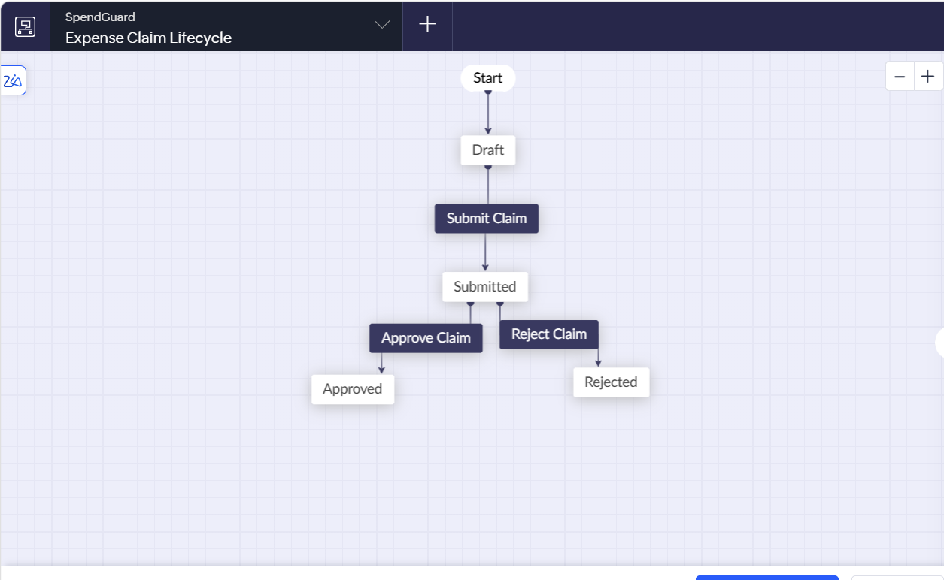
Figure 2: Blueprint designer — the canvas flow from Start to Draft, Submitted, Approved, and Rejected.
Four stages have been placed on the canvas and are used by the Expense Claim workflow: Draft, Submitted, Approved, and Rejected. The blueprint is completed with the Save Blueprint button at the bottom of the designer, after which it can be enabled for the form.

Screenshots 3 – Transitions
The Transitions tab lists each transition as the stage it starts from, the transition button name, and the stage it leads to. These are the actions the reviewer sees on a record while it is in that stage. The tab lists three transitions: Submit Claim from Draft to Submitted, Approve Claim from Submitted to Approved, and Reject Claim from Submitted to Rejected.
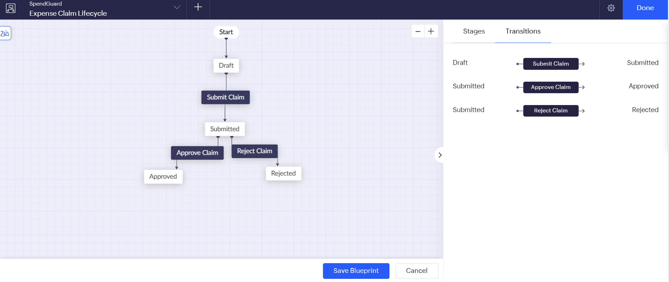
Figure 3: Transitions tab listing the transitions between stages of the Expense Claim Lifecycle blueprint.

Observation
The expense claim approval process was captured as a diagram of stages and transitions, and no code was needed to define the routing. A claim can only move along the connections drawn on the canvas, so a claim cannot reach Approved without first being submitted from Draft and then approved by the reviewer. The Submitted stage offers two outcomes — approve or reject — and each outcome is available to the reviewer as a single button on the record. Because the process is drawn rather than coded, it is easy to read, to explain to non-technical users, and to change by adding a stage or a transition.
The same blueprint can be extended later without rebuilding it. For example, an Under Review stage or a Revision Requested stage with a Resubmit transition can be added on the canvas so that a reviewer can return a claim to the employee for correction. Conditions, field updates and notifications can also be attached to any transition, such as informing the employee by email when a claim is approved or rejected.
A blueprint differs from standard form workflows in an important way. A form workflow reacts to an event after it happens, whereas a blueprint controls what the user is allowed to do next, which makes it suitable for processes that must be followed in a fixed order.

Result
A Blueprint named Expense Claim Lifecycle was successfully created and enabled in the Zoho Creator SpendGuard application. It defines four stages and three transitions covering the submission, approval, and rejection of expense claims, and thereby enforces a uniform approval process.

