SPENDGUARD: ENTERPRISE EXPENSE POLICY AND CLAIM MANAGEMENT APPLICATION
A PROJECT REPORT
Submitted by
CHENTHAN AMUTHAN D
(2116240701090)
in partial fulfilment of the End Semester Examination for the course
CB23F35 –
LOW-CODE APPLICATION DEVELOPMENT USING ZOHO CREATOR
in
BACHELOR OF ENGINEERING
COMPUTER SCIENCE AND ENGINEERING

RAJALAKSHMI ENGINEERING COLLEGE
(An Autonomous Institution, Affiliated to Anna University, Chennai)
Rajalakshmi Nagar, Thandalam, Tamil Nadu – 602 105
NOVEMBER 2026

RAJALAKSHMI ENGINEERING COLLEGE
(An Autonomous Institution, Affiliated to Anna University, Chennai)
BONAFIDE CERTIFICATE
Certified that this project report titled “SPENDGUARD: ENTERPRISE EXPENSE POLICY AND CLAIM MANAGEMENT APPLICATION” is the bonafide work of CHENTHAN AMUTHAN D (2116240701090), who carried out the individual project work on the Zoho Creator low-code platform for the course CB23F35 – Low-Code Application Development using Zoho Creator, during the academic year 2026–2027, Semester V, under my supervision.

SIGNATURE  DR.J.MANORANJINI  HEAD OF THE DEPARTMENT  Department of Computer Science and Engineering  Rajalakshmi Engineering College  Thandalam – 602 105 | SIGNATURE  DR.J.JINU SOPHIA  COURSE FACULTY  Associate Professor  Department of Computer Science and Engineering  Rajalakshmi Engineering College

Submitted for the End Semester Examination (Individual Project) held on 10/11/2026.

INTERNAL EXAMINER | EXTERNAL EXAMINER

DECLARATION

I, CHENTHAN AMUTHAN D (2116240701090), hereby declare that the project report titled “SPENDGUARD: ENTERPRISE EXPENSE POLICY AND CLAIM MANAGEMENT APPLICATION”, submitted for the End Semester Examination of the course CB23F35 – Low-Code Application Development using Zoho Creator, is a record of original work carried out by me individually. The Zoho Creator application described in this report — including its data model, forms, reports, pages, Deluge scripts, workflows and integrations — was designed and developed by me.
I further declare that this work has not been submitted, in part or in full, for the award of any other degree or course credit. Every template, sample application, AI-assisted feature (such as Zia AI OCR), code snippet or external resource used in this work has been duly acknowledged in the report.

Place: Chennai  Date: 10/11/2026 | SIGNATURE OF THE STUDENT  CHENTHAN AMUTHAN D  2116240701090

ACKNOWLEDGEMENT

I express my sincere gratitude to our Chairman MR.S.MEGANATHAN, Chairperson DR.M.THANGAM MEGANATHAN and Vice-Chairman MR.S.ABHAY SHANKAR MEGANATHAN for providing the infrastructure and facilities that made this work possible.
I am grateful to our Principal, DR.S.N.MURUGESAN, Rajalakshmi Engineering College, for the constant encouragement extended to students to take up industry-relevant learning.
I thank DR.J.MANORANJINI, Head of the Department, Department of Computer Science and Engineering, for the guidance and support provided throughout the course.
I owe my sincere thanks to my course faculty, DR.J.JINU SOPHIA, Associate Professor, for the valuable guidance, reviews and feedback that shaped this application and report.
I also acknowledge Zoho Corporation and the Zoho Creator Education Programme for providing access to the Zoho Creator platform and learning resources, and I thank my family and friends for their unwavering support.

CHENTHAN AMUTHAN D

ABSTRACT

Enterprise expense management governs how organisations record, review and reimburse business expenditure incurred by employees. In many mid-sized organisations the process still depends on paper receipts, spreadsheets and email threads. Finance teams and department heads therefore face duplicate and mistyped entries, approvals that stall in inboxes, no real-time view of departmental spending, and little automated enforcement of expense policy, which exposes the organisation to compliance and fraud risk.
This project presents SpendGuard, an enterprise expense policy and claim management application built on the Zoho Creator low-code platform, whose managed hosting, relational data model, visual builders and built-in security allowed a complete solution to be delivered quickly. SpendGuard comprises seven forms — Expense Claim, Expense Policy, Employee Management, Department Management, Claim Review, Reimbursement Management and Audit Log — linked through lookup fields, with seven list reports and two dashboard pages that combine KPI panels, pie charts and bar charts. Deluge scripts calculate a risk score and risk level for every claim by comparing it with the applicable expense policy, write an audit-log entry for each state change, and raise high-risk alerts. A Zia AI OCR field extracts text from uploaded receipts. A multi-step approval process and a lifecycle blueprint route claims to reviewers, a form workflow converts approved claims into reimbursement records and triggers an external payout webhook, and a scheduled workflow sends a weekly pending-reimbursement digest. Access is governed by role profiles for administrators, finance managers, department staff and portal auditors.
The application was tested through unit, integration, role-based and user acceptance testing across development, stage and production environments, and was deployed in November 2026. The live deployment shows eight claims worth ₹1,05,100 captured end to end, each risk-classified, reviewed and logged. Manual spreadsheet duplication is removed, every decision is traceable through the audit log, and management gets instant visibility of spend, risk and pending reimbursements.
Keywords: Low-Code Development; Zoho Creator; Deluge Scripting; Workflow Automation; Role-Based Access Control; Expense Management

PROJECT AT A GLANCE

Table 0.1: Project profile
Project Title | SpendGuard: Enterprise Expense Policy and Claim Management Application
Application Domain | Finance & Enterprise Workflow Automation
Student Name & Register No. | Chenthan Amuthan D – 2116240701090
Zoho Creator Edition | Education / Free Trial Programme
Application Name (Link Name) | SpendGuard (spendguard)
Published / Live URL | https://creatorapp.zoho.in/dcamuthan123/spendguard
Demo Credentials (per role) | Admin: chenthanamuthan.d.2024cs963 (account owner) | Finance Manager / Staff / Auditor: shared portal-user profiles (credentials provided at demonstration)
Number of Forms / Subforms | 7 forms (Expense Claim, Expense Policy, Employee Management, Department Management, Claim Review, Reimbursement Management, Audit Log) / 0 subforms
Number of Reports (by type) | List: 7 | Kanban: 0 | Calendar: 0 | Pivot/Chart: 4 charts embedded in dashboards | Others: –
Number of Pages / Dashboards | 2 (SpendGuard Dashboard, Executive Dashboard)
Number of Workflows | Form: 4 | Schedule: 1 | Approval: 1 | Blueprint: 1 | Batch: 0
Deluge Functions / Custom Actions | Risk scoring, audit-log creation, reimbursement creation, high-risk alert, external webhook call
Integrations | Zoho Creator Zia AI OCR; Zoho Mail (sendmail); external payout webhook (REST)
Roles & Profiles Defined | Administrator, Finance Manager, Department Staff, Portal Auditor
Environments Used | Development → Stage → Production
Date of Production Deployment | November 2026

TABLE OF CONTENTS
DECLARATION iii
ACKNOWLEDGEMENT iv
ABSTRACT v
PROJECT AT A GLANCE vi
LIST OF TABLES ix
LIST OF FIGURES x
LIST OF ABBREVIATIONS xi
CHAPTER 1 – INTRODUCTION 1
1.1 Background 1
1.2 Problem Statement 1
1.3 Objectives 1
1.4 Scope of the Project 1
1.5 Justification for a Low-Code Approach 2
1.6 Organisation of the Report 2
CHAPTER 2 – LITERATURE SURVEY AND SYSTEM STUDY 3
2.1 Study of the Existing System 3
2.2 Limitations of the Existing System 3
2.3 Low-Code versus Traditional Development 3
2.4 Literature Survey 3
2.5 Emerging Trends in Low-Code Development 4
2.6 Proposed System 4
CHAPTER 3 – REQUIREMENT ANALYSIS 5
3.1 Stakeholders and User Roles 5
3.2 Functional Requirements 5
3.3 Non-Functional Requirements 5
3.4 Hardware and Software Requirements 6
3.5 Use Case Model 6
CHAPTER 4 – SYSTEM DESIGN 7
4.1 System Architecture 7
4.2 Data Model 7
4.3 Form Design 8
4.4 Process and Workflow Design 8
4.5 User Interface and Navigation Design 8
4.6 Access Control Design 8
CHAPTER 5 – IMPLEMENTATION 10
5.1 Application Setup 10
5.2 Forms and Data Capture 10
5.3 Reports 11
5.4 Pages and Dashboards 12
5.5 Deluge Scripting 14
5.6 Workflows and Automation 15
5.7 Integrations 16
5.8 User Management and Role-Based Access 16
5.9 AI and Analytics Features 17
5.10 Pro-Code Extension 17
5.11 Mobile and Portal Access 17
CHAPTER 6 – TESTING AND DEBUGGING 18
6.1 Testing Strategy 18
6.2 Test Cases 18
6.3 Debugging Deluge Scripts 18
6.4 Defect Log 18
6.5 User Acceptance Testing 19
CHAPTER 7 – DEPLOYMENT, SECURITY AND GOVERNANCE 20
7.1 Environments and Deployment Strategy 20
7.2 Performance Optimisation 20
7.3 Security Features 20
7.4 Governance and Administration 20
CHAPTER 8 – RESULTS AND DISCUSSION 21
8.1 Application Output 21
8.2 Achievement of Objectives 21
8.3 Comparison with the Existing System 21
8.4 Limitations of the Low-Code Approach 21
8.5 Reflection on the No-Code → Low-Code → Pro-Code Spectrum 21
CHAPTER 9 – CONCLUSION AND FUTURE ENHANCEMENTS 23
9.1 Conclusion 23
9.2 Future Enhancements 23
9.3 Learning Outcomes and Career Relevance 23
REFERENCES 24
APPENDIX A – ZOHO CREATOR FEATURE COVERAGE CHECKLIST 25
APPENDIX B – COURSE OUTCOME MAPPING 27
APPENDIX C – COMPLETE DELUGE SOURCE CODE 28
APPENDIX D – USER MANUAL 30
D.1 Accessing the Application 30
D.2 Instructions for Department Staff 30
D.3 Instructions for Finance Manager 30
D.4 Instructions for Administrator 30
D.5 Instructions for Auditor 30
D.6 Troubleshooting 30
APPENDIX E – EVALUATION RUBRIC 31
APPENDIX F – VIVA-VOCE RECORD SHEET 33

LIST OF TABLES
Table 2.1: Low-code versus pro-code development 3
Table 3.1: User roles and responsibilities 5
Table 3.2: Functional requirements 5
Table 3.3: Hardware and software requirements 6
Table 3.4: Use case summary 6
Table 4.1: Architecture layers 7
Table 4.2: Entities and relationships 7
Table 4.3: Expense Claim form specification 8
Table 4.4: Access control matrix (V = View, A = Add, E = Edit, D = Delete) 8
Table 5.1: Deluge scripts 14
Table 5.2: Workflows 15
Table 6.1: Test cases 18
Table 6.2: Defect log 18
Table 7.1: Environments 20
Table 8.1: Objectives versus outcome 21
Table 8.2: Existing versus SpendGuard 21
Table A.1: Feature Coverage Checklist 25
Table B.1: Mapping of Course Outcomes to Report Chapters 27
Table E.1: Evaluation Rubric for the Individual Project 31
Table E.2: Performance Level Descriptors 32
Table F.1: Viva-Voce Questions and Responses 33
Table F.2: Marks Summary 33

LIST OF FIGURES
Figure 5.1: Application menu showing forms, reports, workflows and pages 10
Figure 5.2: Expense Claim form with OCR field and receipt attachment 10
Figure 5.3: Expense Policy form 11
Figure 5.4: All Expense Claims list report with risk colour coding 11
Figure 5.5: All Department Management report 12
Figure 5.6: All Claim Reviews report 12
Figure 5.7: Audit Log Report 12
Figure 5.8: SpendGuard Dashboard KPI panels and charts 13
Figure 5.9: SpendGuard Dashboard risk counts and total amount claimed 13
Figure 5.10: Executive Dashboard department spend and claim status charts 13
Figure 5.11: In-app notifications for pending approvals and transitions 15
Figure 5.12: Approval summary and history for claim 8 16
Figure 5.13: Completed Tasks view after review 16

LIST OF ABBREVIATIONS

Abbreviation | Expansion
AI | Artificial Intelligence
API | Application Programming Interface
CRUD | Create, Read, Update, Delete
Deluge | Data Enriched Language for the Universal Grid Environment
KPI | Key Performance Indicator
LCAP | Low-Code Application Platform
OCR | Optical Character Recognition
RBAC | Role-Based Access Control
REST | Representational State Transfer
UAT | User Acceptance Testing
UI | User Interface
Zia | Zoho’s AI assistant

CHAPTER 1

INTRODUCTION

1.1 Background
Enterprise expense management governs how organisations track, review and reimburse business expenditure incurred by their people. Employees regularly incur costs on travel, client meals, software tools, accommodation and office supplies, and each of these must be checked against company policy before the finance team reimburses it. In the traditional workflow staff compile physical receipts, fill in spreadsheet templates and email them to department heads, who approve by reply and forward the paperwork to accounts payable.

1.2 Problem Statement
The manual reimbursement process suffers from operational friction and financial risk:
- Data duplication and errors: receipt amounts are retyped into spreadsheets, causing calculation discrepancies and duplicate submissions.
- Delayed approvals: email-routed approvals remain trapped in inboxes, delaying employee reimbursements.
- No real-time visibility: management lacks instant metrics on departmental spend, so budget control is reactive.
- Compliance and fraud exposure: out-of-policy amounts and altered or reused receipts are hard to detect.

1.3 Objectives
- To design a relational data model and forms for expense claims, policies, employees, departments, reviews, reimbursements and audit records.
- To automate risk scoring, status transitions, audit logging and notifications using Deluge scripts and workflows.
- To provide role-based dashboards and reports for finance teams and department managers.
- To integrate AI-powered OCR so that uploaded receipts are parsed automatically.
- To deploy and administer the application across environments with strict role-based access control.

1.4 Scope of the Project
In scope: claim submission, policy-driven risk evaluation, receipt OCR, multi-step approval, reimbursement creation, audit logging, KPI dashboards, scheduled digests and multi-role access control. Out of scope: direct execution of bank transfers and integration with accounting ERPs such as SAP or Tally, which are listed as future enhancements.

1.5 Justification for a Low-Code Approach
Zoho Creator provides a managed relational database, visual form and report builders, a built-in approval engine, role-based security and responsive mobile views out of the box [2]. These remove most boilerplate that a pro-code stack (for example React, Node.js and PostgreSQL) would require, so the effort could be spent on business rules written in Deluge [3] rather than on infrastructure.

1.6 Organisation of the Report
Chapter 2 studies the existing system and related work. Chapter 3 states the requirements. Chapter 4 presents the design. Chapter 5 describes the implementation with screenshots and code. Chapter 6 covers testing, Chapter 7 deployment, security and governance, Chapter 8 results and Chapter 9 the conclusion. The appendices provide the feature checklist, course-outcome mapping, source code and user manual.
CHAPTER 2

LITERATURE SURVEY AND SYSTEM STUDY

2.1 Study of the Existing System
In the existing system staff enter expenses into local spreadsheets, attach scanned receipts to emails and forward them to managers. Managers check the policy handbook manually, approve by reply, and forward the documents to accounts payable for ledger entry.

2.2 Limitations of the Existing System
- High latency in approval cycles and no reliable audit trail.
- No automated enforcement of policy limits against submitted amounts.
- High susceptibility to duplicate or altered receipt attachments.
- No consolidated, real-time view of department-wise spend.

2.3 Low-Code versus Traditional Development
Table 2.1: Low-code versus pro-code development
Criterion | Traditional (Pro-Code) | Low-Code on Zoho Creator
Development effort | Weeks of coding, integration and testing | Days to a few weeks using visual builders
Skills required | Full-stack programming, SQL, DevOps | LCAP concepts and Deluge scripting
Hosting | Self-managed cloud infrastructure | Managed cloud hosting
Mobile access | Separate mobile build | Responsive web and Zoho Creator mobile app
Security | Custom authentication and authorisation | Built-in roles, profiles and record-level criteria
Change management | Refactor and redeploy | Visual updates and environment publishing

2.4 Literature Survey
Industry analyses of low-code platforms, such as Gartner’s Magic Quadrant for enterprise low-code application platforms [4], describe how LCAPs let both citizen and professional developers deliver workflow applications faster than conventional approaches. Practitioner guides on low-code development [1] stress that data modelling and process automation are where such platforms add most value. Zoho’s documentation [2], [3] describes the form, workflow, approval, blueprint and Deluge capabilities used in this project, and the AI field types that perform OCR on uploaded files.

2.5 Emerging Trends in Low-Code Development
- AI-assisted building and AI-powered fields (OCR, prediction, sentiment) embedded directly in forms.
- Composable integrations through REST APIs and webhooks to connect low-code apps with external systems.
- Governance features such as audit trails and environment-based release management for enterprise use.

2.6 Proposed System
SpendGuard replaces spreadsheets and email with a single governed application: policies are stored as data, every claim is risk-scored against its policy on submission, receipts are OCR-parsed, reviews follow an approval process, reimbursements are generated automatically and every transition is written to an audit log.
CHAPTER 3

REQUIREMENT ANALYSIS

3.1 Stakeholders and User Roles
Table 3.1: User roles and responsibilities
Role | Description | Key Responsibilities
Administrator | System IT owner | Manage users, permissions, policies, departments and audit logs
Finance Manager | Department head / finance reviewer | Review, approve or reject claims; process reimbursements
Department Staff | General employee | Submit claims, upload receipts, track claim status
Portal Auditor | Finance controller | Monitor high-risk claims and compliance dashboards (read-only)

3.2 Functional Requirements
Table 3.2: Functional requirements
FR ID | Requirement | Role(s) | Priority
FR-01 | Allow staff to register expense claims with mandatory category, amount and receipt. | Staff | High
FR-02 | Automatically compute risk score and risk level against the applicable expense policy. | System | High
FR-03 | Extract text from uploaded receipts using the AI OCR field. | System | Medium
FR-04 | Route submitted claims to reviewers through an approval process and record the decision. | Manager | High
FR-05 | Create a reimbursement record and audit-log entry when a claim is approved or rejected. | System | High
FR-06 | Display KPI panels and charts for claims, risk, spend and pending reimbursements. | Admin, Manager, Auditor | Medium
FR-07 | Send a weekly digest of pending reimbursements. | System | Low

3.3 Non-Functional Requirements
- Performance: reports and dashboards should load within a few seconds for typical data volumes.
- Security: users access only the data permitted by their role profile (RBAC) and record-level criteria.
- Usability: the application must work on desktop browsers and in mobile views.
- Auditability: every status change must be traceable.

3.4 Hardware and Software Requirements
Table 3.3: Hardware and software requirements
Item | Specification
Platform | Zoho Creator (Education / Free Trial)
Scripting language | Deluge
Browser | Google Chrome / Microsoft Edge (latest)
Client hardware | Intel Core i3/i5 class, 8 GB RAM, internet connection

3.5 Use Case Model
Table 3.4: Use case summary
Use Case | Actor | Description
UC-01 Submit claim | Staff | Fills the Expense Claim form, selects category and policy, uploads receipt.
UC-02 Review claim | Manager | Approves or rejects the claim from the approval notification or review form.
UC-03 Monitor spending | Manager, Auditor | Views dashboards for spend, risk profile and pending reimbursements.
UC-04 Maintain policies and masters | Administrator | Maintains expense policies, departments and employees.
UC-05 Audit trail | Administrator, Auditor | Inspects the Audit Log Report for every claim transition.

CHAPTER 4

SYSTEM DESIGN

4.1 System Architecture
SpendGuard follows a three-tier architecture hosted entirely on Zoho Creator.
Table 4.1: Architecture layers
Layer | Components
Presentation | Web UI, mobile views, SpendGuard Dashboard and Executive Dashboard pages
Application & Logic | Form workflows, approval process, lifecycle blueprint, scheduled workflow, Deluge scripts
Data & Storage | Relational Creator forms, lookups, receipt file storage, audit log records

4.2 Data Model
The Expense Claim form is the central entity. It looks up the Employee and Department masters and the applicable Expense Policy; each Claim Review, Reimbursement and Audit Log record looks up its Expense Claim.
Table 4.2: Entities and relationships
Entity (Form) | Key Fields | Related To | Relationship | Implemented Using
Department Management | Department Code, Name, Head, Annual Budget, Email, Status | Employee Management | One-to-Many | Lookup
Employee Management | Employee details, Department | Expense Claim | One-to-Many | Lookup
Expense Policy | Policy Name, Category, Maximum Allowed Amount, Receipt Required, Effective dates, Active Status | Expense Claim | One-to-Many | Lookup (Policy Reference)
Expense Claim | Claim ID, Employee, Department, Dates, Category, Amount, OCR, Receipt, Payment Method, Policy Reference, Risk Score, Risk Level, Risk Reasons | Claim Review, Reimbursement, Audit Log | One-to-Many | Lookup in child forms
Claim Review | Review ID, Reviewer, Review Date, Decision, Approved Amount, Remarks | Expense Claim | Many-to-One | Lookup
Reimbursement Management | Reimbursement record for an approved claim | Expense Claim | One-to-One | Lookup
Audit Log | Audit ID, Action, Previous / New Status, Performed By, Timestamp, Remarks | Expense Claim | Many-to-One | Lookup

4.3 Form Design
Table 4.3: Expense Claim form specification
Field Label | Field Type | Mandatory | Validation / Remarks
Claim ID | Auto Number | System | Generated on creation
Employee | Lookup | Yes | Linked to Employee Management
Department | Lookup | Yes | Linked to Department Management
Expense Date / Submission Date | Date / Date-Time | Yes | Submission date stamped automatically
Expense Category | Drop Down | Yes | Travel, Accommodation, Meals, Software
Amount | Currency | Yes | Greater than 0
Description | Multi Line | No | Free text
OCR | AI field (OCR) | No | Auto-parsed from Receipt Attachment
Receipt Attachment | File Upload | Yes | Image / PDF
Payment Method | Drop Down | Yes | Cash, Card, Bank Transfer
Policy Reference | Lookup | No | Linked to Expense Policy
Risk Score / Risk Level / Risk Reasons | Number / Drop Down / Multi Line | System | Set by workflow

4.4 Process and Workflow Design
On submission, the Initialize Claim and Audit Log workflow creates the first audit entry and Calculate Risk Score sets the risk fields. The Expense Claim Approval Process and Expense Claim Lifecycle blueprint move the claim through review. Process Review Decision and Reimbursement then updates the claim, creates the reimbursement record and logs the outcome, while External Payout Webhook notifies an external payout endpoint. Weekly Pending Reimbursements Digest runs on a schedule.

4.5 User Interface and Navigation Design
A dark-tone sidebar gives icon access to the dashboards, forms and reports, with a pink accent colour used consistently for actions and charts. The SpendGuard Dashboard opens first so that managers see KPIs immediately.

4.6 Access Control Design
Table 4.4: Access control matrix (V = View, A = Add, E = Edit, D = Delete)
Component | Administrator | Finance Manager | Staff | Portal Auditor
Form: Expense Claim | A E V D | E V | A V | V
Form: Claim Review | A E V D | A E V | – | V
Form: Expense Policy / Masters | A E V D | V | V | V
Report: All Expense Claims | V | V | V (own records) | V
Report: Audit Log Report | V | V | – | V
Dashboards | V | V | – | V

CHAPTER 5

IMPLEMENTATION

5.1 Application Setup
SpendGuard was created as a custom application on Zoho Creator. The sidebar groups the dashboards, operational forms and reports, and the global search menu lists every form, report, workflow and page (Figure 5.1). A corporate dark theme with a pink accent was configured for contrast.
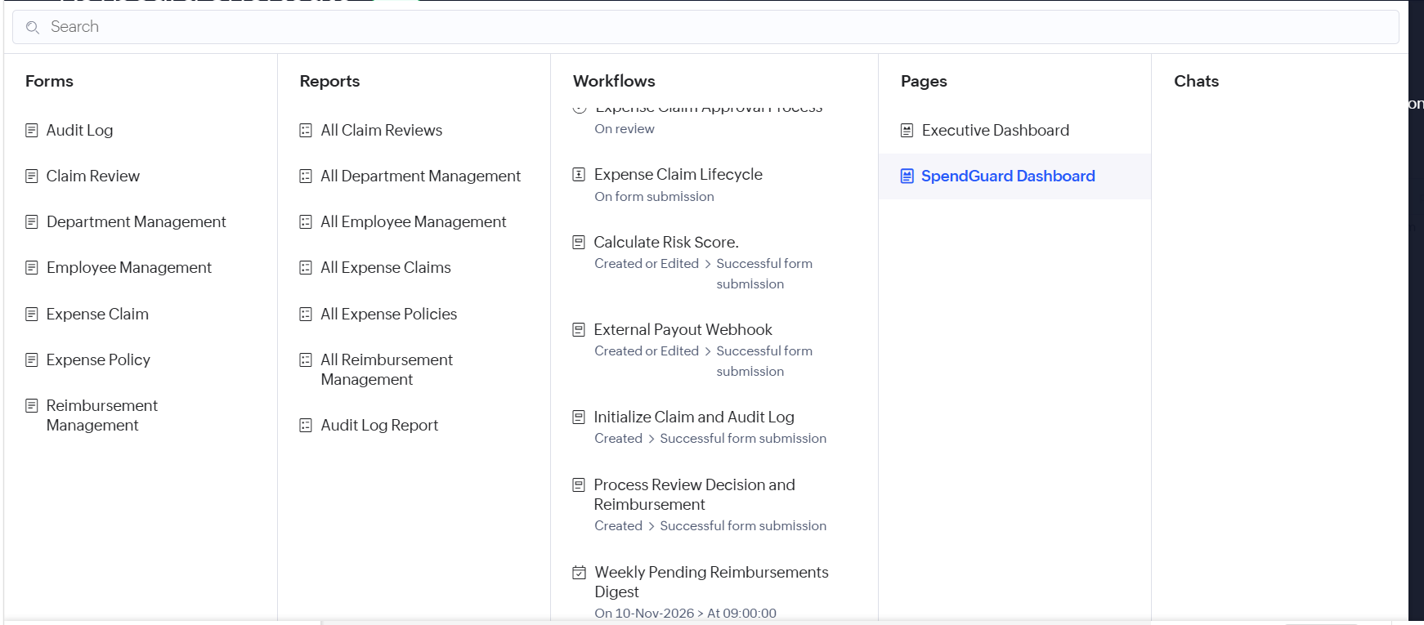
Figure 5.1: Application menu showing forms, reports, workflows and pages

5.2 Forms and Data Capture
The Expense Claim form uses lookup, date, drop-down, currency, multi-line, file-upload and AI OCR fields, among others (Figure 5.2). Selecting a receipt triggers the OCR field, which fills with the parsed text. Validations make category, amount and receipt mandatory and require a positive amount.
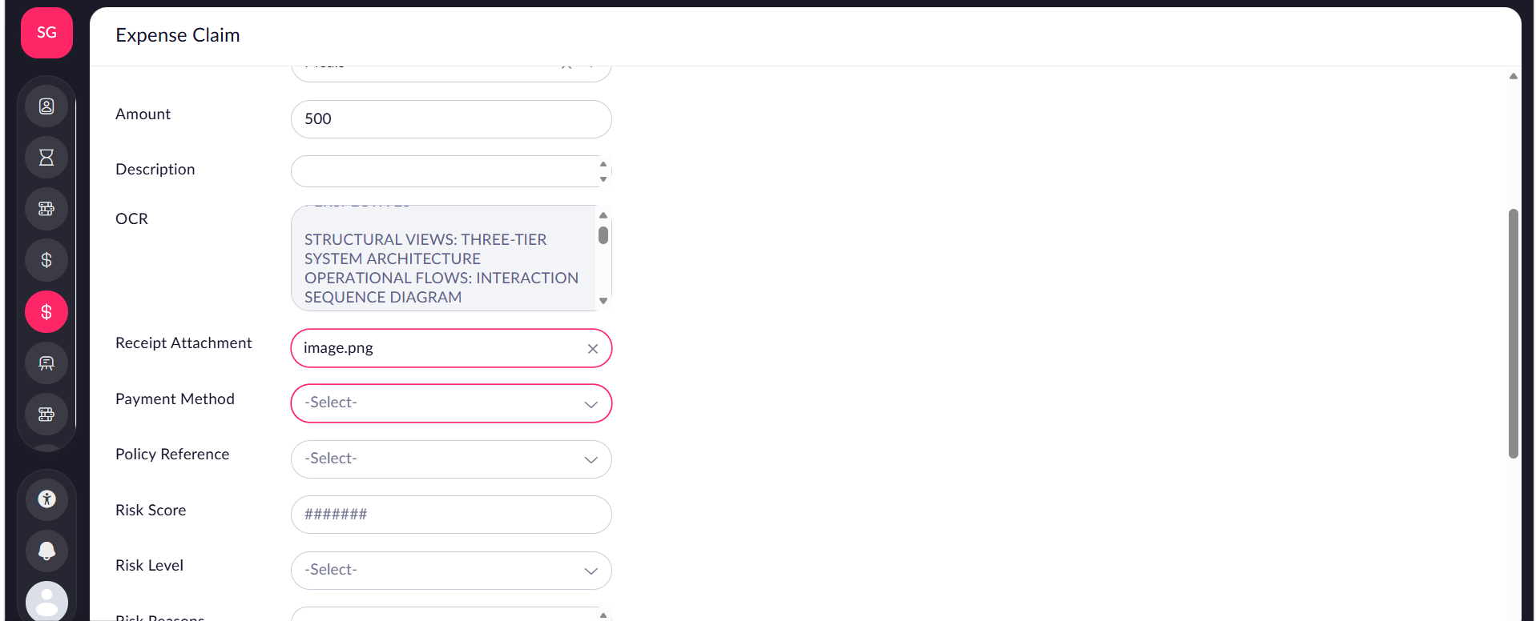
Figure 5.2: Expense Claim form with OCR field and receipt attachment
The Expense Policy form stores the rules that drive risk evaluation: policy name, category, maximum allowed amount, receipt-required flag, effective-from and effective-to dates, active status and the owning employee (Figure 5.3).
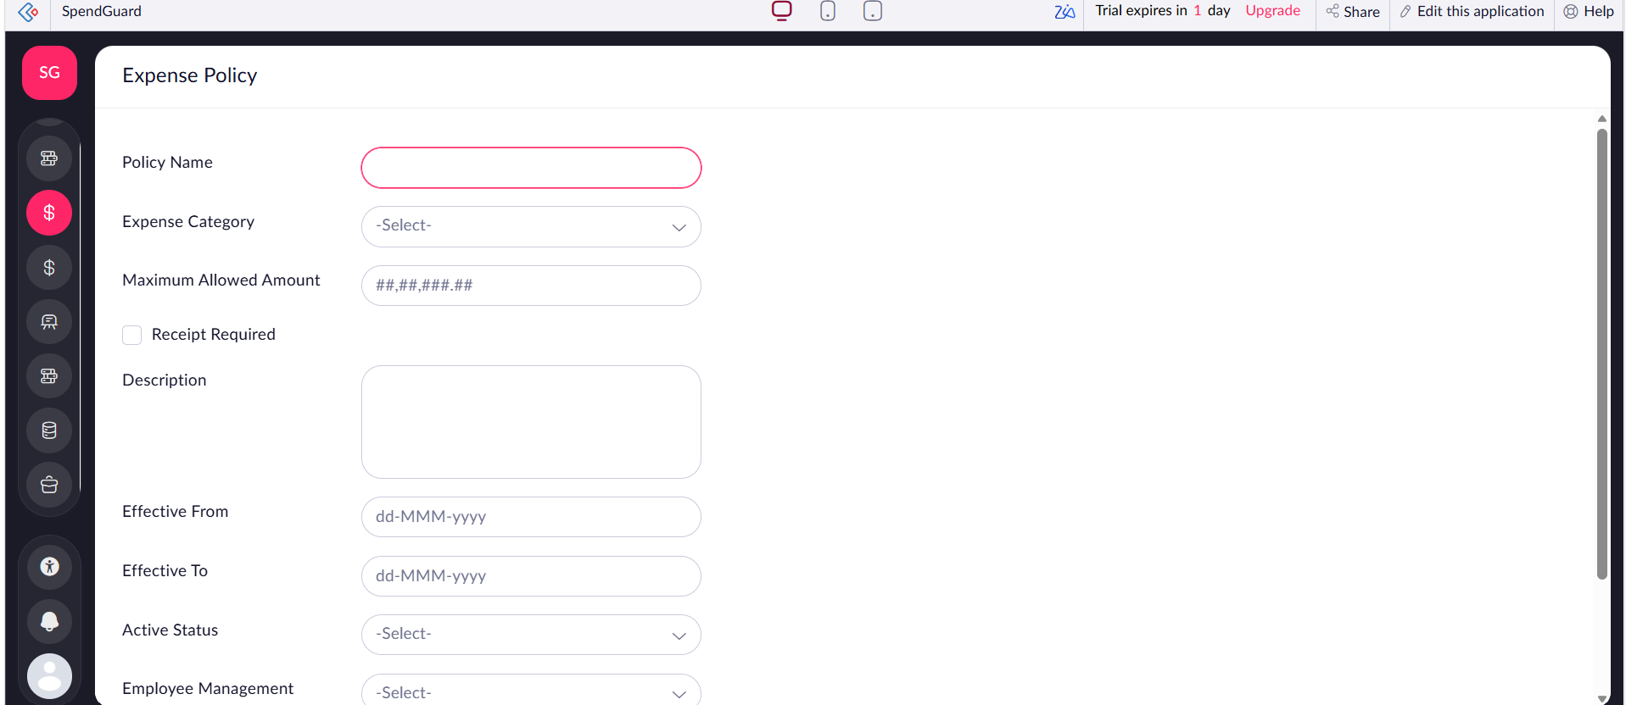
Figure 5.3: Expense Policy form

5.3 Reports
Seven list reports present the data of the seven forms. All Expense Claims is the main operational report: it is sorted by claim ID descending and colour-codes each Claim ID by risk level — green for Low, amber for Medium and red for High (Figure 5.4). All Department Management lists department codes, heads, annual budgets and status (Figure 5.5). All Claim Reviews shows each review decision, approved amount and remarks (Figure 5.6), and Audit Log Report shows the immutable history of every claim action (Figure 5.7). The three remaining list reports — All Employee Management, All Expense Policies and All Reimbursement Management — follow the same pattern.
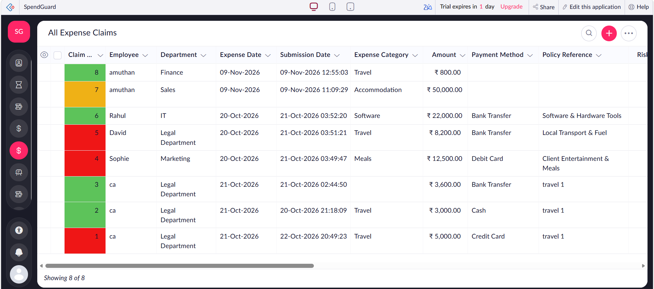
Figure 5.4: All Expense Claims list report with risk colour coding
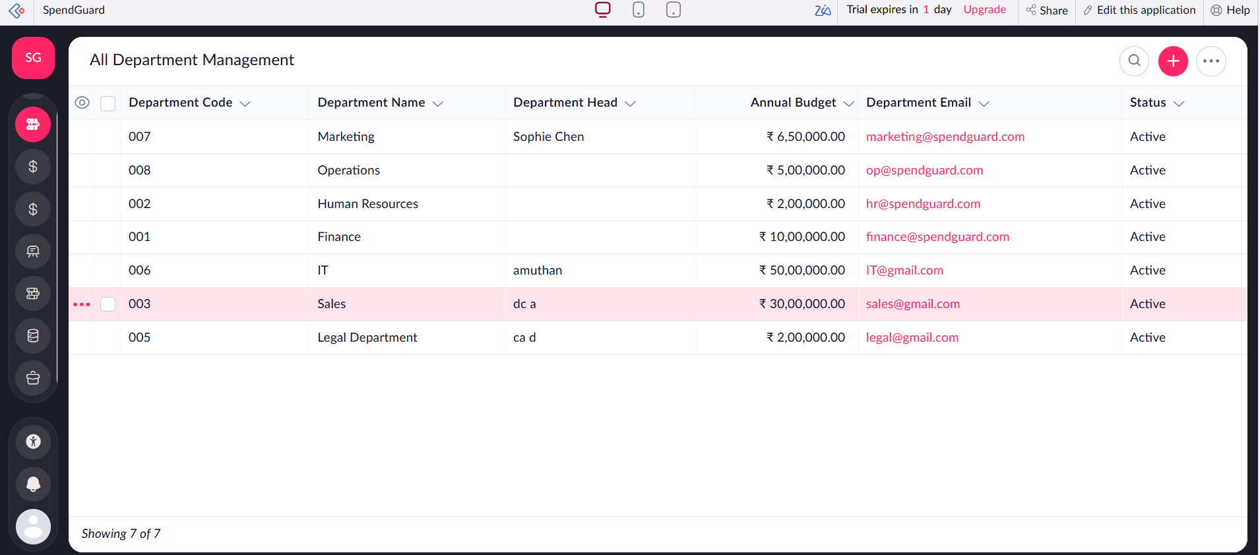
Figure 5.5: All Department Management report
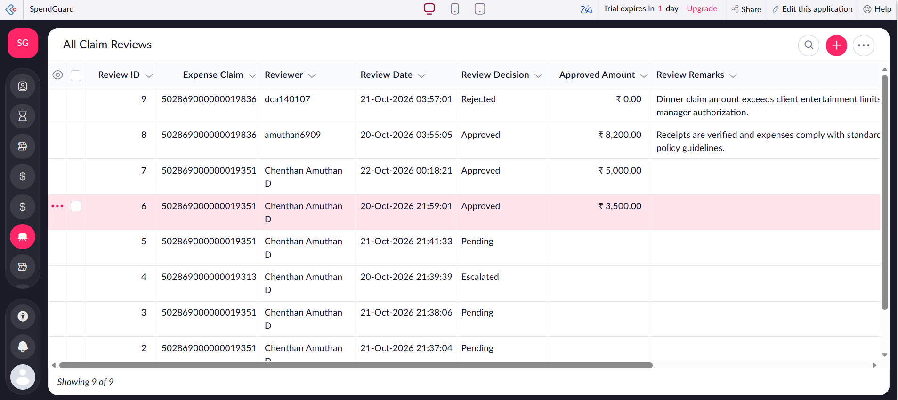
Figure 5.6: All Claim Reviews report
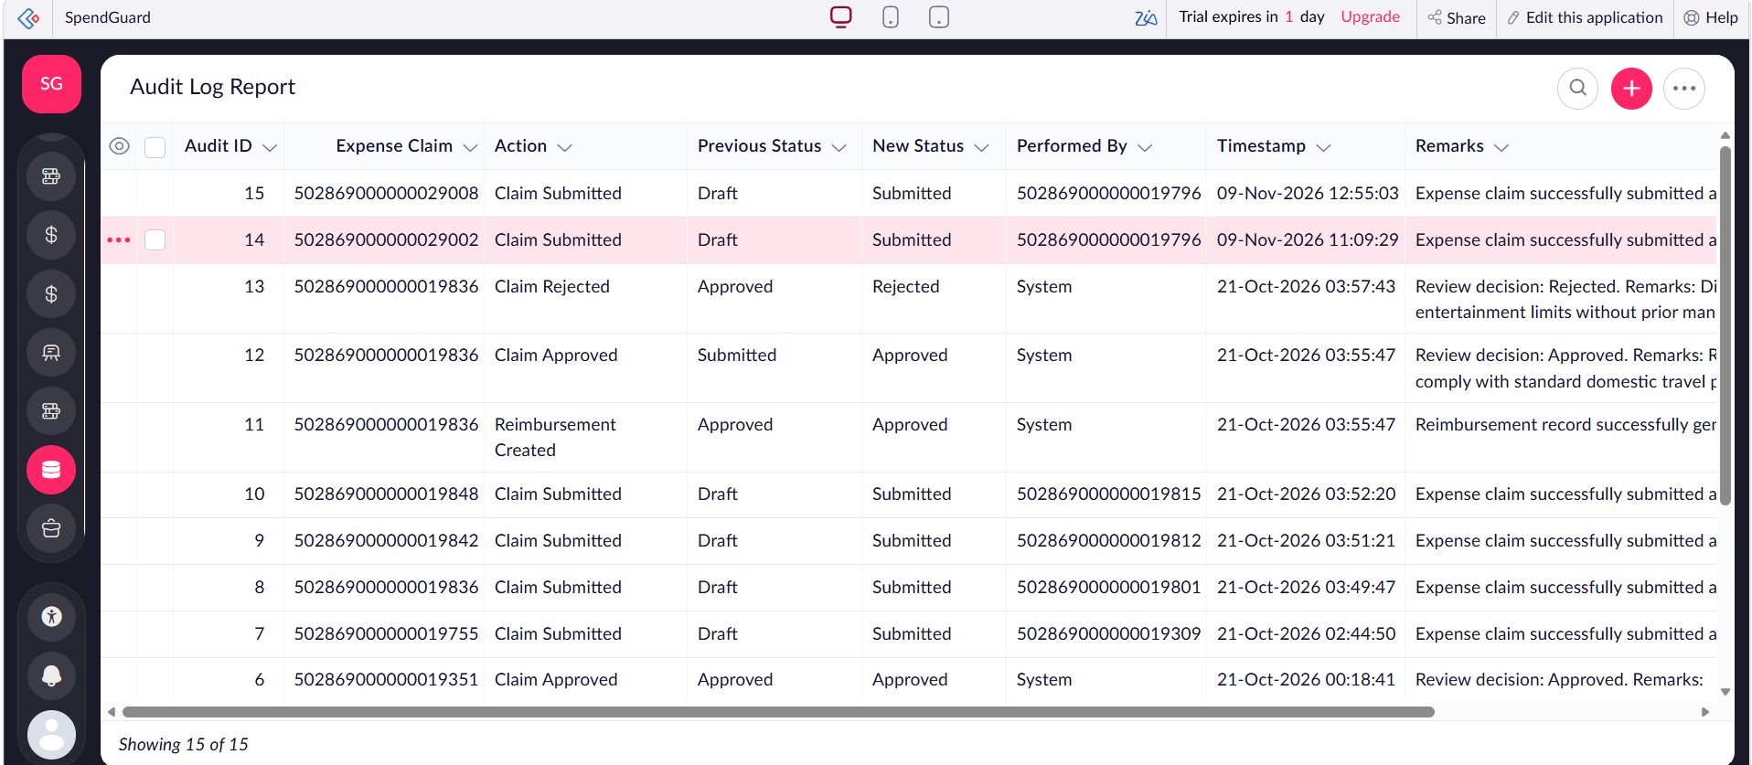
Figure 5.7: Audit Log Report

5.4 Pages and Dashboards
Two pages were built with the Creator UI builder. The SpendGuard Dashboard shows three KPI panels — Total Claims Submitted (8), High Risk Flagged Claims (3) and Pending Reimbursements (2) — together with an Expense Distribution by Category pie chart and a Claims Risk Profile bar chart (Figure 5.8). Its lower section shows risk-level counts (Low 4, Medium 1, High 3), the Total Amount Claimed of ₹1,05,100.00 and the High Risk Claims count (Figure 5.9). The Executive Dashboard adds a department-wise spend bar chart and a claim-status pie chart (Figure 5.10).
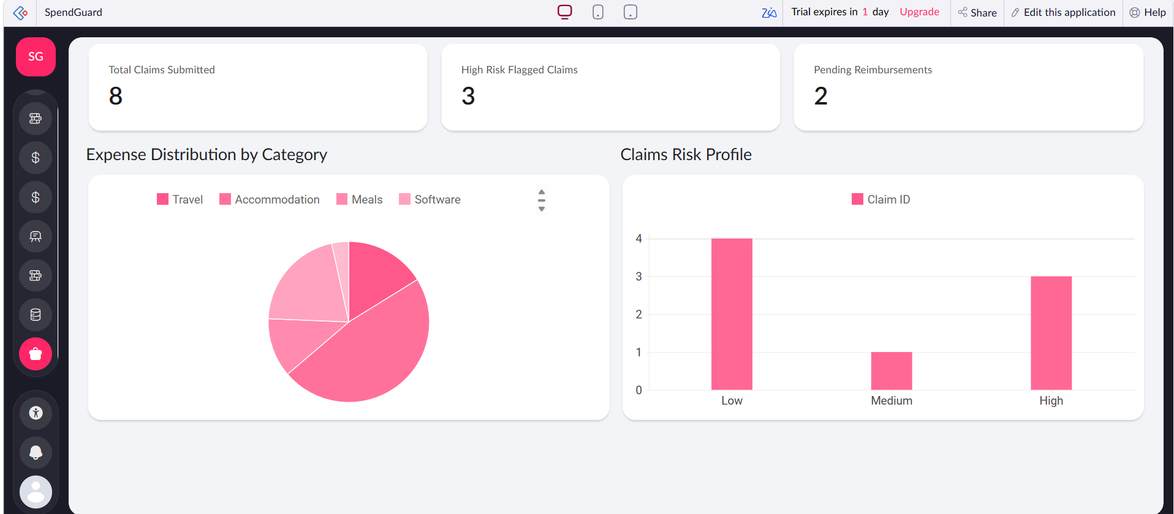
Figure 5.8: SpendGuard Dashboard KPI panels and charts
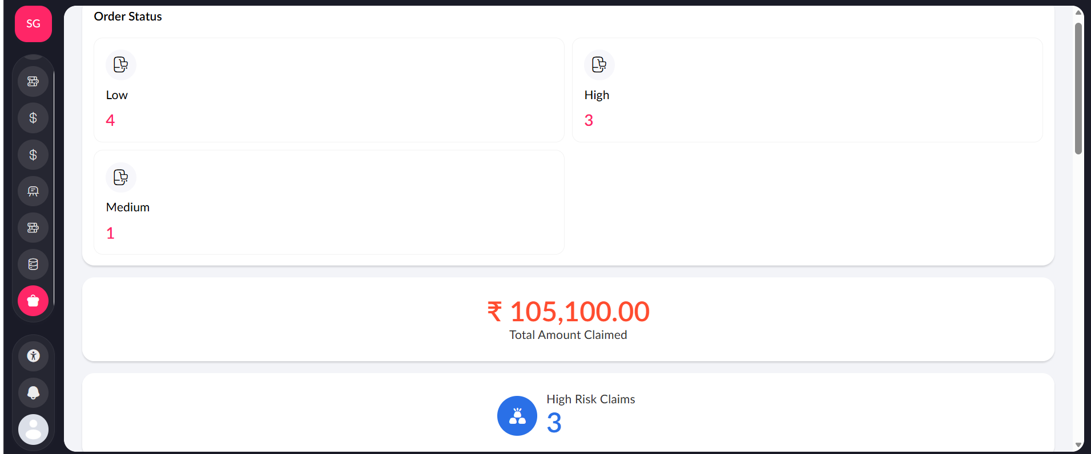
Figure 5.9: SpendGuard Dashboard risk counts and total amount claimed
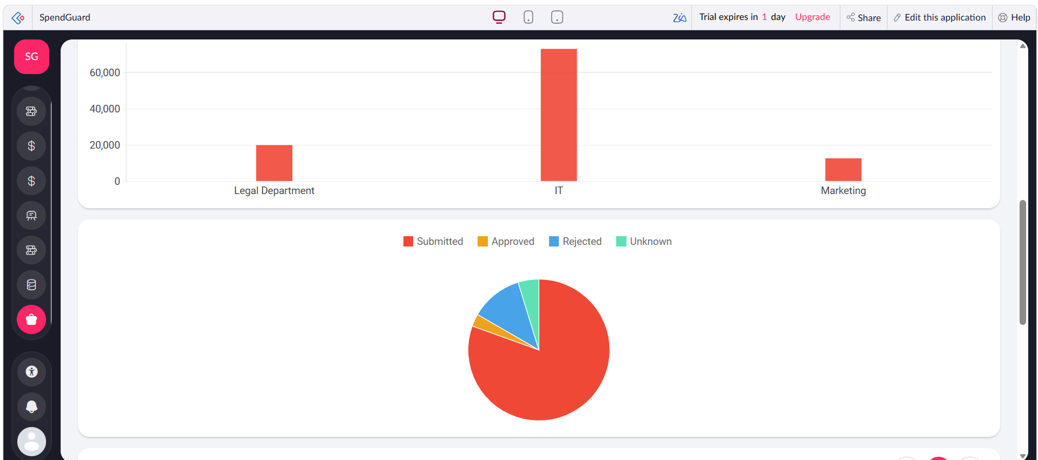
Figure 5.10: Executive Dashboard department spend and claim status charts

5.5 Deluge Scripting
Deluge scripts automate the business logic. Table 5.1 lists the scripts; the complete code is in Appendix C. The risk score is policy-driven: a claim above its policy’s maximum allowed amount is High risk, a claim with no policy reference above ₹10,000 is Medium, and all others are Low.
Table 5.1: Deluge scripts
ID | Location / Trigger | Purpose
DS-01 | Workflow: Calculate Risk Score (Created or Edited → successful submission) | Compute Risk Score, Risk Level and Risk Reasons
DS-02 | Workflow: Calculate Risk Score | Send alert email for Medium/High risk claims
DS-03 | Workflow: Initialize Claim and Audit Log (Created → successful submission) | Insert “Claim Submitted” audit-log entry

Code 5.1: Risk score calculation (DS-01)
pol = Expense_Policy[ID == input.Policy_Reference];
if(pol.count() > 0 && input.Amount > pol.Maximum_Allowed_Amount)
{
input.Risk_Score = 85; input.Risk_Level = "High";
input.Risk_Reasons = "Amount exceeds policy limit";
}
else if(pol.count() == 0 && input.Amount > 10000)
{
input.Risk_Score = 50; input.Risk_Level = "Medium";
input.Risk_Reasons = "No policy reference for high amount";
}
else
{
input.Risk_Score = 15; input.Risk_Level = "Low";
}

Code 5.2: High-risk alert (DS-02)
if(input.Risk_Score >= 50)
{
sendmail
[
from : zoho.adminuserid
to : "finance-alerts@spendguard.internal"
subject : "High Risk Expense Claim Alert: " + input.Claim_ID
message : "Claim by " + input.Employee + " for Rs." + input.Amount
]
}

5.6 Workflows and Automation
Table 5.2: Workflows
Workflow | Type / Trigger | Function
Initialize Claim and Audit Log | Form – on create, successful submission | Writes the first audit-log entry
Calculate Risk Score | Form – on create or edit, successful submission | Sets risk fields; sends alerts
Expense Claim Approval Process | Approval – on review | Sends approval request to reviewers; records approve/reject
Expense Claim Lifecycle | Blueprint – on form submission | Controls claim stage transitions
Process Review Decision and Reimbursement | Form – on create (Claim Review), successful submission | Updates claim status, creates reimbursement and audit entries
External Payout Webhook | Form – on create or edit, successful submission | Calls external payout endpoint (REST)
Weekly Pending Reimbursements Digest | Schedule – recurring, 09:00 | Emails digest of pending reimbursements

Reviewers receive in-app notifications for pending approval and transition actions (Figure 5.11). The approval page presents an Approval Summary and Approval History; claim 8 (₹800, Travel, Finance) was approved on 09-Nov-2026 (Figure 5.12), after which the claim appears under Completed Tasks (Figure 5.13).
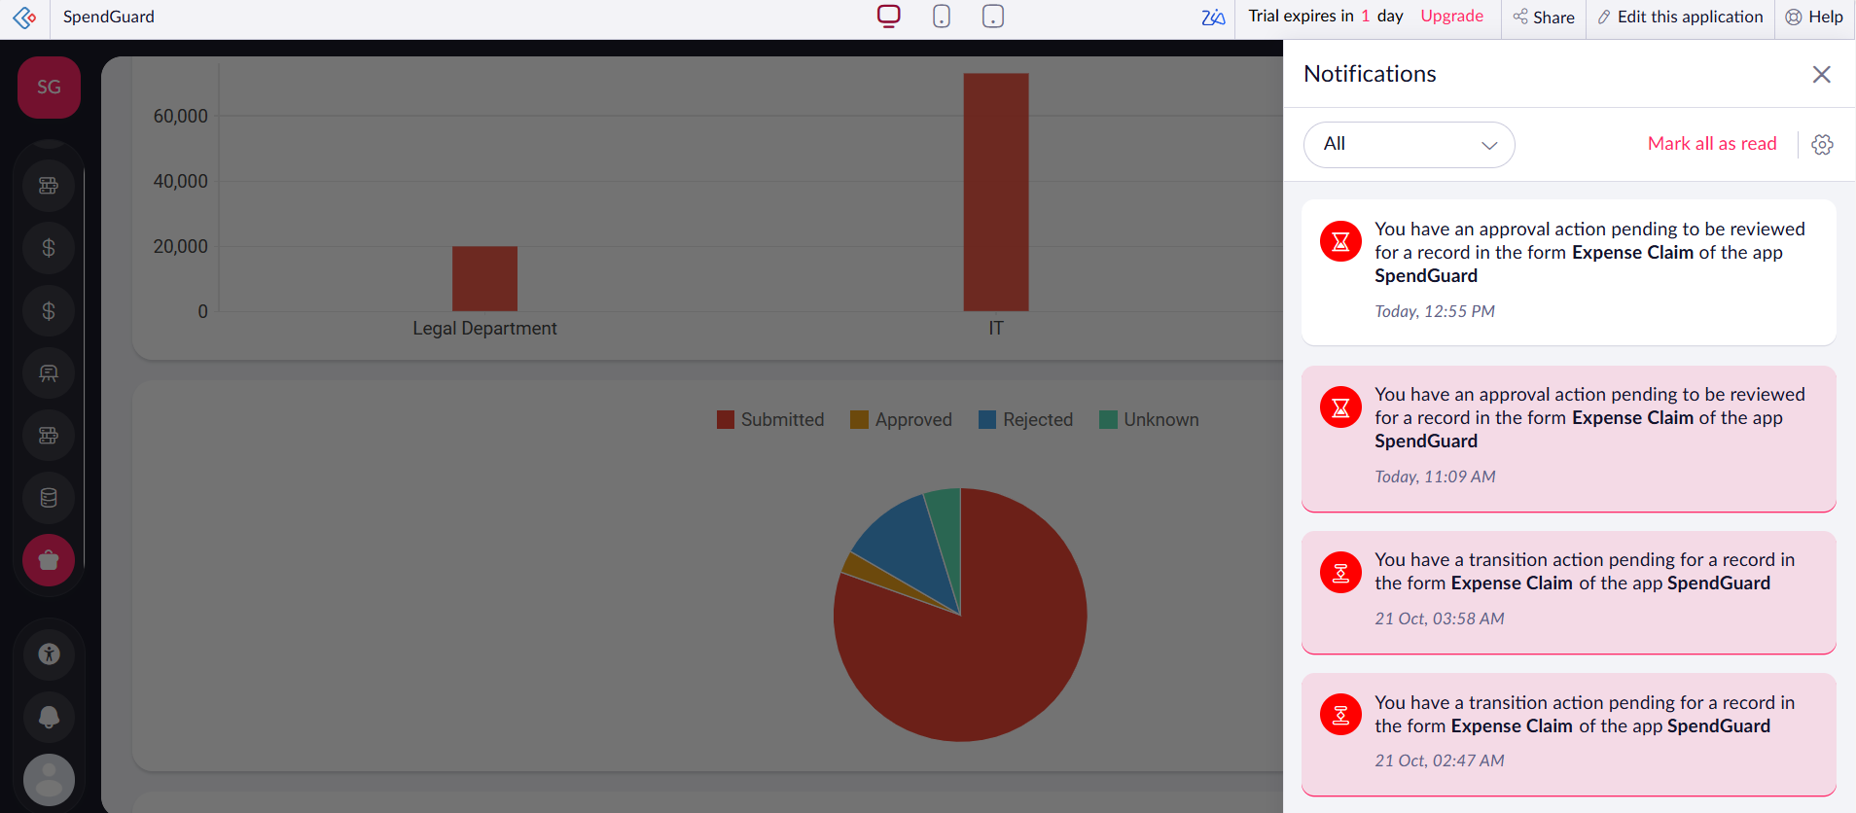
Figure 5.11: In-app notifications for pending approvals and transitions
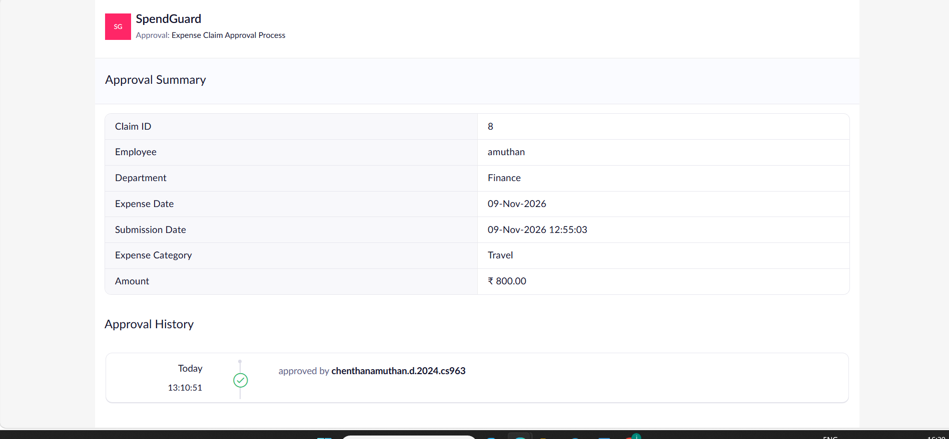
Figure 5.12: Approval summary and history for claim 8
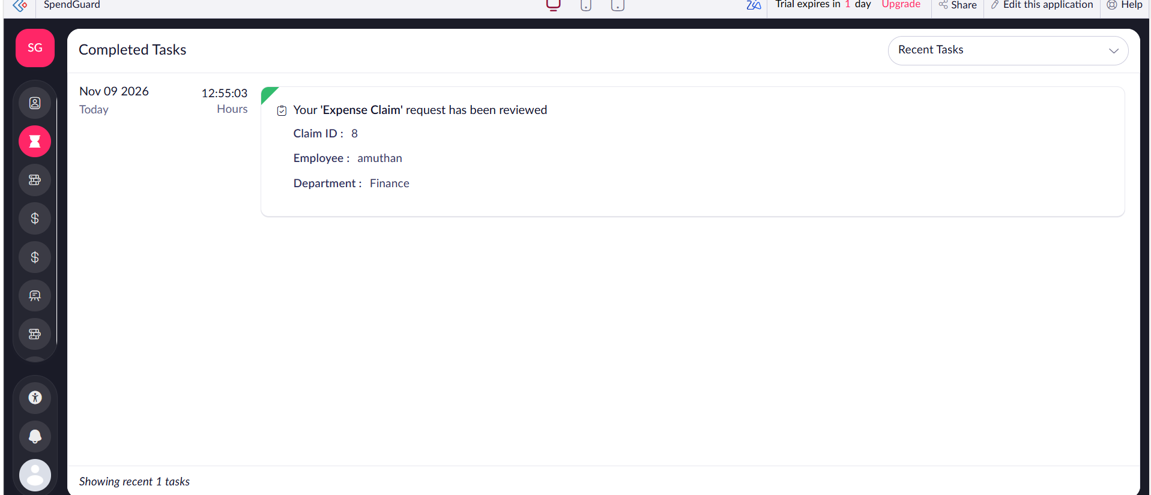
Figure 5.13: Completed Tasks view after review

5.7 Integrations
The Receipt Attachment field is mapped to Zoho Creator’s built-in AI OCR field, so receipt text is extracted without middleware (Figure 5.2). Alert and digest e-mails use Zoho Mail through the sendmail task. The External Payout Webhook workflow sends approved-claim data to an external REST endpoint so that a payment system can act on it.

5.8 User Management and Role-Based Access
Four roles and permission profiles were defined — Administrator, Finance Manager, Department Staff and Portal Auditor — according to the matrix in Table 4.4. Record-level criteria restrict staff to claims where the Employee is the logged-in user, and reviewers appear in the Claim Review report under their own accounts (Figure 5.6).

5.9 AI and Analytics Features
The Zia AI OCR field parses receipt images into text, reducing manual transcription (Figure 5.2). Analytics are provided by native Creator charts and KPI panels embedded in the two dashboards (Figures 5.8 to 5.10).

5.10 Pro-Code Extension
No Catalyst function or custom widget was developed. Every requirement was met with Deluge, workflows and built-in components, so extending beyond low-code was not justified for this scope. A candidate for future pro-code work is a widget for richer spend-forecast visualisation.

5.11 Mobile and Portal Access
Zoho Creator generates responsive layouts for desktop, tablet and phone from the same application, as indicated by the device selectors in every screenshot. Department staff and auditors use shared portal-user profiles with restricted permissions.
CHAPTER 6

TESTING AND DEBUGGING

6.1 Testing Strategy
Testing covered unit validation of form fields, integration testing of the Deluge scripts and workflows, role-based permission checks using multiple accounts, and user acceptance testing on the staged application.

6.2 Test Cases
Table 6.1: Test cases
TC ID | FR Ref. | Description | Input / Steps | Expected Result | Status
TC-01 | FR-01 | Submit valid claim | Fill mandatory fields, attach receipt | Record created (claim 8) | Pass
TC-02 | FR-02 | Claim above policy limit | Claim 1: ₹5,000 Travel under policy “travel 1” | Risk Level High (red) | Pass
TC-03 | FR-02 | Claim within policy limit | Claim 6: ₹22,000 Software | Risk Level Low (green) | Pass
TC-04 | FR-02 | High amount without policy | Claim 7: ₹50,000 Accommodation | Risk Level Medium (amber) | Pass
TC-05 | FR-03 | OCR extraction | Upload receipt image | OCR field populated | Pass
TC-06 | FR-04 | Approve claim | Approve claim 8 | Approval history updated, claim reviewed | Pass
TC-07 | FR-05 | Reject claim | Review decision Rejected | Approved amount ₹0.00; audit entry “Claim Rejected” | Pass
TC-08 | FR-05 | Audit trail | Submit and approve claim | Audit entries with previous and new status | Pass
TC-09 | NFR | Unauthorised access | Staff tries to edit global settings | Access blocked by RBAC | Pass

6.3 Debugging Deluge Scripts
The Deluge IDE console and info statements were used to trace variable values during workflow execution. Null-handling was added for claims with no policy reference, which previously caused empty lookups in the risk calculation.

6.4 Defect Log
Table 6.2: Defect log
ID | Defect | Cause | Resolution
D-01 | Risk calculation failed when no policy selected | Lookup value was null | Added count check before policy comparison
D-02 | Some claims show blank Category or Payment Method | Optional fields left empty in early test data | Made fields mandatory in the form
D-03 | Audit log showed no entry for rejections | Workflow condition covered approval only | Extended workflow to the Rejected decision

6.5 User Acceptance Testing
Users in the staff, manager and auditor roles tested claim submission, review and dashboards on the stage environment. They confirmed that the approval notification arrived promptly, that the dashboards matched the underlying records, and that the audit log gave a complete history.
CHAPTER 7

DEPLOYMENT, SECURITY AND GOVERNANCE

7.1 Environments and Deployment Strategy
Table 7.1: Environments
Environment | Purpose
Development | Build of forms, workflows, scripts and dashboards
Stage | UAT and defect remediation
Production | Final publication and live URL for evaluation (November 2026)

7.2 Performance Optimisation
Reports use targeted columns and the dashboards use aggregate (count and sum) components instead of fetching full record lists. With the current dataset all reports and dashboards load promptly; formal load testing at larger volumes remains future work.

7.3 Security Features
- Role-based access control through permission profiles.
- Record-level criteria so staff see only their own claims.
- Receipts stored in Zoho’s encrypted file storage.
- Zoho-hosted authentication and HTTPS access.

7.4 Governance and Administration
The Audit Log form records every claim action with previous and new status, actor and timestamp (Figure 5.7). Zoho Creator’s own audit trail records administrative changes and sign-ins.
CHAPTER 8

RESULTS AND DISCUSSION

8.1 Application Output
The deployed application captured eight claims totalling ₹1,05,100.00; four were rated Low risk, one Medium and three High (Figures 5.8 and 5.9). Reviews were recorded with decisions, approved amounts and remarks (Figure 5.6), and fifteen audit-log entries trace the lifecycle of the claims (Figure 5.7).

8.2 Achievement of Objectives
Table 8.1: Objectives versus outcome
Objective | Outcome
Relational data model and forms | Achieved – 7 linked forms
Automated risk scoring, workflows, notifications | Achieved – 7 workflows and Deluge scripts
Role-based dashboards and reports | Achieved – 7 reports, 2 dashboards
AI OCR integration | Achieved – OCR field on Expense Claim
Secure deployment | Achieved – RBAC, record-level criteria, environments

8.3 Comparison with the Existing System
Table 8.2: Existing versus SpendGuard
Aspect | Existing System | SpendGuard
Data entry | Manual, error-prone | Validated forms plus OCR
Policy enforcement | Manual handbook check | Automatic risk score against policy
Approval | Email replies | Approval process with notifications
Visibility | None in real time | Live KPI dashboards
Audit trail | Scattered emails | Central Audit Log

8.4 Limitations of the Low-Code Approach
- Platform dependency and trial/edition limits on records and features.
- Limited control over UI beyond the builder’s components.
- Complex logic is constrained by Deluge execution limits.
- Kanban, calendar and subform features were not used in this release.

8.5 Reflection on the No-Code → Low-Code → Pro-Code Spectrum
Forms, reports and dashboards were assembled with no-code tools. Business rules such as risk scoring and audit logging required low-code Deluge. No pro-code extension was needed, but the platform’s webhook and API support leave a clear path to it if requirements grow.
CHAPTER 9

CONCLUSION AND FUTURE ENHANCEMENTS

9.1 Conclusion
SpendGuard shows how low-code development on Zoho Creator can replace fragmented spreadsheets with a governed, automated and AI-assisted expense workflow. The application delivers policy-driven risk scoring, approvals, reimbursements, audit logging and live dashboards while keeping security and governance at enterprise standards.

9.2 Future Enhancements
- Integration with corporate credit-card feeds for automatic reconciliation.
- Predictive overspend forecasting with Zia.
- Kanban pipeline and calendar views for claim tracking.
- Subform line items for multi-item claims.
- ERP integration (SAP / Tally) and automated bank payouts.

9.3 Learning Outcomes and Career Relevance
The project gave hands-on experience of relational schema design, event-driven Deluge scripting, approval and blueprint workflows, dashboard design and environment-based deployment — skills directly relevant to solution-engineering and low-code developer roles.

REFERENCES

[1] W. Rosam and O. Kalnichevski, Low-Code Development: A Practical Guide. New Delhi, India: BPB Publications.
[2] Zoho Corporation, “Zoho Creator Help Documentation,” [Online]. Available: https://www.zoho.com/creator/help/
[3] Zoho Corporation, “Deluge Script Reference Guide,” [Online]. Available: https://www.zoho.com/deluge/
[4] Gartner, Inc., “Magic Quadrant for Enterprise Low-Code Application Platforms,” Gartner Research.

APPENDIX A – ZOHO CREATOR FEATURE COVERAGE CHECKLIST
Table A.1: Feature Coverage Checklist
Unit | Zoho Creator Feature | Done | Where in the Application | Section | Figure / Code
I | Application created & sections/menu organised | Y | Sidebar and global menu | 5.1 | Fig 5.1
II | Forms with ≥ 8 distinct field types | Y | Expense Claim form | 5.2 | Fig 5.2
II | Lookup field (relationship between forms) | Y | Employee, Department, Policy Reference | 4.2, 5.2 | Table 4.2
II | Subform (parent–child data) | N | Not used (see 8.4) | 4.2, 5.2 | –
II | Field validations / layout rules | Y | Amount, mandatory fields | 5.2 | Fig 5.2
II | List report with filter, grouping, custom action | Y | All Expense Claims | 5.3 | Fig 5.4
II | Kanban / Calendar / Timeline / Map report | N | Not used (see 8.4) | 5.3 | –
II | Pivot table / chart report | Y | Dashboard charts | 5.3 | Fig 5.8, 5.10
II | Page / dashboard built with UI Builder | Y | SpendGuard & Executive Dashboards | 5.4 | Fig 5.8–5.10
II | Deluge – form events (validate / success / field actions) | Y | Calculate Risk Score | 5.5 | Code 5.1
II | Deluge – functions, fetch, loops, collections | Y | Policy fetch in risk script | 5.5 | Code 5.1
II | Email / in-app notifications | Y | Alert mail; approval notifications | 5.5, 5.6 | Code 5.2, Fig 5.11
II | Form workflow | Y | Four form workflows | 5.6 | Table 5.2
II | Scheduled workflow | Y | Weekly Pending Reimbursements Digest | 5.6 | Table 5.2
II | Approval process | Y | Expense Claim Approval Process | 5.6 | Fig 5.12
II | Blueprint | Y | Expense Claim Lifecycle | 5.6 | Table 5.2
II | Batch / report workflow | N | Not used | 5.6 | –
II | Testing & debugging evidence | Y | Chapter 6 | 6 | Table 6.1
III | Integration with a Zoho service | Y | Zia OCR, Zoho Mail | 5.7 | Fig 5.2
III | Connection / REST API call (invokeurl) | Y | External Payout Webhook | 5.7 | Table 5.2
III | Webhook or Creator REST API | Y | External Payout Webhook | 5.7 | Table 5.2
III | Users, roles and permission profiles | Y | Four role profiles | 5.8 | Table 4.4
III | Record-level access criteria / customer portal | Y | Staff own-record criteria; portal users | 5.8 | Table 4.4
III | Zia / AI feature | Y | OCR field | 5.9 | Fig 5.2
III | Analytics (charts / Zoho Analytics) | Y | Native charts | 5.9 | Fig 5.8–5.10
IV | Performance optimisation applied & measured | N | Applied, not formally measured | 7.2 | –
IV | Deployment across environments | Y | Dev → Stage → Prod | 7.1 | Table 7.1
IV | Security controls (encryption, OAuth, permissions) | Y | RBAC, record-level criteria | 7.3 | –
IV | Governance (audit trail, administration) | Y | Audit Log form and report | 7.4 | Fig 5.7
V | Pro-code extension (Catalyst / widgets / custom functions) | N | Not used (see 5.10) | 5.10 | –
V | Low-code limitations & spectrum analysis | Y | Chapter 8 | 8.4, 8.5 | –
— | Mobile app / portal access | Y | Responsive views; portal users | 5.11 | –

Total features implemented: 27 / 32

APPENDIX B – COURSE OUTCOME MAPPING
Table B.1: Mapping of Course Outcomes to Report Chapters
CO | Course Outcome Statement | Evidenced In | Level
CO1 | Explain the principles, architecture and business value of low-code application development using Zoho Creator. | Ch. 1, 2 | 3
CO2 | Develop business applications using Zoho Creator forms, reports, workflows and Deluge scripting. | Ch. 4, 5 (5.1–5.6), 6 | 3
CO3 | Integrate Zoho Creator applications with Zoho services and external systems using APIs, connections and role-based security. | Ch. 4.6, 5.7–5.9 | 2
CO4 | Deploy, secure and manage Zoho Creator applications across environments following governance best practices. | Ch. 7 | 2
CO5 | Evaluate low-code strategies, AI-assisted development and the transition from citizen developer to professional developer. | Ch. 5.9, 5.10, 8.4, 8.5, 9.3 | 2

APPENDIX C – COMPLETE DELUGE SOURCE CODE
Note: DS-01 and DS-02 are reproduced from Chapter 5; DS-03 is given below.
C.1 Calculate Risk Score
// Script ID : DS-01
// Location : Workflow Calculate Risk Score (Created or Edited > Successful form submission)
// Purpose : Policy-driven risk score and level
pol = Expense_Policy[ID == input.Policy_Reference];
if(pol.count() > 0 && input.Amount > pol.Maximum_Allowed_Amount)
{
input.Risk_Score = 85; input.Risk_Level = "High";
input.Risk_Reasons = "Amount exceeds policy limit";
}
else if(pol.count() == 0 && input.Amount > 10000)
{
input.Risk_Score = 50; input.Risk_Level = "Medium";
input.Risk_Reasons = "No policy reference for high amount";
}
else
{
input.Risk_Score = 15; input.Risk_Level = "Low";
}

C.2 High-Risk Alert
// Script ID : DS-02
// Location : Workflow Calculate Risk Score
// Purpose : Email alert for Medium/High risk claims
if(input.Risk_Score >= 50)
{
sendmail
[
from : zoho.adminuserid
to : "finance-alerts@spendguard.internal"
subject : "High Risk Expense Claim Alert: " + input.Claim_ID
message : "Claim by " + input.Employee + " for Rs." + input.Amount
]
}

C.3 Initialize Claim and Audit Log
// Script ID : DS-03
// Location : Workflow Initialize Claim and Audit Log (Created > Successful form submission)
// Purpose : Write the first audit-log entry for a new claim
insert into Audit_Log
[
Expense_Claim = input.ID
Action = "Claim Submitted"
Previous_Status = "Draft"
New_Status = "Submitted"
Performed_By = zoho.loginuser
Timestamp = zoho.currenttime
Remarks = "Expense claim successfully submitted"
Added_User = zoho.loginuser
];

APPENDIX D – USER MANUAL

D.1 Accessing the Application
Open https://creatorapp.zoho.in/dcamuthan123/spendguard and sign in with the role-specific account. The SpendGuard Dashboard opens first.

D.2 Instructions for Department Staff
- Open the Expense Claim form from the sidebar and select the category, amount, payment method and policy reference.
- Attach the receipt; the OCR field fills automatically.
- Submit and track the status in All Expense Claims.

D.3 Instructions for Finance Manager
- Open the approval notification or the Claim Review form for a pending claim.
- Check the risk level, OCR text and receipt, then approve or reject with remarks.
- Monitor the dashboards and the Audit Log Report.

D.4 Instructions for Administrator
- Maintain Expense Policy, Department Management and Employee Management records.
- Manage users, role profiles and review the audit logs.

D.5 Instructions for Auditor
- Open the Audit Log Report and filter by claim, user or date to trace every status change.
- Review high-risk claims and the Claim Review decisions; auditors have read-only access and cannot edit records.

D.6 Troubleshooting
- If a form or report is not visible, confirm the user is assigned the correct role profile with the Administrator.
- If OCR text is empty, re-upload a clear image or PDF of the receipt (JPG, PNG or PDF) and resubmit.
- If a reviewer does not receive the approval notification, check the Claim Review queue and the user’s e-mail address in Employee Management.

APPENDIX E – EVALUATION RUBRIC
(For Examiner Use Only)
Student Name | CHENTHAN AMUTHAN D | Register No. | 2116240701090
Project Title | SpendGuard: Enterprise Expense Policy and Claim Management Application | Date | 10/11/2026

Table E.1: Evaluation Rubric for the Individual Project
S.No. | Criterion | Indicators | Max. Marks | Marks Awarded
1 | Problem Definition & Requirement Analysis | Clarity of problem, measurable objectives, complete FR/NFR, use cases | 10
2 | System Design | Architecture, ER/data model, form specifications, workflow design, permission matrix | 10
3 | Forms, Reports & Pages | Variety of field types, lookups/subforms, report types, UI Builder dashboards | 15
4 | Deluge Scripting & Workflows | Correctness and depth of scripts; form, schedule, approval, Blueprint, batch workflows | 15
5 | Integration, RBAC & AI | Zoho/external integrations, connections, roles & permissions, Zia/analytics | 10
6 | Testing, Deployment, Security & Governance | Test coverage, environments, optimisation, security controls, audit | 10
7 | Live Demonstration | End-to-end working of the application across roles; feature checklist verified | 15
8 | Project Report | Adherence to template and format, clarity, figures, references | 5
9 | Viva-Voce | Understanding of the platform, design decisions and low-code concepts | 10
 | TOTAL |  | 100

Table E.2: Performance Level Descriptors
Level | % of Max. Marks | Descriptor
Excellent | 90–100 | Feature implemented completely, correctly and beyond the basic requirement; student explains design choices confidently.
Good | 70–89 | Feature implemented correctly with minor gaps; explanation adequate.
Satisfactory | 50–69 | Feature partially implemented or works only for the main path; limited explanation.
Needs Improvement | < 50 | Feature missing, non-functional or not understood by the student.

Signature of Internal Examiner  Name: ____________________ | Signature of External Examiner  Name: ____________________

APPENDIX F – VIVA-VOCE RECORD SHEET
(For Examiner Use Only)
Student Name | CHENTHAN AMUTHAN D | Register No. | 2116240701090
Department / Section | Computer Science and Engineering | Date of Viva | 10/11/2026
Application URL Verified | Yes / No | Demo Duration | ______ min
Table F.1: Viva-Voce Questions and Responses
Q.No. | Question / Topic Asked | Unit | Response (E / G / S / NI) | Remarks
1
2
3
4
5
6
7
8
E – Excellent G – Good S – Satisfactory NI – Needs Improvement
Table F.2: Marks Summary
Component | Max. Marks | Marks Awarded
Criteria 1–8 (Appendix E) | 90
Viva-Voce | 10
TOTAL | 100

Examiners’ Remarks:
____________________________________________________________________
____________________________________________________________________
INTERNAL EXAMINER  Name: ____________________ | EXTERNAL EXAMINER  Name: ____________________

