CPE301 – SPRING 2019

MIDTERM 1

Student Name: Tian Chen

Student #: 2001086575

Student Email: chent5@unlv.nevada.edu

Primary Github address: <https://github.com/Chentian12138/AAAABBBBB>

Directory: Midterm

Submit the following for all Labs:

1. In the document, for each task submit the modified or included code (only) with highlights and justifications of the modifications. Also, include the comments.
2. Use the previously create a Github repository with a random name (no CPE/301, Lastname, Firstname). Place all labs under the root folder ESD301/Midterm, sub-folder named LABXX, with one document and one video link file for each lab, place modified asm/c files named as LabXX-TYY.asm/c.
3. If multiple asm/c files or other libraries are used, create a folder LabXX-TYY and place these files inside the folder.
4. The folder should have a) Word document (see template), b) source code file(s) and other include files, c) text file with youtube video links (see template).

1. **COMPONENTS LIST AND CONNECTION BLOCK DIAGRAM w/ PINS**

We are using the atmega328p , lm35 sensor and the esp8266 module.

1. **INITIAL/MODIFIED/DEVELOPED CODE OF TASK 1/A**

/*

* main.c

* Author : chent

*/

#define *F_CPU* 16000000UL // MCU operating Frequency

#define BAUD 9600 // Baudrate setting

#define BAUD_PRESCALLER *F_CPU*/16/BAUD-1 // Baudrate prescaller

#include <avr/io.h>

#include <util/delay.h>

#include <stdio.h>

#include <avr/interrupt.h>

#include <stdlib.h>

void read_adc(void); //Read temp with the LM35 using ADC

void adc_init(void); // Initialize ADC

void USART_init( unsigned int ubrr ); // Initialize USART communication

void USART_tx_string(char *data); //sending string through usart

volatile unsigned int adc_temp; // raw temp value from adc

volatile unsigned int tempF; // convert to fahrenheit

volatile unsigned int tempC; // convert to celsius

char outs[256]; // out for sending USART commands

volatile char received_data; // String for receiving USART communication

int main(void) {

adc_init(); // Initialize Analog to Digital Converter on PC4

USART_init(BAUD_PRESCALLER); // Initialize the USART

*_delay_ms*(500); // Delay to sync all the commuication

while(1)

{

//AT connect check

unsigned char AT[] = "AT\r\n"; //Set device mode

unsigned char AT_CWMODE[] = "AT+CWMODE=1\r\n"; //set the ssid and password

unsigned char AT_CWJAP[] = "AT+CWJAP=\"4CD534UITRCD\",\"password\"\r\n"; //Set device for single IP Address Mode

unsigned char AT_CIPMUX[] = "AT+CIPMUX=0\r\n"; //start commuication and the port will be 80

unsigned char AT_CIPSTART[] = "AT+CIPSTART=\"TCP\",\"api.thingspeak.com\",80\r\n"; //set the string length

unsigned char AT_CIPSEND[] = "AT+CIPSEND=100\r\n";

// set up the commuication from the esp 8266 to the router

*_delay_ms*(200);

USART_tx_string(AT);

*_delay_ms*(5000);

USART_tx_string(AT_CWMODE);

*_delay_ms*(5000);

USART_tx_string(AT_CWJAP);

*_delay_ms*(15000);

USART_tx_string(AT_CIPMUX);

*_delay_ms*(10000);

USART_tx_string(AT_CIPSTART);

*_delay_ms*(10000);

USART_tx_string(AT_CIPSEND);

*_delay_ms*(5000);

PORTC^=(1<<5); // port pc2 open

read_adc(); //read from adc

adc_temp = (adc_temp*500)/1023; //calc the temp variable from the raw data

tempC = adc_temp; // C value

tempF = (tempC*1.8)+32; // F value

*snprintf*(outs,sizeof(outs),"GET https://api.thingspeak.com/update?api_key=S7S1IV6H0B04TYPP&field1=%3d\r\n", tempF); // this is the api key

USART_tx_string(outs); //send data

*_delay_ms*(10000);

}

}

void adc_init(void) //initialize ADC

{

ADMUX = (0<<REFS1)| // Reference Selection Bits

(1<<REFS0)| // AVcc - external cap at AREF

(0<<ADLAR)| // ADC Left Adjust Result

(1<<MUX2)| // Analog Channel Selection Bits

(0<<MUX1)| // ADC2 (PC2 PIN25)

(0<<MUX0); // 010

ADCSRA = (1<<ADEN)| // ADC ENable

(0<<ADSC)| // ADC Start Conversion

(0<<ADATE)| // ADC Auto Trigger Enable

(0<<ADIF)| // ADC Interrupt Flag

(0<<ADIE)| // ADC Interrupt Enable

(1<<ADPS2)| // ADC Prescaler Select Bits

(0<<ADPS1)|

(1<<ADPS0);

}

void read_adc(void) {

unsigned char i =4;

adc_temp = 0; //initialize adc_temp variable

while (i--) {

ADCSRA |= (1<<ADSC);

while(ADCSRA & (1<<ADSC));

adc_temp+= ADC;

*_delay_ms*(50);

}

adc_temp = adc_temp / 4; // Average a few samples

}

void USART_init( unsigned int ubrr ) {

UBRR0H = (unsigned char)(ubrr>>8);

UBRR0L = (unsigned char)ubrr;

UCSR0B |= (1 << TXEN0) | (1 << RXEN0)| ( 1 << RXCIE0); // Enable receiver, transmitter & RX interrupt

UCSR0C |= (1<<UCSZ01) | (1 << UCSZ00);

}

void USART_tx_string( char *data ) {

while ((*data != '\0')) {

while (!(UCSR0A & (1 <<UDRE0)));

UDR0 = *data;

data++;

}

}

1. **SCHEMATICS**

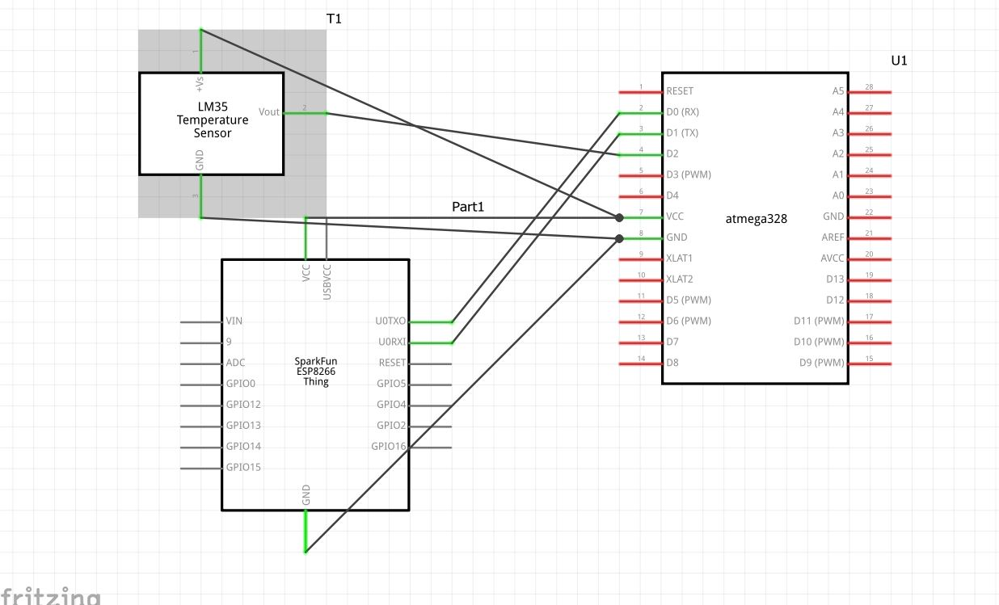

1. **SCREENSHOTS OF EACH TASK OUTPUT (ATMEL STUDIO OUTPUT)**

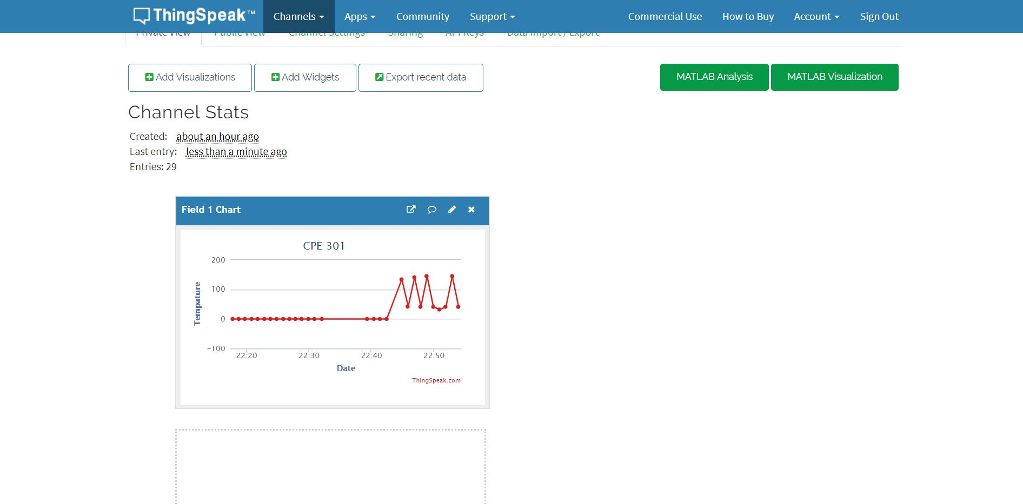

1. **SCREENSHOT OF EACH DEMO (BOARD SETUP)**

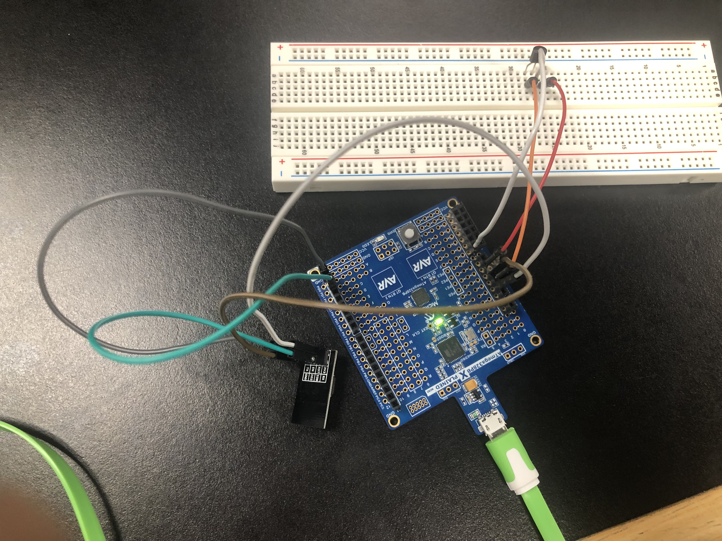

1. **GITHUB LINK OF THIS DA**

<https://github.com/Chentian12138/AAAABBBBB>

**Student Academic Misconduct Policy**

<http://studentconduct.unlv.edu/misconduct/policy.html>

“This assignment submission is my own, original work”.

NAME OF THE STUDENT