https://www.materialpalette.com/cyan/red

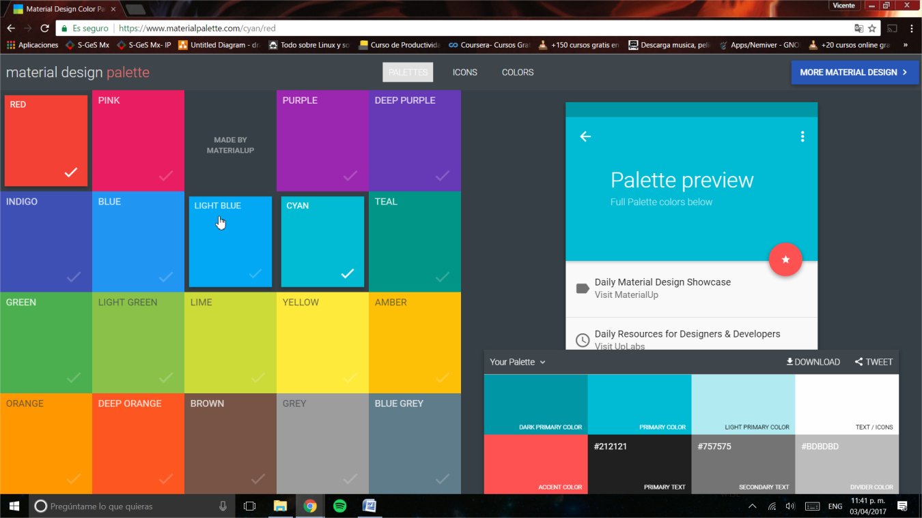

1. Identifica los colores:

* Primary color #03A9F4
* Dark Primary Color: #0288D1
* Accent Color: #FF5252

Proyecto

