Student number -
100181153
Course -
U1027147001 BEng (Hons) Software Engineering (Saegis)

The project is based on a closed system, an AI-assisted, gesture-controlled lighting interface for smart homes. As well as a smart home spreading its reach and touchless interface becoming more common. Gesture-based designs become highly topical, especially in terms of accessibility. The prototype system develops an interface for 3D gesture recognition that enables the control of lighting intensity and color through simple gestures of the user’s hand.

Closed system

The closed system, in terms of human-computer interaction, with a system that is self-contained and has defined boundaries in terms of interaction. The smart home lighting system interface based on gesture can be treated as a closed system because this system only relies upon a predefined number of gestures in swiping up or swiping down, that order to change the intensity of the light, swiping from left or right to change the color temperature of the light, and performing the push action to change the status of the light from off to on or from to off. So that performing each action movement the same result.
This makes the system better suited to academic research, and it excludes factors that could increase the complexity in testing and enables detailed analysis based on users' performance and understanding of gestures in this system. So, this system is academically relevant for several reasons,
- 2D and 3D HCI principles
This system enables the analysis of essential ideas in the realm of human-computer interaction in a controlled setting, and that focuses especially on new ideas currently being developed in 2D and 3D interaction areas. For example, the problem of spatial mapping, for instance, forms the backbone of ensuring that the motion of gestures corresponds appropriately to the system responses. The issue of accuracy and tolerance levels in gesture, and the capacity of the system to correctly interpret expression recognition. So, the concept of embodied interaction or the uses of the body in interaction should be appropriately developed in this system because users would be using gestures in the form of hand actions, compared with clicking or pressing.
- Post-WIMP interaction
The trend in interactive system evaluation has seen the move away from the conventional WIMP interfaces paradigm towards more natural forms of interaction in any users control the technology expressions. The gesture-controlled system key in this aspect is that the key reflects the humans interact with the world. Instead of clicking the mouse to raise the screen brightness, simply make use of the natural upward motion of one’s hand in this aspect. So, this can be attributed to the current research in the world of human-computer interactions. There is more emphasis being placed upon creating seamless and effortless interaction in this aspect. So, AR and VR spatial computing are gaining popularity in the tech world.
- Smart-Home Growth
The home automation industry is growing rapidly, and one of the most automated functions in smart homes would be home lighting. Such as devices being networked in households in the future. There would be a very high demand for more effective and accessible methods of controlling devices in those households. The expressions control would address any needs and requirements in this area because the system would be applicable and accessible to mobility-impaired individuals in the household and would not require the use of hands or touch-sensitive panels.
- Natural User Interface
Natural user interfaces are developed in users can interact with digital technologies in more natural and intuitive ways that are more in sync with real-world human behaviors. Unlike traditional interfaces that only support keyboard, button, or touch inputs. Natural users act out gestures in motion. Voice commands, or presence. The smart home lighting system based on gestures embodies the idea natural user interface in that users can control the system through hand gestures that mimic real-world physical actions, like putting out one’s hand to increase the intensity or moving one’s hand toward the system to switch the light ON. The case study gives information about the role of natural user interface in improving accessibility in different technologies and various ways users can interact with different technologies in the future through smooth human-technology interfaces.

Heuristic System
The heuristic model is built to mesh with nature. It designs the system around thinking patterns, everyday physical actions, and expectations. So, each heuristic aims to reduce the mental and physical effort needed to interact, so gestures feel second nature rather than forced. Spatial mapping helps to sense of space making movements line up, with the system will do next, easing mental load and avoiding confusion. Error tolerance recognizes natural human variability no two gesture are the system recognizes a range of motions rather than requiring attention to physical comfort, so, those people fatigue doing repeated arm gesture, then all together these heuristics make for an interaction that feels like it is working with not against more intuitive, more comfortable and cognitively more effortless.

Heuristic System – Wireframe

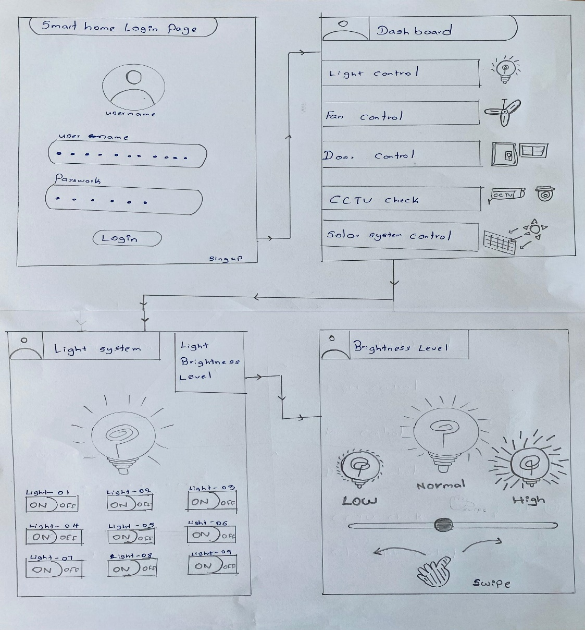
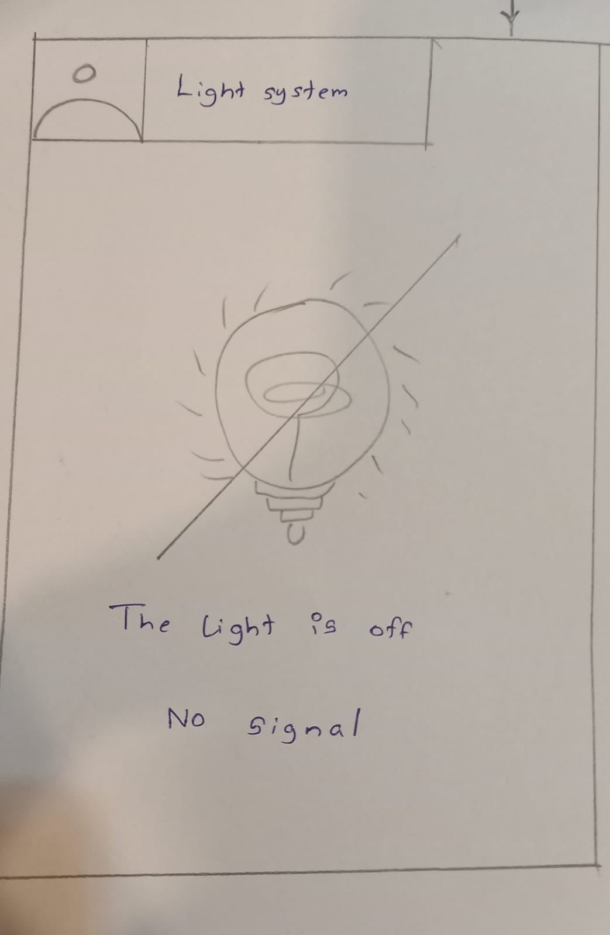

Prototype – Figma Design

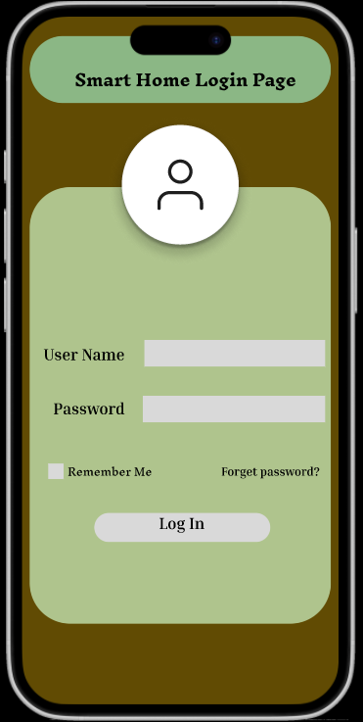

This is the prototype that starts from the login screen, acting as the entry point to the entry point to the entire smart home system. Upon the opening of the application, the user is directly introduced to the simple interface, requiring the input of the username and password. The design of the interface has a positive effect on the users because, despite the first-time experience with the system, the users will be aware of the initial action to undertake in the application, so if it’s a smart home application. The input of the details, followed by the login action, triggers the login process, and the system proceeds to the next interface in the design of the prototype.

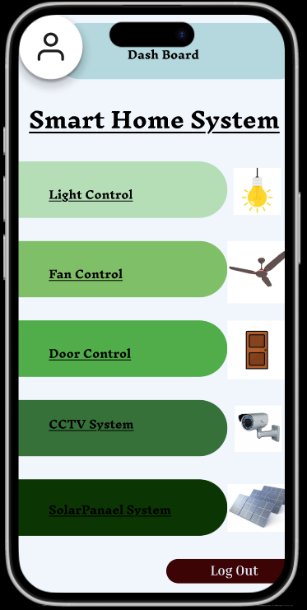

After the username and password are input, and subsequently, the user can access the dashboard page, the control center for the entire functionality of intelligent home components. The design of the dashboard page is meant to be organized, and the application is represented using icons and labels ranging from light bulbs to fans, doors, systems, CCTV cameras, and solar panel systems. The purpose of the entire design is to provide the user with an insight into the entire system, enabling the user to easily identify the component to be controlled through the system. The design will be the first interface the user interacts with at any time that wants to control a different component through the application in an actual software application development.

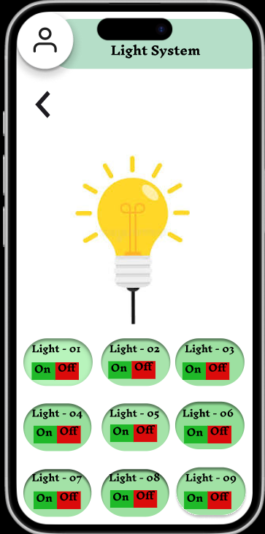

Then, after clicking the icon associated with lighting to the light control system page. The design of this page is limited to light function only, and it is quite simple and easier to understand. The typical icons associated with this light function are the bulb and level to adjust the intensity and turn the light off and on. So, depending on the status of the bulb, it gives a clear message to the user in the lighting control section of the smart home. The design of this interface is simple and clear, and will be easily understood by a non-tech-savvy person to operate the system.
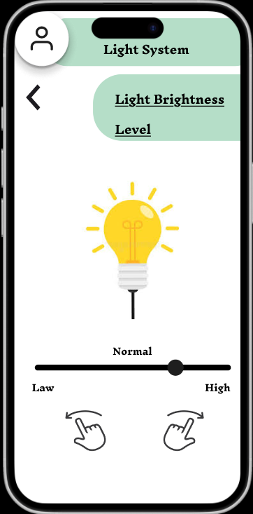

On the light control page, the user can access the brightness adjustment functionality. The prototype has various levels of light intensity, such as low, normal, and high. The appearance of the bulb changes to be brighter or dimmer depending on the choice of the light intensity level. For instance, the bulb illustration changes to be brighter or dimmer depending on the light intensity level. The user experience of the application will be responsive to their interactions in the final application design.
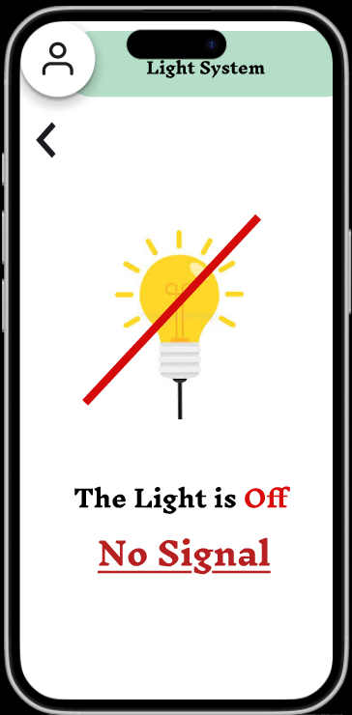

When the light is unplugged, turned off, or simply doesn’t work, the " Off / No Signal” screen will appear for the user. This aspect of the project is quite important because it reflects possible problems that occur in smart devices. That instead of leaving the user in the dark, the message clearly conveys to the user that there has been a loss of communication with the light. This feature is crucial in applications because users should be informed if their messages have been received or if there has been a problem.
The user also has the option to exit and log out of the light control page should press the Back arrow in the top corner of the screen. The user will be able to navigate back to the dashboard and then decide to control another system or simply quit the application allows the users to navigate through the application in a manner described and demonstrates the significance of providing the users with complete control of the movements in the application. The application has a clear flow and demonstrates a functional application in its basic form because it is efficient in its transition to the pages. The above flow clearly shows the manner in which a functional Smart home interface will function in its day-to-day operations.
Analysis of findings
The result shows gesture-based lighting control system usability and effectiveness gesture mapping are according with human behavior patterns. This is aligned with the action model theory in Norman. A reduced (gulf of execution) factor resulting from intuitive mapping enhances usability. Error occurrences related to gestures lacking clear boundaries support the guideline on Nielsen.
This is needed for enhanced visual feedback stems from the fact that the associated literature has found gesture interface to need explicit confirmation because of the absence of touch cues. The gesture performed well in short tasks requiring prolonged effort.

Feedback analysis

- Google form analysis-
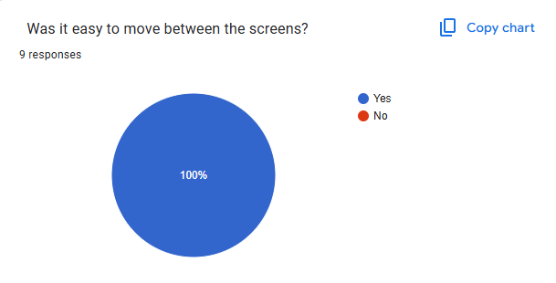
The result of the feedback form is that the entire group of participants 100% found it easy to navigate through the pages in the interface of the smart home system. The fact that there is no negative response to this question shows that the users didn’t find it difficult to navigate through the various pages of the system, and the design of the interface in terms of its structure and functionality is effective and able to provide the users with a smooth experience in the system.

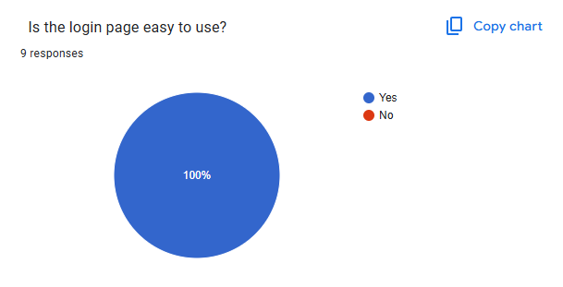

It means that each participant agreed that the login page is user-friendly. Indeed, the fact that the result is supportive implies that the designers of the login interface took into consideration the usability guidelines to make the users feel comfortable and complete the login process effortlessly and with confidence. The fact that users can easily point out to center their login details and continue implies that the login interface is free from complexities and allows the user to complete the login process quickly and effectively.

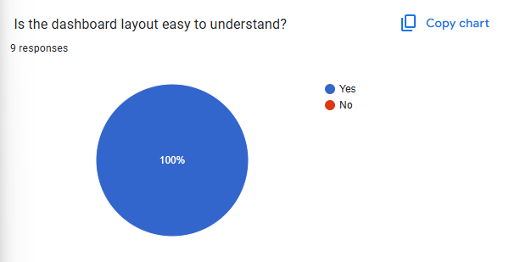
This full positive response shows that the users were able to promptly understand the information delivered through the dashboard design without any confusion or doubts. The placement of icons, labels, and controls in the design appears to be intuitive, implying that the users can show the important elements in that design, such as device control, system status, and navigation, quite easily. The fact non-user chooses No option implies that the design has been able to serve both the beginner and experienced users well and allows the users to interact with the design in an accessible manner, irrespective of comfort levels with technology.

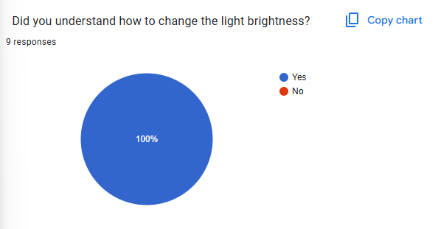

The pie chart below shows the smart home feedback question analyzed. So, everyone selects the Yes, so the chart is completely demonstrating positive responses at 100%. This therefore suggests that all understand adjusting the light brightness within the smart home system, inherently implies that the instructions or the interface for this feature are clear, intuitive, and easy to follow.
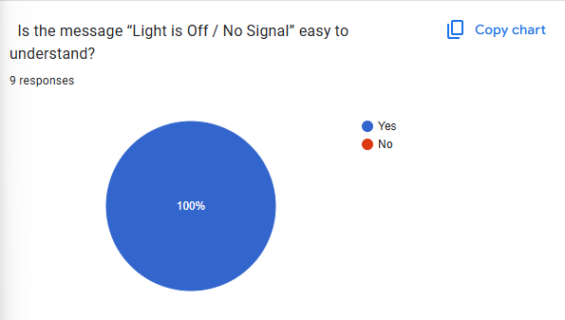

In the chart can be seen that it was easy to understand the message “Light is Off/No signal, the blue column for 100% is filled. This suggests that the system conveys the status of the light effectively, so the users are allowed to immediately identify whether the light is off or not connected.

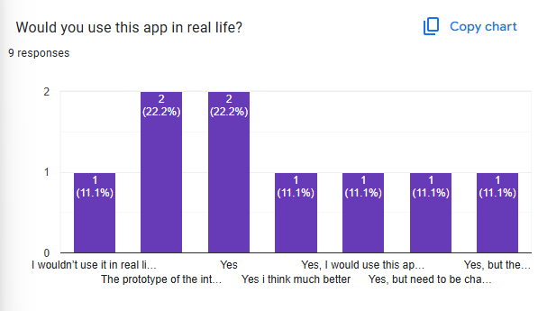

The bar chart also reveals the varied options about using the app in real life; most of the options are positive. Some of the users responded YES, the rest agreed that they will use the app once it is improved. This reveals that the system has huge potential for use in real life. This smart home system will greatly benefit the users in the future since it provides convenience, energy saving, control, and home security.

Future prediction

This study presents the full process of heuristic-based design in the HCI, from the point of heuristic identification and the design process through heuristic testing and resulting heuristic analyses, to find a close gesture-controlled smart home lighting solution and its resulting heuristic-based design process. The result clearly illustrates the huge usability potential of gesture-based interaction to serve a much more intuitive and accessible form of interaction than the more traditional touch-based solutions, but most notably in the environment of smart homes, the absence of need to touch and interact physically has enhanced usability and availability significantly. If the vertical gesture regarding the intensity of the light created an intuitive interaction process, the need to make the color choice through a horizontal gesture proved difficult, accentuating again the importance of space mapping and quality, clear understanding with a high sensitivity rate through design applied to the algorithm implemented for the precise identification and precise action process in gesture interaction design in the end.
AI in the human-computer interaction design process, the prediction indicates the emergence of AI-adjustable gesture personalization, design readings applied to the respective process in the design process implemented for the respective task performed, and depending upon the concrete AI prediction applied to the design process performance in the task applied to the process in the first place.

(I also used the AI tool to get information and perform this Task)

Figma link
https://www.figma.com/proto/5YCjV9Zk48ypagt9rQOj2B/Untitled?node-id=1-2&p=f&t=r6KneHXZLpKRhWjR-1&scaling=scale-down&content-scaling=fixed&page-id=0%3A1

Google Form link
https://forms.gle/PUcNwEkbr4uXWvYr5

References

Nielsen, J., 1994. Usability engineering. Morgan Kaufmann.

Norman, D., 2013. The design of everyday things: Revised and expanded edition. Basic books.

Wigdor, D. and Wixon, D., 2011. Brave NUI world: designing natural user interfaces for touch and gesture. Elsevier.
Gigerenzer, G. and Gaissmaier, W., 2011. Heuristic decision making. Annual review of psychology, 62(2011), pp.451-482.
Chaiken, S., 2014. The heuristic model of persuasion. In Social influence (pp. 3-39). Psychology Press.
Jankowski, J. and Hachet, M., 2015, February. Advances in interaction with 3D environments. In Computer Graphics Forum (Vol. 34, No. 1, pp. 152-190).
Nielsen, M., Moeslund, T.B., Störring, M. and Granum, E., 2008. Gesture interfaces. HCI Beyond the GUI: Design for Haptic, Speech, Olfactory, and Other Nontraditional Interfaces, Elsevier.

