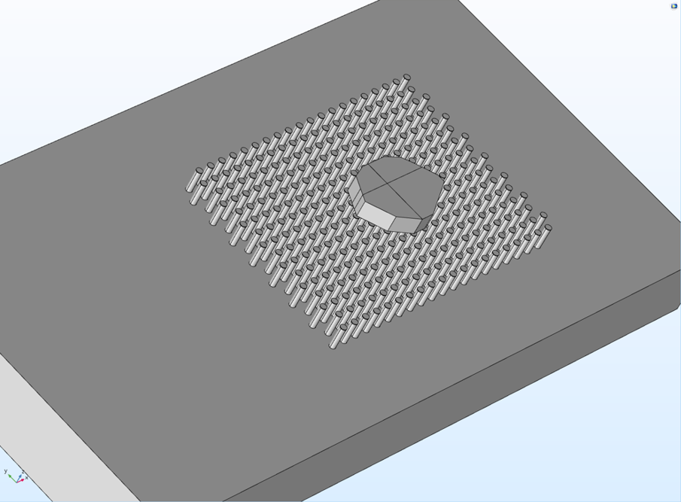

1a) building the shape using COMSOL

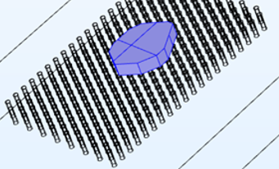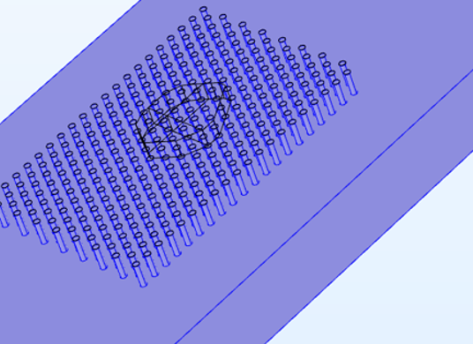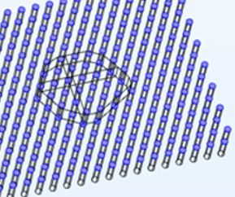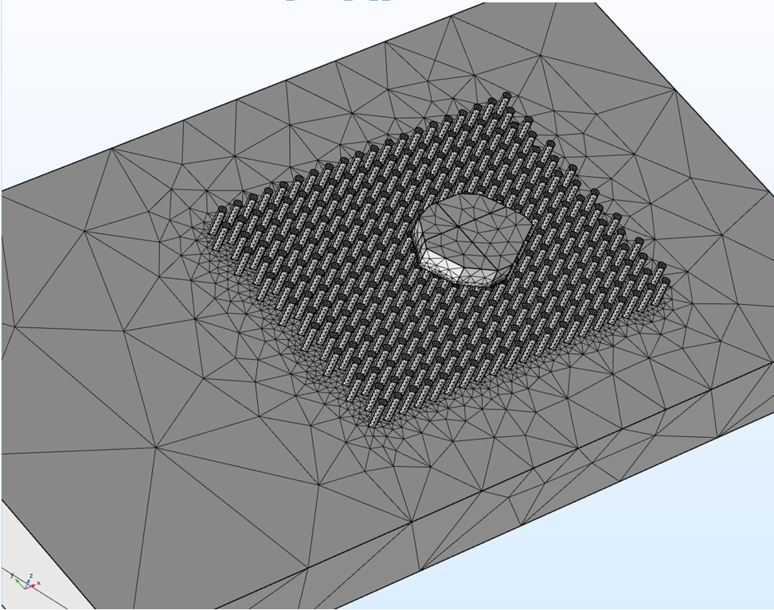

1b) assign material and mesh

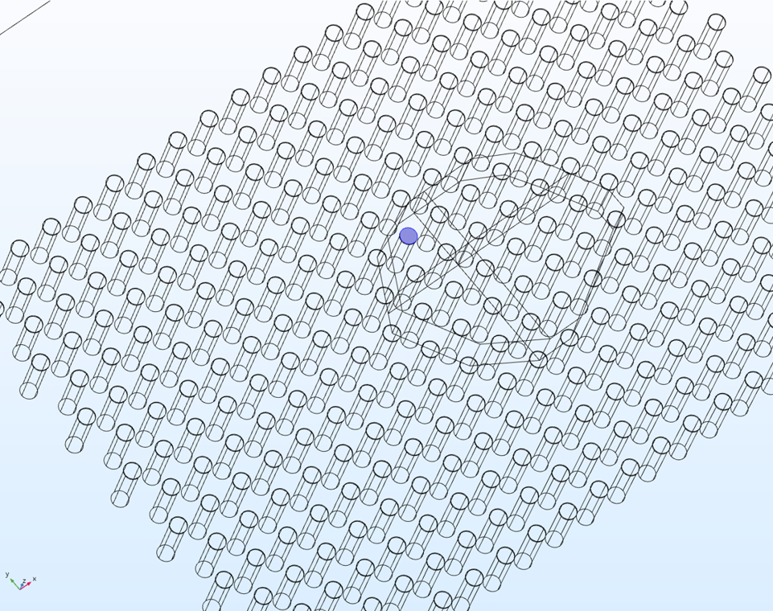

1c) assign different traction forces to pillars

Background:

Cell stiffness is an important bio-marker. I hypothesize that the cell stiffness can be back-calculated from the pillar positions of stretched PDMS pillars with cells on top of them. I will create finite element models of a cell with different thicknesses, and use machine learning to back-calculate the cell stiffness from the positions of the PDMS pillars. I expect my data to show high correlations between the cell stiffness and the displacement of the stretched pillars. My results will enable biologists to obtain the cell stiffness from microscope images.

COMSOL Stimulation;

I first use COMSOL to build the shape of the model with reference to the actual cell and pillars [1a]. Then I assign the material and the mesh to the model [1b]. For the pillars, I assign 1000 different Young’s modules randomly ranging from 0 to 4000 Pa to each of them. Using the data from the experiment, I also assign traction force to all pillars [1c]. This step completes the model. After prescribing the fixed side and the stretching side of the model[1d], I set the elongation to be 55%. Then I perform the stimulation 1000 times (each time with a different Young’s modules on pillars). After the stimulation, I select the pillars covered by the cell to do point evaluation[1f]. As a result, for each pillar, I can get 1000 different values of displacement as a result of different Young’s modules.

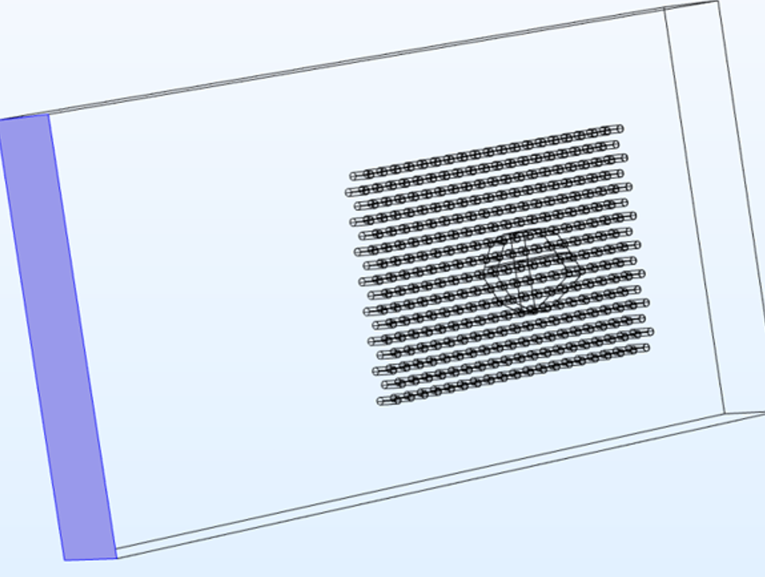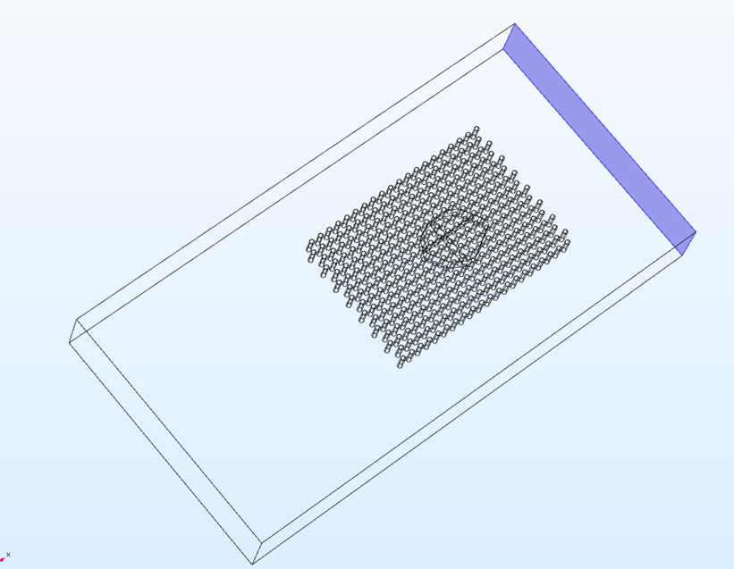

1d) setting the fixed side and stretching side

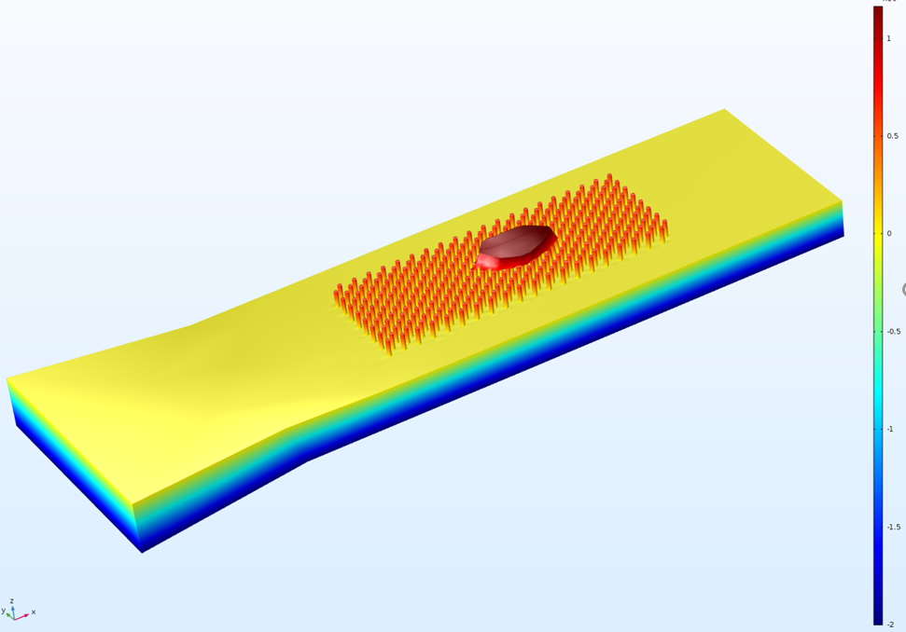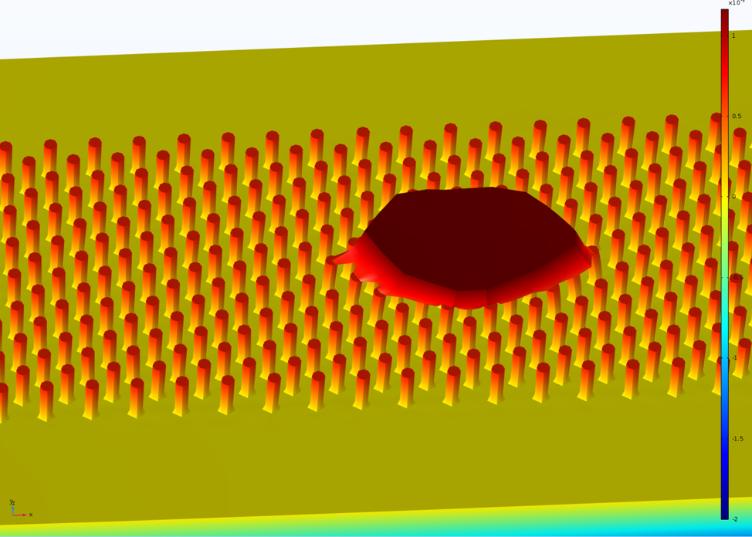

1e) the stress view of the stimulation

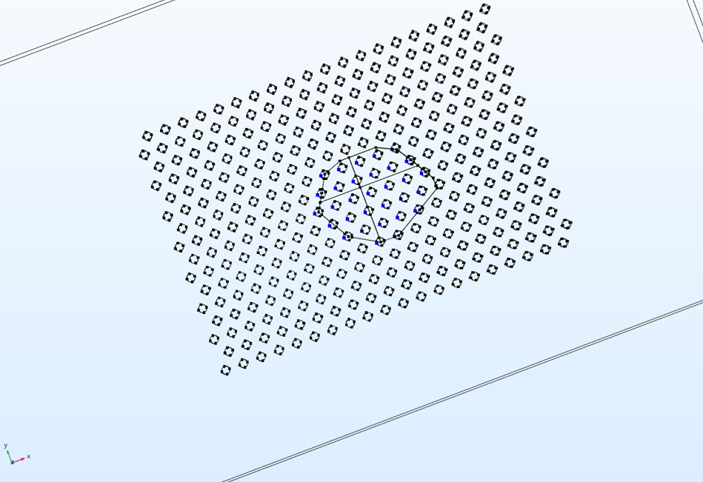

1f) point evaluation

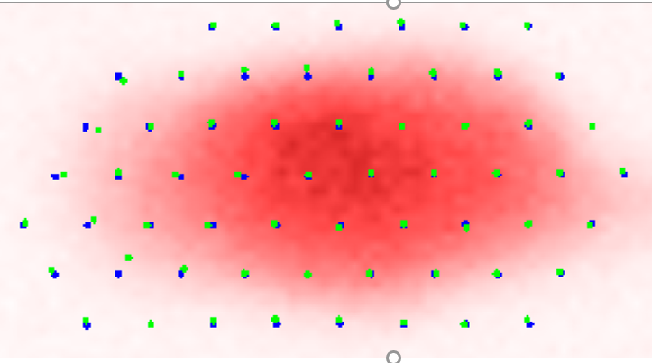

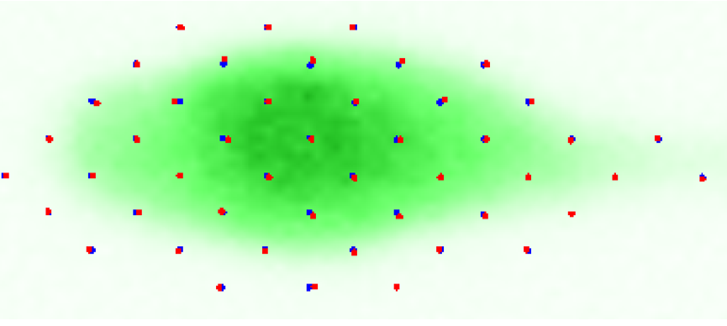

1g) the experiment without cell and with cell

Machine Learning;

After the stimulation, I output the result as csv file and put it in the Machine Learning code. The code will learn to predict the cell stiffness from the its pillar displacement. I assign the first 800 results for the code the learn, the code will predict the next 200 results and check if its prediction matches the actual cell stiffness.

The Experiment;

In the experiment, I first calculate the pillar displacement after stretch without cell (X0), then calculate pillar displacement after stretch with cell (Xc). Then the final stretching displacement U =Xc-X0. With U for each pillar, I put them into the machine learning code to predict the cell stiffness of each pillar.