1.

a)

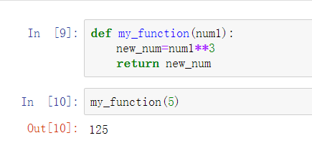

b)



c)

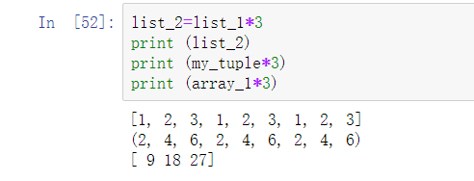

Arrays allow numerical calculation like matrix. So every item in the array is multiplied by 3.

d)

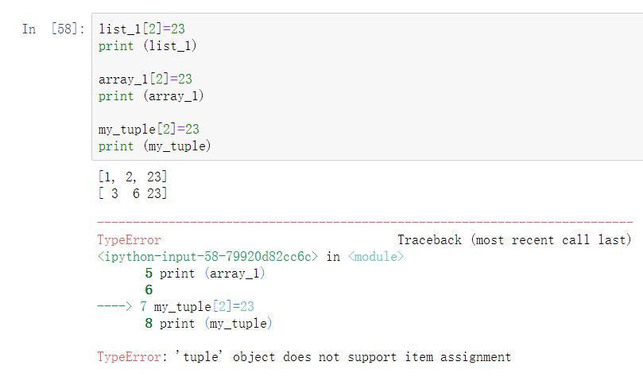

It’s because tuples are immutable. The items in it cannot be changed, but items in lists and arrays could be changed.

e)

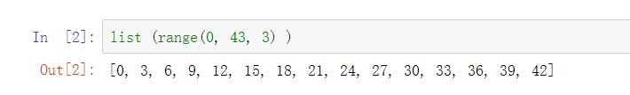

f)

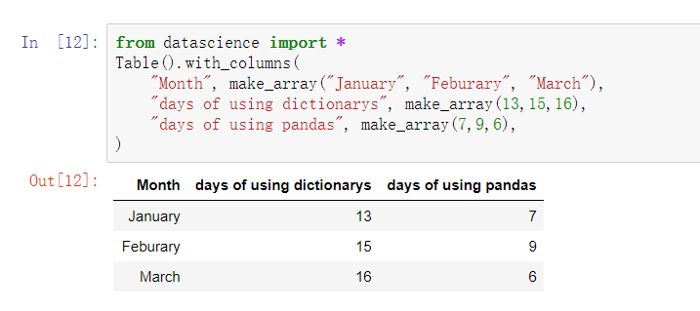

2.

a)

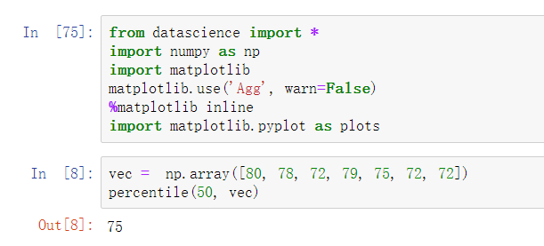

b)

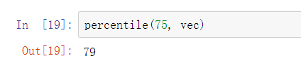

3.

a) 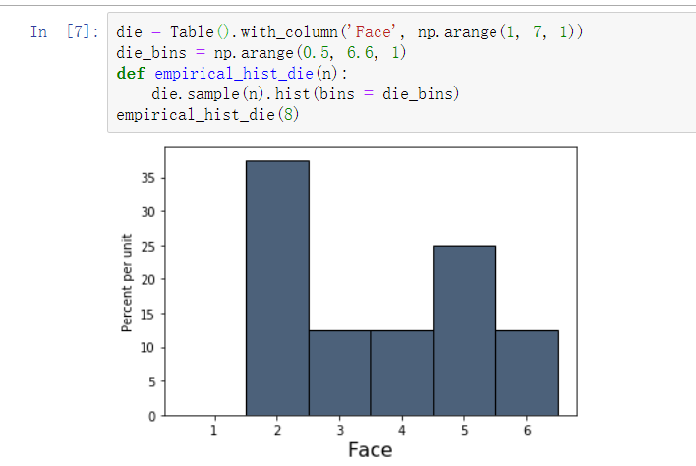

b) 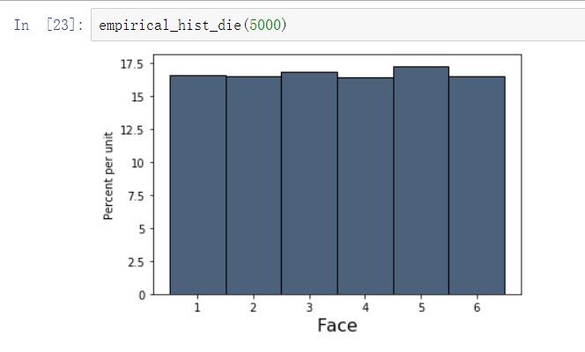

The area of each bar gets closer to 16.7%. It shows that theoretically, each appears about 16,7% of the time we row. It’s because in the long run, the proportion of times that an event occurs gets closer to the theoretical probability of the event.

4.

a)

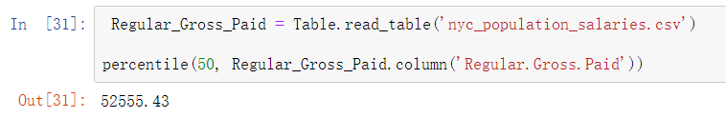

b)

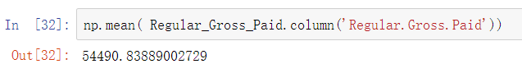

c)

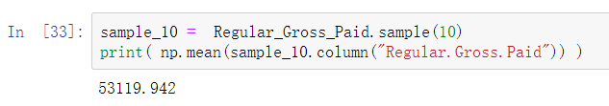

d)

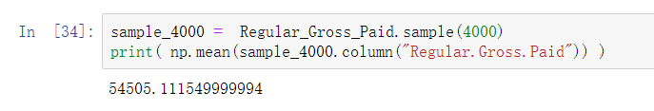

e) The second answer (with sample size of 4000) is closer to the population mean because is has a larger sample size.

f)

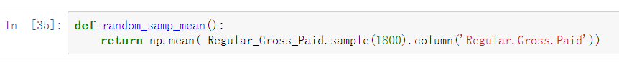

g)

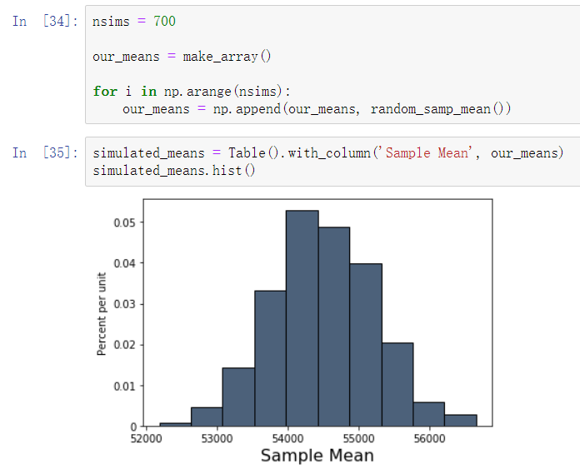

h)

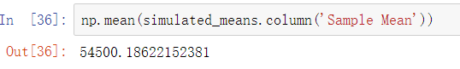

5.

a)

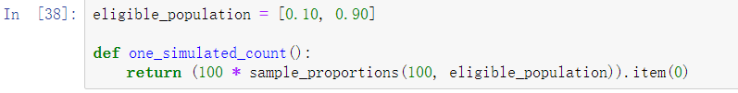\

b)

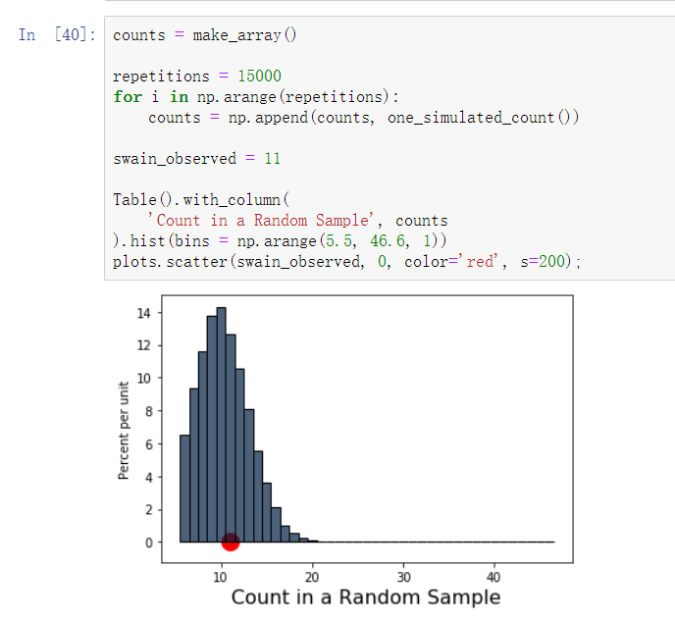

c) Yes.

6.

a)

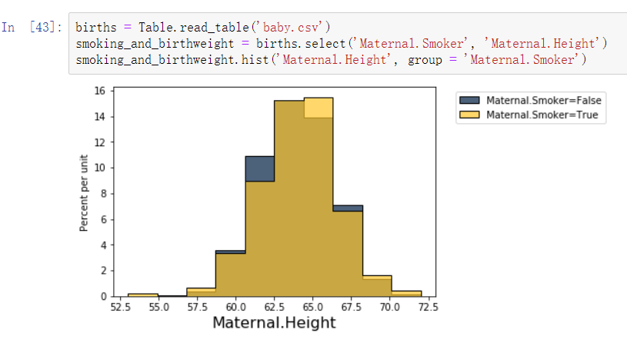

b)

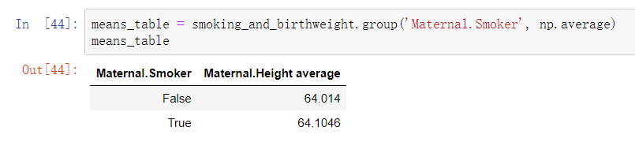

c)

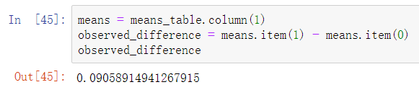

The observed difference is 0.09058914941267915. Maternal smokers are taller.

d)

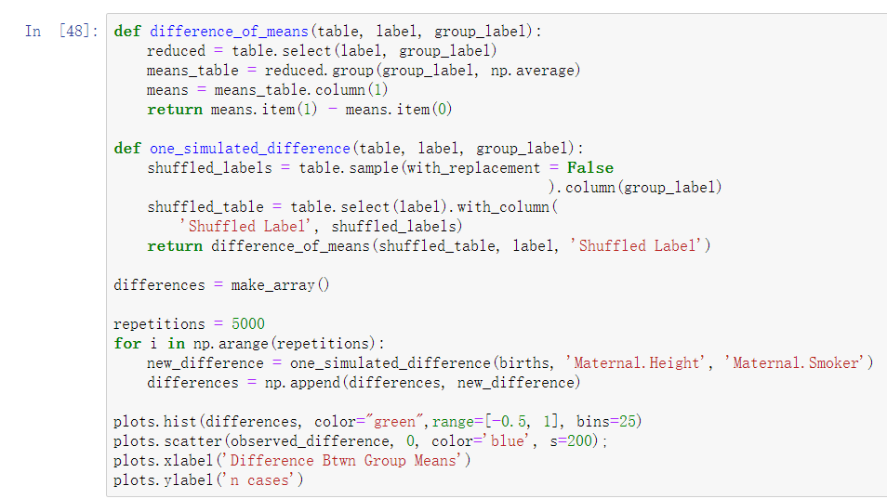

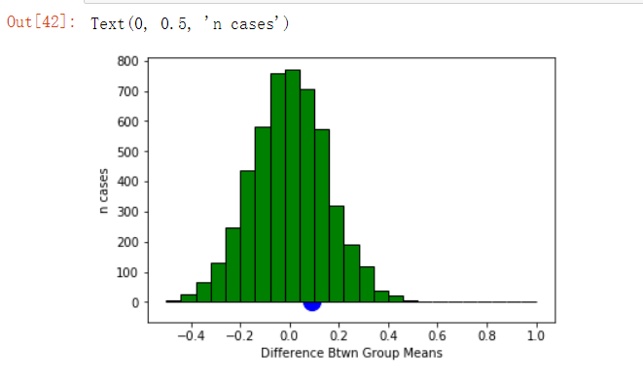

e)

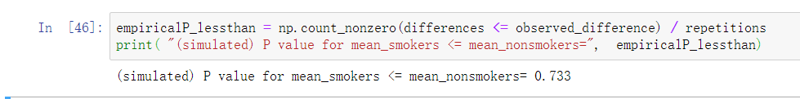

The p-value is 0.733. It’s not statistically significant at conventional levels.

f)

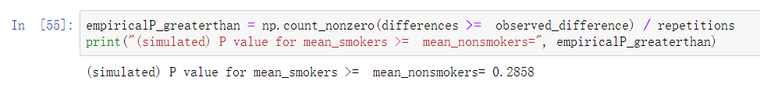

The p-value is 0.2734. It’s statistically significant at conventional levels.

g)



0.5468.

7.

a) 22\*0.05=1.1

b) 22\*0.95=20.9

c) No, it doesn’t. Since the experiments that result p-value greater than 0.05 are never published. But actually those could reject the null hypothesis. So there might actually be relationship between X and Y.