1. a)

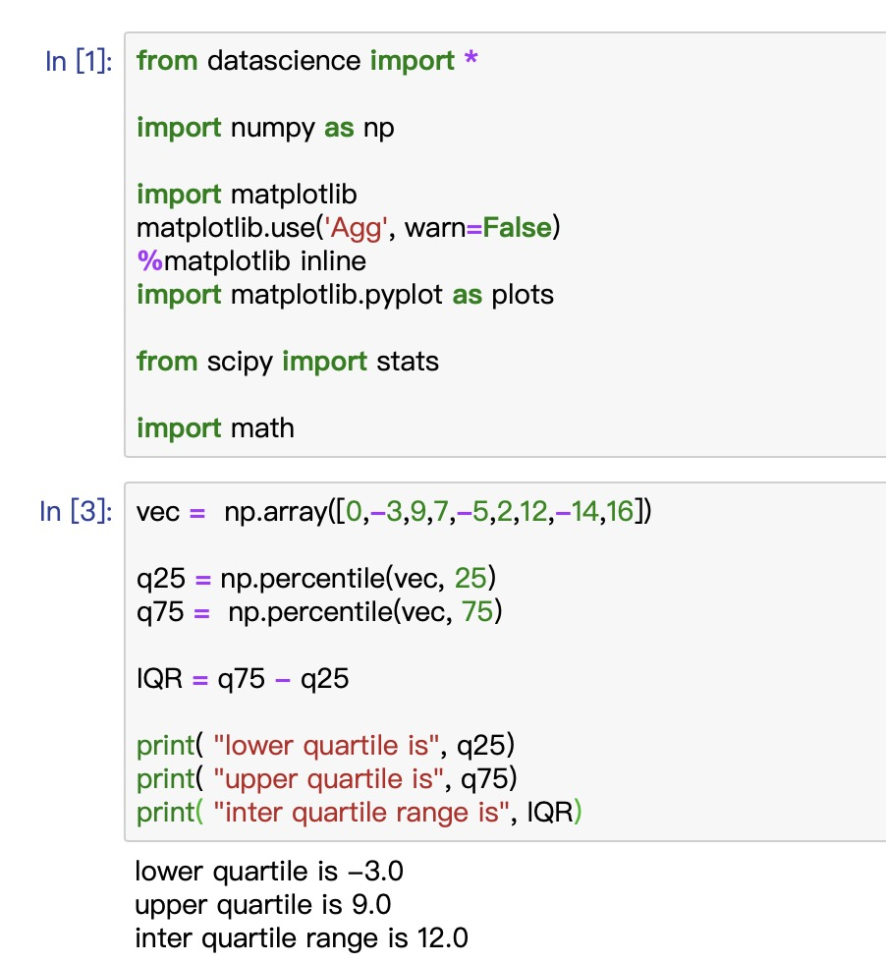

b)

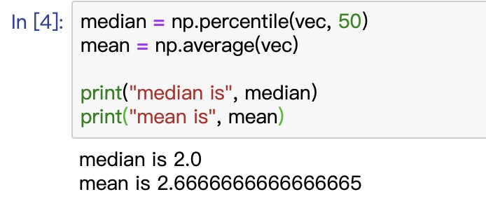

c)

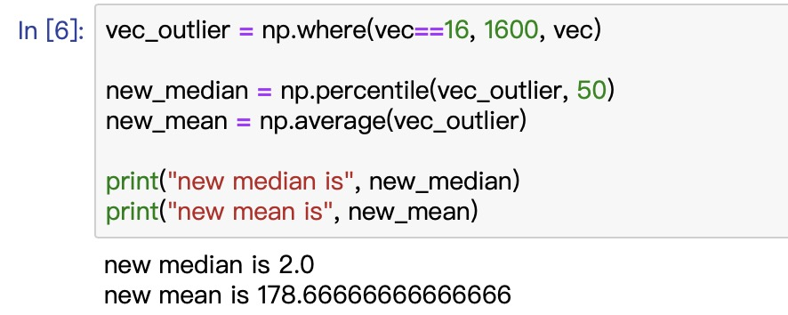

d) This means that median of an array is more sensitive to outliers. It would be less likely to report great error if one or two great outlier arrives in the sample.

1. a)

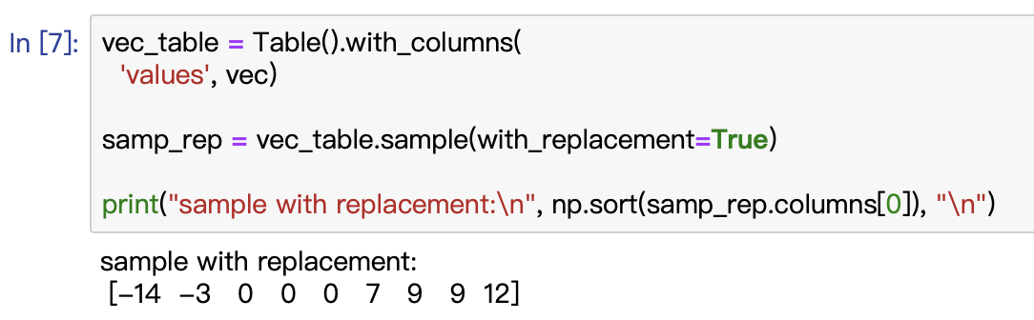

b)

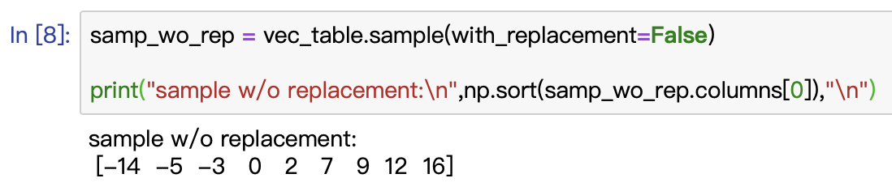

It’s absolutely the same as the original sample. Because the original sample contains only 9 elements, and we should take 9 of them without replacement, we have to take all of them once into the sample.

1. a)

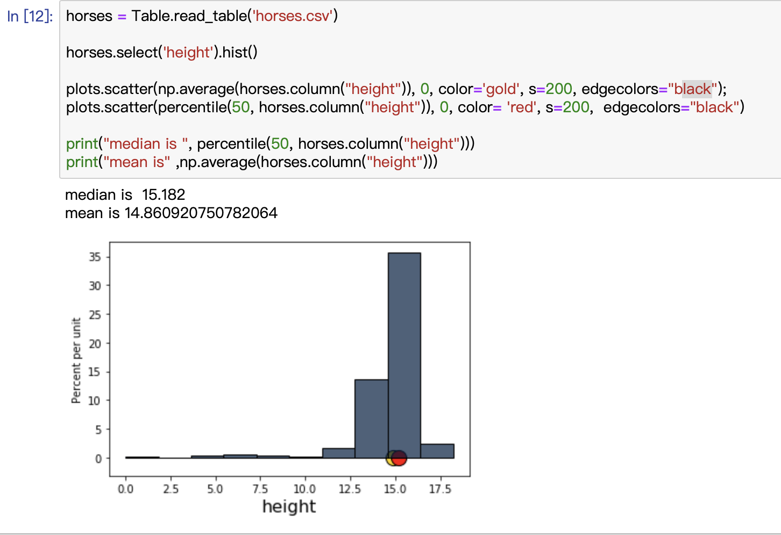

b) The distribution is skewed to the left.

c) 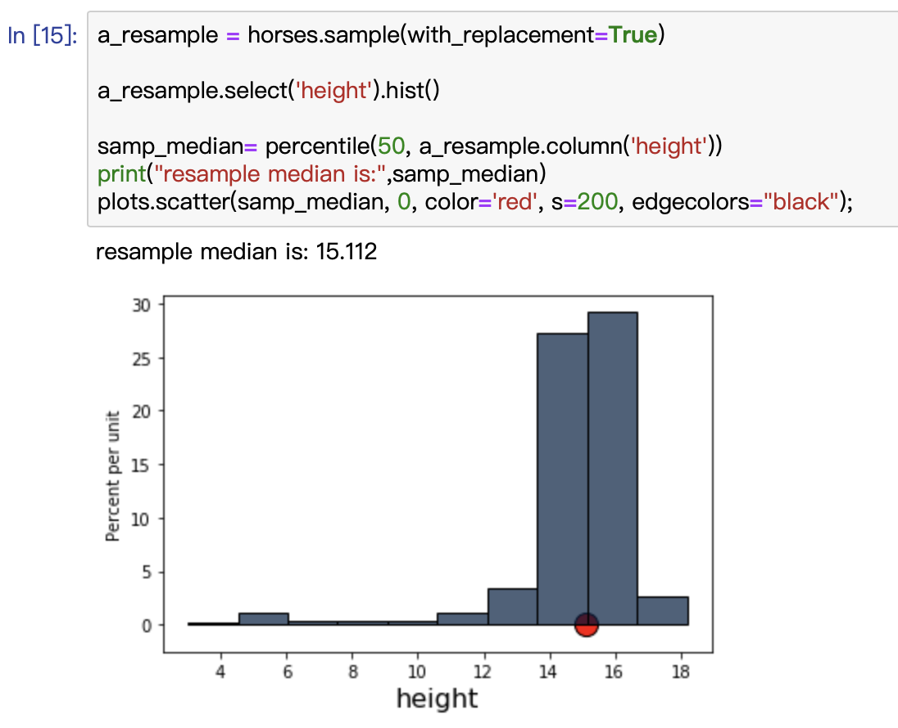

d)

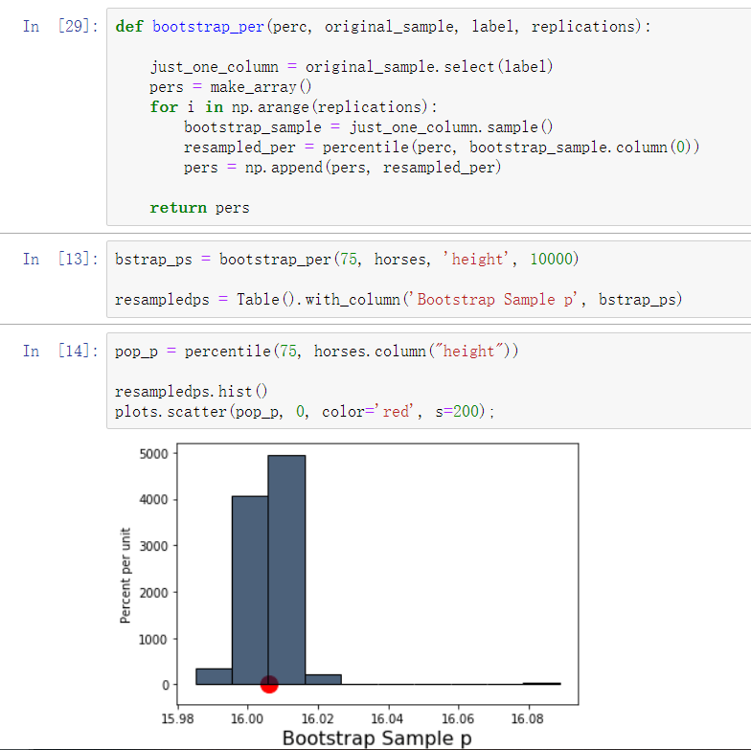

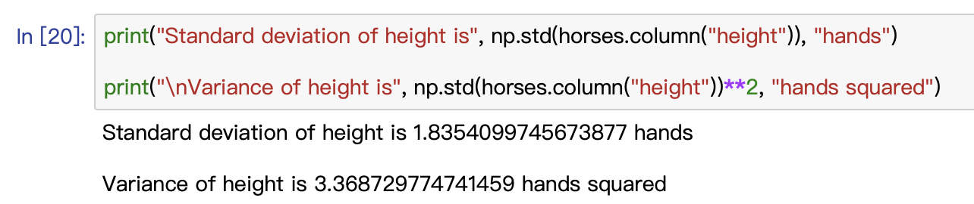

1. a)

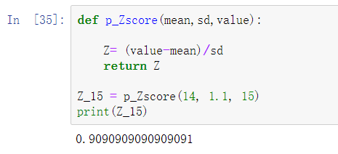

b)

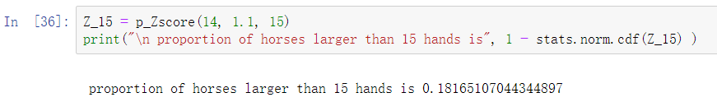

c)

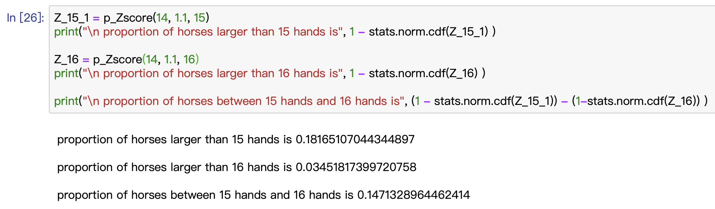

1. a) 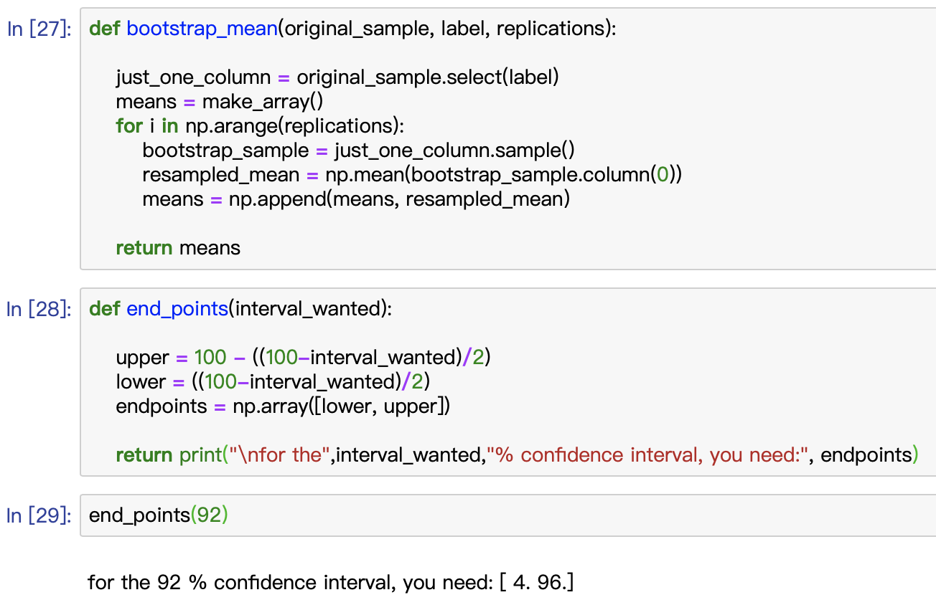

b)

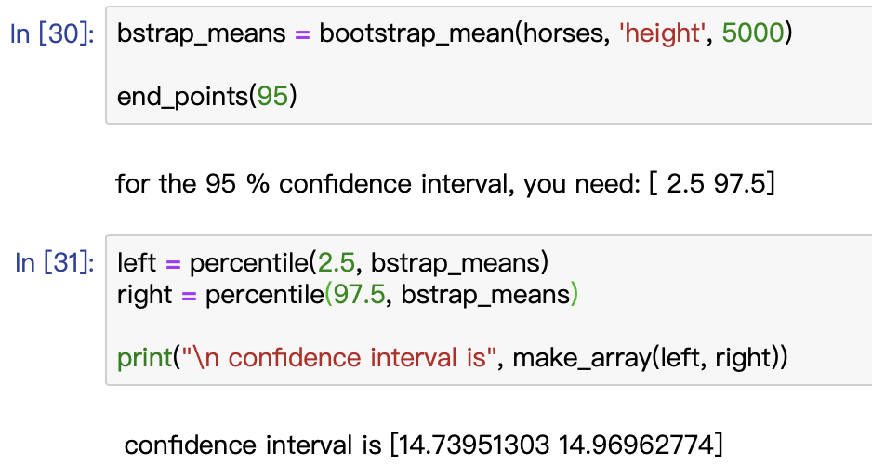

c)

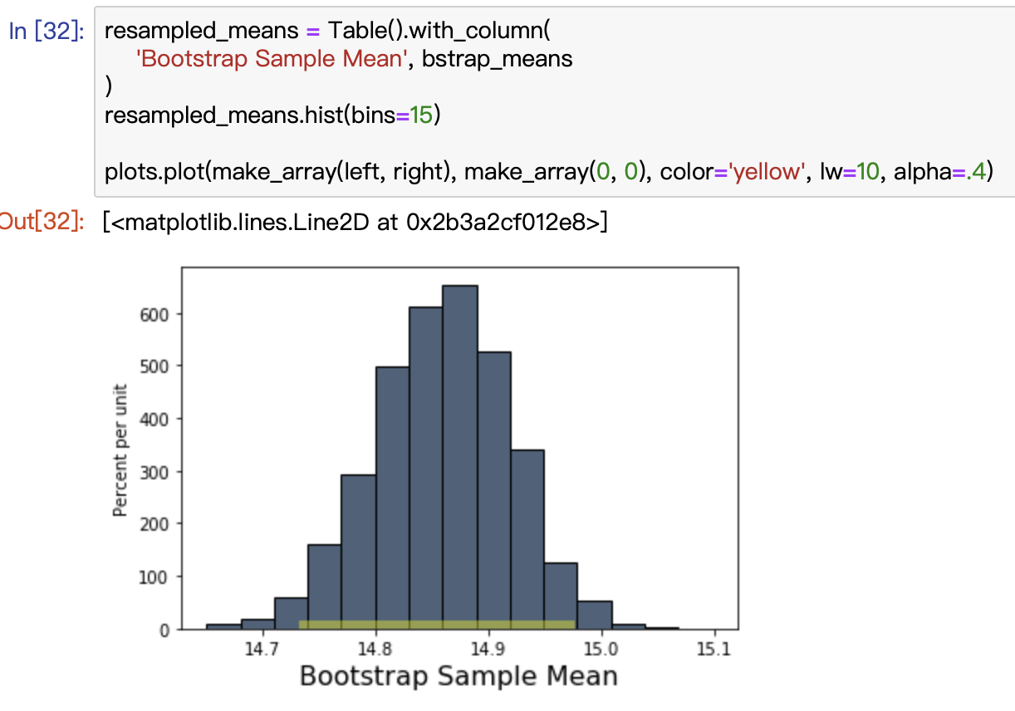

d) I reject the null hypothesis because 14 is not included in the 95% confidence interval which is [14.73951303 14.96962774].

1. a)

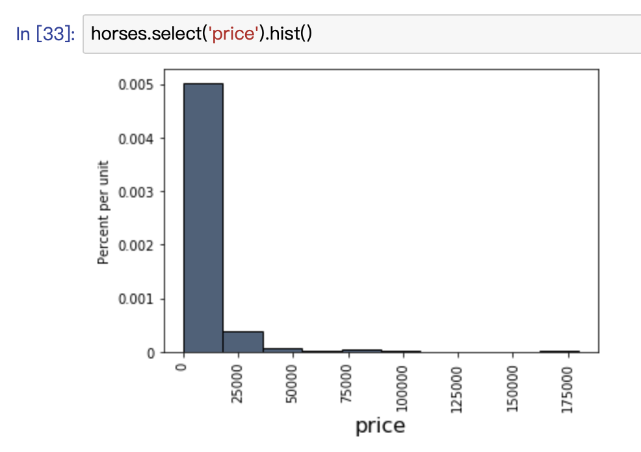

It’s not normally distributed. It’s because the sample size is not large enough.

b)

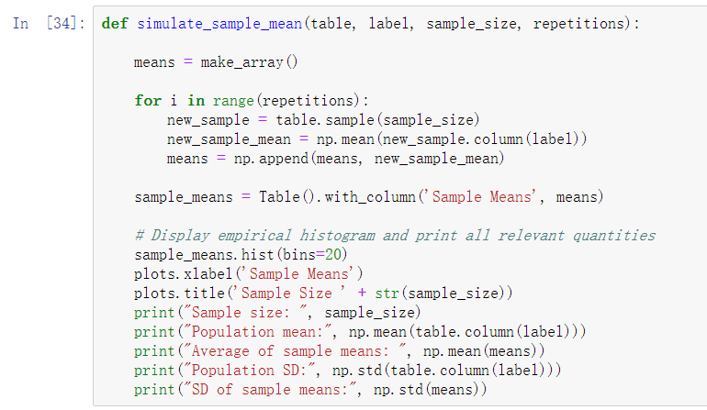

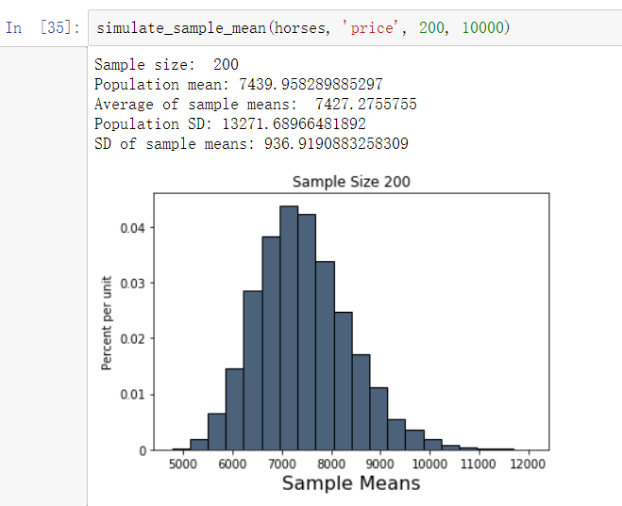

c) The mean of sampling distribution is close to the population mean, but not the same.

d) It’s approximately normal. Because according to the central limit theorem, the sample size is large enough that the sampling distribution is approximately normal.

e) 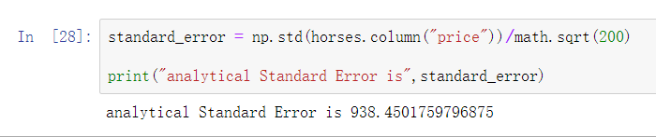

1. a) The margin of error of the poll is 4.3%.

b) The confidence interval around Kamala Harris’s percentage of vote is [1.7pts 10.3pts].

c) The confidence interval around Pete Buttigieg’s percentage of vote is [2.7pts 11.3pts].

d) Because Harris’s “true” performance is within the confidence interval of Buttigieg’s percentage of vote, and Buttigieg’s “true” performance is within the confidence interval of Harris’s percentage of vote, it is not clear who is doing better in the country as a whole.