Program Structures & Algorithms  
Spring 2022  
Assignment No. 3

Name: Chenxu Zhao  
(NUID):001584599

•Output screenshot

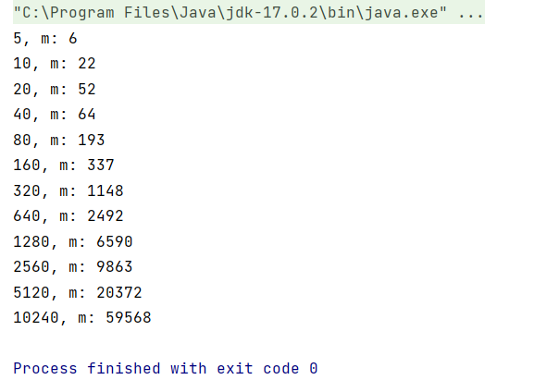

•Relationship Conclusion  
The larger the n increases, the larger the m increases

•Unit tests result

